Week 14 Linux Projects – Chapter 13 Configuring Network Services and Cloud Technologies
Activities
Week 14 Linux Projects – Chapter 13 Configuring Network Services and Cloud Technologies 1
Snapshots are Important! 1
Update Fedora 1
Project 13-2: DNS 1

How to Create Screenshots: Please use the Windows Snip and Sketch Tool or the Snipping Tool. Paste a screenshot of just the program you are working on. If you are snipping a virtual machine, make sure your focus is outside the virtual machine before you snip.
- Press and hold down the Windows key & Shift, then type S. This brings up the on-screen snipping tool.
- Click and Drag your mouse around whatever you want to snip.
- Release the mouse button. This places the snip into the Windows Clipboard.
- Go into Word or wherever you want to paste the snip. Hold down CTRL, then type V to paste the snip.

Update Kali Linux
In Kali Linux in the terminal.
sudo apt update
sudo apt dist-upgrade -y

Project 13-2: DNS
Time required: 20 minutes
In this hands-on project, you configure and test the DNS daemon on your Fedora Linux virtual machine. You will configure some fake local domains, and setup the DNS daemon to forward all other requests to your DNS server.
You will want your VM on a bridged adapter.
- On your Fedora Linux virtual machine, switch to a command-line terminal (tty5) by pressing Ctrl+Alt+F5 and log in to the terminal using the user name of root and the password of LINUXrocks!.
- Type dnf install bind and press Enter to install BIND (the named daemon, the most popular Linux DNS server). Type y and press Enter when prompted to continue the installation.
- Create and edit the /var/named/example.com.dns file with a text editor by adding the following lines:
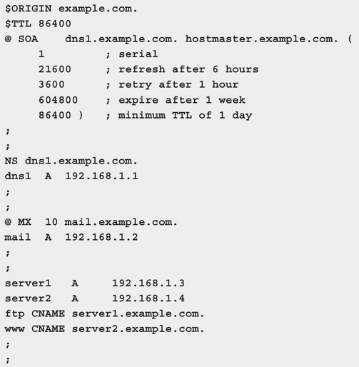
- When finished, save your changes and quit the editor.
- Type chgrp named /var/named/example.com.dns and press Enter to change the group ownership of the example.com.dns zone file.
- Type chmod 640 /var/named/example.com.dns and press Enter to allow named to read the contents of the example.com.dns zone file.
- Edit the /etc/named.conf file with a text editor. Under the line that reads:
add the following line substituting your DNS server or 8.8.8.8:
- At the bottom of the file, add the following lines that identify your example.com.dns zone file:
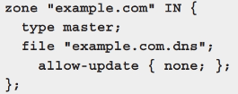
- When finished, save your changes and quit the editor.
- Type systemctl start named.service and press Enter to start the DNS name daemon.
- Edit the /etc/resolv.conf file with a text editor and remove any existing nameserver lines.
- Add the line nameserver 127.0.0.1 before the first existing nameserver entry to ensure that your Linux computer uses the local DNS server daemon for name resolution.
- Save your changes and quit the editor when finished.
- Type host server1.example.com and press Enter.
- Insert a screenshot.
Click or tap here to enter text.
- Type host ftp.example.com and press Enter.
- Insert a screenshot.
Click or tap here to enter text.
- Type nslookup server2.example.com and press Enter.
- Insert a screenshot.
Click or tap here to enter text.
- Type nslookup www.example.com and press Enter.
- Insert a screenshot.
Click or tap here to enter text.
- Type dig @localhost example.com ANY and press Enter.
- Insert a screenshot.
Click or tap here to enter text.
- Type host www.linux.org and press Enter.
- Explain why the name was resolved successfully.
- Type less /var/named/named.ca and press Enter. View the entries.
- What do these entries represent?
- Click or tap here to enter text.
- Logon to Gnome, switch your network settings back to Dynamic.
- Type exit and press Enter to log out of your shell.

