LLP Assignment 2

### Problem Statement

Graph each of the following constraint equations in R. You do not need to shade feasible regions. A. x + y ≥ 4, x + y ≤ 2 B. x + y ≤ 2, x - y ≤ 1

### Load Package

if(!require("ggplot2")){install.packages("ggplot2")}

## Loading required package: ggplot2

### Problem A

### Solving A, x + y ≥ 4 , x + y ≤ 2  
### y ≥ -x + 4, y ≥ -x + 2   
  
fun1 = function(x) -1*x + 4 ## y1  
fun2 = function(x) -1*x + 2 ## y2  
  
  
#Create range of x values  
x=seq(0,10)  
  
#Plug x values into constraint functions  
mydf = data.frame(x, y1=fun1(x), y2=fun2(x))  
  
#Plot functions  
g = ggplot(mydf, aes(x = x)) +   
 geom_line(aes(y = y1), colour = 'blue') +  
 geom_line(aes(y = y2), colour = 'green')+   
 geom_ribbon(aes(ymin=y1, ymax=y2),fill='gray80')  
g

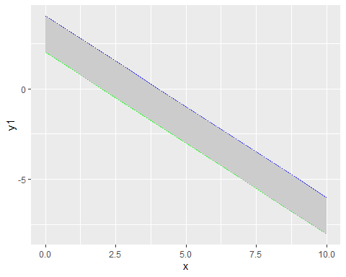

#### Solution of A is feasible but unbounded

### Problem B

### Solving B, x + y ≤ 2 , x - y ≤ 1  
### y ≤ -x + 2, y >= x - 1  
  
fun1 = function(x) -1*x + 2 ## y1  
fun2 = function(x) x - 1 ## y2  
  
  
#Create range of x values  
x=seq(0,10, by = 0.05) # x=seq(0,10) will not give correct region as pmin(y1, y2) values will be discrete  
  
  
  
#Plug x values into constraint functions  
mydf = data.frame(x, y1=fun1(x), y2=fun2(x))  
head(mydf)

## x y1 y2  
## 1 0.00 2.00 -1.00  
## 2 0.05 1.95 -0.95  
## 3 0.10 1.90 -0.90  
## 4 0.15 1.85 -0.85  
## 5 0.20 1.80 -0.80  
## 6 0.25 1.75 -0.75

#Plot functions  
g = ggplot(mydf, aes(x = x)) +   
 geom_line(aes(y = y1), colour = 'blue') +  
 geom_line(aes(y = y2), colour = 'green')+   
 geom_ribbon(aes(ymin=y1, ymax=y2),fill='gray80')  
g

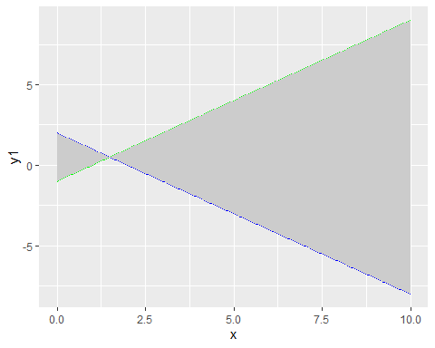

# Correcting the area shaded  
mydf1 = transform(mydf, z = pmin(y1,y2))  
head(mydf1)

## x y1 y2 z  
## 1 0.00 2.00 -1.00 -1.00  
## 2 0.05 1.95 -0.95 -0.95  
## 3 0.10 1.90 -0.90 -0.90  
## 4 0.15 1.85 -0.85 -0.85  
## 5 0.20 1.80 -0.80 -0.80  
## 6 0.25 1.75 -0.75 -0.75

g1 = ggplot(mydf1, aes(x = x)) +   
 geom_line(aes(y = y1), colour = 'blue') +  
 geom_line(aes(y = y2), colour = 'green')+  
 geom_ribbon(aes(ymin=y1, ymax=z),fill='gray80')  
g1

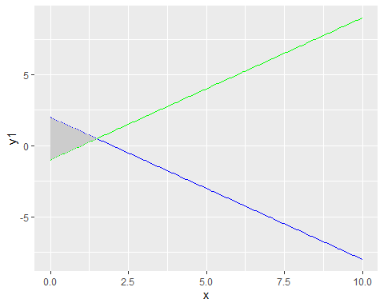

#### Solution of B is feasible and unbounded