Exploratory Data Analysis (EDA)
Summary Statistics
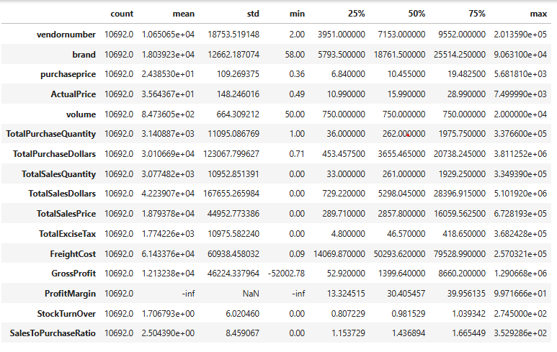
Analysis:
Profit Margin = Min of –infinity suggesting areas where revenue is zero/ lower than the total cost
Gross Profit = -52000 high losses, i.e., selling products at lower prices than purchase cost
Total Sales Quantity = 0 suggesting that the products were purchased but were not sold (could be due to past year’s unsold inventory-obsolete stock)

After analyzing the data’s description, the next steps lies in data filtering:
Data Filtering:
- Profit Margin = 0
- Gross Profit = 0
- Total Sales Quantity = 0

Correlation Analysis
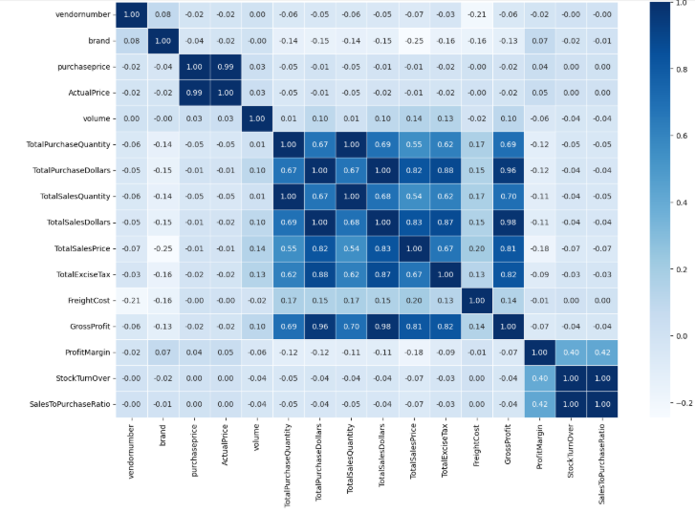
Analysis:
- Strong positive correlation between Purchase Quantity and Sales Quantity (1.00), suggesting very efficient stock management
- Negative correlation between Sales Dollar and Profit Margin (-0.12), with Sales Price increasing and profit margin decreasing

Findings across the business problems
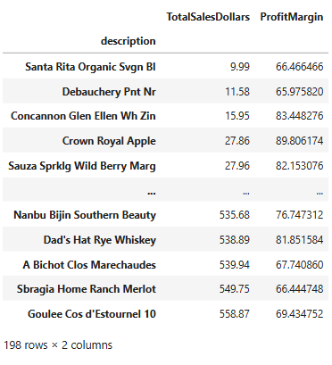
198 brands showed higher profit margins but lower sales. Thus, a need for high promotional activities for these brands to improve sales
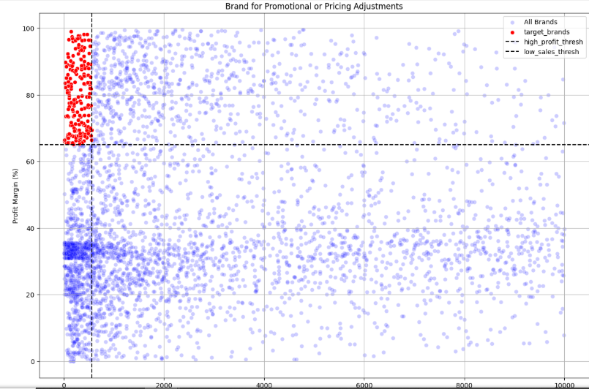
Top Vendors contributing to the purchases
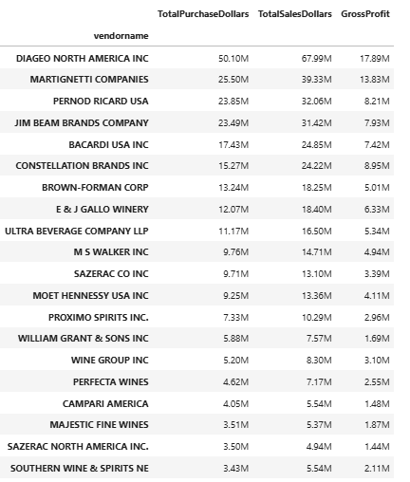
Top 10 vendors have contributed to high revenue, since profit generated from the same are high
Order Size from the Volume
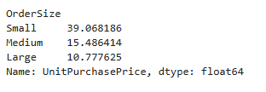
Analysis:
- It is clearly visible that the organization will benefit from the bulk purchases from the vendors
- Purchases in small quantities are not economical for generating revenue
- Large orders clearly help us save 72% of our unit price compared to small orders

Recommendations:
- Focus on pricing for those brands that have low-sales but higher profitability, to boost sales
- Make bulk purchases from vendors, which will encourage them to give us a less price
- Focus on low stock turnover ratio, by launching clearance sale to prevent loss from obsolete products
- Improve marketing and distribution strategy for low-performing vendor to drive high sales volume

