Add a second reward structure to the model called "lost", which assigns 1 to every transition of the model labelled with action request from a state where the queue is full. [*]

rewards "lost"
[request] q=q_max : 1;
endrewards

Now create a new property for checking the expected cumulated reward up until time T. How does this measure vary for different values of q_trigger? Plot a graph to show this.[*]
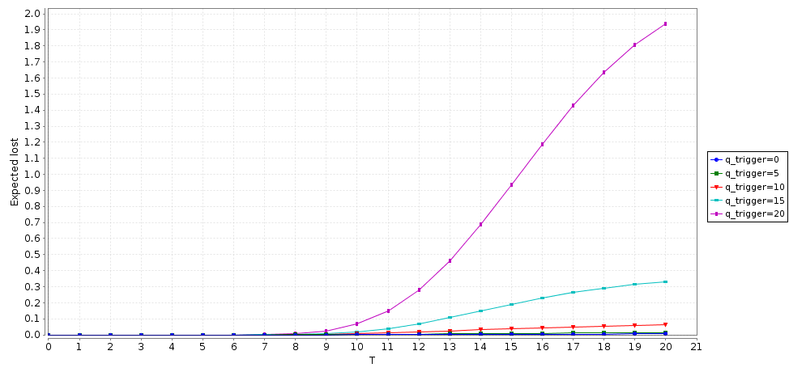
Add a third reward structure to the model representing the power consumption. Use a cumulative reward property to investigate the energy consumption over time of the system. [*]

rewards "energy"
sp=0 : 0.13;
sp=1 : 0.95;
sp=2 : 2.15;
[sleep2idle] true : 7;
[idle2sleep] true : 0.067;
endrewards

R{"energy"}=? [C<=T]

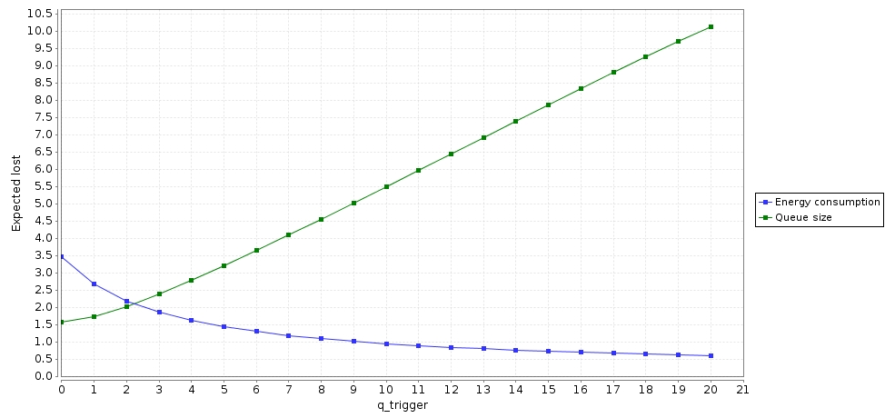
To illustrate the trade off between power consumption and performance, on the same graph plot how the long run average queue size and power consumption vary as q_trigger changes. [*]

Change this power manager such that, instead of switching on (sending the sleep2idle command to the PM) each time the queue becomes full, probabilistically chooses to switches on whenever a request arrives where the probability of switching increases as the request queue size increases. [*]

module PM

// i2s: true when idle2sleep command should be issued
i2s : bool init false;
// s2i: true when sleep2idle command should be issued
s2i: bool init false;

// idle to sleep command triggered by request arrivals/services
// decide to perform command when queue becomes empty with probability p_sleep
[serve_last] true -> p_sleep : (i2s'=true) + 1-p_sleep : (i2s'=false);

// Send idle2sleep command to SP
[idle2sleep] i2s -> (i2s'=false);

// Every time a request is sent, cancel idle to sleep command
// and send a sleep to idle command with probability q/q_max
[request] true -> q/q_max: (s2i'=true) & (i2s'=false) + 1-(q/q_max) : (s2i'=false) & (i2s'=false);
// Send sleep2idle command to SP
[sleep2idle] s2i -> (s2i' = false);

endmodule

