# Need

The need is to create a website about one or more Windows releases. I am the stakeholder.

# Concept Designs

Please see the PowerPoint

I have asked multiple people and the blue colour scheme, the saidebar design and Open Sans font were chosen the most

# Log

16/03/2015: Created concepts and layouts. Started asking my friends, family and teachers. I used the two main professional colours, black and blue, and the colour representing happiness and friendliness, yellow. For the layouts, I used the two common web layouts, the ‘sidebar’ layout and the ‘navbar’ layout. To see the layouts and colours please check the PowerPoint in the same folder.

17/03/2015: Researched two Windows version betas. Windows 95 (codenamed ‘Chicago’) and Windows Vista (codenamed ‘Longhorn’ before the project reset). I’ve also collected some locations where you can download the builds legally. WinWorldPC is one of the places. The downloads would be legal anyway since it is now abandon ware. While Windows Vista itself is not abandon ware yet, but the pre-release builds like the ones in M3 to M7, O13 to Release Candidate are abandon ware. I’ve also layed out the folders. It is in a tree format because it will be easier for people to find the right content and to make it easier for me to fix things.

18/03/2015: Based on the feedback from friends, teachers and family, the blue colour scheme was the most favoured and there were the same amount of people who chose both the Sidebar and NavBar design. I have chosen the Sidebar design because it’s the one that I have the most experience making. Also, some people suggested that I should add an image or gradient to the background because it was a little bit bland. I’ve added a gradient because it was easier to create and it uses less resources in the browser. Finally, most people surveyed liked Open Sans, Made banners for the website. Based on an image of a tree that I took this summer at the light festival in the botanical gardens. I released it as Public Domain, so anyone can use it.

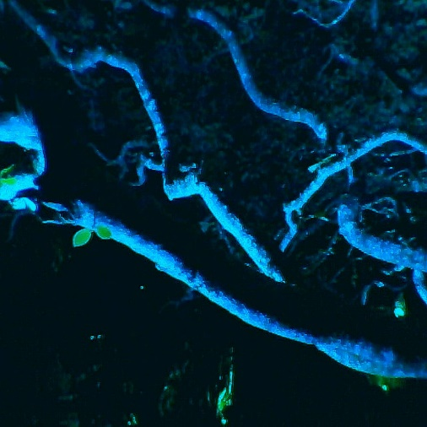Original Picture BetaMuseum Poster

The picture was cropped to fit 1024×150 (which is the ideal banner size). Then a ‘Zoom Blur’ effect was added to it to make the translucent text over it more readable and to give an awesome-looking background. After that I’ve written the title of the website and a little description in white. I set the layer type from ‘Normal’ to ‘Overlay’ set the text is now translucent. All these modifications were made in a freeware program called ‘Paint.NET’. I was going to put some logos on the banner, but it didn’t look good afterwards so I removed them.

19/03/2015: Started building the template HTML file and the linked Cascading Style Sheet (CSS) and JavaScript (JS) files. As I was building the CSS, I found a bug which doesn’t allow the curtain for the sidebar to go down the page completely. The page was continuously opened in Firefox, SeaMonkey, Chrome, Internet Explorer and Opera on Windows 8.1. The bug was corrected by using a JavaScript that continuously obtained the page size from the browser and sets the content and sidebar size respectively. This bug also makes a nice line over the content. I kept it because it’s not ugly and it doesn’t affect other parts of the page. At the same time, the content was overflowing out of the box. To fix that, I’ve made the <div> responsible for the content to be scrollable.

20/03/2015: Another bug was discovered and patched, but this is when the page’s height is too small. The content and the sidebar are unreadable. To fix this, the content and sidebar MUST be larger than 150px. I’ve done this by making a conditional statement that checks the height variable not to be less than 150 pixels. If the page size is smaller than 150 pixels, the script restricts it to only being 150 pixels. I’ve also set a style for the <a> tags in the sidebar because they do not look nice if you use the default styling.

21/03/2015: Compatibility was checked with a new web browser called Vivaldi.

22/03/2015: Compatibility was checked to see if the web page was compatible with Safari, Chrome, Firefox, Vivaldi, Opera and SeaMonkey on OS X Yosemite, IE on OS X 10.1 and Chrome, Chromium and Firefox on both Ubuntu and openSUSE.

23/03/2015: The sidebar is now finished and thanks to some suggestions, the sidebar labels have little icons. I chose to continue with this because it increases usability. The logos are made by myself, but however I’ve made them in such a way that you can kind of recognise where they’re from. I’ve done this to avoid breaking a copyright laws. I’ve also started writing the articles while I experiment with the beta build of both Windows Vista and Windows 95. Written the complete article Windows 95 and up to build 7047 in Windows Vista.

25/03/2015: Compatibility was checked with a web browser called Torch.

26/03/2015: Started and completed the hub page for Windows.

27/03/2015: Started the index page. Most people wanted a static page which describes the purpose of the website and provides with some information and credits.