A Course Project Report on

Predictive Resource Allocation and Virtual Machine Placement in Cloud Computing Systems

undergone at
Department of Information Technology, NITK Surathkal

under the guidance of
Name and designation of Guide

Submitted by
Anirudh S (231IT006)
T Srujan Swamy (231IT079)
VII Sem B.Tech. (IT)

in partial fulfillment for the award of the degree of

BACHELOR OF TECHNOLOGY
in
INFORMATION TECHNOLOGY


Department of Information Technology
National Institute of Technology Karnataka, Surathkal.

October 2026

Abstract
Placing virtual machines (VMs) on physical hosts determines how much energy a cloud data centre consumes and whether tenants receive the performance they expect. Static strategies either isolate sensitive workloads, wasting capacity and energy, or pack VMs tightly, which causes overload when bursty workloads spike. This project presents a CPU-aware VM placement framework that treats spiky and stable workloads differently and uses live migration between two decoupled zones to absorb spikes.
Each VM is first classified as SPIKY or STABLE from its historical minimum, maximum and average CPU utilisation using a deterministic heuristic. All VMs are then placed in an energy-efficient Eco Zone: stable VMs are consolidated by Best-Fit and each Eco host carries at most one spiky VM, while a high-capacity Performance Zone is kept empty. Spikes are simulated by a fixed schedule, and on every simulated second a controller checks each spiky VM against CPU, RAM and MIPS thresholds. When any threshold is crossed the VM is live-migrated to the Performance Zone, and when all fall back below their limits it returns to its original Eco host.
The framework is implemented on CloudSim Plus 8.0.0 with a Spring Boot backend and a React dashboard. A shared resource ledger keeps the policy's accounting consistent with CloudSim's, and energy and host overload time are measured over simulated time. A live mode streams placements, spikes, migrations and host snapshots to the browser over Server-Sent Events, where a datacenter view animates every migration.
In simulation the framework reproduces the placement behaviour of the midsem test cases, completes migrations to the Performance Zone in 1.0 to 2.6 seconds, within the 5-second spike windows, and reduces total host overload time by 69 to 76 percent compared with the same placement without migration, at the cost of 2 to 11 percent more energy for powering the Performance host during spikes. The results show that zone separation combined with threshold-driven migration of only the spiking VMs is a lightweight and explainable way to protect performance while keeping the data centre densely packed.
Keywords: virtual machine placement, live migration, energy efficiency, workload classification, CloudSim Plus, cloud computing

Table of Contents
1. Introduction 1
1.1 Challenges 2
1.2 Motivation for the work 2
2. Literature Survey 4
2.1 Introduction to Literature Survey 4
2.2 Related Work 4
2.2.1 Base paper: Adaptive Resource-Aware VM Placement (ARA) 4
2.2.2 Adaptive live migration (Cho et al., 2025) 5
2.2.3 Carbon-aware, SLA-compliant VM placement (Alex et al., 2025) 5
2.2.4 Other related work 5
2.3 Outcome of Literature Review 7
2.4 Problem Statement 7
3. Methodology and Framework 8
3.1 System Architecture 8
3.2 Algorithms and Techniques 8
3.2.1 Workload classification 8
3.2.2 Eco-only initial placement 9
3.2.3 Spike simulation 10
3.2.4 Threshold-driven live migration 10
3.2.5 Energy and overload accounting 11
3.3 Detailed Design Methodologies 12
3.3.1 Resource ledger and VM sizing 12
3.3.2 Live streaming design 12
4. Work Done 14
4.1 Development Environment 14
4.2 Backend Implementation 14
4.3 Frontend Dashboard 15
5. Results and Analysis 18
5.1 Experimental Setup 18
5.2 Placement and Migration in the Test Cases 18
5.3 Spike-Driven Migration Behaviour 19
5.4 Effect of Live Migration on Host Overload and Energy 20
5.5 Discussion 21
6. Conclusion 22
References 23
Appendix: Acronyms 25

List of Figures
Figure 3.1: Three-layer architecture of the VM placement framework 8
Figure 3.2: Simulated CPU profile of odd- and even-numbered spiky VMs 10
Figure 3.3: Decoupled Eco and Performance Zones and the migration rules between them 11
Figure 3.4: Per-tick decision procedure of the SpikeMigrationController 10
Figure 3.5: Sequence of a live simulation session streamed over Server-Sent Events 13
Figure 4.1: VM submission form with three spiky and two stable VMs 15
Figure 4.2: Per-host CPU utilisation (coloured by zone) and VM composition after a batch run 16
Figure 4.3: Live datacenter view: vm-011 spiking on Host-3, which is overloaded at 140% 16
Figure 4.4: Live datacenter view: vm-011 live-migrated from Host-3 to Performance host Host-0 17
Figure 4.5: Migration log with trigger, thresholds crossed and migration time 17
Figure 5.1: Location of the spiky VMs of scenario S4 over time (live migration enabled) 19
Figure 5.2: CPU load of Host-3 in scenario S4 with and without live migration 20
Figure 5.3: Host overload time and energy with live migration disabled and enabled 21

List of Tables
Table 2.1: Summary of related work on VM placement, consolidation and migration 6
Table 3.1: Classification features and rule 9
Table 4.1: Development environment and technology stack 14
Table 4.2: Default simulation configuration 14
Table 4.3: REST and SSE endpoints 15
Table 5.1: Experimental scenarios 18
Table 5.2: Results of the test cases and scenarios with live migration enabled 18
Table 5.3: First migrations of scenario S4 19
Table 5.4: Effect of live migration (disabled → enabled) 21
Table A.1: Acronyms used in this report 25

1. Introduction
Cloud computing delivers compute, storage and network capacity on demand from large shared data centres. Virtualisation is the enabling technology: many virtual machines (VMs) share each physical machine (PM), and the provider decides which host every VM runs on. This decision, VM placement, is a multi-dimensional bin-packing problem that is NP-hard in general, and it directly determines how many servers must stay powered on, how much energy the data centre consumes and whether tenants receive the performance they pay for [1], [2].
Two classical strategies sit at opposite ends of a trade-off. Strict segregation gives sensitive workloads their own hosts, which protects performance but strands capacity and raises energy use. Tight aggregation packs VMs onto as few hosts as possible, which saves energy but lets co-located workloads compete for the same resources when demand rises. Modern workloads make the trade-off harder because they are heterogeneous: some VMs run at a steady load (stable), while others idle for long periods and then burst to several times their average demand (spiky). A placement that is safe for the average demand of a spiky VM can overload its host the moment the VM spikes, which shows up as Service Level Agreement (SLA) violations [3], [4].
This project, carried out for the IT418 Cloud Computing course, builds and evaluates a CPU-aware placement framework that treats spiky and stable workloads differently. Each VM is first classified as SPIKY or STABLE from its historical CPU profile. All VMs are placed in an energy-efficient Eco Zone, with at most one spiky VM per host and stable VMs packed by Best-Fit. A separate high-capacity Performance Zone is kept empty. When a spiky VM actually spikes and crosses a CPU, RAM or MIPS threshold, it is live-migrated to the Performance Zone, and once its demand falls back below every threshold it is migrated back to the Eco Zone. The framework is implemented on CloudSim Plus 8.0.0 behind a Spring Boot service, with a React dashboard that shows placements, spikes and migrations in real time over Server-Sent Events (SSE).
The work extends the midsem prototype, which supported only a one-shot batch simulation on a single homogeneous zone. Since the midsem evaluation the framework has gained the decoupled Eco and Performance Zones, a simulated spike model, threshold-driven live migration, energy and overload accounting over simulated time, and live streaming of the whole simulation to the dashboard.

1.1 Challenges
Building a placement framework that is both energy-efficient and safe for bursty workloads involves several challenges:
- Workload heterogeneity. Average utilisation hides bursts. A host that is comfortably loaded on average can exceed its capacity when one co-located VM spikes, so placement must distinguish spiky from stable VMs instead of treating all demand alike [4].
- Energy versus SLA. Every additional powered-on host costs idle power, yet packing too densely causes overload. The framework has to keep hosts busy while reserving enough headroom for spikes [5], [6].
- Migration cost and timing. Live migration copies VM memory over the network and takes time. Migrating too late leaves the host overloaded during the spike; migrating too often wastes bandwidth and energy [7], [8].
- Faithful simulation. The simulator's own resource accounting must agree with the policy's accounting. During this work a mismatch was found in which CloudSim capped hosts at one VM per processing element (PE) while the policy believed more VMs fitted, which silently distorted host counts and energy.
- Observability. Placement decisions, spikes and migrations happen within seconds of each other. Without a live view it is hard to verify or explain the behaviour of the policy.

1.2 Motivation for the work
Recent work on adaptive placement, including the base paper of this project [2], shows that combining real-time resource monitoring with heuristic placement decisions can reduce energy consumption and SLA violations compared with static First-Fit and Best-Fit placement. Such approaches, however, typically react to the state of the host as a whole. Our motivation is to exploit a simpler observation: the VMs that threaten a host are known in advance from their CPU history, and they only need extra capacity for the short periods in which they spike.
Placing every VM in an energy-efficient Eco Zone and moving only the spiking VM to a dedicated Performance Zone for the duration of its spike keeps the common case dense and cheap, while giving bursts the headroom they need. Keeping the decision rule deterministic (classification heuristic, fixed thresholds, first-fit targets) also keeps the controller lightweight and explainable, avoiding the computational overhead of continuously retrained machine-learning models [9], [10]. Finally, a live dashboard turns the simulation into something that can be observed and demonstrated, which matters for both validation and teaching.
The rest of this report is organised as follows. Chapter 2 surveys related work and states the problem. Chapter 3 describes the architecture, algorithms and design. Chapter 4 covers the implementation and the dashboard. Chapter 5 presents the results of the simulation experiments, and Chapter 6 concludes the report.

2. Literature Survey

2.1 Introduction to Literature Survey
Research on VM placement and consolidation spans heuristic bin-packing, metaheuristic search, reinforcement learning, workload prediction and live migration. Singh and Walia [1] review consolidation literature from 2015 to 2023 and organise it around three steps: detecting overloaded or underloaded hosts, selecting the VMs to move, and placing them on target hosts. This survey focuses on work published between 2023 and 2026. It first examines the base paper and two recent 2025 studies in detail, one on placement and one on live migration, and then summarises the wider body of related work.

2.2 Related Work

2.2.1 Base paper: Adaptive Resource-Aware VM Placement (ARA)
Kumar, Jain and Pareek [2] propose an Adaptive Resource-Aware (ARA) VM placement framework for energy-efficient cloud data centres. A Monitoring Module collects real-time CPU, RAM, storage and bandwidth usage for every host. A Decision Engine combines a Heuristic Analyzer with a Predictive Model that forecasts future demand, and an Energy Management Unit identifies idle hosts for consolidation or shutdown. For each VM request the algorithm filters candidate hosts whose free CPU, RAM, storage and bandwidth cover the predicted demand, then scores each candidate as α·Available_CPU + β·Available_RAM + γ·Energy_Efficiency − δ·Migration_Cost and places the VM on the highest-scoring host. A periodic energy-optimisation step migrates VMs away from underutilised hosts and powers those hosts down, and a feedback loop tunes the weights.
The authors evaluate ARA in CloudSim with 50 heterogeneous PMs and 200 VMs driven by PlanetLab traces over a 24-hour period, against First-Fit, Best-Fit and a PSO-based placement. They report the highest average CPU utilisation (82.4%), the lowest SLA violation rate (3.2%) and the lowest energy consumption (875 kWh), with 38 migrations and a placement time of 68 ms. The work motivates our use of real-time resource awareness and energy-driven consolidation. ARA, however, treats every VM in the same way and reacts to host state, whereas our framework uses the workload class of each VM to decide in advance which VMs may need to move, and moves them only for the duration of a spike.

2.2.2 Adaptive live migration (Cho et al., 2025)
Cho et al. [7] study how the choice of live-migration algorithm affects service-level objectives (SLOs) and operating cost. They show that relying on a single fixed algorithm, typically pre-copy, causes more SLO violations and higher resource use than choosing an algorithm adaptively for each migration. Their framework selects the migration technique through a multi-objective optimisation that weighs SLOs against operating costs, and in their evaluation it reduces total migration time by about 1.5 times and SLO violations by nearly a factor of ten compared with pre-copy. The study confirms that migration is not free: its duration and resource overhead determine how quickly a stressed VM can be relieved. This directly informs our design, in which migration time is modelled from VM memory size and target-host bandwidth, and the Performance Zone hosts are provisioned with higher bandwidth so that a spiking VM can be moved well within a spike window.

2.2.3 Carbon-aware, SLA-compliant VM placement (Alex et al., 2025)
Alex, Ojo and Awuor [6] propose CARBON-DQN, a VM placement algorithm that balances environmental sustainability, SLA compliance and energy efficiency. It combines a Deep Q-Network that learns placement decisions with carbon-aware profiling of data centres and agglomerative (hierarchical) clustering of VMs by their resource constraints. In extensive simulations the authors report that CARBON-DQN outperforms both conventional and state-of-the-art algorithms such as GRVMP, NSGA-II, RLVMP, GMPR and MORLVMP. Two ideas from this work are relevant to ours: grouping VMs by their resource behaviour before placing them, and treating SLA compliance as a first-class objective alongside energy. Our framework applies the first idea with a lightweight, explainable classifier rather than a learned model, and enforces the second through zone separation and threshold-driven migration.

2.2.4 Other related work
Heuristic and metaheuristic placement. Rjeib and Kecskemeti [5] propose VMP-ER, which reduces energy and resource waste by favouring energy-efficient servers and reducing the number of active PMs. Alourani et al. [3] combine a genetic algorithm with adaptive thresholds that detect over- and under-utilised hosts. Gopu et al. [11] apply NSGA-III to minimise resource wastage, power consumption and network delay together, and Baydoun and Zekri [12] use a two-stage hybrid in which ant colony optimisation performs the initial placement and discrete PSO refines it through migration. Mythrayee and Lavanya [13] handle uncertain resource demand with a lightweight genetic placement, and Selvaganapathy and Chinnadurai [14] use a deep belief network inside an energy-aware load balancer built on CloudSim. Thermal-aware placement is studied by Lin et al. [15] and Chen et al. [16], and surveyed by Dadashi and Aghasi [17].
Reinforcement learning. Wei et al. [10] apply the asynchronous advantage actor-critic (A3C) algorithm to map VMs to hosts while consolidating them, and Ghasemi et al. [9] use clustering-enhanced multi-objective, multi-reward reinforcement learning for heterogeneous data centres. Ma et al. [18] schedule VMs in industrial IoT networks with reinforcement learning, and Jeong et al. [19] use transformer-based deep reinforcement learning to consolidate VMs in SDN-enabled NFV environments.
Consolidation and prediction. Rehman et al. [20] present EEVMC, an energy-efficient consolidation approach, and Kanagaraj and Subashini [21] use elephant herding optimisation for consolidation. Awad et al. [4] base overload and underload decisions on multi-step forecasts of CPU, memory and bandwidth rather than on current utilisation, and Maiyza et al. [22] use value-and-trend GAN models to forecast workload for proactive consolidation. Workload forecasting itself is evaluated by Lackinger et al. [23], who find LSTM and Transformer models most accurate for cloud CPU and memory series, and advanced by hybrid LSTM models [24], [25] and CNN-LSTM predictors tuned by PSO-GA [26].
Live migration and simulation. Hidayat et al. use a graph neural network with an A3C agent to switch between pre-copy and post-copy migration [8], and combine an MDP, random forests and NSGA-III to choose which VMs to migrate and where [27]. Andreoli et al. [28] re-architect CloudSim as CloudSim 7G so that multiple extensions can run in one simulation, reflecting the continued role of CloudSim-family simulators in this research area. Table 2.1 summarises the most relevant studies.
Table 2.1: Summary of related work on VM placement, consolidation and migration
Work | Approach | Objective / finding | Limitation for our setting
Kumar et al. 2026 [2] (base) | Multi-resource filter + weighted score, predictive model, consolidation | Higher CPU utilisation, fewer SLA violations, lower energy than FF/BF/PSO | Same treatment for every VM; reacts to host state
Cho et al. 2025 [7] | Adaptive choice of live-migration algorithm | ≈1.5× shorter migration, ≈10× fewer SLO violations than pre-copy | Focuses on how to migrate, not when or where
Alex et al. 2025 [6] | Deep Q-Network + agglomerative clustering, carbon-aware | Balances carbon, SLA and energy | Learned policy; heavy training
Rjeib & Kecskemeti 2024 [5] | Energy- and resource-aware heuristic (VMP-ER) | Fewer active PMs, less waste | No burst awareness
Alourani et al. 2024 [3] | Genetic algorithm + adaptive thresholds | Lower energy and SLA violations | Host-level thresholds only
Baydoun & Zekri 2025 [12] | ACO placement + discrete PSO refinement | Up to 25% less energy, 18% fewer SLA violations | Metaheuristic search cost
Wei et al. 2023 [10] | A3C deep reinforcement learning | Load balancing with consolidation | Training overhead, opaque decisions

2.3 Outcome of Literature Review
The survey leads to four observations that shape this project:
- Most placement and consolidation methods, including the base paper [2], evaluate hosts as a whole and treat all VMs uniformly. Few separate VMs by burst behaviour before placing them, even though bursty VMs are the main cause of overload.
- Learned and metaheuristic approaches [6], [10], [12] report strong results but add training or search overhead and are harder to explain, which conflicts with a lightweight, deterministic controller.
- Migration time and overhead matter [7], [8]. A framework that migrates on spikes must model migration duration explicitly and provision bandwidth so that moves complete within the spike.
- Reported evaluations are almost always offline. Little of the work exposes placements and migrations as they happen, which makes behaviour hard to inspect.

2.4 Problem Statement
Given a batch or a stream of VM requests, each described by its historical CPU profile (minimum, maximum and average utilisation) and its resource requirements (MIPS, cores, RAM, bandwidth and duration), and a data centre divided into an energy-efficient Eco Zone and a high-capacity Performance Zone, the problem is to place the VMs so that:
- every VM starts in the Eco Zone, hosts never exceed their CPU, RAM or bandwidth capacity for the VMs' average demand, and no Eco host carries more than one spiky VM;
- a spiky VM whose current load crosses a CPU, RAM or MIPS threshold is live-migrated to the Performance Zone, and returned to the Eco Zone when its load falls below every threshold;
- the number of active hosts and the energy consumed stay low, while the time hosts spend overloaded is minimised;
- placements, spikes and migrations can be observed in real time.

3. Methodology and Framework

3.1 System Architecture
The system is organised in three layers, shown in Figure 3.1. The presentation layer is a React single-page application built with Vite. It provides the VM submission form, the results dashboard and a live datacenter view. The orchestration layer is a Spring Boot service. Its VmController exposes the batch endpoint, its LiveSimulationController manages live sessions and streams their events over SSE, and the VmClassifierClient labels each VM as SPIKY or STABLE. The simulation layer runs on CloudSim Plus 8.0.0: the CloudSimRunner builds the zoned data centre and the VMs, the ZonedVmAllocationPolicy performs the initial placement, and the SpikeMigrationController simulates spikes and drives live migrations, supported by the SpikeSchedule, the HostLedger and the HostMonitor.
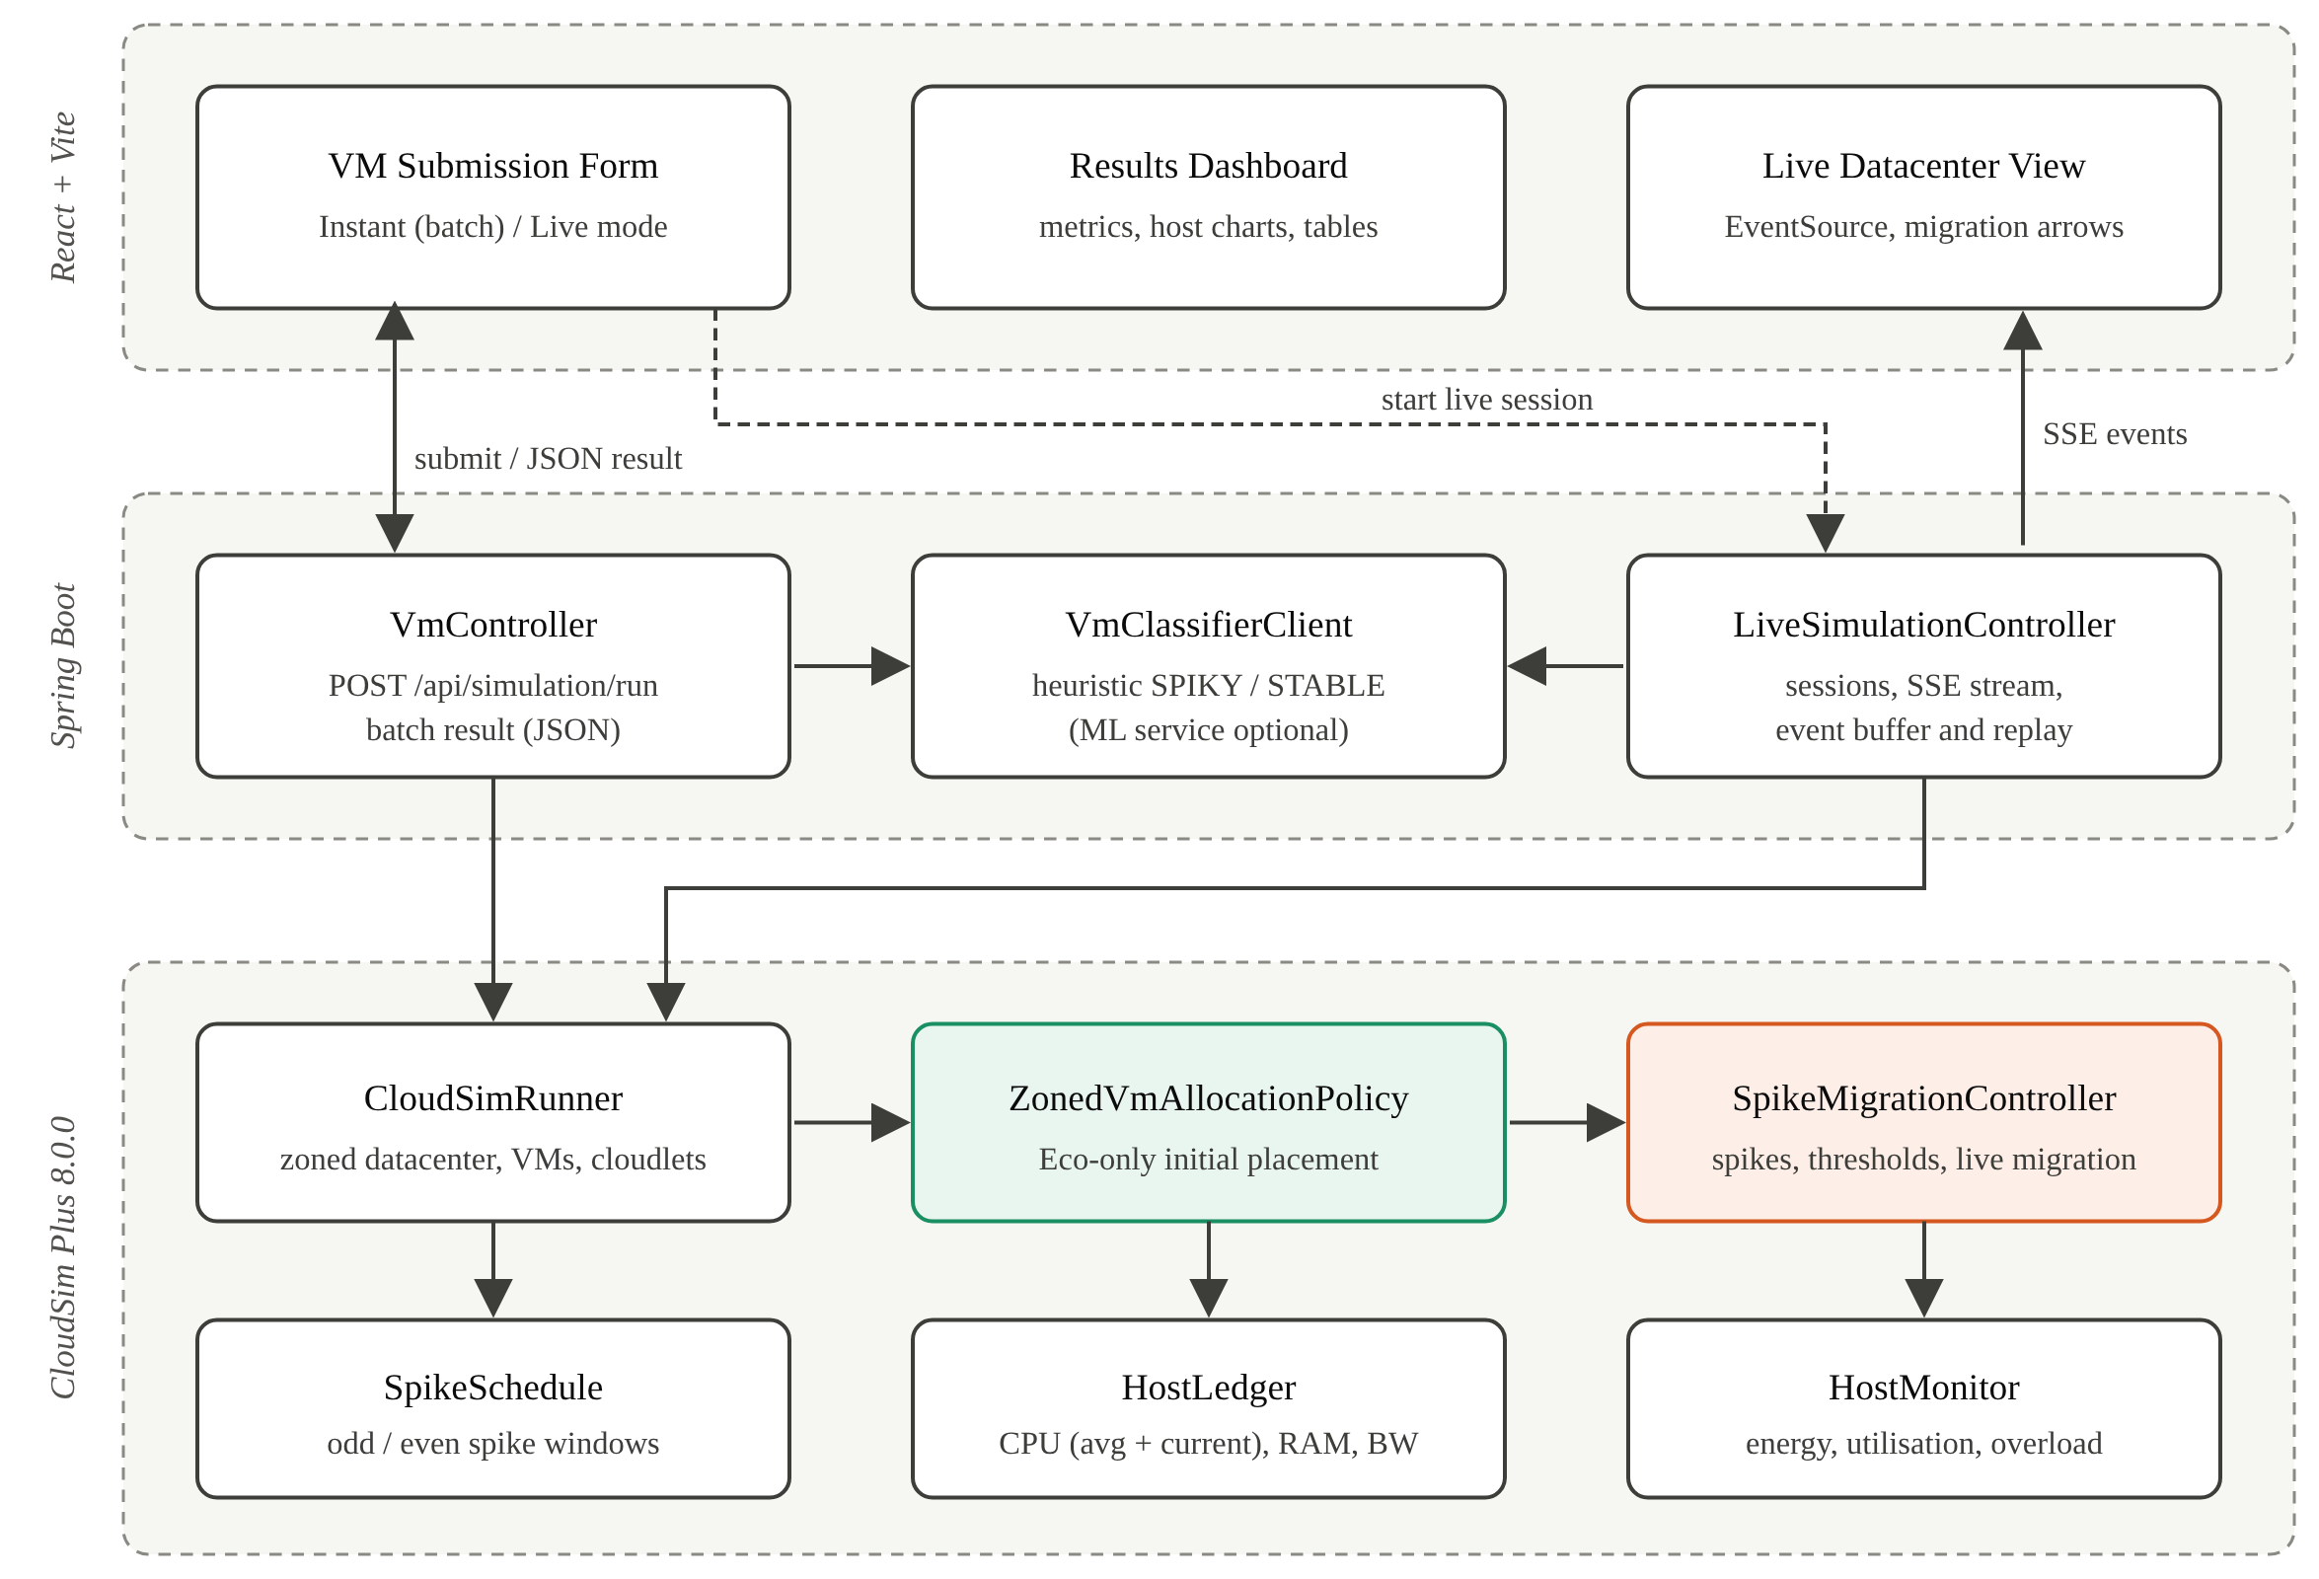
Figure 3.1: Three-layer architecture of the VM placement framework

3.2 Algorithms and Techniques

3.2.1 Workload classification
Each VM is classified from its historical CPU profile with the deterministic heuristic used since the midsem phase. The CPU range is the difference between maximum and minimum utilisation. A VM whose range exceeds 40 percentage points and whose average is below 60% of its maximum (equivalently, a peak-to-average ratio above about 1.7) is labelled SPIKY; every other VM is labelled STABLE. A confidence score grows with the distance from the 40-point boundary. The Python FastAPI service with an ONNX classifier can replace the heuristic without changing the rest of the pipeline. Table 3.1 summarises the inputs.
Table 3.1: Classification features and rule
Feature | Meaning | Use
minCpu, maxCpu, avgCpu | Historical CPU utilisation (%) | Range = maxCpu − minCpu
SPIKY rule | range > 40 and avgCpu < 0.6 × maxCpu | Isolated on Eco hosts; may migrate
STABLE rule | all other VMs | Best-Fit packing in the Eco Zone
Confidence | min(0.5 + |range − 40| / 100, 0.95) | Shown on the dashboard

3.2.2 Eco-only initial placement
The CPU demand of a VM is its average utilisation applied to its capacity, and the demand during a spike is its maximum utilisation applied to the same capacity:
D_avg = (avgCpu / 100) × MIPS × cores D_peak = (maxCpu / 100) × MIPS × cores
Every VM is placed in the Eco Zone; Performance Zone hosts are never candidates for initial placement. A host is a candidate only if its booked RAM and bandwidth leave room for the VM, CloudSim reports it as suitable, and the sum of average demands stays within capacity, Σ D_avg + D_avg(new) ≤ PEs × MIPS per PE. The selection rule then depends on the class of the VM:
- SPIKY VM – First-Fit on the Eco hosts that do not yet carry a spiky VM, so that at most one spiky VM ever shares an Eco host with stable VMs.
- STABLE VM – Best-Fit on the Eco hosts: the host with the least remaining average-demand headroom that still fits, which consolidates stable load onto as few hosts as possible.
- If no Eco host qualifies, the allocation fails and the broker may retry later when capacity is released.
The policy records each VM only after CloudSim confirms its creation, and releases it when CloudSim deallocates the VM, so the policy's view of every host always matches the VMs actually running on it.

3.2.3 Spike simulation
Because the simulation has no real telemetry, the spikes of spiky VMs are generated by a deterministic schedule. Spiky VMs are numbered 1, 2, 3, … in submission order. Odd-numbered spiky VMs spike 15 s after they start, for 5 s; even-numbered spiky VMs spike 20 s after they start, for 5 s. With repetition enabled the window recurs every 20 s and 25 s respectively for as long as the VM runs. Outside a spike a VM runs at its average CPU and 50% RAM usage; during a spike its CPU rises to its maximum utilisation and its RAM usage to 90%. Stable VMs never spike. Figure 3.2 shows the resulting CPU profile for a VM with 25% average and 90% maximum utilisation, against the 70% CPU threshold.
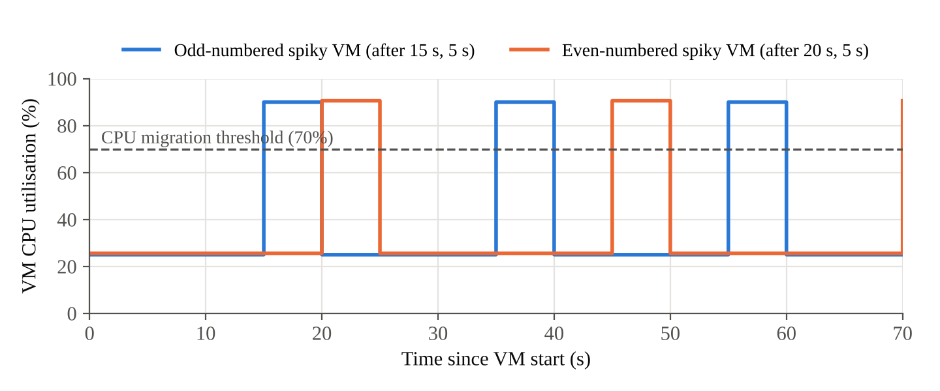
Figure 3.2: Simulated CPU profile of odd- and even-numbered spiky VMs

3.2.4 Threshold-driven live migration
The SpikeMigrationController runs on every tick of the simulation clock, which advances in steps of one simulated second. For every running VM it computes the current load from the spike schedule and records the resulting demand in the HostLedger. For each spiky VM that is not already migrating it then applies the decision procedure of Figure 3.4:
- If any threshold is crossed – VM CPU above 70%, VM RAM usage above 85% or VM demand above 3000 MIPS – and the VM is on an Eco host, it is live-migrated to the first Performance host whose current load plus the VM's current demand fits within capacity.
- If all thresholds are back below their limits and the VM is on a Performance host, it is live-migrated back to its original Eco host if that host still has no spiky VM and enough average-demand room, otherwise to another Eco host that satisfies the same rule.
The CPU of the target host is reserved while a migration is in flight, so concurrent decisions do not oversubscribe it. Migrations use CloudSim's live migration, whose duration is the VM's memory size divided by the bandwidth of the target host, which is why Performance hosts are given 40 Gbps links. Figure 3.3 summarises the zone model.
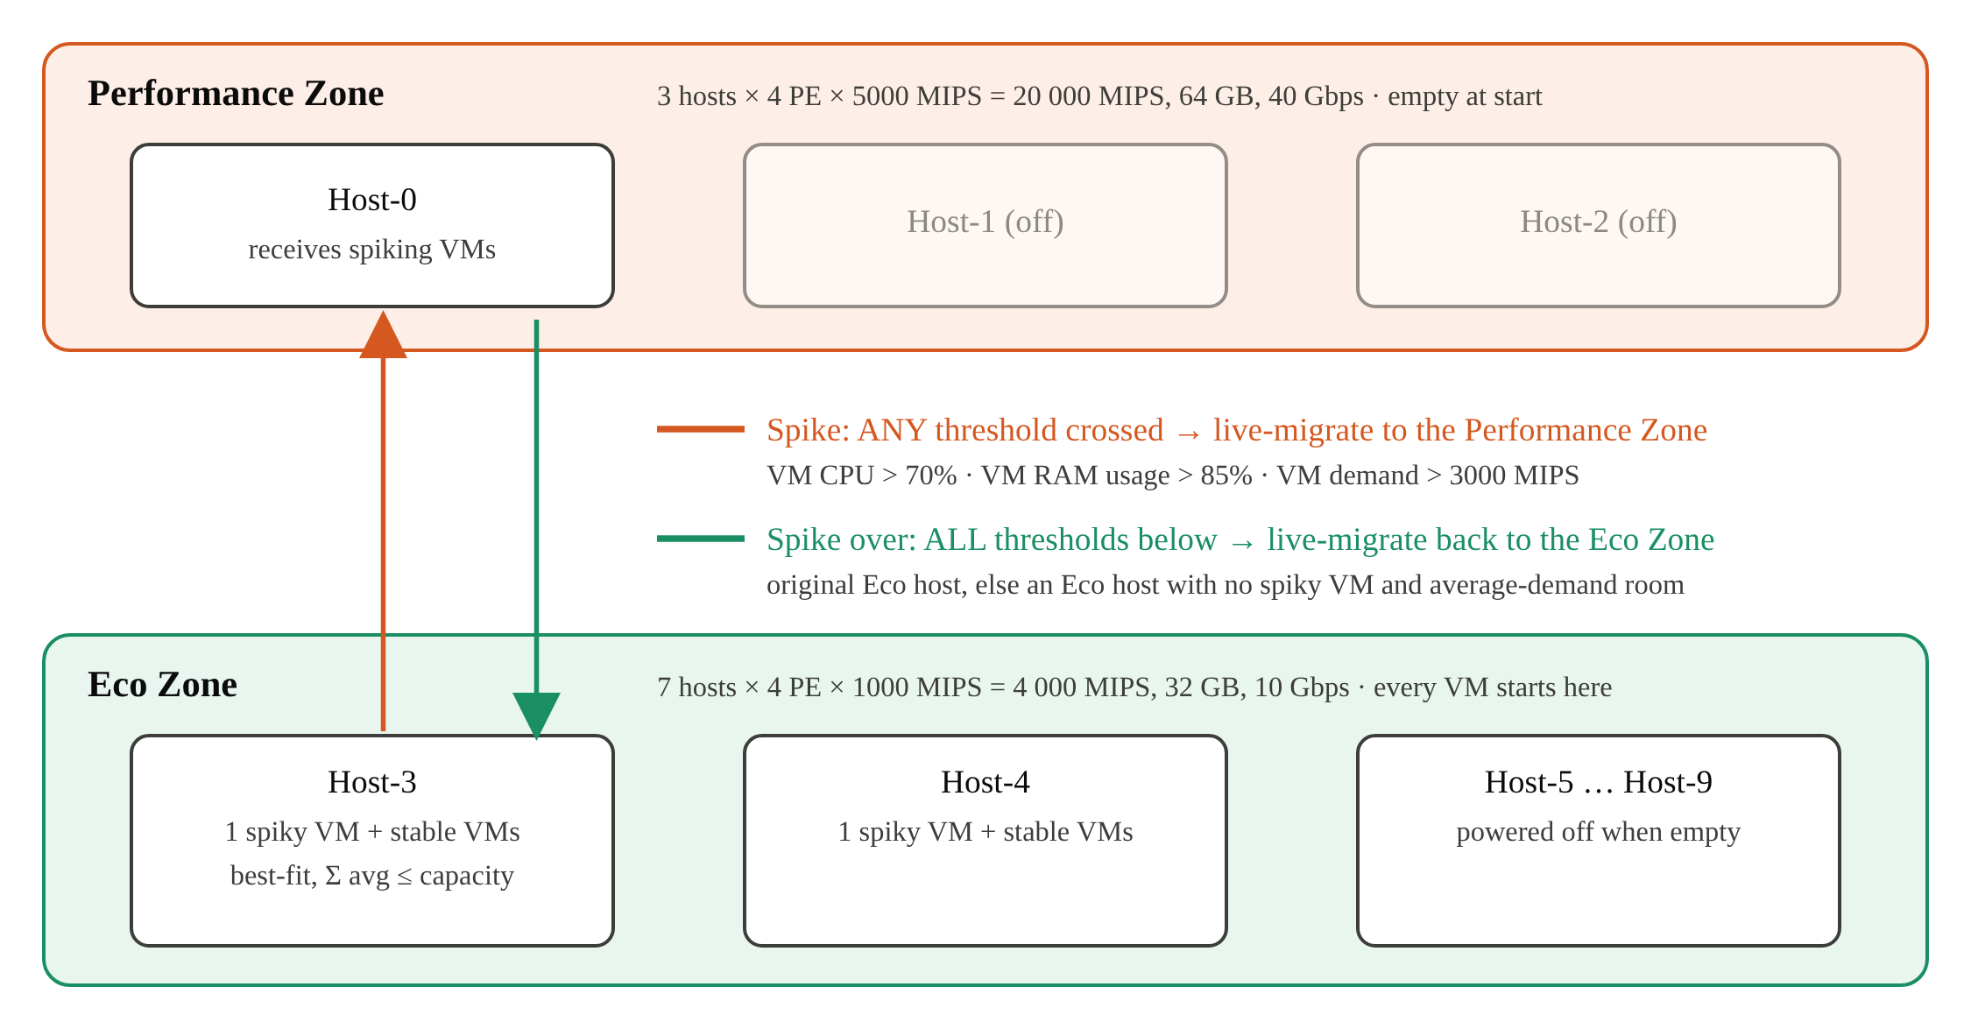
Figure 3.3: Decoupled Eco and Performance Zones and the migration rules between them
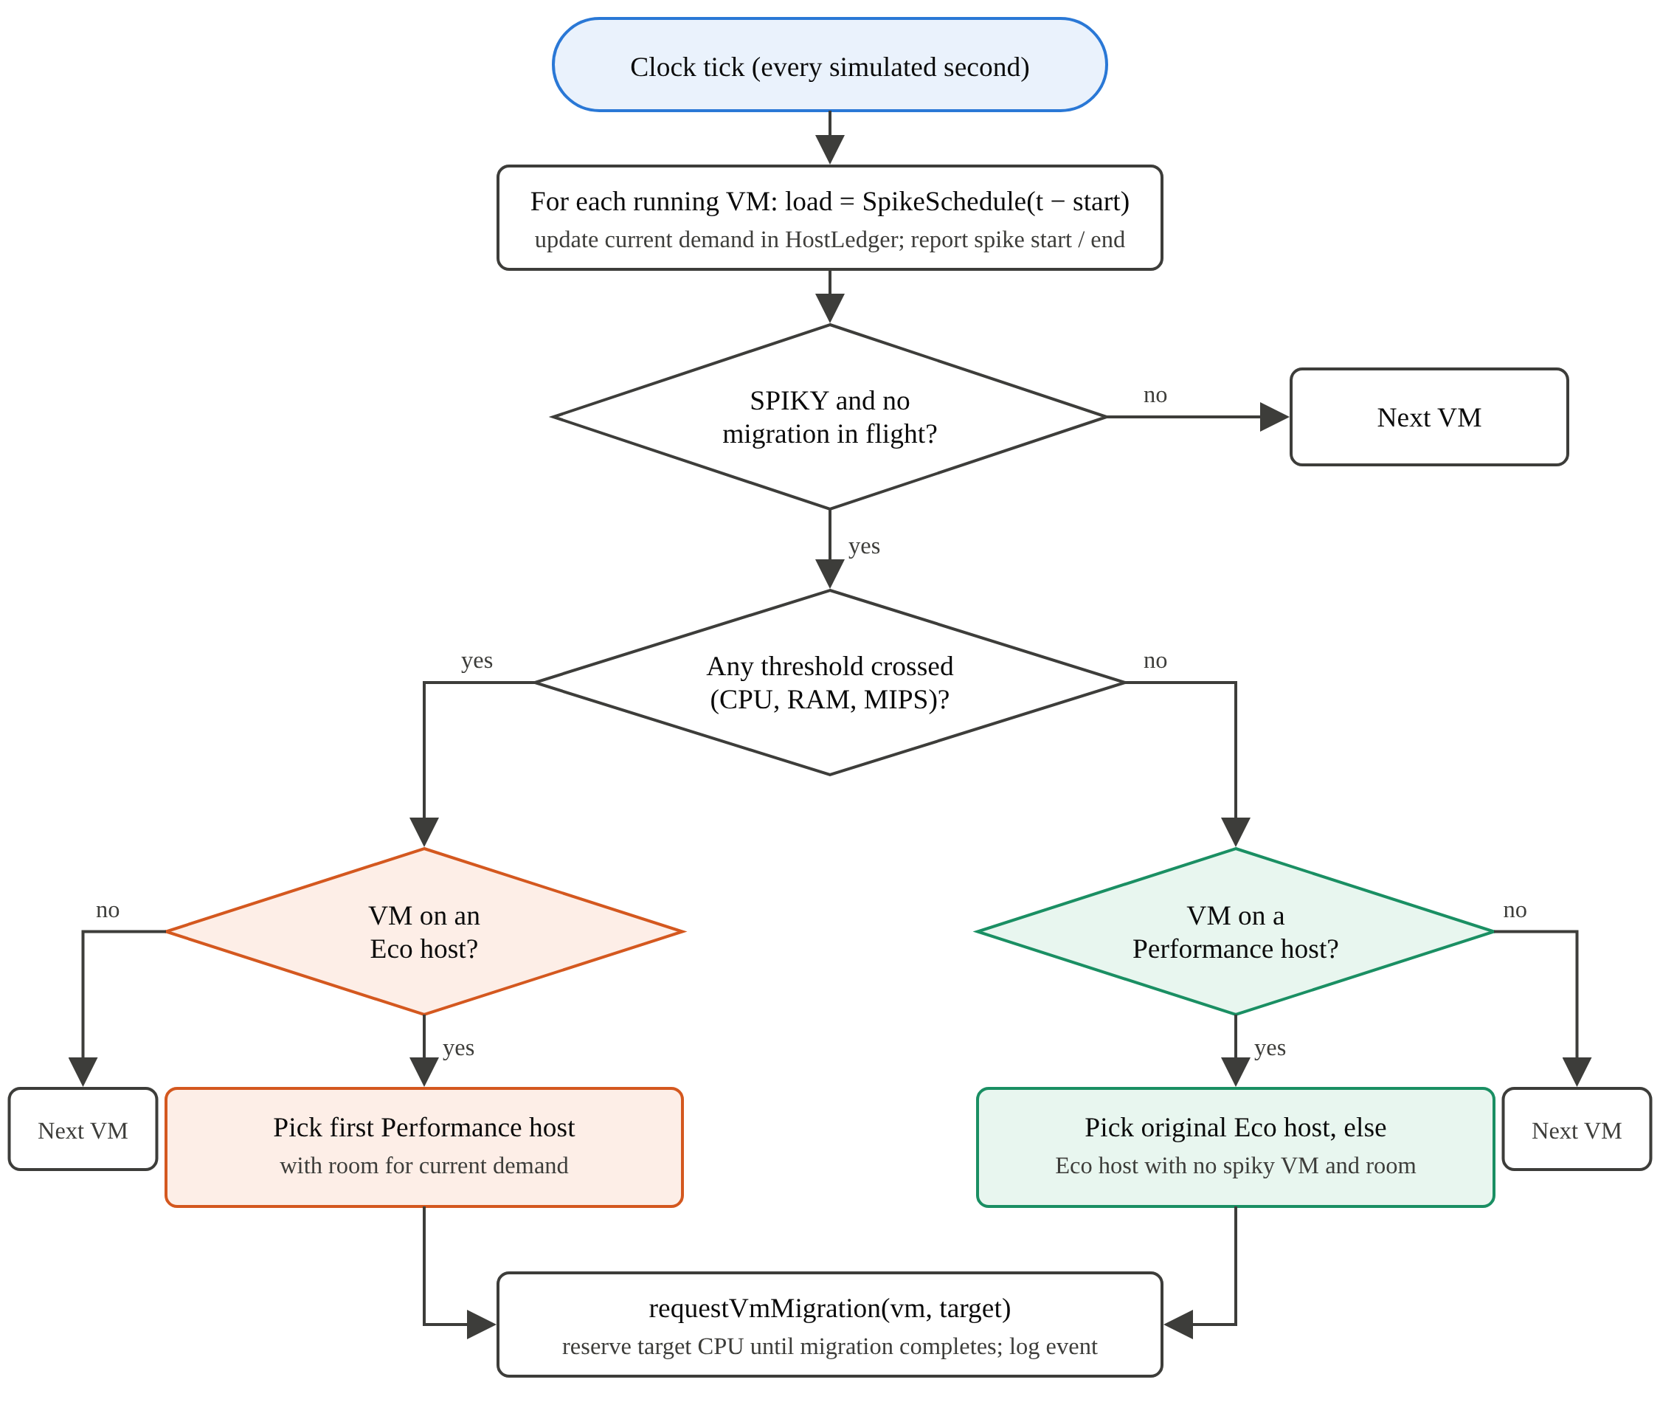
Figure 3.4: Per-tick decision procedure of the SpikeMigrationController

3.2.5 Energy and overload accounting
Every host carries a linear CloudSim power model, P(u) = P_idle + (P_max − P_idle) × u, with 150 W idle and 400 W maximum for Performance hosts and 80 W and 250 W for Eco hosts. The HostMonitor integrates power over simulated time using the current utilisation u from the ledger. Hosts without VMs are treated as powered off. It also accumulates, for every host, the time during which its current demand exceeded its capacity:
E = Σ_hosts Σ_ticks P(min(u, 1)) × Δt T_overload = Σ_hosts Σ_ticks [ u > 1 ] × Δt
Average CPU utilisation is time-averaged over the period in which each host had at least one VM, and active time is measured from the simulation rather than taken from requested durations.

3.3 Detailed Design Methodologies

3.3.1 Resource ledger and VM sizing
The midsem prototype created every CloudSim VM with a single PE at the requested MIPS and tracked the real demand only inside the policy. Testing showed that CloudSim's time-shared VM scheduler then admitted at most one such VM per host PE, regardless of its actual demand, while the policy recorded VMs that CloudSim had rejected. In one test, eight VMs with a combined demand of 3200 MIPS needed two hosts instead of one. The final design sizes each CloudSim VM to its average demand, split across enough PEs to fit any host's PE grid, with whole-number MIPS per PE because CloudSim truncates fractional MIPS. A shared HostLedger books a VM only after CloudSim confirms it and releases it on deallocation. The ledger keeps two views of CPU: the sum of average demands, used for placement, and the sum of current demands, updated every tick from the spike schedule and used for migration decisions, energy and overload. Because a live migration in CloudSim is a deallocation on the source followed by an allocation on the target, the ledger follows migrating VMs automatically.

3.3.2 Live streaming design
Live mode runs the same simulation on a background thread, paced against the wall clock with CloudSim Plus' synchronous stepping (startSync and runFor). A time scale sets how many simulated seconds pass per real second, and VMs can arrive at fixed intervals instead of all at once. Every placement, spike, migration and periodic host snapshot is published as a named SSE event with an increasing identifier. Each session buffers its events, so a client that connects late, or reconnects with a Last-Event-ID header, receives only what it missed. Figure 3.5 shows the sequence.
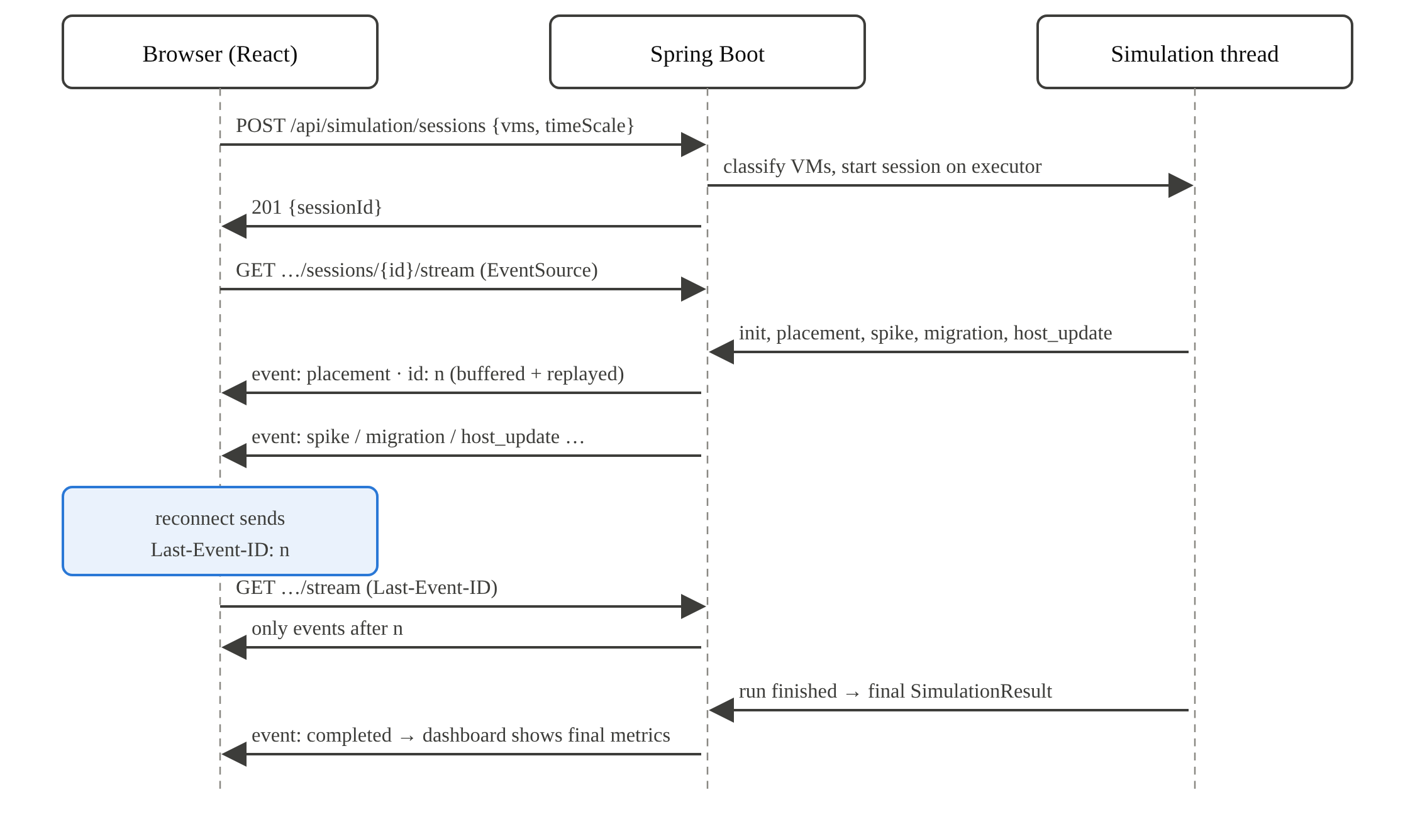
Figure 3.5: Sequence of a live simulation session streamed over Server-Sent Events

4. Work Done

4.1 Development Environment
Table 4.1 lists the technologies used. The backend and frontend run as separate processes during development, with the Vite development server forwarding API calls, including the SSE stream, to the Spring Boot service.
Table 4.1: Development environment and technology stack
Component | Technology | Role
Simulation engine | CloudSim Plus 8.0.0 (Java) | Data centre, VMs, cloudlets, live migration, power models
Backend | Java 17+, Spring Boot 3.2.5, Maven | REST API, SSE streaming, session management
Frontend | React 18, Vite 5, Recharts, Axios | Submission form, dashboard, live datacenter view
ML service (optional) | Python, FastAPI, ONNX Runtime | Learned SPIKY/STABLE classifier
Tools | Git and GitHub, JUnit 5, ESLint | Version control, tests, linting

4.2 Backend Implementation
The backend is organised into configuration, controller, live-session, model, service and simulation packages. All data centre, spike and migration parameters are bound from application.properties into a single configuration class, so experiments can change them without code changes. Table 4.2 lists the default configuration used in this report.
Table 4.2: Default simulation configuration
Parameter | Performance Zone | Eco Zone
Hosts | 3 (Host-0 to Host-2) | 7 (Host-3 to Host-9)
PEs × MIPS per PE | 4 × 5000 = 20 000 MIPS | 4 × 1000 = 4 000 MIPS
RAM / bandwidth | 64 GB / 40 Gbps | 32 GB / 10 Gbps
Power model (idle / max) | 150 W / 400 W | 80 W / 250 W
Initial placement | none (empty at start) | spiky: First-Fit, ≤ 1 per host; stable: Best-Fit
Spike windows | odd VMs: after 15 s for 5 s | even VMs: after 20 s for 5 s (repeating)
Migration thresholds | CPU > 70%, RAM > 85%, demand > 3000 MIPS | return when all are below

Table 4.3 lists the REST and SSE endpoints. The batch endpoint runs the whole simulation and returns the final result; the session endpoints run it live.
Table 4.3: REST and SSE endpoints
Method | Path | Purpose
POST | /api/simulation/run | Run a batch simulation; returns placements, host metrics, migrations, summary
POST | /api/simulation/sessions | Start a live session (VMs, time scale, arrival gap); returns a session id
GET | /api/simulation/sessions/{id}/stream | SSE stream: init, placement, spike, migration, host_update, completed
GET | /api/simulation/sessions/{id} | Session status and final result
POST | /api/simulation/sessions/{id}/stop | Stop a running session

Live sessions run on a bounded thread pool. A session registry removes finished sessions after ten minutes and sends periodic heartbeat comments so that idle connections stay open. As a safety guard, any run that passes twice its last expected event time is terminated instead of blocking a thread.

4.3 Frontend Dashboard
The VM submission form (Figure 4.1) lets the user build a batch of VMs with their CPU profiles and resource requirements and choose between Instant (batch) and Live mode. In Live mode, two further fields set the simulation speed and the gap between VM arrivals.
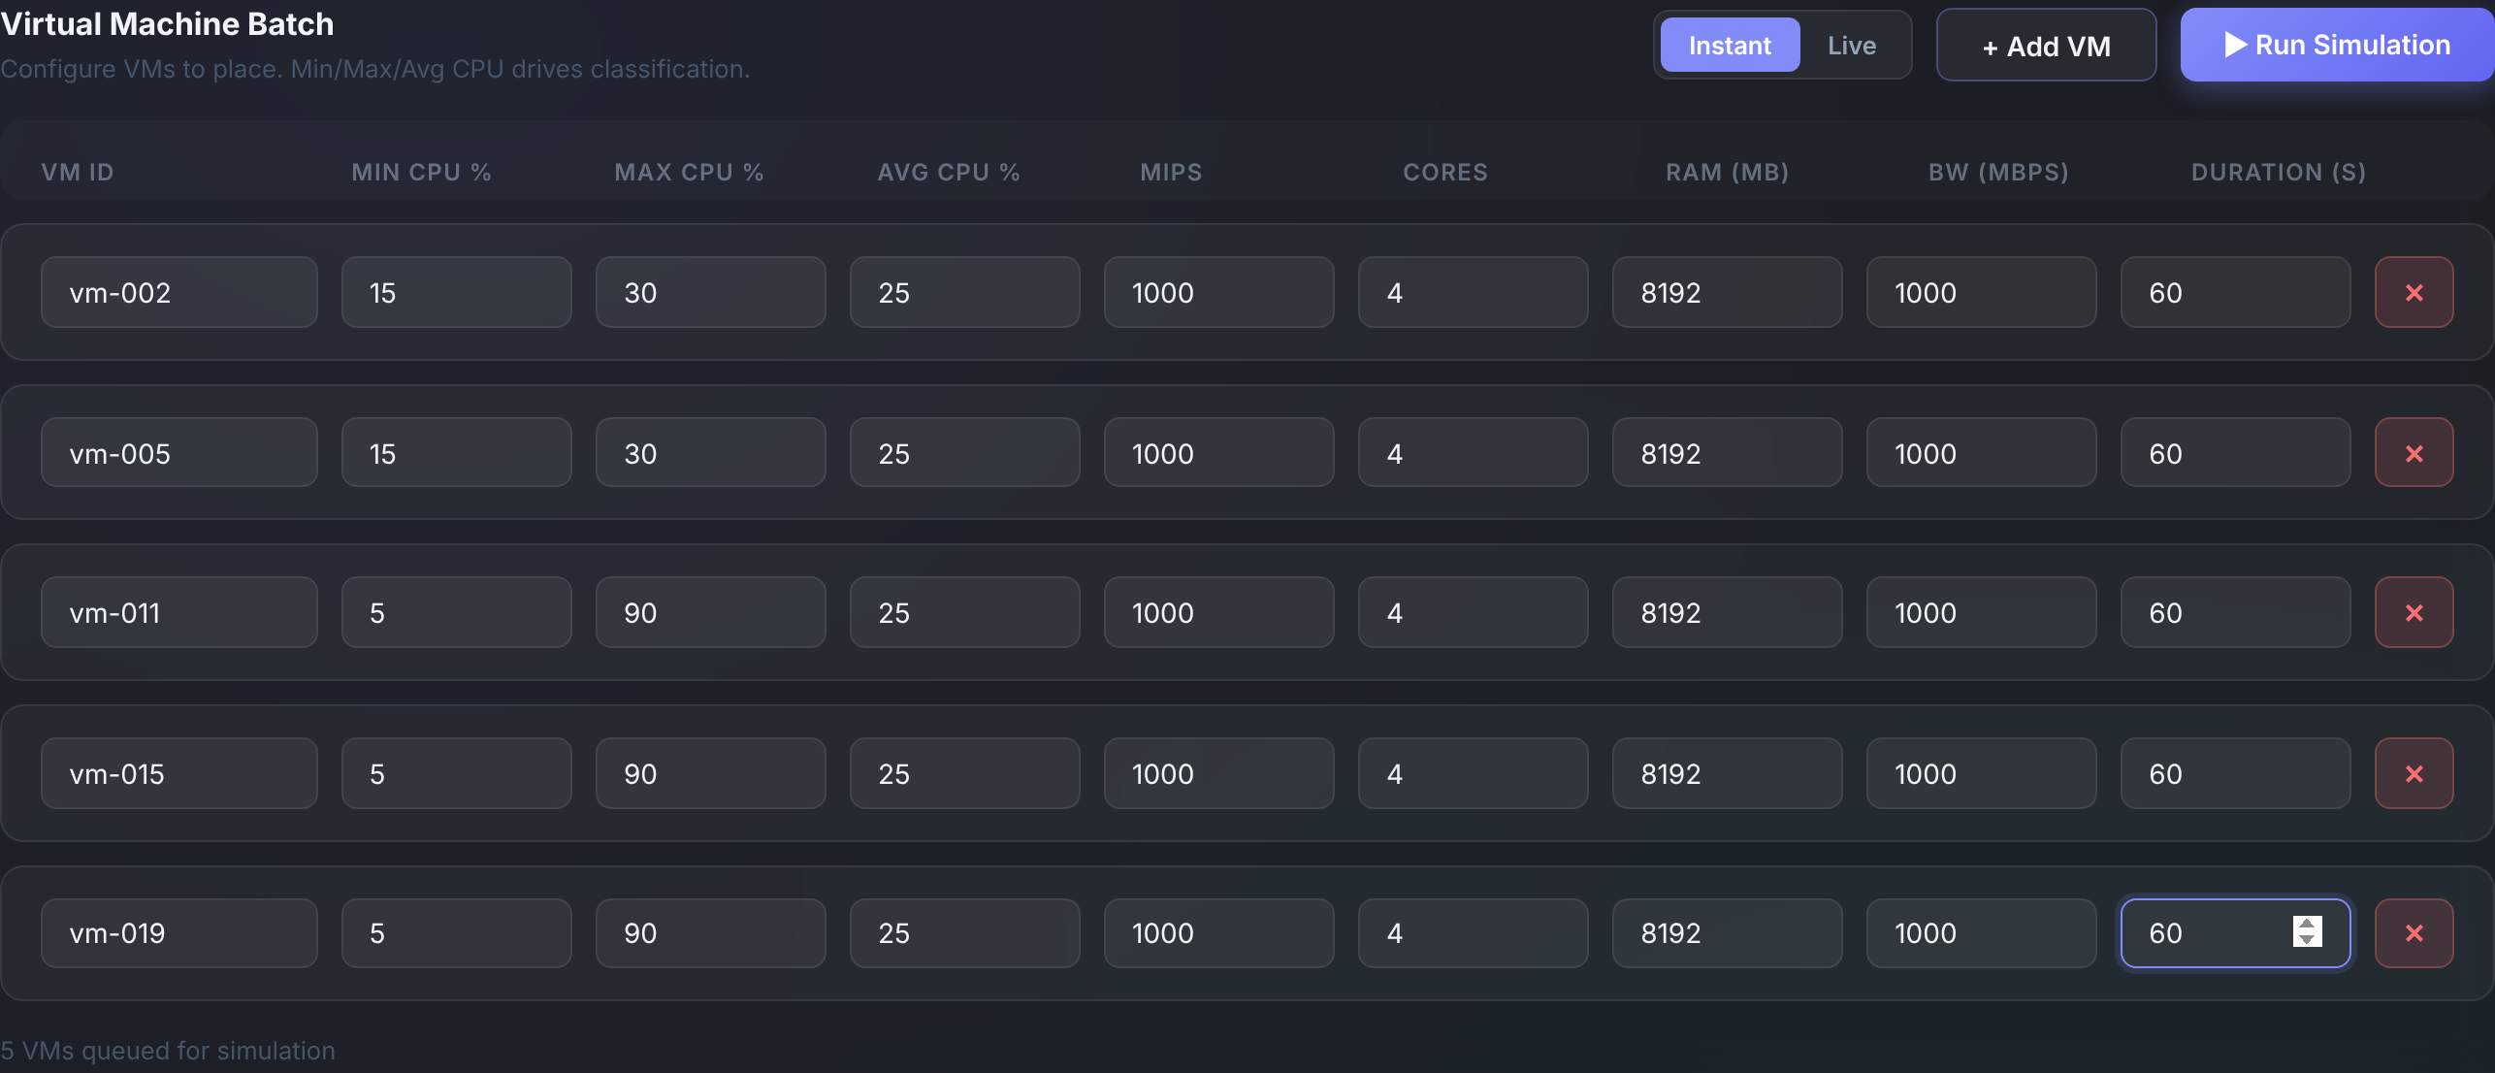
Figure 4.1: VM submission form with three spiky and two stable VMs
After a batch run the dashboard shows summary cards for total VMs, hosts used per zone, average CPU utilisation, live migrations with spikes and overload time, energy and average host time, followed by per-host charts in which bars are coloured by zone (Figure 4.2), a placement table with the initial zone and migration count of every VM, and the migration log.
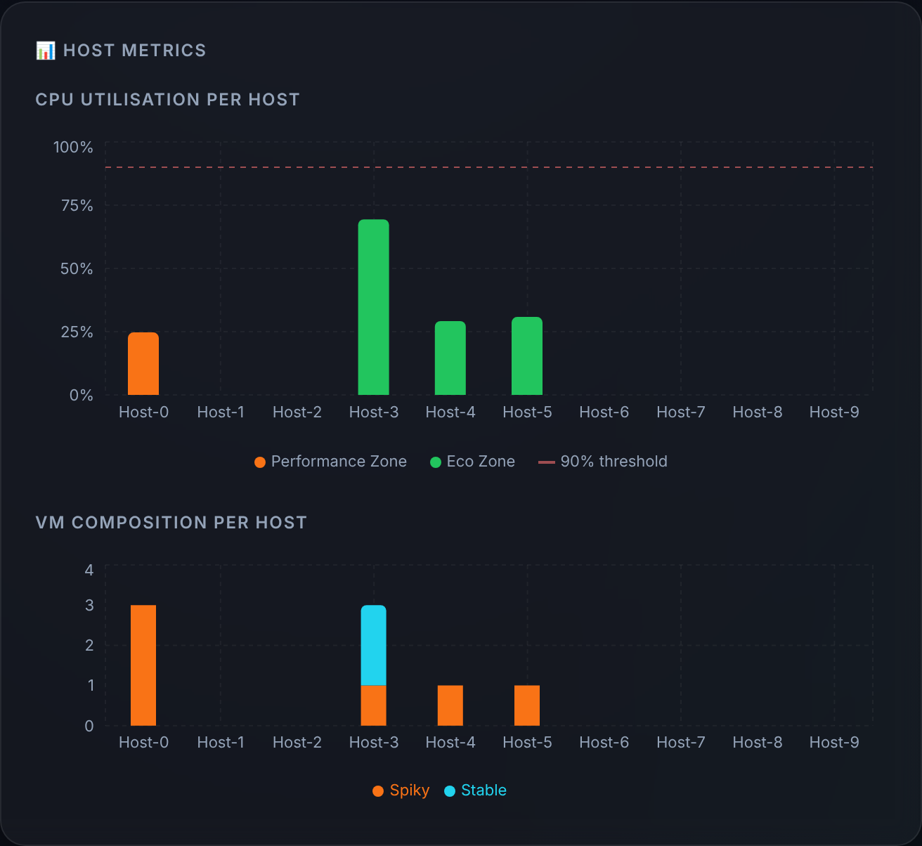
Figure 4.2: Per-host CPU utilisation (coloured by zone) and VM composition after a batch run
In Live mode the datacenter view shows every host of both zones with the VMs currently running on it (Figure 4.3). A spiking VM pulses, and a host whose current demand exceeds its capacity is highlighted with its load, here 140% on Host-3 before the spiking vm-011 has been moved. When a migration completes, an arrow is drawn from the old host to the new one (Figure 4.4), and the migration log records the time, VM, source and target hosts, the thresholds that were crossed and how long the migration took (Figure 4.5).
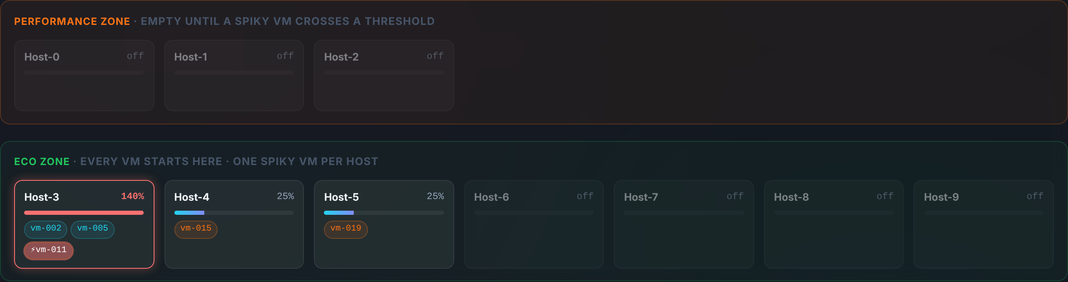
Figure 4.3: Live datacenter view: vm-011 spiking on Host-3, which is overloaded at 140%
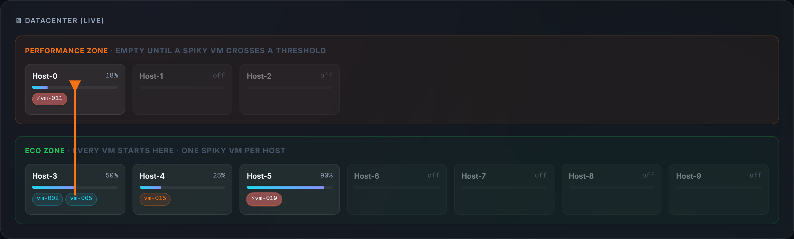
Figure 4.4: Live datacenter view: vm-011 live-migrated from Host-3 to Performance host Host-0
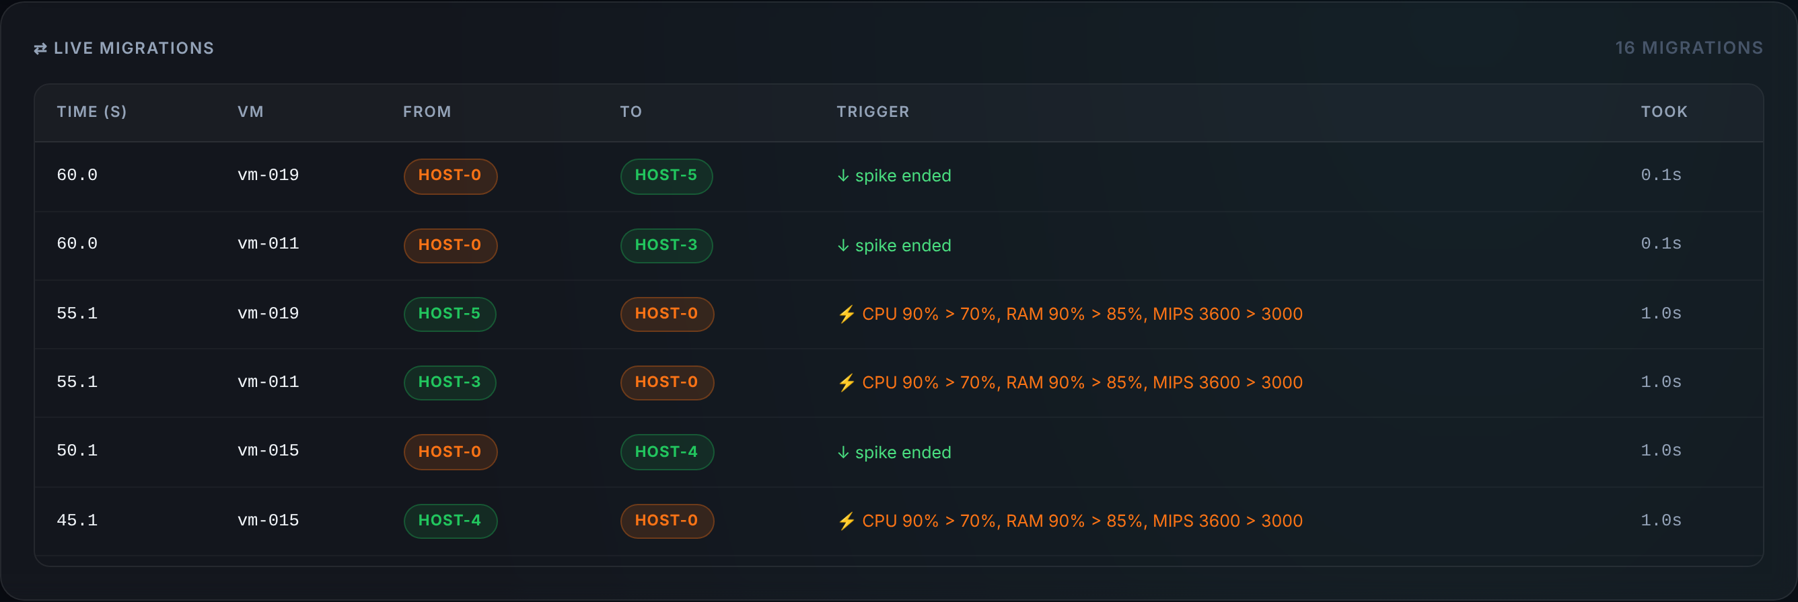
Figure 4.5: Migration log with trigger, thresholds crossed and migration time

5. Results and Analysis

5.1 Experimental Setup
All experiments use the default configuration of Table 4.2. Unless stated otherwise every VM requests 1000 MIPS × 4 cores, 8 GB RAM and 1000 Mbps for 60 s (120 s in scenario S5). Stable VMs have a 15/30/25% minimum/maximum/average CPU profile (D_avg = 1000 MIPS) and spiky VMs a 5/90/25% profile (D_avg = 1000 MIPS, D_peak = 3600 MIPS), so every spike crosses all three migration thresholds. Each scenario was run twice on the same build: once with live migration enabled and once with it disabled, which keeps the same initial placement and the same simulated spikes and isolates the effect of migration. The scenarios are listed in Table 5.1.
Table 5.1: Experimental scenarios
Scenario | VMs | Duration | Purpose
TC1 | 4 stable | 60 s | Consolidation of stable VMs (midsem test case 1)
TC2 | 2 stable + 2 spiky | 60 s | Mixed batch (midsem test case 2)
TC3 | 4 spiky | 60 s | Spiky isolation (midsem test case 3)
S4 | 2 stable + 3 spiky | 60 s | Migration behaviour and dashboard
S5 | 8 stable + 4 spiky | 120 s | Denser mixed workload

5.2 Placement and Migration in the Test Cases
Table 5.2 reports the results with live migration enabled. In TC1 the four stable VMs are packed by Best-Fit onto a single Eco host at 100% average utilisation, using 4.17 Wh. In TC2 and TC3 every spiky VM starts on an Eco host of its own (TC2 shares one host between a spiky VM and the two stable VMs), and every spike leads to a migration to Performance host Host-0 and back. In TC3, four spiky VMs produce 10 spikes and 20 migrations in 60 s, and no host is ever overloaded because each Eco host carries only one VM.
Table 5.2: Results of the test cases and scenarios with live migration enabled
Case | Hosts used | Failed | Spikes | Migrations | Overload (s) | Avg CPU (%) | Energy (Wh)
TC1 | 1 (0 P, 1 E) | 0 | 0 | 0 | 0.0 | 100.0 | 4.17
TC2 | 3 (1 P, 2 E) | 0 | 5 | 10 | 4.6 | 38.0 | 6.64
TC3 | 5 (1 P, 4 E) | 0 | 10 | 20 | 0.0 | 30.0 | 9.14
S4 | 4 (1 P, 3 E) | 0 | 8 | 16 | 4.6 | 38.5 | 8.68
S5 | 7 (1 P, 6 E) | 0 | 22 | 44 | 19.0 | 52.7 | 30.98

"Hosts used" counts every host that ran a VM at any time, including Host-0, which is powered on only while spiking VMs are present. The average CPU utilisation is time-averaged over the active period of each host and is therefore lower for the spiky cases, where Eco hosts carry a single 25% VM and Host-0 is lightly loaded.

5.3 Spike-Driven Migration Behaviour
Figure 5.1 traces where each spiky VM of scenario S4 runs over time. The odd-numbered vm-003 and vm-005 leave their Eco hosts during the spikes that start at about 15 s, 35 s and 55 s, and the even-numbered vm-004 during the spikes at 20 s and 45 s. Each VM returns to its original Eco host after every spike. Table 5.3 lists the first migrations. A migration to the Performance Zone took between 1.0 s and 2.6 s (mean 1.6 s) and a migration back between 0.1 s and 1.1 s, well within the 5 s spike windows.
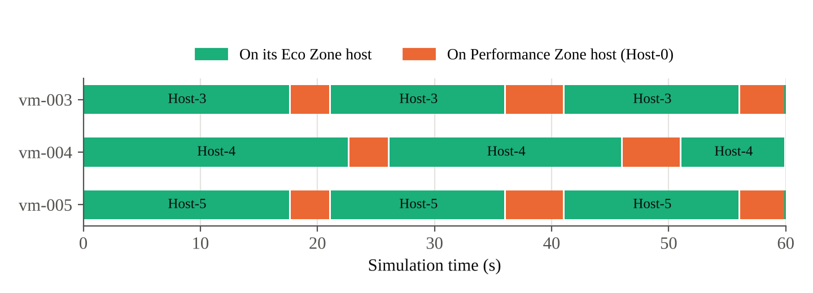
Figure 5.1: Location of the spiky VMs of scenario S4 over time (live migration enabled)
Table 5.3: First migrations of scenario S4
Requested (s) | Completed (s) | VM | From → To | Trigger | VM load at request
15.1 | 17.7 | vm-003 | Host-3 → Host-0 | Spike | CPU 90%, RAM 90%, 3600 MIPS
15.1 | 17.7 | vm-005 | Host-5 → Host-0 | Spike | CPU 90%, RAM 90%, 3600 MIPS
20.1 | 21.2 | vm-003 | Host-0 → Host-3 | Spike ended | CPU 25%, RAM 50%, 1000 MIPS
20.1 | 21.2 | vm-005 | Host-0 → Host-5 | Spike ended | CPU 25%, RAM 50%, 1000 MIPS
20.1 | 22.7 | vm-004 | Host-4 → Host-0 | Spike | CPU 90%, RAM 90%, 3600 MIPS
25.1 | 26.2 | vm-004 | Host-0 → Host-4 | Spike ended | CPU 25%, RAM 50%, 1000 MIPS

In scenario S5, 18 of the 22 return migrations went back to the VM's original Eco host. In the remaining four the original host would have been filled to exactly 100% of its CPU and RAM, and the controller chose another Eco host with no spiky VM; the VM returned to its original host after a later spike. The behaviour stays within the placement rules (at most one spiky VM per Eco host), but it powers on additional Eco hosts, which is why S5 used six Eco hosts with migration enabled compared with four without.

5.4 Effect of Live Migration on Host Overload and Energy
Figure 5.2 shows the CPU load of Host-3 in scenario S4, which carries two stable VMs and the spiky vm-003. Its average load is 75%. When vm-003 spikes, demand rises to 140% of capacity. Without migration the host stays overloaded for the whole 5 s spike; with migration the overload lasts only until vm-003 lands on Host-0, after which Host-3 drops to 50% until the VM returns.
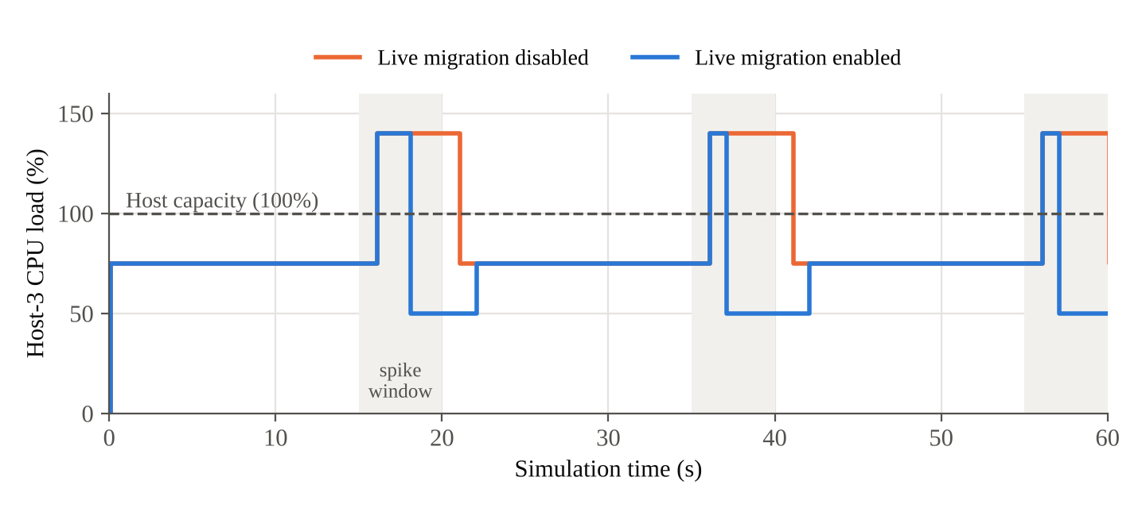
Figure 5.2: CPU load of Host-3 in scenario S4 with and without live migration
Figure 5.3 and Table 5.4 compare the two runs of each scenario that contains spiky VMs sharing hosts. Live migration reduces the total host overload time by 69% in TC2 and S4 and by 76% in S5. The remaining overload is the time between the start of a spike, its detection at the next clock tick and the completion of the migration. Energy rises by 2–11% because Host-0 is powered on during spikes; in TC3, where no host is ever overloaded, migration lowered energy slightly (9.14 Wh against 9.70 Wh) because the spiking VMs were served by the more efficient Performance host.
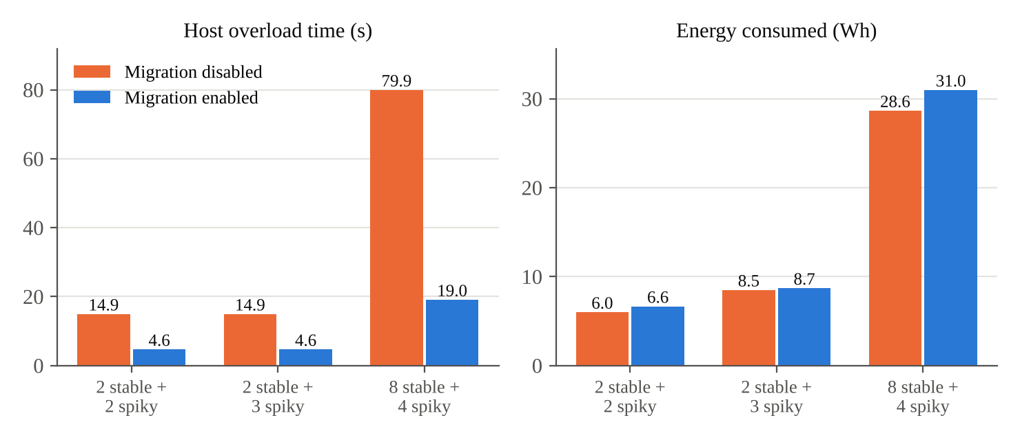
Figure 5.3: Host overload time and energy with live migration disabled and enabled
Table 5.4: Effect of live migration (disabled → enabled)
Scenario | Overload off (s) | Overload on (s) | Change | Energy off (Wh) | Energy on (Wh) | Change | Hosts used
TC2 | 14.9 | 4.6 | −69% | 5.98 | 6.64 | +11% | 2 → 3
S4 | 14.9 | 4.6 | −69% | 8.48 | 8.68 | +2% | 3 → 4
S5 | 79.9 | 19.0 | −76% | 28.64 | 30.98 | +8% | 4 → 7

5.5 Discussion
The results show that separating workloads by class and moving only the spiking VMs gives the intended behaviour. Stable VMs are consolidated densely, spiky VMs never share an Eco host with another spiky VM, and the Performance Zone is used only for the seconds in which it is needed. Live migration removes most of the overload caused by spikes, at the cost of a modest increase in energy and in the number of hosts that are briefly active. The trade-off is controlled by the migration thresholds and by the capacity and bandwidth of the Performance Zone: higher bandwidth shortens migrations and the residual overload, and a larger Performance host can absorb more simultaneous spikes.
Some limitations should be noted. The spikes come from a fixed schedule rather than from real traces, so the results show how the mechanism behaves rather than how often real workloads spike. CloudSim VMs are sized at their average demand and spikes are modelled in the framework's own ledger on top of the simulator, which keeps the accounting consistent but means CloudSim itself does not slow down overloaded VMs. Finally, the experiments are small and run on a ten-host data centre, so absolute energy values are low; the relative effects are the meaningful result.

6. Conclusion
This project designed and implemented a CPU-aware VM placement framework that separates spiky and stable workloads and handles bursts through live migration between two decoupled zones. Every VM is classified from its CPU history and placed in an energy-efficient Eco Zone, with stable VMs consolidated by Best-Fit and at most one spiky VM per host. A simulated spike schedule drives the load of spiky VMs, and whenever a spiky VM crosses a CPU, RAM or MIPS threshold it is live-migrated to an initially empty Performance Zone and returned once its load falls below every threshold.
The framework is built on CloudSim Plus behind a Spring Boot service and a React dashboard. During development, a mismatch between the simulator's resource accounting and the policy's accounting was found and corrected by sizing VMs to their real demand and booking resources only on confirmed placements. The dashboard shows placements, spikes and migrations as they happen over Server-Sent Events.
In simulation, the framework reproduces the placement behaviour of the midsem test cases, completes migrations to the Performance Zone in 1.0–2.6 s, well inside the 5 s spike windows, and reduces the time hosts spend overloaded by 69–76% compared with the same placement without migration, at a cost of a few percent more energy. These results show that zone separation combined with threshold-driven migration of only the spiking VMs is a lightweight and explainable way to protect performance while keeping the data centre densely packed.

References
[1] J. Singh and N. K. Walia, "A Comprehensive Review of Cloud Computing Virtual Machine Consolidation," IEEE Access, vol. 11, pp. 106190–106209, 2023, doi: 10.1109/ACCESS.2023.3314613.
[2] S. Kumar, A. Jain, and A. Pareek, "An Adaptive Resource-Aware Virtual Machine Placement for Energy-Efficient Cloud Computing Environments," in Proc. 2026 Innovations in Machine, Engineering, and Digital Conference (IMED), IEEE, 2026, doi: 10.1109/IMED68921.2026.11484105.
[3] A. Alourani, A. Khalid, M. Tahir, and M. Sardaraz, "Energy efficient virtual machines placement in cloud datacenters using genetic algorithm and adaptive thresholds," PLOS ONE, vol. 19, no. 1, art. e0296399, 2024, doi: 10.1371/journal.pone.0296399.
[4] M. Awad, A. Leivadeas, and A. Awad, "Multi-resource predictive workload consolidation approach in virtualized environments," Computer Networks, vol. 237, art. 110088, 2023, doi: 10.1016/j.comnet.2023.110088.
[5] H. D. Rjeib and G. Kecskemeti, "VMP-ER: An Efficient Virtual Machine Placement Algorithm for Energy and Resources Optimization in Cloud Data Center," Algorithms, MDPI, vol. 17, no. 7, art. 295, 2024, doi: 10.3390/a17070295.
[6] M. Alex, S. O. Ojo, and F. M. Awuor, "Carbon-Aware, Energy-Efficient, and SLA-Compliant Virtual Machine Placement in Cloud Data Centers Using Deep Q-Networks and Agglomerative Clustering," Computers, MDPI, vol. 14, no. 7, art. 280, Jul. 2025, doi: 10.3390/computers14070280.
[7] Y. Cho, C. Jo, R. Entezari-Maleki, J. Altmann, and B. Egger, "Towards smarter live migration: Minimizing SLO violations and costs," Future Generation Computer Systems, Elsevier, 2025.
[8] T. Hidayat, K. Ramli, R. Harwahyu, M. Salman, and T. S. Gunawan, "Reinforcement Learning-Driven Hybrid Precopy/Postcopy VM Migration for Energy-Efficient Data Centers," IEEE Access, vol. 13, pp. 169521–169533, 2025.
[9] A. Ghasemi et al., "Energy-efficient virtual machine placement in heterogeneous cloud data centers: a clustering-enhanced multi-objective, multi-reward reinforcement learning approach," Cluster Computing, Springer, 2024, doi: 10.1007/s10586-024-04657-3.
[10] P. Wei, Y. Zeng, B. Yan, J. Zhou, and E. Nikougoftar, "VMP-A3C: Virtual machines placement in cloud computing based on asynchronous advantage actor-critic algorithm," Journal of King Saud University – Computer and Information Sciences, vol. 35, no. 5, art. 101549, 2023, doi: 10.1016/j.jksuci.2023.04.002.
[11] A. Gopu, K. Thirugnanasambandam, R. Rajakumar, A. S. AlGhamdi, S. S. Alshamrani, K. Maharajan, and M. Rashid, "Energy-efficient virtual machine placement in distributed cloud using NSGA-III algorithm," Journal of Cloud Computing, vol. 12, 2023, doi: 10.1186/s13677-023-00501-y.
[12] A. M. Baydoun and A. S. Zekri, "Towards Efficient VM Placement: A Two-Stage ACO-PSO Approach for Green Cloud Infrastructure," International Journal of Computer Networks & Communications (IJCNC), vol. 17, no. 5, Sep. 2025.
[13] D. Mythrayee and V. S. Lavanya, "An efficient lightweight VM placement for handling resource constraint issues in the cloud environment," International Journal of Cloud Computing, vol. 13, no. 6, 2024.
[14] S. Selvaganapathy and M. Chinnadurai, "Virtual machine placement in energy aware load balancer using fog classifier," Journal of Cloud Computing, vol. 12, art. 180, 2023, doi: 10.1186/s13677-023-00559-8.
[15] J. Lin, W. Lin, W. Wu, W. Lin, and K. Li, "Energy-aware virtual machine placement based on a holistic thermal model for cloud data centers," Future Generation Computer Systems, vol. 161, pp. 302–314, 2024, doi: 10.1016/j.future.2024.07.020.
[16] R. Chen, B. Liu, W. Lin, J. Lin, H. Cheng, and K. Li, "Power and thermal-aware virtual machine scheduling optimization in cloud data center," Future Generation Computer Systems, vol. 145, pp. 578–589, 2023.
[17] S. Dadashi and A. Aghasi, "Thermal-Aware Virtual Machine Placement Approaches: A Survey," Journal of Mahani Mathematical Research, vol. 13, no. 2, pp. 325–363, 2024, doi: 10.22103/jmmr.2024.22069.1497.
[18] X. Ma, H. Xu, H. Gao, M. Bian, and W. Hussain, "Real-Time Virtual Machine Scheduling in Industry IoT Network: A Reinforcement Learning Method," IEEE Transactions on Industrial Informatics, vol. 19, no. 2, pp. 2129–2139, 2023, doi: 10.1109/TII.2022.3211622.
[19] E.-D. Jeong, J.-H. Yoo, and J. W.-K. Hong, "SDN Lullaby: VM Consolidation for SDN using Transformer-Based Deep Reinforcement Learning," in Proc. 19th International Conference on Network and Service Management (CNSM), 2023.
[20] A. U. Rehman, S. Lu, M. Ali, F. Smarandache, S. S. Alshamrani, A. Alshehri, and F. Arslan, "EEVMC: An Energy Efficient Virtual Machine Consolidation Approach for Cloud Data Centers," IEEE Access, vol. 12, pp. 105234–105245, 2024, doi: 10.1109/ACCESS.2024.3429424.
[21] G. Kanagaraj and G. Subashini, "Uniform distribution elephant herding optimization (UDEHO) based virtual machine consolidation for energy-efficient cloud data centres," Automatika, vol. 64, no. 3, pp. 530–540, 2023.
[22] A. I. Maiyza, H. A. Hassan, W. M. Sheta, K. Banawan, and N. O. Korany, "VTGAN based proactive VM consolidation in cloud data centers using value and trend approaches," Scientific Reports, 2025, doi: 10.1038/s41598-025-04757-z.
[23] A. Lackinger, A. Morichetta, and S. Dustdar, "Time Series Predictions for Cloud Workloads: A Comprehensive Evaluation," in Proc. 2024 IEEE International Conference on Service-Oriented System Engineering (SOSE), pp. 36–45, 2024, doi: 10.1109/SOSE62363.2024.00011.
[24] J. Bi, H. Ma, H. Yuan, and J. Zhang, "Accurate Prediction of Workloads and Resources With Multi-Head Attention and Hybrid LSTM for Cloud Data Centers," IEEE Transactions on Sustainable Computing, vol. 8, no. 3, Jul.–Sep. 2023.
[25] P. Sireesha, V. Priyan S, M. Govindarajan, S. Rajan, and V. Rajakumareswaran, "Revolutionizing Cloud Resource Allocation: Harnessing Layer-Optimized Long Short-Term Memory for Energy-Efficient Predictive Resource Management," EAI Endorsed Transactions on Energy Web, vol. 11, no. 1, 2024, doi: 10.4108/ew.6505.
[26] S. Simaiya, U. K. Lilhore, Y. K. Sharma, K. B. V. B. Rao, V. V. R. M. Rao, A. Baliyan, A. Bijalwan, and R. Alroobaea, "A hybrid cloud load balancing and host utilization prediction method using deep learning and optimization techniques," Scientific Reports, vol. 14, art. 1337, 2024, doi: 10.1038/s41598-024-51466-0.
[27] T. Hidayat, K. Ramli, and R. Harwahyu, "Strategy for Precopy Live Migration and VM Placement in Data Centers Based on Hybrid Machine Learning," Informatics, MDPI, vol. 12, no. 3, art. 71, 2025, doi: 10.3390/informatics12030071.
[28] R. Andreoli, J. Zhao, T. Cucinotta, and R. Buyya, "CloudSim 7G: An Integrated Toolkit for Modeling and Simulation of Future Generation Cloud Computing Environments," Software: Practice and Experience, Wiley, 2025.

Appendix: Acronyms
Table A.1: Acronyms used in this report
Acronym | Expansion
A3C | Asynchronous Advantage Actor-Critic
ACO | Ant Colony Optimisation
API | Application Programming Interface
ARA | Adaptive Resource-Aware (VM placement, base paper)
BF / FF | Best-Fit / First-Fit
CPU | Central Processing Unit
CVD | Colour Vision Deficiency
DQN | Deep Q-Network
LSTM | Long Short-Term Memory
MIPS | Million Instructions Per Second
PE | Processing Element (CPU core in CloudSim)
PM | Physical Machine (host)
PSO | Particle Swarm Optimisation
REST | Representational State Transfer
SLA / SLO | Service Level Agreement / Objective
SSE | Server-Sent Events
VM | Virtual Machine

