TestCoLab

aks-storageaccount-subscription-appregistration-notes

Updated 5/21/2024

PX-Backup Location to Azure components mapping 3

stortestcolab – Azure storage account, blob for PX-Backup 5

Blob service – default acces tier, anonymous acces, soft delete: blob/container, versioning 5

Networking – allowed access 5

access keys 6

portworx blob – storage account, containers 7

url, version-level immutability support 7

PX-Backup Cloud Account, Backup Location details needed from Azure: 9

az-px-backup-admin-01 service principal/app registration, client secret; tenant ID 9

create/register- using web portal 9

create, capture client secret – using web portal 11

service principal/app registration details needed for PX-Backup Cloud Account, Backup Location – using web portal 12

Tenant ID 12

# PX-Backup Location to Azure components mapping

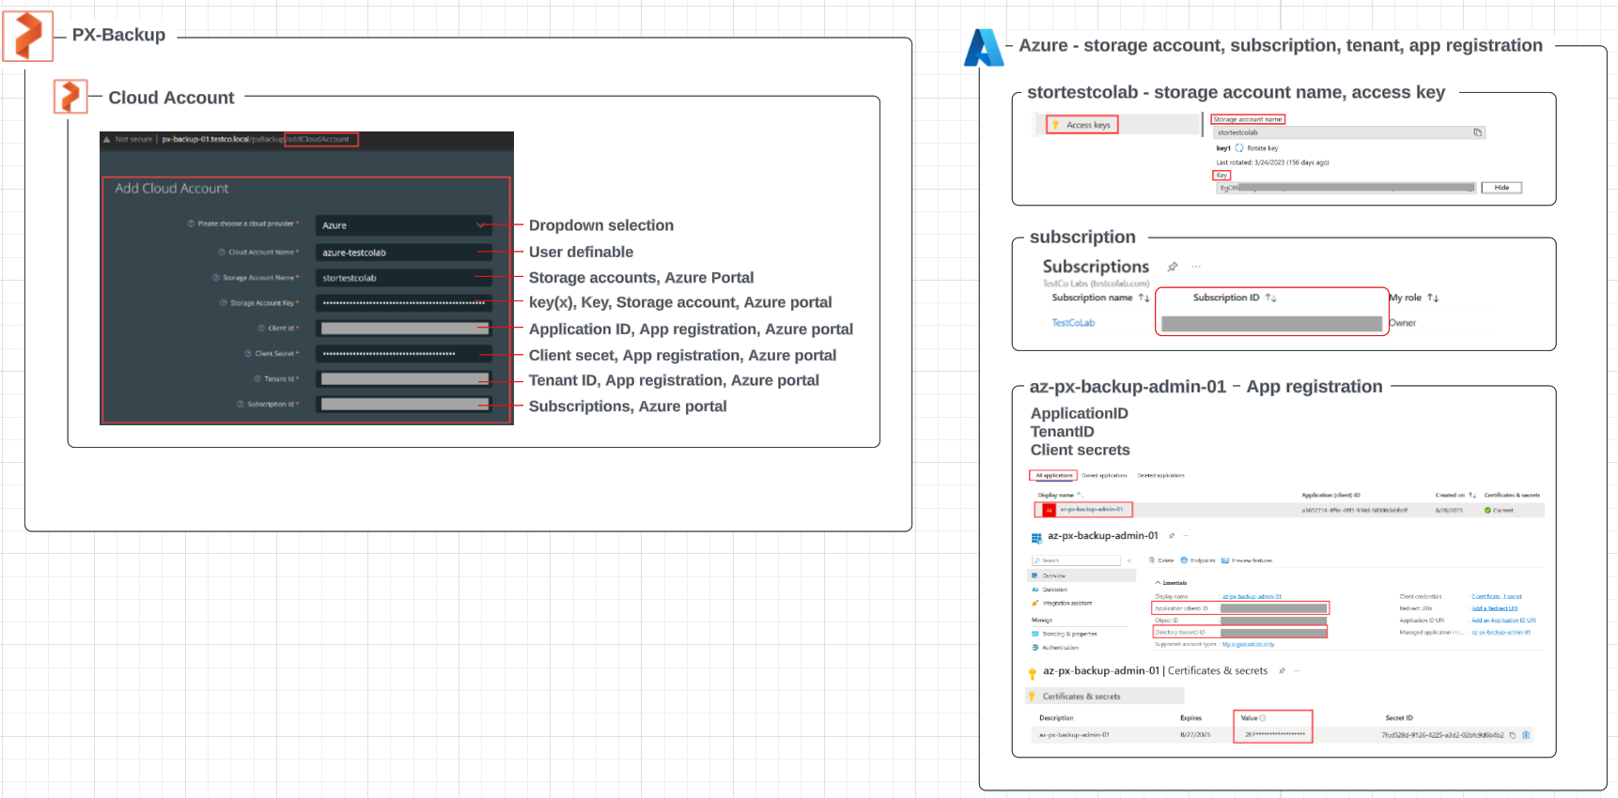

# stortestcolab – Azure storage account, blob for PX-Backup

## Blob service – default acces tier, anonymous acces, soft delete: blob/container, versioning

## Networking – allowed access

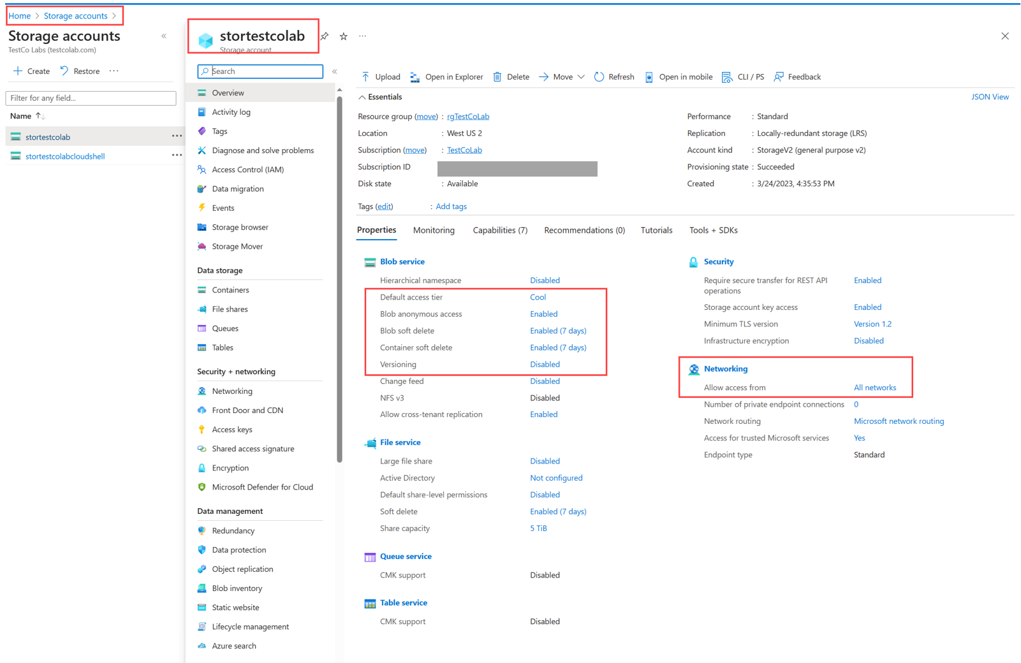

## access keys

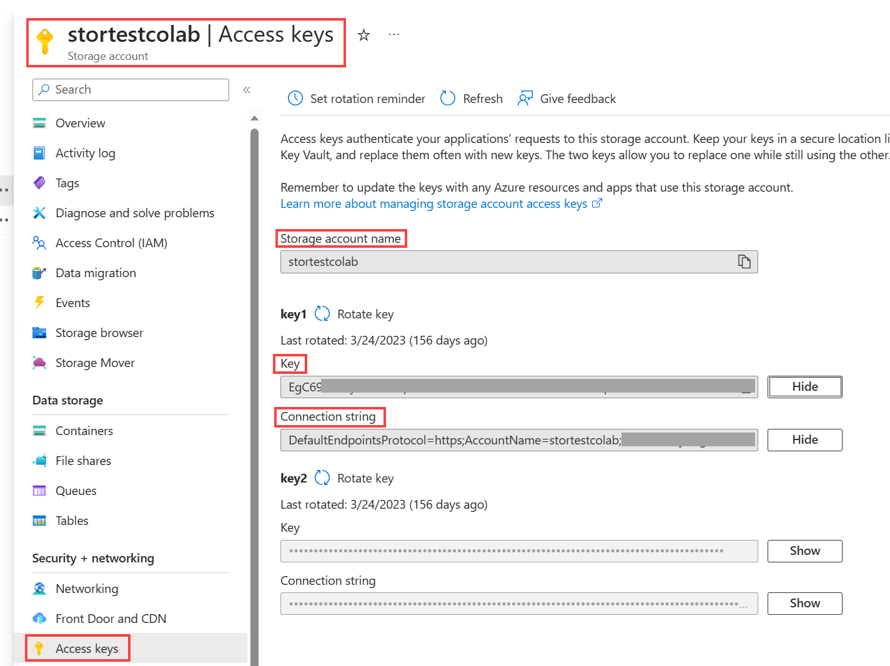

## portworx blob – storage account, containers

## url, version-level immutability support

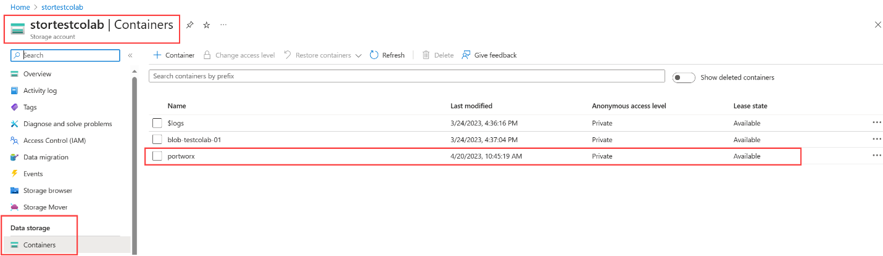

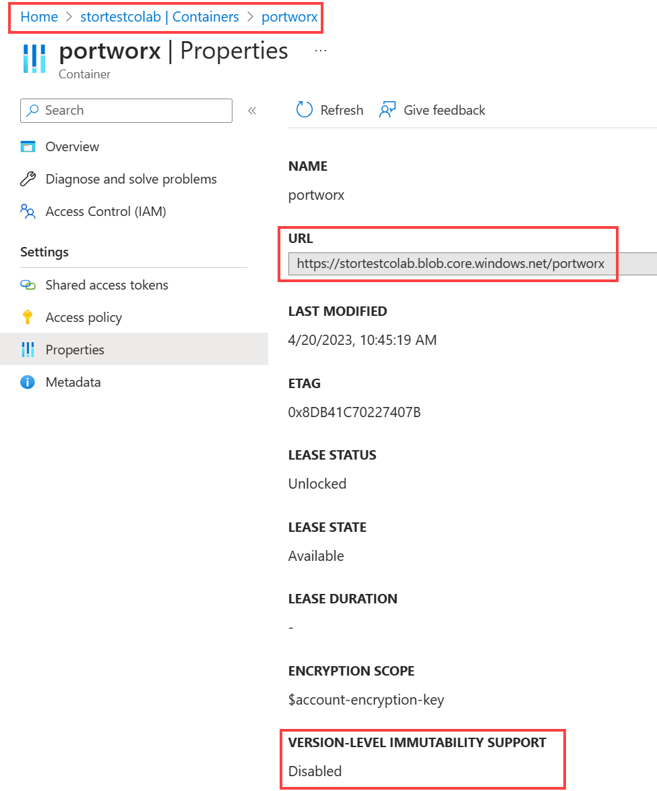

# PX-Backup Cloud Account, Backup Location details needed from Azure:

# az-px-backup-admin-01 service principal/app registration, client secret; tenant ID

## create/register- using web portal

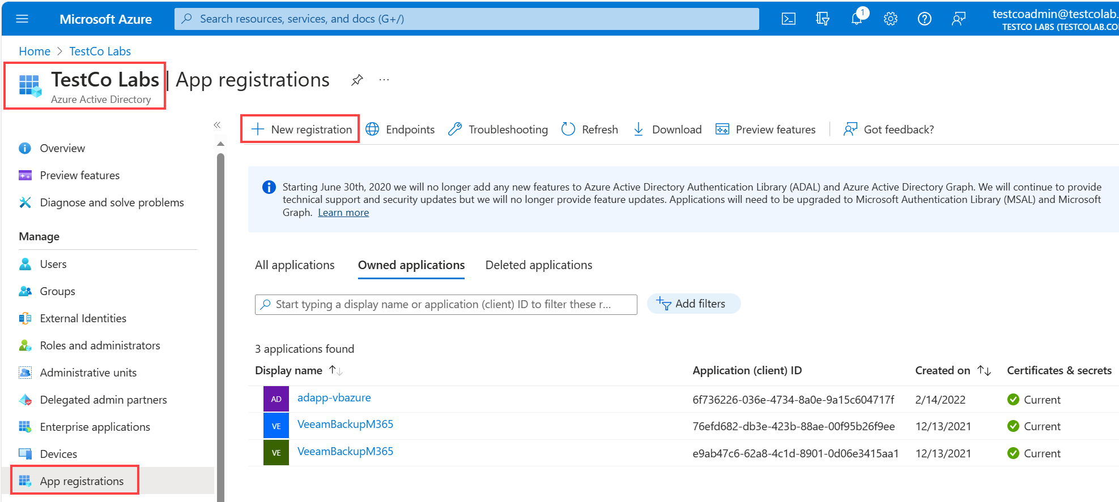

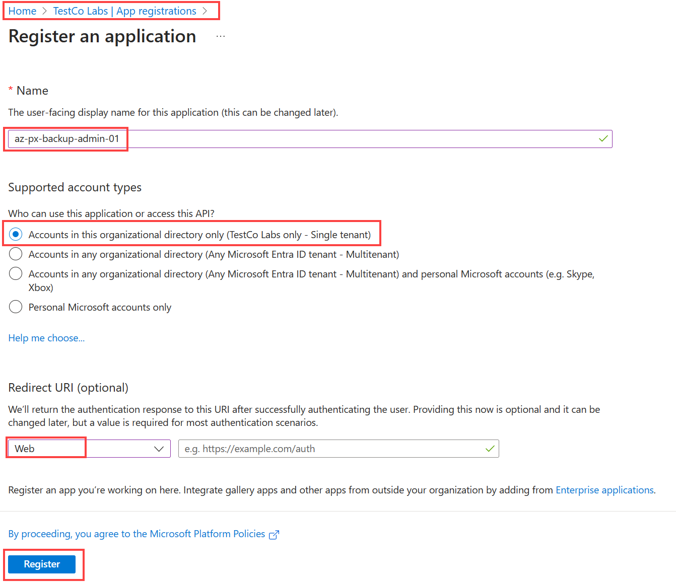

## create, capture client secret – using web portal

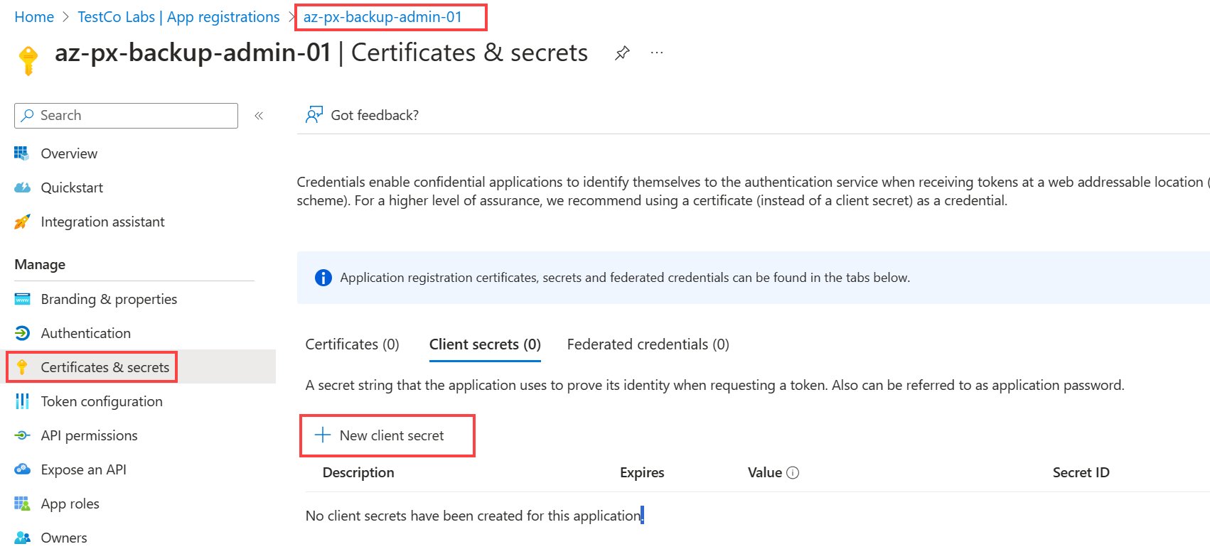

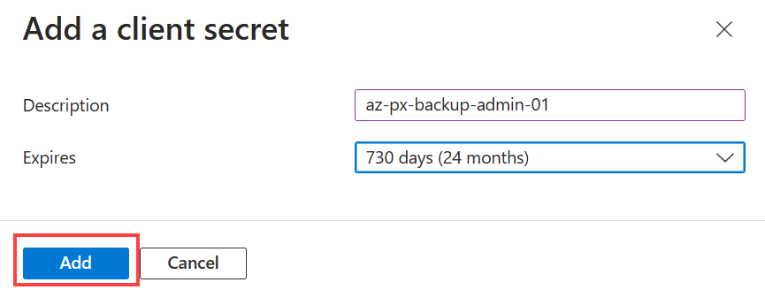

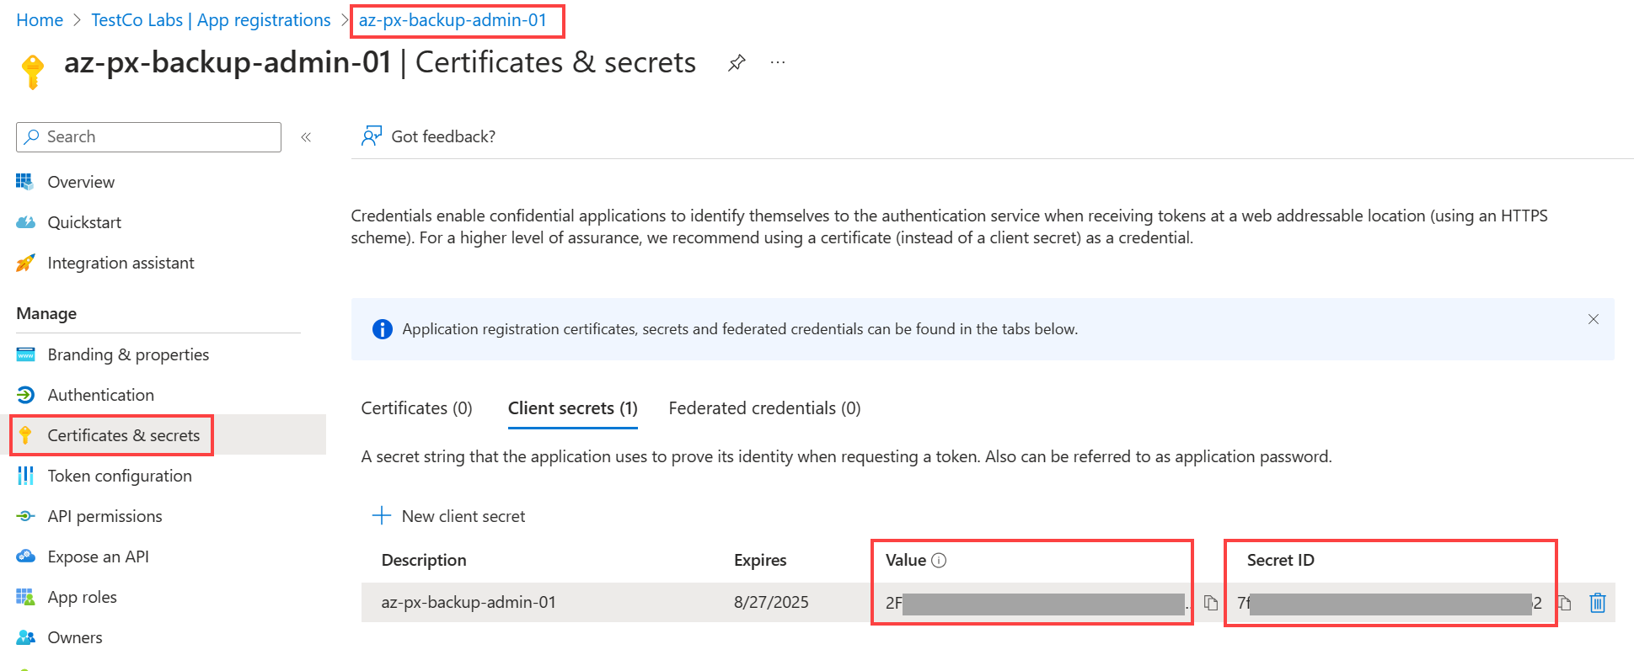

## service principal/app registration details needed for PX-Backup Cloud Account, Backup Location – using web portal

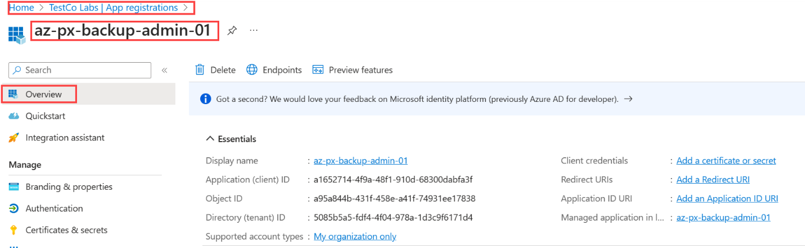

## Tenant ID

