TestCoLab

px-data-protect-nfs-backup-location-notes-proc-rvw-01

Updated 11/2/2023

Procedure review notes: 4

Overview 4

Firewall rules - CentOS v8 NFS server 5

sudo firewall-cmd --get-active-zones 5

sudo firewall-cmd --get-default-zone 5

sudo firewall-cmd --zone=public --list-all 5

sudo firewall-cmd --permanent --add-service nfs 5

sudo firewall-cmd --reload 5

sudo firewall-cmd --zone=public --list-all 6

Create non-privileged user for NFS client access - - - CentOS v8 NFS server 7

create user - sudo passwd px-nfsuser-01 7

sudo passwd px-nfsuser-01 --status 7

set user password – sudo passwd px-nfsuser-01 7

sudo cat /etc/passwd | grep px-nfsuser 7

Troubleshooting note: Confirm nfs client read/write permissions by editing values for anonuid=1001,anongid=1001 in /etc/export; nfs mount may work, but permission denied for read/write operations 7

Manage NFS services - - CentOS v8 NFS server 8

sudo systemctl start nfs-server.service 8

sudo systemctl enable nfs-server.service 8

sudo systemctl status nfs-server.service 8

Create NFS share - - CentOS v8 NFS server 9

sudo mkdir /px-backup 9

sudo chown px-nfsuser-01 /px-backup 9

getfacl /px-backup/ 9

Configure NFS export on or-nfs-svr-01 10

Note: these are the worker node IP addresses for the cluster with PX-Backup deployed 10

sudo vi /etc/exports 10

sudo exportfs -av 10

[Optional] NFS client testing from jump box - from or-jmp-rhel-01 mount local /var/px-backup to /px-backup on or-nfs-svr-01 11

verify basic network connectivity from NFS client to NFS server 11

create and set ownership/permissions on local /var/px-backup mount point 11

manual mount px-backup 11

manual dismount px-backup 11

Troubleshooting note: turn of firewall on nfs server, change export to 11

/px-backup *(all_squash,anonuid=1001,anongid=1001,rw,sync) 11

Monitoring - netstat for NFS client connections from or-nfs-svr-01 12

Configuration of the NFS backup location in PX-Backup 13

PX-Backup url - /pxBackup/cloudSettings 13

Backup Locations +Add 13

Note: validating status 14

Successful test backup 15

Review px-backup location, backup folders/files - - CentOS v8 NFS server 16

ls -RalF 16

# Procedure review notes:

## Overview

* These are informal, as-is observations to help illuminate a testing and troubleshooting process.
* The configuration overview is:

or-nfs-svr-01 CentOS v8 configured with NFS services

PX-Backup v2.5.1

* The issues being considered are:

Configuration of the CentOS v8 NFS server

Firewall rules

Non-privileged user for NFS client access

NFS services, share, export

[Optional] NFS client testing from jump box

Monitoring - netstat for NFS client connections from or-nfs-svr-01

Troubleshooting, validation of the NFS server access and operations

Configuration of the NFS backup location in PX-Backup

Perform a test backup in PX-Backup to the NFS backup location

From the NFS server, review the backup location folders, files

# Firewall rules - CentOS v8 NFS server

## sudo firewall-cmd --get-active-zones

public

interfaces: ens192

## sudo firewall-cmd --get-default-zone

public

## sudo firewall-cmd --zone=public --list-all

public (active)

target: default

icmp-block-inversion: no

interfaces: ens192

sources:

services: cockpit dhcpv6-client ssh

ports:

protocols:

forward: no

masquerade: no

forward-ports:

source-ports:

icmp-blocks:

rich rules:

## sudo firewall-cmd --permanent --add-service nfs

success

## sudo firewall-cmd --reload

success

## sudo firewall-cmd --zone=public --list-all

public (active)

target: default

icmp-block-inversion: no

interfaces: ens192

sources:

services: cockpit dhcpv6-client **nfs** ssh

ports:

protocols:

forward: no

masquerade: no

forward-ports:

source-ports:

icmp-blocks:

rich rules:

# Create non-privileged user for NFS client access - - - CentOS v8 NFS server

## create user - sudo passwd px-nfsuser-01

## sudo passwd px-nfsuser-01 --status

px-nfsuser-01 LK 2023-09-04 0 99999 7 -1 (Password locked.)

## set user password – sudo passwd px-nfsuser-01

New password:

retype new password:

passwd: all authentication tokens updated successfully.

## sudo cat /etc/passwd | grep px-nfsuser

px-nfsuser-01:x:1001:1001::/home/px-nfsuser-01:/bin/bash

## Troubleshooting note: Confirm nfs client read/write permissions by editing values for anonuid=1001,anongid=1001 in /etc/export; nfs mount may work, but permission denied for read/write operations

# Manage NFS services - - CentOS v8 NFS server

## sudo systemctl start nfs-server.service

## sudo systemctl enable nfs-server.service

Created symlink /etc/systemd/system/multi-user.target.wants/nfs-server.service → /usr/lib/systemd/system/nfs-server.service.

## sudo systemctl status nfs-server.service

● nfs-server.service - NFS server and services

Loaded: loaded (/usr/lib/systemd/system/nfs-server.service; enabled; vendor preset: disabled)

Active: active (exited) since Tue 2023-09-05 11:52:28 PDT; 29s ago

Main PID: 6329 (code=exited, status=0/SUCCESS)

Tasks: 0 (limit: 49472)

Memory: 0B

CGroup: /system.slice/nfs-server.service

Sep 05 11:52:28 or-nfs-svr-01 systemd[1]: Starting NFS server and services...

Sep 05 11:52:28 or-nfs-svr-01 systemd[1]: Started NFS server and services.

# Create NFS share - - CentOS v8 NFS server

## sudo mkdir /px-backup

## sudo chown px-nfsuser-01 /px-backup

## getfacl /px-backup/

getfacl: Removing leading '/' from absolute path names

# file: px-backup/

# owner: px-nfsuser-01

# group: root

user::rwx

group::r-x

other::r-x

# Configure NFS export on or-nfs-svr-01

## Note: these are the worker node IP addresses for the cluster with PX-Backup deployed

## sudo vi /etc/exports

/px-backup 10.1.6.101(all_squash,rw)

/px-backup 10.1.2.100(all_squash,rw)

## sudo exportfs -av

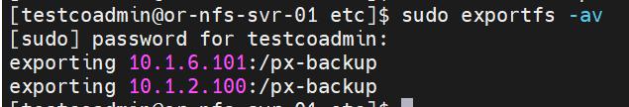

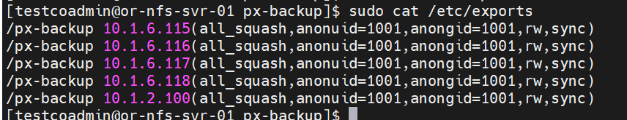

/px-backup [host](rw)

/mnt/nfsshare xx.xx.xx.xx(all_squash,anonuid=1001,anongid=1001,rw,sync)`

/usr/share/doc client01(rw)

When you’re specifying a hostname in the /etc/exports file, the following methods are permitted:

hostname: A hostname that can be resolved into an IP address.

netgroup: An NIS netgroup using the designation of @groupname.

domain: A domain name using wildcards. For example, *.onecoursesource.com would include any machine in the onecoursesource.com domain.

Network: A network defined by IP addresses using either VLSM (Variable Length Subnet Mask) or CIDR (Classless Inter-Domain Routing). Examples: 192.168.1.0/255.255.255.0 and 192.168.1.0/24.

# [Optional] NFS client testing from jump box - from or-jmp-rhel-01 mount local /var/px-backup to /px-backup on or-nfs-svr-01

## verify basic network connectivity from NFS client to NFS server

ping [nfs server fqdn]

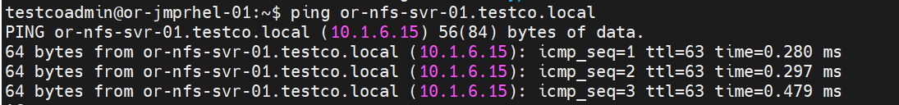

## create and set ownership/permissions on local /var/px-backup mount point

sudo mkdir /var/px-backup

sudo chown testcoadmin /var/px-backup

chmod 755 /var/px-backup

## manual mount px-backup

sudo mount or-nfs-svr-01.testco.local:/px-backup /var/px-backup

ll /var/px-backup/

total 8

drwxr-xr-x. 2 1001 root 22 Sep 5 14:07 ./

drwxr-xr-x. 25 root root 4096 Sep 5 14:20 ../

-rw-r--r--. 1 root root 20 Sep 5 14:07 test.txt

## manual dismount px-backup

umount /var/px-backup

## Troubleshooting note: turn of firewall on nfs server, change export to

## /px-backup *(all_squash,anonuid=1001,anongid=1001,rw,sync)

# Monitoring - netstat for NFS client connections from or-nfs-svr-01

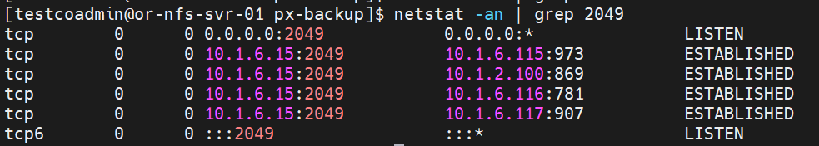

# Configuration of the NFS backup location in PX-Backup

## PX-Backup url - /pxBackup/cloudSettings

## Backup Locations +Add

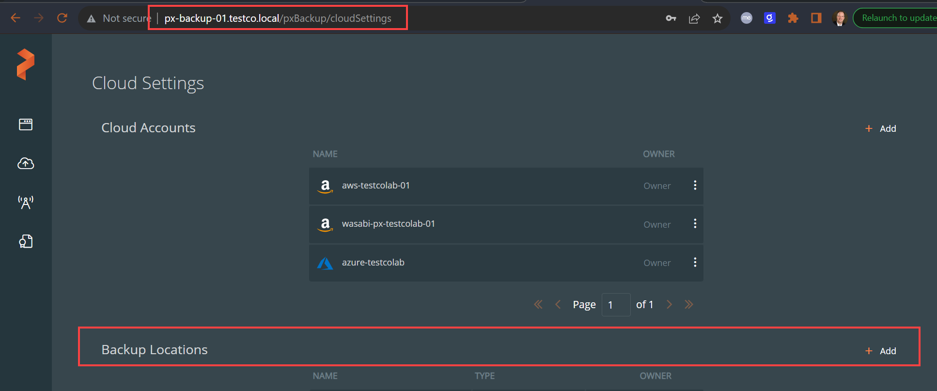

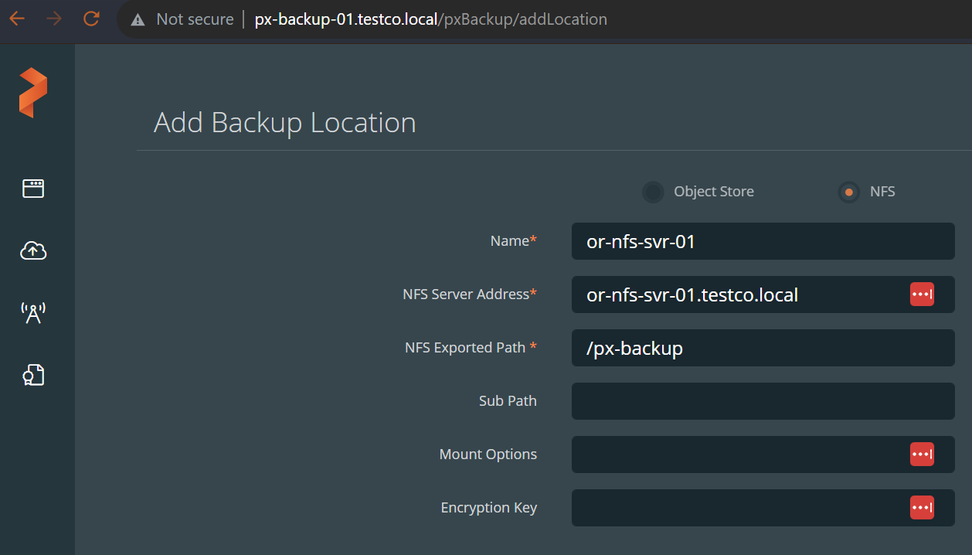

## Note: validating status

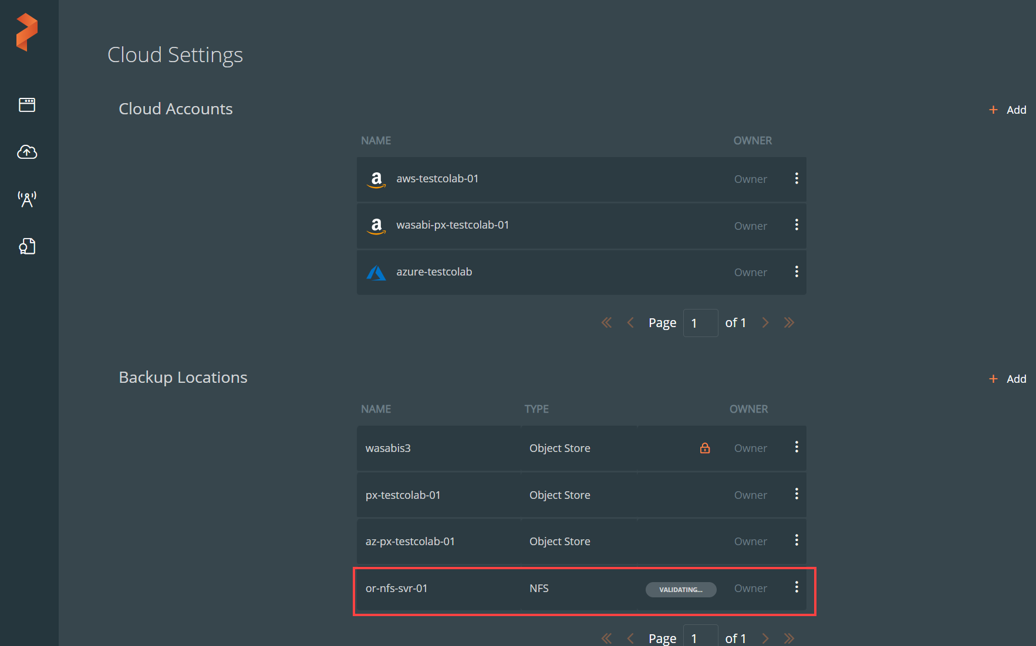

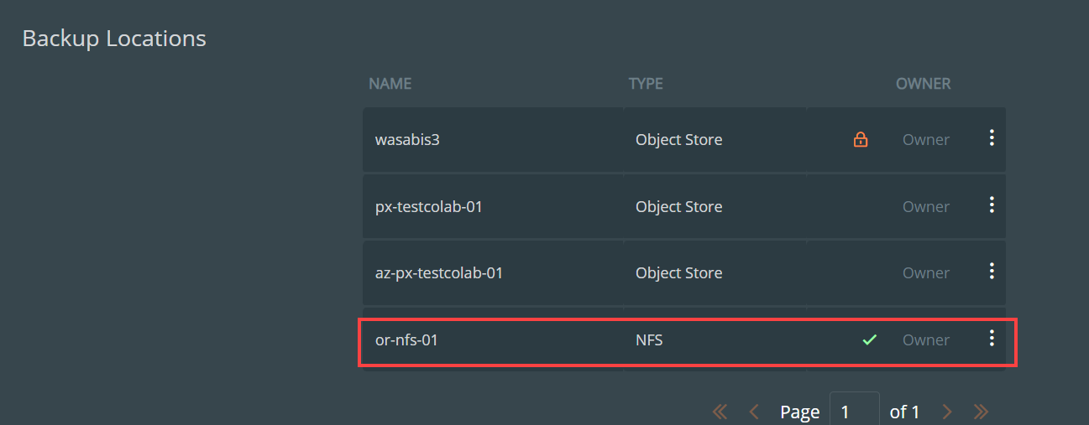

## Successful test backup

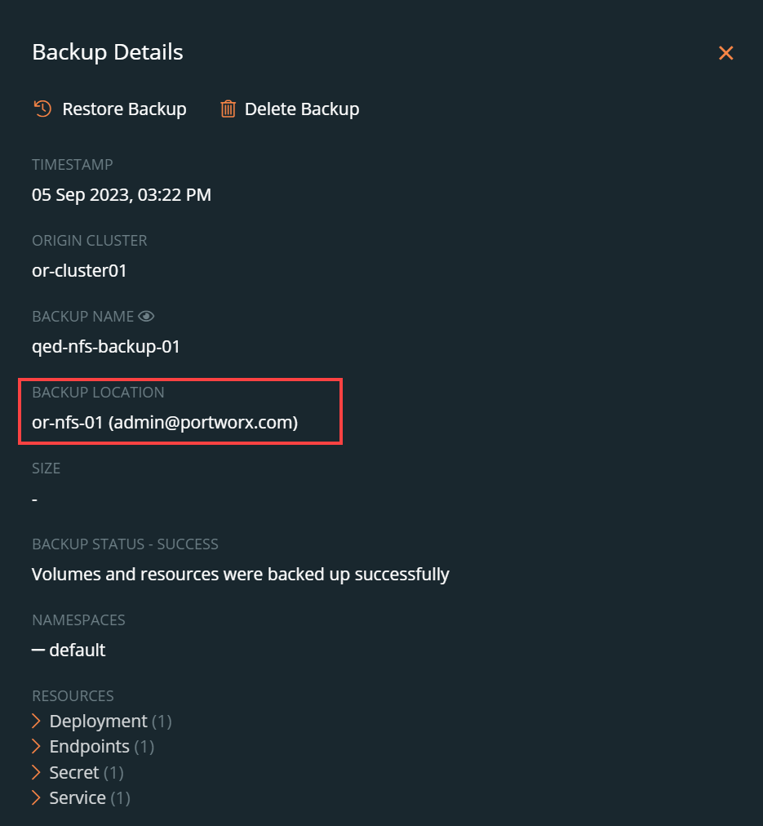

# Review px-backup location, backup folders/files - - CentOS v8 NFS server

## ls -RalF

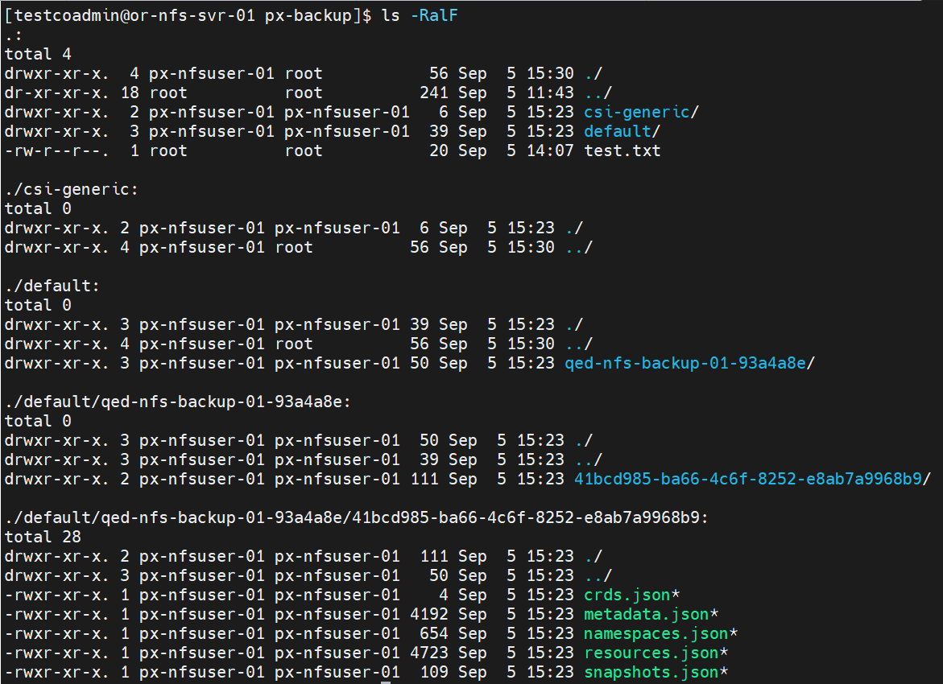

Backup single 1GB pds-demo datadir PVC

Before:



Backup all PVCs

Before

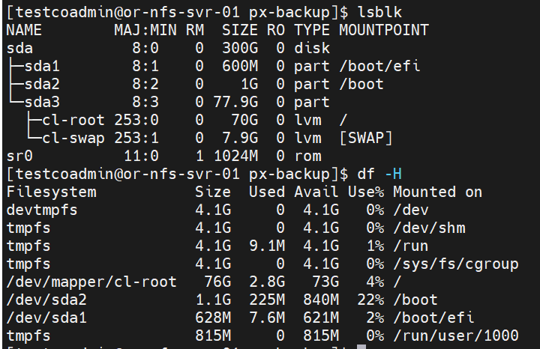

After:

