# Create Schedule Policy

## Use PX-Backup UI to create sample policy to review api results

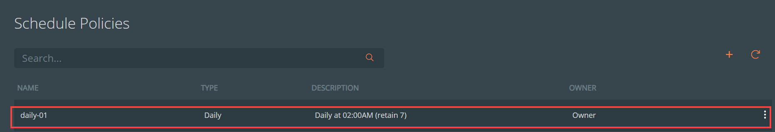

## <http://[LoadBalancerIP> to px-backup svc]:10001/v1/schedulepolicy/default

{

"schedule_policies": [

{

"metadata": {

"name": "daily-01",

"uid": "d65747ab-cc44-4e13-891d-609856b3523e",

"org_id": "default",

"create_time": "2023-09-18T18:37:53.295185282Z",

"last_update_time": "2023-09-18T18:37:53.295185282Z",

"create_time_in_sec": "1695062273",

"ownership": {

"owner": "27c76a0d-4711-4931-822f-69bcee8bc7bf",

"groups": [

{

"id": "px-admin-group",

"access": "Admin"

}

],

"public": {}

}

},

"schedule_policy_info": {

"daily": {

"time": "02:00AM",

"retain": "7",

"incremental_count": {

"count": "6"

}

}

}

}

]

}

## Use Swagger UI to review SchedulePolicy api metadata

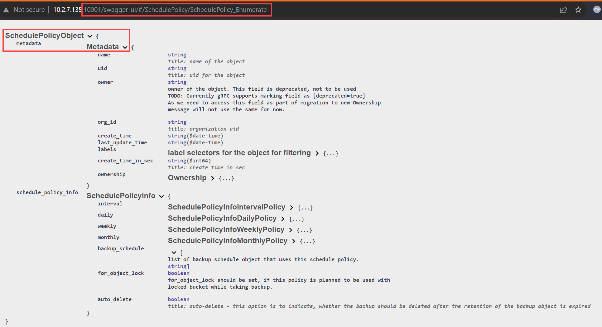

## Use Swqgger UI to create new SchedulePolicy

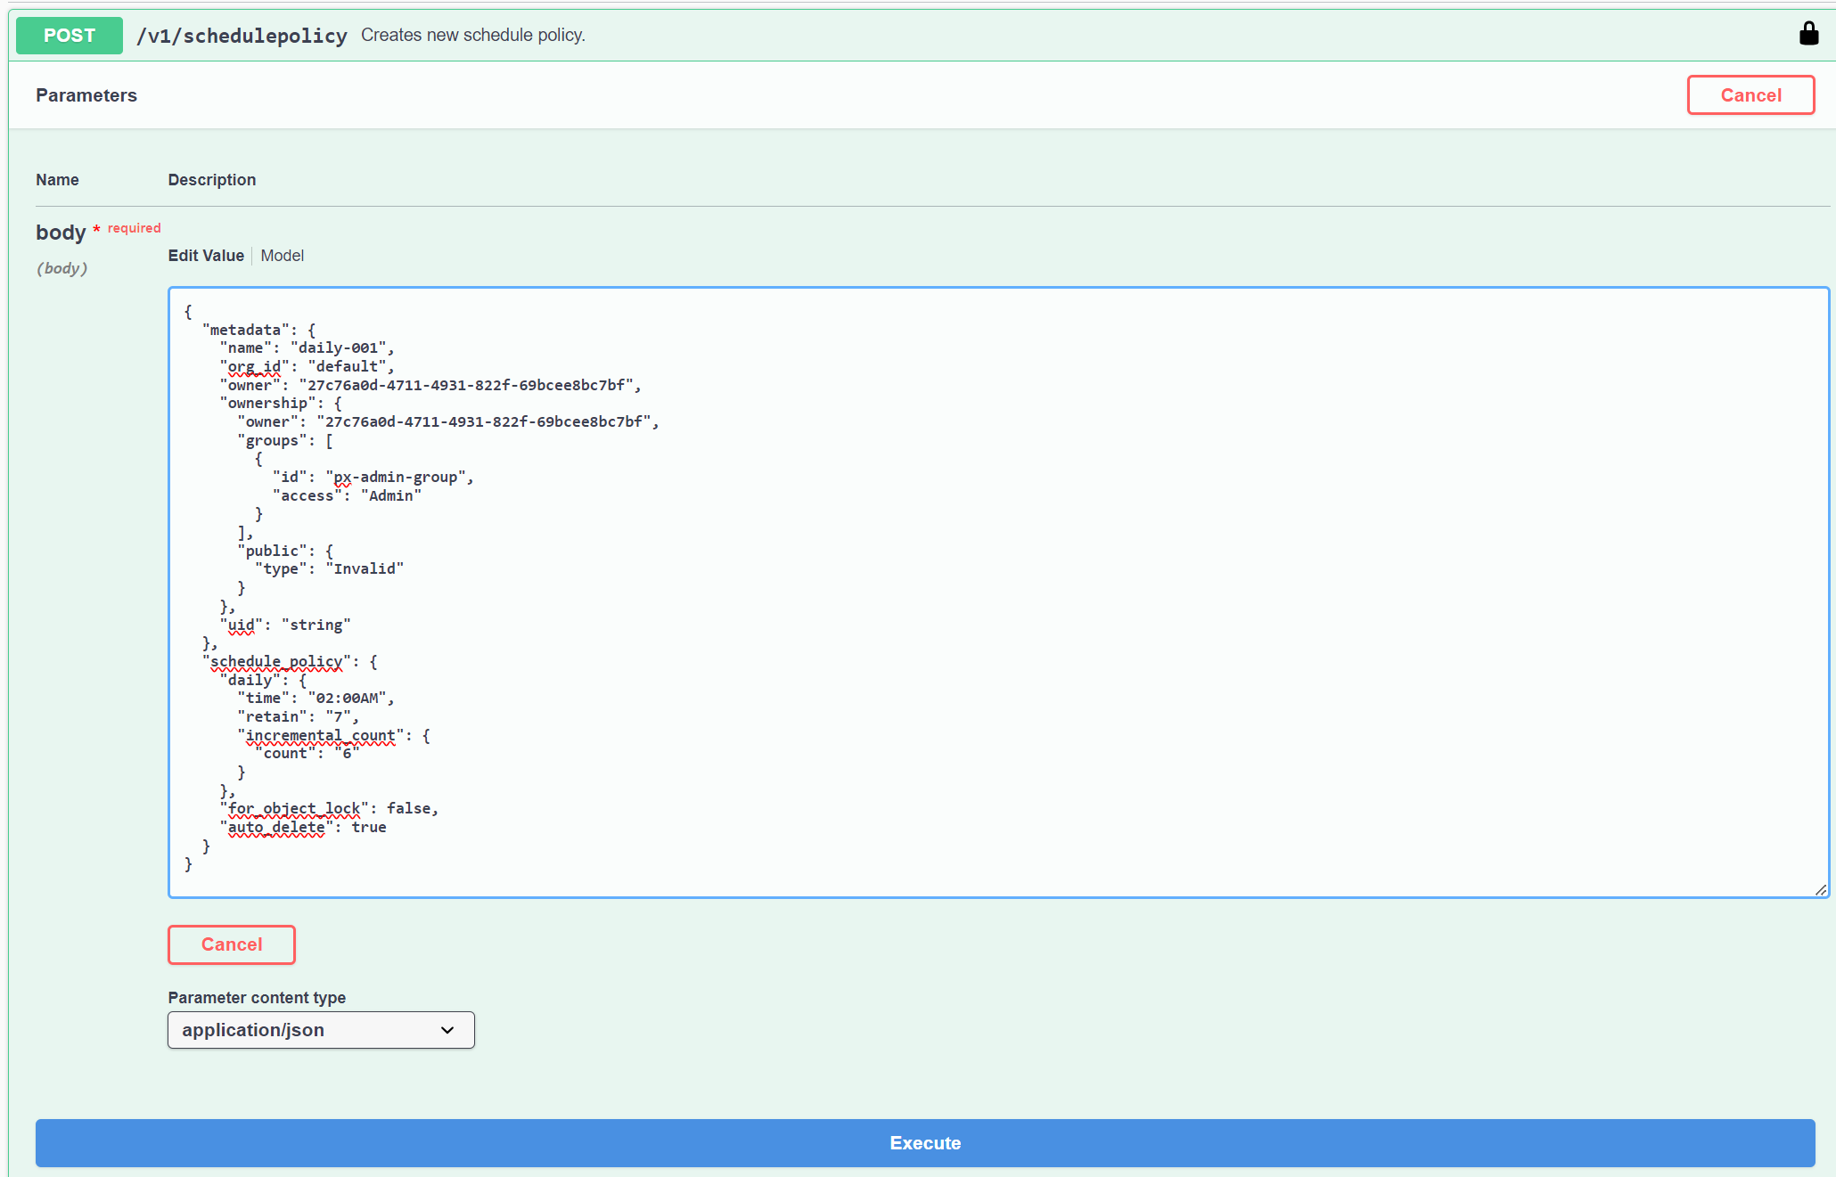

{

"metadata": {

"name": "daily-001",

"org_id": "default",

"owner": "27c76a0d-4711-4931-822f-69bcee8bc7bf",

"ownership": {

"owner": "27c76a0d-4711-4931-822f-69bcee8bc7bf",

"groups": [

{

"id": "px-admin-group",

"access": "Admin"

}

],

"public": {

"type": "Invalid"

}

},

"uid": "string"

},

"schedule_policy": {

"daily": {

"time": "02:00AM",

"retain": "7",

"incremental_count": {

"count": "6"

}

},

"for_object_lock": false,

"auto_delete": true

}

}

## Confirm creation of API-generated SchedulePolicy in PX-Backup UI

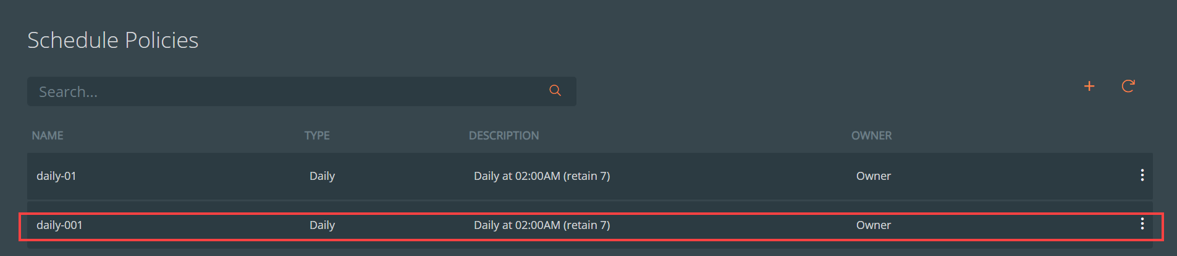

## User Swagger UI to capture syntax of POST request for potential reuse in scripts, etc.

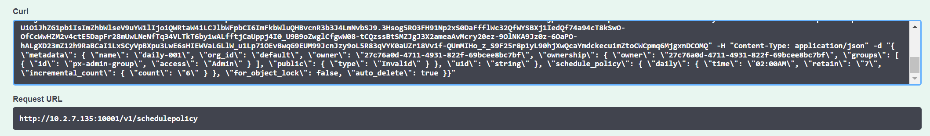

curl -X POST "http://[LoadBalancerIP of px-backup]:10001/v1/schedulepolicy" -H "accept: application/json" -H "Authorization: Bearer [access token]" -H "Content-Type: application/json" -d "{ \"metadata\": { \"name\": \"daily-001\", \"org_id\": \"default\", \"owner\": \"27c76a0d-4711-4931-822f-69bcee8bc7bf\", \"ownership\": { \"owner\": \"27c76a0d-4711-4931-822f-69bcee8bc7bf\", \"groups\": [ { \"id\": \"px-admin-group\", \"access\": \"Admin\" } ], \"public\": { \"type\": \"Invalid\" } }, \"uid\": \"string\" }, \"schedule_policy\": { \"daily\": { \"time\": \"02:00AM\", \"retain\": \"7\", \"incremental_count\": { \"count\": \"6\" } }, \"for_object_lock\": false, \"auto_delete\": true }}"