# Disaggregated installation - Portworx

## Overview

* Label existing userpool portworx.io/node-type: storage
* Edit PX StorageCluster env ENABLE_ASG_STORAGE_PARTITIONING “true’
* Add node pool labeled portworx.io/node-type: storageless

## portworx.io/node-type: storage - Add labels to existing

az aks nodepool update --resource-group rg-aks-01 --cluster-name az-aks-01 --name userpool --labels portworx.io/node-type=storage --no-wait

k get nodes --show-labels | gh storage

2044 az aks nodepool update --resource-group MC_rg-aks-01_az-aks-01_westus2 --cluster-name az-aks-01 --name labelnp --labels portworx.io/node-type=storage --no-wait

2046 az aks nodepool update --resource-group rg-aks-01 --cluster-name az-aks-01 --name labelnp --labels portworx.io/node-type=storage --no-wait

2047 az aks nodepool update --resource-group MC_rg-aks-01_az-aks-01_westus2 --cluster-name az-aks-01 --name userpool --labels portworx.io/node-type=storage --no-wait

2048 az aks nodepool update --resource-group rg-aks-01 --cluster-name az-aks-01 --name userpool --labels portworx.io/node-type=storage --no-wait

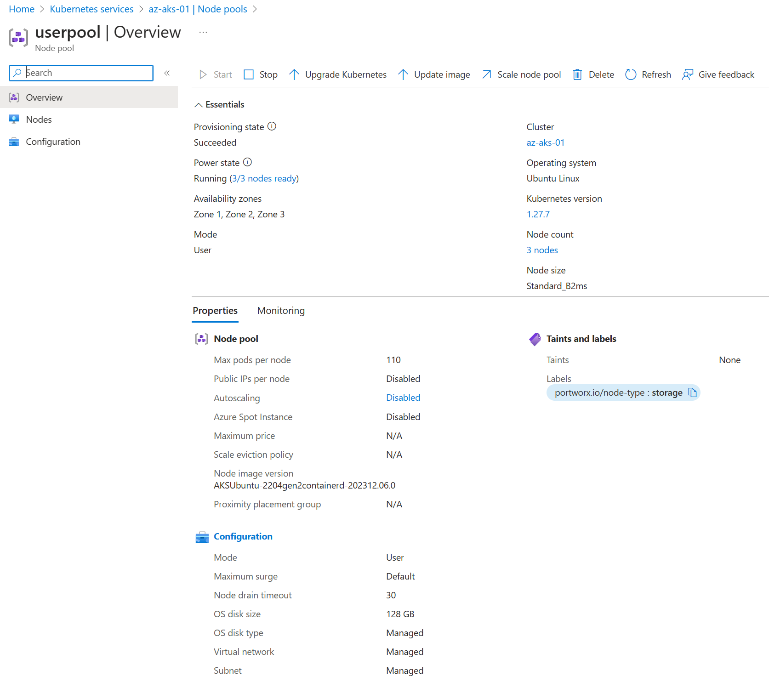

## Edit PX StorageCluster env ENABLE_ASG_STORAGE_PARTITIONING “true’

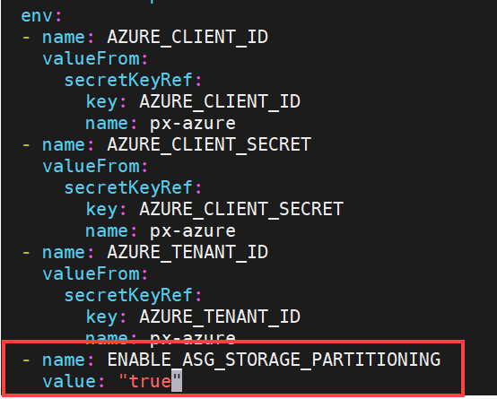

## Appspool – new portworx.io/node-type: storageless

