# AKS Cluster Preset Configuration Comparisons

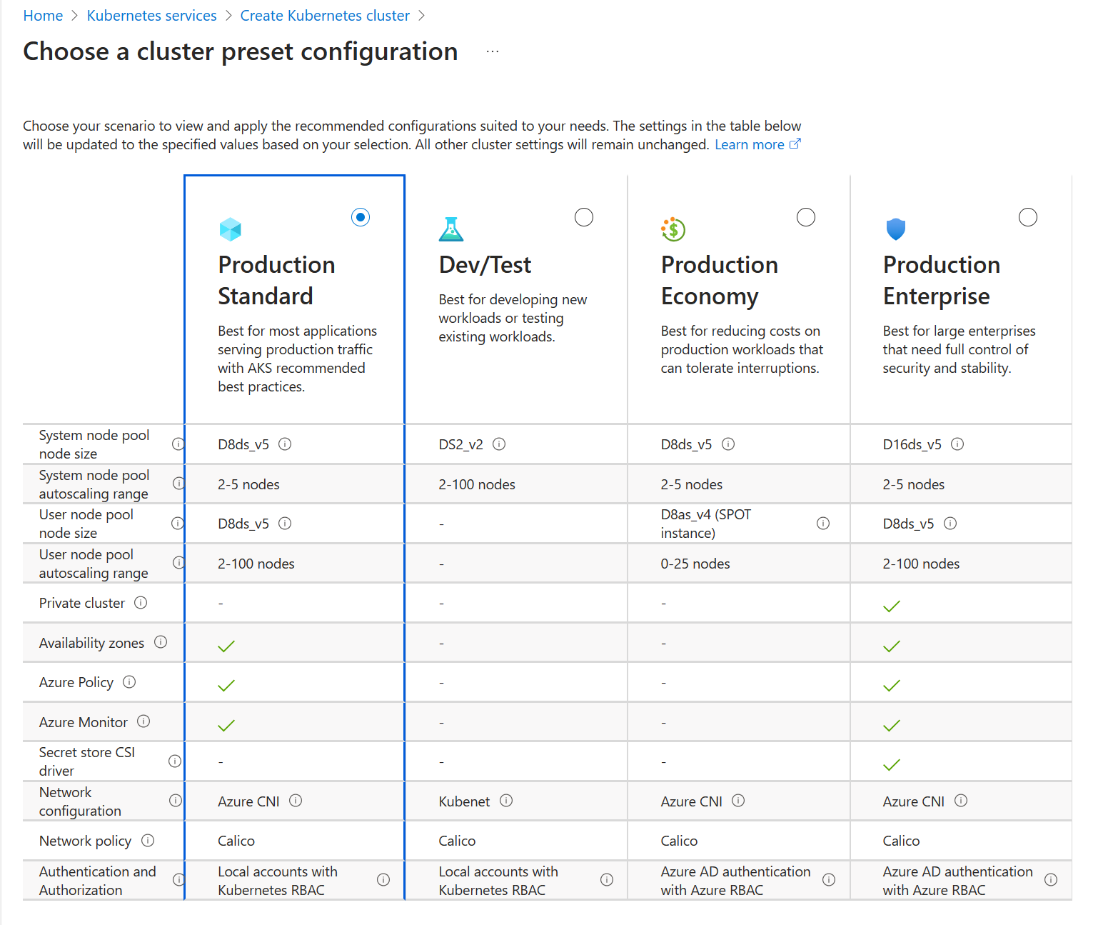

# Procedures Overview

# az-aks-01 Cluster

## agentpool

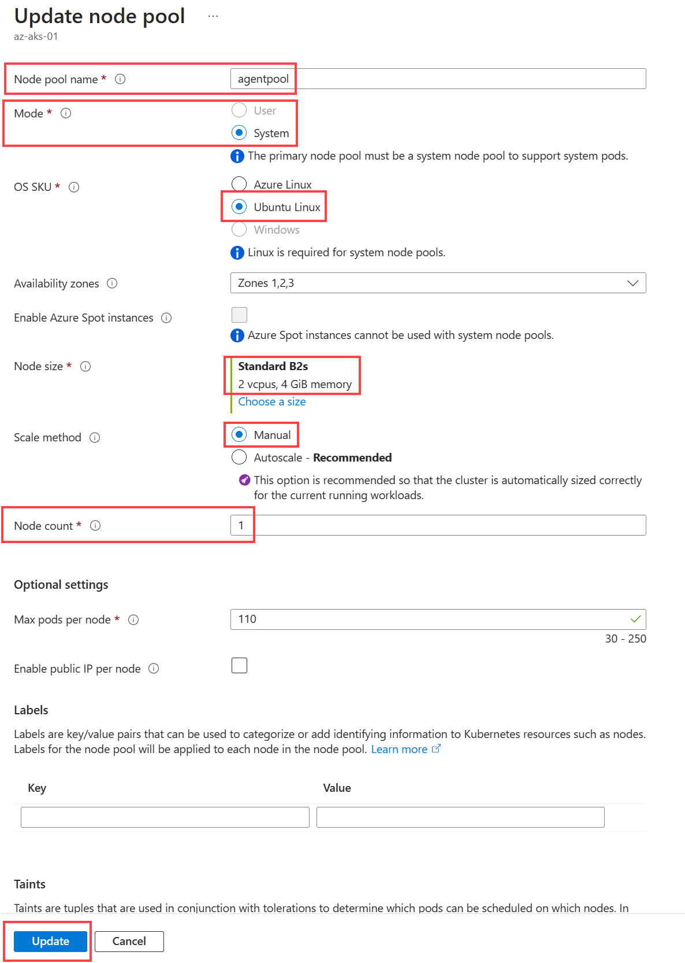

## userpool

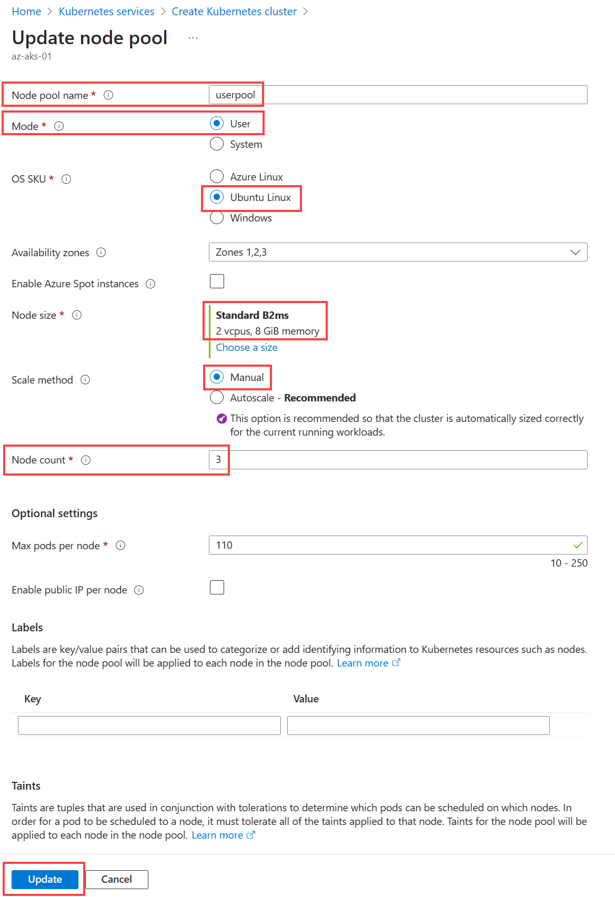

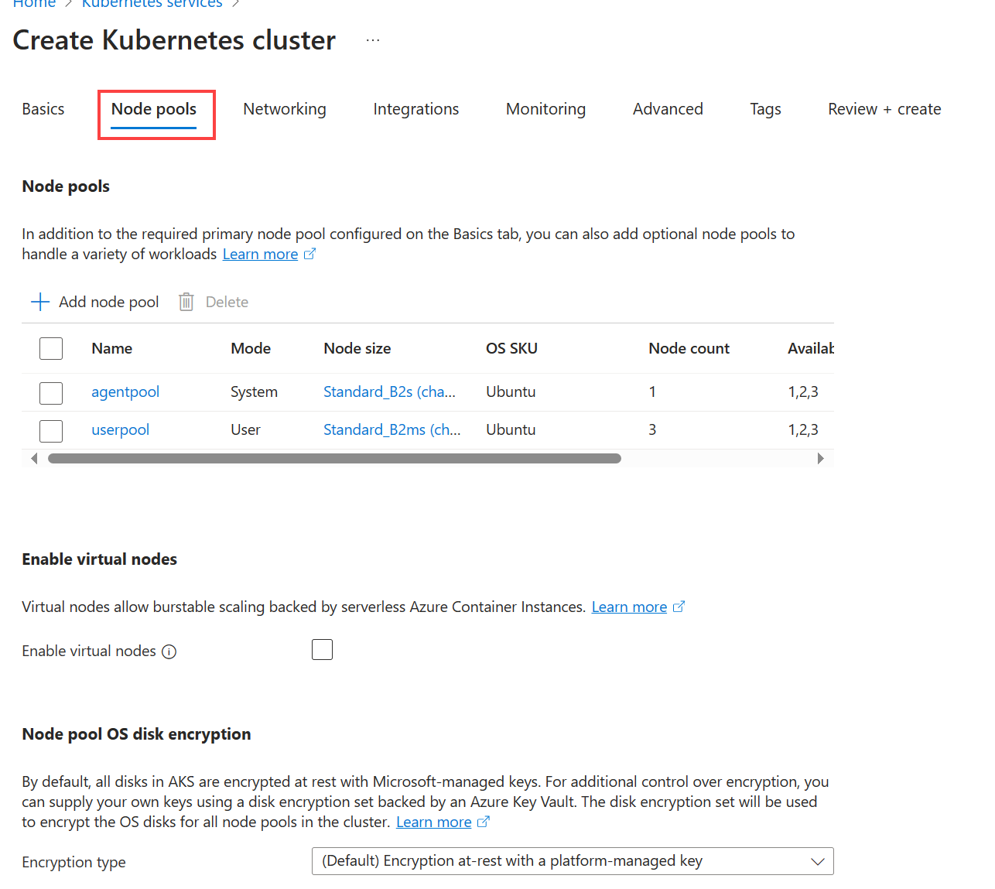

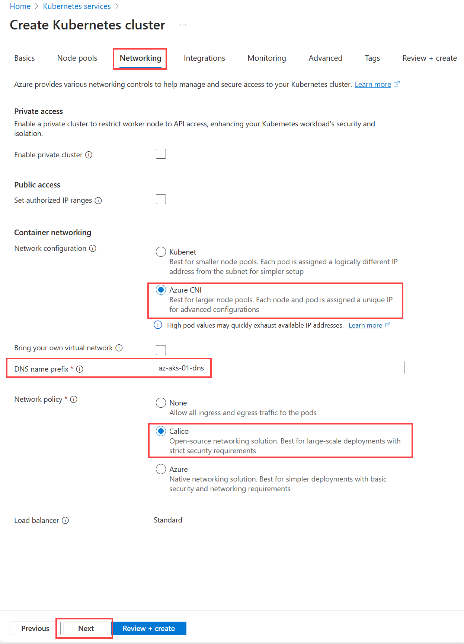

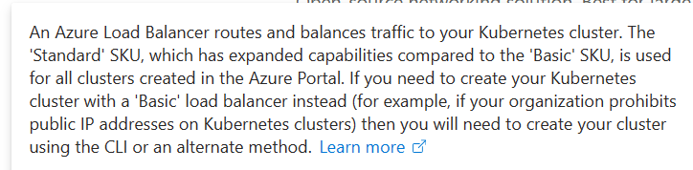

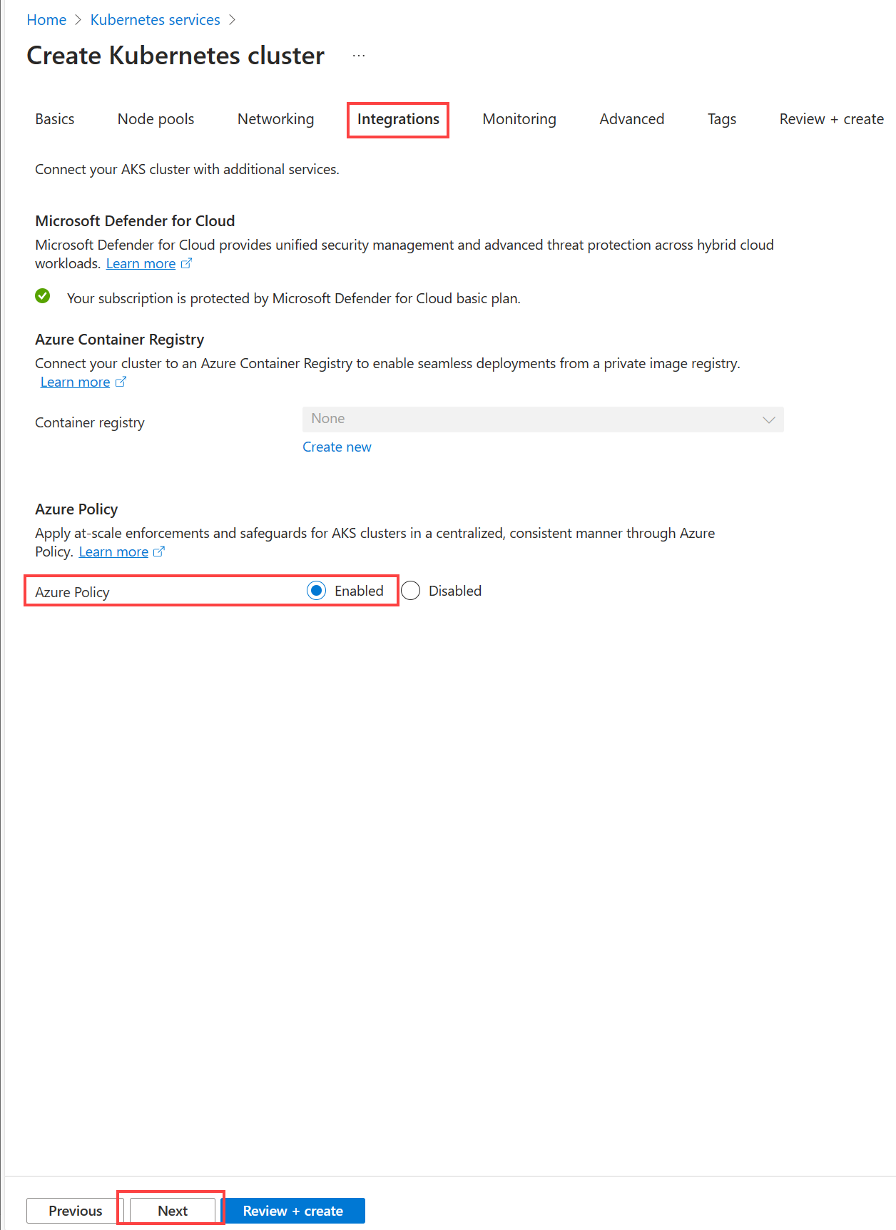

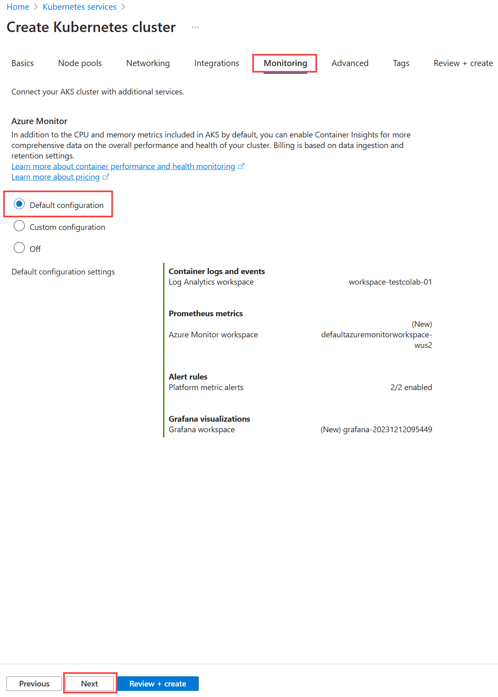

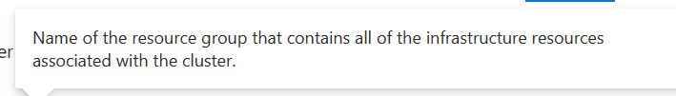

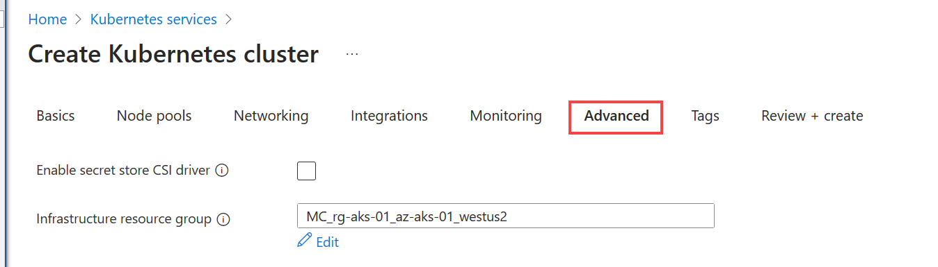

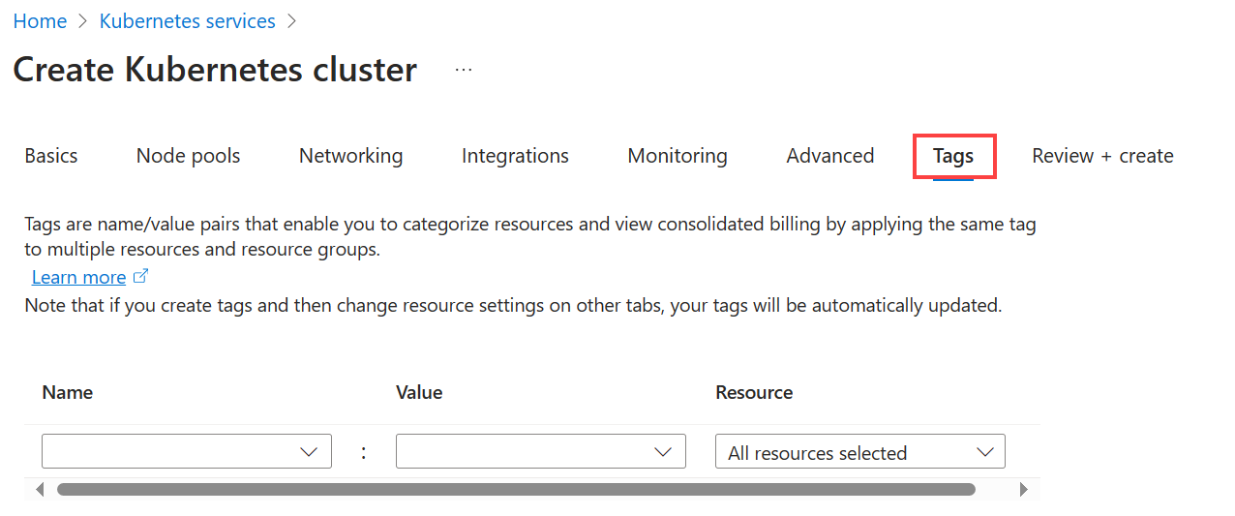

## Initial summary screen

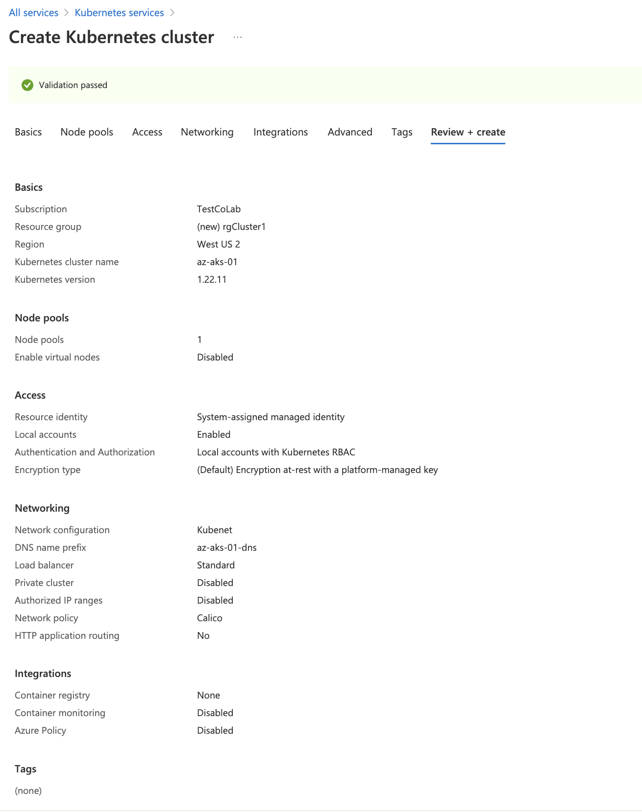

## Configuration overview

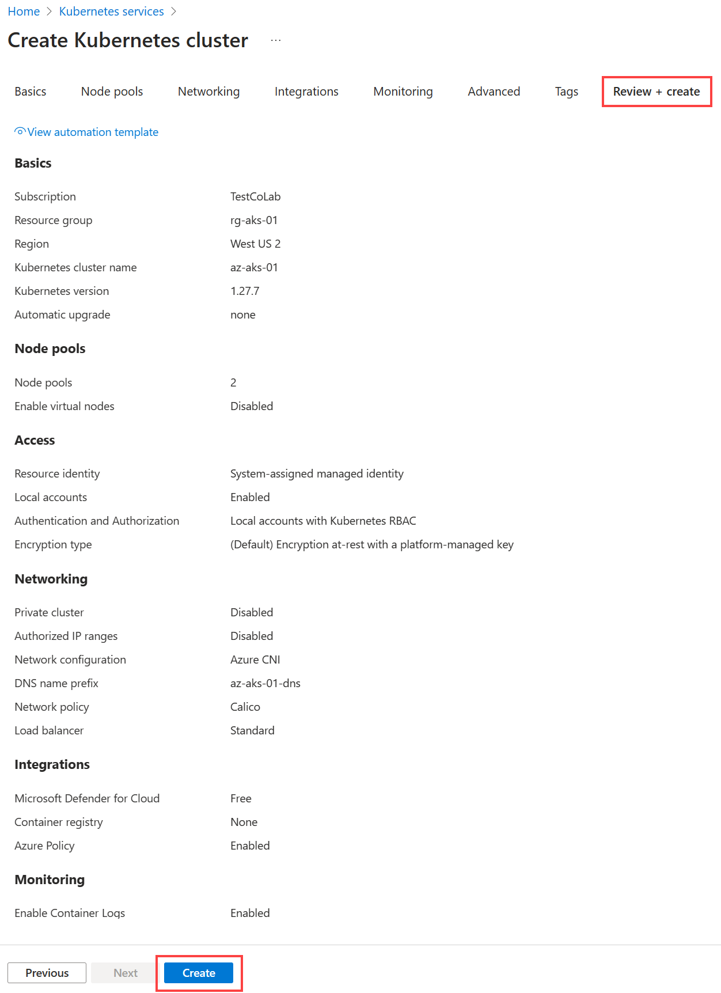

# PX-E

## Custom portworx role

az role definition create --role-definition '{

"Name": "role-portworx",

"Description": "",

"AssignableScopes": [

"/subscriptions/[REDACTED]"

],

"Actions": [

"Microsoft.ContainerService/managedClusters/agentPools/read",

"Microsoft.Compute/disks/delete",

"Microsoft.Compute/disks/write",

"Microsoft.Compute/disks/read",

"Microsoft.Compute/virtualMachines/write",

"Microsoft.Compute/virtualMachines/read",

"Microsoft.Compute/virtualMachineScaleSets/virtualMachines/write",

"Microsoft.Compute/virtualMachineScaleSets/virtualMachines/read"

],

"NotActions": [],

"DataActions": [],

"NotDataActions": []

}'

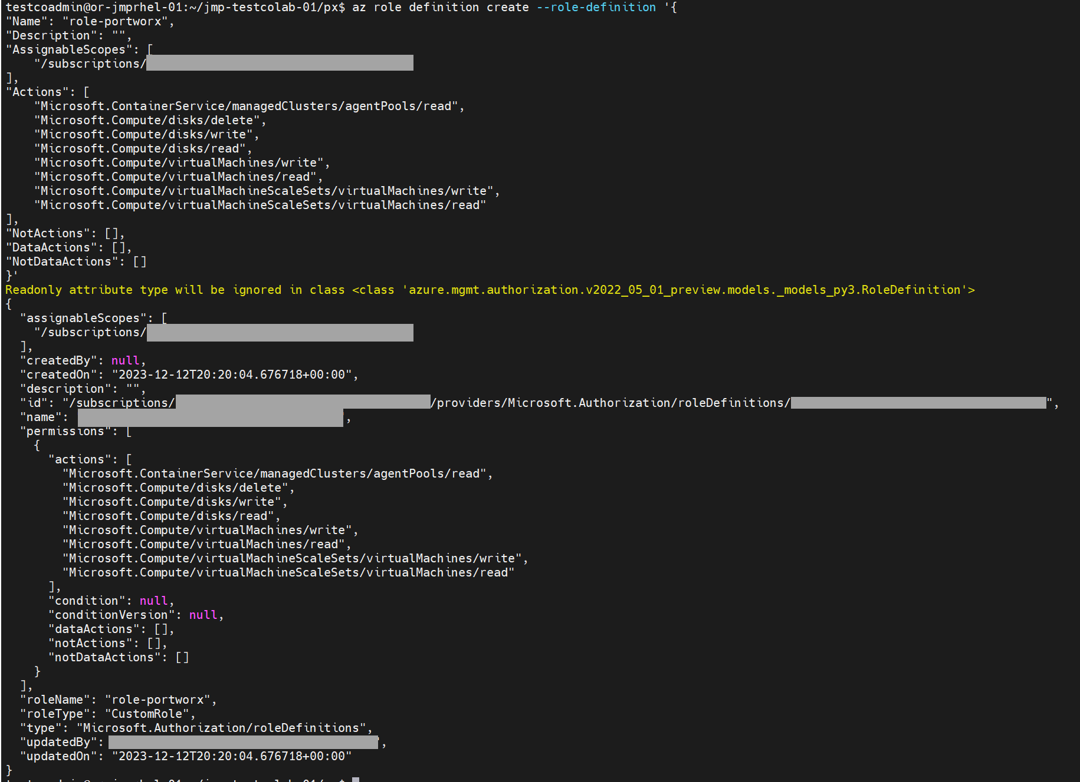

## Create a service principal for Portworx custom role

az aks show -n az-aks-01 -g rg-aks-01 | jq -r '.nodeResourceGroup'



az ad sp create-for-rbac --role=<your-role-name> --scopes="/subscriptions/<your-subscription-id>/resourceGroups/<aks-infrastructure-resource-group>"

az ad sp create-for-rbac --role=role-portworx --scopes="/subscriptions/[REDACTED]/resourceGroups/MC_rg-aks-01_az-aks-01_westus2"

{

"appId": "/[REDACTED]",

"displayName": "azure-cli-2023-12-12-20-32-06",

"password": "/[REDACTED]",

"tenant": "/[REDACTED]"

}

## create secret

testcoadmin@or-jmprhel-01:~/jmp-testcolab-01/px$ kubectl create secret generic -n kube-system px-azure --from-literal=AZURE_TENANT_ID=/[REDACTED]\

--from-literal=AZURE_CLIENT_ID=/[REDACTED] \

--from-literal=AZURE_CLIENT_SECRET=/[REDACTED]

secret/px-azure created

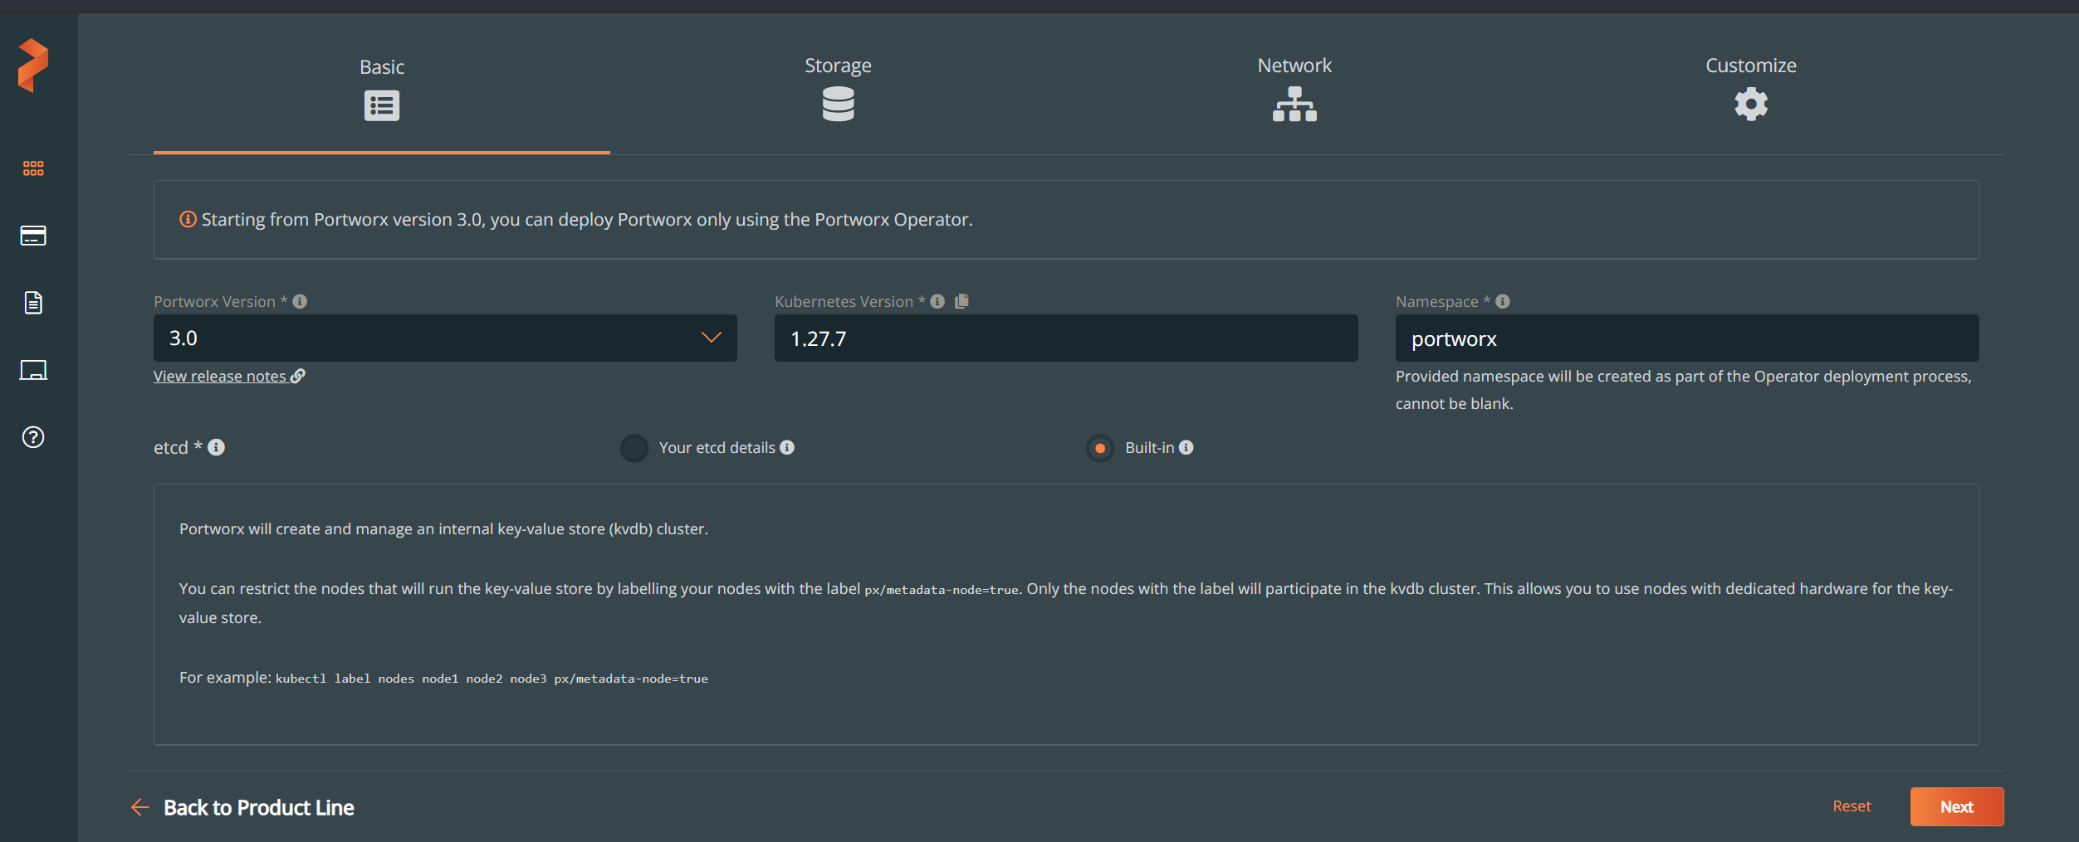

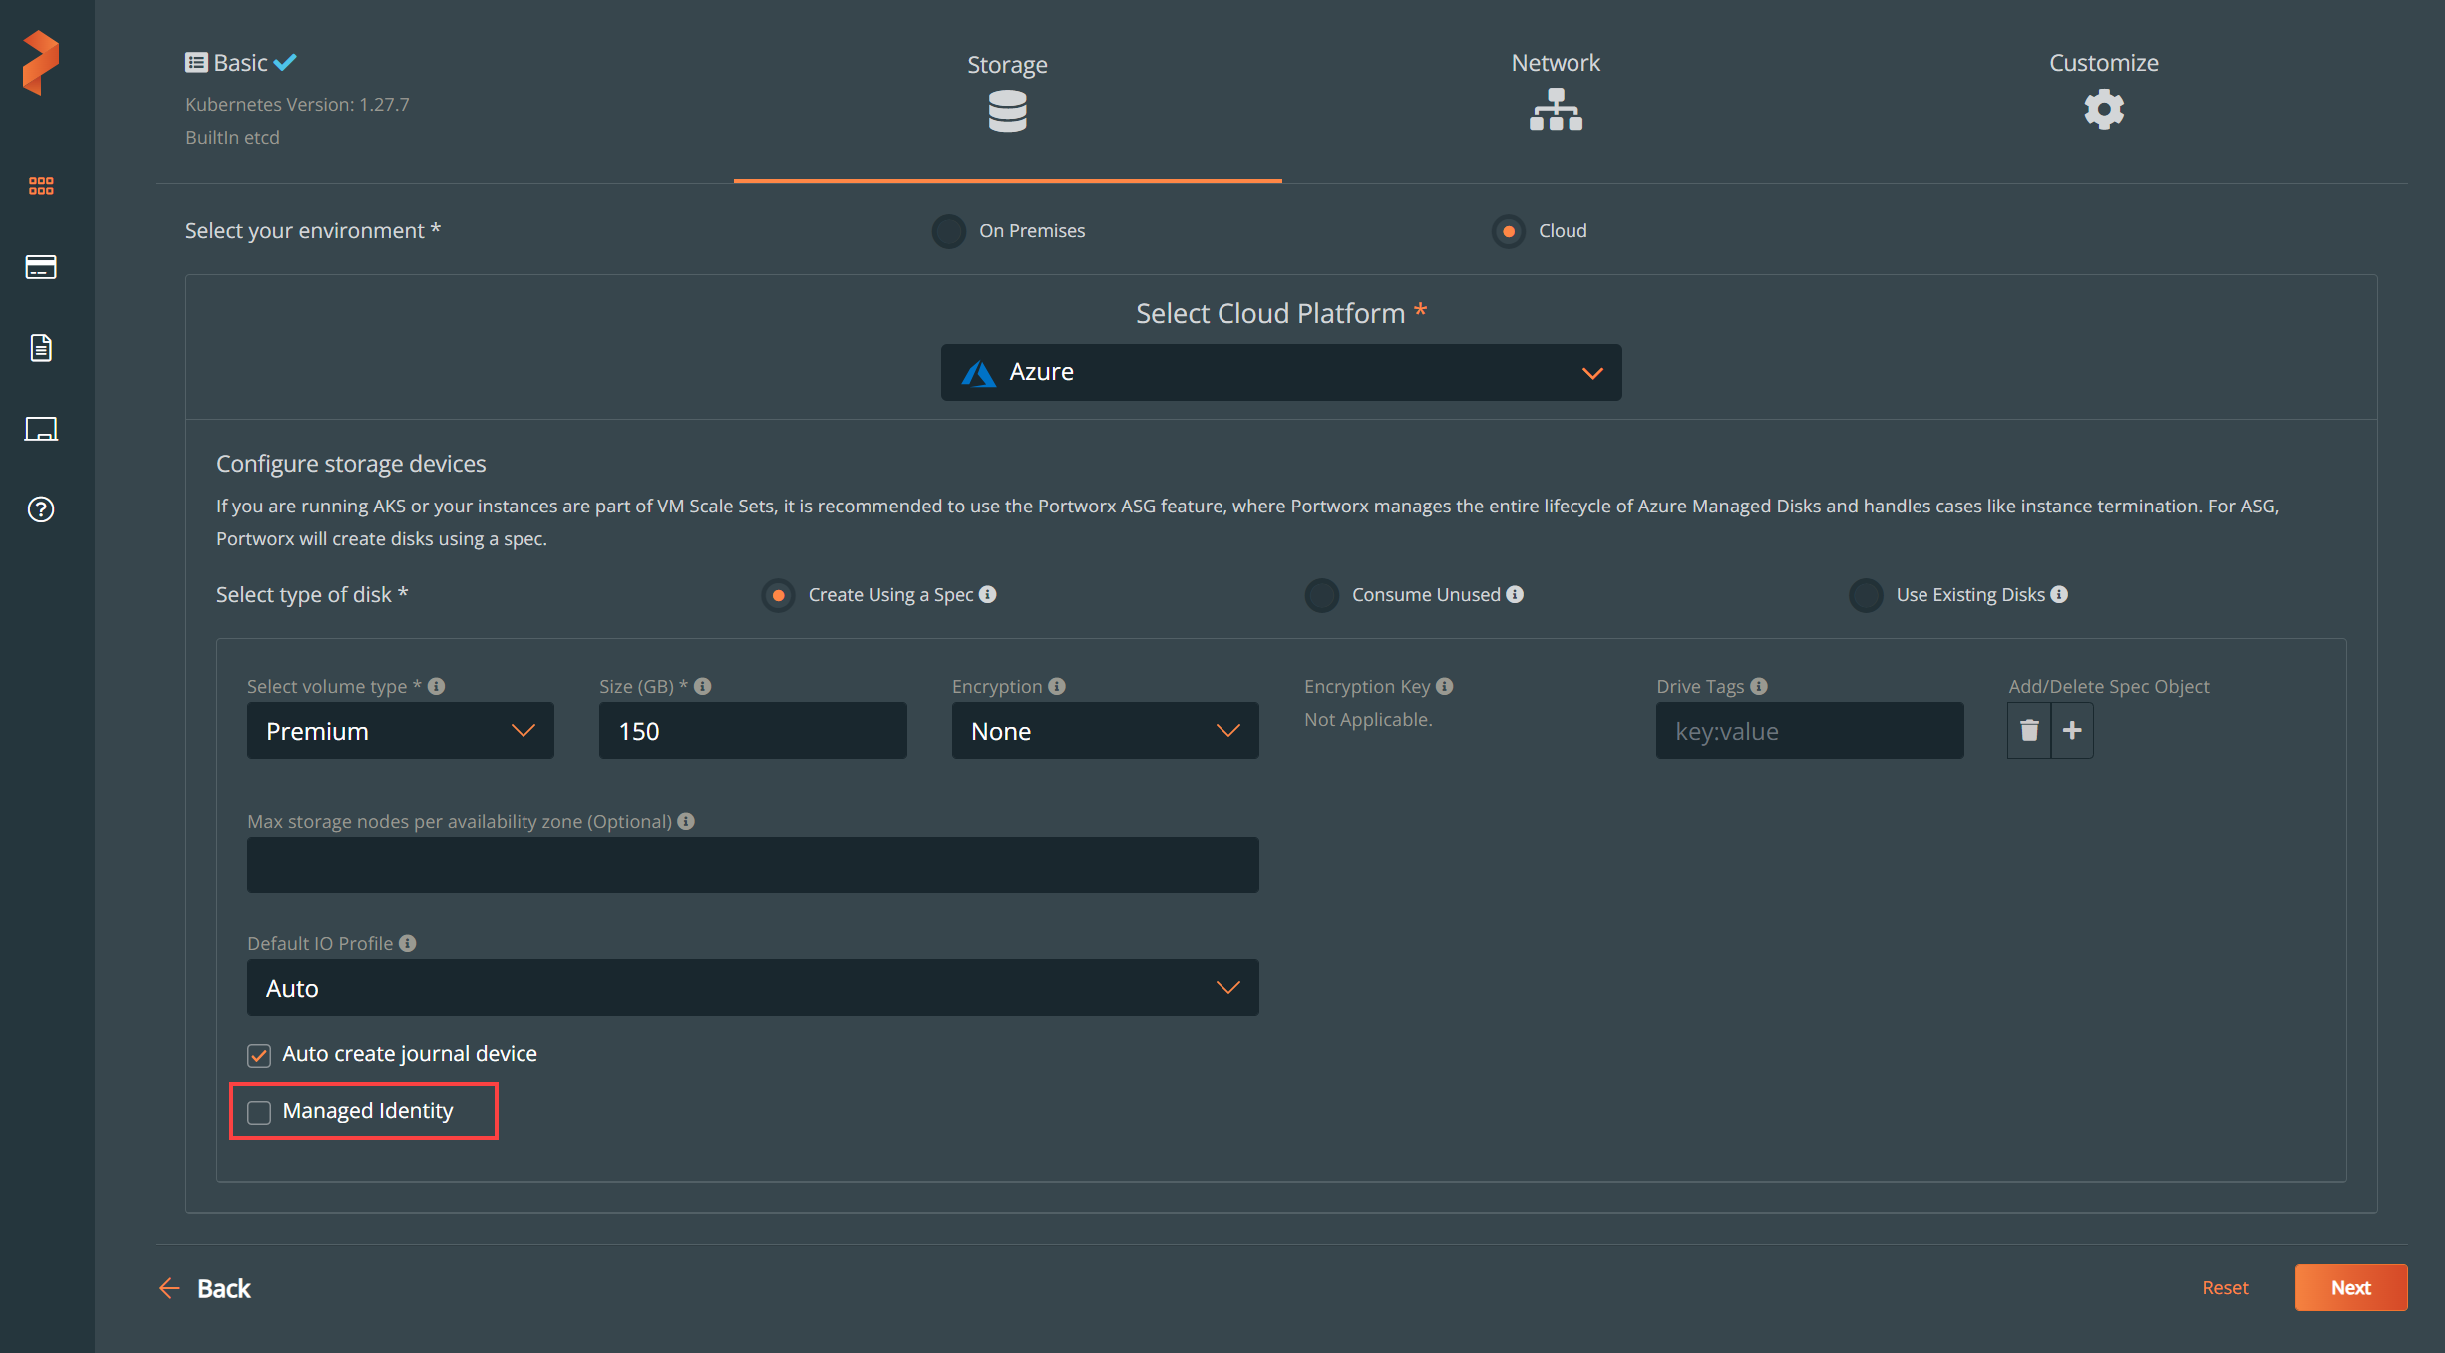

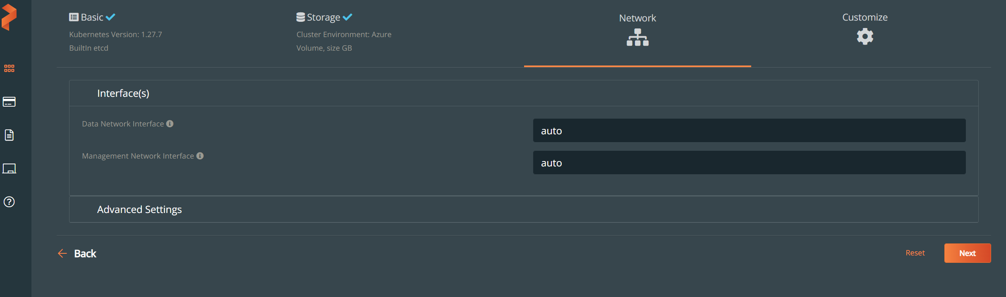

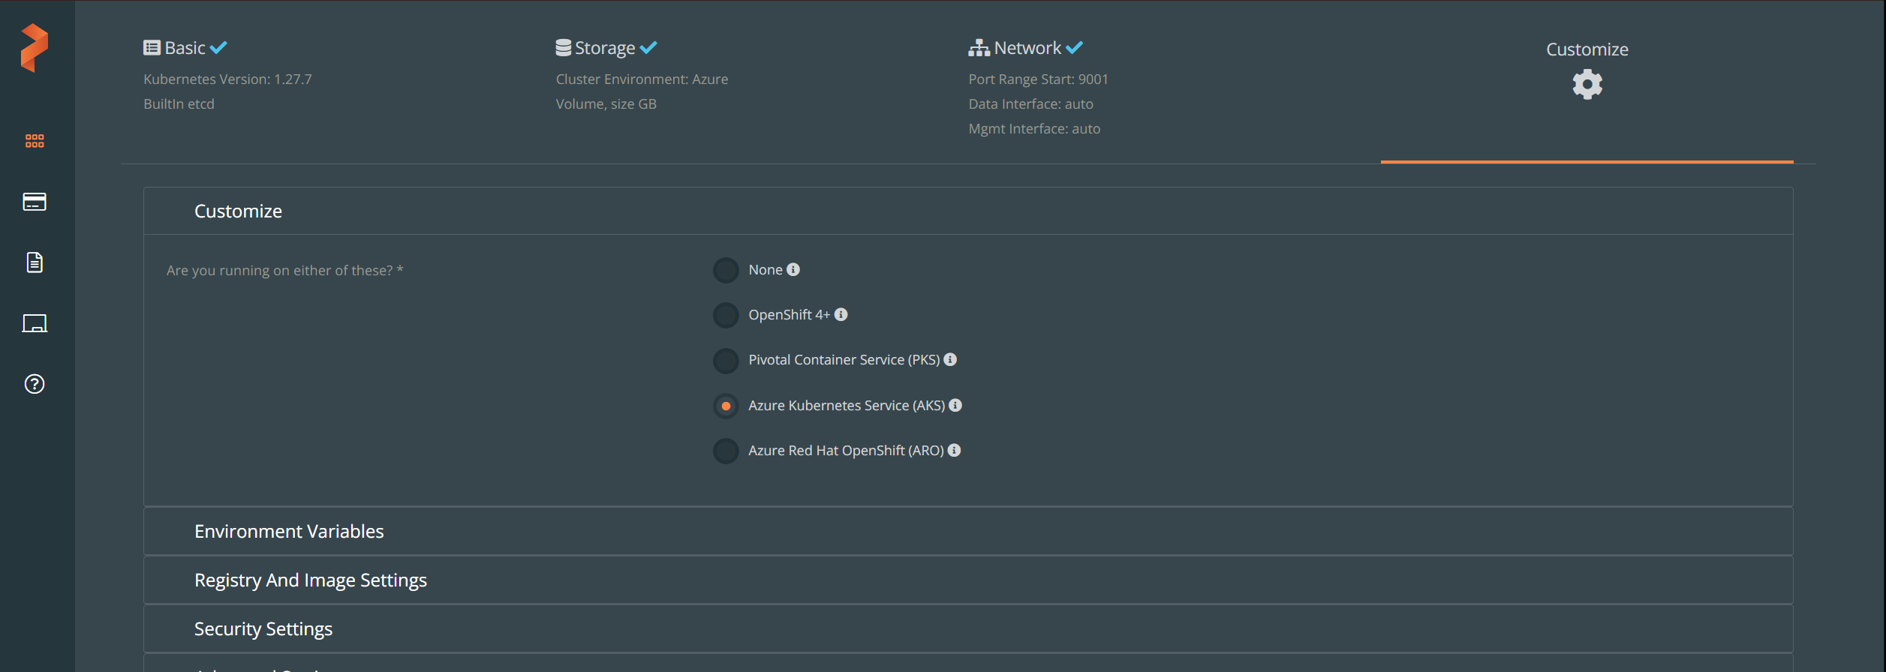

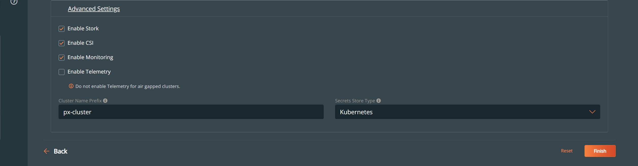

kubectl apply -f 'https://install.portworx.com/3.0?comp=pxoperator&kbver=1.27.7&ns=portworx'

kubectl apply -f 'https://install.portworx.com/3.0?operator=true&mc=false&kbver=1.27.7&ns=portworx&b=true&iop=6&s=%22type%3DPremium_LRS%2Csize%3D150%22&j=auto&c=px-cluster-48d58397-321d-4b72-9b46-f6eb69714b7a&aks=true&stork=true&csi=true&mon=true&tel=false&st=k8s&promop=true'

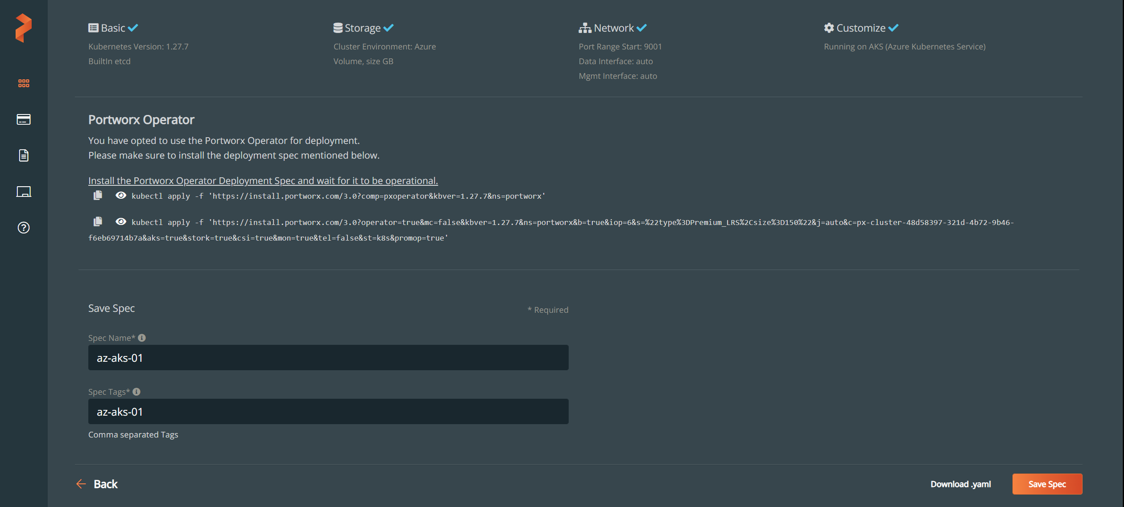

# Troubleshooting

## The maximum node count you have selected is higher than the remaining quota for this subscription. Autoscaling may fail above 1 nodes due to quota restrictions (2 cores remaining).

