TestCoLab

tanzu-supervisor-guest-cluster-storage-decommission-notes-proc-rvw-01

Updated 11/2/2023

Procedure review notes: 3

Overview 3

## 10/27/2023 Decommission dr-apps-01, including all pvc, pv – review, remove corresponding pv, pvc in Supervisor cluster 4

## 10/31/2023 – dr-apps-02 removed at the dr-01 namespace level; all guest, Supervisor cluster pv, pvc, node /etc/containerd mounts removed along with backing datastore files 4

dr-apps-02 – newly deployed cluster – pvc, pv 4

dr-apps-01 –cluster in process of removal – pvc, pv 4

dr-tanzu01 – pvc, pv age 29d lifespan of cluster 5

represent per node: (3) 32Gi containerd mount; (3) 32Gi kvdb disk; (3) 150Gi data disk 5

dr-apps-01 – remove finalizers, delete (2) central/pvc-nfs pv 5

dr-apps-01 – manually remove finalizers from all pvc, delete 6

pv showing released 6

dr-tanzu01 - dr-apps-01 pv NAME match CLAIM in dr-tanzu01 6

dr-tanzu01 – manually remove finalizers from all pvc EXCEPT containerd mounted to worker nodes 6

dr-vctestco-01 manually remove kvdb, data disks – leave os and containerd mounted disks in place 7

dr-apps-01 rededploy PX 8

dr-tanzu01 retains previous pvc 32Gi containerd mounts 8

# Procedure review notes:

## Overview

* These are informal, as-is observations to help illuminate a testing and troubleshooting process.
* The configuration overview is:

dr-tanzu01 TKGS Supervisor cluster running on vSphere v7.0.3

dr-apps-01 TKGS guest cluster

dr-apps-02 TKGS guest cluster

* The issues being considered are:

What is the relationship between pv, pvc on guest clusters and pv, pvc on Supervisor cluster

What are the effective methods to decommission storage at both the guest cluster and Supervisor cluster

e.g., certain guest cluster workload volumes are no longer needed and need to be removed entirely at all levels: guest clusters, Supervisor cluster, backing datastore files

What are the effective methods to retain storage at both the guest cluster and Supervisor cluster.

e.g., guest cluster disks such as worker node volume mounts (/var/lib/containerd, etc.) need to retained between guest cluster major changes. To include: all levels: guest clusters, Supervisor cluster, backing datastore files

# ## 10/27/2023 Decommission dr-apps-01, including all pvc, pv – review, remove corresponding pv, pvc in Supervisor cluster

## ## 10/31/2023 – dr-apps-02 removed at the dr-01 namespace level; all guest, Supervisor cluster pv, pvc, node /etc/containerd mounts removed along with backing datastore files

## dr-apps-02 – newly deployed cluster – pvc, pv

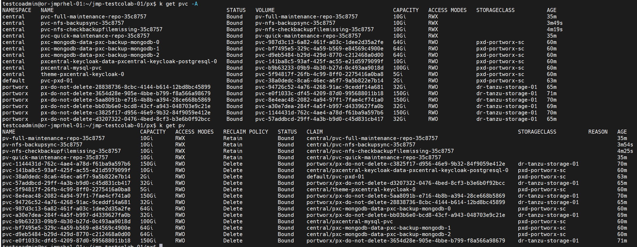

## dr-apps-01 –cluster in process of removal – pvc, pv

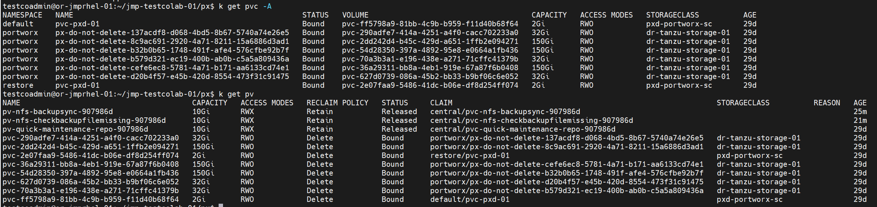

## dr-tanzu01 – pvc, pv age 29d lifespan of cluster

## represent per node: (3) 32Gi containerd mount; (3) 32Gi kvdb disk; (3) 150Gi data disk

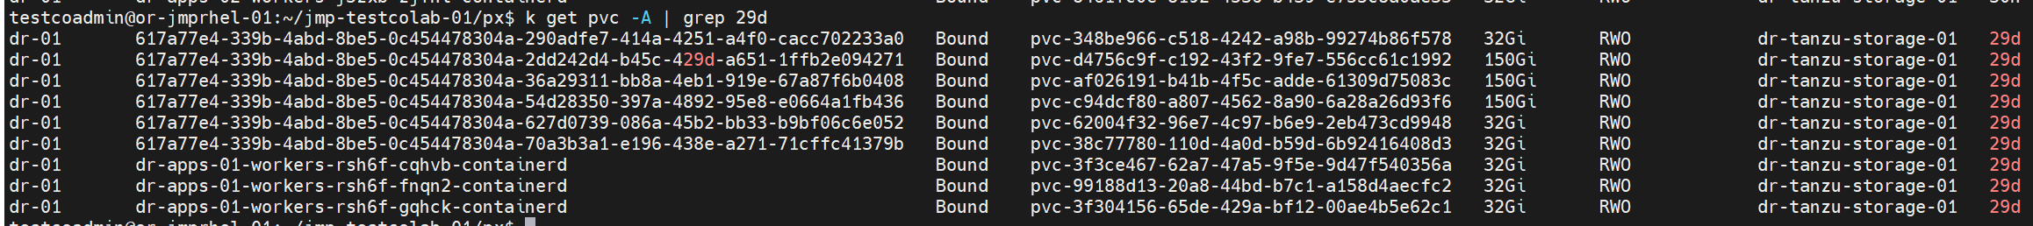

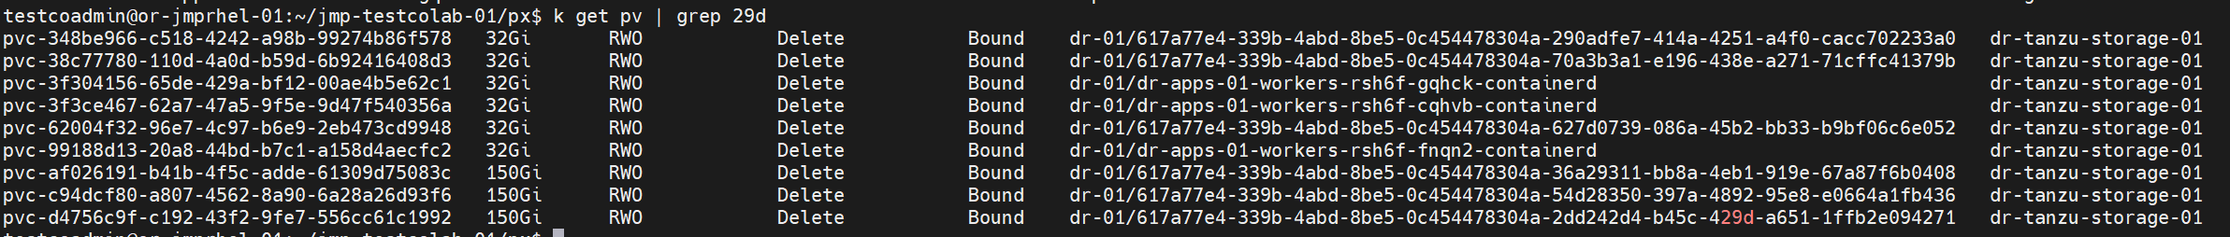

## dr-apps-01 – remove finalizers, delete (2) central/pvc-nfs pv

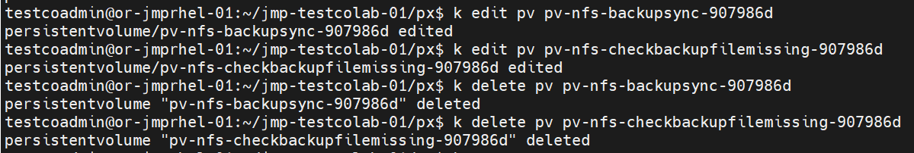

## dr-apps-01 – manually remove finalizers from all pvc, delete

## pv showing released

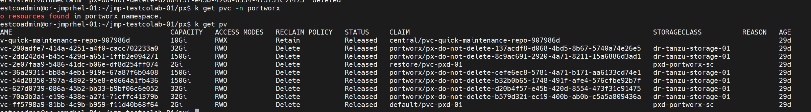

## dr-tanzu01 - dr-apps-01 pv NAME match CLAIM in dr-tanzu01





## dr-tanzu01 – manually remove finalizers from all pvc EXCEPT containerd mounted to worker nodes



## dr-vctestco-01 manually remove kvdb, data disks – leave os and containerd mounted disks in place

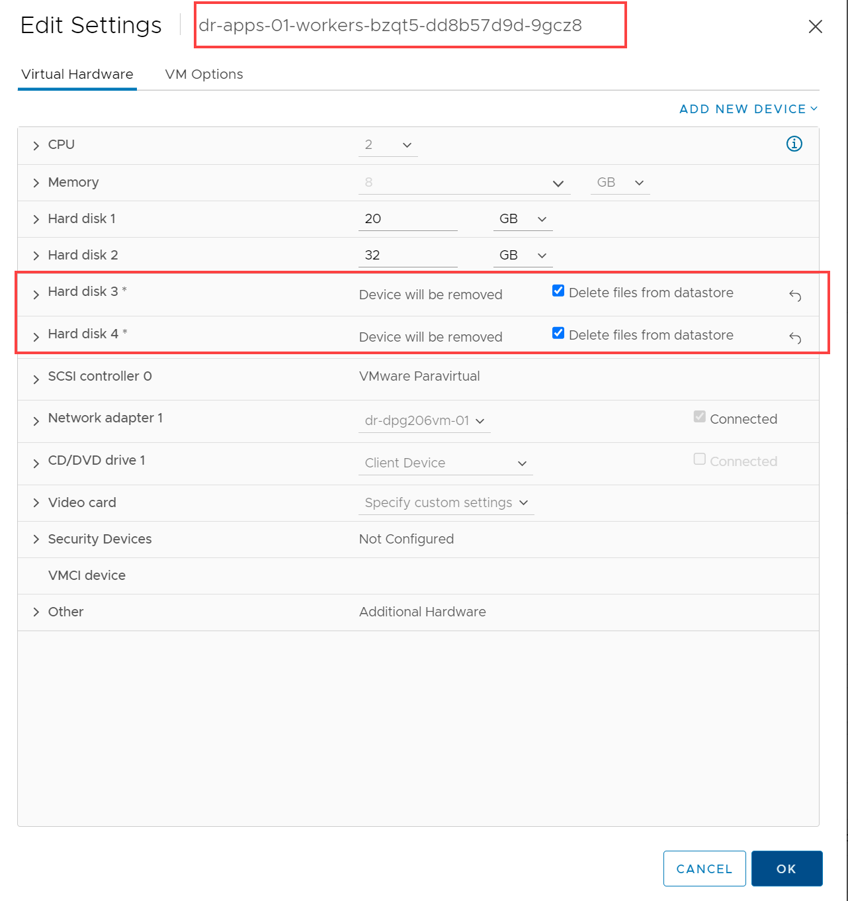

## dr-apps-01 rededploy PX

## dr-tanzu01 retains previous pvc 32Gi containerd mounts

