TestCoLab

tanzu-worker-node-volume-mount-monitoring-notes-proc-rvw-01

Updated 11/2/2023

Procedure review notes: 3

Overview 3

## 10/31/2023 – Tanzu worker node mount requirements - /var/lib/containerd, /var/lib/etcd 4

Separate, additional data volumes on Tanzu worker nodes – expected requirement? 4

Net disk usage by /var/lib/containerd mounts on worker nodes 5

tl;dr provisioned disk consume most configured space despite being thin provisioned 5

PowerCLI /var/lib/containerd usage 7

Worker node with: Portworx, Portworx Central, Portworx Backup installed 7

ssh to worker node - /var/lib/containerd contents 8

Worker node with: Portworx, Portworx Central, Portworx Backup installed 8

PowerCLI /var/lib/containerd usage 9

Vanilla Worker node before installing any non-default workloads 9

ssh to worker node - /var/lib/containerd contents 11

Vanilla Worker node before installing any non-default workloads 11

Worker node after installing PX 12

ssh to worker node - /var/lib/containerd contents 13

Worker node after installing PX 13

# Procedure review notes:

## Overview

* These are informal, as-is observations to help illuminate a testing and troubleshooting process.
* The configuration overview is:

dr-tanzu01 TKGS Supervisor cluster running on vSphere v7.0.3

dr-apps-01 TKGS guest cluster

dr-apps-02 TKGS guest cluster

* The guest worker nodes are using the default Photon OS image with an OS disk size of 20GB
* The issues being considered are:

What are the separate, additional volume mounts needed to supplement the storage available on a default Photon OS TKGS worker node?

What is the disk space used by a thin provisioned worker node volume mount?

In a /var/lib/containerd volume mount, what are the specific disk usages of:

The initial volume

The volume after installing Portworx Enterprise

What are the different tools and methods available to view and monitor the disk space usage of an additional volume mount?

PowerCLI

Worker node command line

# ## 10/31/2023 – Tanzu worker node mount requirements - /var/lib/containerd, /var/lib/etcd

## Separate, additional data volumes on Tanzu worker nodes – expected requirement?

* Deploy Tanzu Kubernetes Clusters with Additional Data Volumes Using Tanzu Mission Control

https://tanzu.vmware.com/content/blog/deploy-tanzu-kubernetes-clusters-data-volumes-tanzu-mission-control#:~:text=Click%20Next%20and%20expand%20the%20default-nodepool.%20Click%20Add,mount%20path%2C%20then%20set%20the%20capacity%20to%2010GB.

* New Proxy Support, Registry Service Trust, and Separate Disks on vSphere with Tanzu

<https://tanzu.vmware.com/content/blog/new-proxy-support-registry-service-trust-separate-disks-vsphere-tanzu>

* Cluster Tuning Guide

https://tanzu.vmware.com/developer/guides/workload-tenancy-cluster-tuning/

## Net disk usage by /var/lib/containerd mounts on worker nodes

## tl;dr provisioned disk consume most configured space despite being thin provisioned

fcd/_0008/138887a0a84f44539ff4335948c3de18.vmdk

fcd/_00d0/a32c2dba69bf4e40ab2078cf7199ecdf.vmdk

fcd/_00b2/61752990e1044b1eb35778ce146be91b.vmdk

fcd/_0078/760aa0f1d6a94b8493126747a65440c4.vmdk

fcd/_00ca/_0068/9c9812c96feb4a7fb9ce0fe42946f526.vmdk

fcd/_00ca/e0763ff30e8b4f9b947f85c616cdd6d0.vmdk

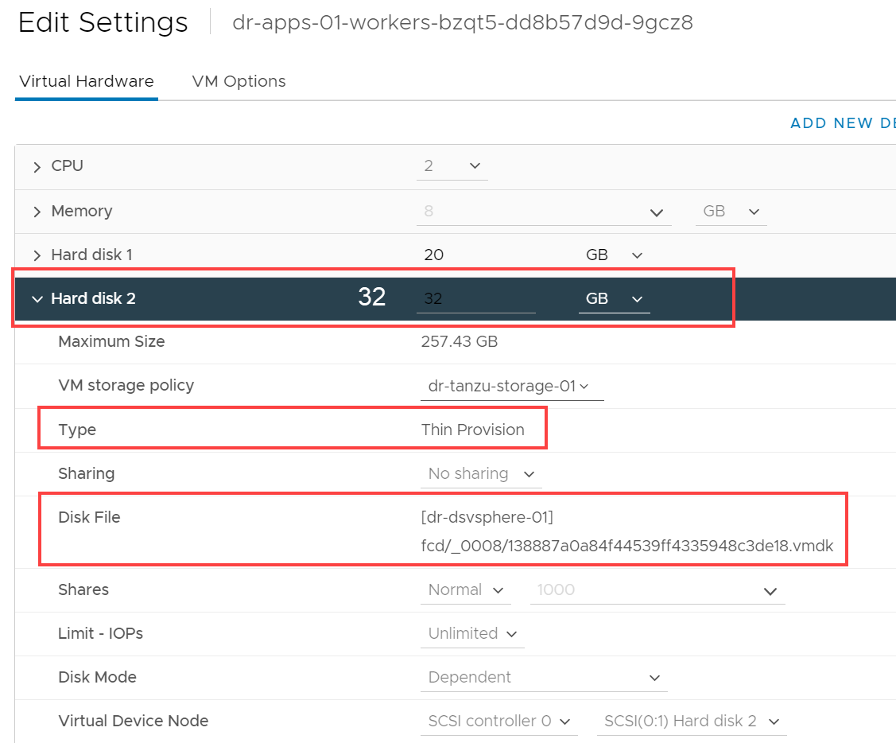

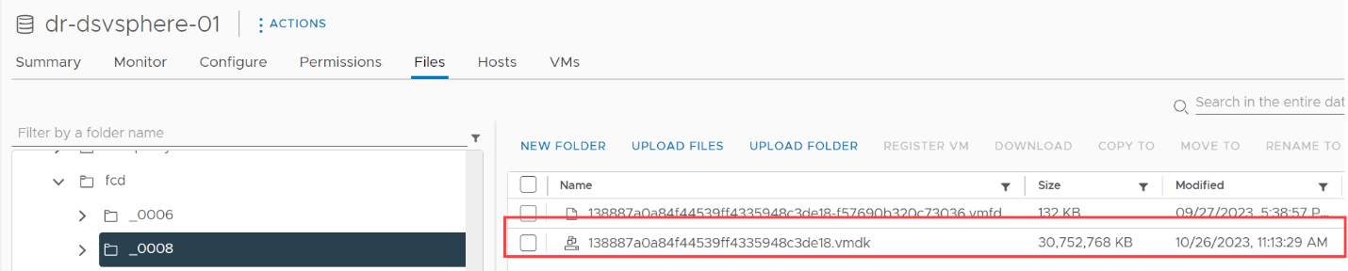

## PowerCLI /var/lib/containerd usage

## Worker node with: Portworx, Portworx Central, Portworx Backup installed

$vmWorkerNode1 = Get-VM -Name dr-apps-01-workers-bzqt5-dd8b57d9d-9gcz8

$vmVarLibContainerd = $vmWorkerNode1.Extensiondata.Guest.Disk | Where-Object {$_.DiskPath -eq '/var/lib/containerd'}

$vmVarLibContainerd

DiskPath : /var/lib/containerd

Capacity : **33634906112**

FreeSpace : **14133317632**

FilesystemType : ext4

Mappings : {2001}

## ssh to worker node - /var/lib/containerd contents

## Worker node with: Portworx, Portworx Central, Portworx Backup installed

* kubectl config use-context dr-tanzu-01 [Supervisor cluster]
* kubectl get secret -n dr-01 dr-apps-01-ssh-password -o yaml
* decode ssh-passwordkey; echo [ssh-passwordkey]| base64 --decode
* ssh vmware-system-user@[worker node ip]
* du -sh /var/lib/containerd



## PowerCLI /var/lib/containerd usage

## Vanilla Worker node before installing any non-default workloads



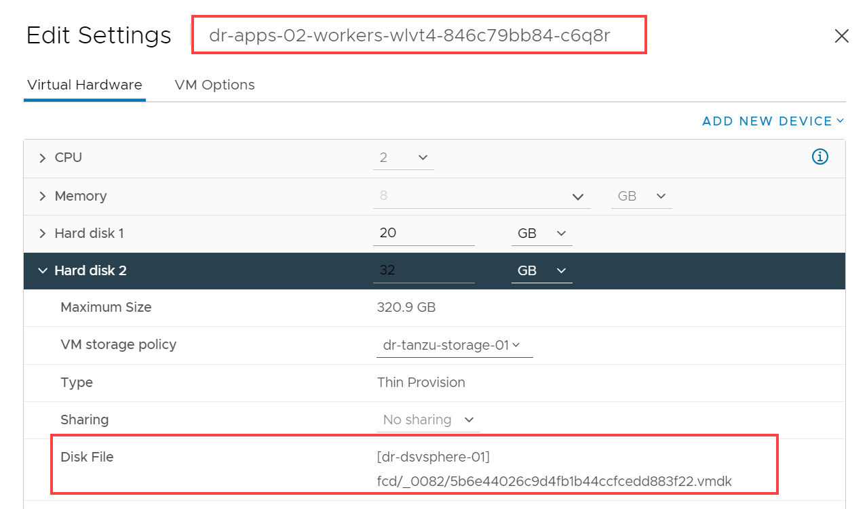

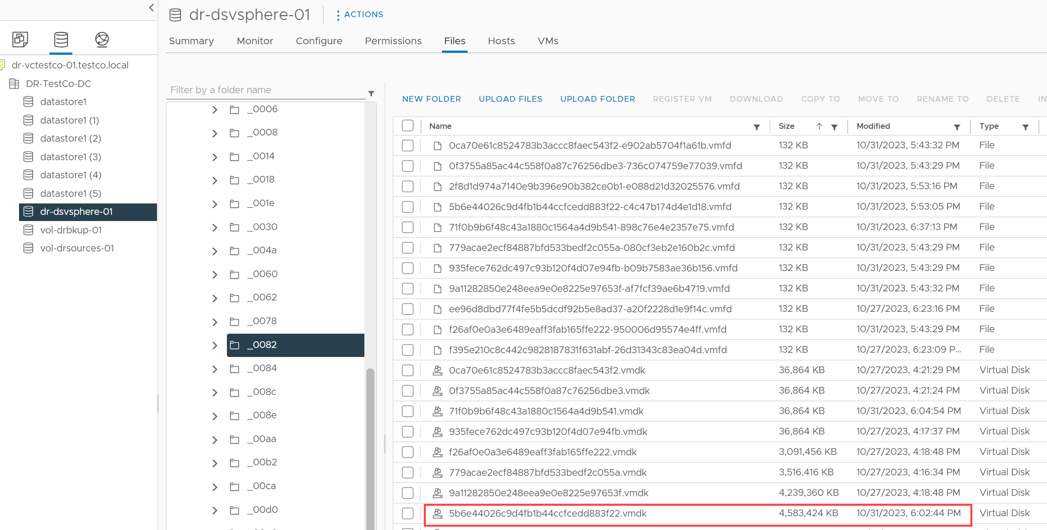

$vmWorkerNode2 = Get-VM -Name dr-apps-02-workers-wlvt4-846c79bb84-c6q8r

$vmVarLibContainerd2 = $vmWorkerNode1.Extensiondata.Guest.Disk | Where-Object {$_.DiskPath -eq '/var/lib/containerd'}

$vmVarLibContainerd2

DiskPath : /var/lib/containerd

Capacity : **33634906112**

FreeSpace : **27421425664**

FilesystemType : ext4

Mappings : {2001}

## ssh to worker node - /var/lib/containerd contents

## Vanilla Worker node before installing any non-default workloads

* kubectl config use-context dr-tanzu-01 [Supervisor cluster]
* kubectl get secret -n dr-01 dr-apps-02-ssh-password -o yaml
* decode ssh-passwordkey; echo [ssh-passwordkey]| base64 --decode
* ssh vmware-system-user@[worker node ip]
* du -sh /var/lib/containerd



## Worker node after installing PX



$vmWorkerNode2 = Get-VM -Name dr-apps-02-workers-wlvt4-846c79bb84-c6q8r

$vmVarLibContainerd2 = $vmWorkerNode1.Extensiondata.Guest.Disk | Where-Object {$_.DiskPath -eq '/var/lib/containerd'}

$vmVarLibContainerd2

DiskPath : /var/lib/containerd

Capacity : **33634906112**

FreeSpace : **17078910976**

FilesystemType : ext4

Mappings : {2001}

## ssh to worker node - /var/lib/containerd contents

## Worker node after installing PX

* kubectl config use-context dr-tanzu-01 [Supervisor cluster]
* kubectl get secret -n dr-01 dr-apps-02-ssh-password -o yaml
* decode ssh-passwordkey; echo [ssh-passwordkey]| base64 --decode
* ssh vmware-system-user@[worker node ip]
* du -sh /var/lib/containerd

ewIDY/qI9KtOuVSjCXlcSaOhDAwbTNaoR6ljn2KgykM=

