1. An error was encountered performing the requested operation:

Listener refused the connection with the following error:

ORA-12518, TNS:listener could not hand off client connection

Vendor code 12518

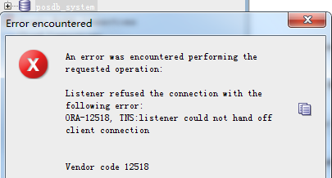

Solution: refer item 2

Try

show parameters dispatchers;

alter system set dispatchers ='(PROTOCOL=TCP)(dispatchers=3)(SERVICE=posdbXDB)'

1. An error was encountered performing the requested operation:

Listener refused the connection with the following error:

ORA-12505, TNS:listener does not currently know of SID given in connect descriptor

Vendor code 12505

Solution: Only need one listener.

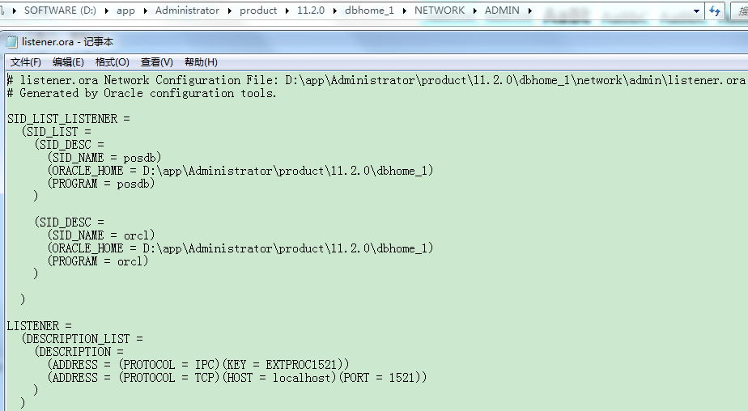

# listener.ora Network Configuration File: D:\app\Administrator\product\11.2.0\dbhome_1\network\admin\listener.ora

# Generated by Oracle configuration tools.

SID_LIST_LISTENER =

(SID_LIST =

(SID_DESC =

(SID_NAME = posdb)

(ORACLE_HOME = D:\app\Administrator\product\11.2.0\dbhome_1)

(PROGRAM = posdb)

)

(SID_DESC =

(SID_NAME = orcl)

(ORACLE_HOME = D:\app\Administrator\product\11.2.0\dbhome_1)

(PROGRAM = orcl)

)

)

LISTENER =

(DESCRIPTION_LIST =

(DESCRIPTION =

(ADDRESS = (PROTOCOL = IPC)(KEY = EXTPROC1521))

(ADDRESS = (PROTOCOL = TCP)(HOST = localhost)(PORT = 1521))

)

)

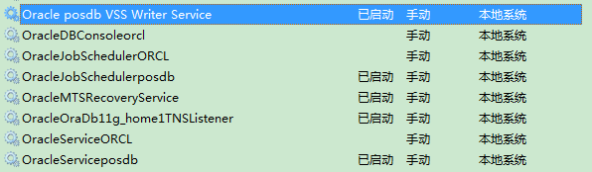

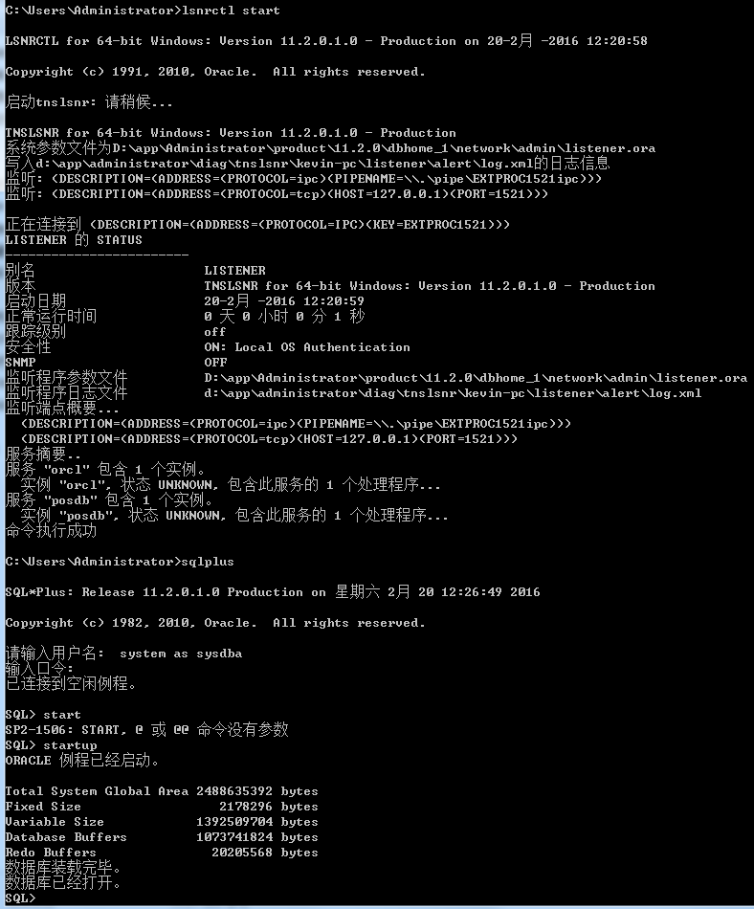

1. 监听程序不支持服务

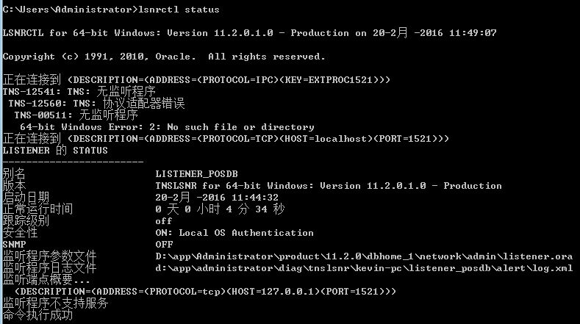

Solution: Refer item 2

4. ORA-12560: TNS: 协议适配器错误

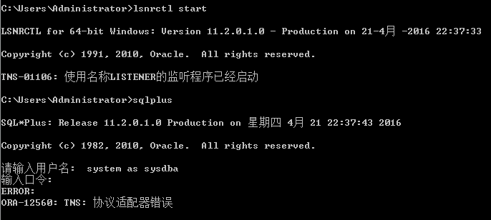

Solution:

Start the db instance service with below command.

net start OracleServiceposdb

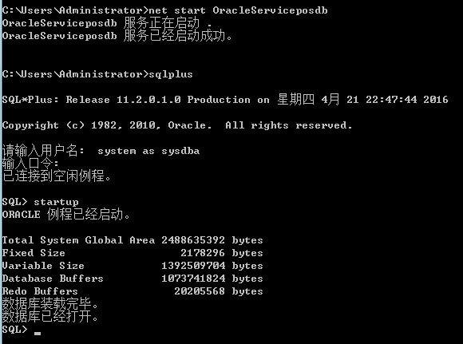

5. 访问 PRODUCT_USER_PROFILE 时出错

警告: 未加载产品用户概要文件信息!

您需要将 PUPBLD.SQL 作为 SYSTEM 运行

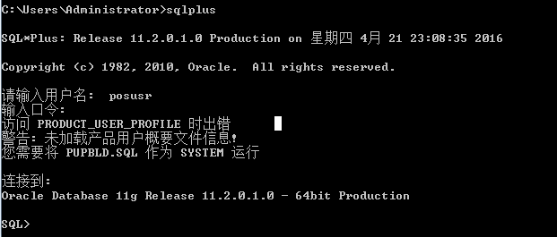

Solution:

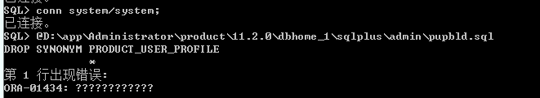



1. For nested table, set the depth

Error: "set describe depth 2" is Obsolete.

Solution:

SQL> SET DESCRIBE DEPTH 2;



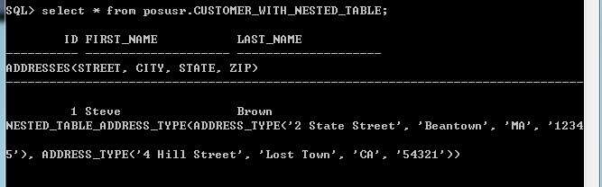

1. EXP-00026: 指定了冲突模式

EXP-00000: 导出终止失败

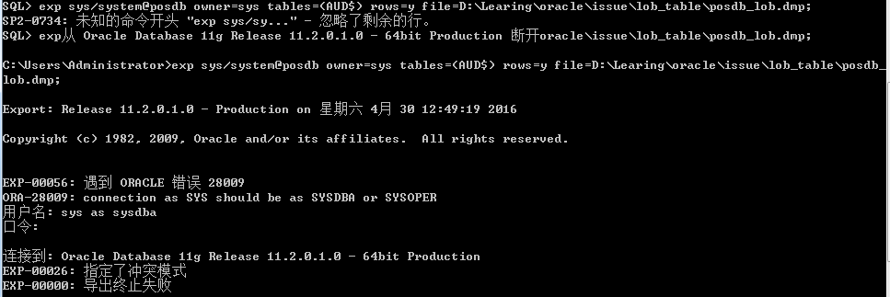

Root: Owner is conflict with table

Remove the owner parameter and special the table schema.

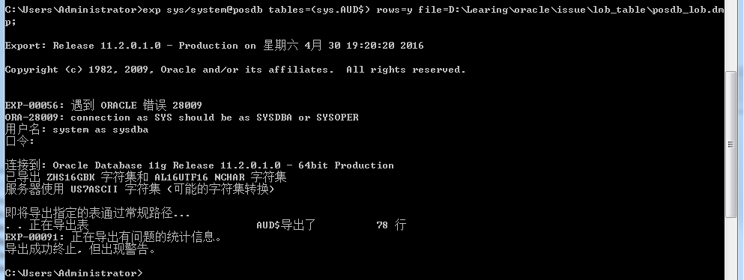

1. ORA-01092: ORACLE instance terminated. Disconnection forced
   1. Startup error.

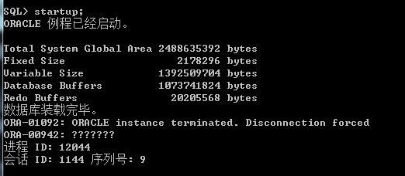

<alert_posdb.log>

|  |
| --- |
| Wed May 11 21:54:34 2016  ALTER DATABASE OPEN  Beginning crash recovery of 1 threads  Started redo scan  Completed redo scan  read 53 KB redo, 25 data blocks need recovery  Started redo application at  Thread 1: logseq 163, block 2, scn 1276987  Recovery of Online Redo Log: Thread 1 Group 1 Seq 163 Reading mem 0  Mem# 0: D:\APP\ADMINISTRATOR\ORADATA\POSDB\REDO01.LOG  Completed redo application of 0.02MB  Completed crash recovery at  Thread 1: logseq 163, block 109, scn 1297124  25 data blocks read, 25 data blocks written, 53 redo k-bytes read  Thread 1 advanced to log sequence 164 (thread open)  Thread 1 opened at log sequence 164  Current log# 2 seq# 164 mem# 0: D:\APP\ADMINISTRATOR\ORADATA\POSDB\REDO02.LOG  Successful open of redo thread 1  SMON: enabling cache recovery  Successfully onlined Undo Tablespace 2.  Verifying file header compatibility for 11g tablespace encryption..  Verifying 11g file header compatibility for tablespace encryption completed  SMON: enabling tx recovery  Database Characterset is US7ASCII  No Resource Manager plan active  replication_dependency_tracking turned off (no async multimaster replication found)  Starting background process QMNC  Wed May 11 21:54:40 2016  QMNC started with pid=20, OS id=2748  Errors in file  d:\app\administrator\diag\rdbms\posdb\posdb\trace\posdb_ora_12044.trc:  ORA-00942: ???????  Errors in file  d:\app\administrator\diag\rdbms\posdb\posdb\trace\posdb_ora_12044.trc:  ORA-00942: ???????  Error 942 happened during db open, shutting down database  USER (ospid: 12044): terminating the instance due to error 942  Instance terminated by USER, pid = 12044  ORA-1092 signalled during: ALTER DATABASE OPEN...  opiodr aborting process unknown ospid (12044) as a result of ORA-1092  Wed May 11 21:54:42 2016  ORA-1092 : opitsk aborting process |

<< posdb_ora_12044.trc>>

|  |
| --- |
| *** 2016-05-11 21:54:39.504  kwqmnich: current time:: 13: 54: 38: 0  kwqmnich: instance no 0 repartition flag 1  *** 2016-05-11 21:54:39.595  kwqmnich: initialized job cache structure  kwqinfy: Call kwqrNondurSubInstTsk  ORA-00942: ???????  ORA-00942: ???????  *** 2016-05-11 21:54:40.495  USER (ospid: 12044): terminating the instance due to error 942 |

ORA-01092: ORACLE instance terminated. Disconnection forced

ORA-00942: table or view does not exist

7. ORA-01034: ORACLE not available

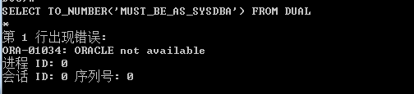

Cd D:\app\Administrator\product\11.2.0\dbhome_1\RDBMS\ADMIN

Sqlplus “/as sysdba”

SQL> startup upgrade;

SQL>@D:\app\Administrator\product\11.2.0\dbhome_1\RDBMS\ADMIN\catupgrd.sql

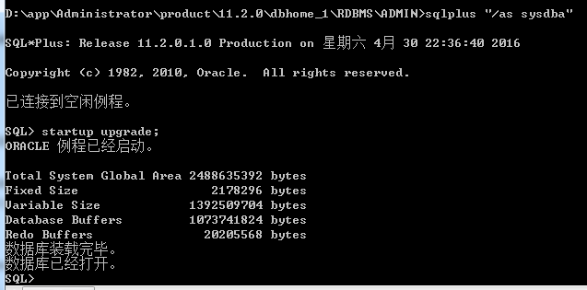

8. ORA-00604: error occurred at recursive SQL level 1

ORA-00942: table or view does not exist

ORA-39710: only connect AS SYSDBA is allowed when OPEN in UPGRADE mode

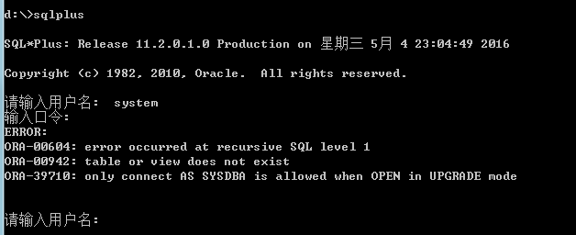

9. ORA-12526: TNS: 监听程序: 所有适用例程都处于受限模式

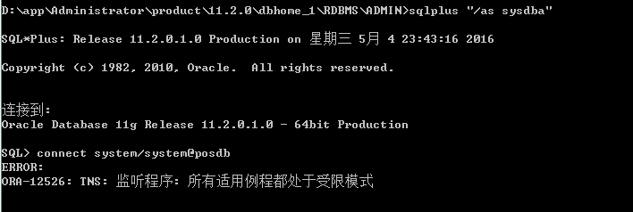

10. ORA-27101: shared memory realm does not exist

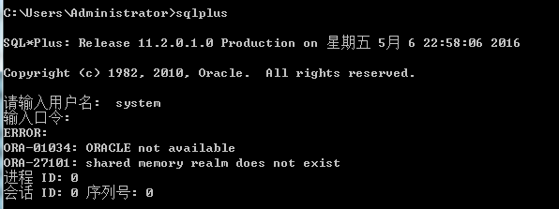

11. ORA-01081: 无法启动已在运行的 ORACLE - 请首先关闭它  
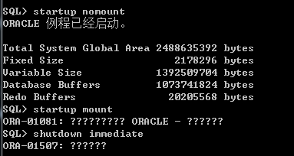



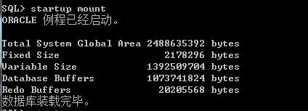

SQL> shutdown abort;

*shutdown immediate – for reference*

SQL> startup mount

12. 06_start_nomount.sql , error

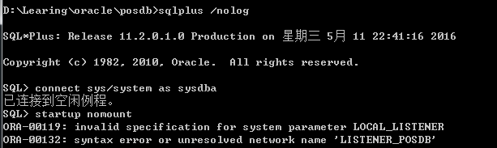

Resolve:

D:\app\Administrator\product\11.2.0\dbhome_1\database\initPOSDB.ora

Comment it

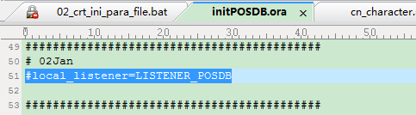

13.

|  |
| --- |
| An error was encountered performing the requested operation:  ORA-01031: insufficient privileges  01031. 00000 - "insufficient privileges"  *Cause: An attempt was made to perform a database operation without  the necessary privileges.  *Action: Ask your database administrator or designated security  administrator to grant you the necessary privileges  Vendor code 1031 |

SQL> show parameter REMOTE_LOGIN_PASSWORDFILE

alter system set REMOTE_LOGIN_PASSWORDFILE=SHARED scope=spfile;

change the role, system without sysdba role privilege.

