https://blog.philipphauer.de/restful-api-design-best-practices/
http://www.vinaysahni.com/best-practices-for-a-pragmatic-restful-api
https://codeplanet.io/principles-good-restful-api-design/

Operation | SQL | HTTP | DDS
Create | INSERT | PUT / POST | write
Read (Retrieve) | SELECT | GET | read / take
Update (Modify) | UPDATE | PUT / POST / PATCH | write
Delete (Destroy) | DELETE | DELETE | dispose

HTTP methods
Uniform Resource Locator (URL) | GET | PUT | POST | DELETE
Collection, such as http://api.example.com/resources/ | List the URIs and perhaps other details of the collection's members. | Replace the entire collection with another collection. | Create a new entry in the collection. The new entry's URI is assigned automatically and is usually returned by the operation.[17] | Delete the entire collection.
Element, such as http://api.example.com/resources/item17 | Retrieve a representation of the addressed member of the collection, expressed in an appropriate Internet media type. | Replace the addressed member of the collection, or if it does not exist, create it. | Not generally used. Treat the addressed member as a collection in its own right and create a new entry within it.[17] | Delete the addressed member of the collection.

- GET /collection: Return a listing (array) of Resource objects
- GET /collection/resource: Return an individual Resource object
- POST /collection: Return the newly created Resource object
- PUT /collection/resource: Return the complete Resource object
- PATCH /collection/resource: Return the complete Resource object
- DELETE /collection/resource: Return an empty document

- GET /zoos: List all Zoos (ID and Name, not too much detail)
- POST /zoos: Create a new Zoo
- GET /zoos/ZID: Retrieve an entire Zoo object
- PUT /zoos/ZID: Update a Zoo (entire object)
- PATCH /zoos/ZID: Update a Zoo (partial object)
- DELETE /zoos/ZID: Delete a Zoo
- GET /zoos/ZID/animals: Retrieve a listing of Animals (ID and Name).
- GET /animals: List all Animals (ID and Name).
- POST /animals: Create a new Animal
- GET /animals/AID: Retrieve an Animal object
- PUT /animals/AID: Update an Animal (entire object)
- PATCH /animals/AID: Update an Animal (partial object)
- GET /animal_types: Retrieve a listing (ID and Name) of all Animal Types
- GET /animal_types/ATID: Retrieve an entire Animal Type object
- GET /employees: Retrieve an entire list of Employees
- GET /employees/EID: Retreive a specific Employee
- GET /zoos/ZID/employees: Retrieve a listing of Employees (ID and Name) who work at this Zoo
- POST /employees: Create a new Employee
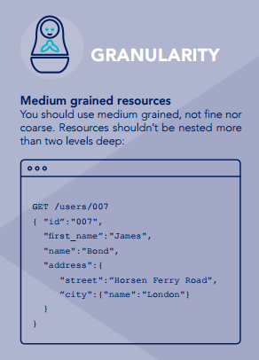
- POST /zoos/ZID/employees: Hire an Employee at a specific ZooDELETE /zoos/ZID/employees/EID: Fire an Employee from a specific Zoo

