**Path Module**

**1. Concept – Path Module kya hai?**

Socho tumhare laptop/PC me ek **bada ghar (File System)** hai. Usme har file ka ek **address (path)** hota hai.

* Kabhi tumhe **file ka naam chahiye**
* Kabhi **sirf extension**
* Kabhi **poora folder path**

Node.js me inhi sab ka solution hain 👉 **path module**.

✅ Ye bhi ek **built-in module** hai (npm se install karne ki zarurat nahi).

**2. Syntax & Common Code**

**Step 1: Import**

const path = require('path');

**Common Functions (Desi Style):**

👉 **path.basename()** → File ka naam nikalta hai

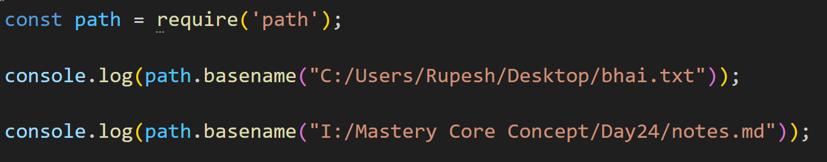

// Output:

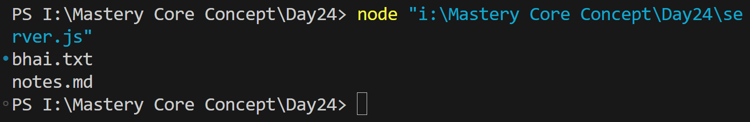

👉 **path.dirname()** → Sirf folder ka address deta hai

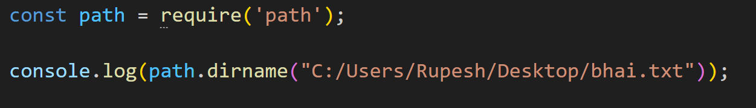

Output:



👉 **path.extname()** → File ka extension nikalta hai

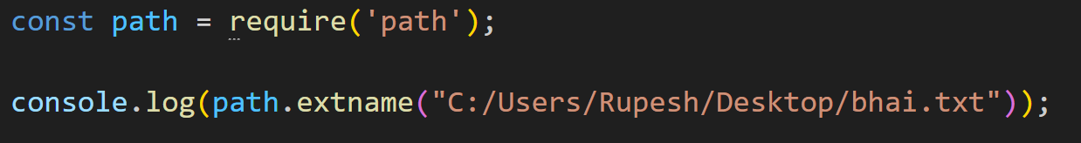

Output:



👉 **path.join()** → Alag-alag path jodkar ek sahi path banata hai

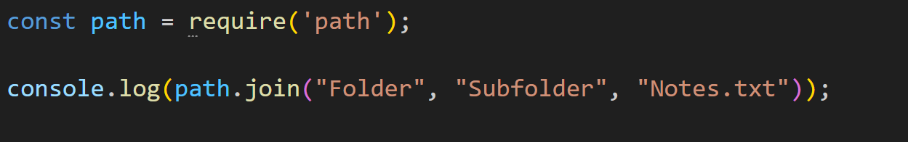

Output:



👉 **path.resolve()** → Absolute (poora) path bana deta hai

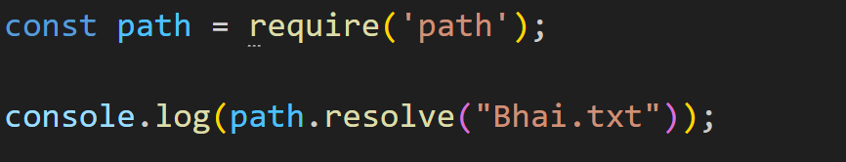Output: 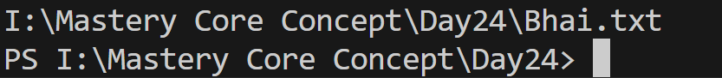👉 **__dirname** → Current folder ka path  
👉 **__filename** → Current file ka poora path

console.log(__dirname); // is file ka folder

console.log(__filename); // is file ka full path

**3. Exercise – Practice Time**

**📝 Exercise 1: File Info Extractor**

Ek script likho jo kisi bhi file ka:

* Name
* Extension
* Folder Path  
  nikal kar terminal me print kare.

**app.js**

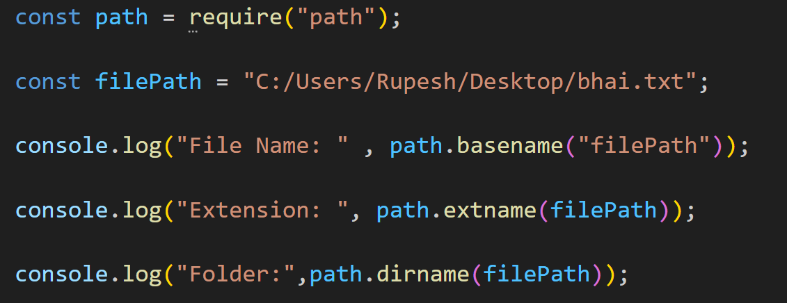

Output :

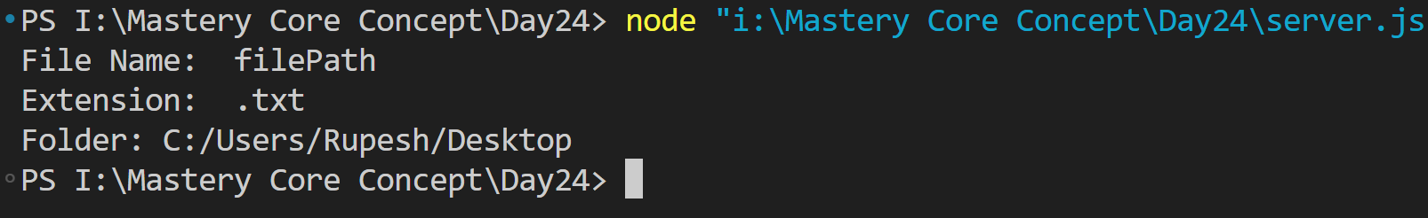

**📝 Exercise 2: Path Builder**

Ek script likho jo 3 string le aur ek proper path banaye.

**builder.js**

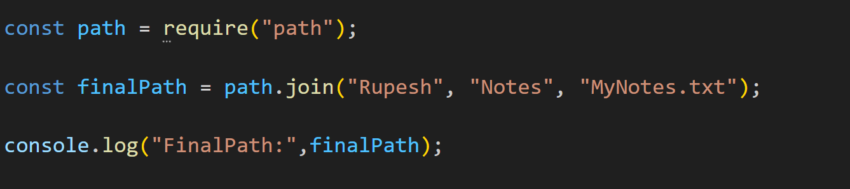👉 Output:



**🎯 Desi Summary**

1. **Concept** → Path module = File ka GPS system 📍
2. **Syntax** → const path = require('path')
3. **Functions** → basename, dirname, extname, join, resolve
4. **Exercise** → File info extractor + Path builder