Bhai 😎 chalo ab samjhte hain **Events Module** ko ekdum **desi style** me, step by step:

**1. Concept – Events Module kya hai?**

Socho tum ek **DJ party** me ho 🕺:

* DJ bole: “Gaana bajao!”
* Sab log nachna shuru kar dete hain.

Yaha par:

* **DJ** = Event Emitter
* **Gaana bajao** = Event trigger
* **Sab log nachna** = Event listener ka kaam

👉 Matlab, **Events module** allow karta hai ki hum “kuch hone par kuch aur kaam karen”.  
Ye Node.js ka **event-driven architecture** hai (isi wajah se Node ekdum fast aur non-blocking hai 🚀).

Node.js me **events module** ke andar ek class hoti hai 👉 EventEmitter.  
Iske through tum:

* Event **emit (trigger)** karte ho
* Event **listen (handle)** karte ho

**2. Syntax & Code – Events Module ka use kaise kare?**

**Step 1: Import**

const EventEmitter = require('events');

**Step 2: Naya event emitter object banao**

const event = new EventEmitter();

**Step 3: Event listener banao (sunne wala)**

event.on("meraEvent", () => {

console.log("Bhai, meraEvent trigger hua! 🎉");

});

**Step 4: Event emit karo (chalu karna)**

event.emit("meraEvent");

👉 Output:

Bhai, meraEvent trigger hua! 🎉

**Dusra Example – Parameters ke sath**

event.on("greet", (name) => {

console.log(`Hello ${name}, kaise ho bhai?`);

});

event.emit("greet", "Rupesh");

👉 Output:

Hello Rupesh, kaise ho bhai?

**3. Exercise – Practice Time**

**📝 Exercise 1: Door Bell Simulation 🚪🔔**

Ek event banao **"doorBell"**, jab emit ho toh console me print ho:

* “Ding Dong! Bhai koi darwaje par hai.”

**Hint:**

const EventEmitter = require('events');

const event = new EventEmitter();

event.on("doorBell", () => {

console.log("Ding Dong! Bhai koi darwaje par hai.");

});

event.emit("doorBell");

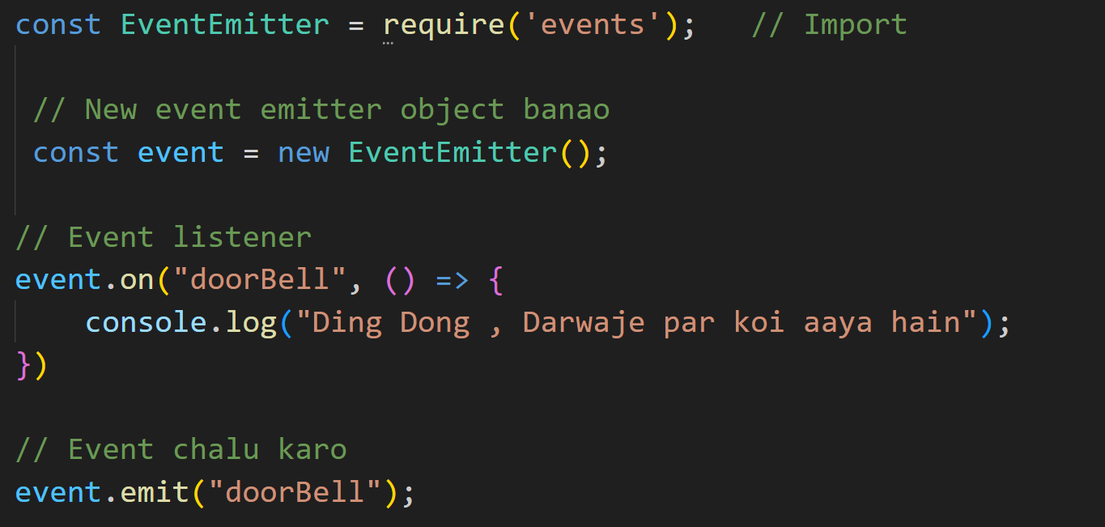

**📝 Exercise 2: Order Status System 🍔**

Ek event banao jisme order ke 3 status ho:

* **orderPlaced** → “Bhai, order place ho gaya!”
* **orderShipped** → “Order abhi ship ho raha hai!”
* **orderDelivered** → “Congratulations! Order deliver ho gaya 🚚”

**Hint:**

const EventEmitter = require('events');

const event = new EventEmitter();

event.on("orderPlaced", () => console.log("Bhai, order place ho gaya!"));

event.on("orderShipped", () => console.log("Order abhi ship ho raha hai!"));

event.on("orderDelivered", () => console.log("Congratulations! Order deliver ho gaya 🚚"));

event.emit("orderPlaced");

event.emit("orderShipped");

event.emit("orderDelivered");

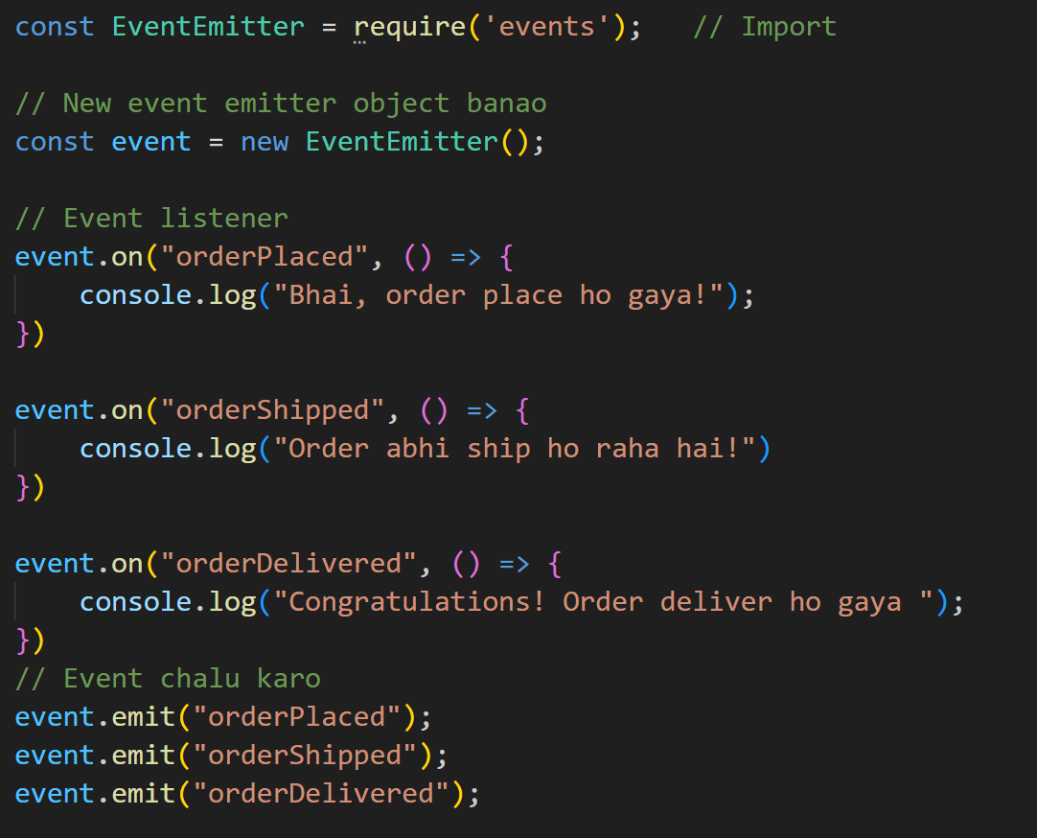

**🎯 Desi Summary**

1. **Concept** → Event system ek DJ party jaisa hai – EventEmitter (DJ) events emit karta hai, aur listeners (public) react karte hain.
2. **Syntax** → require('events'), new EventEmitter(), .on(), .emit()
3. **Exercise** → Door Bell Simulation + Order Status System