Bhai 😎 ab aati hai baat **Process Object** ki, chalo isse ekdum **desi style** me samajhte hain step by step:

**1. Concept – Process Object kya hai?**

Socho tumhare Node.js ka **engine room** hai, jaha se tumhe milti hai:

* Kaunsi file chal rahi hai
* Kitna memory use ho raha hai
* Kaunse arguments ke sath program chalaya gaya
* Environment variables (jaise production ya development mode)

👉 Ye sab dekhne aur control karne ki power deta hai Node.js ka **process object**.  
Aur dhyaan rahe, ye hamesha **globally available** hai → require karne ki bhi zarurat nahi.

**2. Syntax & Code – Process Object kaise use kare?**

**(a) Process info check karna**

console.log("Process ID:", process.pid);

console.log("Node Version:", process.version);

console.log("Platform:", process.platform);

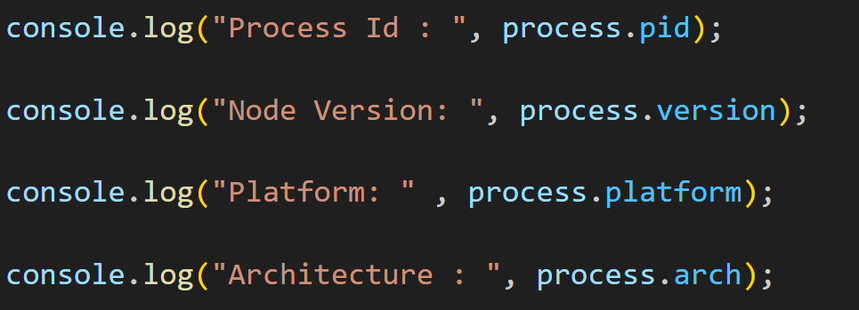console.log("Architecture:", process.arch);

**(b) Command line arguments lena**

Agar tum program ko extra argument ke sath run karo:

node app.js bhai 123

Code:

console.log(process.argv);

👉 Output:

['node_path', 'file_path', 'bhai', '123']

**(c) Current working directory**

console.log("Current Directory:", process.cwd());

**(d) Memory usage**

console.log("Memory Usage:", process.memoryUsage());

**(e) Exit karna manually**

console.log("Bhai, program khatam kar rahe hain!");

process.exit();

**(f) Environment variables**

SET NODE_ENV=production (Windows)

export NODE_ENV=production (Linux/Mac)

Code:

console.log("Environment:", process.env.NODE_ENV);

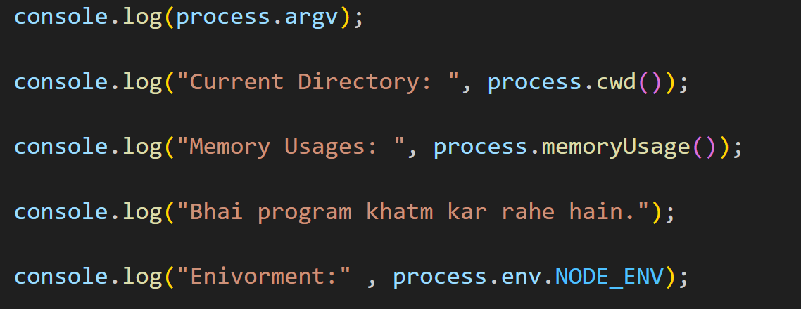

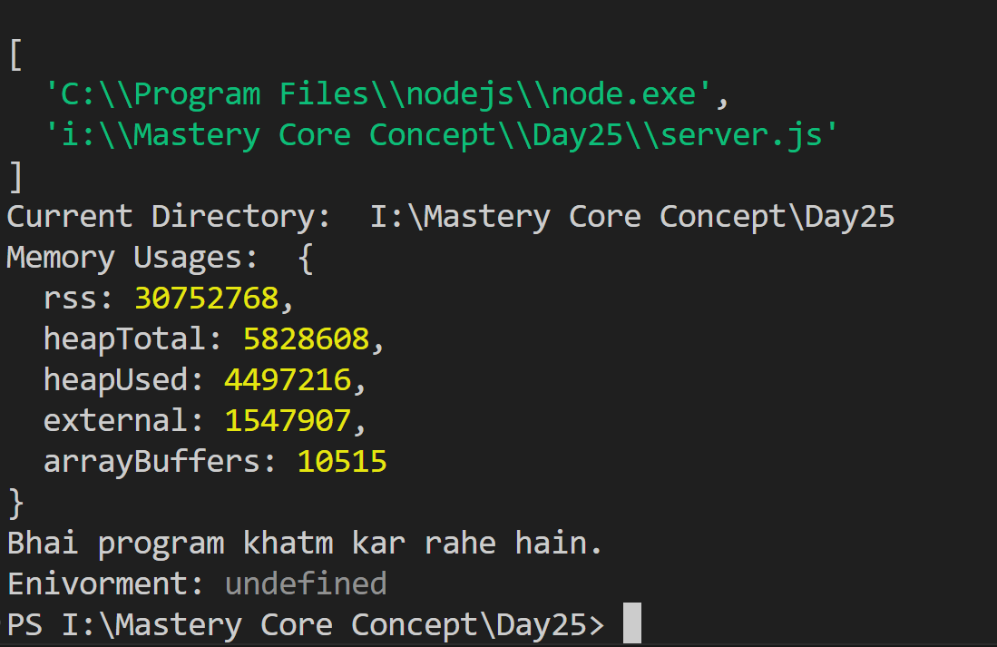

**3. Exercise – Practice Time**

**📝 Exercise 1: Argument Calculator**

Ek program banao jo terminal se do number lega aur unka sum print kare.

Run:

node calc.js 10 20

Code:

const num1 = parseInt(process.argv[2]);

const num2 = parseInt(process.argv[3]);

console.log("Sum =", num1 + num2);

**📝 Exercise 2: System Reporter**

Ek program likho jo:

* Process ID
* Node Version
* Current Directory
* Memory Usage (in MB)

print kare.

Code:

console.log("Process ID:", process.pid);

console.log("Node Version:", process.version);

console.log("Current Directory:", process.cwd());

console.log("Memory Usage:", (process.memoryUsage().heapUsed / 1024 / 1024).toFixed(2), "MB");

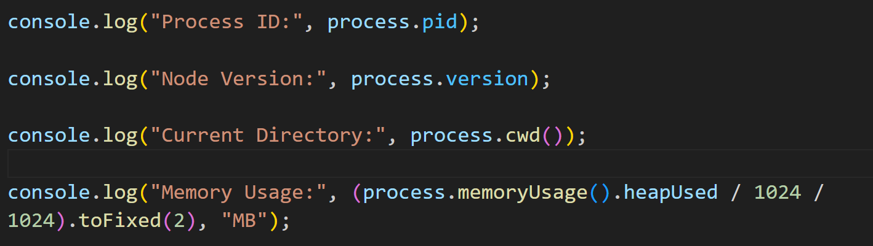

Output:

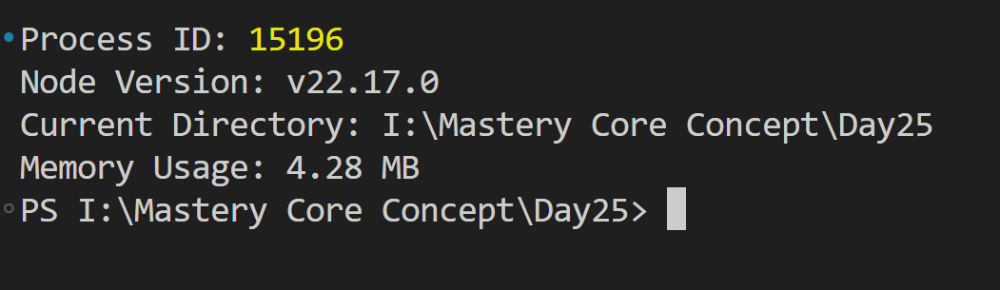

**🎯 Desi Summary**

1. **Concept** → Process object = tumhare Node.js program ka **passport** jisme sab details hai (arguments, env, memory, id).
2. **Syntax** → process.argv, process.cwd(), process.env, process.exit()
3. **Exercises** → Argument Calculator + System Reporter

👉 Bhai, chahte ho kya main tumhe ek **mini project** bana du jisme process object ka use karke ek **custom CLI tool** banayein (jaise apna khud ka terminal command)?