Bhai 😎 ab chalo samajhte hain **Callbacks** ka scene ekdum **desi style** me:

**1. Concept – Callback kya hai?**

👉 Callback = ek **function jo kisi dusre function ko diya jata hai**, taaki wo baad me bulaya (call back) ja sake.

Socho tumne apne dost ko bola:

* “Bhai, main khaana banane laga hu, tu ready hone ke baad mujhe **call kar dena**.”
* Matlab tumne apne dost ko ek **responsibility (function)** de di.
* Jab wo ready hoga, tumhe call kar dega.

⚡ Node.js me jab hum koi **asynchronous task** karte hain (jaise file read, DB call, API call), tab hum ek **callback function** dete hain jo kaam complete hone par execute hota hai.

**2. Code Example**

**Normal Function Call**

function greet(name) {

console.log("Hello " + name);

}

greet("Rupesh");

👉 Yaha turant call ho gaya.

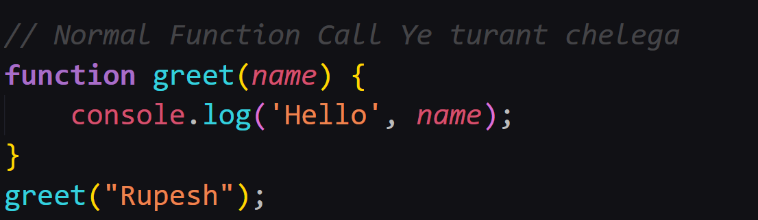

**Callback Example**

function greet(name, callback) {

console.log("Hello " + name);

callback(); // dusra function baad me chalega

}

function afterGreeting() {

console.log("Kaise ho bhai? 😎");

}

greet("Rupesh", afterGreeting);

👉 Output:

Hello Rupesh

Kaise ho bhai? 😎

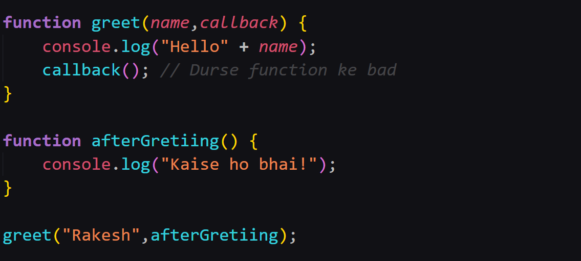

**Asynchronous Callback Example**

console.log("Kaam shuru...");

setTimeout(() => {

console.log("Bhai, 2 second baad kaam complete ho gaya ✅");

}, 2000);

console.log("Main dusra kaam kar raha hu...");

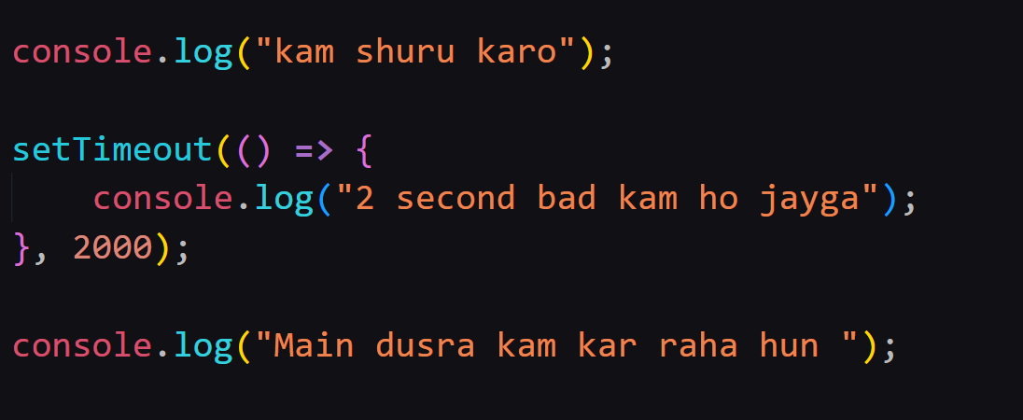

👉 Output:

Kaam shuru...

Main dusra kaam kar raha hu...

Bhai, 2 second baad kaam complete ho gaya ✅

**3. Real World Desi Example**

* **Swiggy/Zomato Order:** Tum order dete ho, aur unhe ek **callback number** dete ho.  
  Jab order ready hota hai toh wo tumhe call karte hain.
* Matlab tumko wait nahi karna, dusra kaam karte raho, order ready hote hi tumhe inform kar diya jayega.

**4. Exercise – Practice Time**

**📝 Exercise 1: File Reading with Callback**

Ek program banao jo file read kare aur callback se bole:

* “File ka data ready hai”

👉 Hint:

const fs = require('fs');

fs.readFile('demo.txt', 'utf8', (err, data) => {

if (err) throw err;

console.log("File ka content:", data);

});

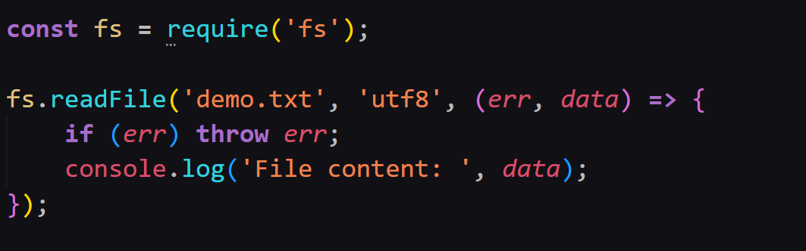

**📝 Exercise 2: Pizza Order Simulation 🍕**

Ek function orderPizza banao jo 2 sec baad bole:

* “Pizza ready ho gaya!”  
  Aur uske baad callback se print ho:
* “Enjoy your Pizza Bhai!”

👉 Hint: setTimeout + callback use karo.

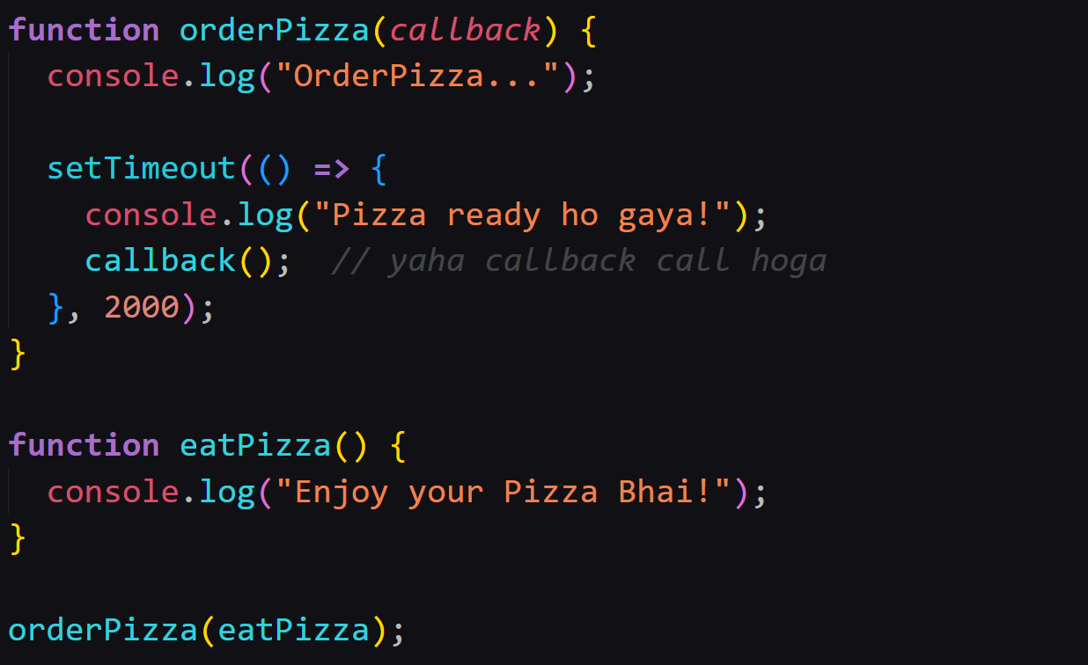

**🎯 Desi Summary**

* **Callback** = ek function jo dusre function ko diya jata hai, aur baad me execute hota hai.
* **Async me kaam** → jab kaam complete hota hai, callback bulaya jata hai.
* **Example** → Swiggy order, File reading, setTimeout.