Bhai 😎 chalo ab **Promises** ko ekdum **desi style** me samajhte hain:

**1. Concept – Promise kya hota hai?**

👉 Promise matlab ek **vachan (waada)**.

* Tumne dost ko bola: *“Bhai, tu party dayega na?”*
* Dost bola: *“Haan, main promise karta hu, daunga.”*

Ab teen situation ho sakti hain:

1. **Pending** → Abhi confirm nahi hai (party dega ya nahi).
2. **Resolved (Fulfilled)** → Party de diye✅
3. **Rejected** → Bhai ne mana kar diya ❌

⚡ Programming me bhi aisa hi hai:

* Kaam chal raha hai → **Pending**
* Kaam ho gaya → **Resolve (Success)**
* Error aaya → **Reject (Fail)**

**2. Code Example – Basic Promise**

let partyPromise = new Promise((resolve, reject) => {

let party = true; // try false and see

if (party) {

resolve("Bhai party pakka hai 🎉");

} else {

reject("Bhai party cancel ho gayi 😢");

}

});

partyPromise

.then((msg) => {

console.log("Success:", msg);

})

.catch((err) => {

console.log("Error:", err);

});

👉 Output (agar party = true):

Success: Bhai party pakka hai 🎉

👉 Output (agar party = false):

Error: Bhai party cancel ho gayi 😢

**3. Async Example with Promise**

function orderPizza() {

return new Promise((resolve, reject) => {

console.log("Pizza order de diya 🍕...");

setTimeout(() => {

resolve("Pizza aa gaya Bhai! Enjoy 😎");

}, 2000);

});

}

orderPizza().then((msg) => console.log(msg));

👉 Output:

Pizza order de diya 🍕...

Pizza aa gaya Bhai! Enjoy 😎

**4. Why Promises?**

* Callback me code **nested** ho jaata tha (callback hell) ⛺
* Promise me .then() chain se code **clean aur readable** ho jata hai.
* Error handling bhi easy: .catch().

**5. Exercise Time 📝**

**Exercise 1:**

Ek function banao jo 2 second baad “Data mil gaya 📦” return kare Promise se.  
Agar error = true hai toh reject kare: “Data nahi mila ❌”.

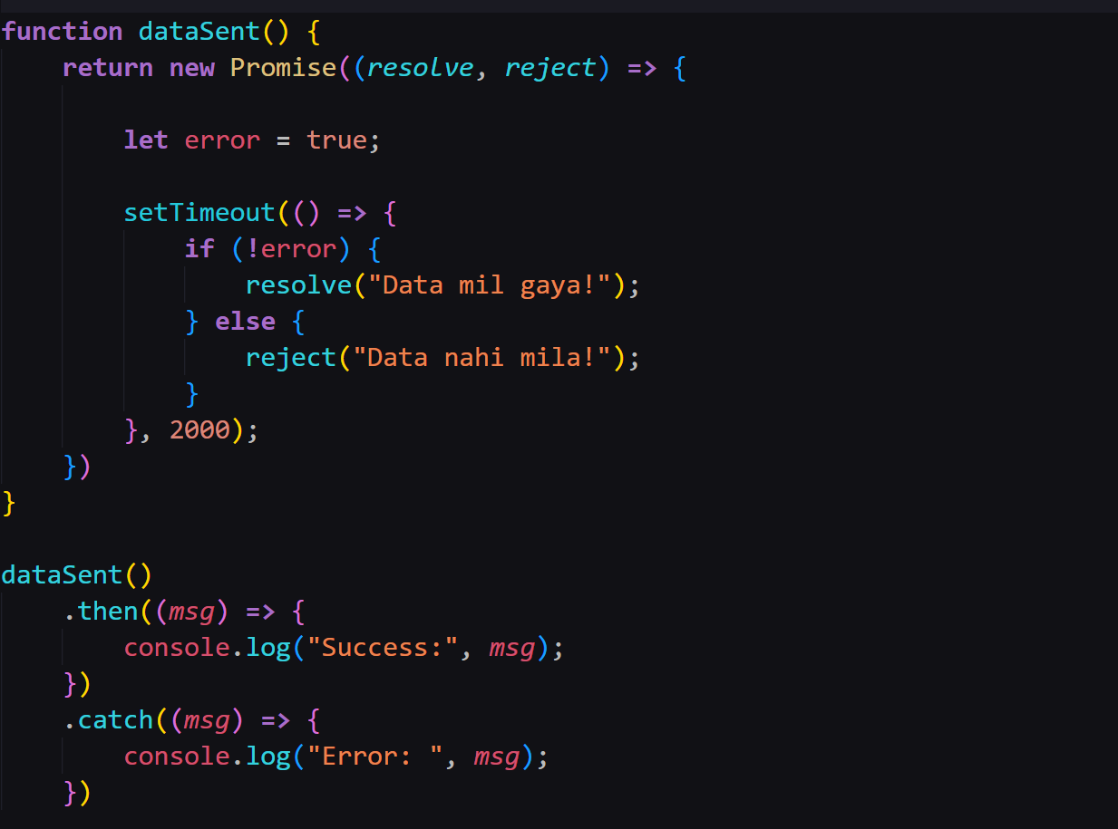

**Exercise 2:**

Ek Promise chain likho:

1. Pehle bole “Step 1 complete”
2. Fir bole “Step 2 complete”
3. Fir bole “Step 3 complete”

**🎯 Desi Summary**

* **Promise** = ek waada (resolve ya reject hoga)
* **3 states**: Pending → Fulfilled → Rejected
* **then** → success ke liye
* **catch** → error ke liye
* Cleaner code than callbacks ✅