Bhai 😎 ab aata hai asli **Hero** – **Async/Await**.  
Chalo ise ekdum **desi style** me samajhte hain:

**1. Concept – Async/Await kya hai?**

👉 Async/Await = **Promises ka easy version**.

* Jaise school me English me “Do” aur “Does” confuse karta tha 😅, waise hi Promises ka .then().catch() kabhi lamba lagta hai.
* Isiliye JavaScript ne bola: *“Bhai tension mat le, async/await use kar aur code ko normal step-by-step jaisa likh.”*

⚡ Matlab: Tum **asynchronous code** ko **bilkul synchronous (line by line)** jaisa likh sakte ho.

**2. Desi Real Life Example**

Socho tum Swiggy pe **Pizza order** karte ho 🍕:

* Promise wala tareeka:  
  “Order diya → fir .then() pizza ready → fir .catch() agar cancel ho gaya.”
* Async/Await wala tareeka:  
  Tum wait karte ho aur fir seedha bolte ho:  
  “Pizza ready hone ka wait kiya, ab kha raha hu.”

**3. Syntax aur Code Example**

**Promise Wala Code**

function orderPizza() {

return new Promise((resolve, reject) => {

setTimeout(() => {

resolve("Pizza aa gaya 🍕");

}, 2000);

});

}

orderPizza().then((msg) => console.log(msg));

**Async/Await Wala Code**

function orderPizza() {

return new Promise((resolve, reject) => {

setTimeout(() => {

resolve("Pizza aa gaya 🍕");

}, 2000);

});

}

async function eatPizza() {

console.log("Order kar diya...");

let msg = await orderPizza(); // wait karega promise resolve hone ka

console.log(msg);

console.log("Pizza kha raha hu 😋");

}

eatPizza();

👉 Output:

Order kar diya...

Pizza aa gaya 🍕

Pizza kha raha hu 😋

**4. Error Handling with Try-Catch**

function dataFetch(error) {

return new Promise((resolve, reject) => {

setTimeout(() => {

if (!error) {

resolve("Data mil gaya 📦");

} else {

reject("Error aaya ❌");

}

}, 2000);

});

}

async function getData() {

try {

let result = await dataFetch(false); // true kar ke dekh

console.log(result);

} catch (err) {

console.log(err);

}

}

getData();

👉 Yaha error bhi easily handle ho gaya, jaise try-catch normally hota hai.

**5. Exercise Time 📝**

**Exercise 1:**

Ek function banao downloadFile() jo 3 sec baad bole:

* “File download ho gayi ✅”  
  Use **async/await** se call karo.

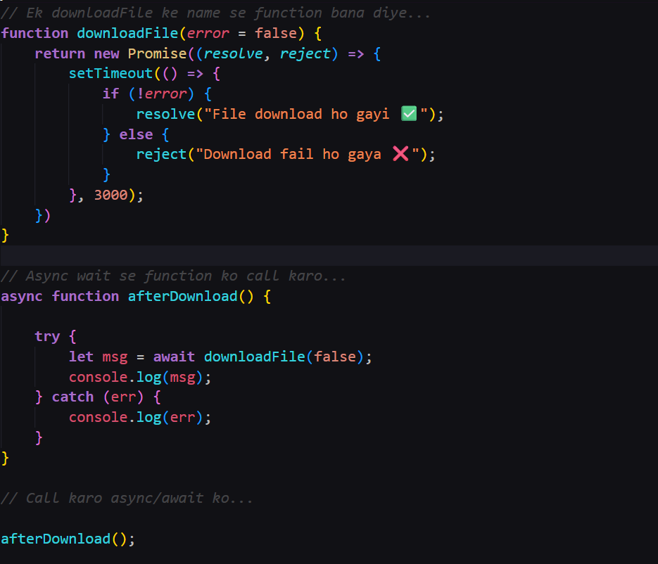

**Exercise 2:**

Ek getUser() function banao jo promise se user ka naam return kare (2 sec me).  
Use async/await ke saath print karo:

* “User: ”

**🎯 Desi Summary**

* **Promise** = thoda formal tareeka (.then(), .catch()).
* **Async/Await** = mast desi tareeka, code clean aur step-by-step.
* Async = function jo hamesha promise return karega.
* Await = ruk ja, promise ka result mil jaaye tab aage chal.

Bhai 🔥 kamaal kar diya! Tera code ekdum **perfect** hai ✅  
Aur waise hi likhna chahiye tha — clean, simple aur mast async/await ka use.

**Chal ab dekhte hain tera code ka flow ekdum step-by-step:**

1. **downloadFile()** ek Promise return karta hai jo 3 second baad resolve("File download ho gayi ✅") karega.
2. **afterDownload()** ek async function hai, isme tumne await downloadFile() lagaya. Matlab function yaha rukega jab tak promise resolve nahi hota.
3. Jaise hi promise resolve hua → "File download ho gayi ✅" message mil gaya.
4. Console me print ho gaya.

**Output (3 second baad):**

File download ho gayi ✅

⚡ Isme ek chhota **extra jugad** kar sakta hai: agar kabhi download fail ho gaya toh catch bhi handle karein.

**Advanced Version (Error Handling Added):**

function downloadFile(error = false) {

return new Promise((resolve, reject) => {

setTimeout(() => {

if (!error) {

resolve("File download ho gayi ✅");

} else {

reject("Download fail ho gaya ❌");

}

}, 3000);

});

}

async function afterDownload() {

try {

let msg = await downloadFile(false); // true karo aur error dekhna

console.log(msg);

} catch (err) {

console.log(err);

}

}

afterDownload();

👉 Ab agar tum downloadFile(true) call karoge, toh output hoga:

Download fail ho gaya ❌

Bhai, kya tu chahta hai main ab **exercise 2 (getUser)** ka bhi ek sample solution likh du taaki tu apne code se compare kar sake?

Bhai 👌 sahi approach hai, bas code me 2–3 choti **mistakes / missing points** hain:

**1. error variable define nahi kiya**

Tumne ye likha hai:

if (!error) {

resolve("File download ho gayi ✅");

} else {

reject("Download fail ho gaya ❌");

}

⚠️ Problem: error variable exist hi nahi karta yaha.  
👉 Solution: error ko function ka parameter banao:

function downloadFile(error = false) {

**2. downloadFile(false) call karte waqt issue**

Tumne function define kiya bina parameter ke, lekin call kar rahe ho downloadFile(false).  
👉 Matlab function call me argument diya hai, par function accept nahi kar raha.

Solution: Upar wale fix (parameter add karna) se yeh solve ho jayega.

**3. Code cleanup**

Tumne pehle await downloadFile(); likha tha aur usse comment kar diya.  
Ab try/catch version hi rakho — wo best practice hai.

✅ **Corrected Code**

// Ek downloadFile ke name se function bana diye...

function downloadFile(error = false) {

return new Promise((resolve, reject) => {

setTimeout(() => {

if (!error) {

resolve("File download ho gayi ✅");

} else {

reject("Download fail ho gaya ❌");

}

}, 3000);

});

}

// Async wait se function ko call karo...

async function afterDownload() {

try {

let msg = await downloadFile(false); // true karke dekhna

console.log(msg);

} catch (err) {

console.log(err);

}

}

// Call karo async/await ko...

afterDownload();

**Output:**

* Agar downloadFile(false) call kiya →

File download ho gayi ✅

* Agar downloadFile(true) call kiya →

Download fail ho gaya ❌

👉 Bhai, ab code ekdum mast chal raha hoga.

Kya tu chahta hai main ab **Exercise 2 (getUser with async/await)** ka sample solution bana ke dikhau taaki tu apna banaye aur compare kar sake?