Bhai 😎 chal ab **Chapter 3: Error Handling** ko ekdum **desi style** me samajhte hain.

**1. Understanding the Concept**

👉 Error handling ka matlab hai:  
Agar code me koi **gadbad (error)** ho jaye, toh pura program na toote, balki us error ko **catch** karke handle kare.

Socho tum scooter chala rahe ho 🛵:

* Agar raste me **gadda (error)** aaya aur tum dhyan nahi doge → accident.
* Agar tumne **handle** kar liya (brake ya dodge) → safe ride.

Node.js me bhi yahi scene hai.

**2. How to Handle Errors (Syntax + Code)**

**(a) Try-Catch Block**

👉 Normal error handle karne ka sabse simple jugad.

try {

let a = 5;

let b = 0;

if (b === 0) {

throw new Error("Arre Bhai, 0 se divide nahi hoga ❌");

}

console.log(a / b);

} catch (err) {

console.log("Error pakda gaya:", err.message);

}

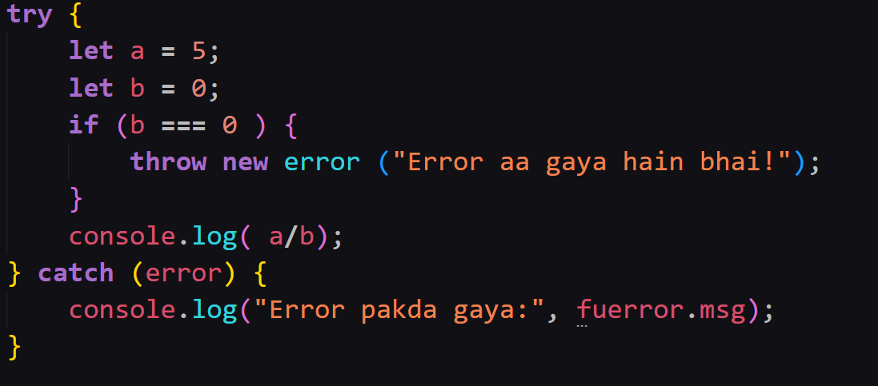

**(b) Asynchronous Error Handling**

**With Promises:**

function getData() {

return new Promise((resolve, reject) => {

let error = true;

if (error) {

reject("Data fetch fail ho gaya ❌");

} else {

resolve("Data mil gaya 📦");

}

});

}

getData()

.then((res) => console.log(res))

.catch((err) => console.log("Error:", err));

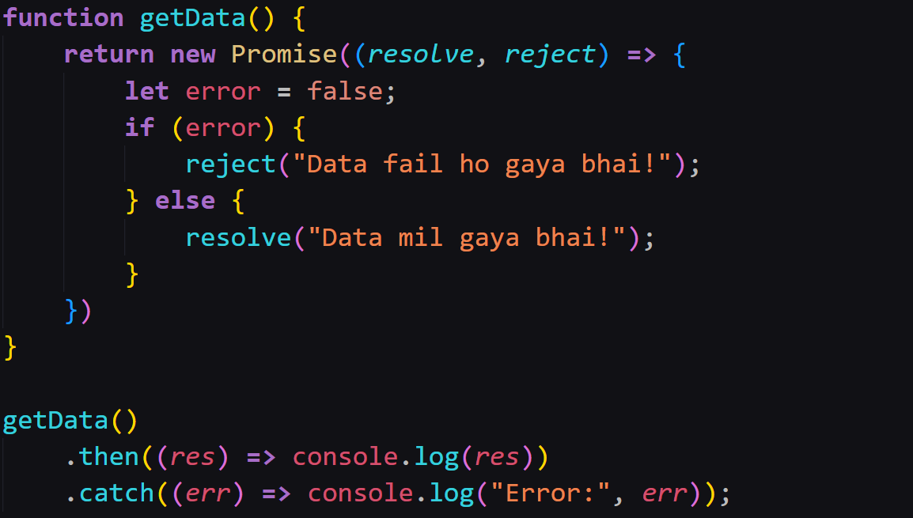

**With Async/Await (Try-Catch)**

async function fetchData() {

try {

let result = await getData();

console.log(result);

} catch (err) {

console.log("Error mila:", err);

}

}

fetchData();

**3. Best Practices (Desi Gyaan 💡)**

1. **Always use try-catch** jab async/await use karo.
2. **Custom error messages** do → taaki samajh aaye problem kya hai.
3. **Centralized error handling** karo bade apps me (Express ke middleware se).
4. **Never ignore errors** → warna production me users royenge 😅.

**4. Exercise Time 📝**

**Exercise 1:**

Ek function banao jo do number divide kare. Agar denominator 0 ho toh error throw kare aur try-catch se handle karo.

**Exercise 2:**

Ek promise banao jo kabhi resolve kare aur kabhi reject kare (random).  
Use async/await + try-catch se call karo aur dono case handle karo.

**🎯 Desi Summary**

* Error handling = gadda bachana 🛵
* **try-catch** → sync aur async/await errors handle karne ke liye
* **.catch()** → Promises ke errors ke liye
* Error ko ignore mat karo, warna code tootega 🚨

👉 Bhai, chahte ho main ab tujhe **Express.js me Error Handling ka real-world example** bhi samjhau (jaise API call fail hone par)?