Bhai 😎 chal ab Chapter 4 **“Create a Basic Server (HTTP)”** ko ekdum **desi style** me samajhte hain.

**1. Concept – HTTP Server kya hota hai?**

👉 Socho tumhare ghar ke gate pe ek **chowkidar (server)** khada hai.

* Har koi guest (client) aata hai aur **request** karta hai.
* Chowkidar (server) use entry deta hai aur **response** deta hai.

⚡ Isi tarah, **HTTP server** ka kaam hai client se request lena (browser → server) aur response dena (HTML, JSON, text, etc.).

**2. Kaise banta hai Server Node.js me?**

Node.js me ek built-in module hai → **http**  
Bas tumhe require("http") karna hai aur server bana sakte ho.

**3. Code Example – Basic HTTP Server**

const http = require('http');

// server create karo

const server = http.createServer((req, res) => {

res.writeHead(200, { 'Content-Type': 'text/plain' });

res.end("Hello Bhai! Ye mera pehla server hai 🚀");

});

// server ko port par sunao

server.listen(3000, () => {

console.log("Server chal raha hai http://localhost:3000 par 😎");

});

**4. Code Samajh Lo**

* http.createServer() → ek server banata hai
* (req, res) → request aur response object
* res.writeHead(200, { 'Content-Type': 'text/plain' }) → response ka status aur type set karte hain
* res.end("Hello Bhai!") → client ko jawab bhejte hain
* server.listen(3000) → server 3000 port par sun raha hai

**5. Output**

1. Terminal me run karo:
2. node server.js
3. Browser me jao:
4. http://localhost:3000
5. Dekhoge:
6. Hello Bhai! Ye mera pehla server hai 🚀

**6. Exercise Time 📝**

**Exercise 1:**

Ek server banao jo browser me “Welcome to It Modem 🚀” return kare.

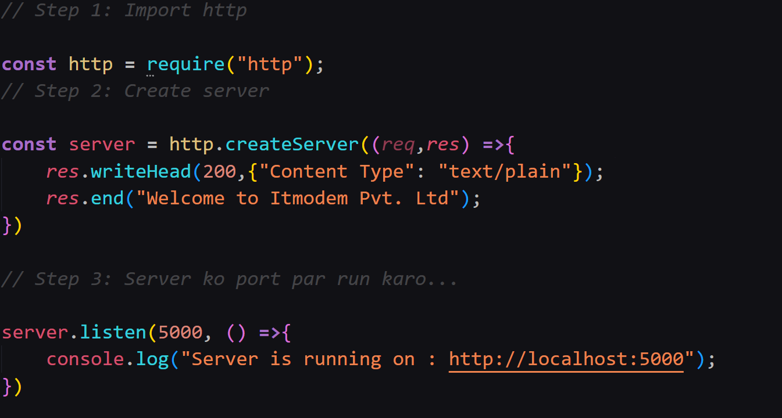

**Exercise 2:**

Ek server banao jo http://localhost:4000 par chale aur response me “Today’s date is: ” bheje.

👉 Bhai, bol kya main tumhe **real-world example** bana du jisme server different routes (/home, /about, /contact) handle kare?