Bhai wah 👌 yehi mindset chahiye mastery ke liye!  
Chalo Responsive Design ko **desi style** aur **developer style** dono mein samajhte hain, fir main tujhe ek solid **exercise set** bhi dunga.

**🎯 Responsive Design – Desi Style**

Soch, tumhara dost ek chai ki dukaan chalata hai.

* Agar **mobile par** banda chai order kare → tumhare dost ka menu chhota aur seedha ho (sirf chai aur biscuit).
* Agar **tablet par** banda dekhe → menu thoda stylish ho jaye (chai, biscuit, samosa, cold drink).
* Agar **desktop par** dekh raha ho → full fancy menu dikhe (chai, biscuit, samosa, cold drink, Maggi, Pizza).

👉 Matlab device ke size ke hisaab se UI apna **roop badalta hai**.  
Isi ko kehte hain Responsive Design.

**💻 Responsive Design – Developer Style**

Tailwind mein **mobile-first approach** hai. Matlab jo bhi class tum bina prefix ke lagate ho, wo **sabhi devices** par apply hoti hai.  
Agar tum specific screen size ke liye alag style chahte ho, to **breakpoint prefixes** use karte ho:

| **Prefix** | **Min-width** | **Example** |
| --- | --- | --- |
| sm: | 640px | sm:text-lg |
| md: | 768px | md:text-xl |
| lg: | 1024px | lg:text-2xl |
| xl: | 1280px | xl:text-3xl |
| 2xl: | 1536px | 2xl:text-4xl |

👉 Example:

<p className="text-sm sm:text-base md:text-lg lg:text-xl xl:text-2xl">

Responsive Text Example

</p>

🔍 Iska matlab:

* Mobile → chhota text (text-sm)
* Tablet → bada (text-lg)
* Desktop → aur bada (text-xl, text-2xl)

**📝 Exercise Set – Responsive Design (Chapter 3 Practice)**

**🔹 Level 1 (Warm-up)**

1. Ek <h1> banao jo **mobile par chhota** aur **desktop par bada** dikhe.

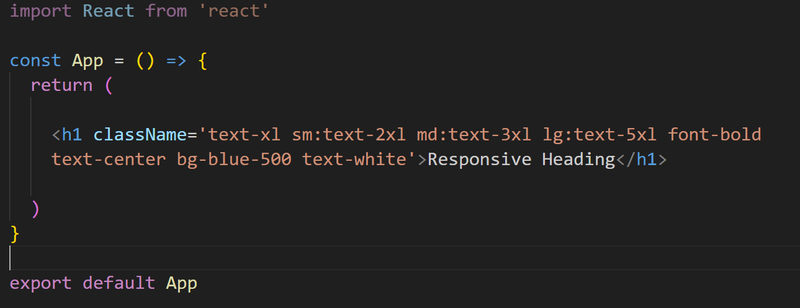

1. Ek <div> banao jisme **mobile par background blue** aur **desktop par background green** ho.

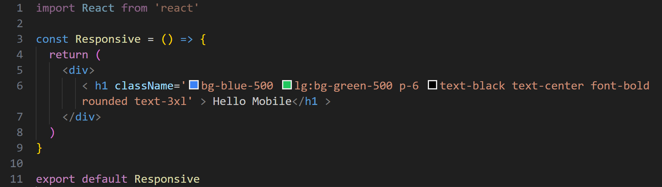

**🔹 Level 2 (Hands-on)**

1. Ek **2-column grid layout** banao:
   * Mobile: 1 column
   * Tablet: 2 columns
   * Desktop: 3 columns

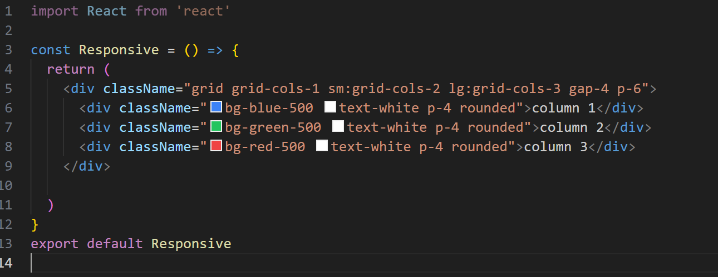

**🔹 Level 3 (Mini Project)**

1. **Responsive Navbar** banao:
   * Mobile: sirf logo aur ek hamburger icon
   * Desktop: logo + 3 nav links side by side
2. **Card Layout Project**:
   * Mobile: 1 card per row
   * Tablet: 2 cards per row
   * Desktop: 3 cards per row
   * Add hover effect (hover:shadow-lg)

👉 Bhai, agar tu chaahe to main in exercises ke **live React + Tailwind code snippets** bhi likh ke dikhata hoon jisse copy-paste karke practice kar sake.

Kya bolta hai, kya tujhe **React + Tailwind practice snippets** chahiye exercises ke liye?

Samajh gya bhai 😄 Chalo isko ekdum **desi style** mein breakdown karte hain 👇

**Code:**

<p className="text-sm sm:text-base md:text-lg lg:text-xl xl:text-2xl">

Responsive Text Example

</p>

**🥤 Desi Explanation**

Soch lo tum ek **chai ki tapri** par ho aur ek hi **poster** lagana hai “Chai Garam Hai”.  
Ab poster ka size har jagah alag hona chahiye:

* **text-sm** → Mobile par poster **chhota** ho (jaise matchbox size).
* **sm:text-base** → Thoda bada mobile ya chhoti tablet par poster thoda **normal size** ho.
* **md:text-lg** → Medium tablet par poster **aur bada** dikhe.
* **lg:text-xl** → Laptop par poster **aur zyada bada** ho jaye.
* **xl:text-2xl** → Bada desktop screen par poster **sabse bada** ho.

👉 Matlab: Tumhara “Responsive Text Example” apne aap **screen ke size ke hisaab se adjust hota rahega**.

**🎯 Developer’s Mindset**

* **Mobile-first rule**: pehle text-sm sab par lagega.
* Phir jaise screen badi hoti jaayegi, Tailwind **agli wali class** apply karta rahega.
* Final result:
  + Mobile → text-sm
  + ≥ 640px → text-base
  + ≥ 768px → text-lg
  + ≥ 1024px → text-xl
  + ≥ 1280px → text-2xl

**💡 Shortcut Samajh**

Bhai isko aise samajh →  
text-size apni khud ki "adjustable chai ki glass" hai, jo mobile pe chhoti cutting chai, aur desktop pe badi lassi glass ban jaati hai 🥛😆

Kya tu chaahega main iska **live output screenshot-style demo** bana ke dikhau, jisme text ka size screen ke saath badalta hai?