CHAPTER NINE
CONSTRUCTION
Areas of some geometrical figures:
Rectangles:
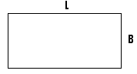
L = the length.
B = the breadth or width.
The area = L .
Triangle:
- This is a three sided figure.
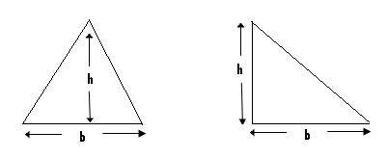
The area = b h = where b = the base and h = the height.
Parallelogram:
- This is a four shaded figure, in which both pairs of its opposite sides are parallel.
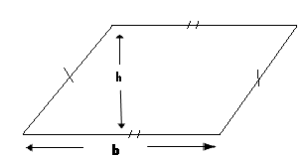
The area of a parallelogram = b h, where b = the base and h = the height.
The trapezium:
- This is a four sided figure, which has its pair of opposite sides being parallel.
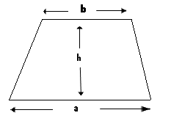
Area = 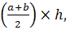 where h = the height and a and b are the parallel sides.
Angles:
- An angle is formed when two straight line meet at a point.
Example:
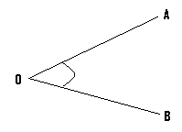
- In the above given figure, the lines OA and OB meet at the point O.
- The angle formed is angle AOB or angle BOA.
- Angle AOB can be written as <AOB or AOB, while angle BOA can be written as <BOA or BOA.

BISECTION OF ANGLES:
- To bisect a given angle means to divide it into two equal parts.
Examples(I):
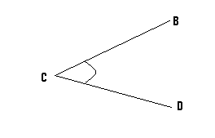
In the given figure, bisect <BCD.
Steps:
(I)
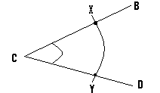
- Open your compass to a suitable length, and with its pin positioned at C, draw an arc to cut line CB at point X and line CD at point Y.
(II)
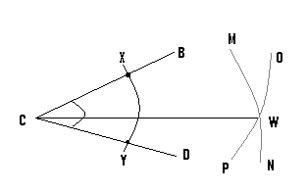
- Open your compass to a greater length and with its pin now positioned at point X, draw arc OP.
- With the same length and the pin now positioned at the point Y, draw arc MN and let the meeting point or the point of intersection of these two arcs be W.
- Finally draw a line to pass through the points C and W.
- By so doing, we have bisected <BCD.
The bisector:
- This may also be referred to as the perpendicular bisector.
- The bisector can be drawn to pass through a line, and by so doing, it will divide the line into two equal parts or lengths.
- On the other hand, a bisector can be drawn to pass through a given point.

Construction of the bisector of a line:
Example:
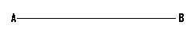
Line AB is of length 6cm. Construct the bisector of this line.

Steps:
(a)
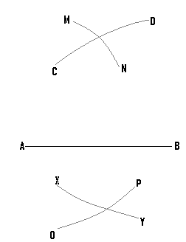
- Open your compass to a suitable length, and with its pin positioned at point B, draw arcs CD and XY.
- Using the same length and the pin now positioned at point A, draw arcs MN, and OP.
- Finally draw a line to pass through the meeting points, or the points of intersection of the various arcs.
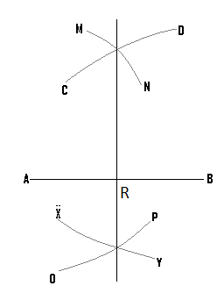
N/B: AR = RB.
Bisector which passes through a given point:
Example:
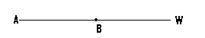
Construct the perpendicular bisector which passes through the point B.
Steps:

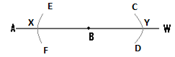
- Open your compass to a suitable length, and with the pin positioned at point B, draw arcs CD and EF.

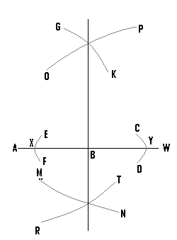
- Open the compass to a greater length, and with the pin positioned at point Y, draw arcs OP and MN.
- Using the same length and with the pin now positioned at point X, draw arcs GK and RT.
- Finally a line drawn to pass through the points of intersection of the various arcs, which is the bisector, will pass through the point B.
Locus of points equidistant from two points:
- Equidistance means equal distance.
- To construct the locus of points which are equidistant from two points, is to determine the various points which are of equal distance away, from these two points.
Examples:
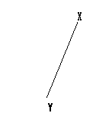
Construct the locus of all the points, which are equidistant from X and Y.
Steps:
(1)
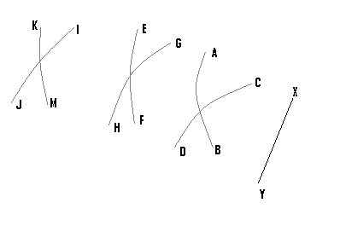
- Open your compass to an appropriate length, and with the pin positioned at the point X, draw arc AB.
- Using the same length and with the pin now positioned at the point Y, draw arc CD.
- Open your compass to a different or a greater length, and with the pin position at point X, draw arc EF.
- Using the same length and with the pin now positioned at the point Y, draw arc GH.
- Using a different length and the same procedure, we construct arcs JI and KM.
(2) Finally draw a line to pass through all the points of intersection, of all the arcs.
N/B: Locus is normally represented by a broken line.
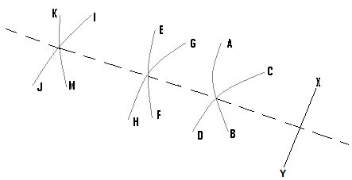
- The broken line is the locus of the points, which are equidistant from the points X and Y.
- Also any point on this line will be equidistant from X and Y.
Locus of points equidistant from two lines:
- In order to get such a locus, we bisect the angle between these two lines.
Examples:
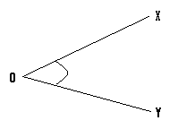
Construct the locus of the points, which are equidistant from the lines OX and OY.
Steps:
- Bisect <XOY.
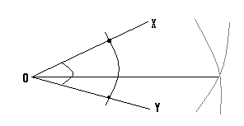
- The required locus is represented by the straight line, and any point on it will be at equal distance away from OX and OY.

Construction of angle 90⁰:

With reference to line AB, construct angle 90⁰ at the point X.
Steps:

(1)
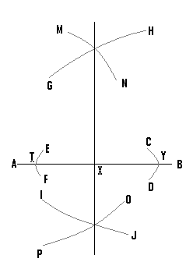
- Open your compass to a small length, and with the pin positioned at point X, draw arcs CD and EF.
- Open your compass to a greater length, and with the pin positioned at point Y, construct arcs GH and IJ.
- Using the same length and with the pin now at point T, draw arcs MN and OP.
- Draw a line to pass through the point X, and the points of intersection of the various arcs.
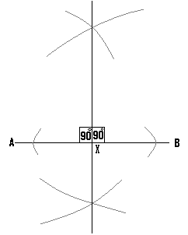
(Q1)(a) Using a ruler and a pair of compasses only, construct triangle ABC, such that <ABC = 90⁰, BC = 7cm and AB = 5cm.
(b) Construct locus P₁ of points which are 3cm away from B.
N/B:
- Ensure that the angle lies on the horizontal line, since this will make the work easy.
- It is also advisable to make a rough sketch of the diagram first.
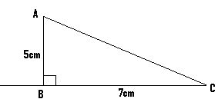

Soln:

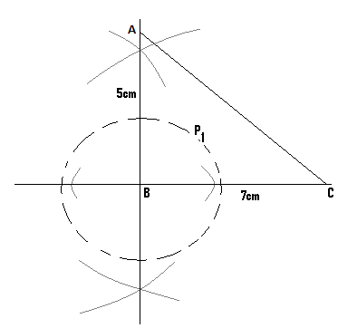
- Open your compass to a length of 3cm, and with the pin positioned at the point B, construct locus P₁ which is represented by the broken line.

Construction of angle 45⁰:
- To construct angle 45⁰ at a given point, we first construct angle 90⁰ at that point.
- The angle 90⁰ is then bisected to get angle 45⁰.
Example:
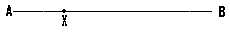
Construct angle 45⁰ at X.
Step(1)
- This involves the construction of angle 90⁰ at the point X.
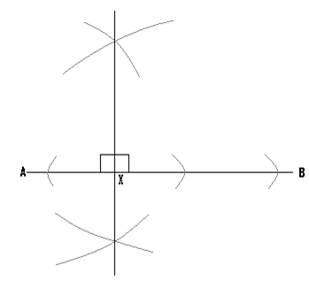
Step(2)
- Bisect the 90⁰ to get 45⁰.
- Since there are two angles of value 90⁰, the one bisected depends on where we want the 45⁰ angle to lie.
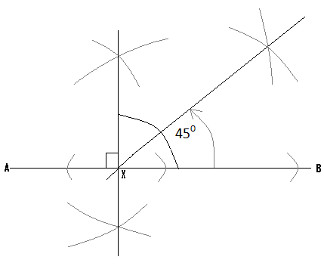

(Q2) (a) Using a pair of compasses and ruler only, construct NKP, such that NKP = 45⁰, KP = 7cm and KN = 5cm.
(b) Construct the locus l₁ of points equidistant from N and P.
(C) Determine the location of the point Y, which is 5cm away from K and 7cm away from P.
Hint:
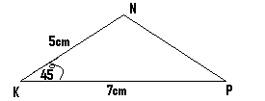
Soln:
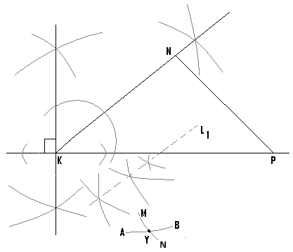

N/B: To locate the position of the point Y, open the compass to a length of 5cm and with the pin positioned at K, construct arc AB.
- The compass is now opened to a length of 7cm and with the pin located at P we draw arc MN.
- The point of intersection of these two arcs, gives us the location of the point Y.
(Q3) (a) With the aid of a pair of compasses and a ruler only, construct XYZ, in which YZ = 60mm, <XYZ = 90⁰ and <YZX = 45⁰.
(b) Construct the locus l₂ of points which are equidistant from XY and XZ.
N/B: XY and XZ can be regarded to refer to lines XY and XZ.
N/B: 60mm = 6cm.
Hint:
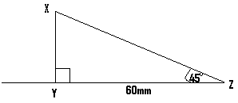

Soln:
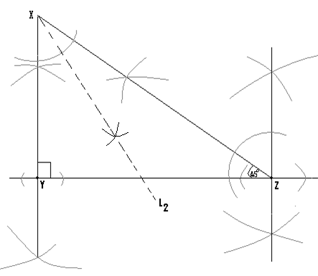
- Bisect the angle between XY and XZ to get the locus L₂.
(Q4) (a)Using a ruler and a compass only construct ABC, in which BC = 6cm and <ABC = 45⁰ and AB = 10CM.
- Locate the point D inside the triangle such that D is equidistant from AB and AC, and 5cm away from B.
- Construct a straight line to cut AB at X and AC at Y such that AX = AY.
Hint: First construct your diagram but in the one drawn, certain portions have been eliminated or removed.

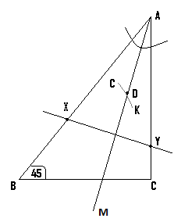

N/B: - Since D is equidistant from AB and AC, in order to locate the possible positions of D, we bisect the angle between these two lines.
- The point D will therefore lie on the line AM.
- Since D is also to be 5cm away from B, open your compass to a length of 5cm and with the pin positioned at B, we draw an arc or arc CK to cut the line.
- The point where it cuts the line is D.
- – in this case AX = AY.
- Open your compass to a suitable length and with the pin placed at A, use it to mark a point i.e. X on line AB.
- Using the same length and with the same pin, still positioned at A, another mark i.e. Y is made on line AC.
- A straight line is then drawn through these two points i.e. X and Y.

Construction of angle 135⁰:
- Since 135 = 90 + 45, we combine angles 90⁰ and 45⁰ in order to get angle 135⁰.
Example:
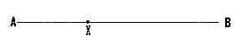
Construct angle 135⁰ at the point X.
Steps:
- Construct angle 90⁰ at X.

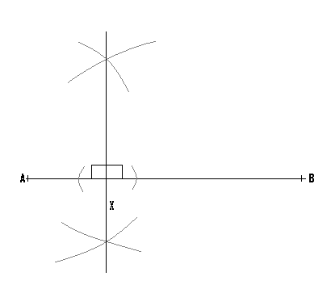
- Bisect one of the 90⁰ angles to get angle 45⁰.
- Let us bisect the one on the left hand side.
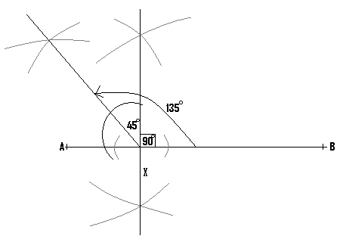
(Q5) (a) With the aid of a pair of compasses and a ruler only construct XYZ, such that <XYZ = 135⁰, xy = 4.7cm and YZ = 6.5cm.
(b) Locate the point P which is equidistant from X, Y and Z.
(C) Using P as the centre draw the circle which passes through the points X, Y and Z, and determine its radius.
Hint:
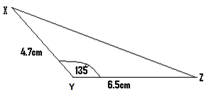

Soln:
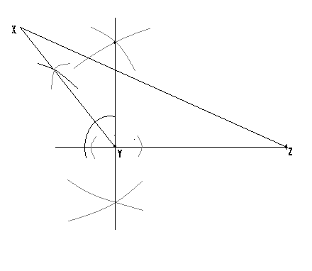
N/B:
- – To locate the point P, we construct the bisectors of lines XZ, XY and YZ.
- These three bisectors will meet at a point, and this point is the point p.
- For better understanding and clarification, this is illustrated in the next diagram.
- The meeting point of two bisectors will even give us the location of this point.

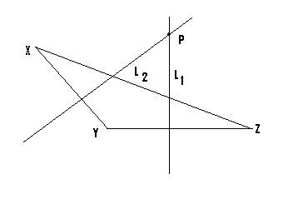
N/B: L₁ = the bisector of line YZ.
L₂ = the bisector of line XY, and using P as centre, a circle can be drawn to pass through X, Y and Z.
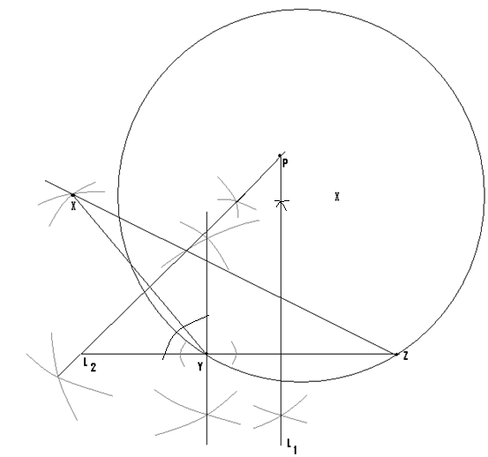
Construction of angle 60⁰:
Example: Construct angle 60⁰ at the point X.
Steps:
- Open your compass to a suitable length and with the pin positioned at X, draw arc BC to cut line AB at Y.
- Using the same length and with the pin of the compass now positioned at Y, draw another arc i.e. arc EF to cut the first one at the point M.
- Using a ruler, draw a straight line to join the points X and M.

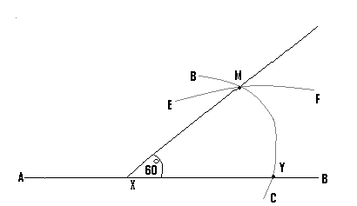
(Q6)(a) By means of a ruler and a pair of compasses only, construct HMK, in which HK = 60⁰, MK = 8cm and HK = 7cm.
(b) Locate the point C inside the which is 5cm away from M and 4cm away from K.
(C) Using C as centre draw a circle whose diameter is 4cm.
Hint:
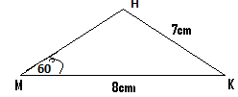

Soln:
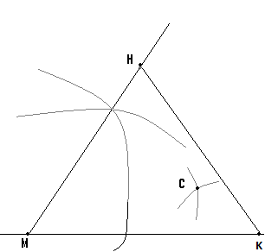
N/B: - Since the diameter of the circle is to be 4cm, then its radius will be 2cm. open the compass to a length of 2cm and use it to construct the circle.
- The final diagram will be as shown next:
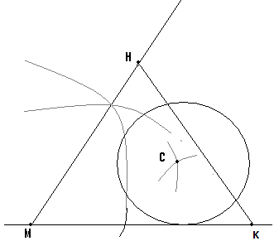

Construction of angle 30⁰:
- To construct such an angle, we first construct angle 60⁰.
- This is then bisected to get angle 30⁰.
Example:
Construct angle 30⁰ at the point X.
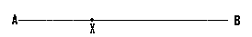
Steps:
- First construct 60⁰ at X.
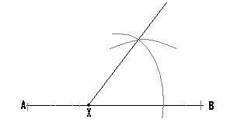
- Bisect the angle 60⁰ to get angle 30⁰.
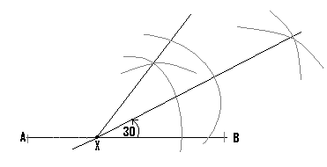
(Q1)(a) Using ruler and compass only construct YXZ, in which <XYZ = 60⁰, <XZY = 30⁰, YZ = 80mm and YX = 4.2cm.
(b) Construct the bisectors of XZ and XY and let K be their point of intersection.

Hint:
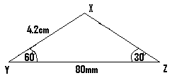
Soln:
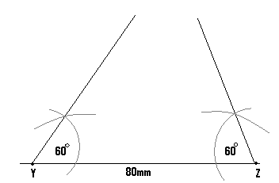
- Bisect the 60⁰ at Z to get angle 30⁰.
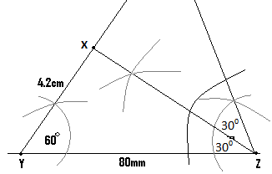
- We finally construct the bisector of XZ and XY.
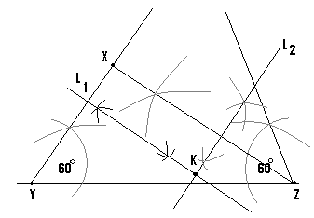
L₁ = bisector of XY and L₂ = that of XZ.
Construction of angle 120⁰:
- Since 120 = 60 + 60, we combine two angle 60⁰ to get angle 120⁰.
Example:
Construct angle 120⁰ at the point X.
Steps:
- Construct angle 60⁰ at X.
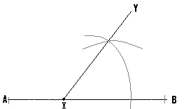
- Open the compass to a greater length and with its pin positioned at X, draw an arc to cut line XY at M, i.e. arc CD.
- Using the same length and with the pin now positioned at M, draw arc GH to cut arc CD at point T.
- Finally a straight line is drawn to join points X and T.
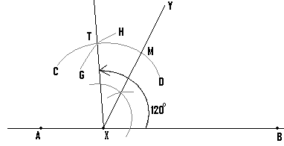
(Q2((a) By means of a ruler and a pair of compasses only, construct ABC in which <ABC = 120⁰, <ACB = 30⁰, AB = 6.7cm and BC = 5.9cm.
(b) Determine the point K which is equidistant from A, B and C.
(C) Using K as centre, draw the circle which passes through A, B and C.
(d) Plot also L₂, the locus of points equidistant from A and C, and let X be the point of intersection of L₁ and L₂.
(e) Measure AX.
Hint:
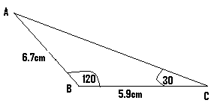
N/B: This question will be solved partly.
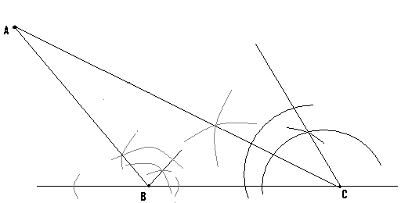
N/B:
(b) To determine the point K, we construct the bisectors of AB, BC and AC and their meeting point is K, and using K as the centre, any circle drawn will pass through A, B and C.
(C) For the locus L₁, bisect the angle between AC and AB.
Construction of angle 150⁰:
- The construction of such an angle is had by the combination of angle 90⁰ and angle 60⁰.
Examples:
Construct angle 150⁰ at the point X.
Steps:
- Construct angle 90⁰ at X.
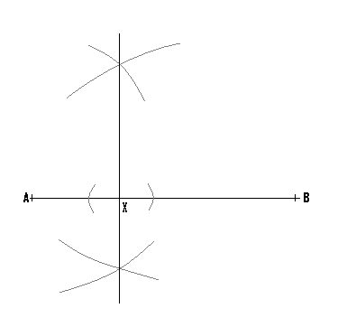
- Construct angle 60⁰ in addition to the 90⁰.
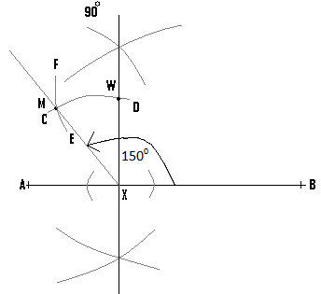
- Open the compass to an appropriate length, and with its pin positioned at point X, draw arc CD.
- Using the same length and with the pin now positioned at point W, draw arc EF to cut the first one at point M.
- Finally draw a straight which passes through X and M.
(Q8)(a) With the aid of compass and ruler only, construct ABC in which AC = 150⁰, AB = 5.5cm and BC = 5cm.
(b) Determine the location of the point Y which divides AB into two equal parts.
Hint:
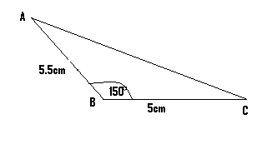
Soln:
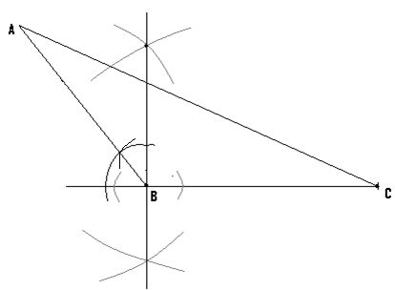
(b)For the point Y, draw the bisector of AB, since it will pass through the mid point of AB, and divides it into two equal parts.

Construction of angle 75⁰:
- This angle is had by a combination of angle 45⁰ and angle 30⁰.
Example:
Construct angle 75⁰ at the point X.
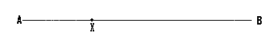
Steps:
- Construct angle 90⁰ and bisect it to get angle 45⁰
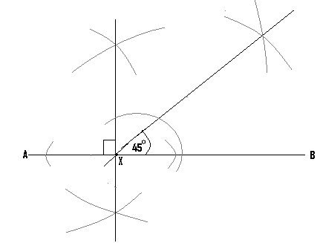
- Construct angle 60⁰ in addition to the angle 45⁰.

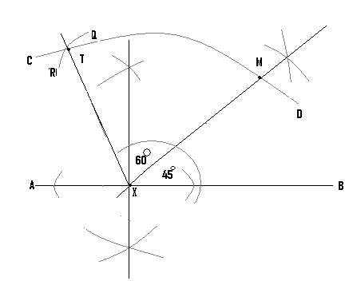
- Open the protractor to a suitable length and with its pin at point X, draw arc CD.
- With the same length and the pin now positioned at point M, draw arc RQ and let it meet the first one at point T.
- From point X, draw a straight line to pass through point T.
- Finally bisect the angle 60⁰ to get angle 30⁰.

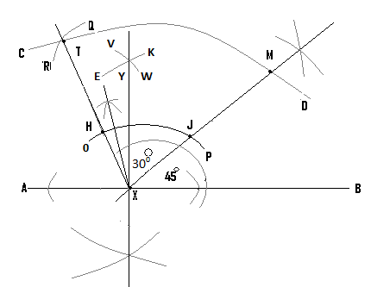
- Using an appropriate length and with the pin at point X, draw arc OP and open the compass to a greater length.
- Positioning the pin at point H and then at point J, draw arc EK and arc VW and let Y be their point of intersection.
- Finally from X, draw a line to pass through point Y.
(Q1)(a) Using ruler and compass only, construct MKF in which <MKF = 75⁰, MFK = 60⁰ and KF = 5CM.
- Using K as centre draw a circle of radius 3cm.

Hint:
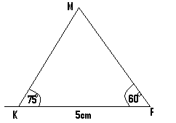
Soln:
N/B: - First construct angles 45⁰ and the 60⁰.
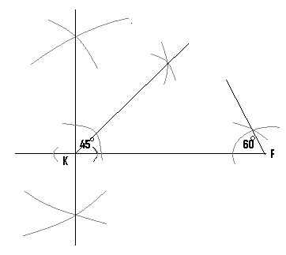
- In addition to angle 45⁰, we construct angle 60⁰ and bisect it to get angle 30⁰.

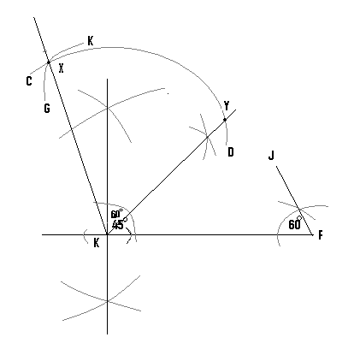
- Using a suitable length and with the pin positioned at K, draw arc CD.
- With the same length and the pin now positioned at point Y, draw arc GK and let X be the meeting point of these two arcs.
- From point K, draw a straight line to pass through the point X.
- The angle just constructed is angle 60⁰.
- In the final stage, bisect the angle 60⁰ to get angle 30⁰.
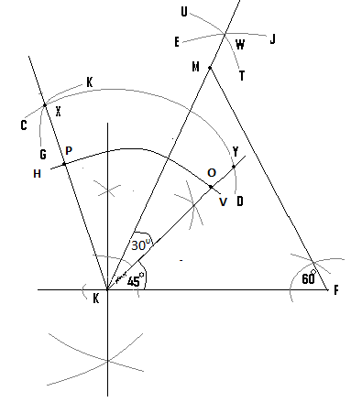
- Using a suitable length and from point K, draw arc HV.
- Using a greater length and from point P and O, draw arcs UT and EJ and let them meet at point W.
- Finally from K, draw a straight line to pass through W.
- Extend the line FJ to meet this straight line and let their meeting point will be point M.
N/B: It is only this final diagram which is necessary to be drawn.
(Q2)(a) Using ruler and a pair of compasses only, construct ABC in which AB = 6cm, BC = 5cm and <ABC = 75⁰.
(b) Locate the point D, such that CD is parallel to AB and D is equidistant from A and C.
(c) Construct the perpendicular line to meet AB at E.
(d) Measure CE .
Hint:
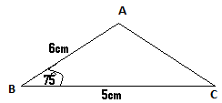
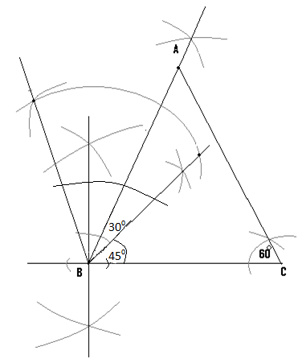
(b) – CD is parallel to AB.
- To locate the position of D, open the compass to the length of AB i.e. 6cm, and with the pin at C draw arc EF.
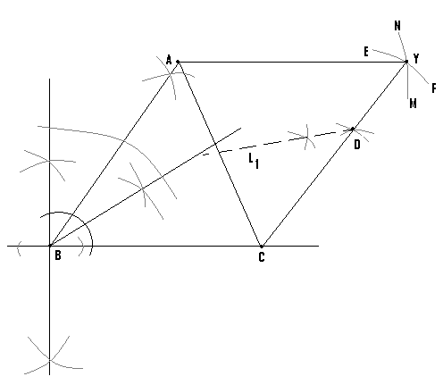
- The compass is now opened to the length BC i.e 5cm, and with the pin at A, draw arc MN to cut the first one at Y.
- Draw the first straight line to join C and Y, and the second one to join A and Y.
- Since CD is parallel to AB, the point D can lie any where on the line CY.
- But since D is also supposed to be equidistant from A and C, then it must also lie on the locus of points which are equidistant from A and C.
- We therefore construct this locus and let this be L₁.
- At the point where L₁ meets CY is the location of D.
N/B:
(C) Construct the bisector to AB and the point where It meets AB is E.
Construction of angle 105⁰:
- This is had by a combination of angle 60⁰ and angle 45⁰.
Example:
Construct angle 105⁰ at the point X.

Steps:
- Construct angle 90⁰ at X and bisect it to get angle 45⁰.
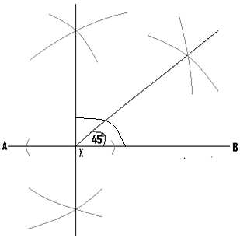
- Construct angle 60⁰

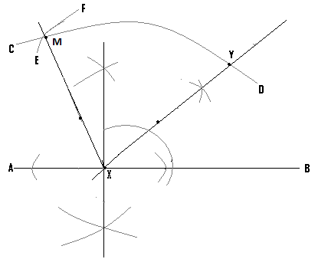
- With the pin at X, construct arc CD.
- With the same length and the pin at Y, construct arc EF.
- From point X draw a straight line which passes through M.
(Q3) Using a ruler and a pair of compasses only construct QRS such that <QRS = 105⁰, QR = 5cm and RS = 7cm.
Hint:
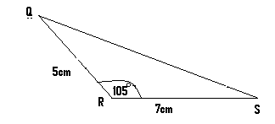

Soln:
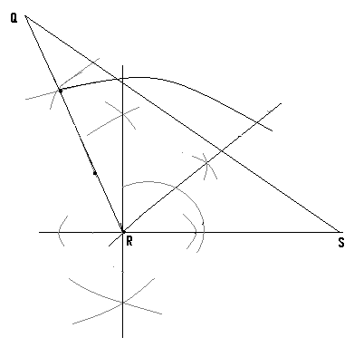
Construction of parallelograms:
- A parallelogram is a four sided figure, with its opposite sides being equal and parallel.
Example:
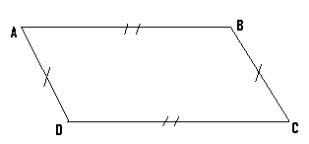
- In parallelogram ABCD, the length AB is equal and parallel to the length DC.
- Also the length AD is equal and parallel to the length BC.
- Any geometrical figure such as a triangle or a parallelogram can be labeled in any manner, provided the given letters follow an ordered manner.
- For this reason, the given parallelogram can also be labeled as
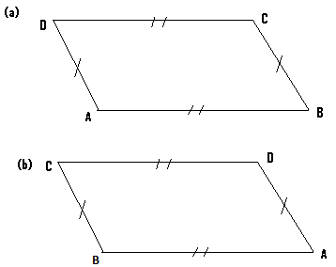
N/B:
- It is good to do the labeling in a way that the angles lie on the horizontal line.
(Q1) By means of a pair of compasses and a ruler only, construct parallelogram ABCD, such that <BCD = 60⁰, <ADC = 120⁰, BC = 3cm and CD = 7cm.

Hint:
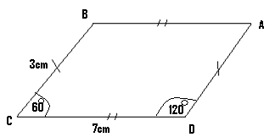
N/B: AB = 7cm and AD = 3cm
Soln:
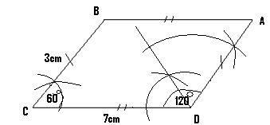
N/B:
- In this question solved, two angles are given, but it is possible to be given only one angle.
(Q2)(a) Using a ruler and a pair of compasses as only, construct parallelogram WXYZ such that <XYZ = 60⁰, YZ = 72mm and XY = 28mm.
(b) Construct the locus L₁ of points which are equidistant from WX and WZ.
(c) Construct also the bisector L₂ of WX and let it meet L₁ at T.
(d) Measure WT.
Hint:
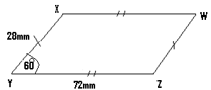
- First construct the given angle and the lines XY and YZ.

Soln:
Step(1):
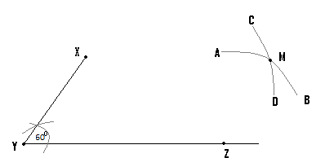
- To locate the position of W, open the compass to a length of 28mm and with the pin at Z, draw arc AB.
- The compass is now opened to a length of 72mm, and with the pin positioned at X, construct arc CD and let M be the point of intersection of these arcs.
- From Z, draw a straight line to join M, and from X, draw another to join M.

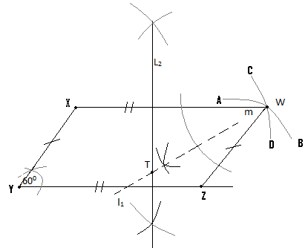
(Q3)(a) Using ruler and compass only, construct parallelogram ABCD, such that <ABC = 75⁰, BC = 7.2cm and BA = 45mm.
(b) Locate the positions of the locus L₂ which are 3cm away from C.
Hint:
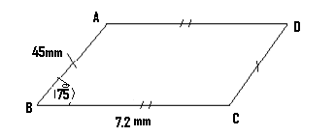

Soln:

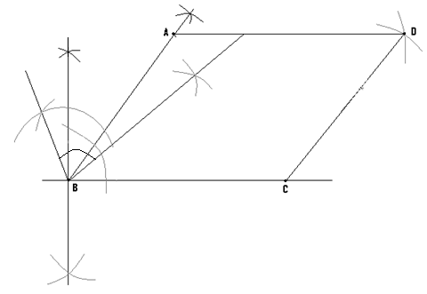
- For L₂, draw the circle which is 3cm away from C.
(Q4)(a) With the aid of a pair of compasses and a ruler only, construct parallelogram ABCD, such that AB = 6cm, <BAC = 45⁰ and <ABC = 60⁰.
(b) Locate the point P inside the triangle such that PA = PB and PC = 3cm.
(c) Find PD.
Hint:
Step (1) Construct angles 45⁰ and 60⁰.

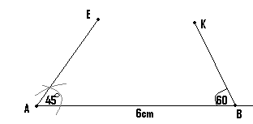
(II) Extend the lines AE and BK and their meeting point will be the point C.
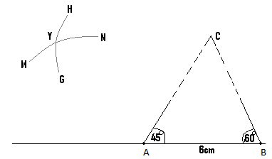
- Open the compass to the length AB i.e. 6cm, and with the pin positioned at C draw arc GH.
- The compass is now opened to the length BC and with the pin positioned at point A, draw arc MN and let Y be the point of intersection of these arcs.
- This point Y becomes the point D of the parallelogram.

Step (3):
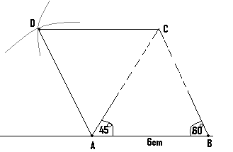
- Draw a straight line to join the point C to D, and another one to join the point A to D.
(b) – Since PA = PB , then the point P must divide the line AB into two equal parts, or lie on the bisector of AB.
- We therefore construct the bisector of AB.
- Also since PC = 3cm, open your compass to a length of 3cm, and from the point C or with the pin positioned at C, draw an arc to cut the bisector.
- At the point where it cuts the bisector is the point P.

Soln:
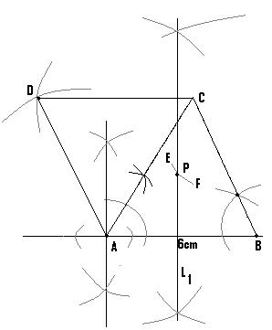
N/B:
- L₁ = the bisector of AB and EF is the arc which is 3cm away from C.
(Q5) With the aid of a pair of compasses and a ruler only, construct parallelogram ABCD in which <BCD = 60⁰, CD = 7cm, CA = 9cm and CB = 4cm.
Hint: First construct the angle and the lines CB and CD.
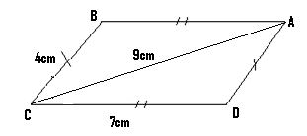
N/B: AD = CB = 4cm.
- To locate the position of A, the compass is opened to a length of 9cm, and with the pin located at C draw arc EF.
- The compass is now opened to a length of 4cm and with the pin at D, draw arc GH.
- The meeting point of these arcs is the location of point A.
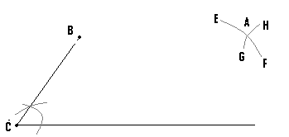

Construction of rectangles:
- A rectangle is a four sided figure, with each of its four angles being 90⁰.
- Apart from that, its lengths are equal and parallel.
- Also its widths or breadth are also equal and parallel.
(Q1) (a) By means of a pair of compasses and ruler only, construct rectangle ABCD in which AB = 7cm and BC = 5cm.
(b) Construct parallelogram ABCD such that <BCD = 60⁰, BC = 3cm and whose height is 5cm, given that parallelogram ABCD has the same area as rectangle ABCD.

(a) Hint:
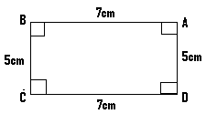
N/B: You must first construct angle 90⁰ at point C and point D.
Soln:
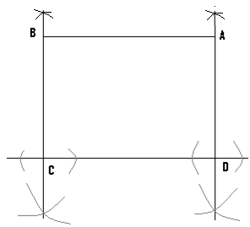
The length of the rectangle = CD = 7cm and its breadth = BC = 5cm.
The area of the rectangle = L = 35CM².
(b)
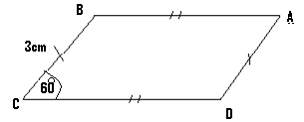
N/B: First determine the length CD which is the base of the parallelogram.
Let b = the base of the parallelogram and let h = its height.
The area of the parallelogram = b . But the height of the parallelogram = 5cm.
=> The area of parallelogram = b h = b 5 = 5b.
Since the area of the parallelogram = the area of the rectangle, then 5b = 35
=> b = 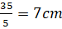.
=> CD = 7cm.
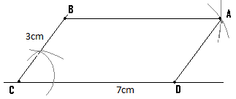
(Q2)(a) Using a pair of compasses and a ruler only, construct parallelogram QRST such that <RST = 60⁰, ST = 70mm and RS = 30mm.
- Construct rectangle ABCD whose length is 60mm, and whose area is the same as that of parallelogram QRST.

(a)
Hint:
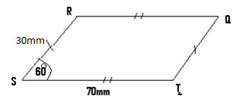
First make an accurate diagram of this figure and determine the height of the parallelogram.
Soln:
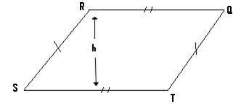
By measurement, h = 28mm, where h = the height.
The base = b = ST = 70mm.
The area of the parallelogram = b h = 70 28 = 1960mm².

(b) Hint:
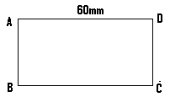
Let B = the breadth of the rectangle and L = its length. The area of this rectangle = L B = 60
Since the area of the rectangle is the same as that of parallelogram QRST, then 60B = 1960 => B =
= 33,=> AB = DC = 33mm.
Soln:
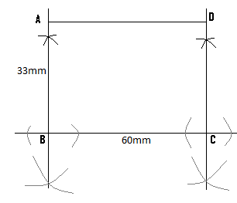

(Q3) Using ruler and a pair of compasses only, construct
I) parallelogram PQRS with RS as the base, such that PQ = 7.8cm, QR = 5cm and angle QRS = 120⁰.
Ii) rectangle ABRS, equal in area to parallelogram PQRS.
(b) Measure
(i) PQ
(ii) AS
Hint:
- Parallelogram :
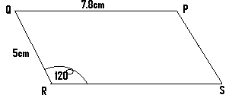
N/B: RS = 7.8cm and PS = 5cm
- Rectangle
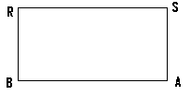

N/B:
- These two figures drawn should have been separated as shown, but since the question goes on further to ask us to measure AP , then the two diagrams must be joined to each other.
- This is due to the fact that while P is on the first figure, A is on the second one, and as such AP can only be measured when these two diagrams are joined, as shown next.
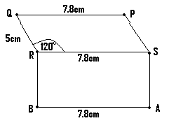 Figure (1)

Soln:
Step(1)
First construct the parallelogram
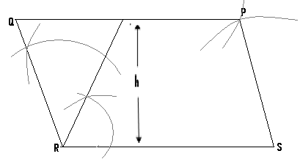
By measurement, the height of the parallelogram = h = 4.5cm, and its base = b = 7.8cm.
=> The area of the parallelogram = b = 7.8 4.5 = 35cm².
For the rectangle, length = L = 7.8cm.
Let its breadth = B.
Area of the rectangle = L B = 7.8 B = 7.8B.
Since the area of the rectangle is the same as that of the parallelogram, then 7.8B = 35 => B = 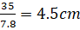.
Step (2):
- We then construct the rectangle.
From figure (1), RB = SA = 4.5cm and for this reason the line BA must be at a distance of 4.5cm away from line RS.
Our final diagram becomes as shown next, after the construction of two bisectors, one to pass through R and the other to pass through S.
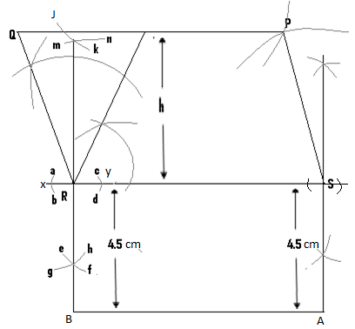
N/B:
- With the pin at R, construct arcs ab and cd.
- With the pin at y, draw arcs mn and ef.
- With the pin, this time at x, draw arcs jk and gh.
- Finally draw a straight line to pass through R, which passes through the points of intersection of arcs jk and mn, as well as arcs ef and gh.
- Using a similar method, we construct the bisector which passes through s.
(Q4)(a) With the aid of a pair of compasses and ruler only, construct rectangle ABCD such that AB = 8.4cm and BC = 3.3cm.
(b) Construct YXZ of height 8cm, in which <XYZ = 60⁰, and XY = 4.2cm, given that the areas of the rectangle and the triangle are the same.

(a)
Hint:
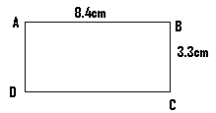
Soln:
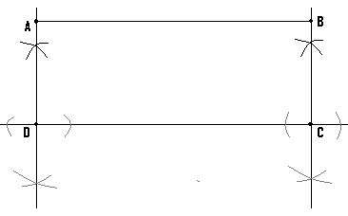
The area of the rectangle = L = 8.4 3.3 = 28cm².
(b) Hint:
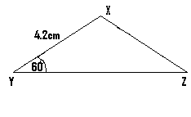
Let the base of the triangle (YZ) = b.

The area of triangle = where h = the height.
=> = 4b.
Since the area of the triangle = the area of the rectangle, then 4b = 28 =>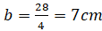 => YZ = 7cm.
We finally proceed by constructing the triangle.
(Q5) With the aid of a ruler and a pair of compasses only, construct
i) triangle XYZ, such that <XYZ = 60⁰, YX = 4.2cm, YZ = 6.8cm and whose height is 5.2cm.
ii) rectangle YZNM, whose area is the same as that of triangle XYZ.
iii) Determine
- MX (b) XN .
Hint:
N/B: Since the point M is on the rectangle point X is on the triangle and we are to determine MX, then the two figures must be joined to each other, as shown next.
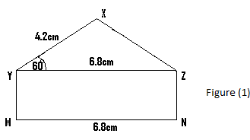
Area of triangle = = 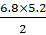 = 17.7cm².
Area of rectangle = L = 6.8 B = 6.8B.
Since area of the triangle = area of the rectangle, then 6.8B = 17.7
=> B = 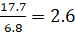
=> YM = 2.6cm.
We then construct figure (1) accurately, and then take the necessary measurements.
Construction of quadrilaterals:
- A quadrilateral is any four sided figure.
(Q1)(a) Using ruler and compass only, construct quadrilateral ABCD, in which BC = 60mm, AD = 58mm, CD = 8cm, <BCD = 75⁰ and <CDA = 60⁰.
(b) Construct the bisectors of CB and AD and let their point of intersection be X.
(c) Using X as centre draw the circle which passes through A and find its radius.
Hint:
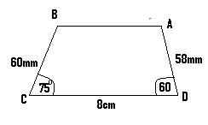
Soln:
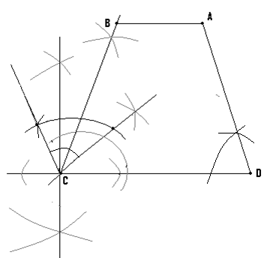
- Construct the bisectors of CB and AD and let where they meet be X.
- With the pin positioned at X, draw a circle to pass through point A.
N/B: The bisectors and the circle which have been omitted from this diagram, must be part of it.
(Q2)(a) Using ruler and compass only construct quadrilateral WXYZ such that XY = 5cm, YZ = 8cm, WZ = 7cm, <XYZ = 120⁰ and <WZY = 30⁰.
(b) Locate the point D inside the quadrilateral, which is 4cm away from Y and 5cm away from Z.
(c) Draw the locus L₁ of points which are equidistant from W and Z.
Hint:
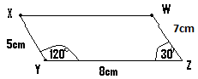
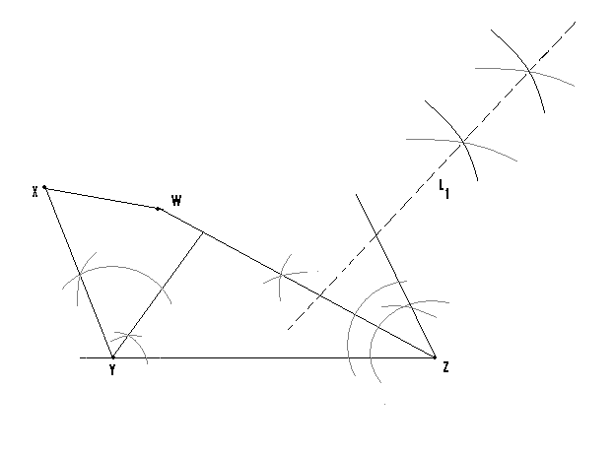
(Q3)(a) With the aid of a pair of compasses and ruler only, construct quadrilateral QRST such that RS = 5cm, ST = 8.2cm, SQ = 8cm, QT = 7cm and <RST = 120⁰.
(b) Construct L₁, which is the locus of points equidistant from QT and ST, as well as L₂ which is the bisector of ST and let Y be their meeting point.
(c) Measure <QRS and SY.
Hint:

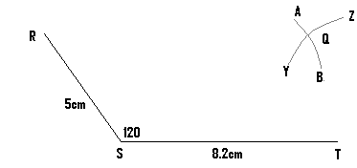
- First construct the angle 120⁰ as shown and locate the position of Q.
- Since SQ = 8cm => the distance from S to Q is 8cm, and since TQ = 7cm, then the distance from T to Q is 7cm.
- The compass is therefore first opened to a length of 8cm, and with the pin located at S, construct arc AB.
- The compass is then opened to a length of 7cm, and with the pin now positioned at T, draw arc YZ.
- The meeting point of these two arcs is the position of Q.

Soln:
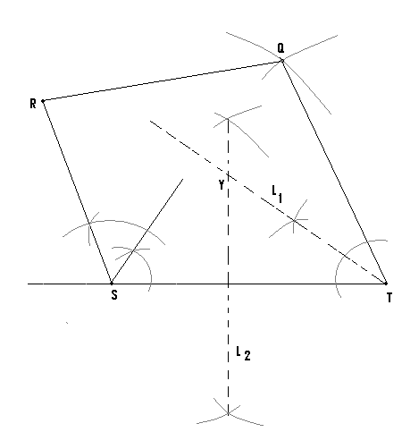
(Q4)(a) Using ruler and compass only construct quadrilateral ABCD, in which AD = 6cm, AB = 6.5cm, <BAD = 60⁰ and<ADC = 135⁰. Also let DC = 5cm.
(b) Construct the locus L₂ of points equidistant from BC and CD.
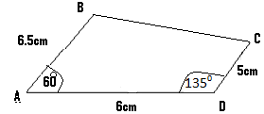

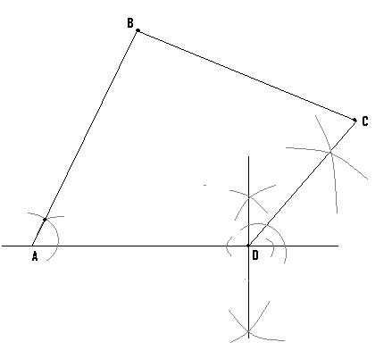
(Q5)(a) Using ruler and compass only, construct quadrilateral ABCD, such that <BAD = 150⁰, AB = 6.5cm, BC = 10cm, CD = 6cm and DA = 4cm.
(b) Determine by construction the point P, which is equidistant from AB, BC and CD.
(c) Find there area of ABC.

Hint:
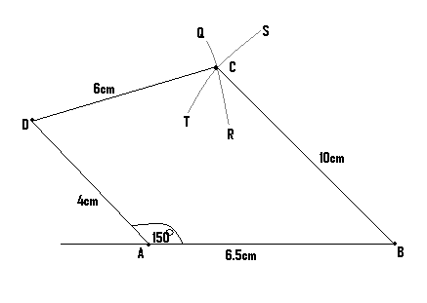
- The angle 150⁾ must first be constructed.
- The compass is opened to a length of 10cm and with the pin positioned at B, arc TS is drawn.
- The compass is then opened to a length of 6cm and with the pin now positioned at D, arc QR is drawn.
- The point of intersection of these two arcs is point C.

Soln:

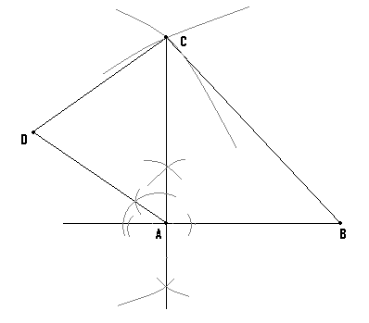
- – To get the position of P, bisect the angle between AB and BC i.e. draw the bisector of the angle between AB and BC.
- Then draw the bisector of the angle between CB and CD.
- The meeting point of these bisectors is the point P.
- Find the length of AB and the length of AC.
Base = AB and height = AC.
Area of ABC = 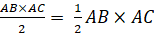.

(Q5) Using a ruler and a pair of compasses only,
a) construct a quadrilateral PQRS in which PQ = 6.5cm, PS = 7.0cm, angle QPS = 105⁰, angle RQP = 120⁰ and PQ is parallel to SR.
b) measure (i) QR (ii) SR .
Hint: Step(1)
- Construct a partial form of the figure which includes the two given angles.
i.e.
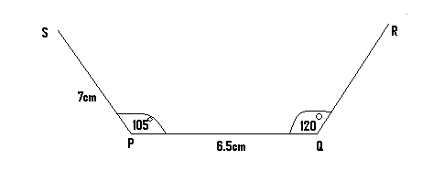
Step (2):
- But the line SR is to be parallel to line PQ and to get line SR, we go through the following steps:

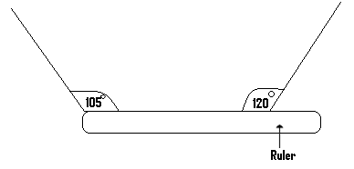
Position the ruler in such a manner that one of its edges lies in line with line PQ, as shown in the just given diagram.

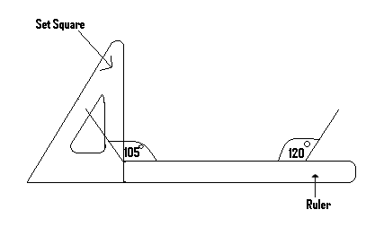
- A set square is positioned so as to be in contact with one side of the ruler, as shown in this diagram.
- With the set square held firmly in position, the ruler is gradually moved or slided upwards until its upper edge is in line with S.
- Draw a line through S along the edge of the ruler, till it meets the other line.
i.e.
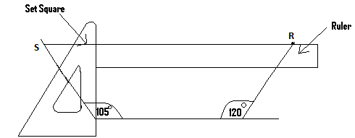
- This drawn line will be parallel to line PQ and pass through the other line at point R, while it also passes through S.

Soln:
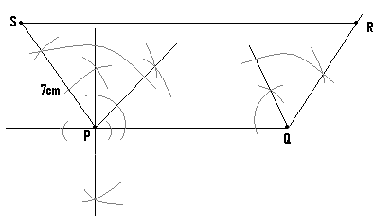

Construction of trapezium:
- A trapezium is a quadrilateral with two parallel sides.
(Q1) With the aid of a pair of compasses and ruler only, construct trapezium ABCD such that <ABC = 45⁰, AD = 5cm, AB = 5cm and BC = 6.5cm.
Hint:
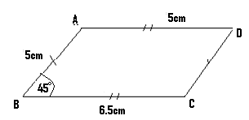
N/B: The line AD must be parallel to line BC, and line AB must be parallel to line DC.

Steps:
- Construct the angle 45⁰, and lines AB and BC.
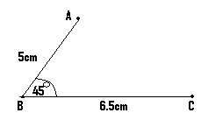

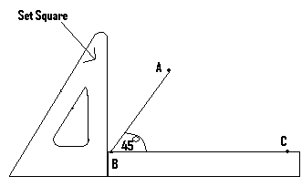
(II) Place one edge of the ruler so that it will be in line or lie on line BC.
- With the set square positioned against one side of the ruler as shown in the diagram, the ruler is moved upward till its top edge comes in line or be at the same level with the point A.
- With the ruler still in position, a straight line is drawn through A along the edge of the ruler, and its length must be 5cm.
- At the other edge of this line which is 5cm away from A, will be the location of the point D as shown in the next diagram.
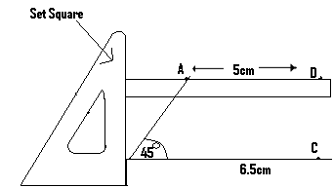
- Finally a straight line which joins the points C and D is drawn.
Soln:
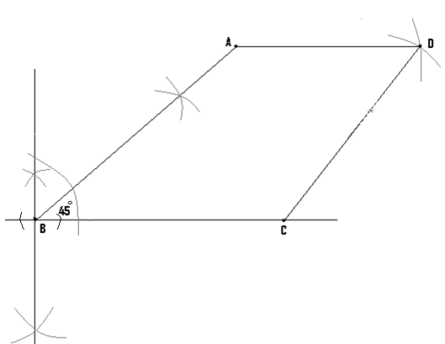
Construction of rhombus:
- A rhombus is a parallelogram with equal lengths.
(Q1) With the aid of a pair of compasses and a ruler only, construct rhombus ABCD in which <BCD = 60⁰ with each length being 5cm long.
Hint:
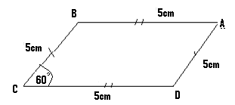
Steps:
(I) Construct the angle 60⁰, line BC as well as line CD.
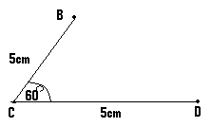
(II)
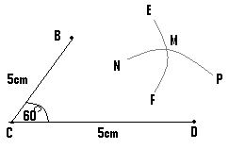
- The compass is then opened to a length of 5cm and with its pin positioned at B, draw arc EF.
- Using the same length of 5cm and with the pin not positioned at D, we draw arc NP and let the meeting point of these arcs be M.
- Finally, two straight lines are drawn, one another to join the point D to M, and another to join the point B to M.
Soln:
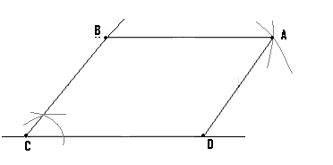
Application of construction:
- There are certain problems whose solutions involve or depend on the application of construction.
(Q1) Town M is 20km from town N and 22km from town P while N is 18km from P. A market is to be built to serve these three towns. It is to be located so that traders from N and M will always travel equal distance to access the market, while traders from P will travel exactly 10km to reach the market.
- Using a ruler and a pair of compasses only, find by construction, the possible locations for the market.
Use a scale of 1cm = 2km.
- How many of such areas are there and which of them will be convenient for all the three towns?

Hint: (I) Make a rough sketch of the towns.

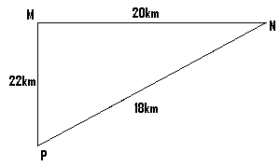
(II) – Since 1cm = 2km, then 20km = 10cm, 22km = 11cm and 18km = 9cm.
- The diagram just drawn becomes as shown next:
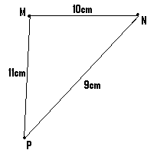

Soln:
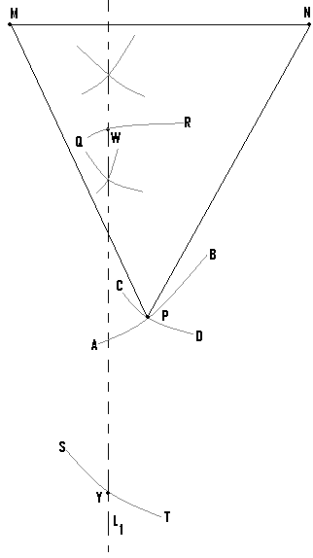
N/B:
- we first draw line MN of length 10cm.
- The compass is then opened to a length of 11cm, and with its pin at M we draw arc AB.
- The compass is then opened to a length of 9cm, and with its pin at N, we draw arc CD.
- The point of intersection of these two arcs will be the location of town P.
- Students must also attempt to solve all the questions already solved on their own as their exercise.
- Since traders from N and M must travel equal distance to access the market, then it must be equidistant from N and M.
- We therefore construct L₁ which is the locus of points equidistant from M and N, since the market must lie on it.
- But traders from P must travel exactly 10km (i.e. 5cm) to access the market.
- The compass is opened to a length of 5cm and with the pin at P, arcs QR and ST are drawn to cut locus L₁.
- Where these arcs meet L₁ are possible locations of the market.
- The market can therefore be located at the point W or Y but W will be more convenient, since it is closer to the three towns than Y. For M and N are too far away from Y.

Construction of a circumscribed circle:
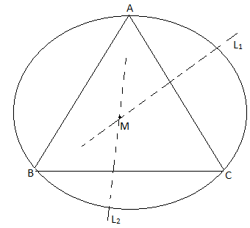
-The circle drawn passes through the points A,B and C which are the vertices of the triangle.
-A circumscribed circle is a circle, which passes through the three vertices of a given triangle.
-To construct such a circle, the perpendicular bisectors of two of the sides of a triangle, are drawn and their meeting point is noted.
-With the pin of the compass positioned at this meeting point, a circle can be drawn to pass through all the three vertices of the triangle.
-In the given diagram, L₁ and L₂ are the two bisectors whose meeting point is M.
-Therefore with the pin positioned at M, the circumscribed circle can be drawn.

Construction of an inscribed circle:
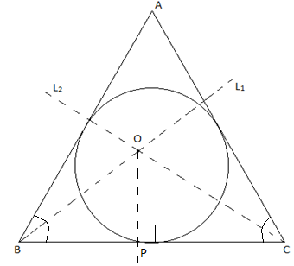
-An inscribed circle is one, which touches all the three sides of a given triangle.
-To construct such a circle and using the diagram just drawn as an example, L₁ which is the bisector of <ABC and L₂ which is the bisector <ACB are drawn, and let their meeting point be O.
-From the side BC, a perpendicular line (op) is then constructed.
- With the pin of the compass positioned at O and using the length OP, the inscribed circle can be drawn.
NB: As exercise, students are advised to attempt solving all the questions already solved, on their own.

