CHAPTER TEN
LOGIC
Statement: This is an assertion or a declaration which may either be true or false. Examples of statements are:
- Ghana is in Europe.
- Nigeria is a country.
- John is a boy.
- A car can travel on the sea.
Conditional statements:These are statements which involve the use of the preposition ‘if’ and ‘then’. Examples of such statements are:
- If you steal, then the police will arrest you.
- If I am a Nigerian, then I come from Nigeria.
- If I am a white man, then I come from Britain.
Conditional statements have the form if P then q, which is abbreviated P=>q. For example, consider the conditional statement: “if you steal, then you will be arrested”.
Let P = if you steal
Q = then you will be arrested.
From these we can say that P => q which means that “if you steal, then you will be arrested”. Also consider the statement “if I am a white man, then I come from Britain”.
Let P = if I am a white man, and q = then I come from Britain. From these, we can say that P => q, which means that “if I am a white man, then I come from Britain”.

A conditional statement may either be true or false. For example, the conditional statement, “if I am a human being, then I can fly”, is false. But the conditional statement, “if I am a boy, then I am a male” is true.

A conditional statement such as the one just given, which is always true, is referred to as an implication. In the abbreviation P => q, P is known as the premise or hypothesis and q is known as the conclusion. For example, consider the conditional statement “if you drink poison, then you will die”
The premise = if you drink poison.
The conclusion = then you will die.

Representation of conditional statements on Venn diagrams:
The conditional statement “if you are a thief, then you are a criminal”, is the same as the statement: “All thieves are criminals”. Also the statement “if you are a monkey, then you are an animal”, is the same as the statement: “All monkeys are animals”.

Question 1
Represent each of the following statements on a Venn diagram
- If you are a blackman, then you come from Africa.

Solution
Let B = {Blackmen}.
A = {People from Africa}.
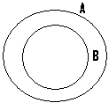
- “if you are a thief, then you are a criminal”.

Solution
Let C = {Criminals}.
T = {Thieves}.
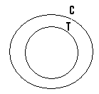
- “All my friends are good boys”.
N/B: The statement implies that if you are my friend, then you are a good boy.

Solution
Let F = {My friends}.
C = {Good boys}.
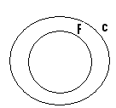
Question 2 Analysis 1
If the statement says that Esi sits on the front row, then Esi can only be found anywhere within the shaded portion of the next diagram.

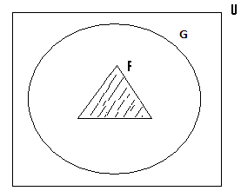
Let U = {Students in the class}.
G = {girls}.
F = {those who sit on the front row}.
Since Esi can be found anywhere within the shaded portion, then the following conclusions can be drawn:
- Esi sits on the front row, since she must be found within the shaded portion.
- Since the shaded portion where Esi can be found lies within the set G, which represents the set of girls, then we can also conclude that Esi is a girl.
- Finally, since the shaded portion also lies within the universal set U, which represents the set of students within the class, then our final valid or true conclusion which can be made is that Esi is a student within the class.

Analysis 2
Assuming that the statement says that Esi is a girl, then she can be found anywhere within the shaded portion.

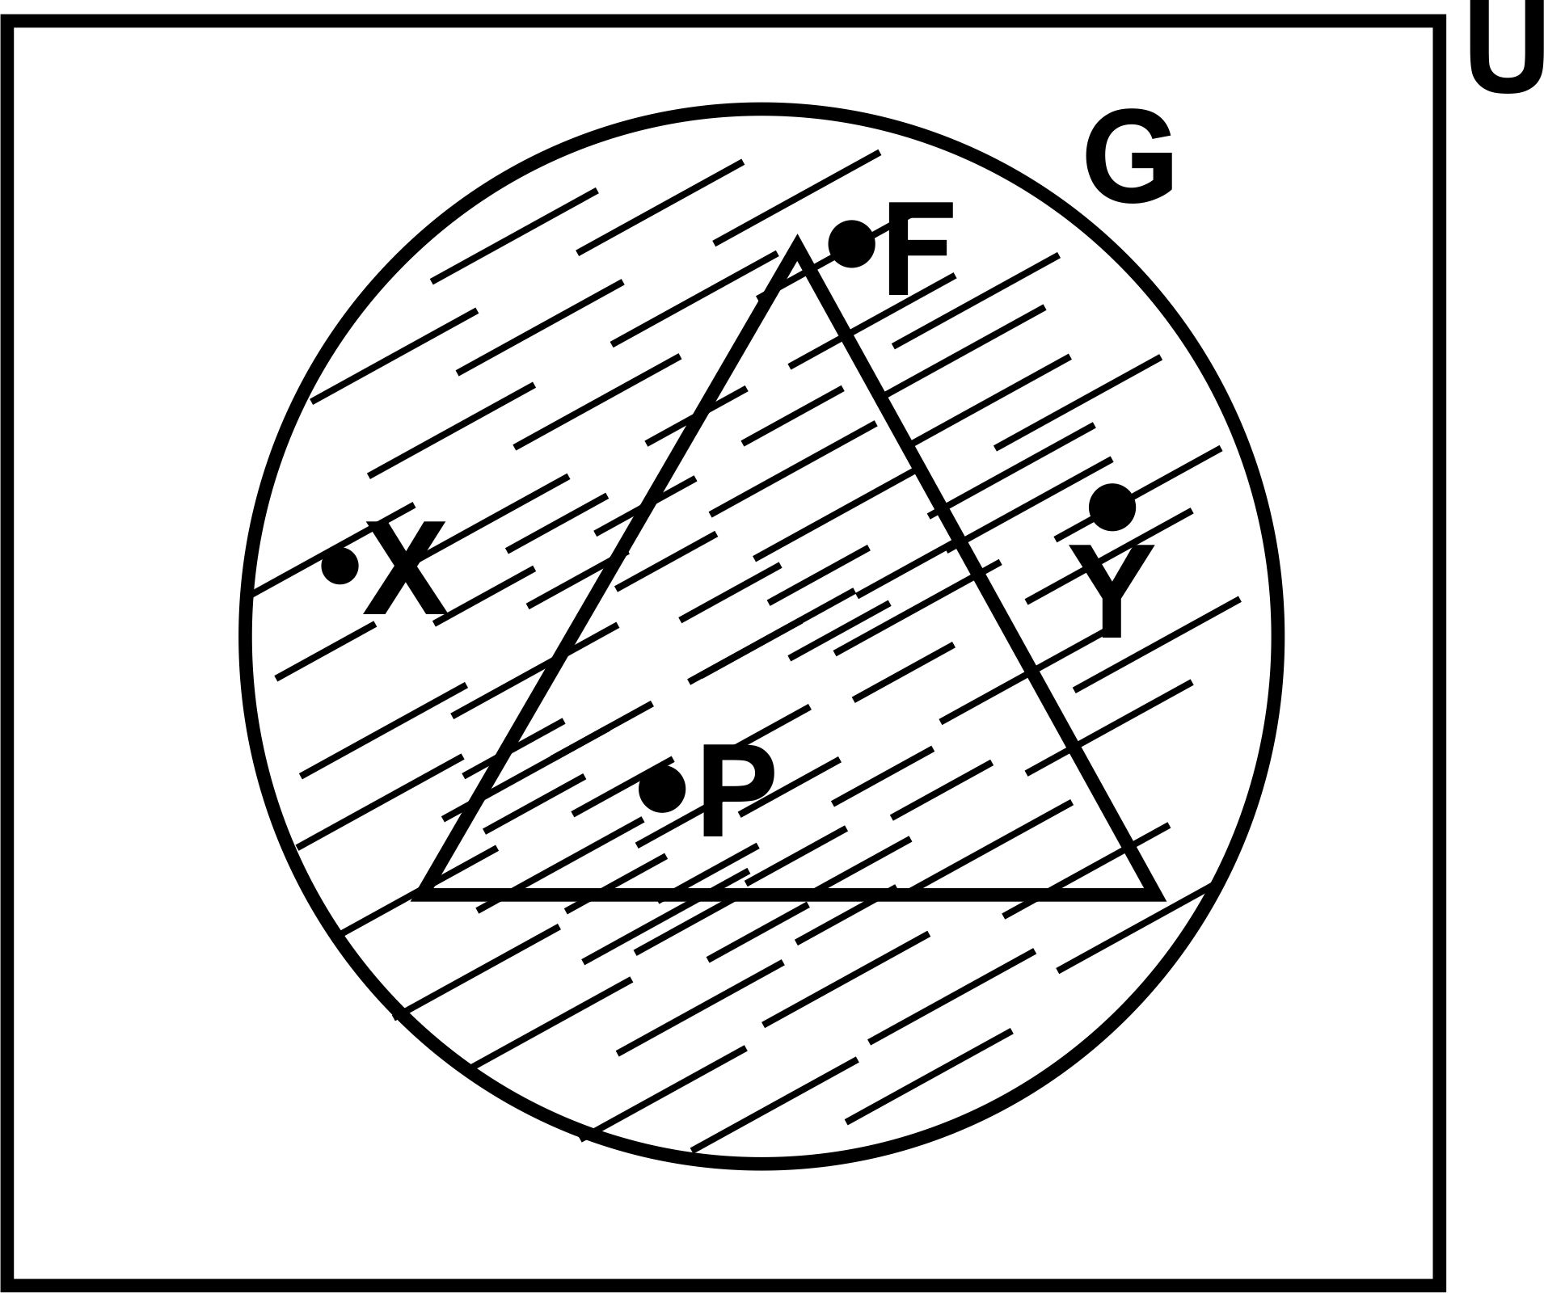

Since the shaded portion where Esi can be found lies within the set U, then we can draw the valid conclusion that Esi is a student in the class. Since Esi can be found at any portion within the shaded portion, then Esi may also be found in the set F or the triangle.

Therefore for the fact that Esi is a girl does not mean that she must be found within the set F.
N/B: Even though in the given answers to the questions, the circle was the symbol used, other geometrical symbols such as triangles, rectangles and squares could have been used.

Logical Analysis:
In solving questions based on logic, the question must be well analyzed from the logical point of view, and not from the normal point of view. Even though a conclusion may seem right from the normal point of view, it may not be correct from the logical point of view.
Analyzing a statement from the logical point of view, may give us a different meaning from the normal point of view. Certain questions on logic can only be solved, by subjecting them to logical analysis. The logical analysis we are going to make next will be centred on the statement: “All those who sit on the front row are girls, and Esi is a girl”.
Example 1
Illustrate the following information on a Venn diagram:
- All those who sit on the front row are girls.
- Esi is a girl.

Solution
Let U = {Students in the class}.
F = {Those who sit on the front row}.
G = {Girls}.
. = Esi.
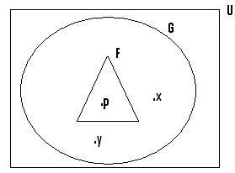
N/B: This Venn diagram is that for the statement: “All those who sit on the front row are girls and Esi is a girl. All that it means is that Esi can be found within the set F or outside the set F, i.e. she must be found within the set G and for this reason to draw the conclusion that because Esi is a girl, then she must sit on the front row i.e. found within the set F will be wrong, invalid or false.
The right conclusion to draw is that Esi may sit on the front row or not.

N/B: If Esi is a girl, then she can be found at the position inside the triangle indicated by the point P, and as such sit on the front row. Also if Esi is a girl, then she can also be found at positions outside the triangle indicated by the points x and y, due to which she cannot sit on the front row.

Analysis 3
Assuming the statement says that Esi is not a girl, then Esi can be found anywhere within the shaded portion of the next diagram, i.e. outside the set G.
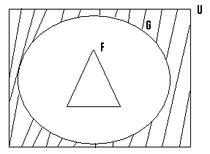
If Esi can only be found within the shaded portion, then she can never be found within the set F or the triangle. Therefore the statement “if Esi is not a girl, then she can never sit on the front row”, will be valid or true.
Since the shaded portion lies within the universal set U, then another valid conclusion we can draw is that, Esi is a student within the class.

Analysis 4
If the statement says that Esi does not sit on the front row, then Esi can be found anywhere within the shaded portion, indicated in the next diagram. In short, she must be found only outside the set F.
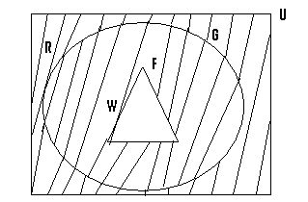
Esi can be found within the set G, at the position indicated by the point w, in which case, she will be a girl, or can also be found at the position indicated by the point R outside the set G or the circle, for which case she is not a girl.
Therefore to conclude that for the fact that Esi does not sit on the front, then she must be a girl or Esi is a girl, will be invalid.
The right or true or valid conclusion to draw is that Esi can be a girl or not a girl, or in short, Esi may possibly be a girl. Also to draw the conclusion that because Esi does not sit on the front row, then she cannot be a girl will also be invalid, since she can be found at the point represented by the point w, for which she can be a girl.

Analysis 5
If the statement is that Esi is a student within the class, then she can be found anywhere within the shaded portion, as shown in the next diagram:
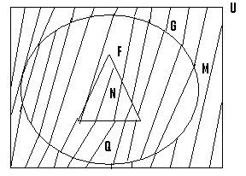
From this diagram the possibilities are that:
- Esi may be found at the position indicated by the point N, for which Esi can be a girl who sits on the front row. To conclude that because Esi is a student in the class, then she must be a girl who sits on the front row will be invalid.
- Esi can be found at the point indicated by the point Q, which indicates that Esi can be a girl who does not sit on the front row. To conclude that Esi is a girl who does not sit on the front row will be invalid.
- Lastly Esi can be found at the point indicated by M, for which we can conclude that Esi may not sit on the front row and may not be a girl. To conclude that Esi must not sit on the front row and will not be a girl will not be valid.

Question 1
- You are given the following statements:
All fishermen are from Bukom.
Mr. Bawa is a fisherman.
Illustrate this information using a Venn diagram.
- Determine which if these statements are true.
i) If Amoo is from Bukom then he is a fisherman.
ii) Since Kwame is not a fisherman, then he cannot come from Bukom.
iii) Because Abu is not from Bukom, then he cannot be a fisherman.
N/B: Bukom is a small town within Accra.

Solution
- Let U = {People from Accra}.
B = {People from Bukom}.
F = {Fishermen}.
. = Mr. Bawa.
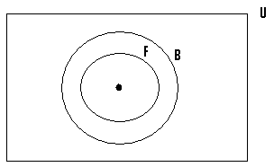
- i. The given statement says that, if Amoo is from Bukom, then he is a fisherman. If Amoo is from Bukom: then he can be found anywhere, within the set B or within the shaded portion in the next diagram:.
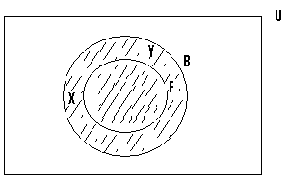
From logical analysis, Amoo can be found within the set F, in which case he will be a fisherman.
At the same time, Amoo can be found outside the set F, at positions indicated by points x and Y, in which case he is not a fisherman. Therefore the fact that Amoo comes from Bukom, does not imply that he is a fisherman.

ii. The given statement is that, since Kwame is not a fisherman, then he cannot come from Bukom. If Kwame is not a fisherman => he can be found anywhere within the shaded portion in the next diagram:
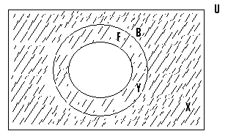
Kwame can be located at the point Y, in which case he will be from Bukom.
Kwame can also be found at the point x, in which case he does not come from Bukom.
Therefore the fact that Kwame is not a fisherman does not necessarily mean that he cannot come from Bukom.
The given statement is therefore invalid.

i) The given statement is that since Abu is not from Bukom, then he cannot be a fisherman.
If Abu is not from Bukom, then he can be found anywhere within the shaded part, with reference to the next diagram:
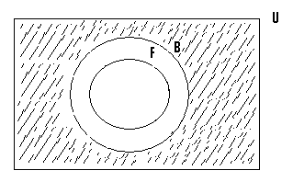
Since Abu can only be found within the shaded portion, then there is no way that he can be found within the set F.
The given statement is valid or true.
N/B: U = the universal set.

Question 2
Consider the following statements:
i) All mathematicians are clever. ii) No clever person is selfish.
- Draw a Venn diagram to illustrate these given statements.
- Determine the validity of the following:
- If Ali is clever => he is a mathematician.
- Since Baba is selfish => he is not a mathematician.
- Because John is not a clever person => he is a selfish person.
- Because I am not a mathematician => I can never be clever.
- Since Esi is not clever =>she is a selfish student.

Solution
- Let U = {Educated people}.
C = {Clever people}.
M = {Mathematicians}.
S = {Selfish people}.
N/B: Since no clever person is selfish => the set c and the set s are separated sets.
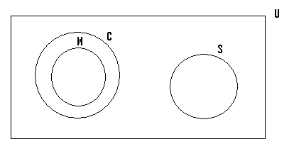
- If Ali is clever => he can be found anywhere, within the shaded portion of the next diagram:
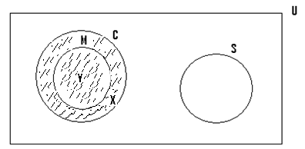
- Ali can be located within the set M at the point Y, in which case he will be a mathematician.
* On the other hand Ali can also be found at the point x, which is outside the set M, in which case he is not a mathematician. Therefore the fact that Ali is clever does not necessarily means that he must be a mathematician.
*The given statement is therefore false or invalid.
- The given statement says that if Baba is selfish, then he cannot be a mathematician.
- If Baba is selfish => he can be found only within the shaded portion of the set S, indicated in the next diagram:
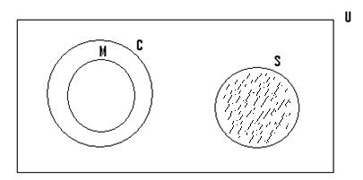
- If Baba can only be found within the shaded portion, then there is no way he can be found in the set M, (i.e he. is a mathematician).
- The given statement is therefore true or valid.
iii. The given statement is that because John is not clever, then he is selfish.
- If John is not clever, then he can be found anywhere within the shaded area, in the next diagram:
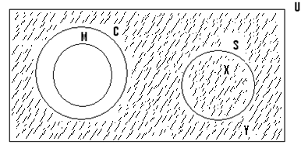
Assuming John is located at the point x, then he is selfish.
John can also be located at other positions outside the set S, such as the point Y, for which he will not be a selfish person.
Therefore the fact that John is not clever, does not necessarily mean that he must be a selfish person. The given statement is therefore false.
iv) The given statement is that because I am not a mathematician, then I can never be clever.
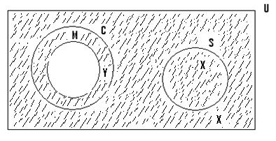
- If I am not a mathematician, then I can be found anywhere within the shaded portion.
- Assuming am located at the point x, then I am not a mathematician and also not a clever person.
- I can also be located at the point Y, in which case I am not a mathematician but a clever person.
- Therefore the fact that I am not a mathematician does not necessarily imply that I can never be a clever person.
- The given statement is therefore false.
i) The given statement is that since Esi is not clever, then she is selfish.
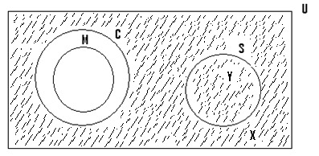
- If Esi is not clever, then she can be found anywhere within the shaded portion.
- Assuming Esi is located at the point x, then she is not clever and also not selfish.
- Now assuming she is located at the point Y, then she is not clever but selfish.
- Therefore the fact that Esi is not clever, does not necessarily mean that she is selfish.
- The given statement is false.

Question 3
You are given the following:
X: All policemen wear uniform.
Y: No civil servant wears uniform.
a)Illustrate this on a Venn diagram.
b) From the Venn diagram, determine the validity of the following: If
1.Bula wears uniform => Bula is a policeman.
2.Since Offei is a policeman => Offei is not a civil servant.
3. Dan is not a civil servant => Dan wears uniform.
4. Enoch is not a policeman => he must be a civil servant.
5. Because Bola does not wear uniform => he is a civil servant.

Solution
- Let & = {People within the community under consideration}.
P = {Policemen}.
C = {Civil servant}.
U = {People who wear uniform}.

- The given statement is that if Bula wears uniform ,
then he is a policeman.
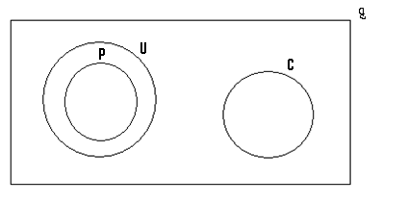
- If Bula wears uniform, then he can be found anywhere within the shaded area.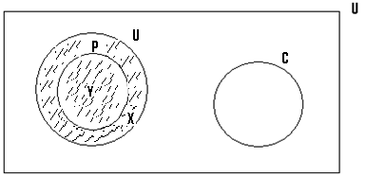
- He can be located at the point Y, in which case he will be a policeman.
- Bula can also be found at the point x in which case he is not a policeman, even though he wears uniform.
- Therefore the fact that Bula wears uniform, does not necessary imply that he is a policeman.
- The given statement is therefore invalid.
- The statement is that since Offei is a policeman,
then he is not a civil servant.
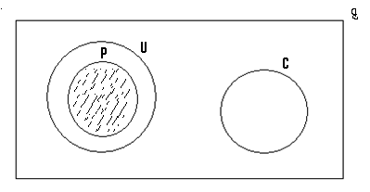
- If Offei is a policeman, then he can only be found within the shaded portion.
- Therefore there is no way that he can be found within the set c.
- The given statement is therefore valid.
2. The statement is that if Dan is not a civil servant, then he wears uniform.
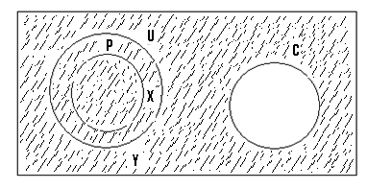
- If Dan is not a civil servant =>he can be found anywhere within the shaded portion.
- If Dan is located at let say the point x, then he wears uniform even though he is not a civil servant.
- Dan can also be located at the point Y, in which case he is not a civil servant and also does not wear uniform.
- Therefore the fact that Dan is not a civil servant, does not necessarily imply that he wears uniform.
- The given statement is therefore invalid or not true.
3. The statement is that if Enoch is not a policeman, then he must be a civil servant.
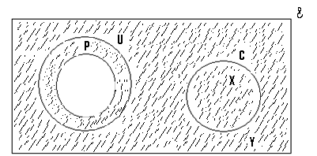
- If Enoch is not a policeman, then he can only be found anywhere within the shaded portion.
- Enoch can be located at the point x, in which case even though he is not a policeman, he is a civil servant.
- It is also possible for him to be located or found at the point Y, in which case he is not a policeman and also not a civil servant.
- The given statement is therefore untrue or false.
- The statement is that because Bola does not wear uniform, then he is a civil servant.
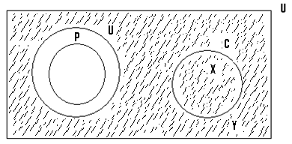
- If Bola does not wear uniform =>he can be found within any part of the shaded portion.
- He can be found at the point x, in which case he is a civil servant who does not wear uniform.
- He can also be found at the point Y, in which case he is not a civil servant, and does not wear uniform.
- Therefore the fact that Bola does not wear uniform, does not necessarily imply that he is a civil servant.
- The given statement is therefore invalid or untrue.

The statement: “All students speak English”, is the same as the statement: “Every student speaks English”.

Question 4
Represent the following statements on Venn diagrams.
- Every Ghanaian is an African.

Solution
Let G = {Ghanaians}.
A = {Africans}.
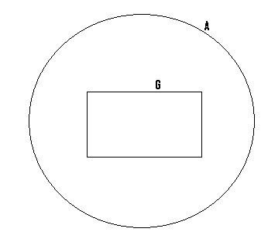
- Every African is a Ghanaian.

Solution
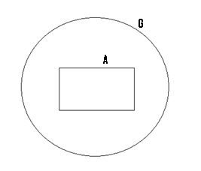
- Every Nigerian is a blackman.

Solution
Let N = {Nigerians}.
B = {Blackmen}.

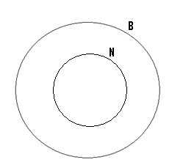
- X: Every Nigerian is a blackman.
Y: Some black men are greedy.

Solution
Let N = {Nigerians}
B = {Blackmen}
G = {Greedy people}
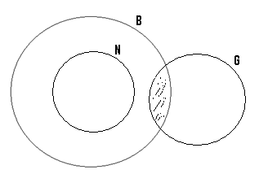
N/B: The shaded portion represents those blackmen who are greedy.

- All my friends are intelligent but some intelligent people are careless.

Solution
Let F = {Friends of mine}.
I = {Intelligent people}.
C = {Careless people}.
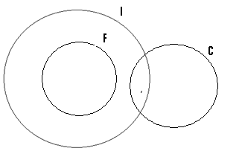
- All my friends are intelligent, but some of my friends are careless.

Solution
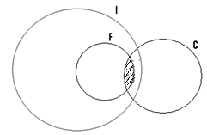
N/B: The shaded portion represents those friends of mine, who are careless.

Question 5
You are given the following statements:
P: Every physics student studies elective maths.
Q: Some of the physics students study chemistry.
- Represent this on a Venn diagram.
- Determine which of these statements are true:
I. There are some students who study all these three subjects.
II..Some chemistry students study elective maths.
III .Since Abu does not study chemistry =>he cannot study elective maths.
IV. If Joan studies elective maths =>she must study chemistry also.

Solution
(a) Let U = {Students in the class}.
P = {Physics students}.
E = {Elective maths students}.
C = {Chemistry students}.
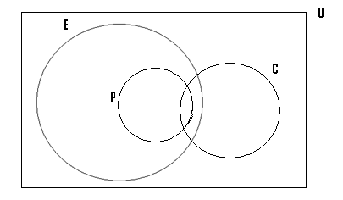
b) (i)
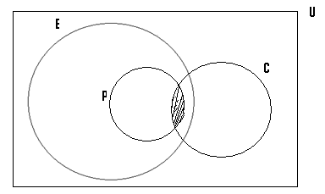
Since the shaded portion represents those who study all the three subjects,’ =>the statement that some students study all the three subjects is true.

(ii)
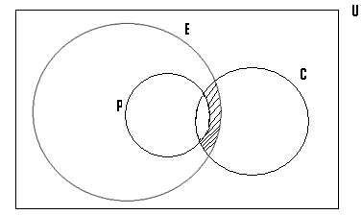
Since the shaded portion represents those who study elective maths and chemistry, => the statement that some chemistry students study elective maths is true.
(iii)
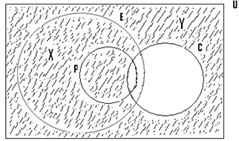
- If Abu does not study or offer chemistry =>he can be found anywhere within the shaded portion.
- If he is found at the point x, then it can be seen that even though he does not offer chemistry, he offers elective maths.
- The given statement that if Abu does not offer chemistry, then he cannot offer elective maths is false.

(iv)
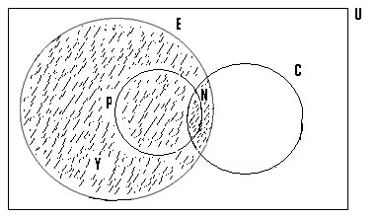
- If Joan studies elective maths =>she can be found anywhere within the shaded portion.
- Assuming she is located at the point N, then she offers chemistry also.
- Now assuming she is located at the point Y, then she offers elective maths and does not also offer chemistry.
- Therefore the statement that if Joan offers elective =>she offers chemistry also is false.

Question 6
Consider the following statements:
P: Some of the physics students study chemistry.
Q: Some of the those students who study physics and chemistry are girls

- Illustrate this on a Venn diagram.
- Determine the validity of the following statements:
- Since Akos studies physics and chemistry, then she is a girl.
- Since Amina is a girl, then she studies chemistry.
- There are girls who study only chemistry.
- Because Esi is not a girl, then she studies physics.
- If I am not a girl, then I cannot study at the university.

Soln.
- Let U = {students within the class}.
P = {Physics students}.
C = {Chemistry students}.
G = {Girls}.

From the first statement, some of the physics students study chemistry.
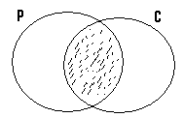

NB: The shaded portion represents those students, who study physics and chemistry.

- From the second statement, some of those who study physics and chemistry are girls
- This implies that the set G = {Girls}, must overlap with part of the shaded portion as shown next:
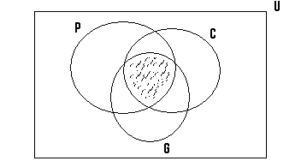
NB: The shaded portion represents those physics and chemistry students, who are girls.
(b)(i)
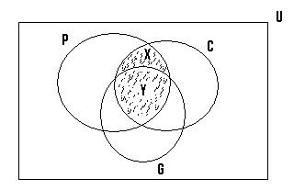
- If Akos studies physics and chemistry => she can be found any where within the shaded portion.
- A person offering physics and chemistry may be located at the point x, for which she is not a girl.
- Therefore the given statement is false

(ii)
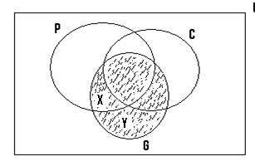
- If Amina is a girl => she can be found anywhere within the shaded portion.
- She can be found at points such as X or Y, in which case she does not offer chemistry.
- The given statement is therefore false

(iii)
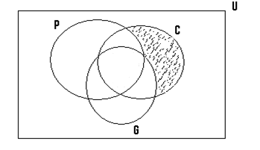
- The shaded part represents those who offer only chemistry.
- From the diagram, it can be seen that there is no girl who offers only chemistry
- The given statement is therefore false

(iv)
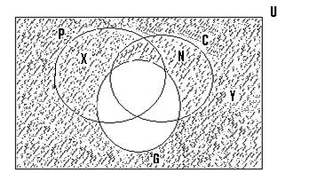
- If Esi is not a girl =>she can be found anywhere within the shaded part.
- If she is found at the point X, then she studies physics
- Also she can be found at the point Y, in which case shedoes not offer physics. The given statement is therefore false.

(v) This statement is false, since it is not out of context i.e. it has no relationship with the topic under consideration.

Q7. Consider the following statements:
W: Some students are hardworking.
Z: Some hard working students are not careless.
a) Draw a Venn diagram to illustrate the above statements.
b) State whether the following conclusions are valid or not from the statements.
W and Z.

- If Jacob is careless => Jacob is hardworking.
- Zoe is hardworking => Zoe is careless.
- Owusu is not a student => Owusu is not careless.

Soln:
S = {Students}.
H = {Hardworking people}.
C = {People who are not careless}.

Consider the first statement i.e. W: Some students are working. Representing this diagrammatically gives us.
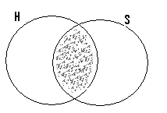
NB: The shaded portion represents those students who are hardworking.

Consider the other given statement, i.e. Z: Some hardworking students are not careless.
- This implies part of the shaded portion should be found within the circle or the set which represent those who are not careless.
- Our final diagram therefore becomes as shown next
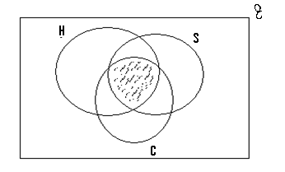
NB: The shaded portion represents those hardworking students, who are not careless.
(b) (i) The given statement is that if Jacob is careless => Jacob is hardworking.
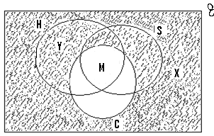
NB: Since those within the set C represents those who are not careless. (i.e. those who are careful) => the region outside it represents those who are careless.
- Therefore if Jacob is careless => he can be found anywhere within the shaded portion.
- If he is found at the point Y, then he is hardworking.
- On the other hand, he can be found at the point X, in which case he is not hardworking.
- Therefore the statement that if Jacob is careless => he is hardworking is false.

(ii) The statement states the if Zoe is hardworking => he is careless
- With the reference to the previous diagram, if Zoe is hardworking => he can only be found within the set H.
- Assuming he is located at the point Y, then he is careless
- Zoe can also be located at the point M, in which case he is not careless, since this area falls outside the shaded portion which represents those who are careless
- Therefore the given statement that if Zoe is hardworking => he is careless is false

(iii) The statement is that if Owusu is not a student => he is not careless
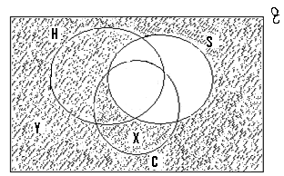
- If Owusu is not a student, then he can be found anywhere within the shaded portion .
- Assuming he is found at the point X, then he is not careless.
- Assuming now Owusu is located at the point Y, then he is careless.
- Therefore the statement that if Owusu is not a student => he is not careless is false.

Q8.
Consider the following statements:
X: Some students are hardworking.
Y: All the hardworking students passed their exams.

- Represent this on a Venn diagram.
- Using your diagram determine which of these statements are true:

- All those who passed their exams are hardworking.
- Eventhough some students did not work hard, they passed their exams.
- Since Abiba is not hardworking, she can never pass her exams.
- Some hard working people were not students and also failed to pass the exams.

Soln:
S = {Students}.
H = {Hardworking students}.
P = {Those who passed their exams}.

From the first statement, some students are hardworking. The diagram drawn from this is as shown next:
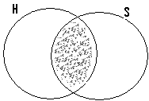
Where the shaded portion represents those students who are hardworking.
- From the second statement all the hardworking students passed their exam. This implies that the whole of the shaded portion must be found within the set P as shown in the next diagram:
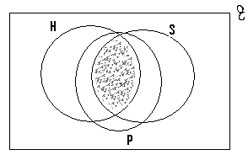
(i)
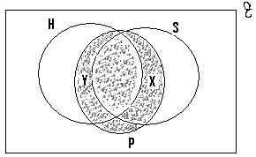

- If a person passes his exams, then he should be found within the shaded part.
- Assuming he is found at the point Y, then he is hard working
- He can also be found at the point X, for which even though he is not hardworking, he passed his exams
- Therefore the statement that all those who passed are hardworking is false

(ii) With reference to the diagram just drawn, a student located at a point such as X passed, even though he did not work hard.
- The statement that some student did not work hard, but passed their exams is true.

(i)
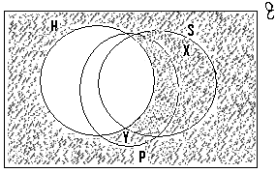
- The shaded portion represents those who are not hardworking.
- If Abiba is not hardworking, then she can be located at the point Y, which indicates that she passed the exams even though she did not work hard.
- The statement that if Abiba did not work hard she can never pass her exams is false.
(iv)
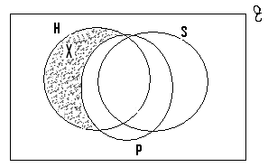
- Consider a student who is located at the point X, which lies within the shaded portion
- Since those located within the shaded portion were not students who were hardworking and also did not pass the exams, then the given statement is true.
NB: One may end up drawing the Venn diagram as shown next which is wrong:
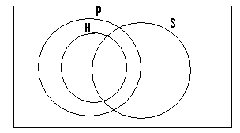
- From this diagram we can conclude that some of the hardworking students passed the exams, which is indicated in the question
- But we can also conclude that some of the hardworking people passed their exams, which the question does not say so.
- For it states that the all the hard working students passed their exams.

Q9.
Consider the following statements:
X: Not all Ghanaians are clever.
Y: Some Nigerians are clever.
- Represent this on a Venn diagram.
- Determine the validity of the following:
i) If Kofi is clever then he must be either a Ghanaian or a Nigerian.
ii) Since Esi is not a Ghanaian, then she can never be a Nigerian.
iii) There are some clever people who are neither Ghanaians nor Nigerians.
iv) Because Abu is a Ghanaian, he will dance everyday.

Let U = {Africans}.
G = {Ghanaians}.
N = {Nigerians}.
C = {Clever people}.

NB: Not all Ghanaians are clever => some Ghanaians are clever.

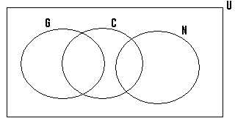

(b)(i)
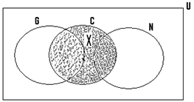
- If Kofi is clever => he can be found anywhere within the shaded portion
- If he happens to be located at the point X, then we can see that even though he is clever, he is neither a Ghanaian nor a Nigerian
- The given statement is therefore invalid.
(ii)
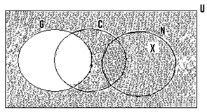
If Esi is not a Ghanaian, then she can be found anywhere within the shaded portion. Assuming she is located at the point X, then she is a Nigerian.

The given statement is therefore false or invalid.

(iii)
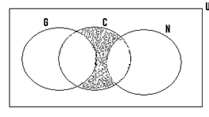
- Consider the people who are located within the shaded portion.
- Even though they are clever, they are neither Ghanaians nor Nigerians.
- The given statement is therefore valid.
(iv) The given statement is invalid since it is out of context.

(Q10)
- Represent the following prepositions on a Venn diagram.
P: All soldiers are men.
Q: There is no soldier who does not have a gun.
- Using your diagram, determine the validity of the following:
- Tunde has a gun => Tunde is a soldier.
- Olufetu is a man => he is a soldier.
- Akosua is a woman => Akosua has no gun.

NB: There is no soldier who does not have a gun => All soldiers have guns.

Hint:
- Let U ={People}.
M = {Men}.
S = {Soldiers}.
G = {People who have guns}.

From the first statement, all soldiers are men => The set S must be found within the set M.
i.e.
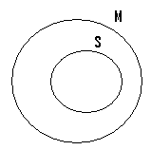
From the second statement, the implication is that all soldiers have a gun => the set S must also be found within the set G.
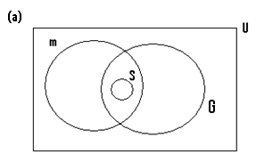

The equivalence Symbol:
Example (1).
Consider the following statement: "If you are a pilot then you can fly a plane”. Let P = { if you are a pilot}.
Q = then you can fly a plane.
P q means that if you are a pilot, then you can fly a plane, which is true.
q p means that if you can fly a plane, then you are a pilot, which is also true.
Since P q is true and q p is also true, then we write p<=>q , where <=> is called the equivalence symbol.
This symbol is only used for a statement which is true and its reversed form is also true.
Example (2).
Consider these statements:
P:If you are a Ghanaian.
q : Then you come from Ghana.
p q means that if you are Ghanaian, then you come from Ghana, which is true.
q means that if you come from Ghana, then you are a Ghanaian, which is also true.
Since p q and q are both true, then we write p<=>q.
Example (3).
Consider the following statements:
X: If you are the pope.
Y: Then you are the head of the Catholic Church.
X=>Y means that if you are the pope, then you are the head of the Catholic Church.
Y =>X means that if you are the head of the Catholic Church, then you are the pope.
Since both X=>Y and Y =>X are true, then we write X<=>Y.
The term "if and only if" has the same meaning as the equivalence sign.
Therefore the p<=>q can also be written as, or has the same meaning as p if and only if q.

(Q1) Write the following statements in symbols:
- If you are a criminal, then the police will arrest you.
Soln.
Let p= If you are a criminal.
Q = the police will arrest you.
Since p=>q is true and q=>p is also true, then we write p<=>q.
- Only science students study elective maths and vice versa.
Soln.
Let p= students who study science.
q= students who study elective maths.
Since only science students study elective maths, then p => q.
Also due to the use of vice versa => only maths students study science, and as such q=>p.
Since p=>q and q=>p are both true, then we write p<=>q.
- All the prefects wear blue shirts and they are the only people who do so.
Soln.
Let X= A person is a prefect
Y= then he wears blue shirt.
Since X => Yis true and Y =>X is also true, then we write X<=>Y.
- You will pass your exams if and only if you study hard.
Soln.
P: You will pass your exams
q: If you study hard.
Due to the term if and only if, we can write p<=>q, since p=> q and q=>p are both valid and true.
Negation:
The negation symbol =
Example (1):
If q = it rained yesterday, then q = it did not rain yesterday.
Example(2)
If z = He fell yesterday, then z= he did not fall yesterday.
If you are given that p=>q or if p then q, then the following rules must be noted:
- q =>p is false.
- q => p is true
- P => q is false.
Therefore given that p=>q or if p then q, it is only q => p which is true.
(Q1) Consider the following statements:
P: Abena has measles.
q: Abena is in hospital.
If p=>q, state whether or not the following are valid:
- If Abena is in hospital, then she has measles.
- If Abena is not in hospital, then she does not have measles.
- If Abena does not have measles, then she is not in hospital.
N/B: Write each of these given statements using symbols.

Soln.
P = Abena has measles.
q = Abena is in hospital.
a) If Abena is in hospital, then she has measles. Symbolically, this statement means that q => p, which is false. The given statement is therefore false.
b) If Abena is not in hospital then she does not have measles. Abena is not in hospital is q.
Abena does not have measles is p.
The given statement symbolically means q => p which is valid, => the given statement is true.
- If Abena does not have measles then she is not in hospital. Abena does not have measles is p, and Abena is not in hospital is q. The given statement therefore means that p => q which is invalid. Therefore the statement is false.
N/B: p => q is always valid.
(Q2) Consider the following statements:
p: Kweku trains hard
q: Kweku wins the race.
Given that p => q or if p then q is true, which of these statements or statement are valid or is valid.
- If Kweku wins the race then he has trained hard.
- If Kweku does not train hard, then he will not win the rice.
- If Kweku does not win the race, then he has not trained hard.

Soln.
P = Kweku trains hard.
q = Kweku wins the race.
- If Kweku wins the race then he has trained hard, symbolically means that q => p which is invalid.
- If Kweku does not train hard, then he will not win the race.
Kweku does not train hard is p, and Kweku does not win the race
is q.
Therefore the given statement means that p => q which is false. The given statement is therefore false.
- If Kweku does not win the race, then he has not trained hard. Kweku does not win the race is q, and Kweku has not trained hard is p. The given statement means that q => p which is valid. The given statement is therefore true or valid.
The relative of an implication:
Three common conditionals are often associated with the conditional. p=> q and these are :
- The converse of p => q which is q => p.
- The inverse of p => q which is p => q.
- The contrapositive of p => q which is q => p.
Example:
Consider the following statements:
Since he was a wanted person, he was arrested by the police.
Let p= since he was a wanted person
q = He was arrested by the police.
- The converse of this statement which is q => p will be :
He was arrested by the police, since he was a wanted person.
- The inverse of the statement which is p => q will be:
Since he was not a wanted person, he was not arrested by the police.
- The contrapositive which is q => p will be:
He was not arrested by the police, since he was not a wanted person.
Example(2): Consider the given statement:
I went to the farm yesterday because I did not go to school.
P= I went to the farm yesterday
q = Because I did not go to school.
- The converse of this statement which is q => p i.e: Because I did not go to school, I went to the farm yesterday.
- The inverse which is p => q is: I did not go to farm yesterday because I went to school.
- The contrapositive, i.e. q => p will be: Because I went to school, I did not go to farm yesterday.
The chain rule:
(Q1) Consider the following statements:
X: If X is a thief => he is a criminal.
X: If X is a criminal => he is dangerous.
X: If X is dangerous => he is in prison.
- Form the chain rule.
- Determine the validity of the following statement.
- Since Kofi is a thief, then he is a criminal.
- Because Abu is a thief then he is in prison.
- If a person is in prison, then he is dangerous.
- If Kofi is in prison then he is a criminal.
- Amadu is a criminal and as such he must be in prison.
N/B: - With reference to chain rule, the arrangement of the given statements determines the validity or invalidity.
* If the arrangement is such that movement is from the left hand side to the right hand side direction, then the conclusion will be true or valid. i.e =>
* On the other hand if this arrangement indicates movement from the right hand side to the left hand side direction i.e <= , then our conclusion will be invalid.
- The rule which can be formed is as follows: If X is a thief => he is a criminal => he is dangerous => he is in prison.
- Consider the given statement i.e. since Kofi is a thief, then he is a criminal.
Because the statement Kofi is a thief, comes before the statement then he is a criminal, the movement is from the left hand side to the right side => the given statement is valid.
(b) Consider the statement given i.e. because Abu is a thief then he is in prison. With reference to the chain rule formed, the first statement which is Abu is a thief, comes before the second statement i.e. then he is in prison, then movement is form the left hand side to the right hand side => the given statement is valid.
(c) Here the first statement is: If a person is in prison and the second one is: Then he is a criminal. With reference to the chain, the second statement comes before the first one => movement is from the right hand side to the left hand side => the given statement is invalid.
(d) The first statement is: If Kofi is in prison.
The second statement is: Then he is a criminal
The second statement comes before the first one => the statement is invalid, since movement is from the right hand side to the left hand side.
- The first statement is: Amadu is a criminal.
The second one is: And as such he must be in prison.
The first one comes before the second one i.e movement is from the left to the right => the given statement is valid.
(Q2) Consider the following statements:
Y: X speaks Twi => X is from Ghana.
Y : X is from Ghana => X is a Ghanaian.
Y: X is a Ghanaian => he is an African.
- Write down the chain rule.
- Determine the validity of the following:
- Since i speak Twi => I am an African.
- If Ziggy is an African =>he speaks Twi.
- If Amoo speaks Twi => he is from Ghana.
- Because Amina is from Ghana => She speaks Twi.
Soln.
- X speaks Twi => X is from Ghana => X is a Ghanaian => X is an African.
- (i) The first statement = I speak Twi.
The second statement = I am an African.
Since the first statement comes before the second one, movement is from left to right, with reference to the chain rule. The statement is therefore valid.
(ii) The first statement = If Ziggy is an African.
The second statement = He speaks Twi.
Here, the second statement comes before the first one => movement is from the right hand side to the left hand side. The statement is therefore invalid.
- a)The first statement = Amoo speaks Twi.
The second statement = He is from Ghana.
The first statement comes before the second one => the given statement is valid.
- First statement = Amina is from Ghana
Second statement = She speaks twi.
The second statement comes before the first one.
The statement is invalid, since movement will be from to right to left.

Questions:
You are given the following statements:
All my friends are boys.
Some boys are stubborn.
a) Represent this on a Venn diagram.
Ans:
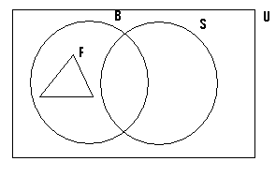
U = {People}.
B = {Boys}.
F = {Friends of mine}.
S = {Stubborn people}.
a)Determine the validity of the following:
i) Because John is stubborn, he cannot be a friend of mine. Ans: Valid.
ii) Since Kofi is a boy, then he is a friend of mine. Ans: Invalid.
iii) Since Amina is not a boy, then she can never be stubborn. Ans: Invalid.
iv) Kojo is not my friend and so he cannot be a stubborn boy. Ans: Invalid.
v) None of the stubborn bad boys happened to be a friend of mine. Ans: Valid.
vi) Because Afum is not a stubborn person, then he can be a friend of mine. Ans: Valid.
(Q2) Consider the following statements:
X: Every European is a white person.
Y: Some European are tall.
- Represent this information on a Venn diagram.
Ans:
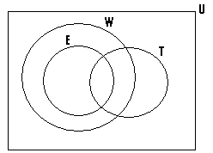
U = {People on earth}.
W = {White people}.
E = {Europeans}.
T = {Tall people}.
a) Which of these statements is true.
i) Mr. Nash is white => he is an European. Ans: Invalid.
ii) Kate is an European => She is white in colour. Ans: Valid.
iii) Mr. Gibbs is also an European => he is white and tall. Ans: Invalid.
iv) Miss Simpson is not an European => She can never be a white person. . Ans: Invallid.
v) John is not a tall person => he cannot be a white man. Ans: Invalid
vi) There are some tall people, who are white and also Europeans.
Ans: Valid.
(Q3) Consider the following statements:
X: Every policeman is a strong person.
Y: There is no strong person who is a thief.
a) Represent this on a Venn diagram.
Ans:
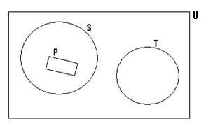
U = {People}.
S = {Strong people}.
P = {Policemen}.
T = {Thieves}.
- Determine the validity of these statements:
I) Some strong people are thieves. Ans: Invalid.
ii) Because I am not strong, then I cannot be a police man. Ans: Valid.
iii) Since John is not a thief, then he cannot be a policeman. Ans: Invalid
iv) There is no policeman who is a thief. Ans: Valid.
V) Since Amoo is not a policeman, then he cannot be a thief. Invalid
v) Every strong person is a policeman. Ans: Invalid.
(Q4) You are given the following statements:
X: All the Physics students offer Elective Maths.
Y: There is no Physics student who does not offer Chemistry.
- Represent this on a Venn diagram.
N/B: There is no Physics student who does not offer Chemistry, => all Physics students offer Chemistry.
Ans:
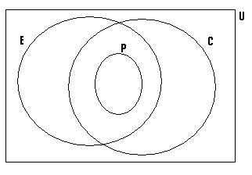
U = {Students in the school}.
E = {Elective Maths students}.
P = {Physics students}.
C = {Chemistry students}.
- Determine the validity of the following statements:
i) There are some students who offer only Chemistry and Elective Maths. . Ans: Valid.
ii) Because Kwame offers Physics, then he must also offer Chemistry.
Ans: Valid.
iii) Since Adjoa is a Chemistry student then she must also be a Physics student. Ans: Invalid.
iv) John is not an Elective Maths student and so he cannot be a Chemistry student. Ans: Invalid.
v) Kofi does not offer Elective Maths, and so he cannot be a physics student. Ans: Valid.
(Q5) Consider the following statement: If you will attend the party, then I will give you the shoes. If p => q, determine which of these statements is valid.
- Esi attended the party and was given the shoes. Ans: Valid.
- Amina was given the shoes since she attended the party. Ans: Invalid.
- Joan was not given the shoes because she failed to attend the party. Ans: Valid.
- Kofi was not given the shoes even though he attended the party. Ans: Invalid.
- Mr. Annoh travelled to Kumasi since he was sick. Ans: Invalid.
(Q6) Consider the following statements:
P= If the frog is not a reptile.
Q: Then it is an amphibian.
Given that if p then q is true, determine which of these statements is true.
- Because the frog is not an amphibian, then it is a reptile. Ans: Valid.
- Since the frog is not an amphibian then it not a reptile. Ans: Invalid.
- The frog is an amphibian since it is not a reptile. Ans: Invalid.
- If the frog happens not to be an amphibian, then it is also not a reptile. Ans: Invalid.
- If Kofi`s frog is not a reptile, then it is an amphibian. Ans: Valid.
(Q7) Consider this statement:
You will be cast into prison, if and only if you commit a crime.
- Since John is in prison, then he had committed a crime. Ans: Valid.
- Abu is not in prison because he has committed no crime. Ans: Invalid.
- Because I have not committed any crime, I am not in prison. Ans: Valid.
- Because Abiba committed that crime, she has been thrown into prison.Ans: valid.
- Because Aboagye did not steal the book, he was not thrown into prison. Ans: Valid.
- Since Abu visited the prison, he saw the prisoners in their cells.
Ans: Invalid or out of context.
- Alice did well in the examination and so her parents were happy. Ans: Invalid or out of context.
(Q8) You are given the following statements:
- If X is in hospital => X is sick.
- If X is sick => X will be treated by the doctor.
- If X is treated by the doctor => X will be given drugs.
- If X is given drugs => X will get well.
- Write down the chain rule.

Ans:
If X is in hospital => X is sick => X will be treated by the doctor => X will be given drugs => X will get well.b) Determine which of these statements is true.
i) Because Kofi is in the hospital => he will be given drugs. Ans: True.
Ii) Since Esi was treated by the doctor => she will get well. Ans: True.
iii) Because Akos got well, then she was treated by the doctor. . . Ans: False.
iv) Ama was treated by the doctor since she was in the hospital. . . . Ans: False.
v) Since John was given drugs, he got well. Ans: True.
vi) Because Amina was given drugs, then she was treated by the doctor. . Ans: False.
(Q9) Consider the following statements:
X: I f X is clever => X will do well in exams.
X: If X does well in exams =>X will be given a prize.
X: If X is given a prize => X will be encouraged to study harder.
(a) Form the chain rule.
Ans: If X is clever => X will do well in exams => X will be given a prize => X will be encouraged to study harder.
(b) Determine which of these statements are valid.
(i) Because John is clever, he will be encouraged to study harder. . . . Ans: Valid.
(ii) Because she won a prize, Esi was encouraged to study harder. . Ans: Valid.
(iii) If Joan is clever, then she will win a prize. Ans: Valid
(iv) Esi was given a prize because she is a clever girl. Ans: Invalid.
(v) John did well in the exams and so he was given a prize. Ans: Valid.
(Q10) Consider the following statements:
X: Some Elective Maths students offer Chemistry and Physics.
Y: There is no Physics student who offers Chemistry.
- Illustrate this on a Venn diagram.
Ans:
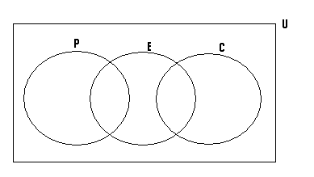
U = {Students in the school}.
P = {Physics students}.
C = {Chemistry students}.
E= {Elective Maths students}.
b) Determine the validity of the following statements:
I) There is no student who offers a combination of Physics, Chemistry and Elective Maths. Ans: Valid.
II) Because John does not offer Chemistry, then he can also not offer only Elective Maths. Ans: Invalid.
III) A student offering Chemistry, either offers only Chemistry or a combination of Chemistry and Elective Maths. Ans: Valid.
IV) Since Kofi does not offer Physics, then he can never offer a combination of Chemistry and Elective Maths. Ans: Invalid.
- Because Justina is an Elective Maths student, then she is also a Physics student. Ans: Invalid.
(Q11) Consider the following statements:
X: Every monkey is an animal.
Y: All apes are monkeys.
Z: Some apes are dangerous.
- Represent this on a Venn diagram.
Ans:
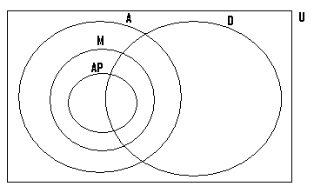
Let U = {Living things}.
A = {Animals}.
M = {Monkeys}.
AP = {Apes}.
D = {Dangerous creatures}.
b) Determine whether or not the following statements are true or false.
i) There are dangerous monkeys. Ans: True
ii) If an animal is not an ape, then it cannot be a monkey. Ans: False.
iii) All monkeys are apes. Ans: false
iii) Since my pet is not a monkey, then it is not an ape. Ans: True.
iv) Every ape is an animal. Ans: True.
v) Because this animal is not an ape, then it cannot be dangerous.
Ans: False

