**CHAPTER FIFTEEN**

**CONSTRUCTION**

**Areas of some geometrical figures:**

**Rectangles:**

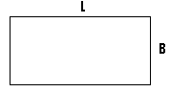

L = the length.

B = the breadth or width.

The area = L $×B$.

**Triangle:**

* This is a three sided figure.

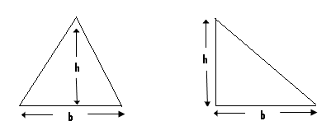

The area = $\frac{1}{2}$ b $×$ h = $\frac{b ×h}{2}$ where b = the base and h = the height.

**Parallelogram:**

* This is a four shaded figure, in which both pairs of its opposite sides are parallel.

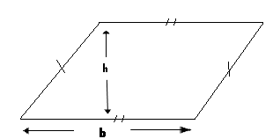

The area of a parallelogram = b $×$ h, where b = the base and h = the height.

**The trapezium:**

* This is a four sided figure, which has its pair of opposite sides being parallel.

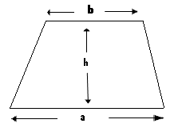

Area = $\left(\frac{a+b}{2}\right)×h,$ where h = the height and a and b are the parallel sides.

Angles:

* An angle is formed when two straight line meet at a point.

Example:

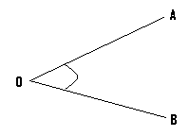

* In the above given figure, the lines OA and OB meet at the point O.
* The angle formed is angle AOB or angle BOA.
* Angle AOB can be written as <AOB or AOB , while angle BOA can be written as <BOA or BOA.

**BISECTION OF ANGLES:**

* To bisect a given angle means to divide it into two equal parts.

Examples(I):

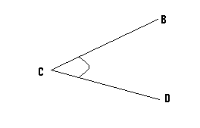

In the given figure, bisect <BCD.

Steps:

(I)

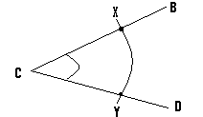

* Open your compass to a suitable length, and with its pin positioned at C, draw an arc to cut line CB at point X and line CD at point Y.

(II)

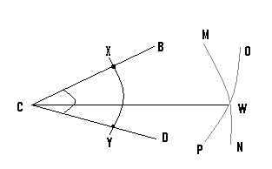

* Open your compass to a greater length and with its pin now positioned at point X, draw arc OP.
* With the same length and the pin now positioned at the point Y, draw arc MN and let the meeting point or the point of intersection of these two arcs be W.
* Finally draw a line to pass through the points C and W.
* By so doing, we have bisected <BCD.

**The bisector:**

* This may also be referred to as the perpendicular bisector.
* The bisector can be drawn to pass through a line, and by so doing, it will divide the line into two equal parts or lengths.
* On the other hand, a bisector can be drawn to pass through a given point.

**Construction of the bisector of a line:**

Example:



Line AB is of length 6cm. Construct the bisector of this line.

Steps:

(a)

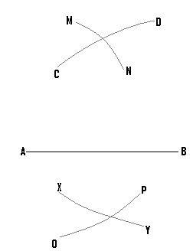

* Open your compass to a suitable length, and with its pin positioned at point B, draw arcs CD and XY.
* Using the same length and the pin now positioned at point A, draw arcs MN, and OP.

1. Finally draw a line to pass through the meeting points, or the points of intersection of the various arcs.

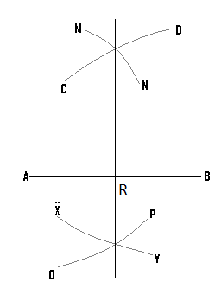

N/B: AR = RB.

**Bisector which passes through a given point:**

Example:



Construct the perpendicular bisector which passes through the point B.

Steps:

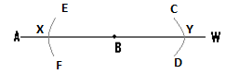

* Open your compass to a suitable length, and with the pin positioned at point B, draw arcs CD and EF.

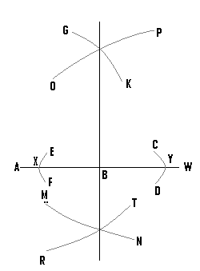

* Open the compass to a greater length, and with the pin positioned at point Y, draw arcs OP and MN.
* Using the same length and with the pin now positioned at point X, draw arcs GK and RT.
* Finally a line drawn to pass through the points of intersection of the various arcs, which is the bisector, will pass through the point B.

**Locus of points equidistant from two points:**

* Equidistance means equal distance.
* To construct the locus of points which are equidistant from two points, is to determine the various points which are of equal distance away, from these two points.

Examples:

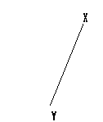

Construct the locus of all the points, which are equidistant from X and Y.

Steps:

(1)

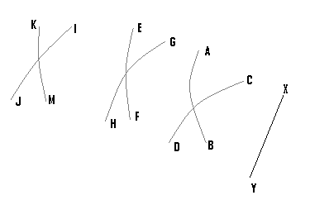

* Open your compass to an appropriate length, and with the pin positioned at the point X, draw arc AB.
* Using the same length and with the pin now positioned at the point Y, draw arc CD.
* Open your compass to a different or a greater length, and with the pin position at point X, draw arc EF.
* Using the same length and with the pin now positioned at the point Y, draw arc GH.
* Using a different length and the same procedure, we construct arcs JI and KM.

(2) Finally draw a line to pass through all the points of intersection, of all the arcs.

N/B: Locus is normally represented by a broken line.

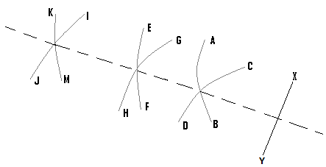

* The broken line is the locus of the points, which are equidistant from the points X and Y.
* Also any point on this line will be equidistant from X and Y.

**Locus of points equidistant from two lines:**

* In order to get such a locus, we bisect the angle between these two lines.

Examples:

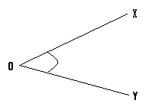

Construct the locus of the points, which are equidistant from the lines OX and OY.

Steps:

* Bisect <XOY.

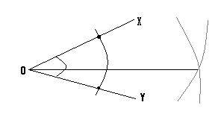

* The required locus is represented by the straight line, and any point on it will be at equal distance away from OX and OY.

Construction of angle 900:



With reference to line AB, construct angle 900 at the point X.

Steps:

(1)

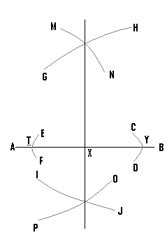

* Open your compass to a small length, and with the pin positioned at point X, draw arcs CD and EF.
* Open your compass to a greater length, and with the pin positioned at point Y, construct arcs GH and IJ.
* Using the same length and with the pin now at point T, draw arcs MN and OP.

1. Draw a line to pass through the point X, and the points of intersection of the various arcs.

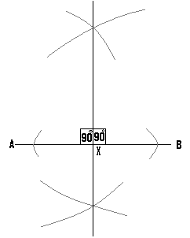

(Q1)(a) Using a ruler and a pair of compasses only, construct triangle ABC, such that <ABC = 900, BC = 7cm and AB = 5cm.

(b) Construct locus P1 of points which are 3cm away from B.

N/B:

* Ensure that the angle lies on the horizontal line, since this will make the work easy.
* It is also advisable to make a rough sketch of the diagram first.

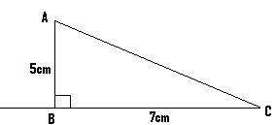

Soln:

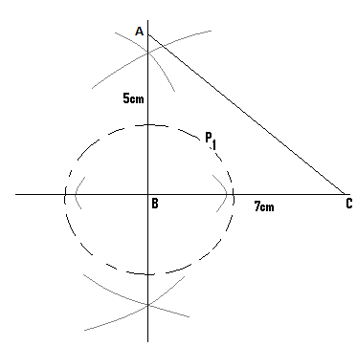

1. Open your compass to a length of 3cm, and with the pin positioned at the point B, construct locus P1 which is represented by the broken line.

**Construction of angle 450:**

* To construct angle 450 at a given point, we first construct angle 900 at that point.
* The angle 900 is then bisected to get angle 450.

Example:



Construct angle 450 at X.

Step(1)

* This involves the construction of angle 900 at the point X.

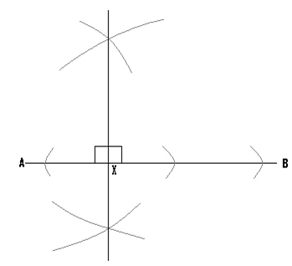

Step(2)

* Bisect the 900 to get 450.
* Since there are two angles of value 900, the one bisected depends on where we want the 450 angle to lie.

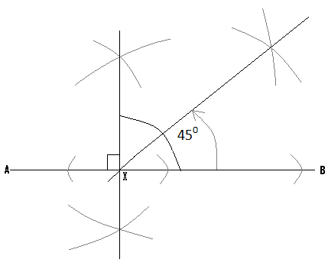

* Using an appropriate length and with the pin at point X, draw arc OP and open the compass to a greater length.
* Positioning the pin at point H and then at point J, draw arc EK and arc VW and let Y be their point of intersection.
* Finally from X, draw a line to pass through point Y.

(Q1)(a) Using ruler and compass only, construct MKF in which <MKF = 750, MFK = 600 and KF = 5CM.

1. Using K as centre draw a circle of radius 3cm.

Hint:

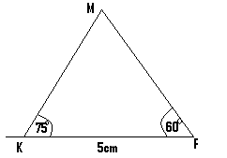

Soln:

N/B: - First construct angles 450 and the 600.

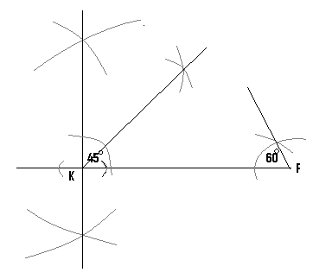

* In addition to angle 450, we construct angle 600 and bisect it to get angle 300.

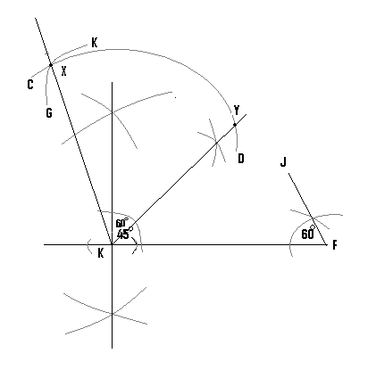

* Using a suitable length and with the pin positioned at K, draw arc CD.
* With the same length and the pin now positioned at point Y, draw arc GK and let X be the meeting point of these two arcs.
* From point K, draw a straight line to pass through the point X.
* The angle just constructed is angle 600.
* In the final stage, bisect the angle 600 to get angle 300.

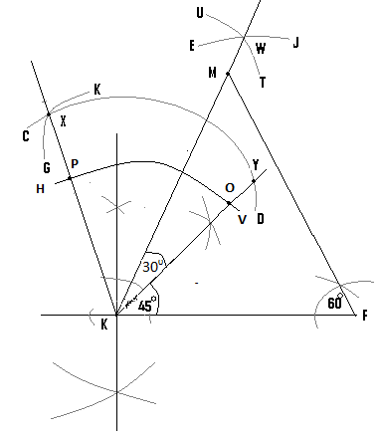

* Using a suitable length and from point K, draw arc HV.
* Using a greater length and from point P and O, draw arcs UT and EJ and let them meet at point W.
* Finally from K, draw a straight line to pass through W.
* Extend the line FJ to meet this straight line and let their meeting point will be point M.

N/B: It is only this final diagram which is necessary to be drawn.

(Q2)(a) Using ruler and a pair of compasses only, construct ABC in which AB = 6cm, BC = 5cm and <ABC = 750.

(b) Locate the point D, such that CD is parallel to AB and D is equidistant from A and .

(c) Construct the perpendicular line to meet AB at E.

(d) Measure CE .

Hint:

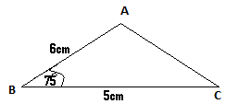

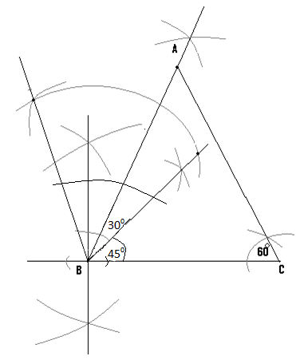

(b) – CD is parallel to AB.

- To locate the position of D, open the compass to the length of AB i.e. 6cm, and with the pin at C draw arc EF.

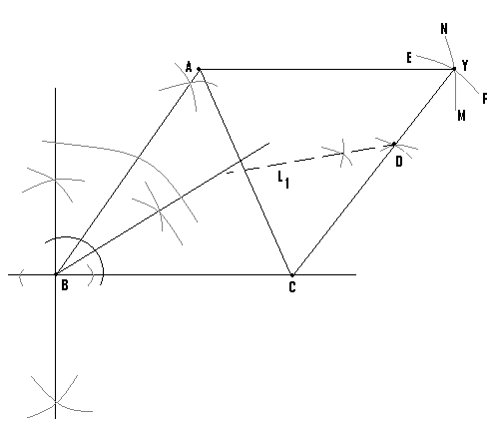

* The compass is now opened to the length BC i.e 5cm, and with the pin at A, draw arc MN to cut the first one at Y.
* Draw the first straight line to join C and Y, and the second one to join A and Y.
* Since CD is parallel to AB, the point D can lie any where on the line CY.
* But since D is also supposed to be equidistant from A and C, then it must also lie on the locus of points which are equidistant from A and C.
* We therefore construct this locus and let this be L1.
* At the point where L1 meets CY is the location of D.

N/B:

(C) Construct the bisector to AB and the point where It meets AB is E.

**Construction of angle 1050:**

* This is had by a combination of angle 600 and angle 450.

Example:

Construct angle 1050 at the point X.



Steps:

1. Construct angle 900 at X and bisect it to get angle 450.

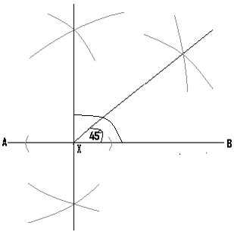

1. Construct angle 600

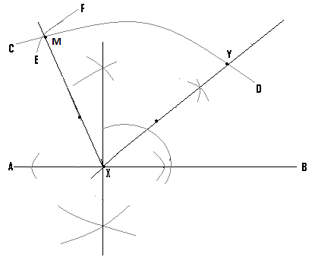

* With the pin at X, construct arc CD.
* With the same length and the pin at Y, construct arc EF.
* From point X draw a straight line which passes through M.

(Q3) Using a ruler and a pair of compasses only construct QRS such that <QRS = 1050, QR = 5cm and RS = 7cm.

Hint:

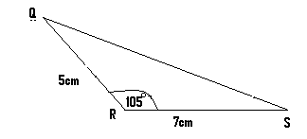

Soln:

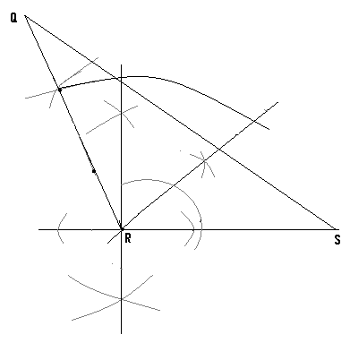

**Construction of a circumscribed circle:**

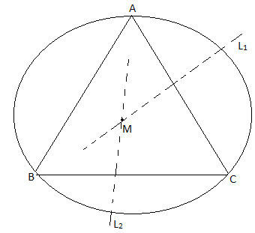

**-**The circle drawn passes through the points A,B and C which are the vertices of the triangle.

-A circumscribed circle is a circle, which passes through the three vertices of a given triangle.

-To construct such a circle, the perpendicular bisectors of two of the sides of a triangle, are drawn and their meeting point is noted.

-With the pin of the compass positioned at this meeting point, a circle can be drawn to pass through all the three vertices of the triangle.

-In the given diagram, L1 and L2 are the two bisectors whose meeting point is M.

-Therefore with the pin positioned at M, the circumscribed circle can be drawn.

**Construction of an inscribed circle:**

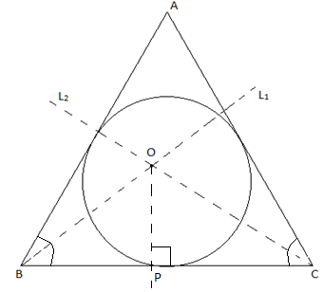

-An inscribed circle is one, which touches all the three sides of a given triangle.

-To construct such a circle and using the diagram just drawn as an example, L1 which is the bisector of <ABC and L2 which is the bisector <ACB are drawn, and let their meeting point be O.

-From the side BC, a perpendicular line (op) is then constructed.

- With the pin of the compass positioned at O and using the length OP, the inscribed circle can be drawn.

**NB:** As exercise, students are advised to attempt solving all the questions already solved, on their own.