**CHAPTER TWELVE**

**GRAPHS:**

**Some basic graphs:**

Before a graph can be plotted, we must first construct a table with reference to the equation of the given graph.

* A few values of x are selected and for each, the corresponding y value is computed.
* These two corresponding values i.e. the x and the y values are then plotted on a graph paper.
* There are certain basic graphs which students must be familiar with and be capable of plotting.
* The way or manner of plotting some of these graphs will be illustrated in the following questions:

Q1). Using values of x from -2 to 2, plot the following graphs:

1. y = 2x . 2). y + 4x = 0.

3). y = . 4) y = -x/2.

5) y = 2x + 1. 6) y + 4x + 2 = 0.

Soln.

(1) y = 2x

|  |  |  |  |  |  |
| --- | --- | --- | --- | --- | --- |
| X | - 2 | - 1 | 0 | 1 | 2 |
| Y | - 4 | - 2 | 0 | 2 | 4 |

1. If x = -2 (b) If x = -1

y = 2x y = 2x

= > y = 2(-2) = -4 => y = 2 (-1) =>y = -4 => y = -2

© If x= 0 (d) If x = 1

y = 2x y = 2x

=> y = 2(0) = 0 => y = 2(1) = 2

=> y = 0 => y = 2

(e) If x = 2

y = 2x

=> y = 2(2)

=> y = 4

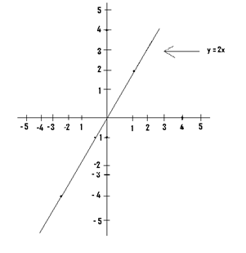

N/B: Before plotting any graph you, must first make sure y is the subject of the given equation. If not, then make y the subject.

(2) From y + 4x = 0, => y = 0-4x => y = -4x

y = - 4x

|  |  |  |  |  |  |
| --- | --- | --- | --- | --- | --- |
| X | -2 | -1 | 0 | 1 | 2 |
| Y | 8 | 4 | 0 | s- 4 | -8 |

1. If x = -2 (b) If x = -1

y = - 4x => y = - 4(-1) => y = - 4 (-2) => y = 4 => y = 8

(c) If x = 0 (d) If x = 1

y = - 4x y = - 4x

=> y = - 4 (0) => y = - 4(1) = - 4

=> y = 0 => y = - 4

(e) If x = 2

y = - 4x

=> y = - 4(2) = - 8

=> y = - 8

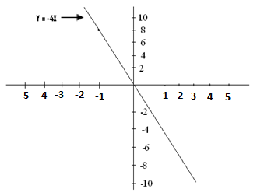

1. y = { or y = x/2}

3) ,

|  |  |  |  |  |  |
| --- | --- | --- | --- | --- | --- |
| X | -2 | -1 | 0 | 1 | 2 |
| Y | -1 | -0.5 | 0 | 0.5 | 1 |

1. If x = -2 (b) If x = -1

y = $\frac{1x}{2}$ = ½(-2) y = $\frac{1x }{2}$ = ½(-1)

=> y = -2/2 => y = -1/2 = - 0.5 . . => y = -1 => y = - 0.5

(c) If x = 0 (d) If x = 1

y = $\frac{1x}{2}$ = ½(0) y = $\frac{1x}{2}$ = ½(1)

=> y = 0/2 => y = 1/2

=> y = 0 => y = 0.5

|  |  |  |  |  |  |
| --- | --- | --- | --- | --- | --- |
| X | -2 | -1 | 0 | 1 | 2 |
| Y | 1 | 0.5 | 0 | - 0.5 | -1 |

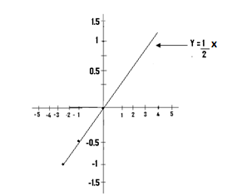

N/B: In the plotting of a graph, the interval used on one particular axis (i.e. the difference between one number and the next) must be the same.

* For a particular graph, the interval used on the x-axis must be the same.
* But the scale used on the x-axis can be different from that used on the y-axis.

4) y = -x/2. or y = $\frac{-x}{2}$

1. If x = -2 2) If x = -1

y = -x/2 = - (-2)/2 y = -x/ 2 = - (-1)/2

🡺 y = 2/2 = 1 => y = ½ = 0.5

3) If x = 0 4) If x = 1

y = -x/2 = - (0)/2 = 0 y = -x/ 2 = - (1)/2

=> y = 0. => y = -1/2 = - 0.5

5) If x = 2

y = -x/2 = - (2)/2

=> y = -1

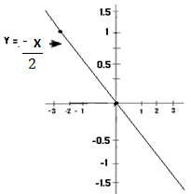

5)

y = 2x + 1

|  |  |  |  |  |  |
| --- | --- | --- | --- | --- | --- |
| X | -2 | -1 | 0 | 1 | 2 |
| Y | -3 | -1 | 1 | 3 | 5 |

1) If x = -2 2) If x = -1

y = 2x + 1 y = 2x + 1

=> y = 2(-2) + 1 => y = 2(-1) + 1= -2+1

=> y = - 4 + 1 = -3. => y = -1.

3) If x = 0 4) If x = 1

y = 2x + 1 y = 2x + 1

=> y = 2(0) +1 => y = 2(1) + 1 = 2 + 1 = 3

=> y = 0+1 =1. => y = 3.

5) If x = 2

y = 2x + 1

=> y = 2(2) + 1

=> y = 5.

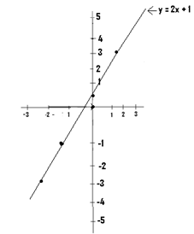

6) From y + 4x + 2 = 0

=> y + 2 = 0 – 4x

=> y + 2 = - 4x

=> y = - 4x – 2

y = - 4x - 2

|  |  |  |  |  |  |
| --- | --- | --- | --- | --- | --- |
| X | -2 | -1 | 0 | 1 | 2 |
| Y | 6 | 2 | -2 | - 6 | -10 |

a) If x = -2 b) If x = -1

y = - 4x-2 y = - 4x -2

=> y = - 4(-2)-2 => y = - 4(-1) -2

=> y = 8 -2 => y = 4 -2

=> y = 6 => y = 2

c) If x = 0 d) If x = 1 If x = 2

y = - 4x -2 y = - 4x -2 y = - 4x -2

=> y = - 4(0) -2 => y = - 4(1) – 2 => y = - 4(2) -2 = .

==> y = 0 - 2 = - 2. => y = - 4 – 2= - 6. - 8 – 2 = - 10.

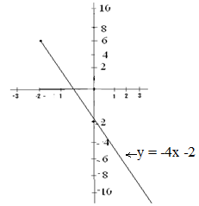

Q2) Using values of x from -3 to 3, plot the graphs of the relations: a) y = x².

b) y = -x² c) y = 2x²

d) y + 2x² = 0 e) y = $\frac{1}{2}$ x²

Soln

a) y = x²

y = x2

|  |  |  |  |  |  |  |  |
| --- | --- | --- | --- | --- | --- | --- | --- |
| X | -3 | -2 | -1 | 0 | 1 | 2 | 3 |
| Y | 9 | 4 | 1 | 0 | 1 | 4 | 9 |

(1) If x = -3 2) If x = -2

y = x² y = x²

=> y = (-3)² = 9. => y = (-2)² = 4.

=> y = 9. =>y = 4.

3) If x = -1 4) If x = 0

y = x² y = x²

=> y = (-1)² = 1 => y = (0)² = 0

=> y = 1. => y = 0

5) If x = 1 6) If x = 2 7) If x = 3

y = x² y = x² y = x²

=> y = (1)² => y = (2)² => y = (3)² = 9

=> y = 1. => y = 4. => y = 9.

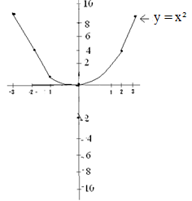

b)

y = -x2

|  |  |  |  |  |  |  |  |
| --- | --- | --- | --- | --- | --- | --- | --- |
| X | -3 | -2 | -1 | 0 | 1 | 2 | 3 |
| Y | -9 | -4 | -1 | 0 | -1 | - 4 | -9 |

1) If x = -3 2) If x = -2

y = -x² y = - x² = - (-2)²

=> y = - (-3)² => y = - (4) = - 4

=> y = - (9) => y = - 4.

=> y = - 9

3) If x = -1 4) If x = 0

y = - x² y = -x²

=> y = - (-1)² => y = - (0)²

=> y = - (1) => y = - (0) = 0.

=> y = -1.

5) If x = 1 6) If x = 2

y = - x² y = -x²

=> y = - (1)² => y = - (2)² = - (4)

=> y = - (1) => y = - 4.

=> y = -1.

7) If x = 3s

y = -x²

=> y = - (3)²

=> y = - (9)

=> y = - 9.

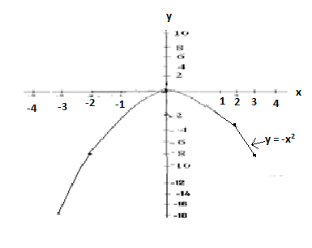

c)

y = $\frac{1}{2}$ x²

|  |  |  |  |  |  |  |  |
| --- | --- | --- | --- | --- | --- | --- | --- |
| X | -3 | -2 | -1 | 0 | 1 | 2 | 3 |
| Y | 4.5 | 2 | 0.5 | 0 | 0.5 | 2 | 4.5 |

1) If x = -3 2) If x = -2

y = ½ x² y = ½ x²

=> y = ½(-3)² => y = ½ (-2)²

=> y = ½ (9) => y = ½(4) = 4/2 = 2

=> y = 9/2 = 4.5

3) If x = -1 4) If x = 0

y = ½x² y = ½x²

=> y = ½(-1)² => y = ½(0)2 = ½(0)

=> y = ½(1) = ½ => y = 0

=> y = 0.5

5) If x = 1 6) If x = 2

y = ½(1)² y = ½(2)²

=> y = ½(1) = ½ => y = $\frac{1}{2}$ (4)

=> y = 0.5 => y = 4/2 = 2

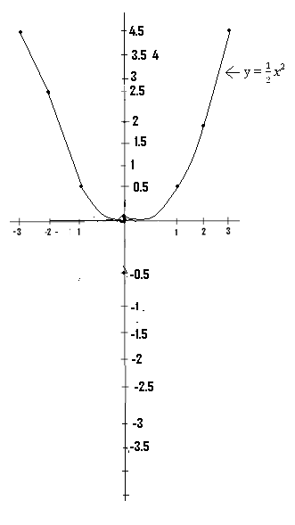

(d) From y + 2x² = 0 => y = 0-2x²,

=>y = -2x² .

y = -2x²

|  |  |  |  |  |  |  |  |
| --- | --- | --- | --- | --- | --- | --- | --- |
| X | -3 | -2 | -1 | 0 | 1 | 2 | 3 |
| Y | -18 | -8 | -2 | 0 | -2 | -8 | -18 |

. 1) If x = -3 2) If x = -2

y = -2x² y = -2x²

=> y = -2(-3)² => y = -2(-2)2 = -2(4)

=> y = -2(9) => y = - 8

=> y = -18.

3) If x = -1

y = -2x² 4) If x = 0

=> y = -2(-1)² y = -2(0)² => y = -2(1) => y = -2(1) = -2 => y = -2

=> y = -2

5) If x = 1 6) If x = 2

y = -2(1)² y = -2(2)²

=> y = -2(1) y = -2(4)

=> y = -2 y = -8

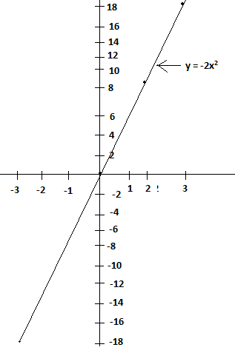

(Q3) Plot the graphs of the relations y = $\frac{2x}{3}- 1$ and y = $\frac{2x -1 }{3}$ for -3 ≤ x ≤ 3.

Soln: y = 2x/3

|  |  |  |  |  |  |  |  |
| --- | --- | --- | --- | --- | --- | --- | --- |
| X | -3 | -2 | -1 | 0 | 1 | 2 | 3 |
| Y | -3 | -2.3 | -1.7 | -1 | -0.34 | 0.3 | 1 |

(1)If x = -3 (2)If x = -2 (3) If x = -1 (4) If x = 0

y = $\frac{2x}{3}$– 1 y = $\frac{2x}{3}$– 1 y = $\frac{2x}{3}$– 1 y = $\frac{2x}{3}$– 1

=> y = $\frac{2(-3)}{3}$– 1 => y = $\frac{2(-2)}{3}$– 1 => $y=\frac{2(-1)}{3}$– 1 => y = $\frac{2(0)}{3}$– 1

=> y = $\frac{-6}{3}$– 1 => y = $\frac{- 4}{3}- 1$ => y = $\frac{-2}{3}- 1$ => y = $\frac{0}{3}- 1$

=> y = -2 -1 = -3 => y = -1.3 – 1 => y = - 0.66 – 1 => y = 0 - 1

=> = -3 => y = -2.3 => y = -1.7 => y = -1

(5) If x = 1 (6)If x = 2 (7) If x = 3

y = $\frac{2x}{3}$– 1 y = $\frac{2x}{3}$– 1 y = $\frac{2x}{3}$– 1

=> y = $\frac{2(1)}{3}$– 1 => y = $\frac{2(2)}{3}$– 1 => y = $\frac{2(3)}{3}$– 1

=> y = $\frac{2}{3}- 1$ => y = $\frac{4}{3}- 1$ => y = $\frac{6}{3}- 1$

=> y = 0.66 – 1 => y = 1.3 – 1 => y = 2 - 1

=> y = - 0.34 => y = 0.3 => y = 1

### 

y = $\frac{2x-1}{3}$

|  |  |  |  |  |  |  |  |
| --- | --- | --- | --- | --- | --- | --- | --- |
| X | -3 | -2 | -1 | 0 | 1 | 2 | 3 |
| Y | -2.3 | -1.7 | -1 | -0.3 | 0.3 | 1 | 1.7 |

(1) If x = -3 (2)If x = -2 (3)If x = 0

=> y = $\frac{2(-3)-1}{3}$ => y = $\frac{2(-2)-1}{3}$ => y = $\frac{2(0)-1}{3}$

=> y = $\frac{- 6 -1}{3}$ => y = $\frac{- 4 -1}{3}$ => y = $\frac{0 -1}{3}$

=> y = $\frac{-7}{3}$ = -2.3 => y = $\frac{-5}{3}$ = -1.7 => y = $\frac{-1}{3}$ = - 0.33 .

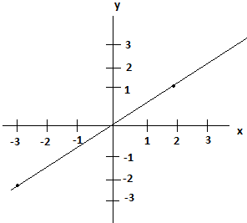

Q4. Using values of x from -2 to 1, plot the graphs of the following relations:

a) y = x b) y = -x

NB: The graph of y =x is the same as the graph of –y = -x..

* Also the graph of y = x is the same as the graph of y-x = 0..

Soln

y = x

|  |  |  |  |  |
| --- | --- | --- | --- | --- |
| X | -2 | -1 | 0 | 1 |
| Y | -2 | -1 | 0 | 1 |

1) If x = -2 2) If x = -1

y = x y = x

=> y = -2 => y = -1

3) If x = 0 4) If x = 1

y = x y = x

=> y = 0 => y = 1

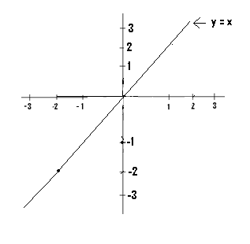

NB: The graph of y = -x, is the same as the graph of –y = x.

* Also the graph of y = -x is the same as the graph of y +x = 0.

b) y = -x

|  |  |  |  |  |  |
| --- | --- | --- | --- | --- | --- |
| X | -2 | -1 | 0 | 1 | 2 |
| Y | 2 | 1 | 0 | -1 | -2 |

1) If x = -2 2) If x = -1

y = -x y = -x

=> y = - (-2) => y = - (-1)

=> y = 2 => y = 1

4) If x = 0 4) If x = 1

y = -x y = -x

=> y = 0 => y = -1

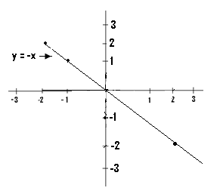

NB: If for each graph, the range or the values of x which must be used is not given, we select a few values of x and compute the corresponding y values.

* Graphs of the form y = a, where a is a whole number, are graphs which are perpendicular to the y-axis, and passes through the whole number concerned.
* Such graphs are plotted straight away, without the construction of any table. These graphs are straight lines graphs.

Q5) Plot the graphs with the following equations:

a) y = 3 b) y = 7

c) y = - 8 d) y = - 4

Soln:

(a)

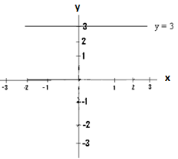

(b)

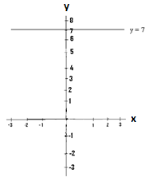

(c)

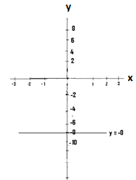

(d)

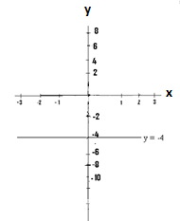

NB: The x-axis is the same as the graph of y = 0.

* Graphs of the form x = a, where a is a whole number are perpendicular to the x-axis, and passes through the whole number concerned.

Q6.) Plot the graphs with the following equations:

a) x = 2 b) x = 6

c) x = - 4 d) x = - 8

Soln:

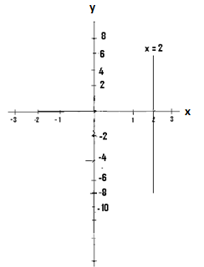

(b)

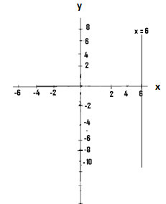

(c)

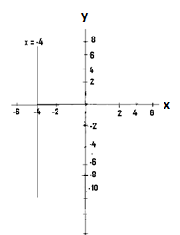

(d)

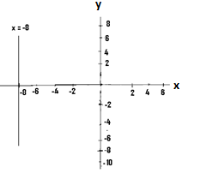

**Quadratic Graphs:**

These are graphs of quadratic expressions, which are expressions of the form ax² + bx + c, where a $≠$ o with b and c being of constants and where x and y are variables, i.e. they are not constants.

Examples are:

1. Y = 2x² + 4x + 1
2. Y = 6x² - 7x – 8
3. Y = - 6x² + x -1
4. Y = - x² - 4
5. Y = x² + 2

When graphs of quadratic expressions are plotted or drawn, we may arrive at any of these four cases:

Case 1:

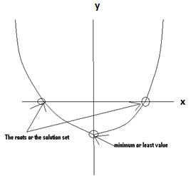

* For example assuming we had the next diagram after drawing our quadratic graph

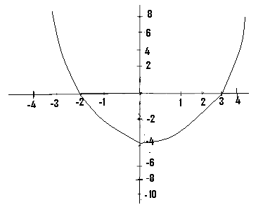

The minimum value is - 4 and the truth set or solution set = {x: x = -2 or x = 3}..

The truth or solution set occurs at the point where the graph cuts the x- axis.

Case 2:

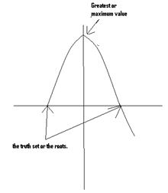

Example:

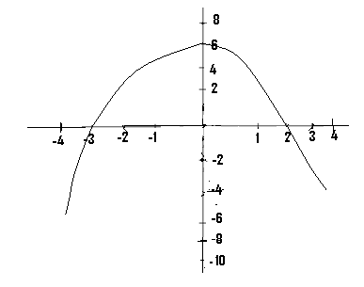

This graph has a maximum or a greatest value of 6. The truth set = { x: x = -3 or x = 2}.

NB:

* When the shape of our graph is as shown next, then we shall have a minimum value.

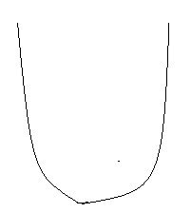

* But when the shape is as shown next, then we shall have a maximum or greatest value.



Case 3:

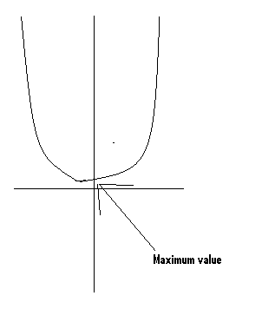

* Since the graph does not cut the x-axis, then the graph has no roots or truth set. But it has a minimum value.

Example:

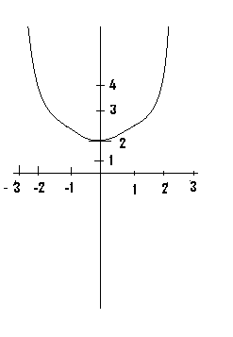

This graph has no roots or truth set, but has a minimum value of 2.

Case 4.

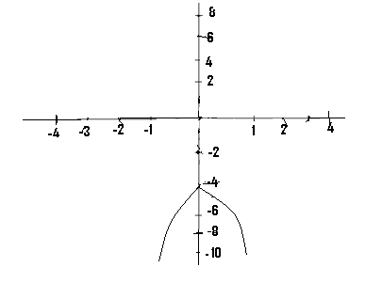

* Such a graph has no truth set, since it also does not cut the x-axis, but it has a maximum value of -4.

Q1. Using values of x from - 6 to 6, plot the graph of the relation y = -x²`-2.

b) Use your graph to determine the truth set of the following: 1) -x² -2 = 0, 2) -x² - 2 = -10,

3) -x² - 2 = -30

NB: In order to save space, only a few values of y will be computed as an illustration but during examinations, all the values of y must be computed.

**Solution**

|  |  |  |  |  |  |  |  |  |  |  |  |  |  |
| --- | --- | --- | --- | --- | --- | --- | --- | --- | --- | --- | --- | --- | --- |
| X | -6 | -5 | -4 | -3 | -2 | -1 | 0 | 1 | 2 | 3 | 4 | 5 | 6 |
| Y | -38 | -27 | -18 | -11 | -6 | -3 | -2 | -3 | -6 | -11 | -18 | -27 | -38 |

1. If x = - 6, y = -x² - 2

=>Y = - (- 6)² - 2

=>Y = - (36) – 2

=> Y = -36 – 2

=>Y = -38

1. If x = -3, y = -x² - 2

=>Y = - (-3)² - 2

=>Y = - (9) – 2

=>Y = - 9 – 2 = -11.

1. If x= 0, y = -x² - 2

=>Y = - (0)² - 2 = - 0 – 2

=>Y = 0 – 2 = -2

1. If x = 2, y = -x² - 2

=>Y = - (2)² - 2 = - (4) – 2

=.>Y = - 4 -2 = - 6.

1. If x = 4, y = -x² - 2

=>Y = - (4)² - 2 = - (16) – 2

=>Y = -16 – 2 = -18

1. If x = 6, y = -x² - 2

=>Y = - (6)² - 2 = - (36) – 2

=>Y = -36 – 2 = -38

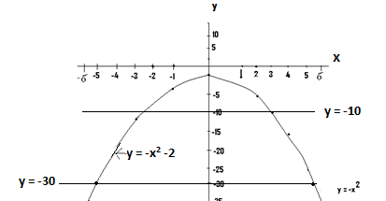

b) The equation of the graph is y = -x2 – 2.

i. From –x² - 2 = 0

=>Y = -x² - 2 = 0

=>Y = 0

We therefore draw the line graph y = 0, which is the x-axis. Since our graph does not cut the x-axis, then there is no truth set.

ii. From -x² - 2 = -10,

=>Y = -x² - 2 = -10

=>Y = -10.

We therefore draw the line y = -10 and at the points where it cuts the graph , we determine the corresponding values of x, which form the truth set. From the graph the truth set = {x: x = -2.5 or x = 3} approx..

iii. From –x2 – 2 = - 30

=>Y = -x² - 2 = - 30

=>Y = - 30.

We therefore draw the line graph of y = -30. From the graph, at the points where the graph cuts this line, the corresponding values of x are approximately -5 and 5,

=> truth set = {x: x = -5 or x = 5’

Q2.

y = 4x² - 8x - 21

|  |  |  |  |  |  |  |  |  |  |  |  |  |
| --- | --- | --- | --- | --- | --- | --- | --- | --- | --- | --- | --- | --- |
| X | -2.0 | -1.5 | -1.0 | -0.5 | 0.0 | 0.5 1.0 | 1.5 | 2.0 | 2.5 | 3.0 | 3.5 | 4.0 |
| Y | 11 |  | -9 |  | -21 | -25 |  | -21 |  |  | 0 |  |

The given table is an incomplete table for the relation y = 4x² - 8x -21, for -2.0 ≤ x ≤ 4.0.

1. Copy and complete the table.
2. Plot the graph for the given relation.
3. From your graph, determine the truth set of :
4. 4x² - 8x - 21 = 0
5. 4x² - 8x – 21 = 10.

Soln:

y = 4x2 – 8x - 21

|  |  |  |  |  |  |  |  |  |  |  |  |  |
| --- | --- | --- | --- | --- | --- | --- | --- | --- | --- | --- | --- | --- |
| X | -2.0 | -1.5 | -1.0 | -0.5 | 0.0 | 0.5 1.0 | 1.5 | 2.0 | 2.5 | 3.0 | 3.5 | 4.0 |
| Y | 11 | 0 | -9 | -16 | -21 | 24 -25 | -24 | -21 | -1.6 | -9 | 0 | 11 |

1. I f x = -1.5

Y = 4x² - 8x -21

=>Y = 4(-1.5)² - 8(-1.5) -21

=>Y = 4(2.25) + 8(1.5) -21

=>Y = 9 + 12 – 21

=>Y = 21 – 21 = 0

=>Y = 0

1. If x = - 0.5

=> Y = 4x² - 8x -21

=>Y = 4(-0.5)² - 8(-0.5) -21

=>Y = 4(0.25) + 8(0.5) -21

=>Y = 1 + 4 – 21

=>Y = 5 – 21

=>Y = -16

3. If x = 1.0

Y = 4x² - 8x -21

=>Y = 4(1)² - 8(1) -21

=>Y = 4 – 8 – 21

=>Y = - 4 – 21

=>Y = - 25

4. If x = 2.5

Y = 4x² - 8x – 21

=>Y = 4(2.5)² - 8(2.5) – 21

=>Y = 4(6.25) – 20 – 21

=>Y = 25 – 20 – 21

=>Y = 5 – 21

=>Y = - 16

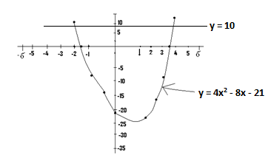

We are required to find the truth set of 4x² - 8x – 21 = 0, using our graph. First you must check whether this equation is similar to that of the graph drawn or not. If these two equations are similar, then we proceed with the working. However, if they differ, then we have to make certain alterations before we continue with the work.

1. The equation of the graph is given by y = 4x² - 8x – 21 and the given equation is 4x² - 8x – 21 = 0. These two equations are the same.

From 4x² - 8x – 21 = 0

=>Y = 4x² - 8x – 21 = 0

=>Y = 0.

We therefore draw the line y = 0 (which is the x-axis) and determine the points where the graph cuts it. From the graph the required truth set = {x: x = -1.5 or x = 3.5}.

1. We are required to find the truth set of 4x² - 8x – 21 = 10. This equation is similar to that of the graph which is y = 4x² - 8x – 21.

From 4x² - 8x – 21 = 10

=>Y = 4x² - 8x – 21 = 10

=>Y = 10

We therefore draw the line y = 10, and at the points where the graph cuts this line, the corresponding values of x are determined.

From the graph the truth set = {x: x = -2 or x = 4}.

Q3.

1. Using the same axes, draw the graphs of the equation y + 3x² = x – 8 and y = 2x – 12, for - 4 ≤ x ≤ 5.
2. Using your graph, find the values of x which satisfy the simultaneous equation -3x² + x – 8 = 2x – 12.

**NB:**

The expression “Using the same axes” implies that these two graphs must be drawn on the same sheet of graph paper, after the construction of separate tables for each of the given equations.

**Solution**

The equation of the first graph is given as y + 3x² = x – 8

=>Y = x – 8 – 3x², which can also be written as y = -3x² + x – 8.

Y = -3x² + x – 8

|  |  |  |  |  |  |  |  |  |  |  |
| --- | --- | --- | --- | --- | --- | --- | --- | --- | --- | --- |
| X | -4 | -3 | -2 | -1 | 0 | 1 | 2 | 3 | 4 | 5 |
| Y | -60 | -38 | -22 | -12 | -8 | -10 | -18 | -32 | -52 | -78 |

1. If x = - 4

Y = -3x² + x – 8

=>Y = -3(- 4)² + (- 4) – 8

=>Y = -3(16) – 4 – 8

=>Y = - 48 – 4 – 8

=>Y = -52 – 8

=>Y = - 60

1. If x = -3

Y = -3x² + x – 8

=>Y = -3(-3)² + (-3) – 8

=>Y = -3(9) – 3 – 8

=>Y = -27 – 3 – 8

=>Y = -30 – 8

=>Y = -38

1. If x = 0

Y = -3x² + x – 8

=>Y = -3(0)² + (0) – 8

=>Y = -3(0) + 0 – 8

=>Y = 0+ 0 - 8

=>Y = 0 – 8

=>Y = - 8

1. If x = 2

Y = -3x² + x – 8

=>Y = -3(2)² + 2 – 8

=>Y = - 12 + 2 – 8

=>Y = -10 – 8

=>Y = -18

1. If x = 5

Y = -3x² + x – 8

=>Y = -3(5)2 + (5) – 8

=>Y = -3(25) + 5 – 8

=>Y = -75 + 5 – 8

=>Y = - 70 – 8

=>Y = -78

We can now construct our second table.

Y = 2x – 12

|  |  |  |  |  |  |  |  |  |  |
| --- | --- | --- | --- | --- | --- | --- | --- | --- | --- |
| X | -4 | -3 | -2 | -1 | 0 | 1 | 2 | 3 | 4 |
| Y | -20 |  |  |  | -12 |  | -8 |  |  |

1b.The given equation i.e. y = 2x – 12 is that of a straight line or a straight line graph. In drawing a straight graph, we only need to compute only for two or three values of y.

1. If x = - 4

Y = 2x – 12

=>Y = 2(- 4) – 12

=>Y = - 8 – 12

=>Y = - 20

1. If x = 0

Y = 2x – 12

=>.Y = 2(0) – 12

=>Y = 0 – 12

=>Y = -12

1. If x = 2

Y = 2x – 12

=>Y = 2(2) – 12

=>Y = 4 – 12

=>Y = -8

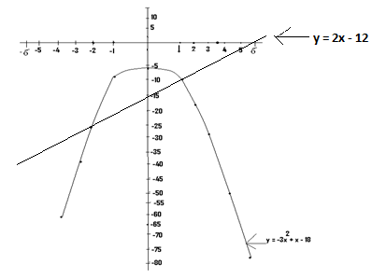

NB: To use the graph to find the values of x which satisfy the equation -3x² + x – 18 = 2x – 12, we consider the points of intersections (i.e. where they meet) of the two graphs, and determine the corresponding x values.

To do this, straight lines are drawn from these points to meet the x-axis. The points where these drawn lines meet the x- axis represents the truth set.

From the graphs drawn, the truth set = {x: x = -1.5 or x = 1}.

Q4.

1. Using values of x from - 4 to 8, plot on the same axis the graphs of the relations y = x² - 6x + 2 and y = 3x² - 2x – 1.
2. Using your graphs, determine the truth set of the simultaneous equation x² - 6x + 2 = 3x² - 2x – 1.

NB:

First construct separate tables for the two given equations.

Table 1

y = x2 - 6x+ 2

|  |  |  |  |  |  |  |  |  |  |  |  |  |  |
| --- | --- | --- | --- | --- | --- | --- | --- | --- | --- | --- | --- | --- | --- |
| x | -4 | -3 | -2 | -1 | 0 | 1 | 2 | 3 | 4 | 5 | 6 | 7 | 8 |
| y | 42 | 29 | 18 | 9 | 2 | -3 | -6 | -7 | -6 | -3 | 2 | 9 | 18 |

1. If x = - 4

Y = x² - 6x + 2

=>Y = (- 4)² - 6(- 4) + 2

=>Y = 16 + 24 + 2

=>Y = 42

1. If x = -2

Y = x² - 6x + 2

=>Y = (-2)² - 6(-2) + 2

=>Y = 4+12 +2

=>Y = 18

1. If x = 0

Y = x² - 6x + 2

=>Y = (0)² + 6(0) + 2

=>Y = 0 + 0 + 2

=>Y = 0 + 2

=>Y = 2

1. If x = 2

Y = x² - 6x + 2

=>Y = (2)² - 6(2) + 2

=>Y = 4 – 12 + 2

=> Y = - 8 + 2

=>Y = - 6

1. If x = 4

Y = x² - 6x + 2

=>Y = (4)² - 6(4) + 2

=>Y = 16 – 24 + 2

=>Y = - 8 + 2

=> Y = - 6

1. If x= 6

Y = x² - 6x + 2

=>Y = (6)² - 6(6) + 2

=>Y = 36 – 36 + 2

=>Y = 0 + 2

=>Y = 2

Table 2

y = 3x2 – 2x - 1

|  |  |  |  |  |  |  |  |  |  |  |  |  |  |
| --- | --- | --- | --- | --- | --- | --- | --- | --- | --- | --- | --- | --- | --- |
| X | -4 | -3 | -2 | -1 | 0 | 1 | 2 | 3 | 4 | 5 | 6 | 7 | 8 |
| Y | 55 | 32 | 15 | 4 | -1 | -1 | 7 | 20 | 39 | 64 | 95 | 132 | 175 |

1. If x = - 4

Y = 3x² -2x – 1

=>Y = 3(- 4)² -2(- 4) – 1

=>Y = 3(16) + 8 – 1

=>Y = 48 + 8 – 1

=>Y = 55

1. If x = -2

Y = 3x² - 2x – 1

=>Y = 3(-2)² - 2(-2) – 1

=>Y = 3(4) + 4 – 1

=>Y = 12 + 4 – 1

=>Y = 15

1. If x = -1

Y = 3x² - 2x – 1

=>Y = 3(-1)² - 2(-1) – 1

=>Y = 3(1) + 2 – 1

=>Y = 3 + 2 – 1

=>Y = 4

1. If x = 4

Y = 3x² - 2x – 1

=>Y = 3(4)² -2(4) – 1

=>Y = 3(16) – 8 – 1

=>Y = 48 – 8 – 1

=> Y = 39

1. If x = 6

Y = 3x² - 2x – 1

=>Y = 3(6)² -2(6) – 1

=>Y = 3(36) – 12 – 1

=>Y = 108 – 12 – 1

=>Y = 95

1. If x = 7

Y = 3x² -2x – 1

=>Y = 3(7)² - 2(7) – 1

=>Y = 132

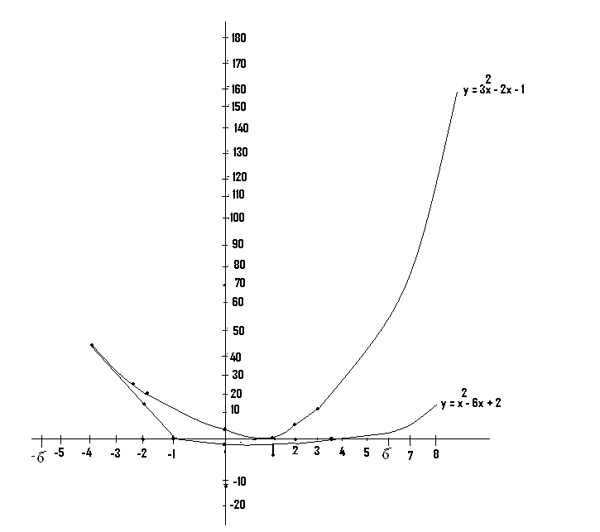

From the graph, the value of x which satisfies simultaneously the equation 3x² - 2x -1 = x2 – 6x + 2 occurs at the points where the two graphs meet. The corresponding x values are then read after drawing straight lines from these point or points to meet the x-axis. From the graphs drawn the required value of x is = -2.5

NB: Before we can determine the value of x which satisfies the equations of two graphs simultaneously, then the two graphs must be drawn on the same axes.

N/B:

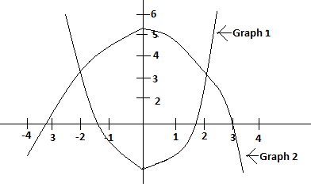

* It is possible to draw two quadratic graphs on the same axes and, get a diagram similar to the one just drawn.
* In such a case, the values of x which satisfy simultaneously the equations, of the two quadratic graphs is had by determining first the points of intersection or the point of intersection of the two graphs.
* From these points, straight lines are drawn to meet the x-axis and the values of x taken as the required ones.

The axis of symmetry or the line of symmetry of a quadratic graph:

* The line of symmetry, the axis of symmetry or the symmetrical axis of a quadratic graph, is a line which is parallel to the y-axis, and which divides the graph into exactly or almost two equal parts.
* In certain cases, the line of symmetry may happen to be the y-axis.

(Q1) Determine the lines of symmetry of these quadratic graphs drawn:

(a)

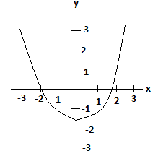

* The line of symmetry in this case is the axis or the line x = 0.

(b)

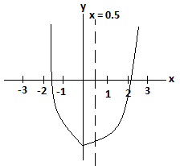.

* For this, the line of symmetry is x = 0.5, since it divides the graph into almost two equal parts.

N/B:- The line of symmetry is represented usually by a broken line, and its position must be determined by the student.

(c)

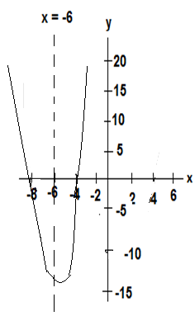

The axis of symmetry in this case is x = - 6.

d)

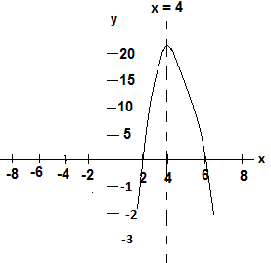

The line of symmetry is x = 4.

e)

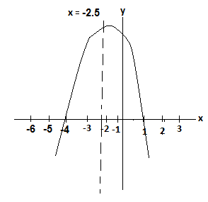

The line of symmetry is x = -2.5.

(Q1) (i) Construct a table for the relation y = 2x2 – 8x – 5 for -2≤ x ≤ 6. (ii) Draw the graph for the given relation. (iii) Use your graph to find the truth set of

1. p = {x: 2x2 – 8x – 5 = 0}.
2. Q = {x: 2x2 – 8x – 5 = 15}.
3. R={x: 2x2 – 9x – 5 = 0}.
4. Draw the line of symmetry and determine its equation.

Soln:

y = 2x2 – 8x – 5

|  |  |  |  |  |  |  |  |  |  |
| --- | --- | --- | --- | --- | --- | --- | --- | --- | --- |
| X | -2 | -1 | 0 | 1 | 2 | 3 | 4 | 5 | 6 |
| Y | 19 | 5 | -5 | -11 | -13 | -11 | -5 | 5 | 19 |

1. If x = -2

y = 2x2 – 8x – 5

=> y = 2(-2)2 – 8(-2) – 5

=> y = 2(4) +16 – 5

=> y = 8 + 16 – 5

=> y = 19.

(2) If x = 1

y = 2x2 – 8x – 5

=> y = 2(1)2 +8(1) – 5

=>y = 2 + 8 – 5

=> y = 10 - 5

=> y = 5.

(3) If x = 0

Y = 2x2 – 8x – 5

=> Y = 2(0)2 – 8(0) – 5

=> y = 0 – 0-5

=> y = 0 – 5

=> y = -5.

(4) If x = 4

Y = 2x2 – 8x – 5

=> Y = 2(4)2 – 8(4) – 5

=>Y =2(16) – 32 – 5

=> y = 32 – 32 – 5

=> y = 0 – 5

=> y = -5.

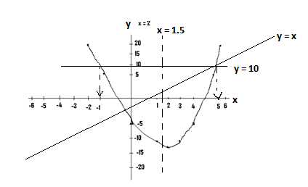

(iii) (a) We are required to find the truth set of P={x: 2x2 – 8x – 5 = 0.).

But the equation of the graph is y = 2x2 – 8x – 5. Since these two equations are similar, then from 2x2 – 8x – 5 = 0 => y = 2x2 – 8x – 5 = 0 => y = 0.

We therefore consider the line y = 0, which is the x - axis and take the corresponding values of x, at the points where the graph cuts the x- axis.

Therefore the required truth set={x: x = - 0.5 or x = 4.5}.

(b) We are required to find the truth set of Q = {x: 2x2 – 8x = 15}. Since this equation i.e. 2x2 – 8x = 15 is different from that of the graph, it must be altered using any possible means to make it become similar to that of the graph, which is y = 2x2 – 8x – 5.

From 2x2 – 8x = 15 => 2x2 – 8x - 15 = 0, Adding 10 to both sides of the equation => 2x2 – 8x = 15 + 10= 0 + 10 => 2x2 – 8x – 5 = 10, which is similar to the equation of the graph ,which is y = 2x2 – 8x – 5.

Now from 2x2 – 8x – 5 = 10, => y =2x2 – 8x – 5 = 10,

=> y = 10. We therefore draw the line y = 10, and where it cuts the graph, the corresponding x values are determined from the graph, the required truth set is given by {x:x = -1 and x = 5}.

(c) We are required to find the truth set of R={x: 2x2 – 9x – 5 = 0}. Since the relation 2x2 – 9x – 5 = 0 differs from y =2x2 – 8x – 5, it must be altered to become like that of the graph. The only way to do this is to add x to both sides of the equation.

i.e. 2x2 – 9x – 5 + x = 0 + x, => 2x2 – 8x – 5 = x, but since y = 2x2 – 8x – 5.

Then from y = 2x2 – 8x – 5 = x => y = x. We therefore draw the line y = x and at the points where it cuts the graph, the corresponding x – axis values are determined. Before we draw the graph of y = x, we must first construct a table.

|  |  |  |  |
| --- | --- | --- | --- |
| x | 1 | 2 | 3 |
| Y | 1 | 2 | 3 |

1. If x = 1 (2) If x = 2 (3) If x = 3

y = x y = x y = x

=> y = 1 => y = 2 => y = 3

From the graph drawn, the required truth set is given by {x: x = - 0.5 or x = 5} approx.

1. From the line of symmetry drawn, its equation is x = 1.5 approx.

(Q2) (i) Using a scale of 2cm to 1 unit on the x-axis and 2 cm to 2units on the other axis, draw on the same axes the graphs of

1. x 6 + 2x – x2
2. x x + 2, For -3 ≤ x ≤ 5.
3. Use your graph to determine the truth set of the simultaneous equation

y – x = 2 and x2 + y = 6 + 2x.

N/B: x 6 + 2x - x2 => y = 6 + 2x - x2, which we may choose to write as

y = - x2 + 2x + 6.

Also x x + 2 => y = x + 2.

We therefore construct separate tables for y = - x2 + 2x + 6 and y = x + 2 and draw their graphs on the same sheet of graph paper.

Soln:

y = -x2 + 2x + 6

|  |  |  |  |  |  |  |  |  |  |
| --- | --- | --- | --- | --- | --- | --- | --- | --- | --- |
| X | -3 | -2 | -1 | 0 | 1 | 2 | 3 | 4 | 5 |
| Y | -9 | -2 | 3 | 6 | 7 | 6 | 3 | -2 | -9 |

1) If x = -3 (2) If x = -1

y = -x2 + 2x + 6 y = -x2 + 2x + 6

=> y = - (-3)2 + 2(-3) + 6 => y = - (-1)2 + 2(-1) + 6

=>y = - (9) - 6 + 6 => y = - (1) - 2 + 6

=> y = - 9. => y = -3 + 6 = 3

3) If x = 0 (4) If x = 2

y = -x2 + 2x + 6 y = -x2 + 2x + 6

=> y = - (0)2 + 2(0) + 6 => y = - (2)2 + 2(2) + 6

=> y = 0 + 0 + 6 => y = - (4) + 4 + 6

=> y = 0 + 6 = 6 => y = - 4 + 4 + 6 => y = 6

(5) If x = 4 (6) If x = 5

y = -x2 + 2x + 6 y = -x2 + 2x + 6

=> y = - (4)2 + 2(4) + 6 => y = - (5)2 + 2(5) + 6

=> y = - (16) + 8 + 6 => y = - (25) + 10 + 6

=> y = -16+ 8 + 6 => y = -25 + 10 + 6

=> y = - 8 + 6 = -2 => y = - 9

=> y = -2

y = x + 2

|  |  |  |  |  |  |  |  |  |  |
| --- | --- | --- | --- | --- | --- | --- | --- | --- | --- |
| X | -3 | -2 | -2 | 0 | 1 | 2 | 3 | 4 | 5 |
| Y | -1 |  |  | 2 | 3 |  |  |  |  |

Since this is a straight line graph, we shall only compute three values of y.

1. If x = -3 (2) If x = 0 (3) If x = 1

Y = x + 2 y = x + 2 y = x + 2

=>Y = -3 + 2 => y = 0 + 2 = 2 => y = 1 + 2 = 3

=> y = -1

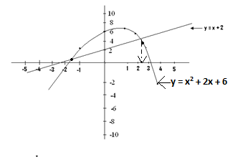

1. We are required to use our graphs to find the truth set of the simultaneous equation

y – x = 2

x2 + y = 6 + 2x

Soln:

From y – x = 2 => y = 2 + x, which is the equation for the second graph just drawn.

Also from x2 + y = 6 + 2x, => y = 6 + 2x – x2 => y = -x2 + 2x + 6, which is the equation for the first graph drawn.

We therefore determine the meeting point or the points of intersection of these two graphs and for each of these points, we determine the corresponding x – axis value or component. The required truth set ={x: x = -1.5 or x = 2.5} approx.

(Q3) Copy and complete the following table for the relation y = $\frac{1}{2}\left(2x-1\right)\left(x+2\right)$

|  |  |  |  |  |  |  |  |  |
| --- | --- | --- | --- | --- | --- | --- | --- | --- |
| X | -3.5 | -3 | -2 | -1 | -0.5 | 0 | 1 | 2 |
| Y | 6 |  | 0 |  |  |  | 1.5 |  |

1. Using a scale of 2cm to 1 unit on each axis, draw the graph of the relation y = $\frac{1}{2}\left(2x-1\right)\left(x+2\right)$ for -3.5 ≤ x ≤2.
2. From your graph, determine the values of x for which y is least.
3. Find also from your graph the truth set of $\frac{1}{2}\left(2x-1\right)\left(x+2\right)$ = 4

Soln:

|  |  |  |  |  |  |  |  |  |
| --- | --- | --- | --- | --- | --- | --- | --- | --- |
| X | -3.5 | -3 | -2 | -1 | -0.5 | 0 | 1 | 2 |
| Y | 6 | 3.5 | 0 | -1.5 | -1.5 | -1 | 1.5 | 6 |

(1) If x = -3

y = $\frac{1}{2}\left(2x-1\right)\left(x+2\right)$

=> y = $\frac{1}{2}\left(2(-3)-1\right)\left(\{-3\}+2\right)$

=> y = $\frac{1}{2}\left(- 6-1\right)\left(-1\right)$

=> y = $\frac{1}{2}\left(-7\right)\left(-1\right)$

=> y = $\frac{1}{2}\left(7\right)$ = $\frac{7}{2}=3.5.$

(2) If x = - 0.5

y = $\frac{1}{2}\left(2x-1\right)\left(x+2\right)$

=> y = $\frac{1}{2}\left(2(- 0.5)-1\right)\left(\{- 0.5\}+2\right)$

=> y = $\frac{1}{2}\left(-1-1\right)\left(1.5\right)$

=> y = $\frac{1}{2}\left(-2\right)\left(1.5\right)$

=> y = $\frac{1}{2}(-3)$ => y = -1.5.

(3) If x = 2

y = $\frac{1}{2}\left(2x-1\right)\left(x+2\right)$

=> y = $\frac{1}{2}\left(2\{2\}-1\right)\left(2+2\right)$

=> y = $\frac{1}{2}\left(4-1\right)\left(4\right)$

=> y = $\frac{1}{2}\left(3\right)\left(4\right)$ = $\frac{1}{2}\left(12\right)$

=> y = 6.

(a)

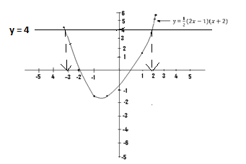

(b) y is least at the point where the minimum value occurs and the corresponding x values are - 0.5 and -1.

(c) The equation of the graph is y = $\frac{1}{2}\left(2x-1\right)\left(x+2\right)$.

The given equation which is $\frac{1}{2}\left(2x-1\right)\left(x+2\right)$ = 4 is similar to that of the graph.

From y = $\frac{1}{2}\left(2x-1\right)\left(x+2\right)$ = 4 => y = $\frac{1}{2}\left(2x-1\right)\left(x+2\right)$ = 4,=> y = 4.

Draw the line y = 4 and at points that is meets the graph, find the corresponding x components or values.

Truth set = {x:x = -3 or x = 2} approx.

(Q4)

|  |  |  |  |  |  |  |  |  |
| --- | --- | --- | --- | --- | --- | --- | --- | --- |
| X | -3 | -2 | -1 | 0 | 1 | 2 | 3 | 4 |
| Y |  | 1.7 |  | 4 | 4.2 | 3.7 |  |  |

Copy and complete the table for the relation y = 4 + x - x2 for -3 ≤ x ≤ 4.

1. Draw the graph for the relation y = 4 + x - x2.
2. From your graph, determine the line of symmetry.
3. What is the truth set of 24 + 3x – 2x2 = 0.

Soln:

y = 4 +x - x2

|  |  |  |  |  |  |  |  |  |
| --- | --- | --- | --- | --- | --- | --- | --- | --- |
| X | -3 | -2 | -1 | 0 | 1 | 2 | 3 | 4 |
| Y | -0.5 | 1.7 | 3.2 | 4 | 4.2 | 3.7 | 2.5 | 0.7 |

1. If x = -3

y = 4 + x - x2

=> y = 4 + (-3) - (-3)2

=> y = 4 + - (-3)2

=> y = 4 + - (9)

=> y = 4 + -

=> y = 4 -–

=> y = - 0.5

(2) If x = -1

y = 4 + x - x2

=> y = 4 + (-1) - (-1)2

=> y = 4 + - (1)

=> y = 4 – 0.5 – 0.33

=> y = 3.2

(3) If x = 3

y = 4 + x - x2

=> y = 4 + - 9)

=> y = 4 + 1.5 – 3

=> y = 2.5

(4) If x = 4

y = 4 + x - x2

=> y = 4 + - 16)

=> y = 4 + 2 – 5.3

=> y = 0.7

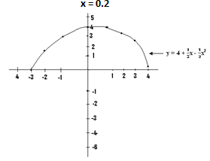

1. From the graph, the line of symmetry is x = 0.2 (approximately).
2. We are required to find the truth set of 24 + 3x – 2x – 2x2 = 0.

This must be altered to be similar to the equation of the graph which is

y = 4 +x - x2.

From 24 + 3x– 2x2 = 0, divide through using 6

=>x - x2 = 0,

=>x - x2 = 0 => y = 0 (which is the - x axis constitute the truth set.

The truth set ={x: x = -2.5} approx, i.e. determine the points where the graph cuts the x-axis.

(Q5) An object is thrown vertically upward from the top of a cliff and its height, y metres, above sea level after t seconds is given by y = -16t2 + 64t + 5.

1. Copy and complete the table of values for y = -16t2 + 64t + 5, for 0 ≤ x ≤4.0.

|  |  |  |  |  |  |  |  |  |  |
| --- | --- | --- | --- | --- | --- | --- | --- | --- | --- |
| T | 0.0 | 0.5 | 1.0 | 1.5 | 2.0 | 2.5 | 3.0 | 3.5 | 4.0 |
| Y | 5 |  |  | 65 |  | 65 | 53 |  |  |

1. Using scales of 2cm to 0.5 seconds on the t – axis, and 2cm to 10m on the y – axis, draw the graph of y = -16t2 + 64t + 5 for 0 ≤ x ≤4.0.
2. Use the graph to find the
3. height reached when t = 1.75 seconds.
4. time the object was at a height of 50m.
5. maximum height reached.

Hint:

From y = -16t2 + 64t + 5 => when t = 2, then y = -16(2)2 + 64(2) + 5,

=> y = -16(4) + 128 + 5

=> y = - 64+ 128 + 5 = 69.

A rough sketch of how the graph will look is shown next.

(c)

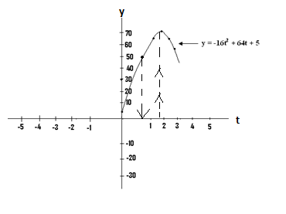

1. t = 1.75 can be approximated to t = 1.8: From t = 1.8, draw a straight line to meet the graph and from this point, draw another one to meet the y – axis. The point where it meets the y – axis is the required value.
2. If the height is 50m, then y = 50m.

From y = 50, draw a straight line and at the points where it meets the graph, straight lines are then drawn to meet the t or time axis. These meeting points are the required values.

1. The maximum height reached refers to the highest value of y i.e. 69(69m).

**Graphs of the form y = $\frac{Ax+C}{Bx+D}$**

* There are certain graphs which are of the form y = $\frac{Ax+C}{Bx+D}$, and examples are

1. y = $\frac{2x+5}{x^{2}+1}$ (ii) y = $\frac{5x-1}{x-2}$

* Questions based on this type of graph are solved in the usual manner.

(Q1) The following is an incomplete table of values for the relation y = $\frac{x+5}{x^{2}+1}$ for

-3 ≤ x ≤ 3.

|  |  |  |  |  |  |  |  |  |
| --- | --- | --- | --- | --- | --- | --- | --- | --- |
| X | -3.0 | -2.0 | -1.0 | 0.0 | 0.2 | 1.0 | 2.0 | 3.0 |
| Y | 0.2 |  |  | 5 |  |  |  |  |

1. Copy and complete the table.
2. Using a scale of 2cm to 1 unit on each axis, draw the graph of the given relation.
3. From your graph, find the greatest value of $\frac{x+5}{x^{2}+1}$.
4. Using the same axes and scale, draw the graph of the relation y = x.
5. From your graphs, find the truth set of $\frac{x+5}{x^{2}+1}$ = x.

Soln:

1. y = $\frac{x+5}{x^{2}+1}$

|  |  |  |  |  |  |  |  |  |
| --- | --- | --- | --- | --- | --- | --- | --- | --- |
| X | -3.0 | -2.0 | -1.0 | 0.0 | 0.2 | 1.0 | 2.0 | 3.0 |
| Y | 0.2 | 0.6 | 2 | 5 | 5 | 3 | 1.4 | 0.8 |

1. If x = -2 (2)If x = -1

y = $\frac{x+5}{x^{2}+1}$ y = $\frac{x+5}{x^{2}+1}$

=> y = $\frac{-2+5}{{-(-2)}^{2}+1}$ => y = $\frac{-1+5}{{- (-1)}^{2}+1}$

=> y = $\frac{3 }{4 +1}$ = $\frac{3}{5}$ => y = $\frac{-1+5}{1+1}$ = $\frac{4}{2}$

=> y = 0.6 => y = 2

(3) If x = 0.5 (4) If x = 2

y = $\frac{x+5}{x^{2}+1}$ y = $\frac{x+5}{x^{2}+1}$

=> y = $\frac{0.5+5}{{(0.5)}^{2}+1}$ => y = $\frac{2+5}{{(2)}^{2}+1}$

=>y = $\frac{5.5 }{1.25}$ = $\frac{3}{1.25}$ => y = $\frac{2 + 5}{4 + 1}$ = $\frac{7}{5}$

=> y = 4.4 => y = 1.4

(b)

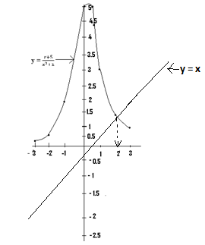

(c)From the graph, the greatest value of $\frac{x+5}{x^{2}+1}$ is around or about 5.

(d) To draw the graph of y = x, we first construct a table.

y = x

|  |  |  |  |
| --- | --- | --- | --- |
| X | 0 | 1 | 2 |
| Y | 0 | 1 | 2 |

1. If x = 1 (2)If x = 0 (3) If x = 2

y = x y = x y = x

=> y = 1 => y = 0 => y = 2

From $\frac{x+5}{x^{2}+1}$ = x => y = $\frac{x+5}{x^{2}+1}$ = x,

=> y = x.

We therefore draw the line y = x (which we`ve already drawn), and where it cuts the graph, the corresponding x value or values are taken.

the truth set ={x: x = 1.5}.

N:B – Ordinate refers to the y – axis,

* Abscissa refers to the x – axis.

(Q2) (i) Plot the graphs of y = $\frac{-2x+2}{{-x}^{2}-1}$ and y = 2x for -2 ≤ x ≤ 3 on the same axes.

1. Determine the minimum or maximum value of the graph.
2. Find the values of x for which $\frac{-2x+2}{{- x}^{2}-1}$ = 2x.

Soln:

|  |  |  |  |  |  |  |
| --- | --- | --- | --- | --- | --- | --- |
| X | -2 | -1 | 0 | 1 | 2 | 3 |
| Y | -1.2 | -2 | -2 | 0 | 0.4 | 0.4 |

1. If x = -2

y = $\frac{-2x+2}{{- x}^{2}-1}$

=> y = $\frac{-2(-2)+2}{{-(-2)}^{2}-1}$

=> y = $\frac{4 + 2}{-\left(4\right)- 1}$

=> y = $\frac{6}{-5}=-1.2$

1. If x = -1

y = $\frac{-2x+2}{{- x}^{2}-1}$

=> y = $\frac{-2(-1)+2}{{-(-1)}^{2}-1}$

=> y = $\frac{2+2}{-\left(1\right)- 1}$

=> y = $\frac{4}{-2}=-2$

1. If x = 0, y = $\frac{-2x+2}{-x^{2}- 1}$

=> y = $\frac{-2(0)+2}{{-(0)}^{2}-1}$

=> y = $\frac{-2(0)+2}{{-(0)}^{2}-1}$

=> y = $\frac{0+2}{-\left(0\right)- 1}$

=> y = $\frac{2}{-1}=-2'$

1. If x = 2

y = $\frac{-2x+2}{{- x}^{2}-1}$

=> y = $\frac{-2(2)+2}{{-(2)}^{2}-1}$

=> y = $\frac{- 4 + 2}{- \left(4\right)- 1}$

=> y = $\frac{- 2}{-5}=0.4.$

Next we construct a table for the relation y = 2x, which is a straight line graph.

y = 2x

|  |  |  |  |
| --- | --- | --- | --- |
| X | 0 | 1 | 2 |
| Y | 0 | 2 | 4 |

1. If x = 0 (2) If x = 1 (3) If x = 2

y = 2x y = 2x y = 2x

y = 2(0) y = 2(1) y = 2(2)

y = 0 y = 2 y = 4

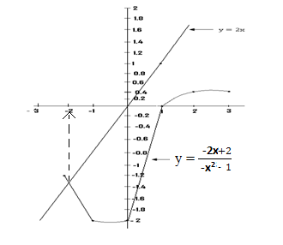

1. From the graph drawn, the minimum value is -2 (with reference to the y-axis).
2. y = $\frac{-2x+2}{{- x}^{2}-1}$

From $\frac{-2x+2}{{- x}^{2}-1}$ = 2x

=> y = $\frac{-2x+2}{{- x}^{2}-1}$ = 2x

=> y = 2x.

We therefore draw the line y = 2x (which has already been drawn), and at the point where it cuts the graph, the corresponding x component or value is determined.

Truth set = {x: x = -2} approx.

N/B: - The value of x for which $\frac{-2x+2}{{- x}^{2}-1}$ = 2x is the same as the value of x which satisfies simultaneously the equation $\frac{-2x+2}{{- x}^{2}-1}$ = 2x.

* Before this value can be had, then the two graphs must be plotted on the same axes, or on the same graph sheet, even if we are not told to do so in the question.

(Q3) (i) On the same axes, plot the graphs of y = $\frac{3x^{2}+1}{x+1}$ and y = $\frac{2x^{2}- 6}{x^{2}- 2}+5$ for -5 ≤ x $≤$ 6.

(ii) Using your graphs, determine the value of x for which $\frac{2x^{2}- 6}{x^{2}- 2}$ = $\frac{3x^{2}+1}{x+1}$.

Soln:

Table one: y = $\frac{3x^{2}+1}{x+1}$

|  |  |  |  |  |  |  |  |  |  |  |  |  |
| --- | --- | --- | --- | --- | --- | --- | --- | --- | --- | --- | --- | --- |
| x | -5 | -4 | -3 | -2 | -1 | 0 | 1 | 2 | 3 | 4 | 5 | 6 |
| y | -19 | -16.3 | -14 | -13 | 0 | 1 | 2 | 4.3 | 7 | 9.8 | 12.7 | 15.6 |

1. If x = - 4

y = $\frac{3x^{2}+1}{x + 1}$

=> y = $\frac{3{(- 4)}^{2}+1}{- 4+1}$

=> y = $\frac{3\left(16\right) + 1}{-3}$

=> y = $\frac{48 + 1}{-3}$

=> y = $\frac{49}{-3}$

=> y = -16.

1. If x = -3

y = $\frac{3x^{2}+ 1}{x + 1}$

=> y = $\frac{3{(-3)}^{2}+1}{-3 + 1}$

=> y = $\frac{3\left(9\right) + 1}{-2}$

=> y = $\frac{27 + 1}{-2}$

=> y = $\frac{28}{-2}$

=> y = -14.

1. If x = 2

y = $\frac{3x^{2}+ 1}{x + 1}$

=> y = $\frac{3{(2)}^{2}+ 1}{2 + 1}$

=> y = $\frac{3\left(4\right) +1}{3}$

=> y = $\frac{12 + 1}{3}$

=> y = $\frac{13}{3}$

=> y = 4.3

1. If x = 6

y = $\frac{3x^{2}+1}{x+1}$

=> y = $\frac{3{(6)}^{2}+1}{6 + 1}$

=> y = $\frac{3\left(36\right) + 1}{7}$

=> y = $\frac{108+1}{7}$

=> y = $\frac{109}{7}$

=> y = 15.6

Table two:

y = $\frac{2x^{2}- 6}{x^{2}- 2}$ + 5

|  |  |  |  |  |  |  |  |  |  |  |  |  |
| --- | --- | --- | --- | --- | --- | --- | --- | --- | --- | --- | --- | --- |
| x | -5 | - 4 | -3 | -2 | -1 | 0 | 1 | 2 | 3 | 4 | 5 | 6 |
| y | 6.8 | 6.8 | 6.7 | 6 | 9 | 8 | 9 | 6 | 6.7 | 6.9 | 7 | 6.9 |

1. If x = -5

y = $\frac{2x^{2}- 6}{x^{2}- 2}$ + 5

=> y = $\frac{2{(-5)}^{2}- 6}{{(-5)}^{2}- 2}$ + 5

=> y = $\frac{2\left(25\right) - 6}{25 - 2}$ + 5

=> y = $\frac{50 - 6}{23}$ + 5

=> y = $\frac{44}{23}$ + 5

=> y = 1.8 + 5

=> y = 6.8

1. If x = -2

y = $\frac{2x^{2}- 6}{x^{2}- 2}$ + 5, => y = $\frac{2{(-2)}^{2}- 6}{({-2)}^{2 }- 2}$ + 5

=> y = $\frac{2\left(4\right) - 6}{4 - 2}$ + 5

=> y = $\frac{8 - 6}{2}$ + 5

=> y = $\frac{2}{2}+5$

=> y = 1 + 5

=> y = 6.

1. If x = 3

y = $\frac{2x^{2}- 6}{x^{2} - 2}$ + 5

=> y = $\frac{2{(3)}^{2}- 6}{({3)}^{2}- 2}$ + 5

=> y = $\frac{2\left(9\right) - 6}{9 - 2}$ + 5

=> y = $\frac{18 - 6}{7}$ + 5

=> y = $\frac{12}{7}+5$

=> y = 1.7 + 5

=> y = 6.7

1. If x = 6

y = $\frac{2x^{2}- 6}{x^{2}- 2}$ + 5

=> y = $\frac{2{(6)}^{2} - 6}{({6)}^{2} - 2}$ + 5

=> y = $\frac{2\left(36\right) - 6}{36 - 2}$ + 5

=> y = $\frac{72- 6}{34}$ + 5

=> y = $\frac{66}{34}+5$

=> y = 1.9 + 5

=> y = 6.9.

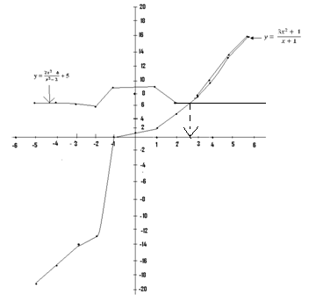

(ii) The two graphs are equal i.e. $\frac{2x^{2}- 6}{x^{2}- 2}$ = $\frac{3x^{2}+ 1}{x+1}$ at their points of intersection and the corresponding x value is x = 2.5 approx.

**Other forms of graphs:**

(Q1) The following is an incomplete table for the relation $\frac{y}{x+1}=3-x$ for -2 ≤ x ≤ 3.5.

|  |  |  |  |  |  |  |  |  |  |
| --- | --- | --- | --- | --- | --- | --- | --- | --- | --- |
| X | -2 | -1 | 0 | 1 | 1.5 | 2 | 2.5 | 3 | 3.5 |
| Y |  | 0 | 3 | 4 |  |  | 1.75 |  | -2.25 |

1. Copy and complete the given table.
2. Using 2cm as 1 unit on both axes draw the graph of the relation for the given interval.
3. Use your graph to find:  
   (a) the truth set of (x+1)(x-3) = -1.

(b) the greatest value of y and the value of x for which is occurs.

N/B: - As already mentioned, before any graph is plotted, we must first make y the subject of the given equation.

* From $\frac{y}{x+1}$ = 3 – x => y = (3-x) (x+1).
* We therefore plot the graph of y = (3-x) (x+1).
* In multiplication, when there is a negative or a positive sign between a number and a letter, we must introduce the bracket sign as we have just done.

Example(1): $\frac{y}{x - 1}=2$ => y = 2(x-1) => y = 2x – 2.

Example (2): $\frac{y}{2+x}=x$- 1 => y = (2 + x) (x – 1).

Soln:

y = (x+1) (3-x)

|  |  |  |  |  |  |  |  |  |  |
| --- | --- | --- | --- | --- | --- | --- | --- | --- | --- |
| X | -2 | -1 | 0 | 1 | 1.5 | 2 | 2.5 | 3 | 3.5 |
| Y | -5 | 0 | 3 | 4 | 3.8 | 3 | 1.75 | 0 | -2.25 |

1. If x = -2 (2) If x = 1.5

y = (x+1) (3-x) y = (x+1) (3-x)

=> y = {(-2) + 1} {3-(-2)} => y = (1.5+1) (3-1.5)

=> y = (-2+1) (3+2) => y = (2.5)(1.5)

=> y= (-1) (5) => y = 3.8. .

=> y = -5.

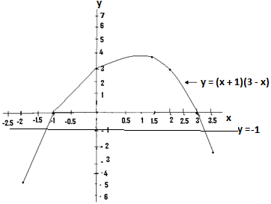

(a) y = (x+1)(3-x) is the equation of the graph.

From (x+1)(3-x) = -1 => y = (x+1)(3-x) = -1, => y = -1.

Draw the line y = -1 and at the points where it cuts the graph, determine the corresponding x components.

Truth set ={x :x = -1.2 or x = 3.2} approx.

(b)From the graph, the greatest value of y is 4, and occurs when x = 1.

(Q2)(a) Copy and complete the table for the relation (x-1) (y-1) = 6 for 2 ≤ x ≤ 7.

|  |  |  |  |  |  |  |  |
| --- | --- | --- | --- | --- | --- | --- | --- |
| X | 2 | 2.5 | 3 | 4 | 5 | 6 | 7 |
| Y | 7 |  |  | 3 |  |  | 2 |

(b) Using a scale of 2cm to 1unit on both axes, draw the graphs of (x-1) (y-1) = 6 and x + y = 8 within the given interval.

(c) Using your graph, find the truth set of the simultaneous equations (x – 1) (y -1) = 6 and x + y = 8.

Soln:  
(a)

N/B:: Considering (x-1) (y - 1) = 6, first make y the subject by dividing through using (x-1), and (y-1) will be left on the left hand side of the equation/.The -1 found on the left hand side is then made to cross the equal to sign and this changes to +1.The y is then left alone on the left hand side of the equation..This is illustrated below: Table one:

$$y=\frac{6}{(x-1)}+1$$

|  |  |  |  |  |  |  |  |
| --- | --- | --- | --- | --- | --- | --- | --- |
| X | 2 | 2.5 | 3 | 4 | 5 | 6 | 7 |
| Y | 7 | 5 | 4 | 3 | 2.5 | 2.2 | 2 |

From (x – 1) (y – 1) = 6, divide through using (x-1)

=> $\frac{\left(x - 1\right) (y - 1)}{(x - 1)}=\frac{6}{(x - 1)}=>y-1=\frac{6}{(x - 1)}$

=> y = $\frac{6}{(x - 1)}$ + 1.

(1) If x = 2.5 (2) If x = 3 (3) If x = 6

y = $\frac{6}{(x - 1)}$ + 1 y = $\frac{6}{(x - 1)}$ + 1 y = $\frac{6}{(x - 1)}$ + 1

=> y = $\frac{6}{(2.5 - 1)}$ + 1 => y = $\frac{6}{(3 - 1)}$ + 1 => y = $\frac{6}{(6 - 1)}$ + 1

=> y = $\frac{6}{1.5}$ + 1 = 4 + 1 => y = $\frac{6}{2}$ + 1 = 3 + 1 => y = $\frac{6}{5}$ + 1 = 1.2 + 1  
=> y = 5. => y = 4 => y = 2.2.

Table (2)

y = 8 –x

|  |  |  |  |  |  |  |  |
| --- | --- | --- | --- | --- | --- | --- | --- |
| X | 2 | 2.5 | 3 | 4 | 5 | 6 | 7 |
| Y | 6 |  |  | 4 |  |  | 1 |

From x + y = 8 => y = 8 – x. Since this is a straight line graph, we compute only three values of y.

1. If x = 2 (2) If y = 4 (3) If x = 7

y = 8 – x y = 8 – x y = 8 - x

=> y = 8 – 2 => y = 8 – 4 => y = 8 -7

=> y = 6 => y = 4 => y = 1

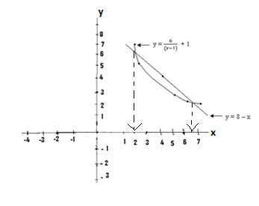

(c)For the required truth set, we fist locate the points of intersection of the graphs, and determine their corresponding x components. Truth set={ x : x = 2 or x = 6.2} approx.

Q3

|  |  |  |  |  |  |  |  |
| --- | --- | --- | --- | --- | --- | --- | --- |
| Dist/ km | 10 | 15 | 40 | 45 | 70 | 80 | 85 |
| Time/ hrs | 1 | 2 | 3 | 4 | 5 | 6 | 7 |

The given table shows the distance travelled by a car, with respect to time.

1. Represent this on a graph.
2. Using your graph, determine the distance travelled when the time is 4 $\frac{1}{2}$ hours.
3. If the distance travelled is 75km, find the time.

Soln:

(i)

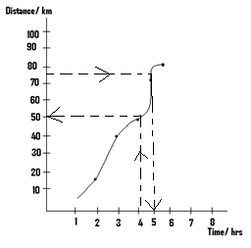

(ii) Form the graph, the distance travelled in4 $\frac{1}{2}$ hrs is 50km.

1. From the graph, when the distance travelled is 75km, the time is 5hrs.

N/B: The variable with the constant interval is plotted usually on the x - axis unless otherwise stated.

Q4)

|  |  |  |  |  |  |  |
| --- | --- | --- | --- | --- | --- | --- |
| Temp/0C | 5 | 10 | 15 | 20 | 25 | 30 |
| Mass/ kg | 10 | 15 | 60 | 65 | 100 | 110 |

The given table shows the manner in which the temperature of a body varies with its mass.

1. Represent this graphically.
2. From the graph, determine the temperature when the mass of the body is 30kg.
3. At what mass will the temperature be 170C.

N/B: Since temperature has a constant or the same interval, it is plotted on the x-axis.

* If the interval is time, then we must plot it on the x - axis.

Soln:

(i)

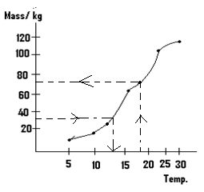

(ii) From the graph, when the mass is 30kg, the temperature is 120C.

(iii) When the temperature is 170C, then the mass is 70kg.

(Q5)

|  |  |  |  |  |  |  |  |  |
| --- | --- | --- | --- | --- | --- | --- | --- | --- |
| Temp/0C | -60 | -40 | 0 | 10 | 15 | 20 | 50 | 40 |
| Time/ sec | -4 | -2 | 0 | 2 | 4 | 6 | 8 | 10 |

The variation of temperature with time of a substance is shown in the given table.

1. Represent this on a graph.
2. At what temperature will the time be 5 seconds?
3. At what time will the temperature be 300C.

Soln:

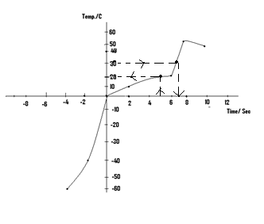v

1. When the time is 5 seconds, the temperature is 200c.
2. When the temperature is 300C, the time is 61sec.

(Q6)

|  |  |
| --- | --- |
| W | D |
| -5 | -100 |
| -4 | -60 |
| -3 | -20 |
| -2 | 0 |
| -1 | 30 |
| -0 | 40 |
| 1 | -30 |
| 2 | -60 |

The given table shows the way and manner the variable W, varies another one, D represents this on a graph.

Soln:

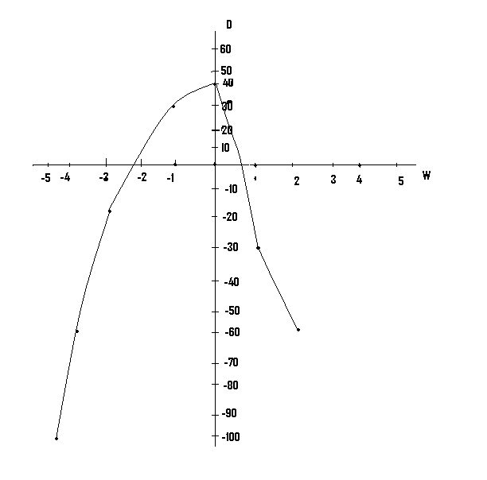

Questions:

(Q1) (a) Construct a table for the relation y = 3x2 + 4x – 3 for -6 ≤ x ≤ 5.

(b) Plot the graph of the given relation.

(c) Determine the maximum or the minimum value of your graph.

(d) Determine the equation of the line of symmetry.

Ans:

Y = 3x2 + 4x -3

|  |  |  |  |  |  |  |  |  |  |  |  |  |
| --- | --- | --- | --- | --- | --- | --- | --- | --- | --- | --- | --- | --- |
| X | -6 | -5 | -4 | -3 | -2 | -1 | 0 | 1 | 2 | 3 | 4 | 5 |
| Y | 81 | 52 | 28 | 12 | 1 | -4 | -3 | 4 | 17 | 36 | 61 | 92 |

(b)

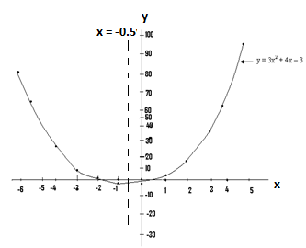

(c) The minimum value of the graph is -4.

(d) The equation of the line of symmetry is x = -0.5

(Q2) (a) Construct a table for the relation y = -2x2 – 4x + 1 for -7 ≤ x ≤ 5.

(b) Plot the graph of the given relation.

(c) Determine the maximum or minimum value of your graph.

(d) Using your graph, find the truth set of -2x2 – 4x + 1 = - 40

Ans:

1. Y = -2x2 – 4x + 1

|  |  |  |  |  |  |  |  |  |  |  |  |  |  |
| --- | --- | --- | --- | --- | --- | --- | --- | --- | --- | --- | --- | --- | --- |
| X | -7 | -6 | -5 | -4 | -3 | -2 | -1 | 0 | 1 | 2 | 3 | 4 | 5 |
| Y | -69 | -47 | -29 | -15 | -5 | 1 | 3 | 1 | -5 | -15 | -29 | -47 | -69 |

(b)

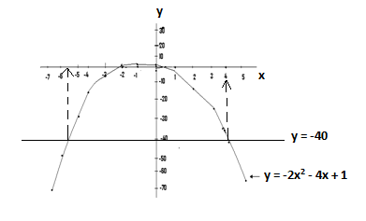

1. From the graph, the maximum value is 3.
2. Truth set = {x x = -5.5 or x = 4} approx.

(Q3)(a) Using the same axes, plot the graphs of y = x2 – 5 and y – 5x = 0 for -7 $≤x≤7$.

(b) Use your graph to find the truth set of 5x = -x2 - 5

Ans:

1. y = -x2 – 5

|  |  |  |  |  |  |  |  |  |  |  |  |  |  |  |  |
| --- | --- | --- | --- | --- | --- | --- | --- | --- | --- | --- | --- | --- | --- | --- | --- |
| x | -7 | -6 | -5 | -4 | -3 | -2 | -1 | 0 | 1 | 2 | 3 | 4 | 5 | 6 | 7 |
| y | -54 | -41 | -30 | -21 | -14 | -9 | -6 | -5 | -6 | -9 | -14 | -21 | -30 | -41 | -54 |

y = 5x

|  |  |  |  |  |  |  |  |  |  |  |  |  |  |  |  |
| --- | --- | --- | --- | --- | --- | --- | --- | --- | --- | --- | --- | --- | --- | --- | --- |
| x | -7 | -6 | -5 | -4 | -3 | -2 | -1 | 0 | 1 | 2 | 3 | 4 | 5 | 6 | 7 |
| y |  |  |  |  |  |  |  | 0 | 5 |  | 15 |  |  |  |  |

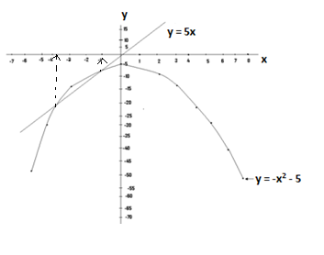

1. From the graph, the required truth set ={x: x = -3.5 or x = -1} approx.

(Q4)(a) On the same axes, plot the graphs of the relation y = $\frac{2x+1}{x^{2}-2}$, and y = $-\frac{1}{2}x+3$ for

- 6 $≤x≤6.$

(b) Determine the truth set of $\frac{2x+1}{x^{2}-2}$ = $-\frac{1}{2}x+3$.

Ans: y = $\frac{2x+1}{x^{2}-2}$

|  |  |  |  |  |  |  |  |  |  |  |  |  |  |
| --- | --- | --- | --- | --- | --- | --- | --- | --- | --- | --- | --- | --- | --- |
| X | -6 | -5 | -4 | -3 | -2 | -1 | 0 | 1 | 2 | 3 | 4 | 5 | 6 |
| Y | -0.3 | -0.4 | -0.5 | -0.7 | -1.5 | 1 | -0.5 | -3 | 2.5 | 1 | 0.6 | 0.5 | 0.4 |

y = $-\frac{1}{2}x+3$

|  |  |  |  |  |  |  |  |  |  |  |  |  |  |
| --- | --- | --- | --- | --- | --- | --- | --- | --- | --- | --- | --- | --- | --- |
| X | -6 | -5 | -4 | -3 | -2 | -1 | 0 | 1 | 2 | 3 | 4 | 5 | 6 |
| Y |  |  |  |  |  |  | 3 | 2.5 | 2 |  |  |  |  |

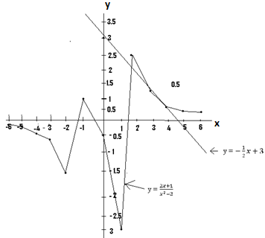

1. Truth set ={x : x = 2 or x = 4} approx.

|  |  |  |  |  |  |  |  |  |  |
| --- | --- | --- | --- | --- | --- | --- | --- | --- | --- |
| X | -4 | -3 | -2.5 | -2 | 0 | 0.5 | 2 | 3 | 4 |
| Y | 12.5 |  |  |  | -0.5 | 0.4 |  |  | 10.5 |

1. Copy and complete the given table for the relation y = $\frac{1}{4}\left(3x+2\right)\left(x-1\right)$ for

- 4 $≤x≤4$.

(b) Plot the graph of the given relation.

(c) Draw on the same axes the graph of y + x = 0.

Ans:

(a)

y = $\frac{1}{4}\left(3x+2\right)\left(x-1\right)$

|  |  |  |  |  |  |  |  |  |  |
| --- | --- | --- | --- | --- | --- | --- | --- | --- | --- |
| X | -4 | -3 | -2.5 | -2 | 0 | 0.5 | 2 | 3 | 4 |
| Y | 12.5 | 7 | 6.6 | 3 | -0.5 | 0.4 | 2 | 5.5 | 10.5 |

(b)

