**CHAPTER SEVEN**

**POLYGONS**

Definition:

A polygon is a plane figure which is bounded by straight lines.

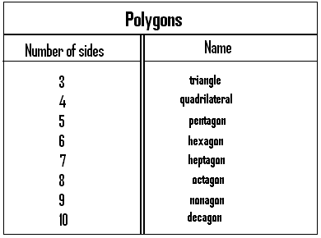

* A polygon has both interior as well as exterior angles.
* The interior angles of a polygon are those angles which lie within the polygon.
* The exterior angles of a polygon lie outside the polygon.

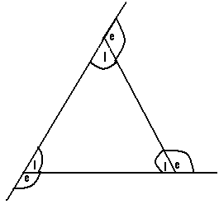

I = interior angle.

e = exterior angle.

N/B: For any polygon, the sum of the exterior angles = 36 $0^{0}.$

Q1. Calculate the value of each exterior angle of a regular decagon.

Soln.

Decagon has 10 sides and as such 10 exterior angles.

But the sum of the exterior angles of any polygon = 36 $0^{0}.$

⇒ 10 exterior angles = 36 $0^{0}.$

∴ 1 exterior angle = $\frac{1}{10}×360$

= 3 $6^{0}$.

⇒ each exterior angle of a decagon = 3 $6^{0}$.

Q2. Find the exterior angle of a regular pentagon.

Soln.

Pentagon has 5 sides, and as such 5 exterior angles. But the sum of the exterior angles of a polygon = 36 $0^{0}$

⇒ 5 exterior angles = 360

⇒ 1 exterior angle = $\frac{1}{5}×360$

= ${72}^{0}.$

∴ Each exterior angle of the regular pentagon =720. For any polygon, the sum of the exterior angle and the exterior angle at any of its vertices = 18 $0^{0}$.

**Determination of the interior angle of a regular polygon:**

- We must first determine the value of the exterior angle.

- Using the fact that at any vertex, exterior angle + interior angle = 18 $0^{0}$.

⇒ interior angle = 18 $0^{0}$- exterior angle.

Q1. Calculate the interior angles of a regular decagon.

Soln.

Decagon has 10 exterior angles

⇒ 10 exterior angles = ${360}^{0}$.

∴ 1 exterior angle = $\frac{1}{10}×360$

= ${36}^{0}.$

But at any vertex, exterior angle + interior angle = 18 $0^{0}$.

⇒ ${ 36}^{0}$ + interior angle = 18 $0^{0}$.

Interior angle =18 $0^{0}- 36^{0}=144^{0}$.

The interior angle of the decagon = $144^{0}$.

Q2. Find the value of each Interior angle of a triangle.

Soln.

A triangle has 3 sides and as such 3 exterior angles.

⇒ 3 exterior angles = $3{60}^{0}$

∴ 1 exterior angle = $\frac{1}{3} ×360$

= 12 $0^{0}$.

But at any vertex, interior angle + exterior angle = 18 $0^{0}$

⇒ Interior angle + 12 $0^{0}$ = 18 $0^{0}$

∴ Interior angle = ${ 60}^{0}$

**Determination of the sum or the total interior angles of a polygon:**

For any polygon, the sum of the interior angles = the number of sides of the polygon $×$ the value of one interior angle.

Q1. Calculate the sum of the interior angles of a regular decagon.

Soln.

Decagon has 10 exterior angles

⇒ 10 exterior angles = $3{60}^{0}$

∴ 1 exterior angle = $\frac{1}{10}×360^{0}$

= 3 $6^{0}.$

But at any vertex, interior angle + exterior angle = 1 $80^{0}$

⇒ Interior angle + 360 = 1800

⇒ Interior angle = 180 – 36

⇒ Interior angle = 14 $4^{0}$.

But the sum of the interior angles of a decagon = interior angle $×$ the number of sides.

∴ Sum of interior angles of the decagon = 14 $4^{0}×10= 14{40}^{0}.$

Q2. Find the sum of the interior angles of a regular octagon.

Soln.

Octagon has eight sides and as such eight exterior angles.

⇒ 8 exterior angles = $360^{0}$

∴ 1 exterior angle = $\frac{1}{8}× {360}^{0}$

= ${45}^{0}$.

But at any vertex, exterior angle + interior angle = 18 $0^{0}$

∴ ${45}^{0}$ + interior angle = 1 $80^{0}$

⇒ Interior angle = 180 – 45 = ${135}^{0}$.

But the sum of interior angle = the number of sides of the polygon $×interior$ angle = 8 $× {135}^{0}$ = ${1080}^{0}$.

Q3.The interior angles of a regular triangle are marked ${20}^{0}+ {2x}^{0}, {10}^{0}+{5x}^{0}$ and ${40}^{0}+{4x}^{0}.$ Find the actual values of each of these angles.

N/B: First calculate the sum of the interior angles of the triangle.

Soln.

Triangle has 3 exterior angles

⇒ 3 exterior angles = ${360}^{0}$

∴ 1 exterior angle = $\frac{1}{3} ×{360}^{0}$

= ${120}^{0}$.

But at any vertex, exterior angle + interior angle = ${180}^{0}$

⇒ ${ 120}^{0}$ + interior angle = ${180}^{0}$

⇒ Interior angle = ${180}^{0}$- ${120}^{0}$ = ${60}^{0}$.

But the sum of the interior angles of the triangle = the number of sides $×$ interior angle = 3 $×$ 60 = ${180}^{0}$.

But the interior angles of the triangle are given as ${20}^{0}+ {2x}^{0}, {10}^{0}+{5x}^{0}$ and ${40}^{0}+{4x}^{0}.$ The sum of these interior angles = ${20}^{0}+ {2x}^{0}{+10}^{0}+{5x}^{0}$ + ${40}^{0}+{4x}^{0}$

= ${20}^{0}+{10}^{0}+{40}^{0}+{2x}^{0}+{5x}^{0}+{4x}^{0}={70}^{0}+11x$.

But the sum of the interior angles of the polygon or triangle = ${180}^{0}$

⇒ $70+11x={180}^{0}$

⇒ $11x= {180}^{0}- 70=110^{0}$

⇒ $x=\frac{110}{11}={10}^{0}$.

∴ The angle marked 0 + 200 = 400.

The angle marked 100 + 5x0 = 100 + 50(10) = 10 + 500 = 600.

Lastly, the angle marked ${40}^{0}+{4x}^{0}=40+4\left(10\right)=40+40={80}^{0}$.

Q4. The angles of a pentagon are marked $x^{0}, \left(x^{0}+{20}^{0}\right), \left(x^{0}+{25}^{0}\right), {2x}^{0} and \left({2x}^{0}+5\right)$.

1. Find the value of x.
2. Determine the value of each of those angles.

Soln.

Pentagon has 5 exterior angles.

5 exterior angles = ${360}^{0}$

∴1 exterior angle = $\frac{1}{5}×360$

= ${72}^{0}$.

But at any vertex, exterior angle + interior angle = ${180}^{0}$

⇒ ${72}^{0}+interior angle= {180}^{0}$

⇒ interior angle = 0.

Sum of the interior angles of the pentagon = number of sides $×$ interior angle

= $5×108={540}^{0}$.

The given angles which are $x^{0}, x+20^{0}, x+{25}^{0}, 2x and 2x+5^{0}$ are the interior angles of the pentagon.

Sum of these interior angles = $x^{0}+ x+20^{0}+ x+{25}^{0}+ 2x+ 2x+5^{0}$

= 7x + 50.

Since the sum of the interior angles of the pentagon has been calculated to be equal to ${540}^{0}7x+50={540}^{0} 7x=540-50 7x=490$

⇒ $x=\frac{490}{7}=70,$ ∴ x = ${70}^{0}.$

The value of the angle marked $x^{0}={70}^{0}$.

The value of the one marked x + ${20}^{0}=70+20={90}^{0}$.

The angle marked x + 25 = 70 + 25 = ${95}^{0}$.

The angle marked 2x = 2 $×70={140}^{0}$.

Lastly, the angle marked 2x + 5 = 2(70) + 5 = 140 + 5 = ${145}^{0}$

Q5.

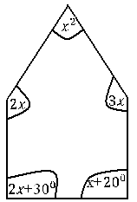

Determine the value of *x*.

Soln.

The given figure has five sides (a pentagon) and as such has five exterior angles.

5 exterior angles = ${360}^{0}$

⇒ 1 exterior angle = $\frac{1}{5}×360$

= ${72}^{0}.$

But at any vertex, interior angle + exterior angle $={180}^{0}$

⇒ ${72}^{0}$ + interior angle = ${180}^{0}$

⇒ interior angle = 180 – 72 = ${108}^{0}$.

The sum of the interior angles of the pentagon = number of sides $×interior angle=5×108={540}^{0}$.

The sum of the interior angles of the given figure = x + 2x + 3x + 2x + ${30}^{0}+ x+ {20}^{0}=9x+50$

⇒ 9x + ${50}^{0}={540}^{0}$

⇒ 9x = 540 – 50 = 490

⇒ 9x = 490 ⇒ x = $\frac{490}{9}=54$

∴ x = ${54}^{0}$

Q6.

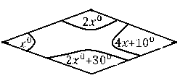

Calculate the value of *x.*

Soln.

The given figure is a quadrilateral and as much has four exteriior angles.

4 exterior angles = ${360}^{0}$

∴ 1 exterior angle = $\frac{1}{4}×{360}^{0}$

= ${90}^{0}$.

But at a vertex, exterior angle + interior angle = ${180}^{0}$

⇒ 9 $0^{0}+ interior angle= {180}^{0}$

⇒ interior angle = 180 – 90 = 90.

Sum of the interior angles of a polygon = number of sides $×$ interior angle

= 4 $×90={360}^{0}$.

The sum of the interior angles of the given polygon = $x^{0}+{2x}^{0}+{2x}^{0}+{30}^{0}+{4x}^{0}+{10}^{0}=9x+{40}^{0}$

⇒ $9x+{40}^{0}= {360}^{0}$

⇒ 9x = ${360}^{0}-40={320}^{0}$

∴ x = ${35.5}^{0}.$

Q7.

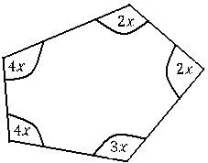

Find the value of x.

Soln.

The given figure has five sides (pentagon), and as such has five exterior angles.

5 exterior angles = ${360}^{0}$

∴ 1 exterior angle = $\frac{1}{5}×360$

= ${72}^{0}$.

But at a vertex, interior angle + exterior angle = ${180}^{0}$

⇒ interior angle + ${72}^{0}=180^{0}$

∴ interior angle = 18 $0^{0}-{72}^{0}$

⇒ Interior angle = ${108}^{0}.$

Sum of the interior angles of the given figure = number of sides $×$ interior angle

= 5 $×{108}^{0}={540}^{0}$.

The sum of the interior angles of the given figure = 4x + 4x + 2x + 2x + 3x = 15x

∴ 15x = ${540}^{0} x=\frac{540}{15}=36$

⇒ x = ${36}^{0}$.

N/B: The sum of the exterior angles of any polygon is equal to ${360}^{0}$.

Q8.

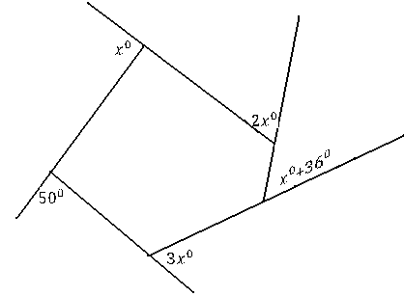

Find the value of x.

N/B: All the given angles are exterior angles.

Soln.

The given figure is a polygon (pentagon) and has five exterior angles.

But the sum of the exterior angles of a polygon = ${360}^{0}$

⇒ ${ x}^{0}+{50}^{0}+{3x}^{0}+x^{0}+{36}^{0}+{2x}^{0}={360}^{0}$

⇒ 7x + 86 = 360 => 7x = 360 - 86 = 2740.

∴ x =

⇒ x = .

Q9

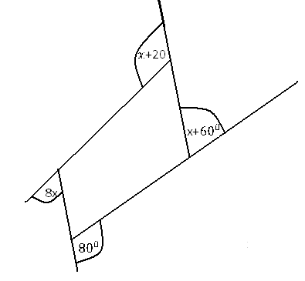

Determine the value of x.

N/B: The exterior angles of the given figure are ${8x}^{0}, {80}^{0}, x$ + ${ 60}^{0}$ and $x+{20}^{0}$.

Soln.

Sum of the exterior angles of the given figure = ${8x}^{0}+{80}^{0}+x$ + ${ 60}^{0}$ + $x+{20}^{0}$

= 10x + 160.

Since the given figure is a polygon (i.e a quadrilateral), then the sum of its exterior angles is ${360}^{0}.$

⇒ 10x + 160 = ${360}^{0}$

⇒ 10x = 360 – 160 = 200

⇒ x = $\frac{200}{10}={20}^{0} .$

Q10.

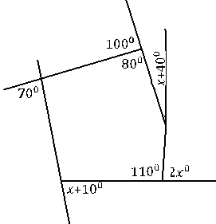

Calculate the values of the angles marked ${2x}^{0}$ and x + 4.

Soln.

The sum of the exterior angles of the given figure which is a polygon

= 70 + 100 + x + 40 + 2x + x + 10 = 220 + 4x.

Since the sum of the exterior angles of a polygon = ${360}^{0}, then 220+4x=360$

⇒ 4x = 360 – 220 = 140

⇒ x = $\frac{140}{4}=35$.

The value of the angle marked 2x = 2(${35}^{0})= {70}^{0}$.

Also the value of the angle marked x + 40 = 35 + 40 = 75..

**Determination of the number of sides of a polygon:**

The number of sides of any polygon = $\frac{{360}^{0}}{exterior angle}$

Q1. The exterior angle of a polygon is ${72}^{0}.How many sides has this polygon?$

Soln.

Number of sides = $\frac{{360}^{0}}{exterior angle}$ = ${\frac{360}{{72}^{0}}}^{0}=5 sides.$

Q2.Given that the exterior angle of a polygon is ${45}^{0},$ determine its number of sides.

Soln.

Number of sides = $\frac{{360}^{0}}{exterior angle}$

= $\frac{360}{45}=8 sides.$

Q3. Determine the number of sides of a polygon, whose interior angle is ${140}^{0}$.

N/B: First find the exterior angle and use it to divide ${360}^{0}.$

Soln.

At any vertex, exterior angle + interior angle = ${180}^{0}$

⇒ exterior angle + ${140}^{0 }={180}^{0}$

⇒ exterior angle = ${180}^{0}-{140}^{0}$

⇒ exterior angle = ${40}^{0}$.

Number of sides = $\frac{{360}^{0}}{exterior angle}$

$$=\frac{360}{40}=9 sides.$$

Q4. Determine the name of a polygon, whose interior angle is ${135}^{0}.$

N/B: By determining the number of sides, we can know the name of such a polygon.

Soln.

At any vertex, exterior angle + interior angle = ${180}^{0}$.

∴ exterior angle + ${135}^{0}=180^{0}$

⇒ exterior angle = 180 – 135 = 45.

Number of sides = $\frac{{360}^{0}}{exterior angle}$ = $\frac{360}{45}=8 sides.$

∴ The polygon has 8 sides and as such it is an octagon.

$$.$$