Ticket Created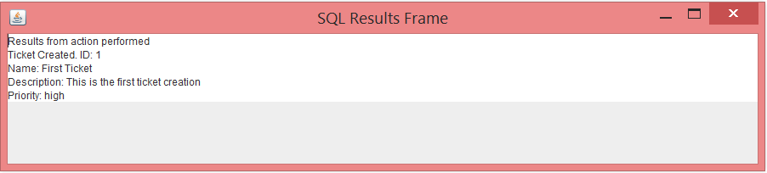

5 Tickets Created

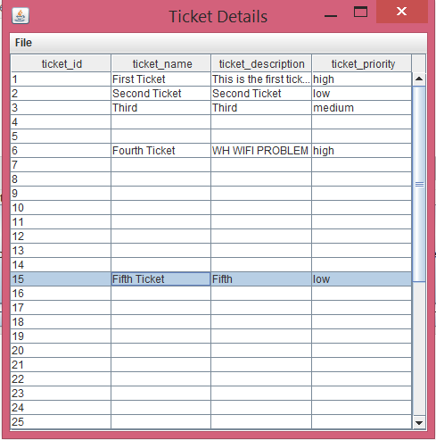

Closed Ticket:

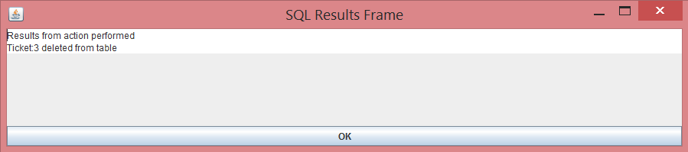

Request to deleted:

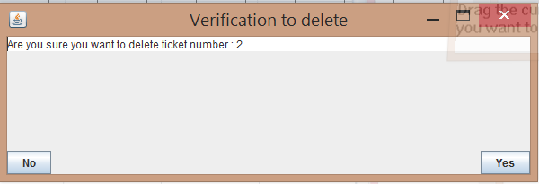

updated ticket

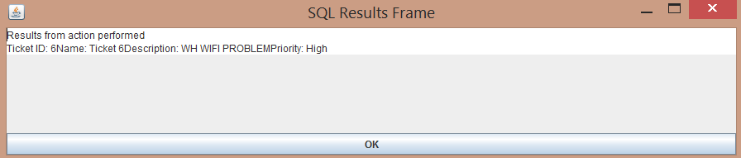

All Tickets

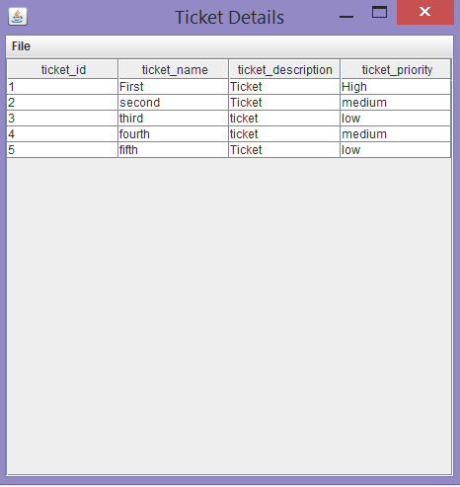

Closed to open:



High priority tickets:

