Azure Vm Creation

Go to azure portal -> virtual machines -> create virtual machine (on demand)
Basic
- > select Resource Group
-> give name
-> select Region
- > availability option :- no infrastructure needed
-> security type: standard
-> select iso Image : windows server 2022 (as per your requirement)
-> select vm size : Standard_B2als_v2 - 2 vcpus, 4 GiB memory ($24.67) (as per your requirement)
->give admin username : and Password
-> open port for RDP/SSH : 3389,22
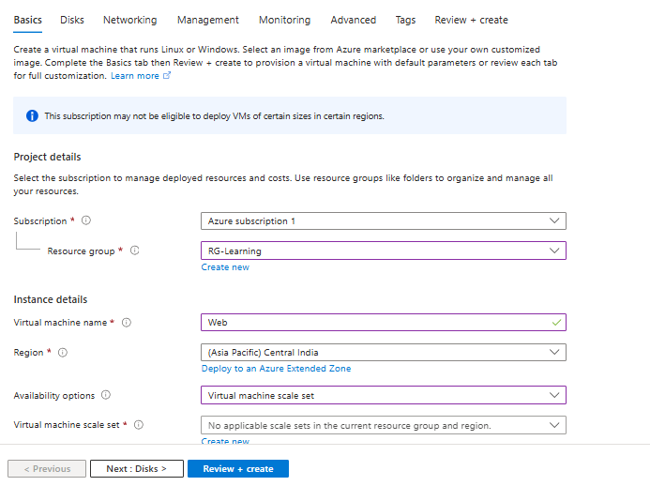
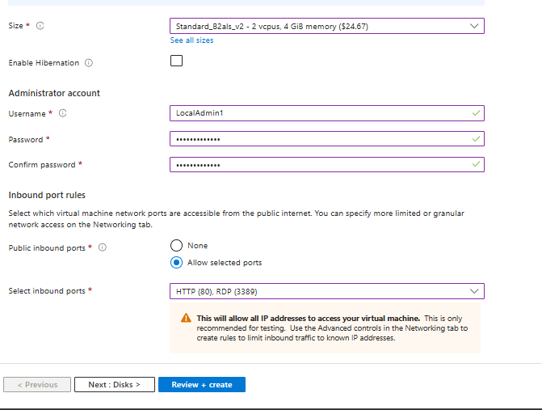

Disk
-OS disk size:128gb
- OS disk type : Standard SSD (locally-redundant storage)
-If you need to attach a disk then attach data disk
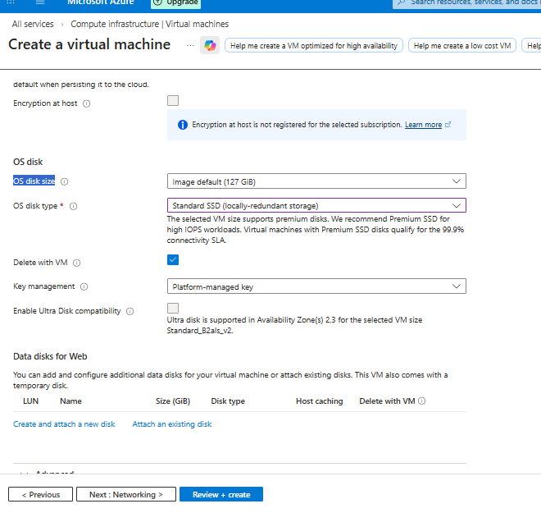

Networking
Configure vnet , subnet .if you don’t have any of these az will automatically create it for you .
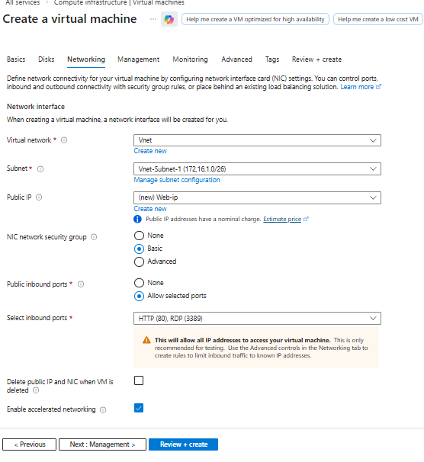

Then skip other steps or modify as per requirements

