VMSS
Virtual machine scale set is a cluster where we can deploy multiple Vms at a time . and configure vms by configuring cluster . its easier to manage vms , it supports autoscalling .
Supported features :
- Autoscalling
- Multiple vm creation
- Configure Load balancer
- Configure settings of multiple vms at a same time .
- Deploy 1000 Vms at a time
- Easy to manage and troubleshoot

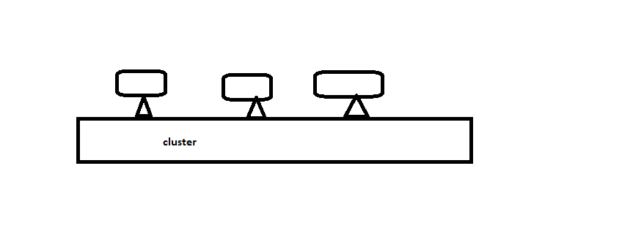
- Autoscalling
- Horizonatal scalling – it will add a same configured Vms if traffic increases .
- Scale in – it will delete vms if traffic/cpu usage decreases
- Scale out – it will deploy Vms if traffic/Cpu usage increases
- Vertical Scalling – it will increase the configuration of Vm if the traffic / cpu usage is increases .
Suppose a Vm1 has configuration 4gb RAM and 128Gb C drive . its is ideal for handling 200 users at atim if the users number increases then we need to increase the RAM and ROM configuration ie 8gb and 512GB in same VM ie Vm1 .

