

User guide

MailPerformance addon for Magento2

SUMMARY

Installation 3

Part 1. Plugin’s installation 3

Part 2. Plugin’s initialisation 4

Update 5

Configuration 6

Interface 7

MailPerformance’s components 8

Installation

### Part 1. Plugin’s installation

Navigate to Magento 2’s root folder and run :

|  |
| --- |
| composer require np6/mailperformance  php –f bin/magento setup:upgrade |

Then go in Magento’s backend and flush its cache.

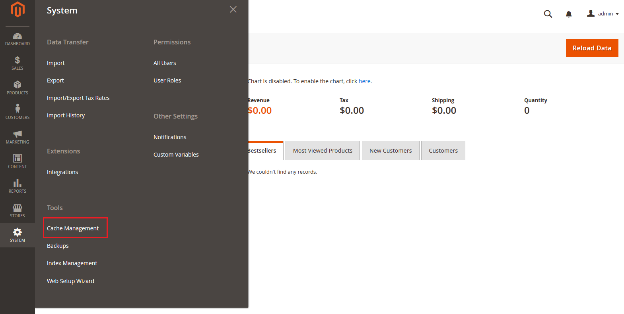

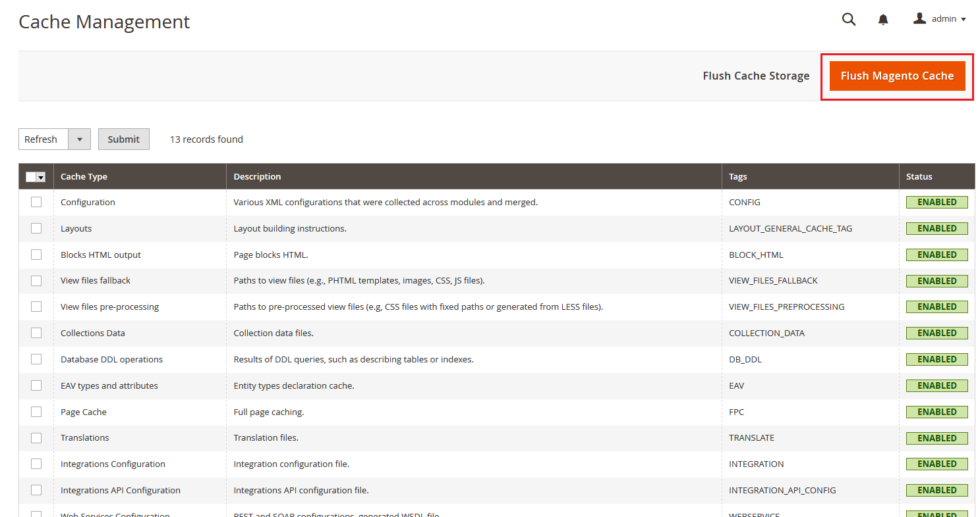

### Part 2. Plugin’s initialisation

In Magento’s configuration, find MailPerformance’s tab *(1)* and enter your XKey *(2).*

|  |
| --- |
| Warning!  Xkey’s account requires the following permissions: Contact, Target, Field and Segment. |

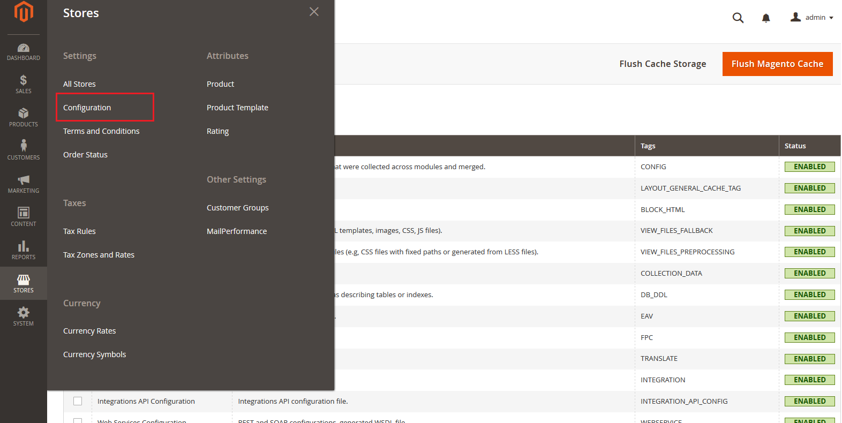

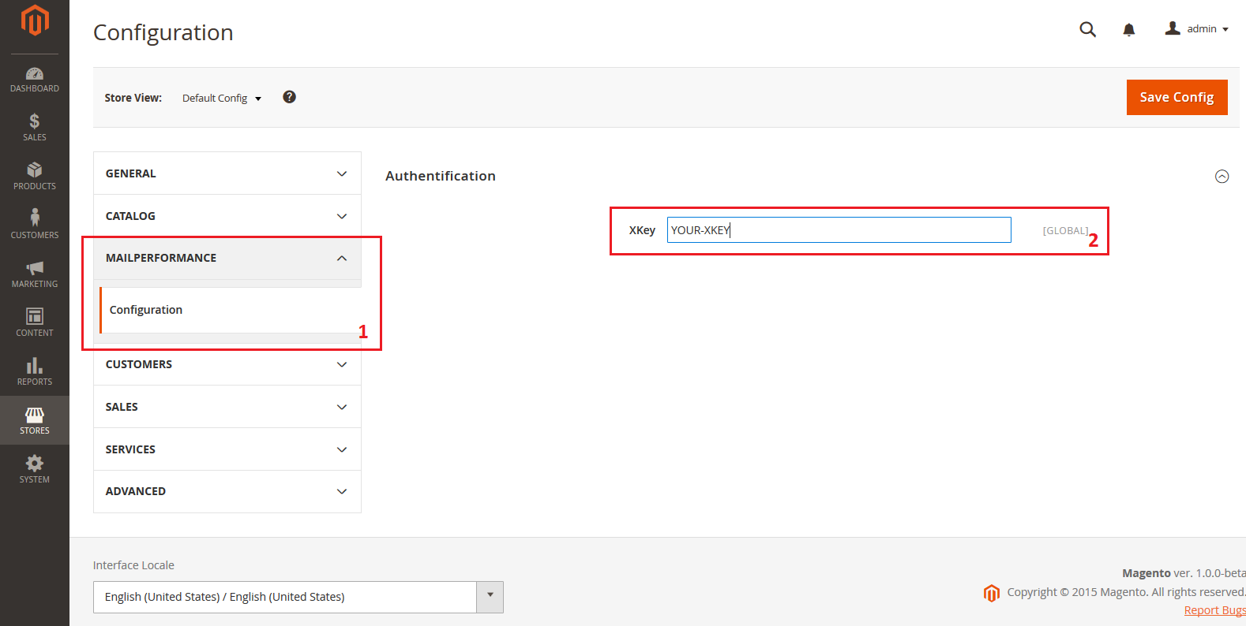

Flush Magento’s cache then go to MailPerformance’s tab in « Stores » and click the « Authenticate » button.

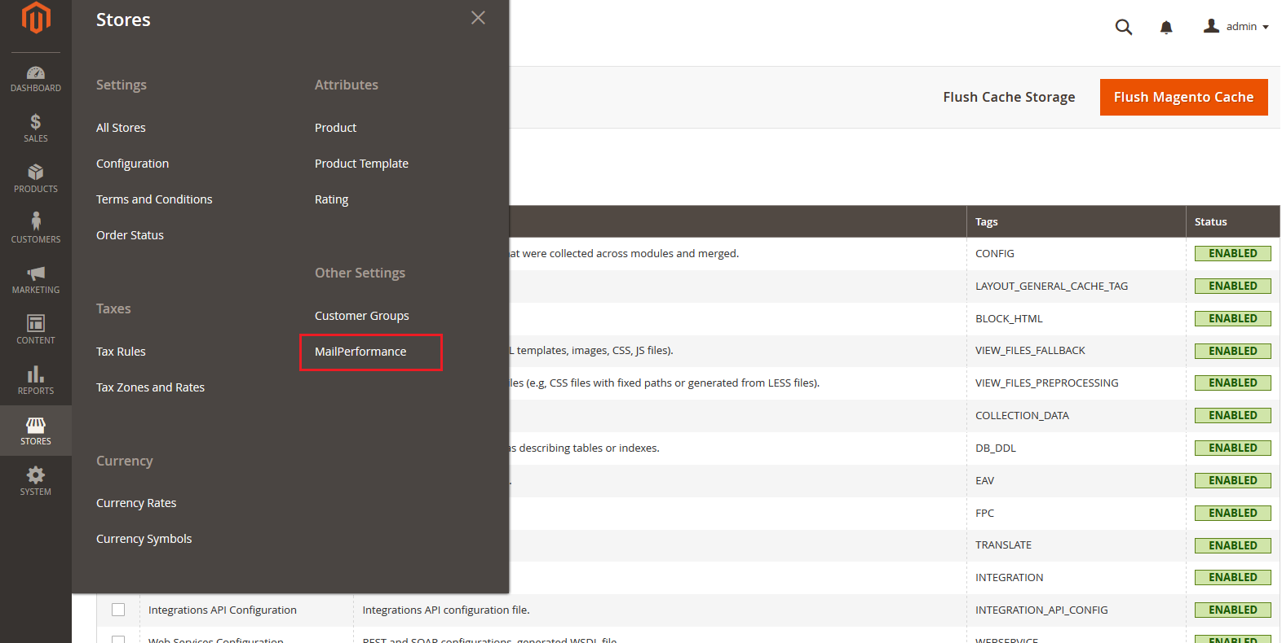

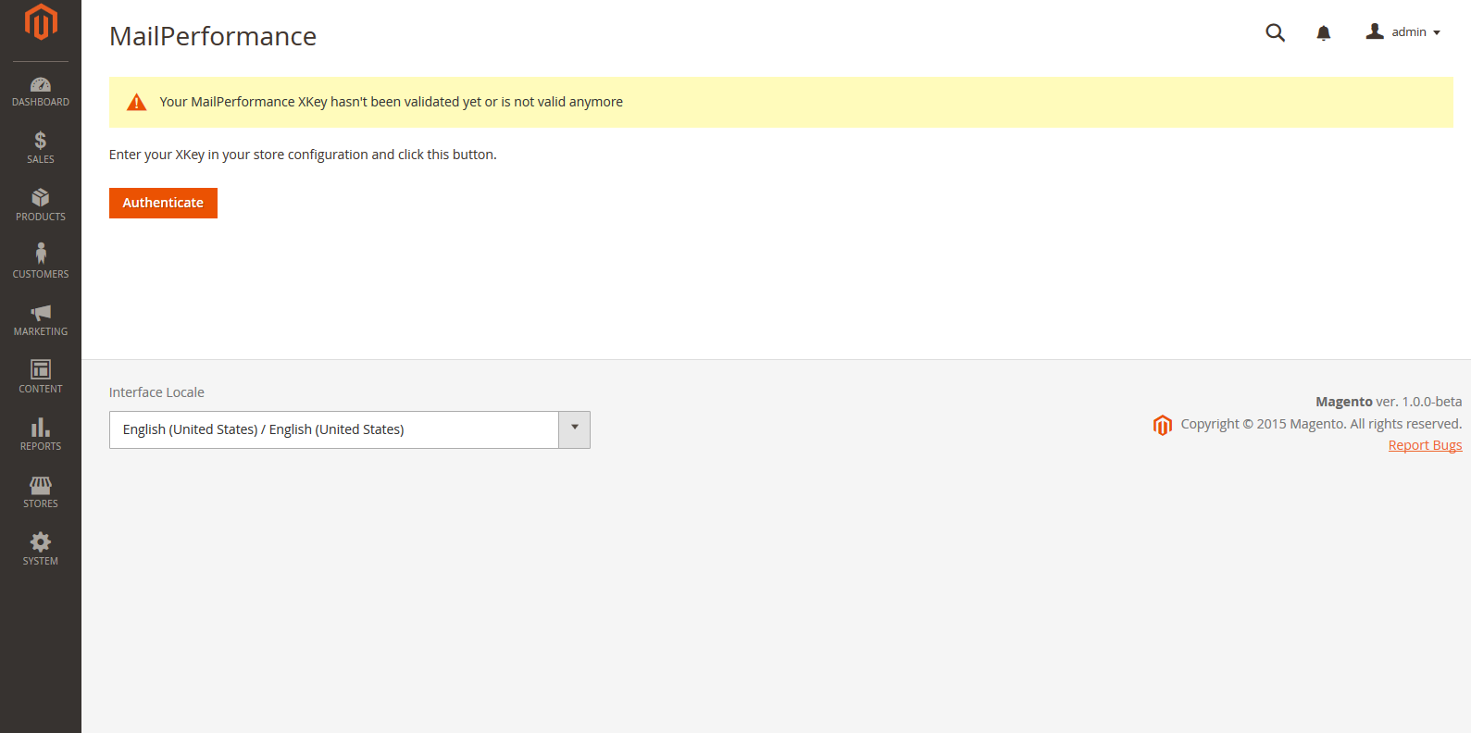

# Update

To update the plugin, repeat the first part of the install process. If you use a new XKey, then repeat the second part of the install process.

To refresh MailPerformance’s segments and fields list, you need to go in the MailPerformance configuration Panel and click the « Reload » button (Presented block 3 in Interface chapter).

# Configuration

After following the install process, you now have access to MailPerformance’s configuration panel. It is located in « Store/Other Settings ». From there, you can choose which values will link to your MailPerformance’s account when one of your customer makes a successful order.



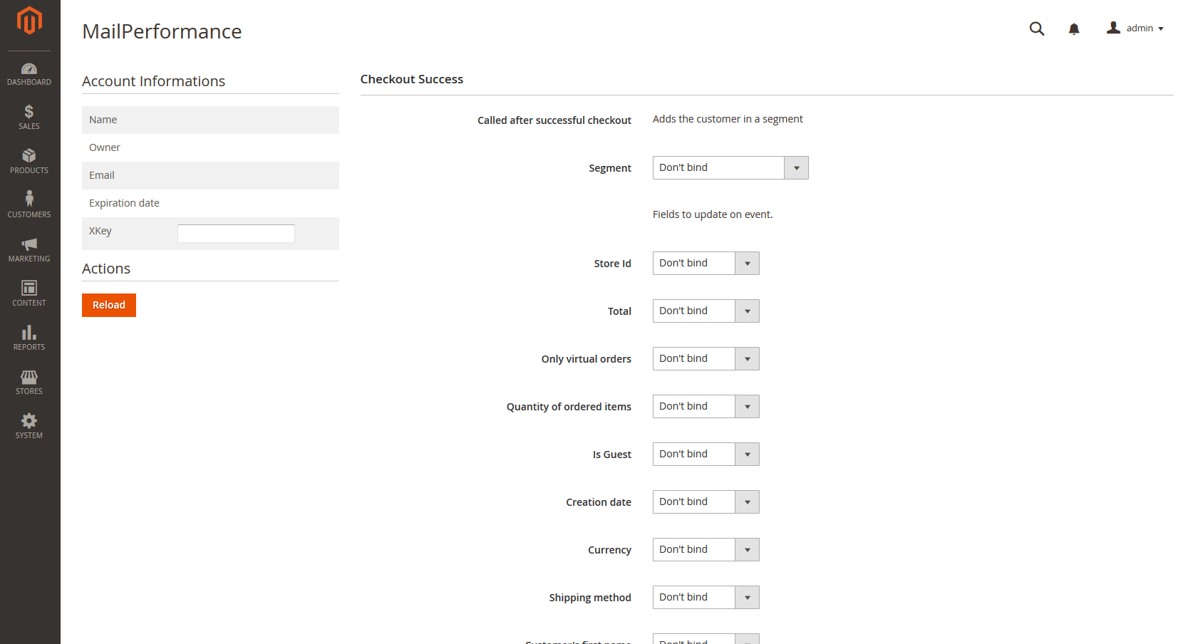

# Interface

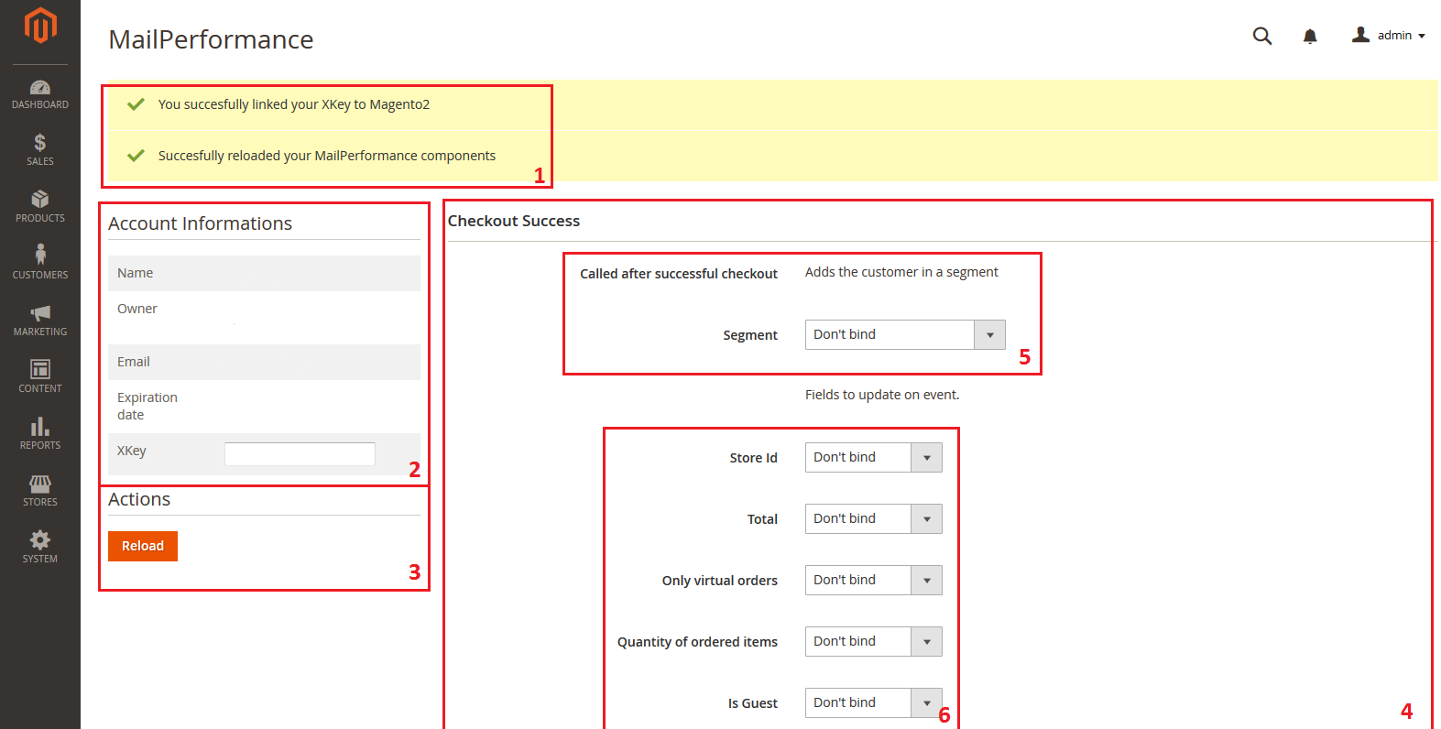

1. You successfully linked your XKey and Magento successfully refreshed your MailPerformance’s components.
2. Your account’s information’s.
3. Actions, this is where you are going to find the button which will allow you to refresh MailPerformance’s components you can see in block 4. If you create or remove a MailPerformance’s segment or field, you will then have to click this button in order to refresh the present list.
4. This block allows you to choose and save your preferences on what values to link and what actions to do when one of your customers makes a successful order.  
   At the bottom of this block, you will find a save button.
5. You can choose to add the customer in an existing MailPerformance’s segment.
6. When ordering, multiples values can be added to a MailPerformance’s target. You can choose which values to link to which fields.

|  |
| --- |
| Warning! Unicity criteria must be present. |

# MailPerformance’s components

Linking MailPerformance’s fields to Magento imposes some conditions:

* 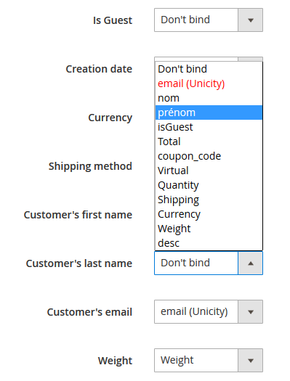You must link one unicity field, otherwise, no targets would be created in MailPerformance.
* If you want to link a field which type is « list of values », there may be some unknown effects such as no target creation. Please ensure that the lists of values you created are compatible with the fields you linked it with. Here are some examples :
  + - Currency
      * EUR
      * USD
      * AUD
      * RUB
      * JPY
      * CNY
      * GBP
      * CAD
    - Shipping
      * freeshipping_freeshipping
      * flatrate_flatrate
      * none (applies when buying virtual products)

Present lists are not compatible with any cases. As example, if you use a plugin which adds shipping methods to your store, when a customer will choose this method, no target will be created since the new shipping method isn’t present in the following list.

* 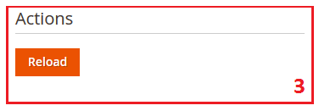To save you some API calls, a list of your MailPerformance’s fields and segments is present in your Magento’s installation. If you create or delete a new segment of field, you will then need to refresh the list or you won’t be able to see the modifications you made. In order to do this, click on the button located in the Action block (presented as block 3 in interface’s chapter) which will then do API calls and refresh your MailPerformance’s components.