**CHX002**

**DDRPHY**

**Specification**

**V0.7**

Revision History

|  |  |  |  |  |
| --- | --- | --- | --- | --- |
| **Rev #** | **Status\*** | **Date** | **Author** | **Reason for change/description** |
| V0.1 | D | 2016/12/1 | Martin Si | Draft version.  Copy from T16_CMT003_DDRPHY BYTE Spec V05.docx.  Mainly change is:   1. DCLK structure from PLL to different BYTE |
| V0.2 | U | 2017/3/9 | Martin Si | Draft version. Based on T16_CMT002_DDRPHY BYTE Spec V08.docx.  1. Modify DDR_BYTECLK_BUF_S24 description and clock structure in part 2.3  2. Delete Package description in part 6.4  3. update Bump map  4. ~~add new input pin for latch mode test: LATCHUP_NDTREE_N~~  5. add new input pin for tuning feedback delay: DLL_FBDLY2~0  6. add frequency change note in chapter 5.6  7. add new input pin for ODT dynamic enable (page 30) : LEADINGOE_X_ODT & LEADINGOE_X_ODT_X4  8. change LEADINGOE_X & LEADINGOE_X_X4 for COMPPD dynamic enable only |
| V0.3 | U | 2017/7/18 | Martin Si | 1. separate DRVMODE_P & DRVMODE_N of DQ/DQS pad,  delete pin:  DRVMODE_P2~0  DRVMODE_N2~0  add pin:  DQ_DRVMODE_P2~0  DQ_DRVMODE_N2~0  DQS_DRVMODE_P2~0  DQS_DRVMODE_N2~0 |
| V0.4 | U | 2017/7/21 | Martin Si | 1. Add pin VREF_MODE2 to separate low/high 4 bit VREFC_CTRL |
| V0.5 | U | 2017/8/10 | Martin Si | 1. delete pin  DCLK & DCLK800_IN  VCDL_SRCTRL1~0 & VCDL_SFCTRL1~0  2. add pin for input clock  DCLKP & DCLKN  DCLKP_EN & DCLKN_EN  DCLK800P & DCLK800N  DCLK800P_EN & DCLK800N_EN  BUFRX_BIASEN  BUFRX_PTATEN  BUFRX_DIGBUFEN  BUFRX_IBP100U_IN_0  BUFRX_IBP100U_IN_1  BUFRX_IBP100U_OUT_0  BUFRX_IBP100U_OUT_1  3. add pin for debug  DCLKOP_OUT  DCLKD_OUT  DCLKS_OUT  DCLKDSI_OUT  DQSN_OUT  4. add pin for Clock Duty Tuning  DCLK1600_SRCTRL1~0  DCLK1600_SFCTRL1~0  DCLK800_SRCTRL1~0  DCLK800_SFCTRL1~0  DCLKO_SRCTRL1~0  DCLKO_SFCTRL1~0  DCLKOP_SRCTRL1~0  DCLKOP_SFCTRL1~0  DCLKD_SRCTRL1~0  DCLKD_SFCTRL1~0  DCLKS_SRCTRL1~0  DCLKS_SFCTRL1~0  DCLKDSI_SRCTRL1~0  DCLKDSI_SFCTRL1~0  5. add reserved pin  DDRPHY_REV15~DDRPHY_REV0 |
| V0.6 | U | 2017/9/8 | Martin Si | 1. add output pin:  DDRPHY_DBGOUT15~0  2. change pin description:  DDRPHY_REV0 |
| V0.7 | U | 2017/11/15 | Martin Si | 1. modify pin description  DDRMODE1/0  DDRPHY_REV 0/1/2 & 4/5/6  2. add debug table in DDRPHY_DBGOUT description  3. modify external pin of VCDL Loop (DDRPHY_REV0/1/2)  4. update internal constraint table in chapter 5.2.4 & 5.2.2  5. update delay description and add clock balance requirement in Part 2.1  6. update clock domain transfer margin table in 2.2  7. update DDR_BYTECLK_BUF structure in 2.3 |
|  |  |  |  |  |
|  |  |  |  |  |
|  |  |  |  |  |
|  |  |  |  |  |
|  |  |  |  |  |

*Statuses include: D: Draft, P: Pending review/frozen, U: Update needed, A: Approved

Contents

Revision History 2

1 Introduction 6

1.1 Features 6

1.2 Process 6

1.3 Related Documents 7

2 DDR Top-Level Architecture 8

2.1 DDR Clock Structure Diagram 8

2.2 DDR clock jitter tolerance margin 10

2.3 CHX002 DDR_BYTECLK_BUF_S24 11

3 DDRPHY Architecture 13

3.1 DDRPHY IP List 13

3.2 DDRPHY Clock Scheme 14

3.2.1 TX clock scheme 14

3.2.2 RX Clock Scheme 15

3.3 DDRPHY Block Description 16

3.3.1 VCDL_BYTE_S24 16

3.3.2 DDRCKG_DDRCLK_S24 20

3.3.3 Logic DIOs 21

3.3.4 DDRIO 23

4 DDRPHY Interface List 24

4.1 External DC Supply 24

4.2 External Signal Pins 24

4.2.1 VCDL_BYTE 24

4.2.2 DIO 28

4.2.3 PAD 32

4.3 Internal Connection 39

4.3.1 DDRPHY TXDIO 39

4.3.2 DDRPHY RXDIO 40

4.3.3 DDRPHY DDRCKG 40

4.3.4 DDRPHY DDRIO 40

5 Implement Note 41

5.1 Power states 41

5.1.1 Normal work state 41

5.1.2 DLL WeakLock Mode 41

5.1.3 DCLK turn off 42

5.2 Timing 42

5.2.1 Balance Requirement 42

5.2.2 External Constraint Requirement(less) 47

5.2.3 Internal Constraint Requirement(not final) 47

5.3 Calibration(less) 48

5.4 Glitch 48

6 DDRPHY FloorPlan & BumpMap 50

6.1 Floorplan 50

6.2 Pad assignment 50

6.3 BumpMap 50

7 Test(less) 52

# Introduction

## Features

- DDRPHY Data & strobe supports for:

- DDR4 X8 1600/1866/2133/2400/2666/3200

- DDR4 X4 1600/1866/2133/2400/2666/3200

- DDR4L X8 1600/1866/2133/2400/2666/3200

- DDR4L X4 1600/1866/2133/2400/2666/3200

- Transmitter

- Programmable clock phase for data transfer between different clock domain

- Programmable TX driver output resistance and drive strength

- Programmable Equalizer

- Programmable DQ TX per-bit-de-skew

- Receiver

- Programmable ODT resistance and ODT strength

- Programmable per-bit VREF value

- Programmable RX CTLE

- Programmable DQ RX per-bit-de-skew

- Programmable RX per-bit Strobe phase

- Separate data sampling by rise/fall edge of strobe

-Loading

-Max support 2S4R (2DIMM and 2Rank per DIMM)

## Process

Process: TSMC 16nm FFC LL (1P13M_6X2Y2YY2R)

DC Spec

|  |  |  |  |  |
| --- | --- | --- | --- | --- |
| Corner | Temperature | DVDD | VPP  (DDR4) | VPP  (DDR4L) |
| TT | 85 | 0.8 | 1.2 | 1.05 |
| SS | -40 | 0.72 | 1.14 | 0.945 |
| SS | 125 | 0.72 | 1.14 | 0.945 |
| FF | -40 | 0.88 | 1.26 | 1.155 |
| FF | 125 | 0.88 | 1.26 | 1.155 |

## Related Documents

1. DDR_BYTECLK_BUF_S24 Specifications
2. T16 CHX002 DDR_BYTECLK_BUF layout guide
3. T16 CHX002 DDR_PAD Specifications
4. T16 CHX002 PLLIN_COMP_ESD Specifications
5. T16 CHX002 VCDL_CA Specifications
6. T16 DDR Bump Map & Whole Chip Bump map
7. CHX002 Pinlist

# DDR Top-Level Architecture

## DDR Clock Structure Diagram

There are 2 PLL in DDR system and REF clock is their reference clock.

PLLIN will output 1600MHz clock. PLLIN output clock to DRAMC core logic clock tree CTS delay is t1(<1ns) and to PLLIN feedback clock tree delay is also t1. Low frequency jitter in PLLIN bandwidth will be filtered between REF、PLLIN FB and DRAMC leaf clock.

PLLINDDR will output 1600MHz to DDRPHY and DDRIO logic near PHY. PLLINDDR output clock will be balanced through all byte DDRPHY by circuit design and its clock tree delay is t2 (delay~1ns). 1600M clock will be divided by 2 and sample signals from DRAMC in 800M clock domain, the divided clock tree delay is t3 (~100ps). PLLINDDR feedback clock tree delay is t2+t3 (>1ns). Low frequency jitter in PLLINDDR bandwidth will be filtered between REF、PLLINDDR FB and DDRPHY clock.

In the picture below, all the clock phase with red point will be aligned to same clock phase t0.



目前CMT003/CHX002的PLL 和clock structure 修改方案如下。黄色的粗线和绿色的线是需要circuit 做tree的，其他是APR tree。

1. PLLIN CKOUT1 1.6G output, CKOUT2 800M output 给logic用，feedback 800M clock, APR tree t1 feedback 长齐。
2. PLLINDDR CKOUT1 1.6G output, CKOUT2 800M output，由circuit 完全一直长到PHY的input，然后PHY 分别output 两个1.6G 和800M clock。这两个clock要求严格balance，skew控制在15+20ps内。这两个clock的绝对latency t2尽量小，在PLL内部和feedback t2 做balance。
3. T3是PHY output的APR tree，100ps左右，和PLLDDR 800M feedback外面的t3 balance。
4. DIO的逻辑需要经过下面clock domain的转换：
   1. PLLIN 800M -> PLLINDDR 800M 1/2T转换(follow Part 2.2.1)
   2. PLLINDDR 800M-> PLLINDDR 1600M 转换
   3. PLLINDDR 1600M -> PHY VCDL DCLKO 转换(follow Part 2.2.2)

5. Balance requirement

表格中所有的t3需要在TT、SS、FF下尽可能的balance, 总delay在100ps左右。如果不能meet各个corner下都balance，TT的优先级最高

## DDR clock jitter tolerance margin

### PLLIN and PLLDDR margin

|  |  |  |  |
| --- | --- | --- | --- |
| Item | Description | setup | hold |
| phase jitter | PLLIN and PLLDDR 1600M output phase jitter +/-120ps | 120 | 120 |
| t1 CTS jitter +/-80ps @2ns  (forward+feedback CTS Jitter included) | 80 | 80 |
| t2+t3 CTS jitter +/-25ps @500ps | 25 | 25 |
| Period Jitter | PLL output 15ps @1600M，21ps @ 800M(divided clock) | 21 | 0 |
| t1 CTS Jper 20ps @2ns | 20 | 0 |
| t2 CTS Jper 5ps @500ps | 5 | 0 |
| OCV | 2.1% on launch clock cell  2.1% on capture clock cell 7% on clock net  (Worst case t1 2ns, average cell and net 4.5%, DRAMC leaf t1 OCV and PLLIN feedback OCV) | 200 | 0 |
| 37ps clock uncertainty | 37 | 0 |
| 4.8% on launch clock cell  4.8% on capture clock cell  10% on clock net  (best case t1 1ns, average cell and net 7.5%, DRAMC leaf t1 COV and PLLIN feedback OCV) | 0 | 150 |
| 38ps clock uncertainty | 0 | 38 |
| SUM2 |  | 508 | 413 |

Clock tree requirement:

* + - 1. t0 may be separated to 2 parts. Circuit will do the clock tree to DRAMC core area boundary and to each DDRPHY area boundary in order to reduce t0 total delay. DRAMC internal clock tree will be done by BE tool.
      2. t2 path use M13 to transfer DDRPHY clock. Because of big buffer size, enough de-cap should be surrounded and good power connection is must.

### DDRPHY DCLK_OUT to DCLKO margin

|  |  |  |  |
| --- | --- | --- | --- |
| Item | Description | setup | hold |
| phase jitter | ±20p（PLL高频）±10p（VCDL） | 30 | 30 |
| Period Jitter | ±15p（PLL）±5p（CTS）±10p（VCDL+PI） | 30 | 0 |
| Clock skew | ±5p | 5 | 5 |
| Phase skew  DCLKO和理想PH phase之间的skew | ±20p | 20 | 20 |
| Margin | ±25p | 25 | 25 |
| STA uncertainty |  | 110 | 80 |

### DDRPHY DCLKO and TXCLKD/S internal margin

|  |  |  |  |
| --- | --- | --- | --- |
| Item | Description | setup | hold |
| phase jitter | ±20p（PLL高频）±10p（VCDL） | 30 | 30 |
| Period Jitter | ±15p（PLL）±5p（CTS）±10p（VCDL+PI） | 30 | 0 |
| Clock skew | ±5p | 5 | 5 |
| Phase skew  DCLKO/DCLKD 和理想PH phase之间的skew | ±20p | 20 | 20 |
| Margin | ±25p | 25 | 25 |
| STA uncertainty |  | 110 | 80 |

## CHX002 DDR_BYTECLK_BUF_S24

In CHX002, 6 DDR_BYTECLK_BUF per channel is used. PLL output clock is buffered (DDR_BYTECLK_BUF) to drive all CA BYTE via M13, then 4 repeater buffer (DDR_BYTECLK_BUF2 in below picture) is introduced to drive all data BYTE. Red/Blue path in picture is 1600M & 800M clock for DDRPHY.

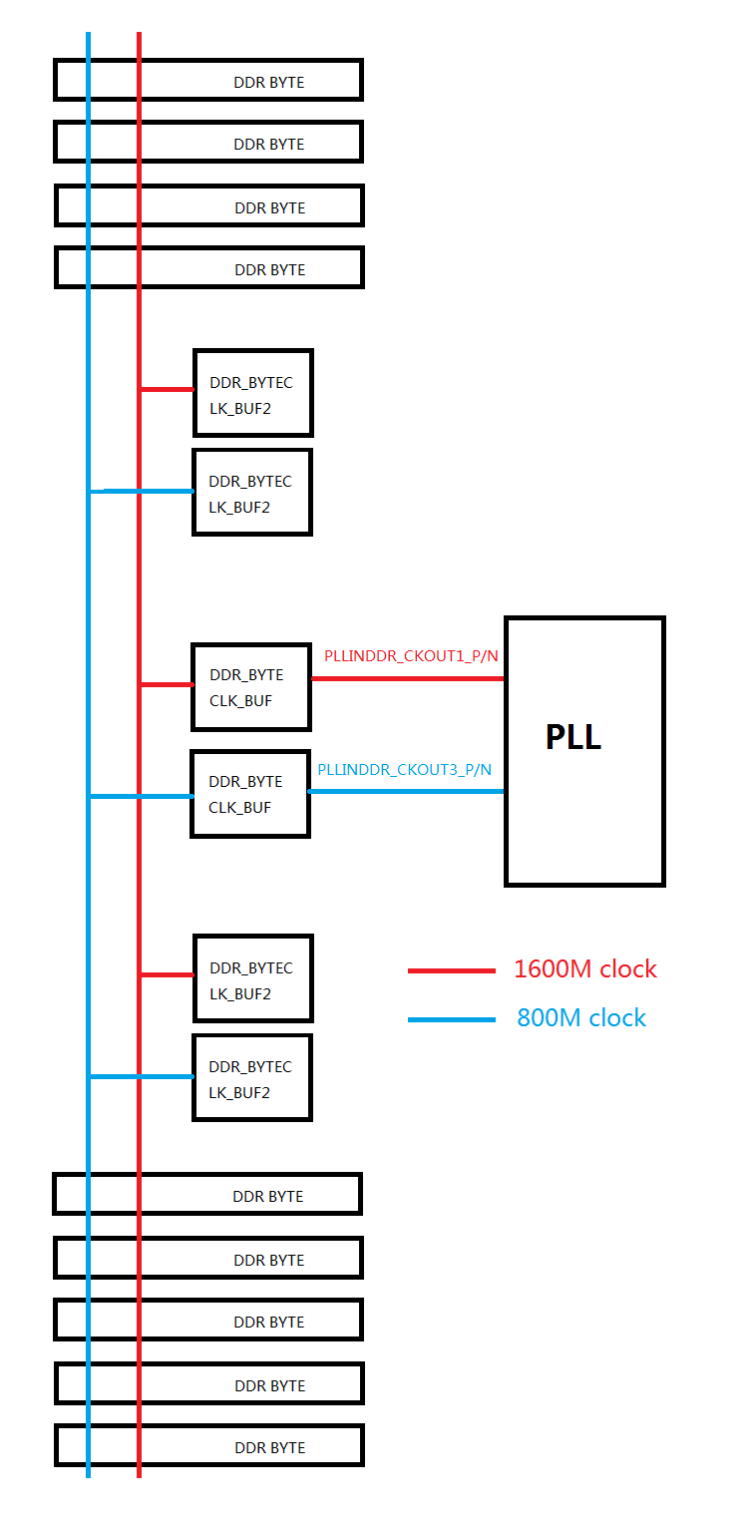

# DDRPHY Architecture

## DDRPHY IP List

|  |  |  |  |  |
| --- | --- | --- | --- | --- |
| Group | Basic IP name | Size  (before shrink) | Number in PHY | Note |
| Analog | VCDL_BYTE_S24 | 606*200 | 1 | TX DQS/DQ clock |
| DDRCKG_DDRCLK_S24 | 606*50 | 1 | Clock tree balance |
| bdddrdq_S24 | 44.976*500 | 8 | DQ pad |
| bdddrdqs_S24 | 89.952*500 | 2 | DQS pad |
| padVCC4_MEM_S24 | 44.976*500 | 1 | VCC pad |
| Cap Filler | 21.312*500 | 1 |  |
| Digital | DX2DD |  | 8 | TX data |
| DX2DS |  | 2 | TX DQS |
| TXSDQ |  | 2 | TX data select |
| DMOE_GEN |  | 2 | TX output enable |
| DQSIEN_GEN |  | 2 | RX input enable |
| RXDIO |  | 8 | RX data |

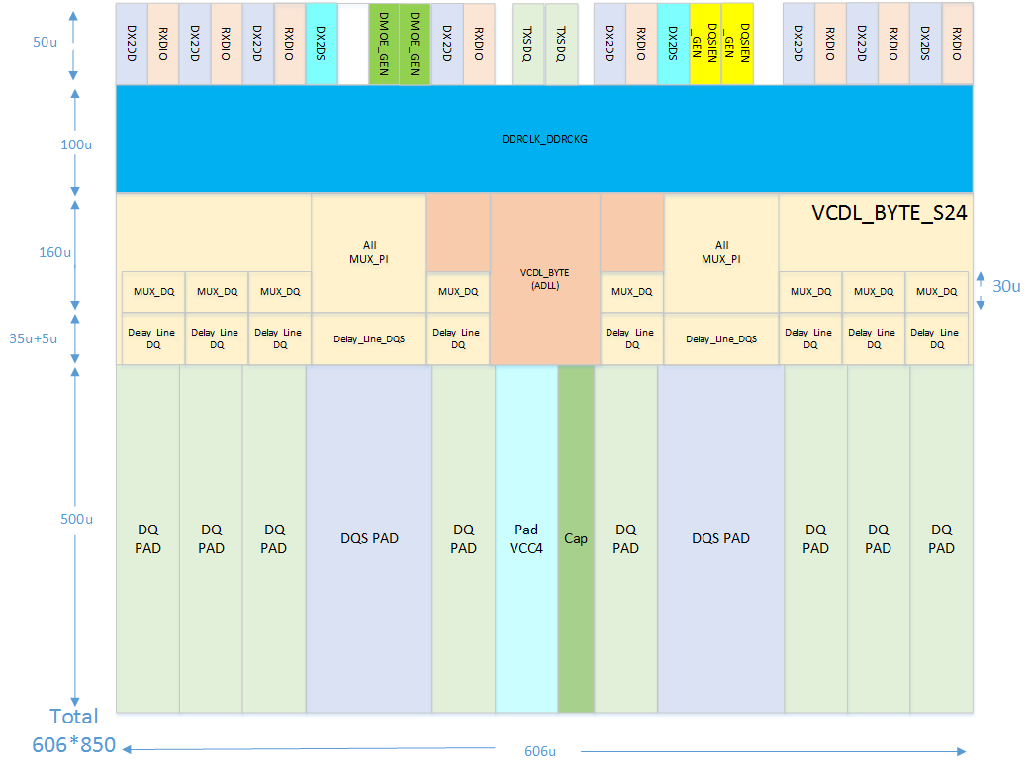

## DDRPHY Clock Scheme

### TX clock scheme

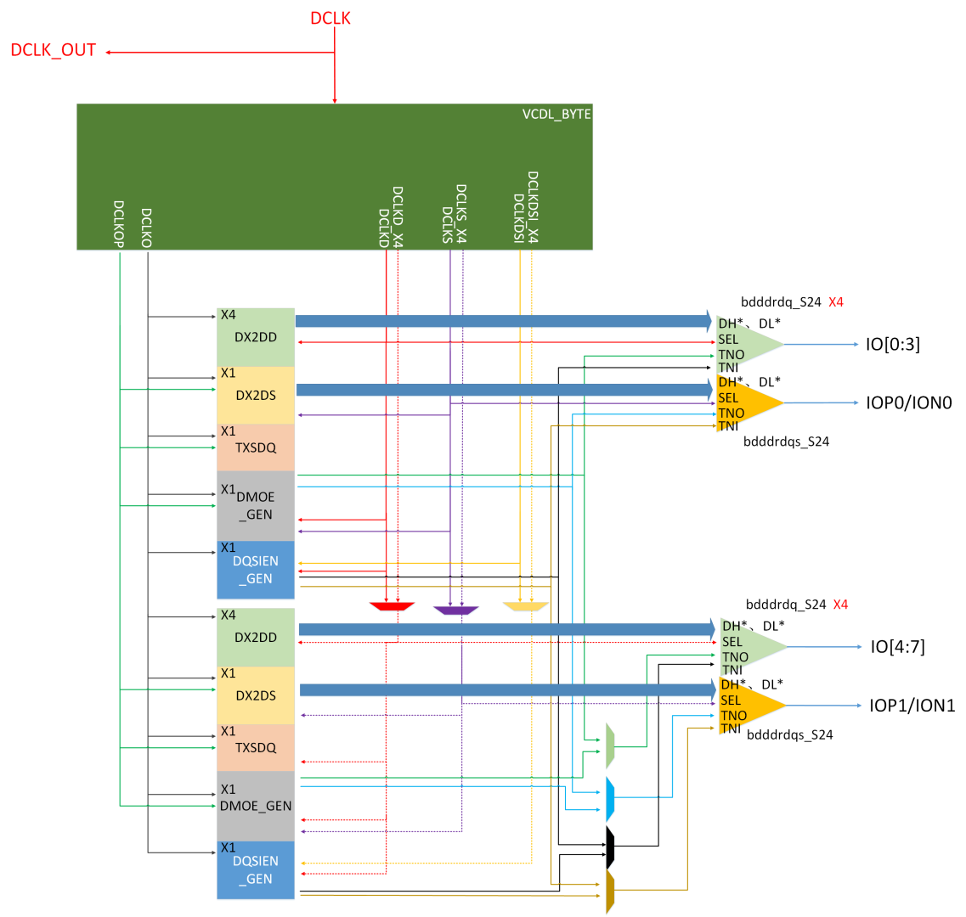

Note:

* + - 1. VCDL_BYTE_S24 input clock frequency is full speed DDR clock
      2. All clock generated by VCDL_BYTE_S24 is full speed DDR clock with programmable 64 phase, including DCLKO、DCLKOP、DCLKD、DCLKS、DCLKDSI、DCLKD_X4、DCLKS_X4 and DCLKDSI_X4
      3. MD* inputted to DX2DDs is sampled at DCLKO falling edge by external logic IPs. Then DX2DD & DX2DS capture data by DCLKO rising edge.
      4. Skew and jitter requirement between different clock please refer to chapter on timing
      5. Per-Bit-De-skew is composed by bdddrdq, not in DDRCKG_DDRCLK

|  |  |  |  |  |  |
| --- | --- | --- | --- | --- | --- |
| VCDL_BYTE_S24 output clock to DIOs list | | | | | |
| Clock Name  DIO Name | DCLKO | DCLKOP | DCLKD  &  DCLKD_X4 | DCLKS  &  DCLKS_X4 | DCLKDSI  &  DCLKDSI_X4 |
| DX2DD | Y |  | Y |  |  |
| DX2DS | Y | Y |  | Y |  |
| TXSDQ | Y | Y |  |  |  |
| DMOE_GEN | Y | Y | Y | Y |  |
| DQSIEN_GEN | Y |  | Y |  | Y |

### RX Clock Scheme

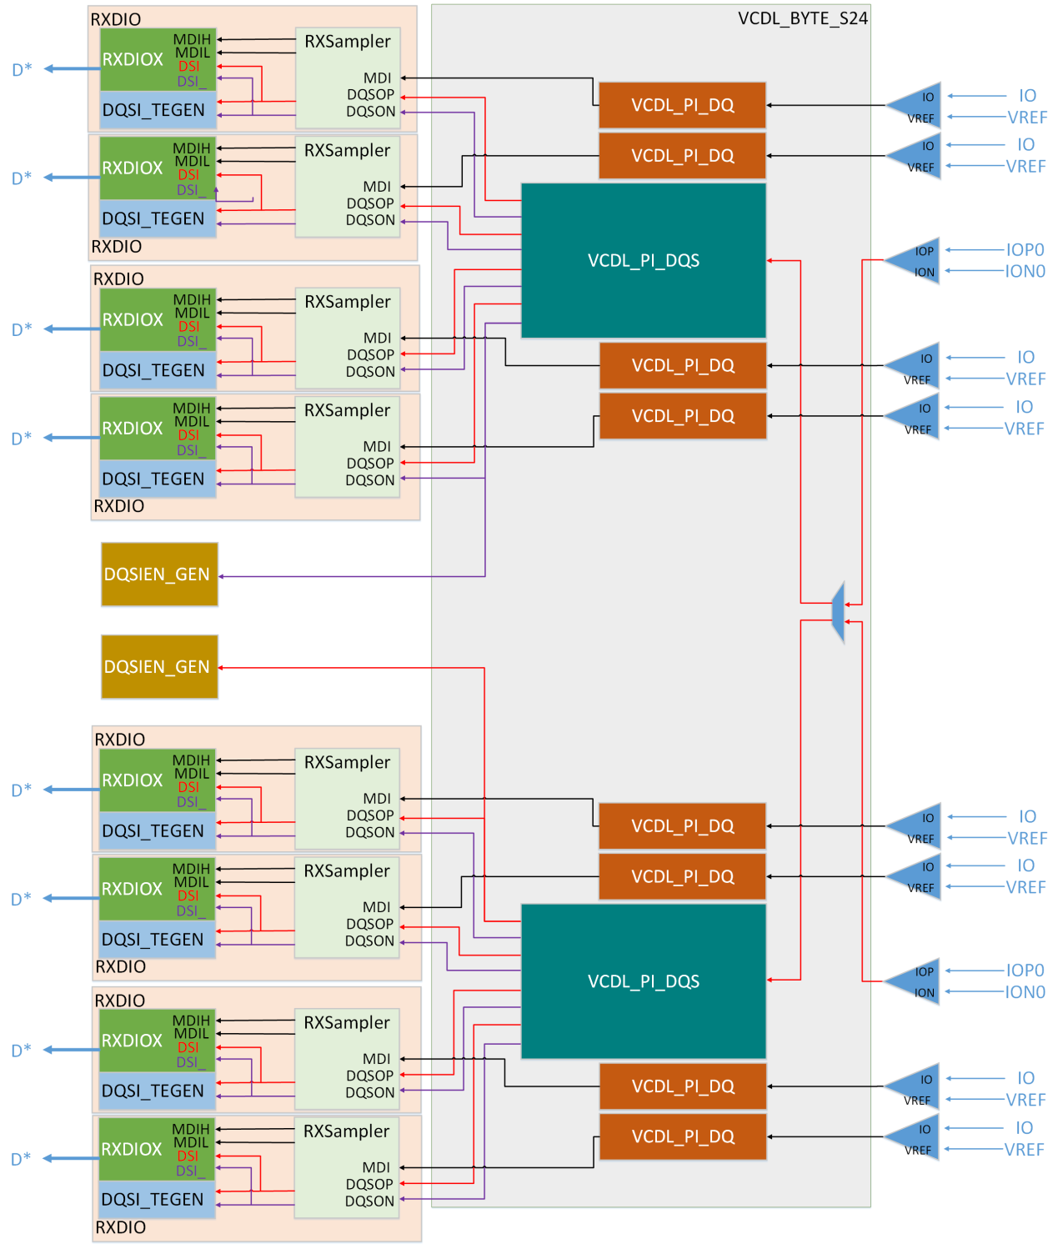

Note:

* + - 1. DQSOP*/DQSON* for each RXSampler is not of same delay with other RXSampler.
      2. Cell TNI_Detector is included in bdddrdqs_S24
      3. 2 VCDL_PI_DQS will operate in either X8 or X4 mode, which means connection between RXDIO* to bdddrdq_S24* could not be changed in different X8/X4 mode.
      4. 2 DQSIEN_GEN output signal: TNID & TNIS to all DQ/DQS pad input is of same delay.

## DDRPHY Block Description

### VCDL_BYTE_S24

VCDL_BYTE_S24 is composed of ADLL, 8 MUX_PI, 8 VCDL_PI_DQ, 2 VCDL_PI_DQS and other basic cell. ADLL+MUX_PI(8) would generate 8 clock with 64 phase tunable for DIOs. Both VCDL_PI_DQS will work for X8 or X4 mode. And path from DQS_ORG/DQS_ORG_X4 to each VCDL_PI_DQS input is balanced.

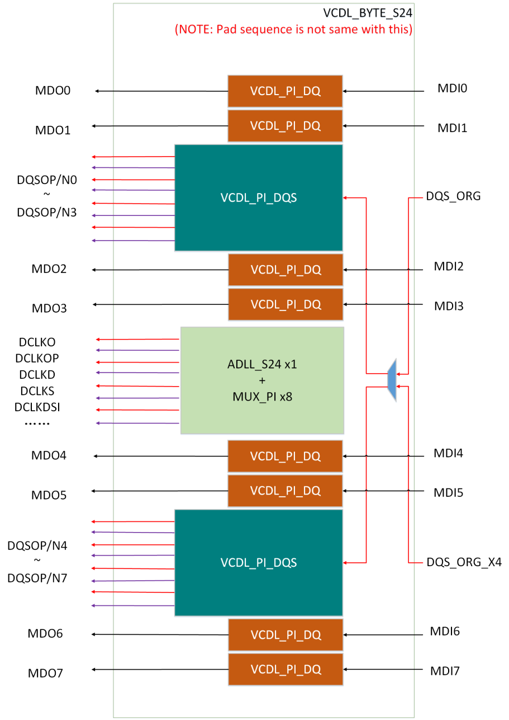

#### ADLL_S24

ADLL is composed of several basic cells, such as phase detector (PD), charge pump (CP), v2v cell (V2V), analog delay line, and phase interpolator (PI). In general, there is one ADLL in 8’bit DDRPHY.

PD check the phase difference of input clock DCLK and feedback clock output from delay line in ADLL loop, then generate UP/DN signal for CP to increase/decrease the analog delay line control signal: BIASP & BIASN.

1. Total 8 full speed clock with 45℃ phase difference with each adjacent clock generated by ADLL will be applied to all TX/RX clock PI
2. Analog signal bus: BiasP/BiasN will be used for RX path VCDL_PI_DQS and VCDL_PI_DQ analog delay line too.

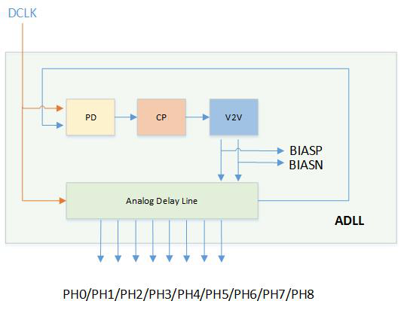

Note:

1. When DLL_LOCKOK rise to high, it means the delay value of delay line chain is equal to one cycle of DCLK.
2. DLL_CKRANGE pin should follow DDR work frequency.
3. DLL_REFDLY is used to tuning the VCDL chain delay value.

#### MUX_PI

MUX_PI is used to generate clock with 64 programmable phase. Each MUX_PI need 9 phase input clock as below picture from phase 0 to phase 360℃. Then 8 phase will be interpolated via either 2 adjacent clock. So each MUX_PI output clock phase can be tuned among 64 step by setting PH_*<5:0>, one step is T/64. For example, below picture illustrates how to generate one phase between 4T/8 and 5T/8, and any clock from 33T/64~39T/64 can be output of MUX_PI according to their setting.

Phase 0T/8 lrhhhflllrhhhflllrhhhfll

Phase 1T/8 llrhhhflllrhhhflllrhhhfl

Phase 2T/8 lllrhhhflllrhhhflllrhhhf

Phase 4T/8 llllrhhhflllrhhhflllrhhh

Phase 5T/8 lllllrhhhflllrhhhflllrhh

Phase 6T/8 llllllrhhhflllrhhhflllrh

Phase 7T/8 lllllllrhhhflllrhhhflllr

Phase 8T/8 llllllllrhhhflllrhhhflll

Phase 4T/8 lrhhhhhhhhhhhhhhhhhhhhh

Phase 33T/64 llrhhhhhhhhhhhhhhhhhhhh

Phase 34T/64 lllrhhhhhhhhhhhhhhhhhhh

Phase 35T/64 llllrhhhhhhhhhhhhhhhhhh

Phase 36T/64 lllllrhhhhhhhhhhhhhhhhh

Phase 37T/64 llllllrhhhhhhhhhhhhhhhh

Phase 38T/64 lllllllrhhhhhhhhhhhhhhh

Phase 39T/64 llllllllrhhhhhhhhhhhhhh

Phase 5T/8 lllllllllrhhhhhhhhhhhhh

#### VCDL_PI_DQS_S24

VCDL_PI_DQS is composed of VCDL (voltage controlled delay line) chain and several MUX_PI for DQSOP* and DQSON*, which is input clock of RXSampler in RXDIO.

VCDL can work only after DLL_LOCKOK rise to high. The delay value of each VCDL cell is T/8, controlled by BiasP & BiasN from ADLL. There are total 8 VCDL cell and 9 clock from phase 0 to phase 360℃ by step 45℃ would be generated as input clock of all PI in VCDL_PI_DQS.

Each PI would generate corresponding clock with phase programmable range from 0 to 1T by step T/64. And RX work range of each MUX_PI may diff with other.

There are 8 MUX_PI in one VCDL_PI_DQS_S24, and total 16 MUX_PI for RX path in one DDRPHY.

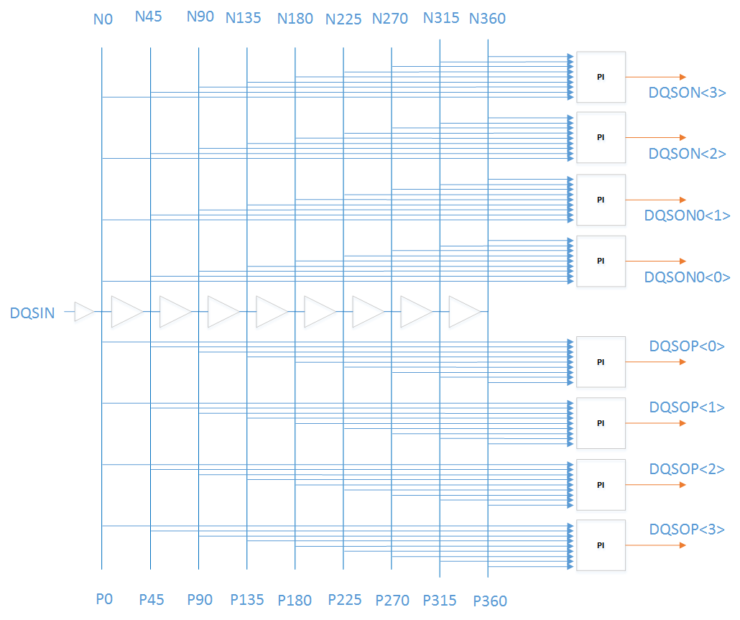

#### VCDL_PI_DQ_S24

VCDL_PI_DQS is composed of VCDL chain and MUX, which is used to coarse tuning de-skew between different DQ in one BYTE. DQ can delay by 5 setting, which is 0,T/8,T/4,3T/8, and T/2.

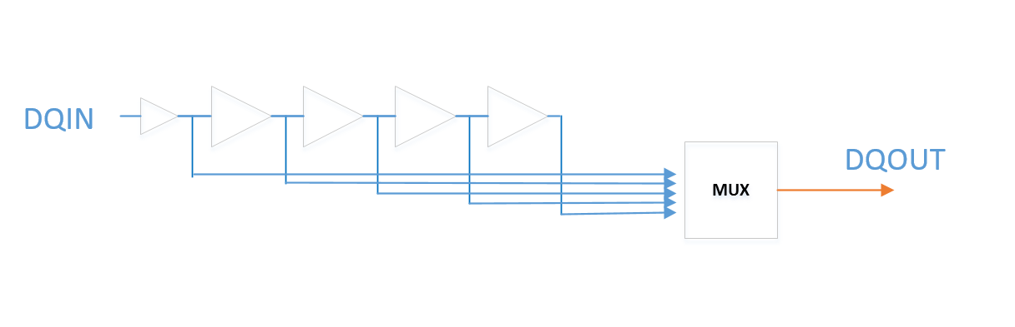

### DDRCKG_DDRCLK_S24

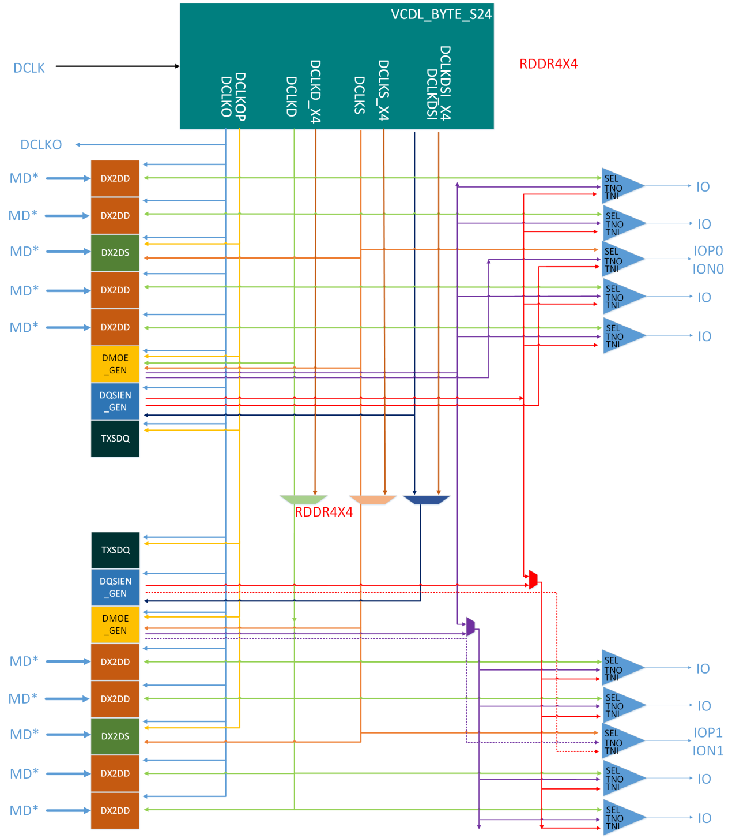

### Logic DIOs

#### TXSDQ



#### DX2DD

#### DX2DS



#### DMOE_GEN



#### DQSIEN_GEN

#### RXDIO

### DDRIO

DDRIO list as below, and please refer to T16 CHX002 DDR PAD spec* for detail.

Bdddrdq_S24 ( total 8)

bdddrdqs_S24 (total 2)

padVCC4_MEM_S24 (total 1)

# DDRPHY Interface List

## External DC Supply

|  |  |  |  |
| --- | --- | --- | --- |
| Signal Name | Domain | I/O | Description |
| DVDD | Core | Power | Core power supply |
| DVSS | Ground | Ground | Ground for core & IO & RVPP domain |
| VPP | VPP | Power | IO pad power supply, typical 1.2V for DDR4 & 1.05V for DDR4L |

## External Signal Pins

### BUFRX for clock

|  |  |  |  |
| --- | --- | --- | --- |
| Signal Name | Power Domain | I/O | Description |
| DCLKP  DCLKN | CORE | I | Input full speed differential clock from PLL, 800MHz~1600MHz |
| DCLK800P  DCLK800N | CORE | I | Input half speed differential clock from PLL  400MHz~800MHz |
| DCLKP_EN  DCLKN_EN | CORE | I | DCLKP & DCLKN enable  1: enable DCLKP & DCLKN(default)  0: disable DCLKP & DCLKN |
| DCLK800P_EN  DCLK800N_EN | CORE | I | DCLK800P & DCLK800N enable  1: enable DCLK800P & DCLK800N(default)  0: disable DCLK800P & DCLK800N |
| DCLK1600_SRCTRL1  DCLK1600_SRCTRL0  DCLK1600_SFCTRL1  DCLK1600_SFCTRL0 | Core | I | Duty tuning for DCLK1600 input clock  20ps per step @ss -40C as below   |  |  |  |  | | --- | --- | --- | --- | | SRCTRL | SFCTRL | Rise delay | Fall delay | | 11 | 00 | +60 | +0 | | 10 | 00 | +40 | +0 | | 01 | 00 | +20 | +0 | | 00 | 00 | +0 | +0 | | 00 | 01 | +0 | +20 | | 00 | 10 | +0 | +40 | | 00 | 11 | +0 | +60 | |
| DCLK800_SRCTRL1  DCLK800_SRCTRL0  DCLK800_SFCTRL1  DCLK800_SFCTRL0 | Core | I | Duty tuning for DCLK800 input clock  20ps per step @ss -40C as below   |  |  |  |  | | --- | --- | --- | --- | | SRCTRL | SFCTRL | Rise delay | Fall delay | | 11 | 00 | +60 | +0 | | 10 | 00 | +40 | +0 | | 01 | 00 | +20 | +0 | | 00 | 00 | +0 | +0 | | 00 | 01 | +0 | +20 | | 00 | 10 | +0 | +40 | | 00 | 11 | +0 | +60 | |
| BUFRX_BIASEN | CORE | I | Enable DCLKP/N & DCLK800P/N bias current  1: enable(default)  0:disable |
| BUFRX_PTATEN | CORE | I | select current of PTAT or BUFRX_IBP100U_IN  1: PTAT current  0: BUFRX_IBP100U_IN_0/1 current |
| BUFRX_DIGBUFEN | CORE | I | DCLKP/N & DCLK800P/N mode  0: analog mode(default)  1: digital mode |
| BUFRX_IBP100U_IN_0  BUFRX_IBP100U_IN_1 | CORE | I | 100uA bias current input |
| BUFRX_IBP100U_OUT_0  BUFRX_IBP100U_OUT_1 | CORE | O | 100uA bias current output |
| DDRPHY_REV15  DDRPHY_REV14  DDRPHY_REV13  DDRPHY_REV12  DDRPHY_REV11  DDRPHY_REV10  DDRPHY_REV9  DDRPHY_REV8  DDRPHY_REV7  DDRPHY_REV3 | CORE | I | DDRPHY_REV3 & 7~15 Reserved |
| DDRPHY_REV6  DDRPHY_REV5  DDRPHY_REV4 |  |  | Debug signal control.  Refer debug table in DDRPHY_DBGOUT descrition. |
| DDRPHY_REV2  DDRPHY_REV1 | CORE | I | used for de-glitch enable of TX clock phase change ( DCLKO/DCLKOP/DCLKD/DCLKS/DCLKDSI)  REV2:1=11: enable de-glitch, 2T loss  REV2:1=10: enable de-glitch, 1T loss  REV2:1=00: disable de-glitch  REV2:1=01: Reserved  (Same description in VCDL_BYTE) |
| DDRPHY_REV0 | CORE | I | Connect to VCDL_BYTE DLL_CP_EN, used to enable bias current advanced by DLL_EN.  1: always enable bias  0: enable bias only when DLL_EN=0  (Same description in VCDL_BYTE) |
| DDRPHY_DEBUGOUT15  DDRPHY_DEBUGOUT14  DDRPHY_DEBUGOUT13  DDRPHY_DEBUGOUT12  DDRPHY_DEBUGOUT11  DDRPHY_DEBUGOUT10  DDRPHY_DEBUGOUT9  DDRPHY_DEBUGOUT8  DDRPHY_DEBUGOUT7  DDRPHY_DEBUGOUT6  DDRPHY_DEBUGOUT5  DDRPHY_DEBUGOUT4  DDRPHY_DEBUGOUT3  DDRPHY_DEBUGOUT2  DDRPHY_DEBUGOUT1  DDRPHY_DEBUGOUT0 | CORE | O | Debug signal output  Debug table as below. |

|  |  |  |  |
| --- | --- | --- | --- |
|  | DDRPHY_REV4=1 | DDRPHY_REV5=1 | DDRPHY_REV6=1 |
| DDRPHY_DEBUGOUT15 | TNI_GATE | TNI_GATE | TNI_GATE |
| DDRPHY_DEBUGOUT14 |  |  | Bit6 TE15 |
| DDRPHY_DEBUGOUT13 |  |  | Bit6 TE0 |
| DDRPHY_DEBUGOUT12 |  |  | RSTEN |
| DDRPHY_DEBUGOUT11 |  | DSODT | MDI6 |
| DDRPHY_DEBUGOUT10 |  | CMPENDQS | DQSP6 |
| DDRPHY_DEBUGOUT9 |  | CMPENDQ | DQSN6 |
| DDRPHY_DEBUGOUT8 |  | DQIEN | DQSIEN_HEAD2 |
| DDRPHY_DEBUGOUT7 |  | DSIEN | DQSIEN_HEAD0 |
| DDRPHY_DEBUGOUT6 |  | DQODT | DDWPG2 |
| DDRPHY_DEBUGOUT5 | DL_DQS of DX2DS |  |  |
| DDRPHY_DEBUGOUT4 | DH_DQS of DX2DS |  |  |
| DDRPHY_DEBUGOUT3 | TNOS of DMOE_GEN |  |  |
| DDRPHY_DEBUGOUT2 | TNOD of DMOE_GEN |  |  |
| DDRPHY_DEBUGOUT1 | DLO of DX2DD0 |  |  |
| DDRPHY_DEBUGOUT0 | DHO of DX2DD0 |  |  |

### VCDL_BYTE

#### ADLL_S24+MUX_PI for TX

|  |  |  |  |
| --- | --- | --- | --- |
| Signal Name | Power Domain | I/O | Description |
| DLL_EN | CORE | I | ADLL enable  DLL_EN=1, ADLL enable  DLL_EN=0, ADLL disable |
| DDRPHY_REV0 | CORE | I | used to enable bias current advanced by DLL_EN.  1: always enable bias, large power  0: enable bias only when DLL_EN=0 |
| DDRPHY_REV2  DDRPHY_REV1 | CORE | I | used for de-glitch enable of TX clock phase change ( DCLKO/DCLKOP/DCLKD/DCLKS/DCLKDSI)  REV2:1=11: enable de-glitch, 2T loss  REV2:1=10: enable de-glitch, 1T loss  REV2:1=00: disable de-glitch  REV2:1=01: Reserved |
| VCDL_BYPASS | CORE | I | VCDL_BYPASS=1: test mode to bypass delay line  VCDL_BYPASS=0: normal work mode |
| DLL_CKRANGE2  DLL_CKRANGE1  DLL_CKRANGE0 | CORE | I | Select corresponding setting for different DCLK frequency  3’b000~3’b011: reserved  3’b 100:400M~565M  3’b 101:565M~800M  3’b 110:800M~1.13G  3’b 111:1.13G~1.6G |
| DLL_REFDLY2  DLL_REFDLY1  DLL_REFDLY0 | CORE | I | 3 bit delay setting to correct reference clock delay line in ADLL loop  Default: 3’b011 |
| DLL_FBDLY2  DLL_FBDLY1  DLL_FBDLY0 | CORE | I | 3 bit delay setting to correct feedback delay line in ADLL loop  Default: 3’b011 |
| DLL_V2VSEL2  DLL_V2VSEL1  DLL_V2VSEL0 | CORE | I | Tuning voltage range of BIASP/BIASN for analog delay line  Default:3’b100 |
| DLL_BWSEL1  DLL_BWSEL0 | CORE | I | Tuning charge current value for charge pump in ADLL to tuning bandwidth  Default:2’b01 |
| DLL_WEAKLOCK | CORE | I | Weak lock control for lower power. When DLL_WEAKLOCK asserted, ADLL loop is disabled and BIASP/BIASN will change slow by leakage.  DLL_WEAKLOCK should be de-assert after given resume time.  DLL_WEAKLOCK=1, weak lock enable  DLL_WEAKLOCK=0, weak lock disable  (Note: resume time may be 0.1~1us, not final) |
| DLL_WEAKLOCK_GATE | Core | I | Gating DCLK when DLL_WEAKLOCK enable  DLL_WEAKLOCK_GATE=1，gate DCLK  DLL_WEAKLOCK_GATE=1，not gate DCLK |
| PH_DCLKO5  PH_DCLKO4  PH_DCLKO3  PH_DCLKO2  PH_DCLKO1  PH_DCLKO0 | CORE | I | Phase setting for output clock: DCLKO  6’b000000: Phase 0  ….  6’b111111: Phase 63 |
| PH_DCLKOP5  PH_DCLKOP4  PH_DCLKOP3  PH_DCLKOP2  PH_DCLKOP1  PH_DCLKOP0 | CORE | I | Phase setting for output clock: DCLKOP  6’b000000: Phase 0  ….  6’b111111: Phase 63 |
| PH_DCLKD5  PH_DCLKD4  PH_DCLKD3  PH_DCLKD2  PH_DCLKD1  PH_DCLKD0 | CORE | I | Phase setting for output clock: DCLKD  6’b000000: Phase 0  ….  6’b111111: Phase 63 |
| PH_DCLKD5_X4  PH_DCLKD4_X4  PH_DCLKD3_X4  PH_DCLKD2_X4  PH_DCLKD1_X4  PH_DCLKD0_X4 | CORE | I | Phase setting for output clock: DCLKD_X4  6’b000000: Phase 0  ….  6’b111111: Phase 63 |
| PH_DCLKS5  PH_DCLKS4  PH_DCLKS3  PH_DCLKS2  PH_DCLKS1  PH_DCLKS0 | CORE | I | Phase setting for output clock: DCLKS  6’b000000: Phase 0  ….  6’b111111: Phase 63 |
| PH_DCLKS5_X4  PH_DCLKS4_X4  PH_DCLKS3_X4  PH_DCLKS2_X4  PH_DCLKS1_X4  PH_DCLKS0_X4 | CORE | I | Phase setting for output clock: DCLKS_X4  6’b000000: Phase 0  ….  6’b111111: Phase 63 |
| PH_DCLKDSI5  PH_DCLKDSI4  PH_DCLKDSI3  PH_DCLKDSI2  PH_DCLKDSI1  PH_DCLKDSI0 | CORE | I | Phase setting for output clock: DCLKDSI  6’b000000: Phase 0  ….  6’b111111: Phase 63 |
| PH_DCLKDSI5_X4  PH_DCLKDSI4_X4  PH_DCLKDSI3_X4  PH_DCLKDSI2_X4  PH_DCLKDSI1_X4  PH_DCLKDSI0_X4 | CORE | I | Phase setting for output clock: DCLKDSI_X4  6’b000000: Phase 0  ….  6’b111111: Phase 63 |
| PIEN_DCLKO | CORE | I | Output clock enable: DCLKO |
| PIEN_DCLKOP | CORE | I | Output clock enable: DCLKOP |
| PIEN_DCLKD | CORE | I | Output clock enable: DCLKD |
| PIEN_DCLKD_X4 | CORE | I | Output clock enable: DCLKD_X4 |
| PIEN_DCLKS | CORE | I | Output clock enable: DCLKS |
| PIEN_DCLKS_X4 | CORE | I | Output clock enable: DCLKS_X4 |
| PIEN_DCLKDSI | CORE | I | Output clock enable: DCLKDSI |
| PIEN_DCLKDSI_X4 | CORE | I | Output clock enable: DCLKDSI_X4 |
|  |  |  |  |
| DLL_LOCKOK | CORE | O | ADLL loop lock OK flag  DLL_LOCKOK =1 means ADLL loop lock and output clock is valid  DLL_LOCKOK =0 means ADLL loop is unlocked and DDRPHY can’t work |
|  |  |  |  |
| DLL_FALSELOCK_DEBUG1  DLL_FALSELOCK_DEBUG0 | CORE | O | Debug signal for ADLL false lock |
| DLL_CKPH_DEBUG8  DLL_CKPH_DEBUG7  DLL_CKPH_DEBUG6  DLL_CKPH_DEBUG5  DLL_CKPH_DEBUG4  DLL_CKPH_DEBUG3  DLL_CKPH_DEBUG2  DLL_CKPH_DEBUG1  DLL_CKPH_DEBUG0 | CORE | O | Debug clock for ADLL loop clock phase output (high speed) |
| DLL_CLK1600 | CORE | O | Debug clock for buffered full speed input PLL clock |
| DLL_CLK800 | CORE | O | Debug clock for buffered half speed input PLL clock |

#### DDRCKG+RX VCDL_PI_ DQS + VCDL_PI_DQ

|  |  |  |  |
| --- | --- | --- | --- |
| Signal Name | Direction | Power Domain | Description |
| RDDRX4 | I | Core | DDR X4 mode setting  1’b1 X4 mode  1’b0 X8 mode |
| DCLKO_SRCTRL1  DCLKO_SRCTRL0  DCLKO_SFCTRL1  DCLKO_SFCTRL0 | I | Core | Duty tuning for DCLKO output clock  20ps per step @ss -40C as below   |  |  |  |  | | --- | --- | --- | --- | | SRCTRL | SFCTRL | Rise delay | Fall delay | | 11 | 00 | +60 | +0 | | 10 | 00 | +40 | +0 | | 01 | 00 | +20 | +0 | | 00 | 00 | +0 | +0 | | 00 | 01 | +0 | +20 | | 00 | 10 | +0 | +40 | | 00 | 11 | +0 | +60 | |
| DCLKOP_SRCTRL1  DCLKOP_SRCTRL0  DCLKOP_SFCTRL1  DCLKOP_SFCTRL0 | I | Core | Duty tuning for DCLKOP output clock  20ps per step @ss -40C as below   |  |  |  |  | | --- | --- | --- | --- | | SRCTRL | SFCTRL | Rise delay | Fall delay | | 11 | 00 | +60 | +0 | | 10 | 00 | +40 | +0 | | 01 | 00 | +20 | +0 | | 00 | 00 | +0 | +0 | | 00 | 01 | +0 | +20 | | 00 | 10 | +0 | +40 | | 00 | 11 | +0 | +60 | |
| DCLKD_SRCTRL1  DCLKD_SRCTRL0  DCLKD_SFCTRL1  DCLKD_SFCTRL0 | I | Core | Duty tuning for DCLKD output clock  20ps per step @ss -40C as below   |  |  |  |  | | --- | --- | --- | --- | | SRCTRL | SFCTRL | Rise delay | Fall delay | | 11 | 00 | +60 | +0 | | 10 | 00 | +40 | +0 | | 01 | 00 | +20 | +0 | | 00 | 00 | +0 | +0 | | 00 | 01 | +0 | +20 | | 00 | 10 | +0 | +40 | | 00 | 11 | +0 | +60 | |
| DCLKS_SRCTRL1  DCLKS_SRCTRL0  DCLKS_SFCTRL1  DCLKS_SFCTRL0 | I | Core | Duty tuning for DCLKS output clock  20ps per step @ss -40C as below   |  |  |  |  | | --- | --- | --- | --- | | SRCTRL | SFCTRL | Rise delay | Fall delay | | 11 | 00 | +60 | +0 | | 10 | 00 | +40 | +0 | | 01 | 00 | +20 | +0 | | 00 | 00 | +0 | +0 | | 00 | 01 | +0 | +20 | | 00 | 10 | +0 | +40 | | 00 | 11 | +0 | +60 | |
| DCLKDSI_SRCTRL1  DCLKDSI_SRCTRL0  DCLKDSI_SFCTRL1  DCLKDSI_SFCTRL0 | I | Core | Duty tuning for DCLKDSI output clock  20ps per step @ss -40C as below   |  |  |  |  | | --- | --- | --- | --- | | SRCTRL | SFCTRL | Rise delay | Fall delay | | 11 | 00 | +60 | +0 | | 10 | 00 | +40 | +0 | | 01 | 00 | +20 | +0 | | 00 | 00 | +0 | +0 | | 00 | 01 | +0 | +20 | | 00 | 10 | +0 | +40 | | 00 | 11 | +0 | +60 | |
| PH_DQ[7:0]_[2:0] | I | Core | DQ[7:0] per-bit-deskew, coarse tuning  DQ Delay from MDI[7:0] to MDO[7:0] increases by step=T/8 from code 000 to code 100  Code 101~111 reserved |
| PH_DQS[7:0]P[5:0] | I | Core | DQSOP0[7:0] phase selection, fine tuning  Phase step is T/64 from code 0 to code 6’b111111 |
| PH_DQS[7:0]N[5:0] | I | Core | DQSON0[7:0] phase selection, fine tuning  Phase step is T/64 from code 0 to code 6’b111111 |
| PIEN_DQS  PIEN_DQS_X4 | I | Core | RX DQS PI enable for X8/X4 mode  1: enable (default)  0: disable |
| MUXEN_DQ7  MUXEN_DQ6  MUXEN_DQ5  MUXEN_DQ4  MUXEN_DQ3  MUXEN_DQ2  MUXEN_DQ1  MUXEN_DQ0 | I | Core | RX DQ MUX_DQ enable for DQ[7:0]  1: enable (default)  0: disable |
| DQSP_OUT | O | CORE | RX DQSP1 output debug signal |
| DQSN_OUT | O | CORE | RX DQSN1 output debug signal |

### DIO

#### DCLKO_OUT

|  |  |  |  |
| --- | --- | --- | --- |
| Signal Name | Direction | Power Domain | Description |
| DCLKO_OUT | CORE | O | 64 phase programmable clock to controller near PHY, it is sync with internal clock of TXDIOs |
| DCLK_OUT | CORE | O | Buffed DCLK to logic |
| DCLK800_OUT | CORE | O | Buffed DCLK800_IN to logic |

#### TXSDQ (Number=2)

|  |  |  |  |
| --- | --- | --- | --- |
| Signal Name | Direction | Power Domain | Description |
| WRDY_IN WRDY_IN_X4 | I | Core |  |

#### DX2DD (Number=8)

|  |  |  |  |
| --- | --- | --- | --- |
| Signal Name | Direction | Power Domain | Description |
| MDL0_[7:0] | I | Core |  |
| MDL1_[7:0] | I | Core |  |
| MDH0_[7:0] | I | Core |  |
| MDH1_[7:0] | I | Core |  |
| TESTEN_7  TESTEN_6  TESTEN_5  TESTEN_4  TESTEN_3  TESTEN_2  TESTEN_1  TESTEN_0 | I | Core |  |
| TESTIN_7  TESTIN_6  TESTIN_5  TESTIN_4  TESTIN_3  TESTIN_2  TESTIN_1  TESTIN_0 | I | Core |  |

#### DX2DS (Number=2)

|  |  |  |  |
| --- | --- | --- | --- |
| Signal Name | Direction | Power Domain | Description |
| SDHXX_PRE  SDHXX_PRE_X4 | I | Core |  |
| SDLXX_PRE  SDLXX_PRE_X4 | I | Core |  |
| TESTIN_DQS  TESTIN_DQS_X4 | I | Core |  |
| TESTEN_DQS  TESTEN_DQS_X4 | I | Core |  |

#### DMOE_GEN (Number=2)

|  |  |  |  |
| --- | --- | --- | --- |
| Signal Name | Direction | Power Domain | Description |
| MDOEDDX MDOEDDX_X4 | I | Core |  |
| DQSOEDDX_PRE  DQSOEDDX_PRE_X4 | I | Core |  |
| DQWPH1_X8  DQWPH0_X8  DQWPH1_X4  DQWPH0_X4 | I | Core |  |
| DSWPH1_X8  DSWPH0_X8  DSWPH1_X4  DSWPH0_X4 | I | Core |  |
| RST_ | I | Core | RST_ again，who control？ |
| DRAMDATAOE_EN | I | Core |  |
| WLVL_MODE | I | Core |  |
| RDSOLNGPRE1  RDSOLNGPRE0 | I | Core |  |
| DQTESTEN | I | Core | X4 need or not？ |
| DSTESTEN | I | Core | X4 need or not？ |
| TEST_TNOD | I | Core |  |
| TEST_TNOS | I | Core |  |

#### DQSIEN_GEN(Number=2)

|  |  |  |  |
| --- | --- | --- | --- |
| Signal Name | Direction | Power Domain | Description |
| DQSIEN_HEAD0X  DQSIEN_HEAD0X_X4 | I | Core |  |
| DQSIEN_HEAD2X  DQSIEN_HEAD2X_X4 | I | Core |  |
| LEADINGOE_X  LEADINGOE_X_X4 | I | Core |  |
| LEADINGOE_X_ODT  LEADINGOE_X_ODT_X4 | I | Core |  |
| DDWPG2_X  DDWPG2_X_X4 | I | Core |  |
| DSIEN1_X8  DSIEN0_X8  DSIEN1_X4  DSIEN0_X4 | I | Core |  |
| DMRLEN_RST_ | I | Core |  |
| RST_ | I | Core | 与其他的RST_是否相同 |
| RDSIEN | I | Core |  |
| RDQIEN | I | Core |  |
| FLOATDSI | I | Core | X4 need or not? |
| FLOATDQI | I | Core | X4 need or not? |
| RCMPEN_ALWSON | I | Core |  |
| RCMPENDQ_ON | I | Core |  |
| RCMPENDQS_ON | I | Core |  |
| RDSODTON | I | Core |  |
| RDQODTON | I | Core |  |
| RODTEN | I | Core |  |
| ATPGEN | I | Core |  |
| ~~LATCHUP_NDTREE_N~~ | ~~I~~ | ~~CORE~~ | ~~DQ/DQS COMPPD control in Latch up / NDTREE mode~~  ~~0: DQ/DQS COMPPD=0~~  ~~1: normal read/write mode~~ |

#### RXDIO（Number=8）

|  |  |  |  |
| --- | --- | --- | --- |
| Signal Name | Direction | Power Domain | Description |
| DMRLEN_RST_ | I | Core |  |
| RXSAMPLER_EN | I | Core |  |
| CNT_DQSOPN1  CNT_DQSOPN0 | I | Core |  |
| RST_ | I | Core |  |
| LD0F_b[7:0]  LD1F_b[7:0]  LD2F_b[7:0]  LD3F_b[7:0]  LD4F_b[7:0]  LD5F_b[7:0]  LD6F_b[7:0]  LD7F_b[7:0] | O | Core |  |
| LD0R_b[7:0]  LD1R_b[7:0]  LD2R_b[7:0]  LD3R_b[7:0]  LD4R_b[7:0]  LD5R_b[7:0]  LD6R_b[7:0]  LD7R_b[7:0] | O | Core |  |

### PAD

#### bdddrdq (Number=8)

|  |  |  |  |  |
| --- | --- | --- | --- | --- |
| Signal Name | I/O | Power Domain | Description | |
| DQ_NS3  DQ_NS2  DQ_NS1  DQ_NS0 | I | core | Four bits driving setting for nmos pulling down  4’b0000 max output resistance  …  4’b1111 min output resistance | |
| DQ_PS3  DQ_PS2  DQ_PS1  DQ_PS0 | I | core | Four bits driving setting for pmos pulling up  4’b0000 max output resistance  …  4’b1111 min output resistance | |
| FTB_DET | I | VPP | Feed through SUS mode power down control. TX / RX / ODT all disable, IO high-Z when FTB_DET=1 | |
| DLY_DQ[7:0]3  DLY_DQ[7:0]2  DLY_DQ[7:0]1  DLY_DQ[7:0]0 | I | Core | Gray code TX Per-Bit-Deskew setting, total 16 step | |
| IO7  IO6  IO5  IO4  IO3  IO2  IO1  IO0 | IO | VPP | IO port to board | |
| DQ_DRVMODE_N2  DQ_DRVMODE_N1  DQ_DRVMODE_N0 | I | core | 000 | Output pull down 240ohm, Rnom/1 |
| 001 | Output pull down 120ohm, Rnom/2 |
| 010 | Output pull down 80ohm, Rnom/3 |
| 011 | Output pull down 60ohm, Rnom/4 |
| 100 | Output pull down 48ohm, Rnom/5 |
| 101 | Output pull down 40ohm, Rnom/6 |
| 110 | Output pull down 34ohm, Rnom/7 |
| 111 | Reserve |
| DQ_DRVMODE_P2  DQ_DRVMODE_P1  DQ_DRVMODE_P0 | I | core | 000 | Output pull up 240ohm, Rnom/1 |
| 001 | Output pull up 120ohm, Rnom/2 |
| 010 | Output pull up 80ohm, Rnom/3 |
| 011 | Output pull up 60ohm, Rnom/4 |
| 100 | Output pull up 48ohm, Rnom/5 |
| 101 | Output pull up 40ohm, Rnom/6 |
| 110 | Output pull up 34ohm, Rnom/7 |
| 111 | Reserve |
| ODTMODE2 ODTMODE1  ODTMODE0 | I | core | 000 | RODTpu/pd=240ohm, Rnom/1 |
| 001 | RODTpu/pd=120ohm, Rnom/2 |
| 010 | RODTpu/pd=80ohm, Rnom/3 |
| 011 | RODTpu/pd=60ohm, Rnom/4 |
| 100 | RODTpu/pd=48ohm, Rnom/5 |
| 101 | RODTpu/pd=40ohm, Rnom/6 |
| 110 | RODTpu/pd=34ohm, Rnom/7 |
| 111 | Reserve |
| DDRMODE1  DDRMODE0 | I | core | 00 | DDR3 1.35V, Rodt pu & pd both |
| 01 | LPDDR4 1.05V, RODT pd only |
| 10 | DDR4L 1.05V, RODT pu only |
| 11 | DDR4 1.2V, RODT pu only |
| DE1_EN  DE2_EN | I | Core | 00 | De_emphasis disable |
|  | 01 | Two former bit de_emphasis enable |
| 10 | Former bit de_emphasis enable |
| 11 | Two former bit de_emphasis and Former bit de_emphasis all enable |
| EQ_SET_N3  EQ_SET_N2  EQ_SET_N1  EQ_SET_N0 | I | Core | 0000~1000 | DQ TX Pull down emphasis strength  0000 minimum  …  1000 maximum |
| 1001~1111 | Reserved |
| EQ_SET_P3  EQ_SET_P2  EQ_SET_P1  EQ_SET_P0 | I | Core | 0000~1000 | DQ TX Pull up emphasis strength  0000 minimum  …  1000 maximum |
| 1001~1111 | Reserved |
| VREF_SEL | IN | core | NA | VREF selection.  1: VREF_INT  0: VREF_EXT  Default:1 |
| NDTREE | In | core | NA | NAND tree enable. (High active) |
| PI[7]  PI[6]  PI[5]  PI[4]  PI[3]  PI[2]  PI[1]  PI[0] | In | core | NA | NAND tree input. |
| PO[7]  PO[6]  PO[5]  PO[4]  PO[3]  PO[2]  PO[1]  PO[0] | Out | core | NA | NAND tree output. |
|  |  |  |  |  |
| BIASEN | In | Core | NA | DQ/DQS RX bias current enable  1: enable (default)  0: disable |
| CTLE_EN | In | Core | NA | RX EQ enable  1:enable  0:disable |
| CTLE_TUNE5  CTLE_TUNE4  CTLE_TUNE3  CTLE_TUNE2  CTLE_TUNE1  CTLE_TUNE0 | In | Core |  | RX EQ tuning |
| RXMODE1  RXMODE0 | in | Core | 11 | For max Ron and min Rtt in DDR4 |
| 10 | For min Ron and max Rtt in DDR4 |
| 00 | For min Ron and max Rtt in DDR4L |
| 01 | For max Ron and min Rtt in DDR4L |
| ZIT7  ZIT6  ZIT5  ZIT4  ZIT3  ZIT2  ZIT1  ZIT0 | Out | core | NA | Output port to core, for test, driving same as ZI. ZIT=IO when COMPPD=1&TNI=1 ZIT=0 when COMPPD=0 or TNI=0 |
|  |  |  |  |  |
| DDR_PAD_INLP | IN | Core | 1 | SEL=1： ZI=DH  SEL=0： ZI=DL |
| 0 | COMPPD=1 & TNI=1： ZI=IO  Else： ZI=0 |
| VREFF[7:0]_CTRL[3:0] | In | Core | NA | Fine Tuning for per-bit VREF  In X8 mode, VREFF[7:0]_CTRL[3:0] share same range according to VREFC_CTRL[5:0], there is 16 step for per-DQ-VREF  In X4 mode,  REFF[3:0]_CTRL[3:0] share same range according to VREFC_CTRL[5:0], and REFF[7:4]_CTRL[3:0] share same range according to VREFC_CTRL[5:0]_X4.  Please refer to DDRIO padVCC4_MEM spec for detail |
| VREF_EXT | IO | VPP | NA | External VREF from PCB,  which value is 50% VPP |

#### bdddrdqs (Number=2)

|  |  |  |  |  |
| --- | --- | --- | --- | --- |
| **Pin name** | **In/Out** | **domain** | **Value** | **Description** |
| DQS_NS3  DQS_NS2  DQS_NS1  DQS_NS0 | In | Core | NA | Four bits driving setting for nmos pulling down |
| DQS_PS3  DQS_PS2  DQS_PS1  DQS_PS0 | In | Core | NA | Four bits driving setting for pmos pulling up |
| EQS_SET_N3  EQS_SET_N2  EQS_SET_N1  EQS_SET_N0 | I | Core | 0000~1000 | DQS TX Pull down emphasis strength  0000 minimum  …  1000 maximum |
| 1001~1111 | Reserved |
| EQS_SET_P3 EQS_SET_P2  EQS_SET_P1  EQS_SET_P0 | I | Core | 0000~1000 | DQS TX Pull up emphasis strength  0000 minimum  …  1000 maximum |
| 1001~1111 | Reserved |
| DQS_DRVMODE_N2  DQS_DRVMODE_N1  DQS_DRVMODE_N0 | I | core | 000 | Output pull down 240ohm, Rnom/1 |
| 001 | Output pull down 120ohm, Rnom/2 |
| 010 | Output pull down 80ohm, Rnom/3 |
| 011 | Output pull down 60ohm, Rnom/4 |
| 100 | Output pull down 48ohm, Rnom/5 |
| 101 | Output pull down 40ohm, Rnom/6 |
| 110 | Output pull down 34ohm, Rnom/7 |
| 111 | Reserve |
| DQS_DRVMODE_P2  DQS_DRVMODE_P1  DQS_DRVMODE_P0 | I | core | 000 | Output pull up 240ohm, Rnom/1 |
| 001 | Output pull up 120ohm, Rnom/2 |
| 010 | Output pull up 80ohm, Rnom/3 |
| 011 | Output pull up 60ohm, Rnom/4 |
| 100 | Output pull up 48ohm, Rnom/5 |
| 101 | Output pull up 40ohm, Rnom/6 |
| 110 | Output pull up 34ohm, Rnom/7 |
| 111 | Reserve |
| PI_DQS_P  PI_DQS_N  PI_DQS_P_X4  PI_DQS_N_X4 | In | Core | NA | DQS、DQS_X4 NAND Tree input |
| PO_DQS_P  PO_DQS_N  PO_DQS_P_X4  PO_DQS_N_X4 | Out | Core | NA | DQS、DQS_X4 NAND Tree output |
| IOP  ION | IO | VPP | NA | X4 DQSP/N IO port to board. |
| IOP_X4  ION_X4 | IO | VPP | NA | X8 & X4[3:0] DQSP/N IO port to board. |
| ZITP  ZITP_X4 | Out | core | NA | Output port to core, for test, driving same as ZI. ZITP=IOP when COMPPD=1&TNI=1 ZITP=0 when COMPPD=0 or TNI=0 |
| TNI_SEL | In | Core | NA | DQS pre-amble calibration range selection:  1: TNI calibration DQS High  0: TNI calibration DQS Low |

#### padVCC4_MEM (Number=1)

|  |  |  |  |
| --- | --- | --- | --- |
| Pin name | In/Out | domain | Description |
| PD_BIAS | In | core | Powerdown control of Ibias.  1: enable bias  0: disable bias  Settle time of IBIAS is 100ns. |
| VREFC_CTRL5  VREFC_CTRL4  VREFC_CTRL3  VREFC_CTRL2  VREFC_CTRL1  VREFC_CTRL0 | In | core | VREF coarse control for per-bit-VREF for DQ[7:0] at VREF_MODE2=0 or DQ[3:0] at VREF_MODE=1 |
| VREFC_CTRL5_X4  VREFC_CTRL4_X4  VREFC_CTRL3_X4  VREFC_CTRL2_X4 VREFC_CTRL1_X4 VREFC_CTRL0_X4 | In | core | VREF coarse control for per-bit-VREF for DQ[7:4] at VREF_MODE2=1 |
| VREF_MODE | In | core | VREF mode selection  1 for coarse mode , step larger  0 for fine mode, step 0.0045V |
| VREF_MODE2 | In | Core | Low/High 4 bit VREF control mode  1: Low/High 4 bit use separate VREFC_CTRL5~0  0: Low/High 4 bit use same VREFC_CTRL5~0 |
| VREF_OVERLAP | In | core | Overlap mode for VREF calibration |
| VREF_OVERLAP_X4 | In | core | Overlap mode for VREF calibration |
| PD_VREF | In | Core | Powerdown control of VREF  1: enable VREF  0: disable VREF  Settle time of VREF is 1us. |
| VREF_TST2  VREF_TST1  VREF_TST0 | In | Core | VREF for test  000: VREFC_H  001: VREFC_L  010: VPP  011: DVDD  100: DVSS |
| IREF_TST1  IREF_TST0 | in | Core | IREF for test  01: IBN  10: IBP |
| VREF_TST_EN | in | Core | Test mode enable  1:enable |

## Internal Connection

### DDRPHY TXDIO

#### TXSDQ to DX2DD & DX2DS

SEL_H/SEL_L & SEL_H_X4/SEL_L_X4 from TXSDQ/TXSDQ_X4 connect to DX2DD[7:0] and DX2DS & DX2DS_X4 as below.

Timing requirement：

SEL_H⬄SEL_L⬄SEL_H_X4⬄SEL_L_X4 balance with each other

Each SEL should follow 5T/8 setup & -T/8 hold timing

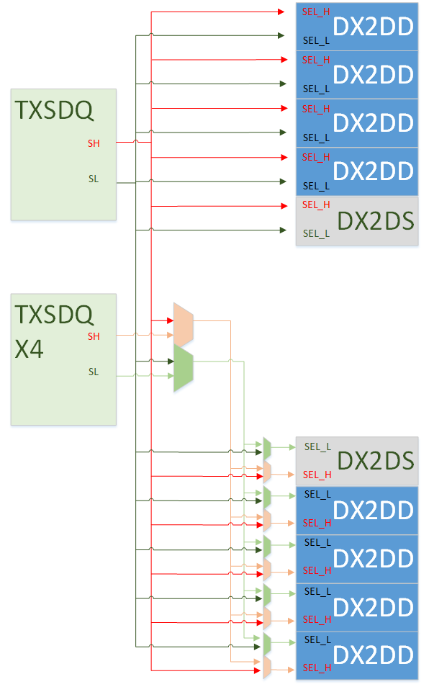

#### DMOE_GEN to DX2DD & DX2DS

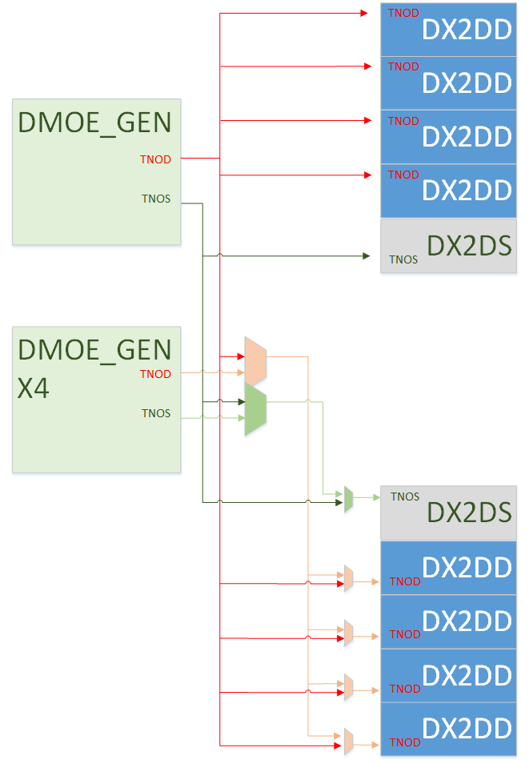

### DDRPHY RXDIO

Tree for DQSIEN_HEAD0, DQSIEN_HEAD2, DDWPG2

### DDRPHY DDRCKG

Follow DDRCKG_DDRCLK_S24

TNOD/TNOS/TNOD_X4/TNOS_X4

TNID/TNIS/TNID_X4/TNIS_X4

DCLKO/DCLKOP

DCLKD/DCLKS/DCLKD_X4/DCLKS_X4

### DDRPHY DDRIO

COMPPD/ODT/NDTREE and others

# Implement Note

## Power states

### Normal work state

After DLL_EN asserts, ADLL need more than 8000 cycle to settle stable delay (total 1T in loop) with core power and PLL clock ready. If DLL_LOCKOK doesn’t turns to logic High, it means different clock phase generated by ADLL and RX delay line is not accurate, and all logic IP can’t work normally.

In below picture, t1>0, t2>0 and t3>8000T

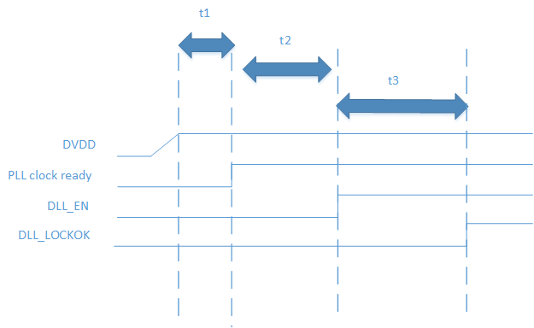

### DLL WeakLock Mode

Assert DLL_WEAKLOCK will enable power saving mode, and DDRPHY could resume immediately when de-assert DLL_WEAKLOCK. In this mode, DCLK will be gated by DLL_WEAKLOCK, and delay of analog delay line will hold in certain time. Then DLL_WEAKLOCK should be de-asserted and ADLL loop re-work to correct the delay of delay line. In Weaklock mode, DLL_LOCKOK is always on.

As below diagram, when DLL_WEAKLOCK turns to 1, delay of delay line will change slowly. Delay will change to T+td in t4 time. Then controller turn off DLL_WEAKLOCK mode, and delay will change back to T in t5 time.

In CMT003 DDRPHY, td is limited to 5% of T, such as for 1600MHz clock, td=31.25ps. In t5 time or later, DDRPHY can work fine.

td<5%T

t4<1us

t5>100ps

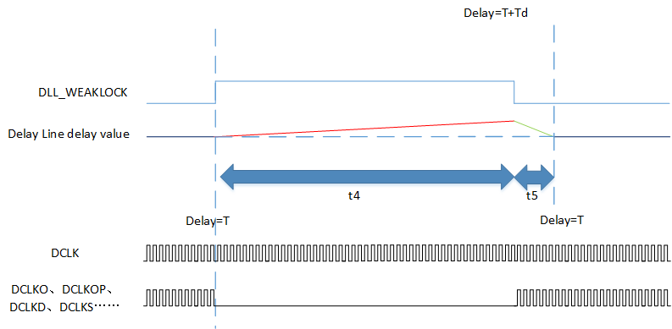

### DCLK turn off

WEAKLOCK mode could not be applied to case as below:

1. DVDD power down, suspend mode as example
2. DCLK is turn off for longer time than t4.

Once they happen, DLL_EN should be de-asserted and it takes t3 time to resume DDRPHY after DLL_EN assert again.

## Timing

### Balance Requirement

#### Path 1 SEL_H/L & SEL_H/L_X4 from TXSDQ to DX2DD & DX2DS

|  |  |  |  |  |  |
| --- | --- | --- | --- | --- | --- |
| Begin | | End | | Delay | Note |
| IP name | Port | IP name | Port |
| TXSDQ | SH | DX2DD0  DX2DD1  DX2DD2  DX2DD3  DX2DD4  DX2DD5  DX2DD6  DX2DD7 | SEL_H | T1 | T/2 setup & –T/4 hold time requirement |
| SL | DX2DD0  DX2DD1  DX2DD2  DX2DD3  DX2DD4  DX2DD5  DX2DD6  DX2DD7 | SEL_L |
| TXSDQ_X4 | SH | DX2DD4  DX2DD5  DX2DD6  DX2DD7 | SEL_H |
|  | SL | DX2DD4  DX2DD5  DX2DD6  DX2DD7 | SEL_L |

#### Path 2 TNOD/S & TNOD/S_X4 from DMOE_GEN to DX2DD/S & pads

|  |  |  |  |  |  |
| --- | --- | --- | --- | --- | --- |
| Begin | | End | | Delay | Note |
| IP name | Port | IP name | Port |
| DMOE_GEN | TNOD | bdddrdq0  bdddrdq 1  bdddrdq 2  bdddrdq 3  bdddrdq 4  bdddrdq 5  bdddrdq 6  bdddrdq 7 | TNO | T2 |  |
| TNOS | bdddrdqs 0 | TNO |  |
| DMOE_GEN_X4 | TNOD | bdddrdq 4  bdddrdq 5  bdddrdq 6  bdddrdq 7 | TNO |  |
| TNOS | bdddrdqs 1 | TNO |  |
| DMOE_GEN | TNOD | DX2DD0  DX2DD1  DX2DD2  DX2DD3  DX2DD4  DX2DD5  DX2DD6  DX2DD7 | TNOD | T3 |  |
| TNOS | DX2DS  DX2DS_X4 | TNOS |  |
| DMOE_GEN_X4 | TNOD | DX2DD4  DX2DD5  DX2DD6  DX2DD7 | TNOD |  |
| TNOS | DX2DS_X4 | TNOS |  |

#### Path 3 TNI & TNI_X4 from DQSIEN_GEN to bdddrdq[s]

|  |  |  |  |  |  |
| --- | --- | --- | --- | --- | --- |
| Begin | | End | | Delay | Note |
| IP name | Port | IP name | Port |
| DQSIEN_GEN | TNID | bdddrdq0  bdddrdq 1  bdddrdq 2  bdddrdq 3  bdddrdq 4  bdddrdq 5  bdddrdq 6  bdddrdq 7 | TNI | T4 |  |
| TNIS | bdddrdqs 0 | TNI |  |
| DMOE_GEN_X4 | TNID | bdddrdq 4  bdddrdq 5  bdddrdq 6  bdddrdq 7 | TNO |  |
| TNIS | bdddrdqs 1 | TNO |  |

#### Path 4 DQSIEN_GEN header signal to RXDIO

|  |  |  |  |  |  |
| --- | --- | --- | --- | --- | --- |
| Begin | | End | | Delay | Note |
| IP name | Port | IP name | Port |
| DQSIEN_GEN | DQSIEN_HEAD0 | RXDIO0  RXDIO1  RXDIO2  RXDIO3  RXDIO4  RXDIO5  RXDIO6  RXDIO7 | DQSIEN_HEAD0 | T5 |  |
| DQSIEN_HEAD2 | RXDIO0  RXDIO1  RXDIO2  RXDIO3  RXDIO4  RXDIO5  RXDIO6  RXDIO7 | DQSIEN_HEAD2 |  |
|  | DDWPG2 | RXDIO0  RXDIO1  RXDIO2  RXDIO3  RXDIO4  RXDIO5  RXDIO6  RXDIO7 | DDWPG2 |  |
| DQSIEN_GEN_X4 | DQSIEN_HEAD0 | RXDIO4  RXDIO5  RXDIO6  RXDIO7 | DQSIEN_HEAD0 |  |
| DQSIEN_HEAD2 | RXDIO4  RXDIO5  RXDIO6  RXDIO7 | DQSIEN_HEAD2 |  |
| DDWPG2 | RXDIO4  RXDIO5  RXDIO6  RXDIO7 | DDWPG2 |  |

#### Path 4 DCLKO/DCLKOP/DCLKD/DCLKS/DCLKDSI & DCLKD_X4 /DCLKS_X4/DCLKDSI_X4 from VCDL_BYTE_S24 to DIO & pads

|  |  |  |  |  |  |
| --- | --- | --- | --- | --- | --- |
| Begin | | End | | Delay | Note |
| IP name | Port | IP name | Port |
| VCDL_BYTE_S24 | DCLKO | DX2DD0  DX2DD1  DX2DD2  DX2DD3  DX2DD4  DX2DD5  DX2DD6  DX2DD7  TXSDQ  TXSDQ_X4  DX2DS  DX2DS_X4  DMOE_GEN  DMOE_GEN_X4  DQSIEN_GEN  DQSIEN_GEN_X4 | CLKO | T6 |  |
| DCLKO | PHY TOP | DCLKO |  |
| DCLKOP | TXSDQ  TXSDQ_X4  DX2DS  DX2DS_X4  DMOE_GEN  DMOE_GEN_X4 | CLKOP |  |
| DCLKD | ~~DX2DD0~~  ~~DX2DD1~~  ~~DX2DD2~~  ~~DX2DD3~~  ~~DX2DD4~~  ~~DX2DD5~~  ~~DX2DD6~~  ~~DX2DD7~~  DMOE_GEN  DQSIEN_GEN | ~~TXCLK~~  TXCLKD |  |
| DCLKD_X4 | ~~DX2DD4~~  ~~DX2DD5~~  ~~DX2DD6~~  ~~DX2DD7~~  DMOE_GEN_X4  DQSIEN_GEN_X4 | TXCLK  TXCLKD |  |
| DCLKS | DX2DS  DMOE_GEN | TXCLK  TXCLKS |  |
| DCLKS_X4 | DX2DS_X4  DMOE_GEN_X4 | TXCLK  TXCLKS |  |
| DCLKDSI | DQSIEN_GEN | CLKDSI |  |
| DCLKDSI_X4 | DQSIEN_GEN_X4 | CLKDSI |  |

|  |  |  |  |  |  |
| --- | --- | --- | --- | --- | --- |
| Begin | | End | | Delay | Note |
| IP name | Port | IP name | Port |
| VCDL_BYTE_S24 | DCLKD | bdddrdq 0  bdddrdq 1  bdddrdq 2  bdddrdq 3  bdddrdq 4  bdddrdq 5  bdddrdq 6  bdddrdq 7 | SEL | T7 |  |
| DCLKD_X4 | bdddrdq 4  bdddrdq 5  bdddrdq 6  bdddrdq 7 | SEL |  |
| DCLKS | bdddrdqs 0 | SEL |  |
| DCLKS_X4 | bdddrdqs 1 | SEL |  |

|  |  |  |  |  |  |
| --- | --- | --- | --- | --- | --- |
| Begin | | End | | Delay | Note |
| IP name | Port | IP name | Port |
| VCDL_BYTE_S24 | DCLKD | DX2DD0  DX2DD1  DX2DD2  DX2DD3  DX2DD4  DX2DD5  DX2DD6  DX2DD7 | TXCLK | T8 |  |
| DCLKD_X4 | DX2DD4  DX2DD5  DX2DD6  DX2DD7 | TXCLK |  |

### External Constraint Requirement(less)

### Internal Constraint Requirement

#### SEL_H/L setup/hold constraint

tck2q+tmux1+tmux2+T1+tmux3<5T/8-VCDL_Jitter_Skew-Tsetup  
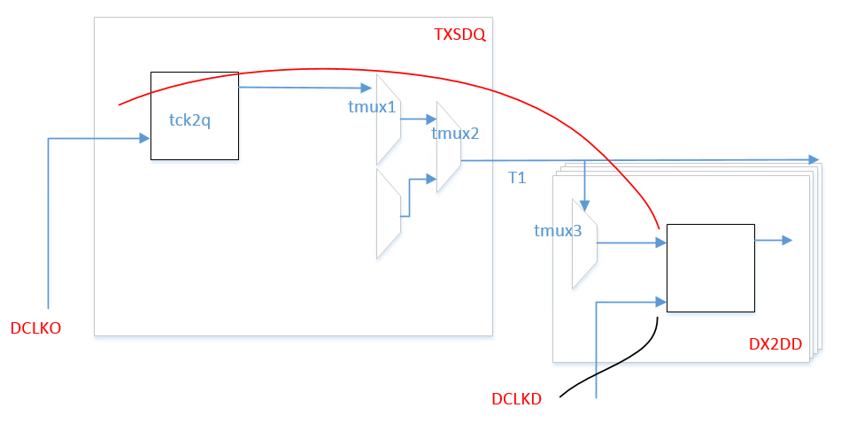

#### TNOD/S & TNI header delay requirement

T3 delay as min as possible

T4<300ps

T5<300ps

#### DCLKD/S constraint

T6=T7

T7<T8

#### TXDIO internal

### Internal Constraint Conclusion Table

Internal timing requirement in Verilog module by FE as:



Actual timing calculation in schematic by CKT as:



## VCDL_BYPASS mode

## Calibration(less)

## Glitch

For TX clock such as DCLKO/DCLKOP/DCLKD/…, when controller changes corresponding phase setting, there would be no glitch at each clock. It should be noted that, the output clock phase doesn’t follow the setting change immediately. It may take another 0.5~2T to change output clock phase to avoid glitch. Case 1 and case 2 are both possible in below picture.

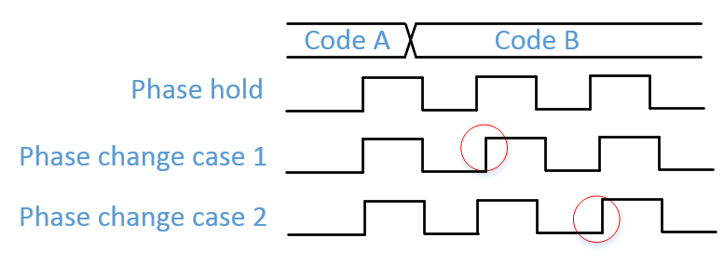

There is no glitch-avoid function for VCDL_PI_DQS, so controller can change VCDL_PI_DQS phase setting when there is no DQS input. If VCDL_PI_DQS phase setting change in Reading Mode, DQS glitch would appear and DDR couldn’t work.

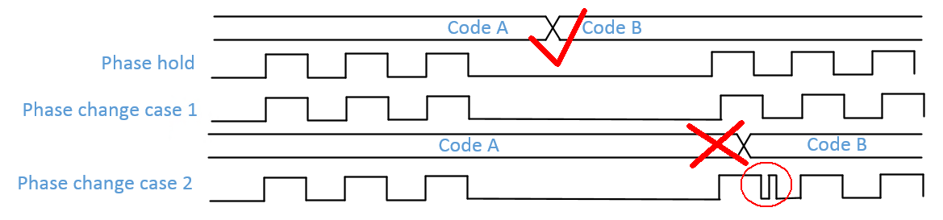

## Frequency change

**In normal operation, frequency can’t be changed.**

**When frequency change, DLL_EN must be trigger from 0 to 1.**

# DDRPHY FloorPlan & BumpMap

## Floorplan

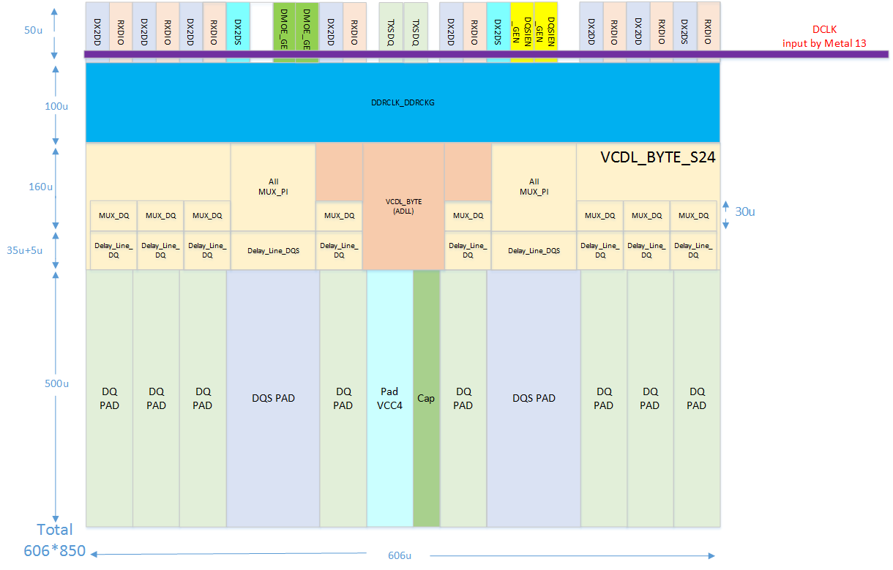

## Pad assignment

|  |  |  |  |  |  |  |  |  |  |  |
| --- | --- | --- | --- | --- | --- | --- | --- | --- | --- | --- |
| DQ4 | DQ5 | DQ0 | DQS9N  -DQS9P | DQ1 | VCC4  +CAP | DQ6 | DQS0P  -DQS0N | DQ7 | DQ2 | DQ3 |

## BumpMap

Version:T16 DDR Bump Map Ver.0.5 for CMT003

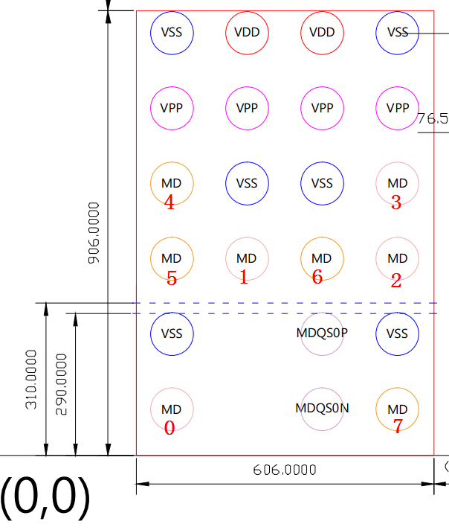

# Test(less)