Basic Introduction of devops

Devops : It is new culture or process the release and develop maintain with higher quality in faster way. I have to do that.
We can achieve with automation tools.
1. Development Group
2. Operation Group or Non Development Group or AdministratorGroup

1. Development Group

Business Analyst
System Analyst
Design Architech
Developers/coders
Build Engineer
Test Engineer

2.
a. Release
b. Deployement
c. Operations
d. Monitoring

Operation Group

Release Engineer
Configuration Engineer
System Admin
Database Admin
Network Admin

etc

Devops : It is combinaton operation and development
Main objective is to maintain the corelation between operation and development team

SDLC
1. Waterfall model
2. Prototype model
3. Incremental or itrative model
4. spiral model
5. rad model
6. Big bang model
7. Fish model
8. V model
9. Agile model

1. Water Fall Model
Requirement Gathering
Design
High level, Low level , Gui Design
Coding
Testing
Release
Maintenance
Flow water
Also Known as Linear sequencial Model.

Limitations:
--
1. Development Time Increasing
2. Cost of Time Started
3. It wan’t accept requirement change in middle
4. Client Satisfication very low
5. Bug fixing is very costly because we can’t identify
6. Not at all suitable if requirement change
7. Not suitable for large project

Advantage:
1. easy to implement
2. Best suitable if requirement are fixed
3. Best suitable for small project

Agile Model
----------------
This is most frequently used and hot cake model software model.
Agile model devided into multiple sub model

1. Rational Unify Process( RUP)
2. Advative software development
3. Feature Drivent Development
4. Crystal Clear
5. Dynamic software Developoment Model (DSDM)
6. Extreme Programming (xP)
7. Scrum Model

Among Scrum Model most popular and frequently used in market

Agile ===> speed
Scrum
It is not linear sequential Model

Sprint: Small part of software is called sprint
Total software is develop by increament by increament, each increament is called sprint.

Webisite 100 Page
we develop only 10 page ( sprint 1) deliver the client means not change required like whole project at a time in waterfall.
Continous Delivery
Continous Feedback
Requirement Change in middle
Less Development time
Less Development cost( All team is working simultaneouly and due no on batch and employee cost utilization is properly)

SCRUM
Every sprint 7 to 9 member will work
each sprint will be delivered 1 week to 3 weeks time

For single sprint some member of group is working for

3 Developer
1 ui designer
1 test engineer

Why we should go for devops ??
------------------------------------
Devops and Agile both are diffrent models

Similarities:
-------------
1. Both are software methodologies
2. Both model are consentering on rapid development with team colobrations

Diffreneces :
______---------
1. Diffrence will come when project is completed

Agile model talks only development but devops talks about complete product life cycle
development as well as operations

2. Every one is all rounder ( they know all about of testing, development , operations)
Devops Engineer is all rounder
In Agile every person has seprate work Development , Testing, operation etc.
But Devops people know each terminogy, Development to operations

3. Agile model want to force us to use automations tools.
But Devops model is completely based on Automations tools

4. Agile Giving highest priority to rapid development
But Devops give highest priority to both quality as well as speed.

5. Here Client is giving the Feedback but In Devops imediatly feedback by monitring tool.

End to End care by Devops with the automations tools

Devops : It is new culture for development and operations. Continous Development, Continues Test, Continous monitoring.

Still completed two years of project but it providing support.

Devops Infinite and continous loop

Version Control system tool
------------------------------------
Version control system tool is also known as softeware configration managemnet.
Souce code Management (SCM)

Benifit:
--------

Type of version control system
centralized and distributed system

GIT

Clinet Project
|-Client Suggested some changes
|-File have changed on the basis requirement
|- Again suggested some changes
|- Changed Again
|- Agian they said show me first day code
This is very hectic show that first day code , Main suggestion not over the code each every time
Write version control system
version 1
version 2
version 3

1. Mainting Multiple version by manually very difficult
2. Every change should be track
3. when he did change
4. which change he did
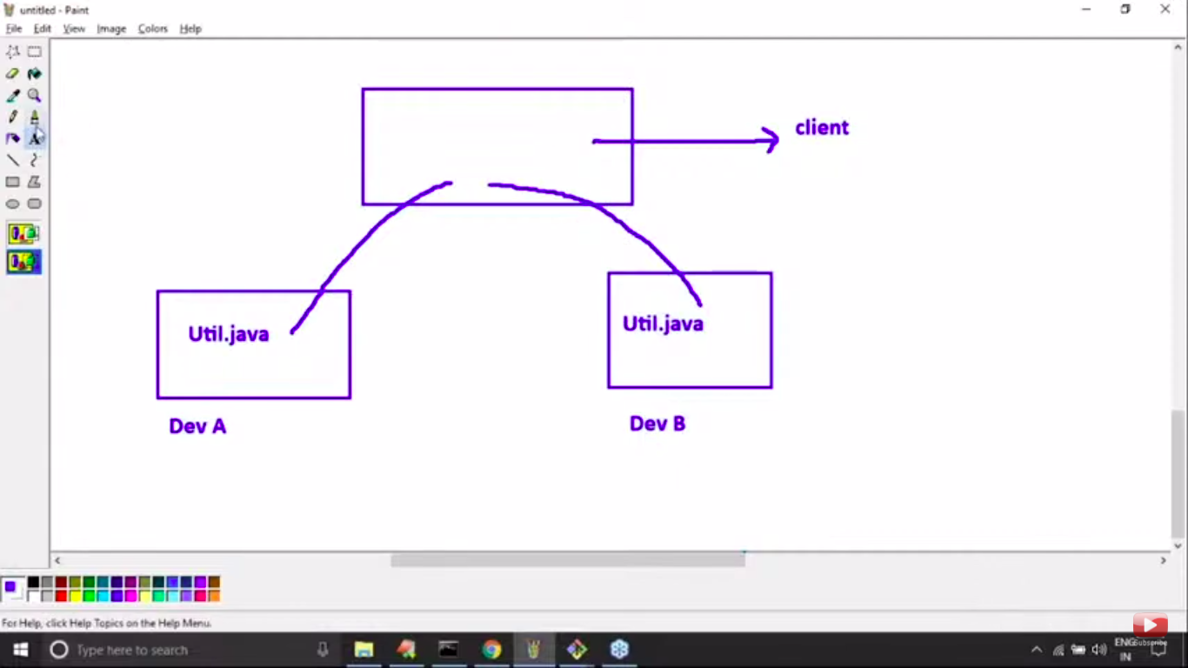

It might be condition over write to here. Due to version control over writing should not happen

4. Developer share code to pear developer
5. Parallel development must be requirement

How version control system works:
-----------------------------------------

version control system always talks about file which contains source code.

Tester write-----> scripts
Architecht ----> Document
Project Manager ----> Excel Sheets

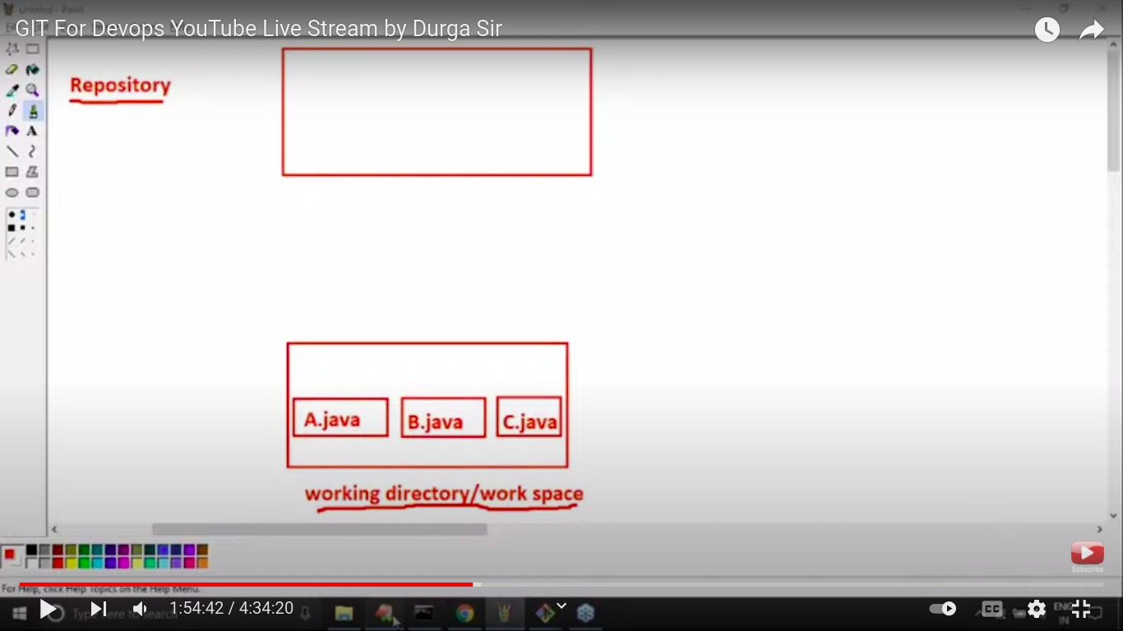
Working directory: Where developer require to create and modify the file
here version is not applicabel

Repository: Where store file and meta Data
here version control is applicable , Verson 1, verson 2 etc

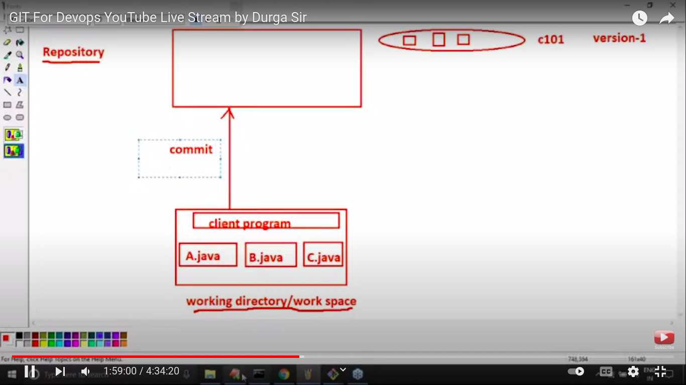
After chage
commit:
----------

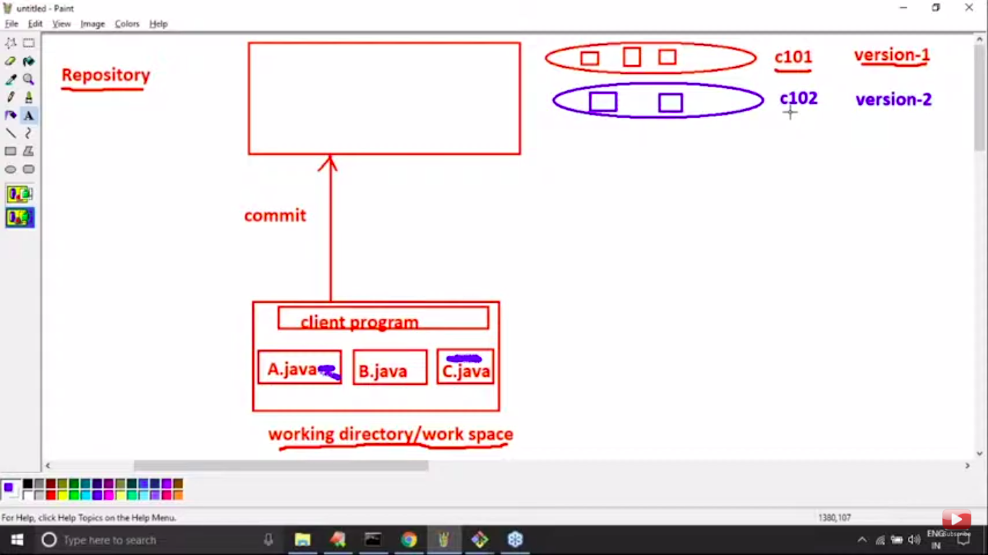

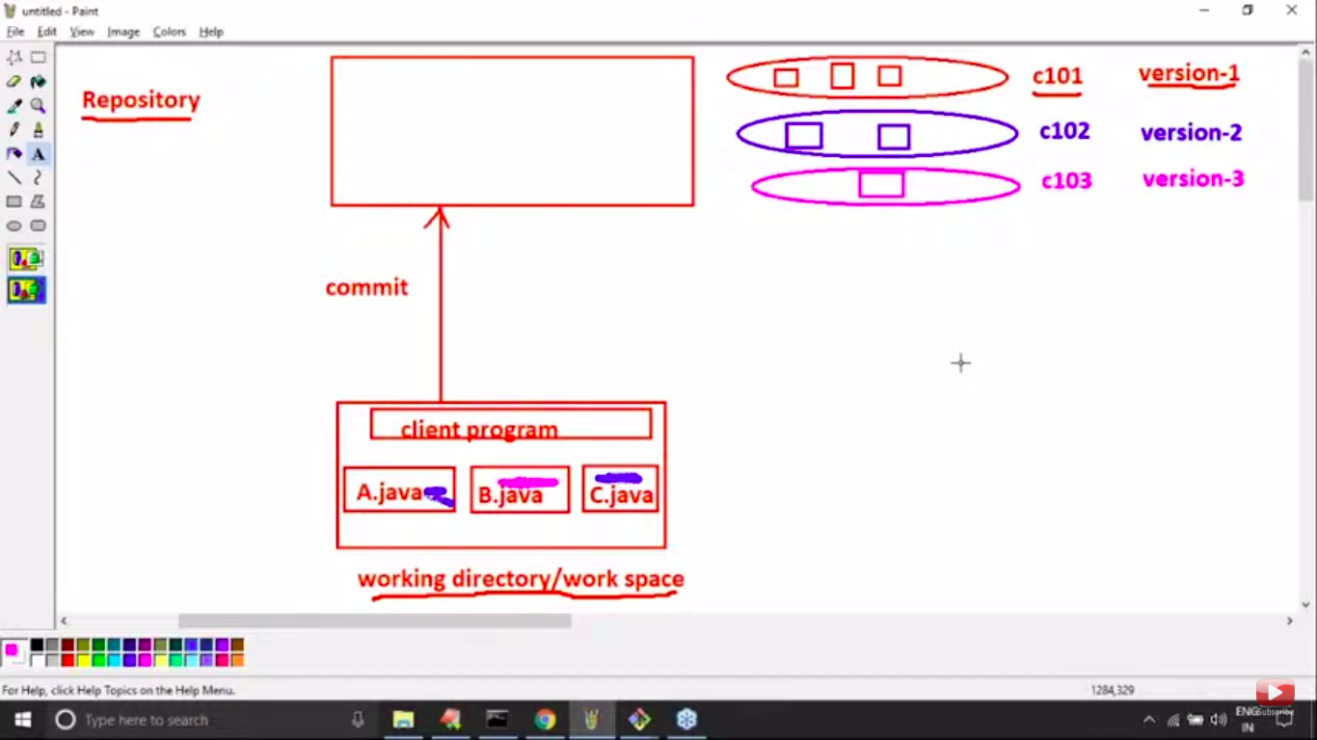
Checkout:
--------------------------
When we want previous version
This is called checkout/pull/clone

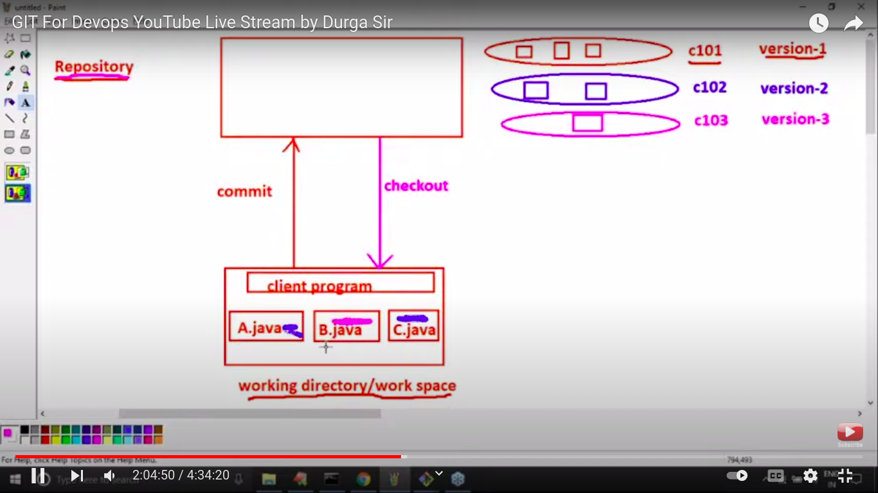
Benifite of version control:
------
1. choose version based on client requiremnt.
2. Mainten Meta Data

3. Developer can share the code to peers developers
4. Multiple developer can work simultanously
5. parralel devlopement

6. We can provide access control like
7.

