File based approach
Means each application has own file : conculudely we are wasting our time store same data redundantly
Disadvantage is data inconsistanct due to updating indepandly
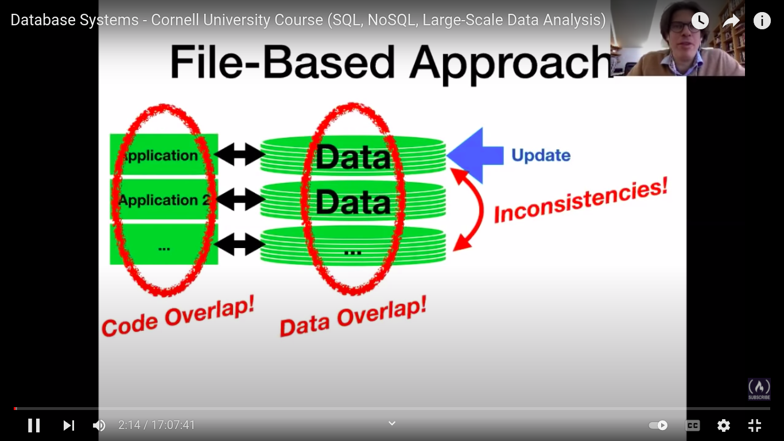
This problem resolve by data base system (DBMS)
It is central data center who can handle withougth using explicit own file for each application
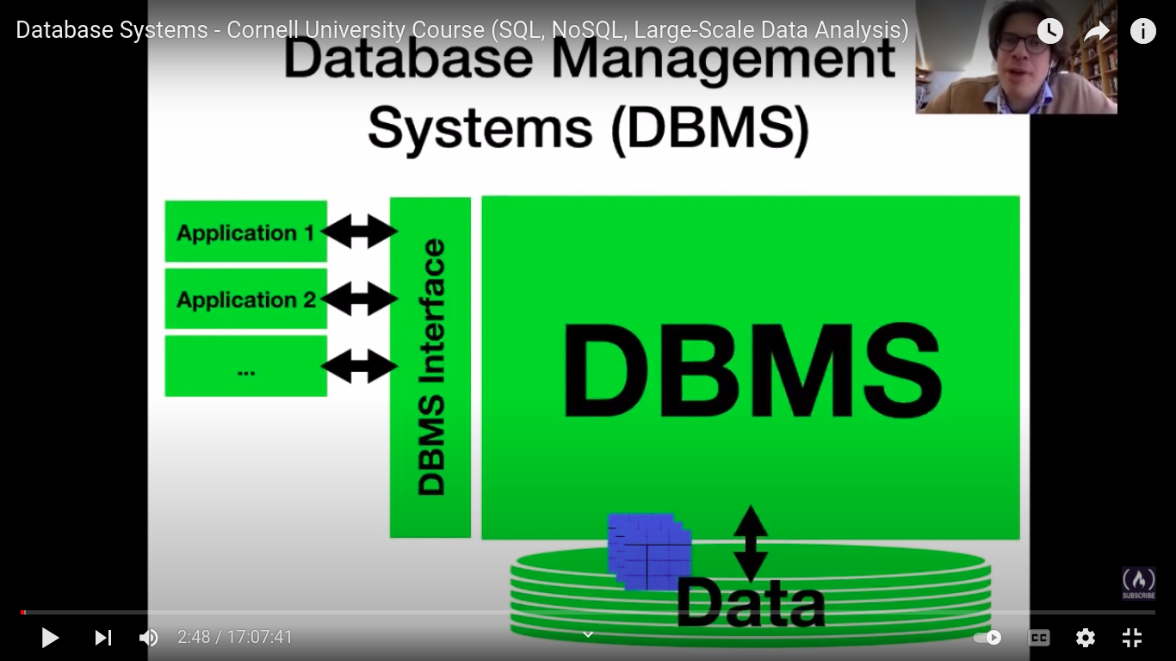
We learn about relation database means it connection between table
DBMS Interface: It is the language wich will use for modifaction. i.e. Structured query lanaguage.
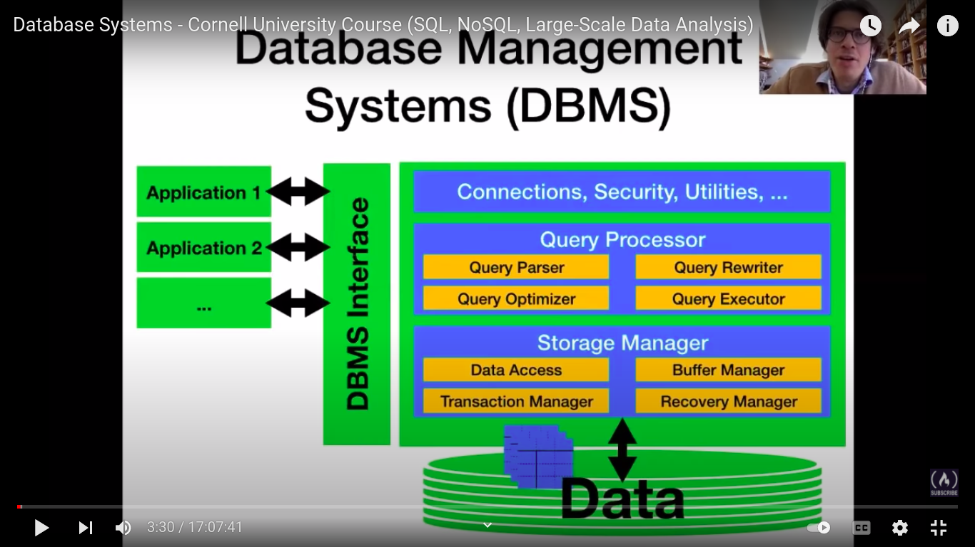
Data Storage:
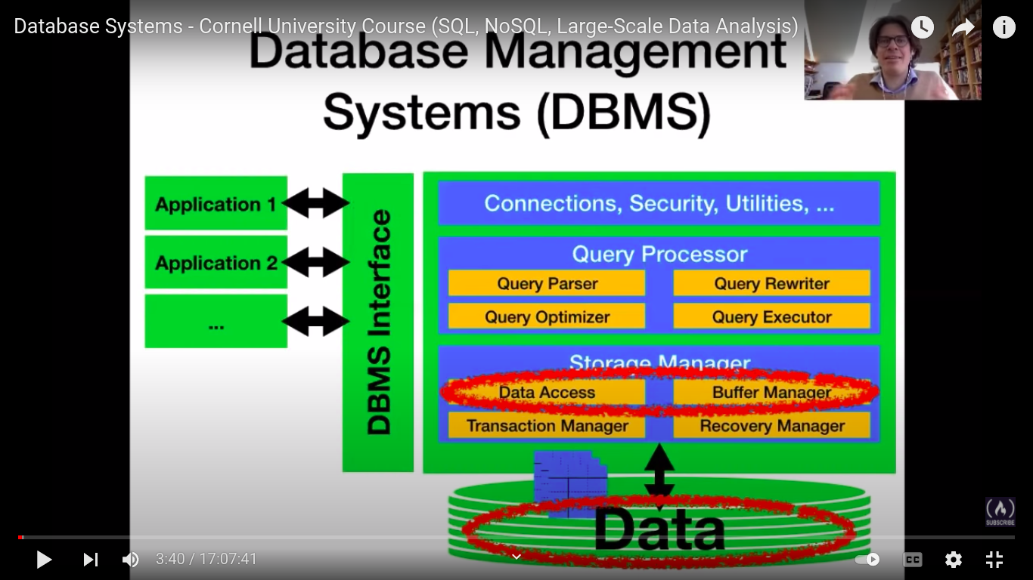
Storage Media Data Layout Files and Indexes:

How to process the data and get new insites
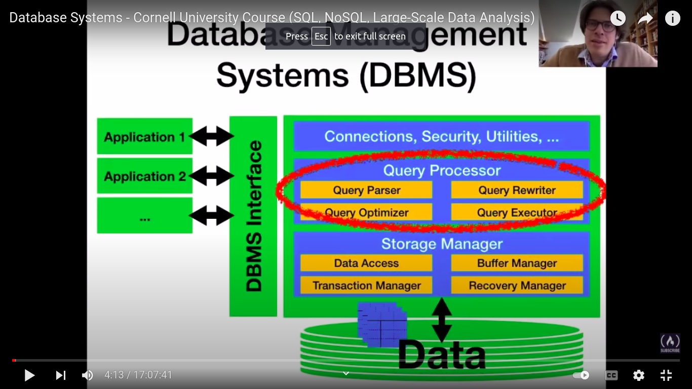
Operator : How to fileter the data and connect the database
Cost estimations and Query optimisations: Before apply the query we have to plan in effient way to apply sql

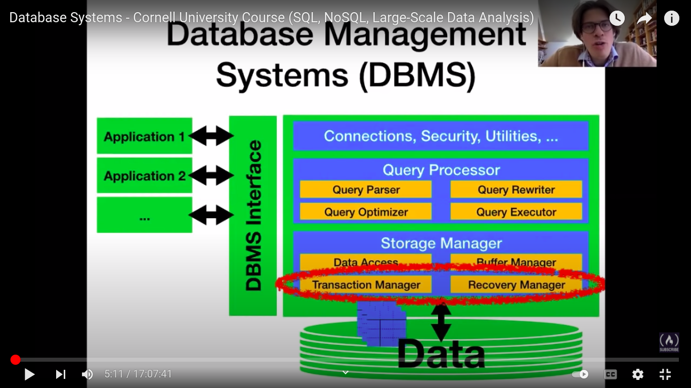
Transaction and processing
Concurrency control crash recovery
It insure the data transaction should be smoothly and updation possible

How design our DB: Schema Design Detecting Redundancy Schema Normalization

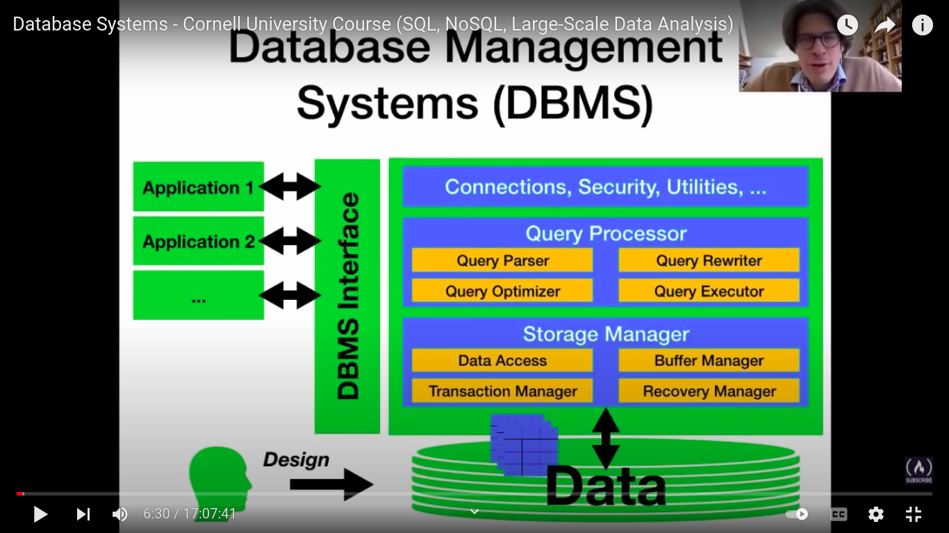
Distributed Data Processing
NoSQL and NewSQL

Other data as well as
Graph data
Data Stream
Spatial Data

The SQL Language
our plan is to see subset of sql command it a very vast all of this .

SQL Command Types

a. DDL : Data definaton Language
Define the data admissible data content
b. DML: Data Manupulation Language
Change and retrieve the data content
c.TCL : Transactional Control Language
Grap sql command
d. DCL: Data Conrol Language
Assign data access rights

New subset

Defination Database Schema

. Define relations with thier schema
What colums and type of colums
. Define constrant between the data
a. Cosntrain in single relations
b. Cosntrain in multiple relations

Schema Definations in SQL
. Create Table <table>
. Table Name<table>
. <tabel def> comma seprated columns definations
. column defination is form <col-name> <col-type>

i.e
create Table student (sid int, Sname text, Gpa real);
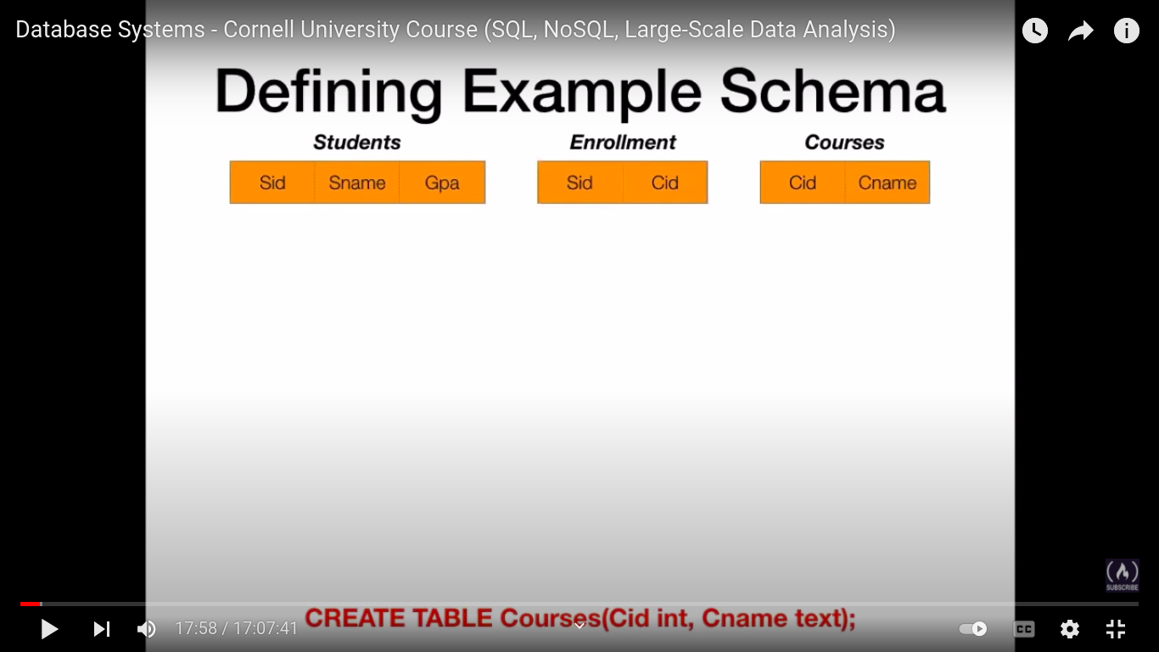
constraints
like id should unique
Linking more number of table with the relations

Integrity Constraints
. Constriants that limit admissible content of tables
. DBMS enforce integraity constraints
. can be add the table via ALTER TABLE
. can define when creating table

1. First type constraints
Primary Keys Constraints
. A primary key constriants refers to a single table.
. It identify the subset of columns as key colums.\
. Fixing value for key columns must be indetify row
. Not two row has same value in key rows

Syntax
ALTER TABLE <tabel>
ADD CONSTRAINT Primary Key (<key-col>);
<tabel> tabe name
<key-col> is commans seprated columns names

Forein key constraint
Forein key is not primary key. This constrain relate the two columns
First tabel is forein key to the second primary key.
Means first table all rows wich forein key of second table rows are equal. All rows maps with second table rows

Sytex:
ALTER TABLE <table-1>
ADD CONSTRAINT Forein key (<fkey-columns>)
REFFRENCES <table 2> (<pkey-columns>);

table-1 : table with forein key
fkey -columns : columns with commans seperated forien keys
table -2: is table with primary key columns
<pkey-columns>: columns with commans seperated with primary keys

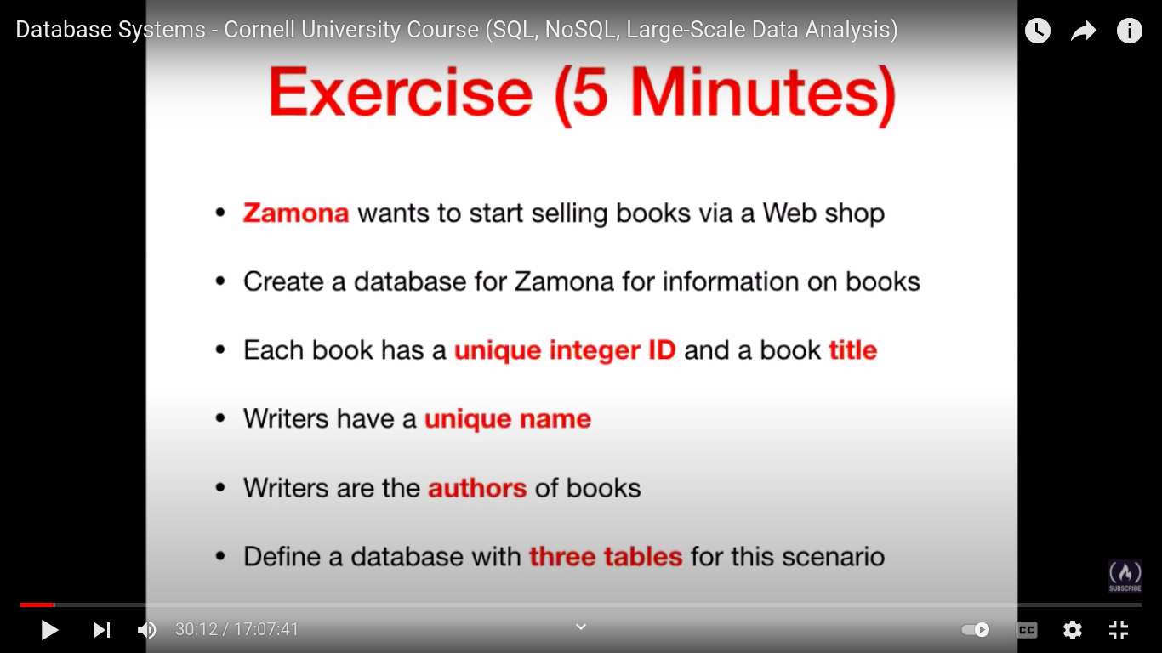

create books (unique<bookid>, unique<title>, authorName);

