user
Distributed System

Fallacies of Distributed System
a. Network is reliable
b. Latency is zero
c. Bandwith is infinite
d. Transport ( data moving) cost is zero
e. Topology does't change
f. Network is secure
g. Only one admistrator

Distributed System Characteristic
a. No shared clock
b. No shared Memory
c. shared Resources
d. Concurency and constistency

Distributed System Communication
a. Different parts of Distributed System need to be able to talk
b. Required agreed upon format or protocol
c. Losts of things can go wrong, need to handle them shomehow
d. Client can't find server
e. server crash mid request
f. Server response Lost
g. Client crashes

Benefits
a. More reliable, fault tolerant
b. Scalability
c. Lower Latency, increase performance
d. Cost effective

System Design performance Metrics

Scalability
a. Ability of system to grow and manange increased traffice
b. Increased volume of data or requests

Reliability
a. Reliability a system will fail during a period of time
b. Slightly harder to define than hardware Reliability

Measured by Mean Time Between failure= ( Total Elaped time - total downtime )/number of failure

Availabity
a. Amount of time a system is operational during a period of time
b. Poorly designed software required downtime for updates is less Availabity

Availabity=(available time / total time)*100

Reliable vs Available
a. Reliable system is always an available system
b. Availabity can be maintained by redundancy, but system may not be reliable
c. Reliable software will be more profitable because providing same service required less backup Resources
d. Requirements will depend on function of the software

Efficiency
a. How well the system performs
b. Latency and throughput oftem used as metrics

Manageability
a. Speed and difficulty involved with maintaining system
b. Observability how hard to track bugs
c. Difficulty of deploying updates
d. Want to abstract away infrastructure so product engineers don't have to worry about it.

Numbers Programmers should know

Latency key Takeaways
a. Avoid Network calls whenever possible
b. Replicate data across data centers for disaster recovery as well as performance
c. Use CDNs to reduce Latency
d. Keep frequency accessed data in Memory if possible rather than seeking from disk, caching

8 bit - 1byte
Char -1byte
Integer-4bytes
Unix Timestamp -4 bytes

Traffic Estimates
Memory
Bandwith
Storage

Horizontal vs Vertical Scaling

<img src="Screenshot from 2021-11-20 00-02-11.png" alt="itnesh">
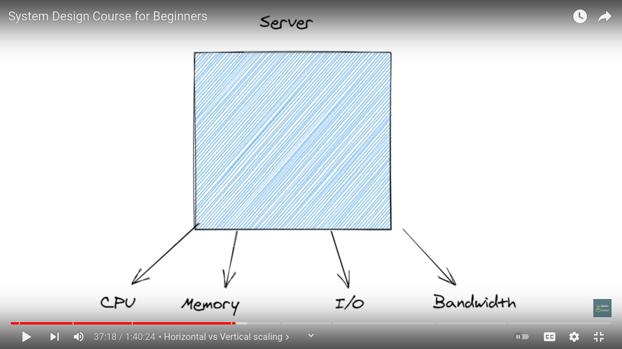

Vertical Scaling
a. Easiest way to scale an Application
b. Diminishing returns, limits to Scalability
c. Single Point of failure

Horizontal Scaling
a. More complexity up front, but more efficient long term
b. Redundancy built in
c. Cloud providers make this easier

Buzzwords
Docker
Kubernetes
Hadoop, Sparks

Tradeoff

Redundancy
Latency

System Design Components
Load Balancers
a. Balance incoming traffic to multiple servers
b. Sofware or Hardware based
c. Used to improve Reliability and Scalability of Application
d. Nginx, HAProxy, F5, Critix

Simple website
user--->Internet--->Web sever(example.com)--->Application

Basic LB setup
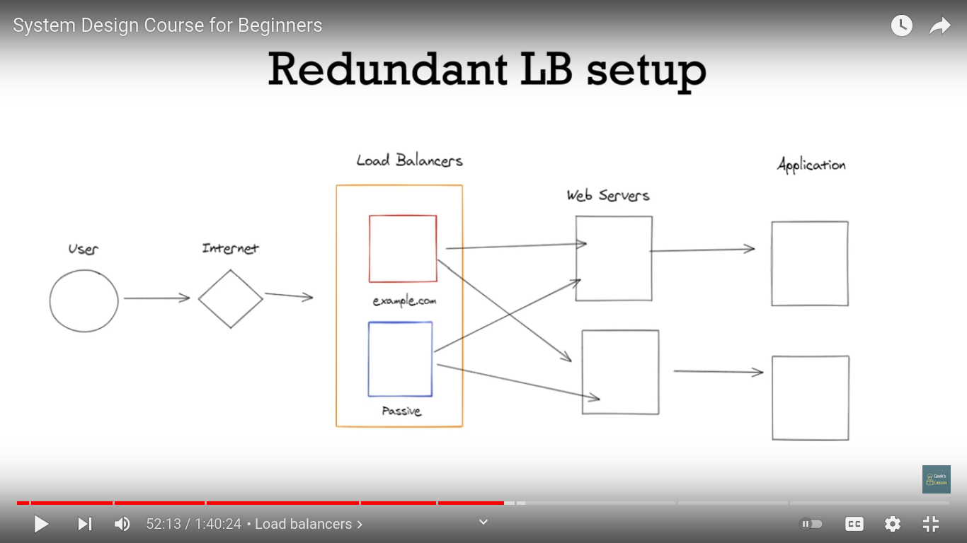
User--->Internet--->Load Balancer(example.com)--->Web sever(example.com)--->Application
|
|
^web server---> Application

Load Balancing Routing Method
a. Round Robin
1. Simple type of Routing
2. Can result in uneven traffic
b. Least Connections

1. Routes based on number of client connections to server
2. Useful for chat or streaming Application
c. Least Response Time
1. Routes based on how quickly servers respond
d. IP Hash
1. Routes client to server based on IP
2. Useful for stateful sessions

Layer4(L4) vs L7
a. Layer 4
1. Only has access to TCP and UDP data
2. data
3. Lack of information can lead to uneven traffic
b. Layer 7
1. Full access HTTP protocol and data
2. SSL termination
3. Check for authentication
4. Smarter routing options

Redundant LB Setup
<img src="Screenshot from 2021-11-20 08-58-35.png" alt="itnesh">

Caching
Why caching
a. improve performance of Application
b. Save Memory

How does caching works
<img src="Screenshot from 2021-11-20 09-02-57.png" alt="itnesh">
Client ---> App server ---> <--- cache ---> <--- Database

Speed and performance
a. Reading from memory is much faster than disk, 50-200x faster
b. Can serve the same amount of traffic with fewer Resources
c. Pre- Calculate and cache data
d. Most apps have far more reads than writes, perfect for caching

Caching layers
a. DNS
b. CDN
c. Application
d. Database

Cachin layers
<img src="Screenshot from 2021-11-20 09-12-37.png" alt="itnesh">

Distributed cache
a. Works same as traditional cache
b. Has built-in functionality to replace data, shard data across servers, and locate proper server for each key

Cache Eviction
a. Needed for 2 reasons
b. Preventing stale data
c. Caching only most valuable data to save Resources

TTL(Time to Live)
a. set a time period before a cache entry is deleted
b. Used to prevent stale data

LRU/LFU
a. Least Recently used
. Once cache is full, remove last accessed key and add new key
b. Least frequency used
. Track number of time key is accessed
. Drop least used when cache is full

Caching Strategies
a. Cache Aside most common
b. Read Through
c. Write Trough
d. Write Back

Cache consistency
a. How to maintain consistency between database and cache efficiently
b. Importance depends on use case

Database Scaling

Basic Scaling Techniques
. Indexes
. Denormalization
. Connection pooling
. Caching
. Vertical Scaling

Vertical Scaling
a. Get a bigger server
b. Easiest solution when starting out

Indexes
a. Index based on colulmns
b. Speeds up read performance
c. Writes and update become slightly slower
d. More storage required for index

Denormalization
a. Add redundant data to tables to reduce joins
b. Boosts read performance
c. Slows down writes
d. Risk inconsistent data across tables
e. Code is harder to write

Connection Pooling
a. Allow multiple application threads to use same DB connection
b. Saves on overhead of independent DB connections

Caching
a. Not directly related to DB
b. Cache sits in front of DB to handle serving content
c. Can’t cache everything

Replication and Partitioning
Read Replicas
a. Create replica servers to handle reads
b. Master server dedicated only to writes
c. Have to handle making sure new data reaches replicas

Sharding
a. Horizontal partitioning
b. Schema of table stays the same, but split across multiple Dbs.
c. Downsides- Hot keys, no joins across shards

Vertical partition
a. Divide schema of database into separate tables
b. Generally divide by functionality
c. Best when most data in row isn’t need for most queries

