Similarity between hume and machine in computer vision
by eye and cameras
photonic energy is converted into eletcric signal
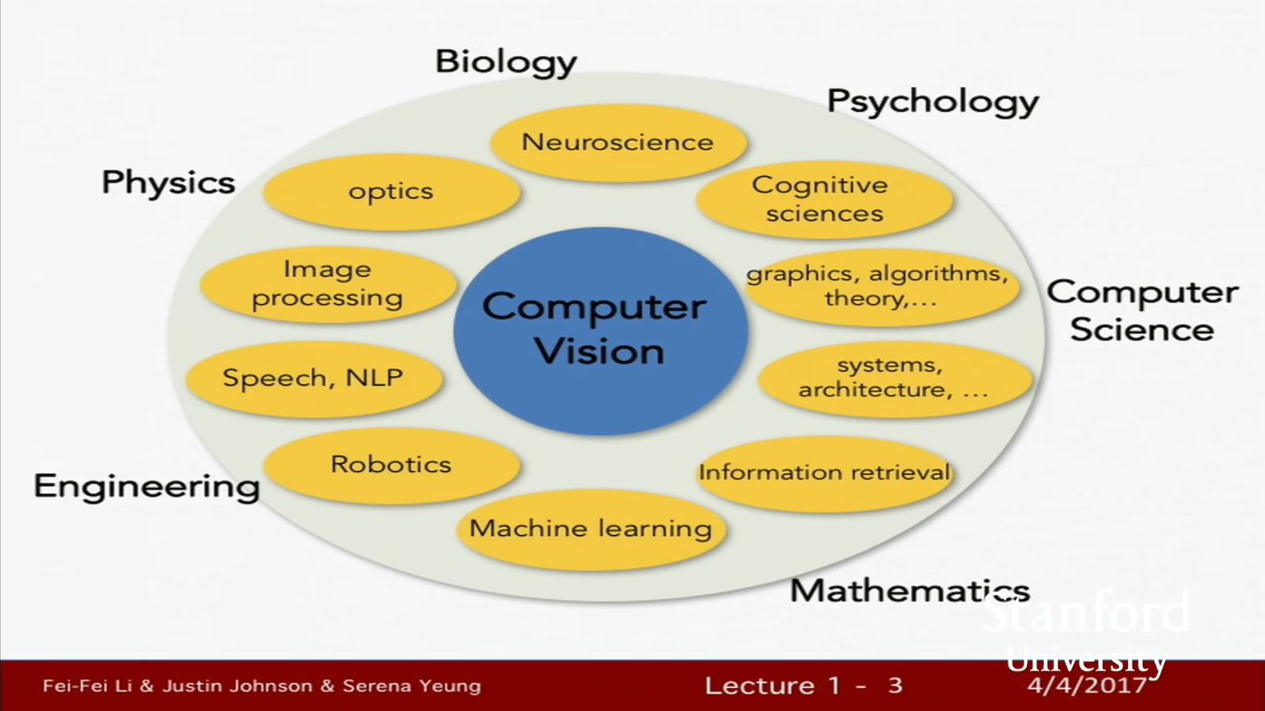

Find the object and drow the similar object which is found in picture. It is one process of image segmentations
Take all the picture in diffrent orientation and put them into feature descrption and match them new feature of new picture.
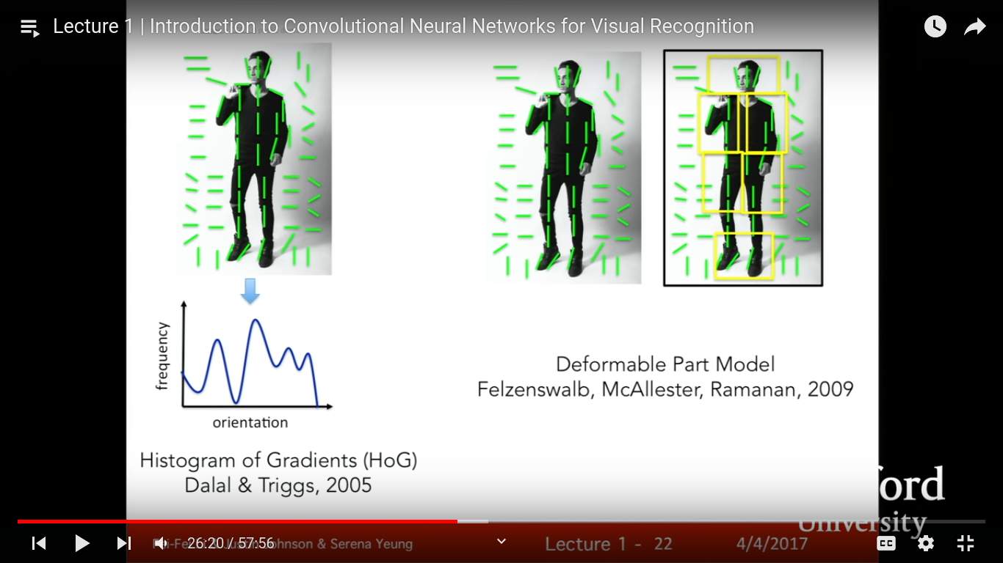

Two ways to do human recoginitions
1. Histogram of Gradients Dalal & Triggs
2. Deformable part model

Pascal object challenge

In computer vision generally hapens overfitting due to heavy feature of image
New concept is image-net( download the milion image in collect in dictionary data and organise in several categories)
convolutional neural network by this model (CNN)

1. object detection
2. image captioning

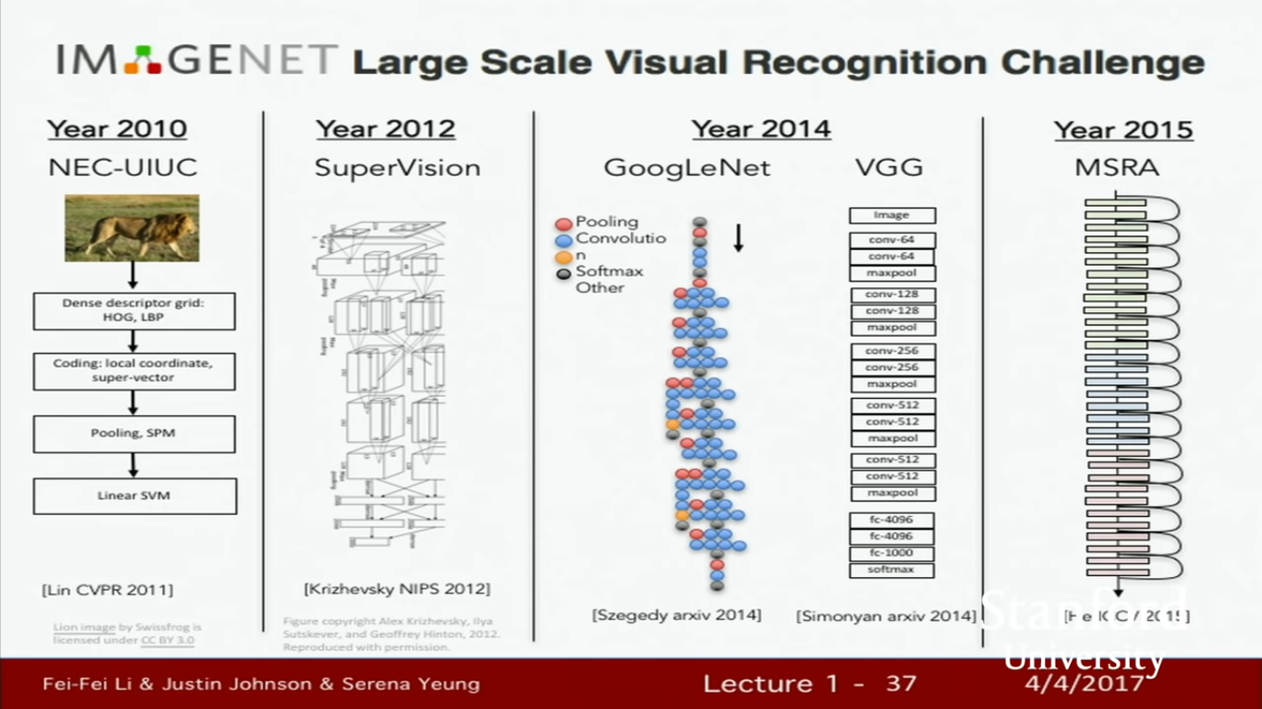
from featrue to getting convoltion neturol newok
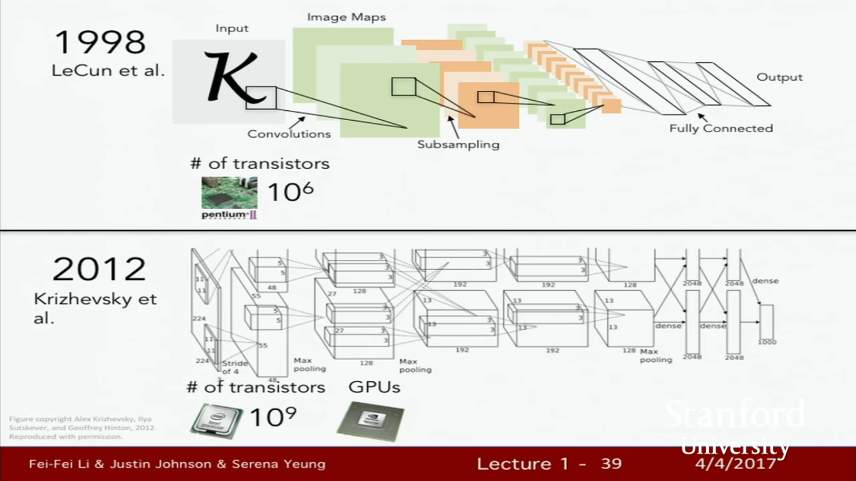
why it is booming in 20 even it is in 19 due to large transitor in chip and large number of labeled data.

