First neural network

Logistic regresion

Machine learning
^
Y=p(y=1)
^
0<=Y<=0

Neural network
^
Y=sigmoid(W^{T}X +b)
W^{T}+b=z

sigmoid=1/(1+e^{-z})
if data is large 1
if data is very less 0

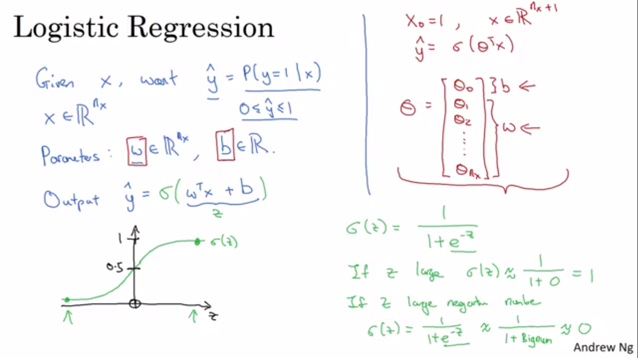

Traing model is easy but instead of increase accuracy as well
by the concept finding the minima Gradient Decent

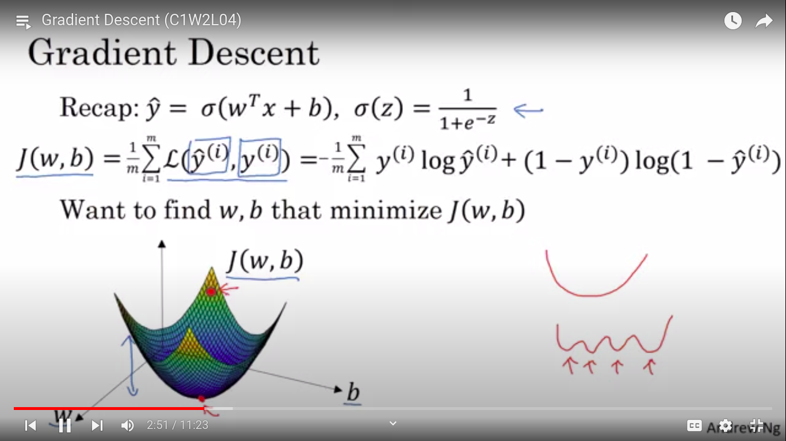
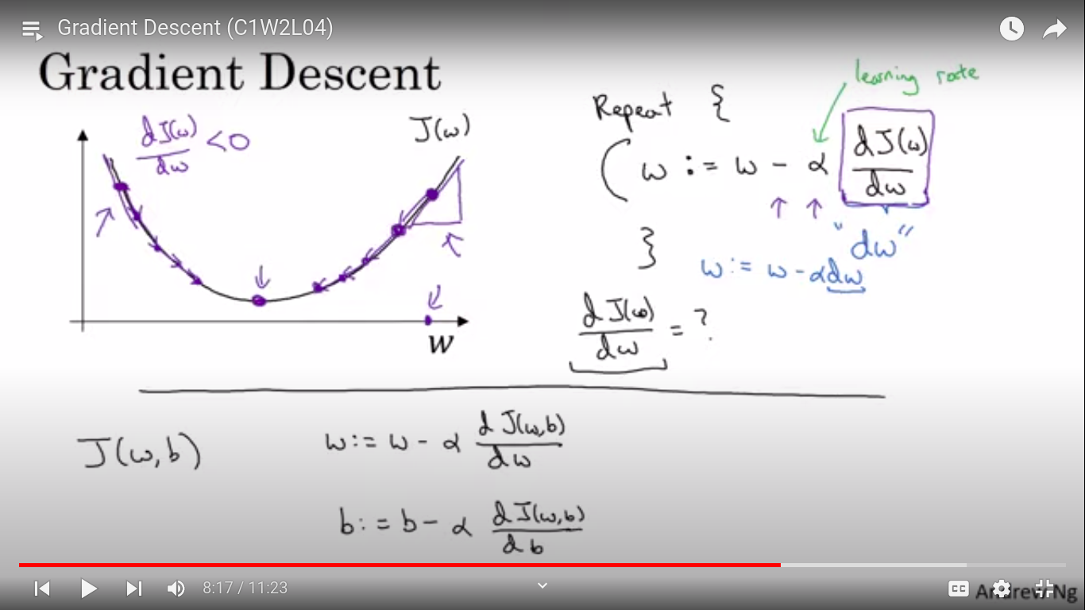
Forward propgation
To train the model

Backward Propgration
To calculate the derivative

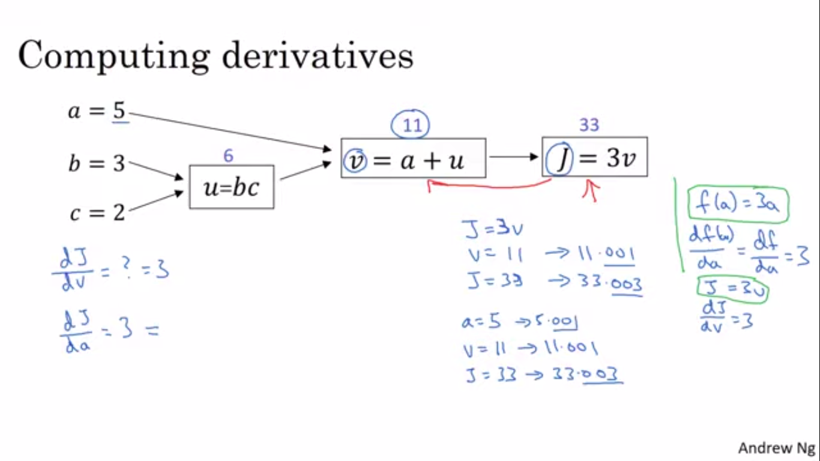
Logistic Function (z, y^)
Loss function

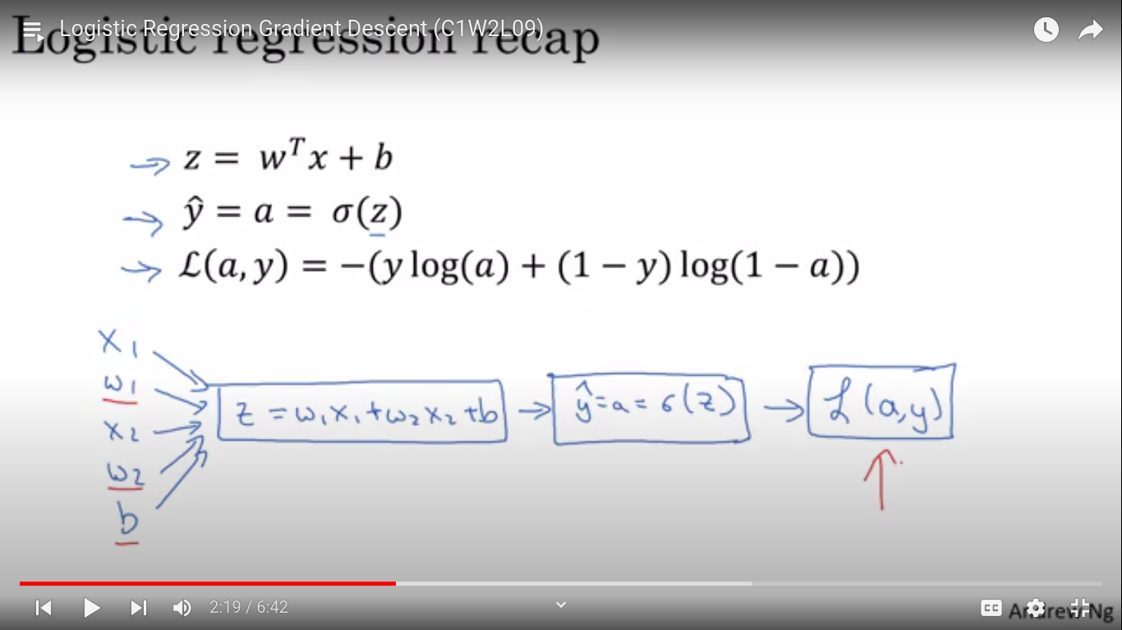

Vectorisation

means use dot product while using for loop multiplication
