Faculty Review Analysis

# Distribution of predicted sentiments

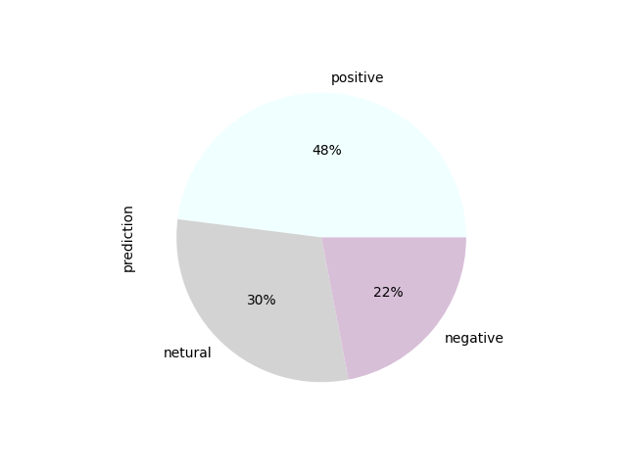

# Faculty ID 1

* Number of positive feedback :5
* Number of negative feedback :3
* Number of netural feedback :2

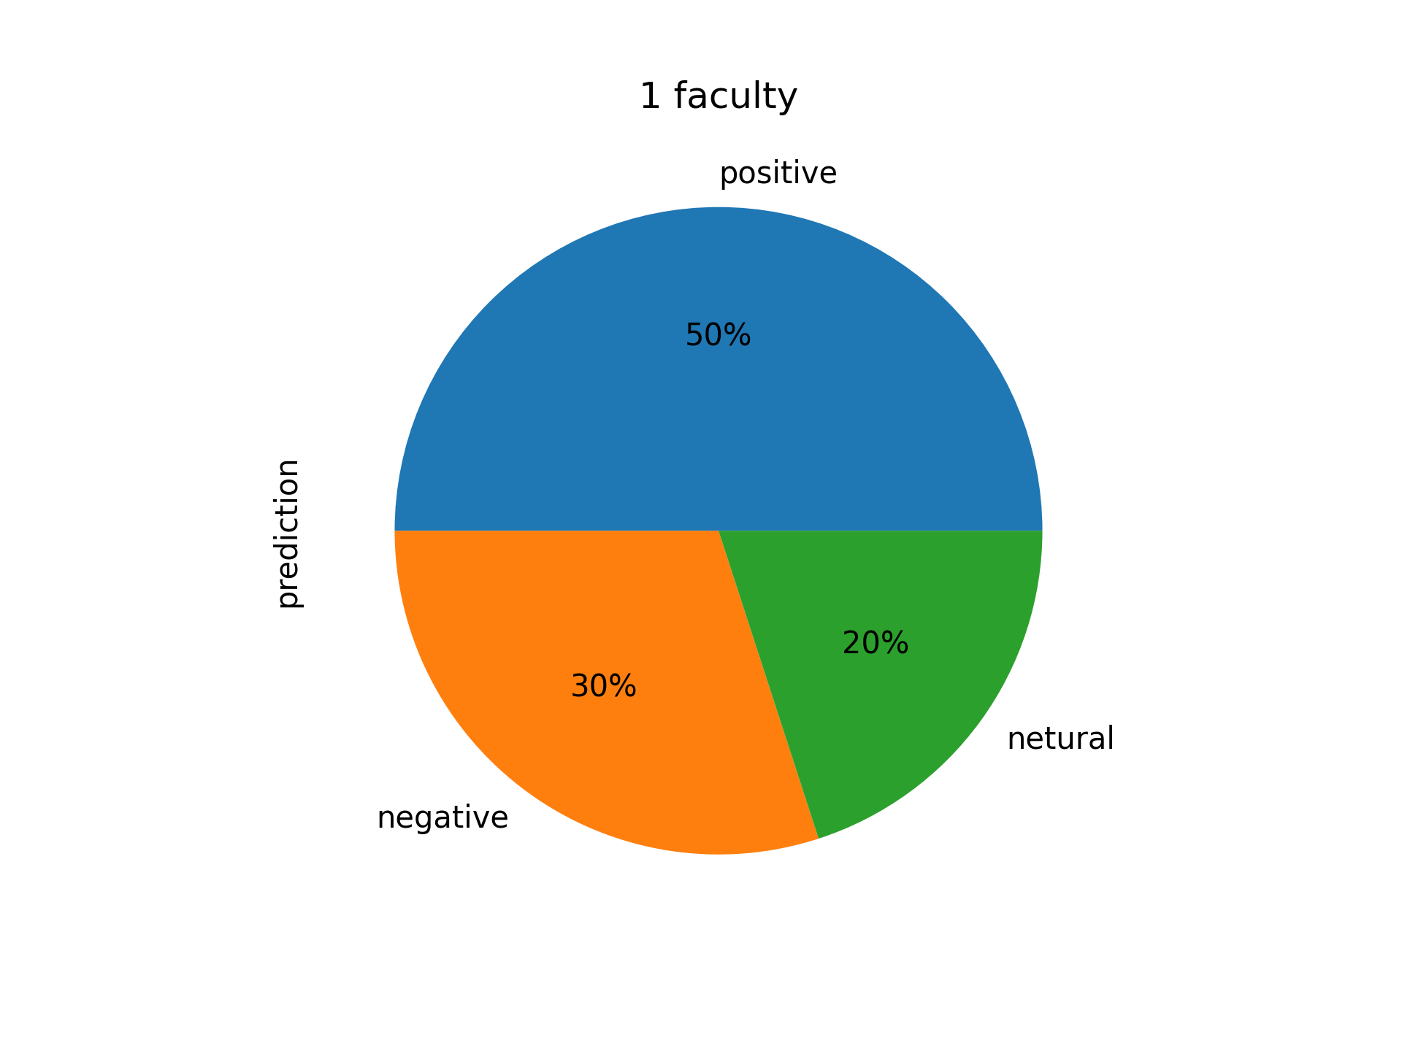

# Faculty ID 2

* Number of positive feedback :6
* Number of negative feedback :3
* Number of netural feedback :1

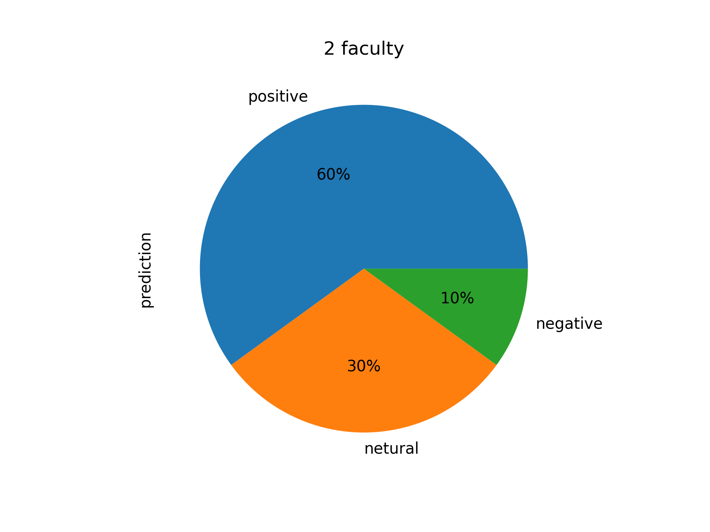

# Faculty ID 3

* Number of positive feedback :5
* Number of negative feedback :3
* Number of netural feedback :2

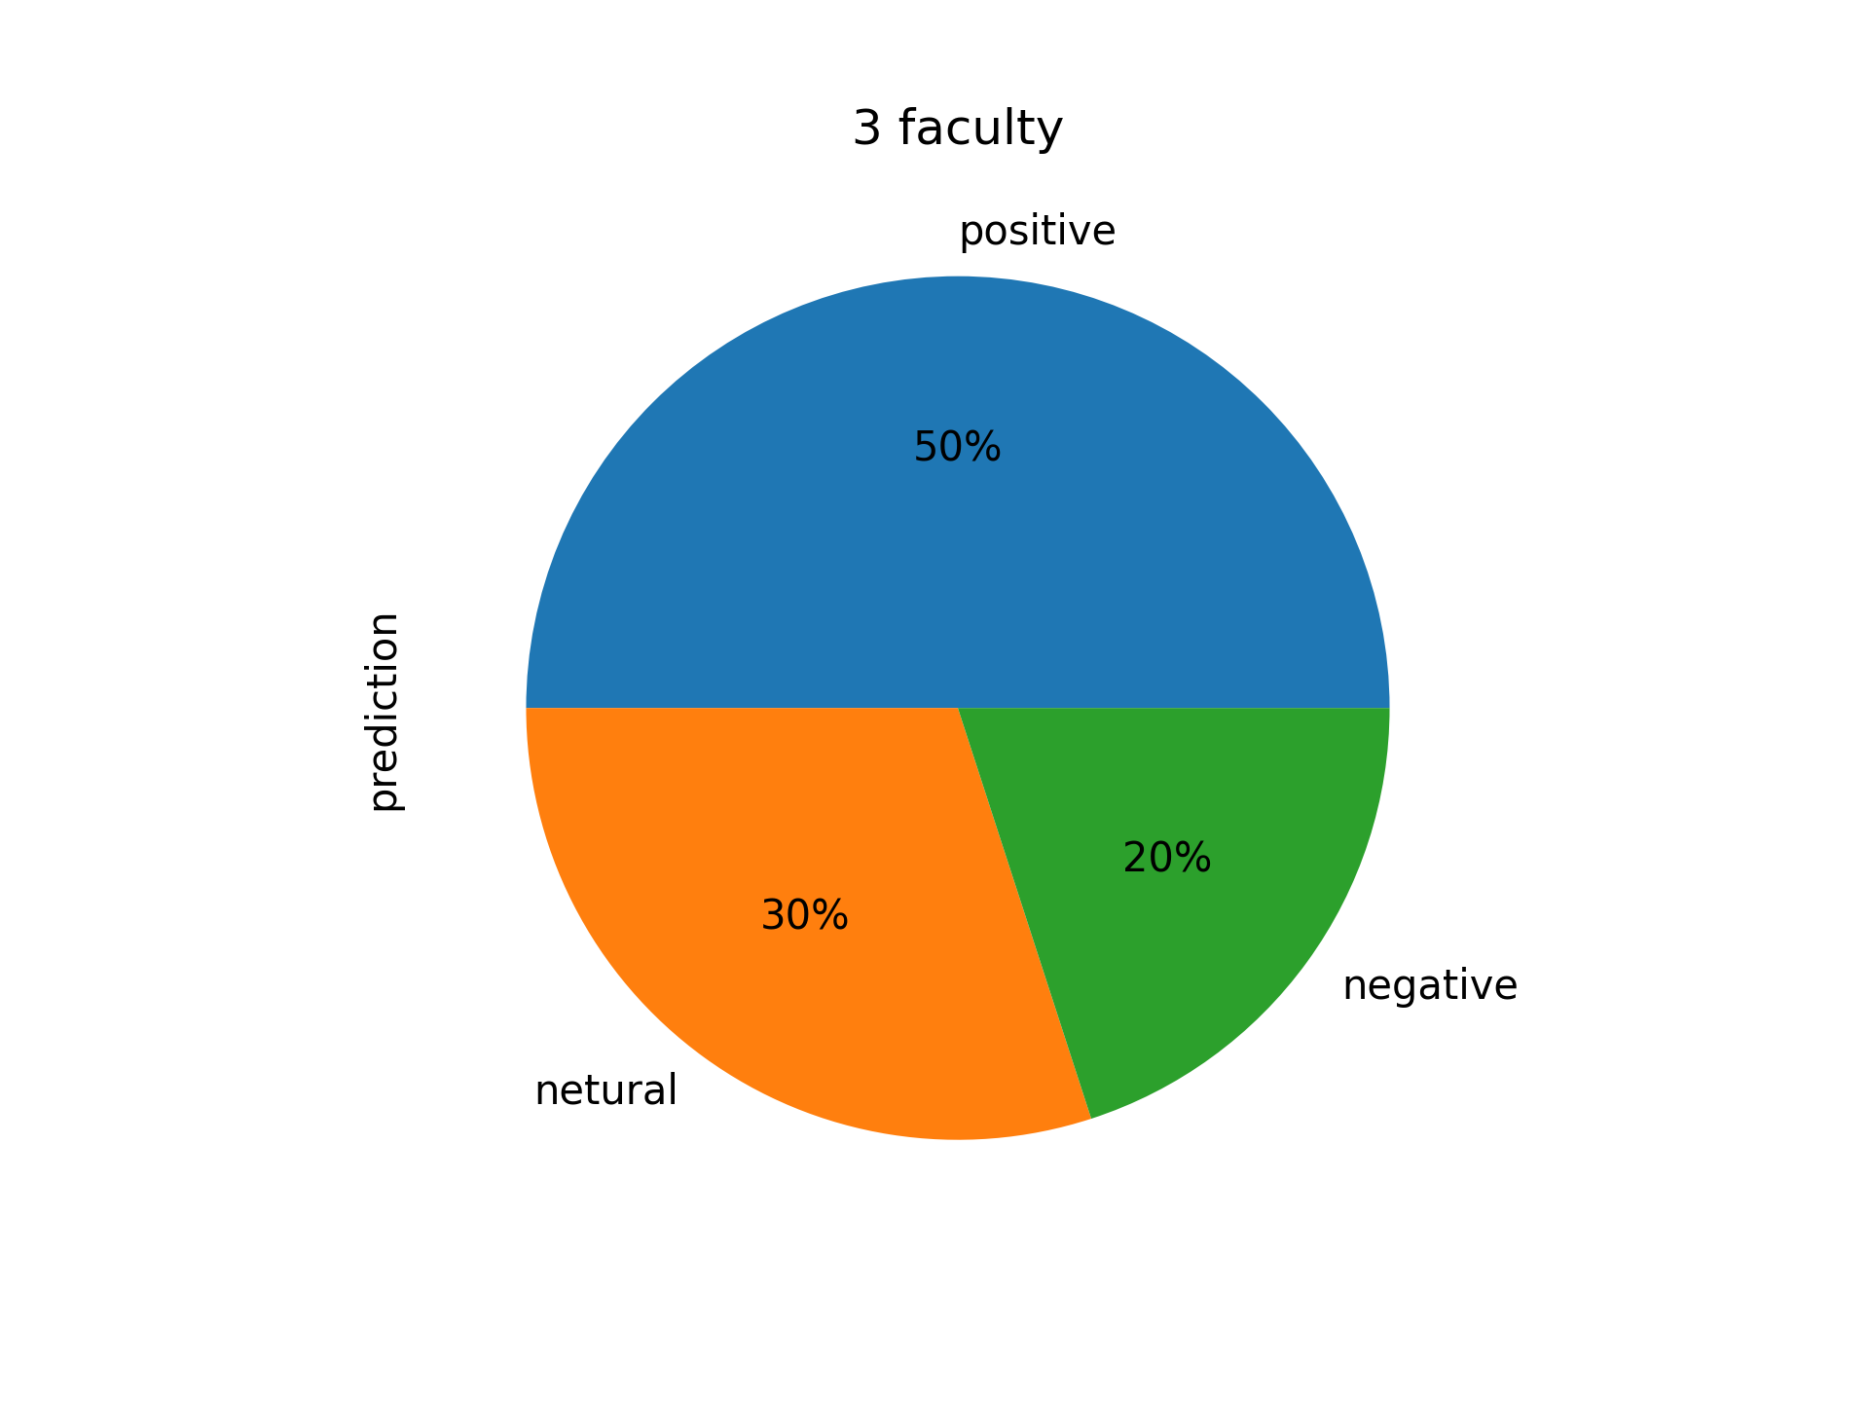

# Faculty ID 4

* Number of positive feedback :3
* Number of negative feedback :3
* Number of netural feedback :3

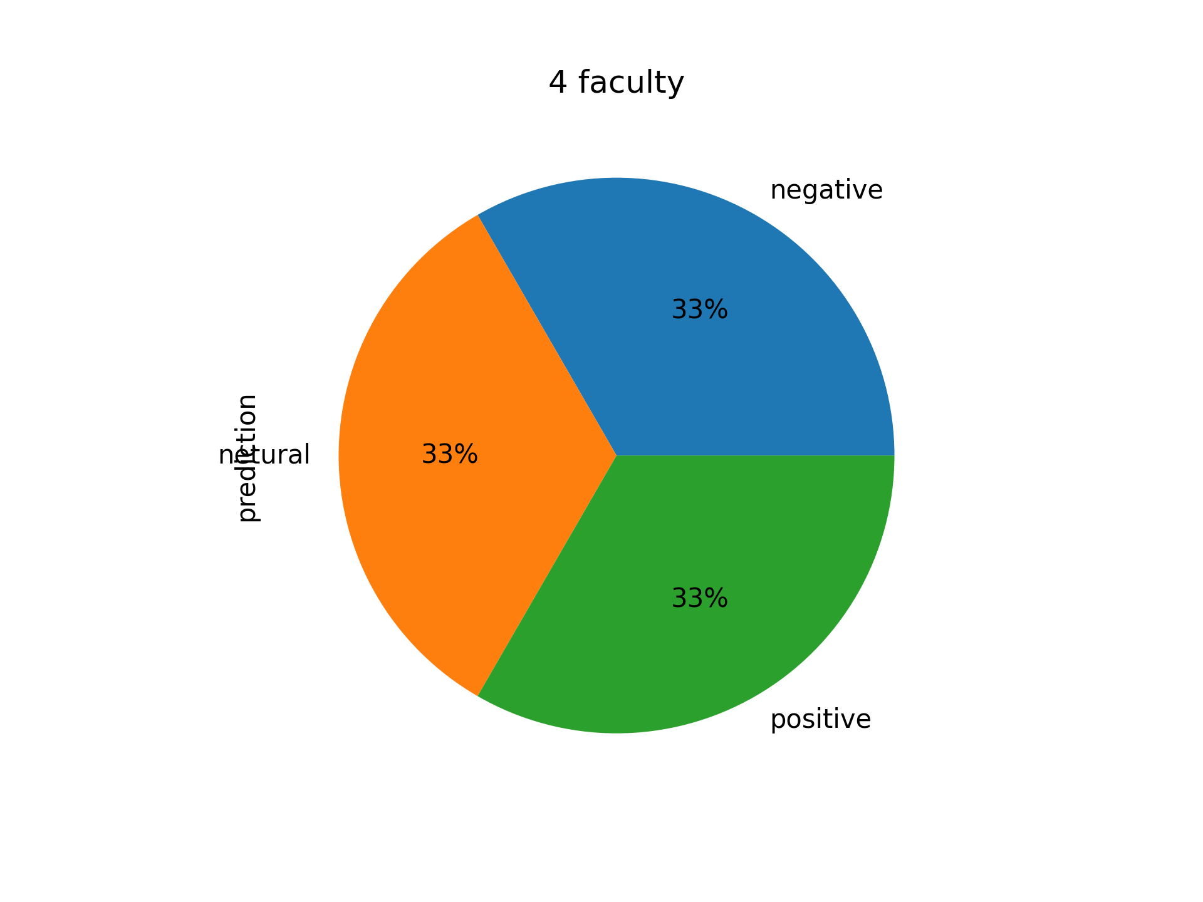

# Faculty ID 5

* Number of positive feedback :5
* Number of negative feedback :4
* Number of netural feedback :2

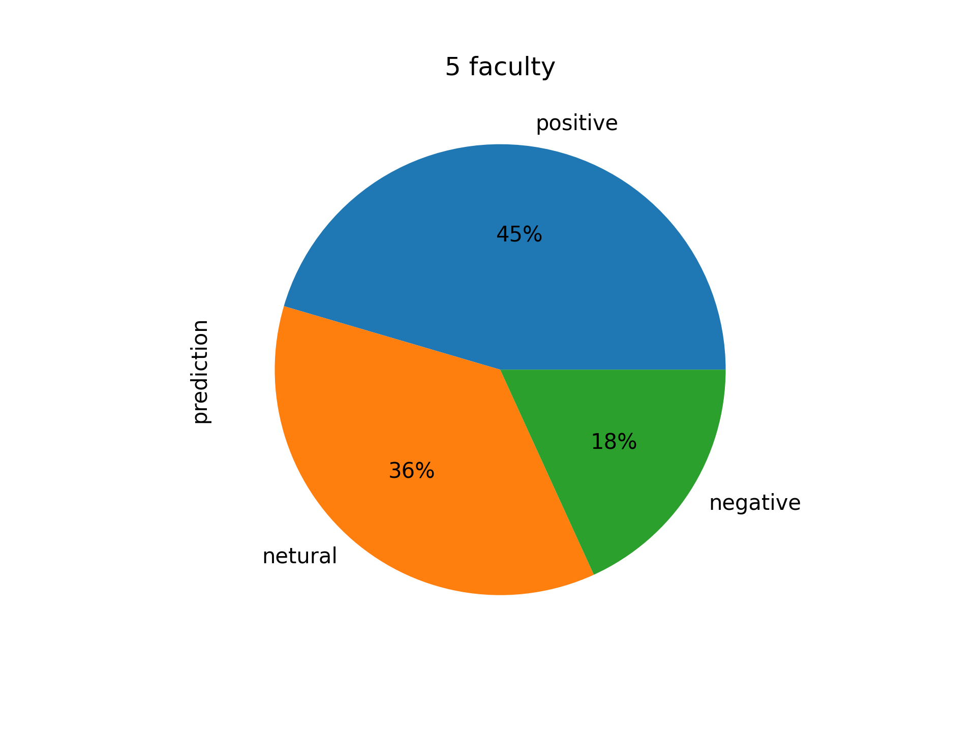

# Students Sentiments in wordcloud

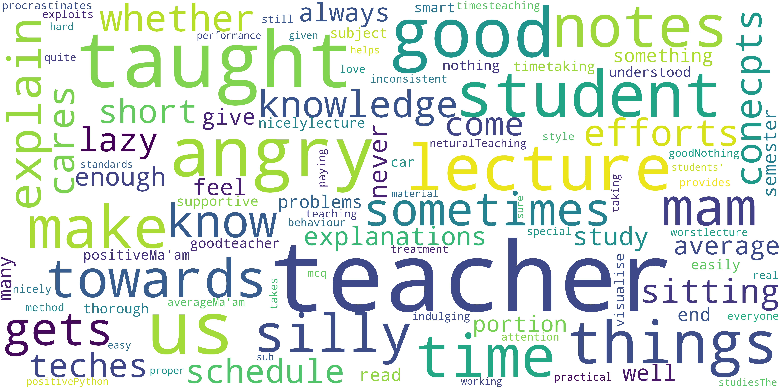

# Comparasion of among all Faculty

