**ITOHAN UKPONMWAN (IIU2)**

**ECE 4960 PROJECT 5**

**LANGUAGE: PYTHON**

**PLATFORM: MAC OS X**

The software consists of two files:

1. **lab5Library.py:**

This file has all the functions necessary for the software to run appropriately. The functions for circuit equations as well as the functions for the various ode methods the software can handle are defined in this file. This file evolved from the library used in lab 4.

1. **lab5Interactive.py:**

This is the file the user runs to start the software. The user starts the software by typing “python lab5Interactive.py”, it takes in inputs from the user and simulates results based on user preferences. It then gives the user the option to select how they would want to view the results (1: Graph, 2: Values, 3: Graph and Values). After simulation, it outputs the total simulation time.

**Testing Strategy**

1. **Validation of ODE Solver and ODE functions**

In order to confirm that the all the ODE methods worked, I validated my ODE solver as well as the four ODE methods;

1. Forward Euler
2. Backward Euler
3. Trapezoidal Euler
4. RK34 (with and without time adaptation)

I used the equation used in project 4 . I compared the results with the results in the class notes and only proceeded when I confirmed the ODE solver worked appropriately. The results are shown below;

############ FORWARD EULER ##############

xVals: [2.0, 5.0, 11.402163713969871, 25.513211554565395, 56.84931129984912]

error: [0.0, 19.284538146127275, 23.181542046959027, 24.241436129805521, 24.541988478943015]

############ BACKWARD EULER ##############

xVals: [2.0, 8.4021637139698715, 21.662670626072927, 50.433643643330882, 113.90900075965236]

error: [0.0, 35.636904948985745, 45.945365667809249, 49.756936910445951, 51.195265081368689]

############ TRAPEZOIDAL EULER ##############

xVals: [2.0, 6.7010818569849357, 16.319781937898281, 37.199248896864745, 83.33776733540077]

error: [0.0, 8.1761834014292347, 9.9493494434971428, 10.458915274118079, 10.617034119646892]

############ RK4 - NO ADAPTATION ##############

xVals: [2.0, 6.2258144844757721, 14.925728394402398, 33.862838381776257, 75.751991855592564]

error: [0.0, 0.50389830619849219, 0.55735629187090352, 0.55182582111309564, 0.54817804270373316]

############ RK4 - WTIH ADAPTATION ##############

xVals: [2.0, 6.2258144844757721, 14.925728394402398, 33.862838381776257, 75.751991855592564]

error: [0.0, 0.50389830619849219, 0.55735629187090352, 0.55182582111309564, 0.54817804270373316]

1. **TESTING CIRCUIT FUNCTION**

I added 3 additional circuits to the program. After writing each function, I tested them and graphed them with certain parameters. I proceeded when I got appropriate results, I determined this by observing the graph. The testing for each new circuit is discussed below. All ode methods were tested, however the results presented below were simulated using rk4 without time adaptation. I also tested using print statements in various parts of the code.

1. RLC Parallel Circuit

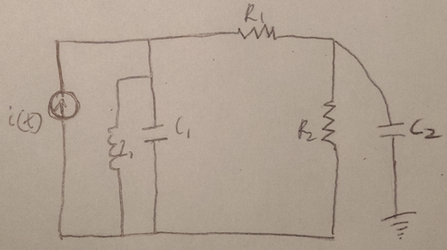

Fig: RLC Circuit Used

Function name – rlcParallel

Testing Parameters:

R1 = R2 = 10KΩ

C1 = C2 = 1pF

L1 = 1μH

i(t) = 0.1mA when time is less than 1nS and 0 otherwise

initialTime = 0, timeStep = 10nS, timeStop = 100nS

all initial parameters (V1, V2, iL) = 0

RESULTING GRAPH

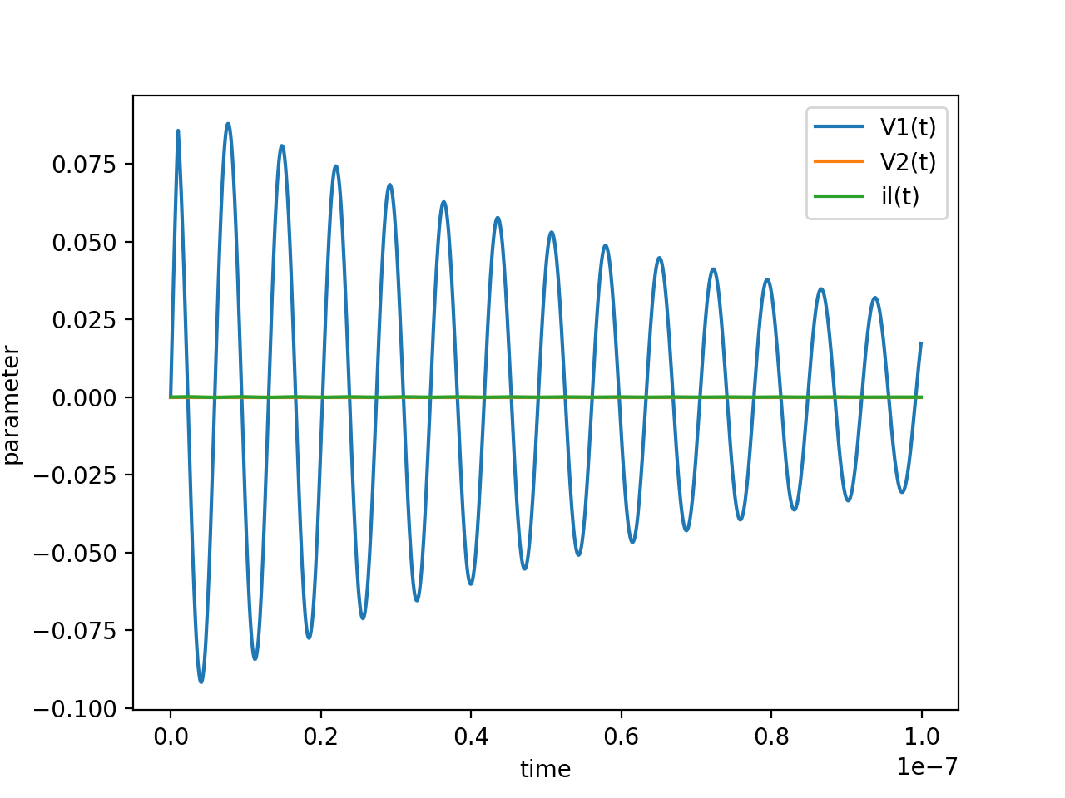

**Total simulation time: 0.040259 seconds**

The first voltage had very good resonance, however the other two parameters remained at very low values.

1. Bridge Rectifier

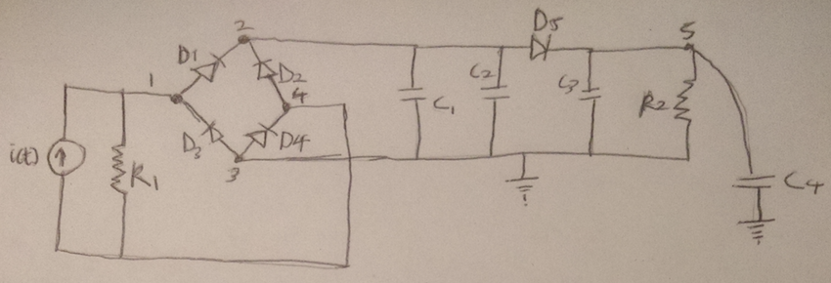

Fig: Bridge Rectifier Circuit

Function name – bridgeRectifier

Testing Parameters:

R1 = R2 = 10KΩ

C1 = C2 = C3 = C4 = C5 = C6 = C7 = C8 = 1pF

i(t) = 0.1mA when time is less than 1nS and 0 otherwise

initialTime = 0, timeStep = 10nS, timeStop = 100nS

all initial parameters (V1 – V5) = 0

RESULTING GRAPH

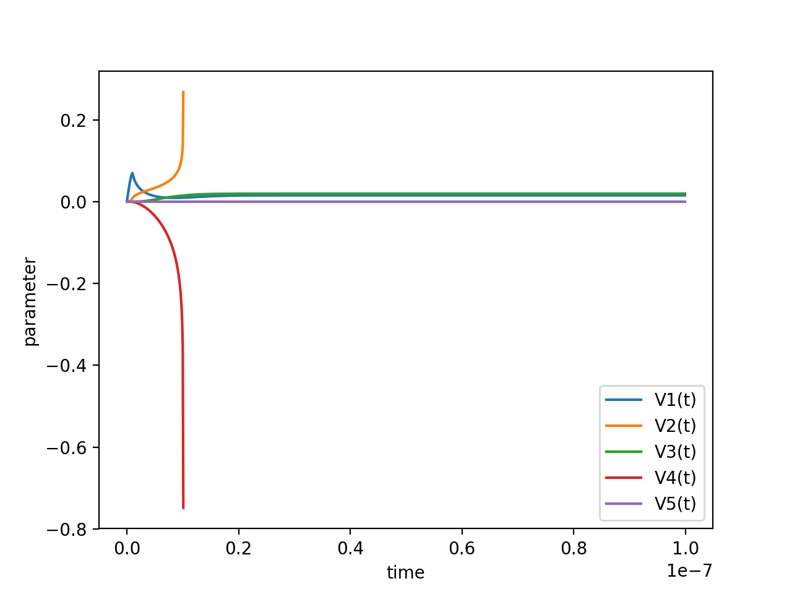

**Total simulation time: 0.099427 seconds**

1. Pump Circuit

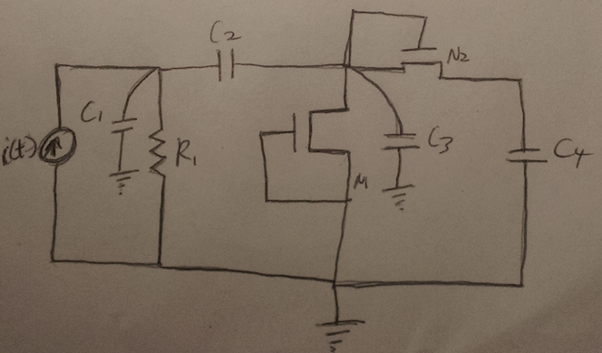

Fig: Pump Circuit

I did two tests on this graph

Function name – pumpCircuit

Testing Parameters:

R1 = R2 = 1KΩ

C1 = C2 = 5pF

C3 = C4 = 1pF

Is = 5μA

Io = 0.5mA

Vth = 0.3V

Vt = 26mV

F = 50MHz

I = IoSin(2Πft)

initialTime = 0, timeStep = 10nS, timeStop = 100nS

all initial parameters (V1 – V3) = 0

RESULTING GRAPH TEST 1

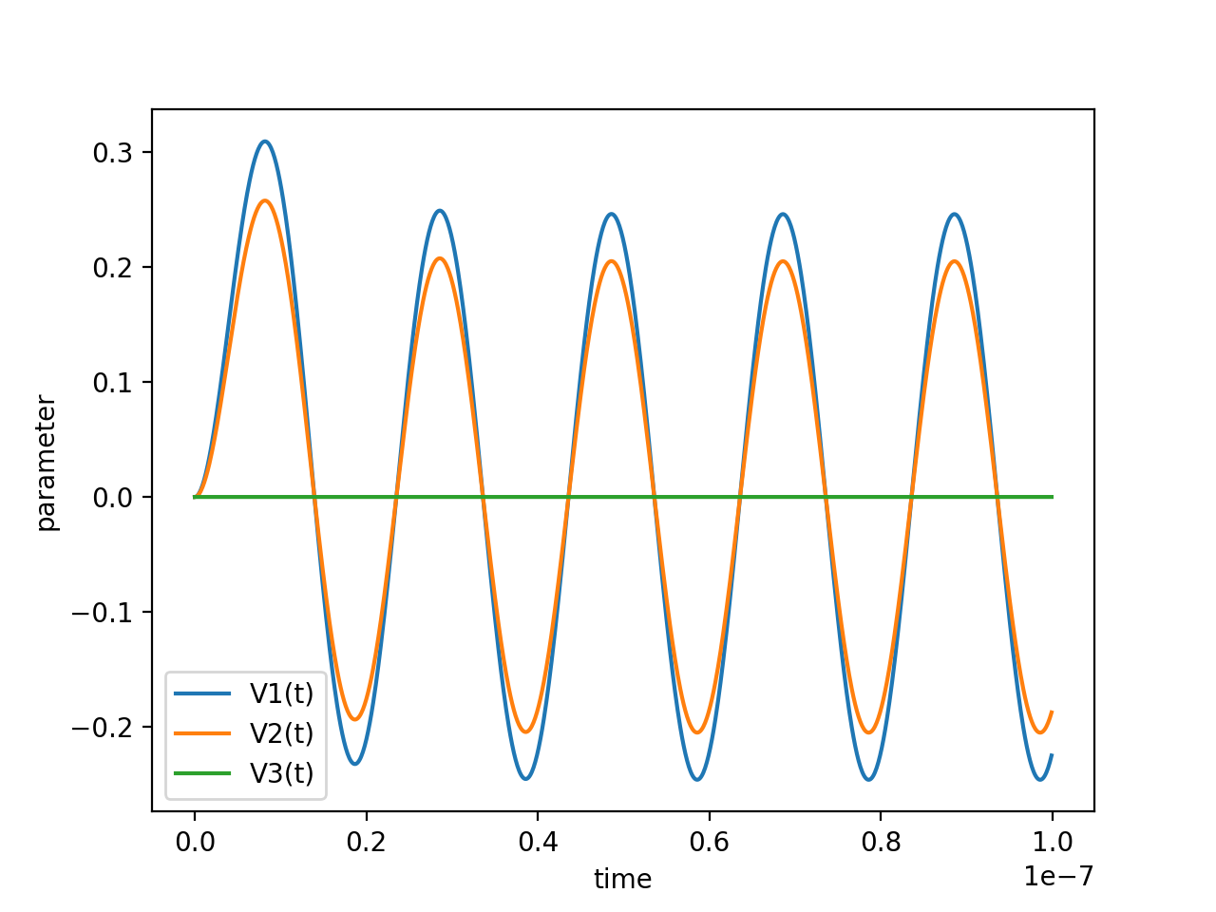

**Total simulation time: 0.158812 seconds**

**RESULTING GRAPH STEP 2**

initialTime = 0, timeStep = 0.1μS, timeStop = 3μS

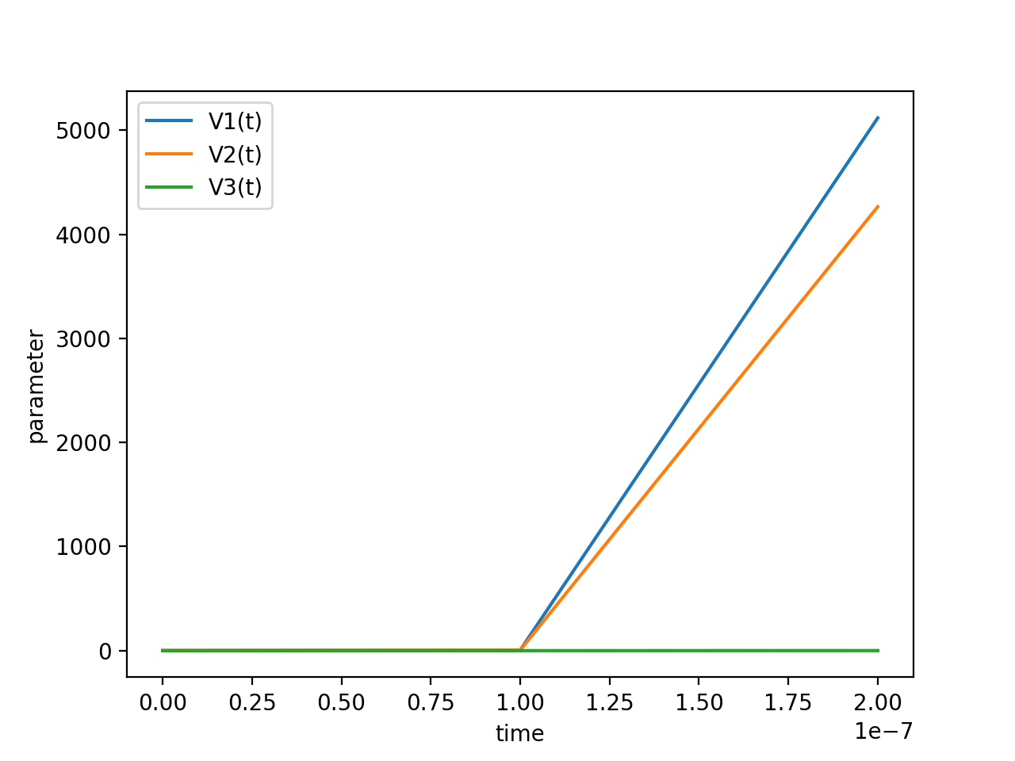

**Total simulation time: 0.009212 seconds**