**WHEEL WASH CAR WASH BOOKING SYSTEM**



A Final Project Presented to the

Faculty of the College of Computer Studies

St. Michael’s College

Iligan City

In Partial Fulfilment

Of the Requirement of the subjects   
Information Management

Photoshop

Database Management System

By:

Abella, Krizia Mea Galindo

Paque, Jefferson Magsayo

Surban, Elca Ubanan

**May 2023**

**Chapter 1**

**THE PROBLEM AND ITS SETTINGS**

* 1. **Introduction**

A car wash booking system is a technology-based solution that enables customers to schedule appointments for car wash services. However, manual car wash operations may face various issues, such as operational inefficiencies, longer wait times for customers, and decreased customer satisfaction. Relying on manual processes for appointment scheduling can be time-consuming and error-prone, resulting in customers feeling neglected or dissatisfied with the service.

Therefore, implementing a car wash booking system is crucial to enhancing the customer experience of the online car wash booking system. It allows for automation of the scheduling process, leading to increased efficiency and reduced workload for staff. The system also enables customers to book appointments conveniently, resulting in improved satisfaction and loyalty. Additionally, the booking system can help car wash businesses maximize their revenue potential by ensuring efficient scheduling and resource allocation. Furthermore, the system can help manage customer data more effectively, providing a personalized service and improving customer service.

A study conducted in Saudi Arabia found that implementing an online booking system for car wash services can significantly improve customer satisfaction by providing a more convenient and efficient scheduling process. The study also found that implementing the system can enhance the overall performance of the car wash business by reducing operational inefficiencies (Al-Kilidar and Al-Nuaim, 2019).

The primary goal of the car wash business is to cater to the customers' needs by providing them with a wide range of services to facilitate their vehicles, including car washing and interior cleaning. This study aims to ensure that customers receive high-quality services that meet their requirements and exceed their expectations.

The study will be conducted from February 2023 to May 2023 to test the efficacy of car washing technology and review its lessons. The location was chosen to assess the effectiveness of the study among people who want to use the system and to make them feel comfortable.

**1.2 Statement of the Problem**

The researchers have recognized three following problems;

* The manual scheduling process is prone to errors and conflicts.
* The lack of transparency in pricing for services can create confusion.
* Manual reports can be time-consuming, error-prone, tedious, and can lead to mistakes, especially when dealing with large amounts of data. Sharing manual reports can also be difficult, causing communication gaps and delays in decision-making.

**1.3 Objective of the Study**

The objective of this study is to develop the Iligan City Community Reporting System Using Web-Based Application. Specifically, this study aims to;

* To design a system that evaluate the causes of errors and conflicts in manual scheduling processes, and to develop strategies and recommendations to improve the accuracy and efficiency of the manual scheduling process.
* To develop a system that examine the effect of the lack of pricing transparency on customer satisfaction and loyalty and propose strategies to enhance transparency and improve the customer experience.
* To test and evaluate the system that may identify the causes of errors and delays, streamlining the report creation process, improving data accuracy, and making reports more accessible, leading to faster and more informed decision-making.

**1.4 Scope and Limitation of the Study**

The scope of the system revolves around three primary entities, namely customers, car wash boys, and managers. Customers can use the system to create an account, log in, schedule appointments, view schedules, receive invoices, access receipts, and manage profile information through a user-friendly platform. The system's scope for car wash boys is centered around appointment management to ensure prompt and efficient service delivery. Car wash boys can easily receive their schedule through the system's user-friendly interface.

The system provides managers with an extensive platform for managing service details, receiving and managing appointments, updating appointment status, generating reports, and tracking appointment progress. Additionally, features such as, and real-time reports are included to promote communication, productivity, and decision-making, ensuring seamless and efficient operations.

One limitation of the system is that it does not include a mobile application for customers, which may limit the accessibility of the service to customers who prefer mobile devices. Additionally, the system requires internet connectivity, which may pose a challenge to customers with limited or no internet access. Another limitation is that the system does not include payroll management for car wash boys, which may result in additional manual processes for payroll computation. Finally, online payment is not included in the system, which may limit the convenience of the service for customers who prefer online payment options.

**1.5 Significance of the Study**

The following entities that will benefit from this study are the monitoring team, user, current researcher, and future researchers.

**Car wash managers.** The proposed system will provide them with an efficient and organized way of managing customer appointments and monitoring the performance of their business.

**Customers**. The proposed system will provide them with an easy and convenient way of booking car washing services, saving them time and effort.

**Current researcher.** The researcher will gain knowledge and skills in developing an online booking system for car washbusinesses**.**

**Future researchers.** The study will provide a foundation for future researchers who may want to improve or expand the car wash booking system.

**1.6 Definition of Terms**

**Car wash booking system. A**n online system that enables car wash businesses to manage customer appointments and allows customers to book car washing services.

**Online booking.** A method of scheduling appointments through a website or application.

**Manual Process.** The process of scheduling appointments manually, which is time-consuming and prone to errors.

**Transparency.** A system that provides clear and easily accessible information about the scheduling process.

**Privacy.** The right of individuals to keep their personal information and data confidential.

**Operational Inefficiencies.** Problems in the operations of the car wash business that can lead to reduced productivity, delays, and other issues.

**CHAPTER 2**

**REVIEW OF RELATED LITERATURE AND STUDIES**

This section provides a comprehensive analysis and evaluation of the existing literature and studies related to the research topic.

**RELATED LITERATURE**

Development of an intelligent car wash reservation system that utilizes cloud computing technology. The system allows customers to make reservations online and receive real-time updates on their appointments via SMS and email. The system also includes features such as automatic billing and payment processing, customer feedback collection, and data analysis to improve the efficiency and quality of the car wash service. The cloud-based architecture of the system ensures scalability, security, and accessibility from anywhere at any time. The study concludes that the intelligent car wash reservation system is a viable solution for improving customer satisfaction and service efficiency in the car wash industry (Liu et al. 2019).

The authors propose a smart car wash system that utilizes intelligent techniques to optimize the vehicle washing process. The system includes a camera system for image acquisition, a microcontroller-based control system, and an automatic washing system. The image processing algorithm is used to analyze the images captured by the camera system to detect the vehicle's shape and size. Based on this information, the washing process is automatically adjusted to ensure optimal washing of the vehicle. The microcontroller-based control system is used to control the automatic washing system, while the cloud-based system is used for data storage and analysis. The authors also describe how the system can be used to reduce water usage and improve the overall efficiency of the car wash process (Ahmad et al., 2018).

**RELATED STUDIES**

The authors present a novel approach for a smart car wash system that utilizes a range of intelligent technologies such as IoT, big data analytics, and machine learning algorithms. The proposed system aims to enhance the efficiency and effectiveness of the traditional car washing process by automating several tasks and providing a personalized experience for customers. The system includes various sensors and cameras that capture data on the car's condition, such as its size, shape, and dirt level, and use this information to generate an optimal washing plan. The authors also highlight the benefits of using big data analytic to analyze customer preferences and behaviors to offer personalized services and promotions. The proposed system is expected to reduce water and energy consumption, increase revenue and customer satisfaction, and improve the overall car washing process (2019).

This article represents the development of an intelligent car wash reservation system based on the cloud computing platform. The system aims to optimize the car wash experience for customers by providing them with an efficient and convenient way of booking a car wash service. The system uses cloud computing technology to enable real-time communication and data sharing between customers, car wash service providers, and the system administrators. The system also utilizes a predictive algorithm to estimate the time required for each car wash service, thus reducing wait times for customers. The system's features include online booking and payment, service management, customer management, and data analysis. The authors conducted a case study of the system's implementation in a car wash service company and demonstrated its effectiveness in improving the efficiency of the car wash service.

**Chapter 3**

**Research Method**

This methodology aims at the process of the car wash booking system. Limitations include limited service coverage, then dependence on the internet connectivity, limited resources, and lack of online payment feature.

**3.1 Analysis Modeling**

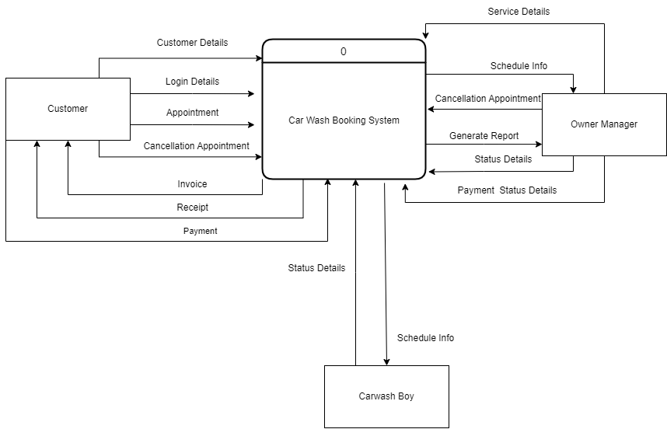

**Figure 3.1 Context Diagram**

The Context Diagram for the car wash booking system shows a box containing the customers, car wash boys, and payment processors as external entities in the surrounding system. The arrows indicate the flow of data and interactions between the system and its external entities. Customers can make a booking through the system. The system will automatically show available times. The customer will receive an invoice. If the customer pays personally, the manager will change the payment status. The customer will then receive a receipt. Car wash boys can receive the appointment from the customer and change the appointment status to either ongoing or done. They can also receive a cancellation of the appointment. The manager can manage the appointments, customers, services, payments, and reports.

**3.2 System Design**

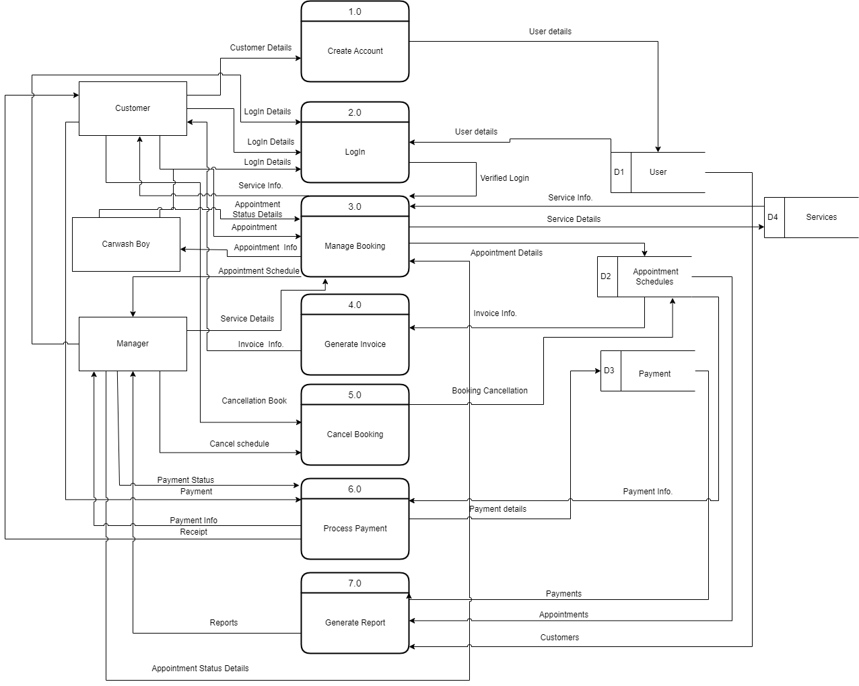

**Figure 3.2 Data Flow Diagram**

The car wash booking system has a series of processes that customers can follow to create an account and book appointments. The first process involves navigating the website's sign-up pages and inputting personal information to create a user account. In the second process, customers enter their login credentials into the system's user interface to access their account and fill in further personal information. The third process involves selecting a booking from a list, viewing its details, and selecting available schedule information on the system. Process five allows customers to cancel bookings by selecting the button initiating the cancellation appointment. Payment is handled in process six, where customers can pay in person because we didn't handle the online payment. Finally, in process seven, the system generates reports that both the owner and customer can read and use to apply the system.

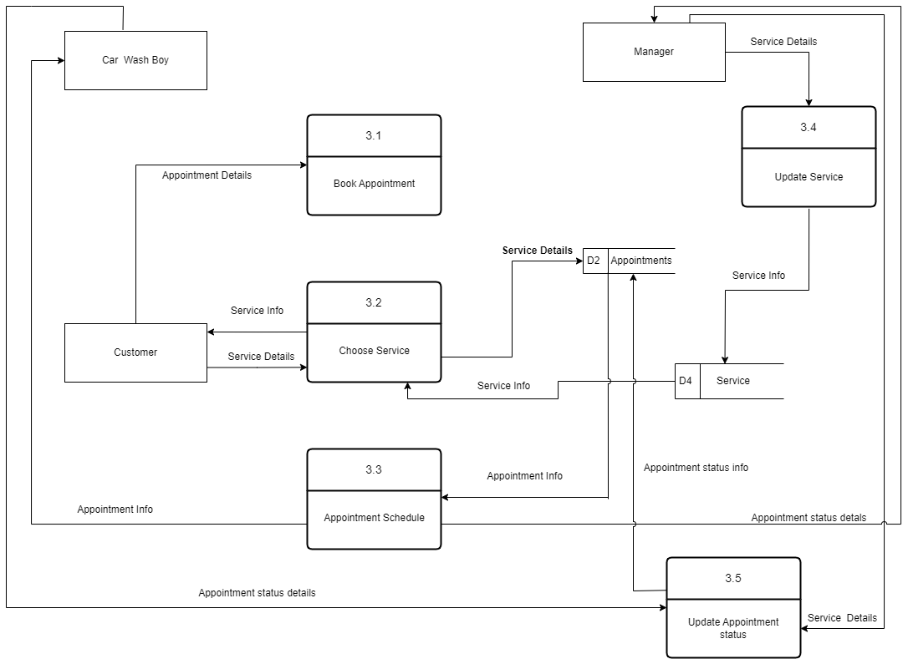

**Figure 3.3.1 Manage Booking System**

Our booking management system allows you to easily submit your appointment information. The system stores and displays the appointments and allows communication between the customer, car wash boy, and manager, with the ability to change appointment status. The manager can ensure that the appointment or booking system is always in the right place.

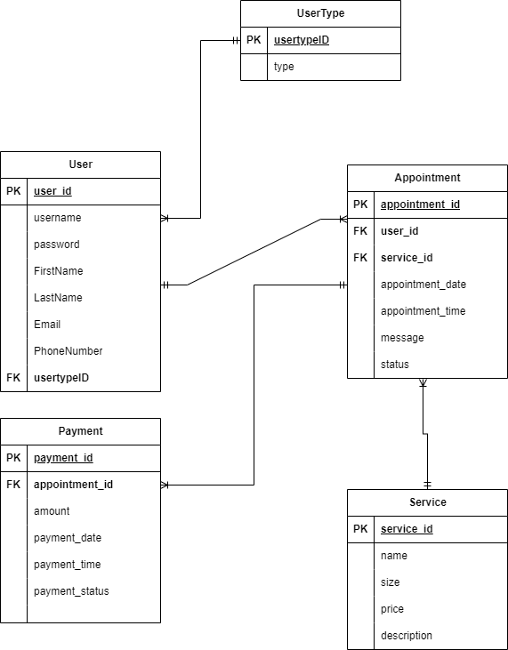

**3.3 Entity Relationship Diagram**

**Figure 3.3 Entity Relationship Diagram**

The UserType table has a one-to-many relationship with the User table, where the PK column in UserType is usertypeID, and the FK column in User is usertypeID. The User table has a one-to-many relationship with the Appointment table, where the PK column in User is user_id, and the FK column in Appointment is user_id. The Appointment table has a one-to-many relationship with the Service table, where the PK column in Appointment is appointment_id, and the FK column in Service is service_id. The Service table has a one-to-many relationship with the Payment table, where the PK column in Service is service_id, and the FK column in Payment is service_id. The Payment table has a one-to-many relationship with the Appointment table, where the PK column in Payment is payment_id, and the FK column in Appointment is appointment_id.

**3.4 Data Dictionary**

The researchers had created a data dictionary during the stage so that the programmers and others who needed to refer to the data objects or items in the data model could have a collection of descriptions of them. It consists of the various tables, fields, descriptions, and types that were used in the system’s development.

**UserType**

| **Name** | **Type** | **Null** |
| --- | --- | --- |
| usertypeID | int | No |
| type | varchar | No |

The UserType table in the database contains information about the different types of users that can interact with the system. It has two columns, one of which is the primary key column, usertypeID, and the other is the type column. The primary key column, usertypeID, uniquely identifies each record in the table and is used as a foreign key in other tables to establish relationships between data.

**User**

| Name | Type | Null |
| --- | --- | --- |
| user_id | int | No |
| username | varchar | No |
| password | int | No |
| FirstName | varchar | No |
| LastName | varchar | No |
| Email | varchar | No |
| PhoneNumber | varchar | No |
| usertypeID | int | No |

The User table in the database contains information about the users who interact with the system. It has several columns, including a primary key column user_id, which uniquely identifies each user record in the table. Additionally, the table has a foreign key column, usertypeID, which references the primary key column in the UserType table, establishing a relationship between the User and UserType tables.

**Service**

| Name | Type | Null |
| --- | --- | --- |
| service_id | int | No |
| name | varchar | No |
| size | varchar | No |
| price | varchar | No |
| description | varchar | No |

The Service table in the database contains information about the services offered by the system. It has several columns, including a primary key column service_id, which uniquely identifies each service record in the table. The name column in the Service table contains the name of the service, and the size column contains the size or dimensions of the service if applicable. The price column contains the cost of the service, while the description column provides a brief description of the service offered.

**Payment**

| **Name** | **Type** | **Null** |
| --- | --- | --- |
| payment_id | int | No |
| amount | varchar | No |
| payment_date | varchar | No |
| payment_time | varchar | No |
| payment_status | varchar | No |

The Payment table stores information about customer payments for services received, including a unique identifier (payment_id), appointment reference (appointment_id), payment amount, date and time of the payment transaction, and payment status. The table enables efficient tracking and analysis of payment-related data for financial reporting and customer billing purposes.

**Appointment**

| **Name** | **Type** | **Null** |
| --- | --- | --- |
| **appointment_id** | **int** | **No** |
| **user_id** | **int** | **No** |
| **service_id** | **int** | **No** |
| **appointment_date** | **varchar** | **No** |
| **appointment_time** | **varchar** | **No** |
| **message** | **varchar** | **No** |
| **status** | **varchar** | **No** |

The Appointment table stores information about customer appointments for specific services offered by the system, including a unique identifier (appointment_id), user reference (user_id), service reference (service_id), appointment date and time, message details, and appointment status. The table enables efficient management and tracking of appointment-related data for scheduling and resource allocation purposes.

**References**

Sun, H., Guo, H., Tang, Y., Hu, G., & Zhang, S. (2019). Development of an Intelligent Car Wash Reservation System Based on the Cloud Computing Platform. IEEE Access, 7, 30981-30988. <https://doi.org/10.1109/ACCESS.2019.2909260>

Author(s): Khanna, Aditi; Tiwari, Prerna; Kumar, Manoj; Kumar, Dinesh

Year: 2019

Source: International Journal of Vehicle Structures and Systems

Link: https://www.researchgate.net/publication/338249202_Smart_car_wash_system_a_novel_intelligent_approach_for_vehicle_washing_process