3. In some path create a folder called “CPE333-B” for User B. Make this a git repository and pull data from GitHub. Show status.

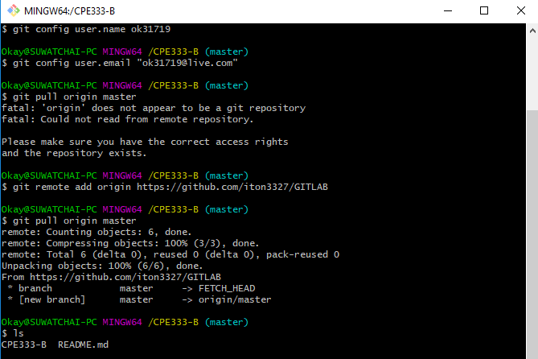

7. User B pulls data from GitHub. Show status.

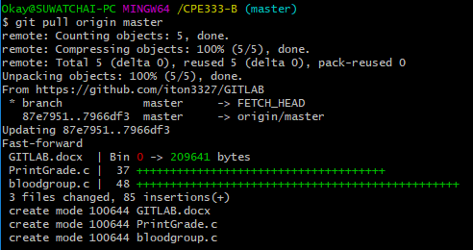

8. User B change 1 function in Program #2. Print local status User B.