**Acceleration Structures and Anti-Aliasing**

**Test Result**

## Many_spheres.xml

### Bounding box

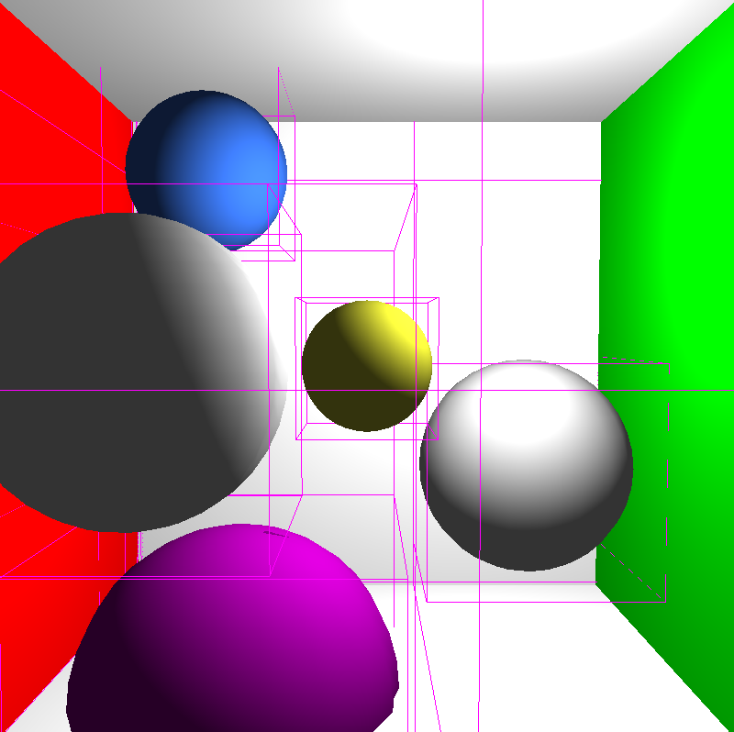

### Antialiasing Samples

1x1 2x2 4x4

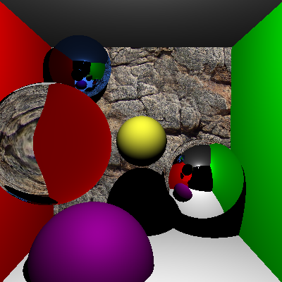 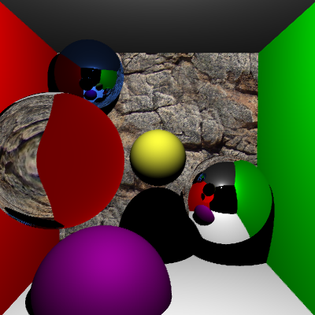 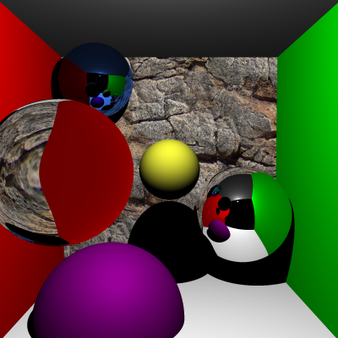

### Antialiasing Strategy

Uniform Random Stratified

 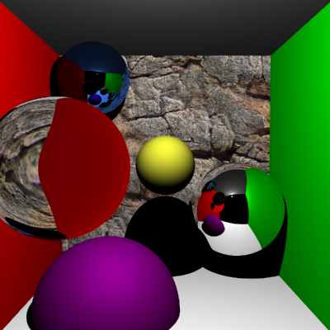 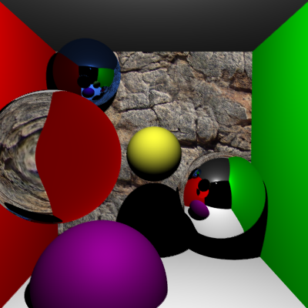

### Time Cost

1x1 Uniform Sampling AA 2x2 Uniform Sampling AA 4x4 Uniform Sampling AA

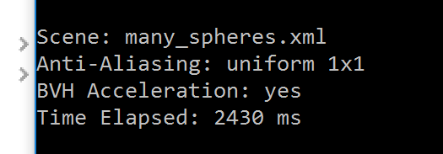 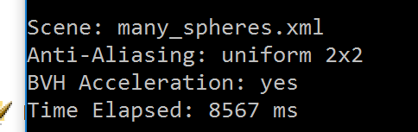 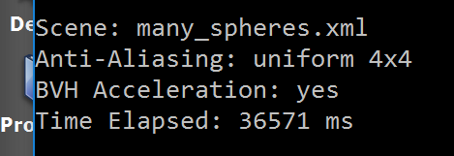

4x4 Uniform Sampling AA 4x4 Random Sampling AA 4x4 Stratified Sampling AA

 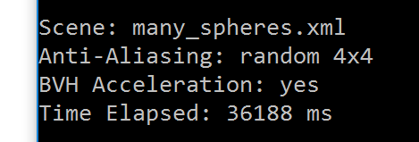 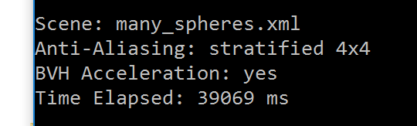

## Wahoo.xml

### Bounding Box

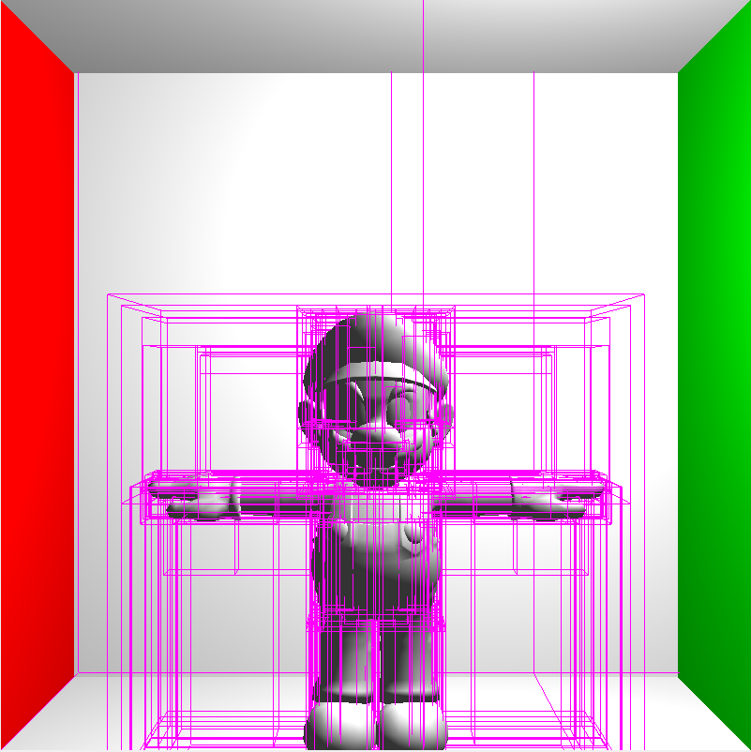

### Antialiasing Samples

1x1 2x2 4x4

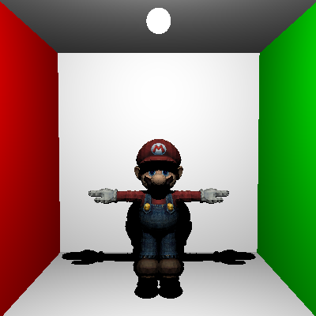 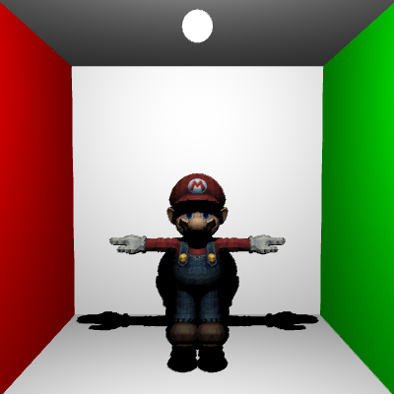 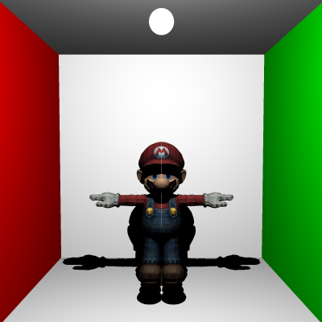

### Antialiasing Strategy

Uniform Random Stratified

 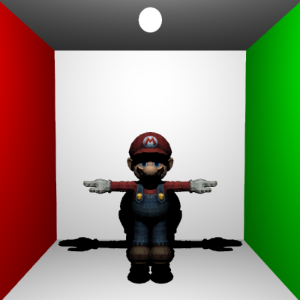 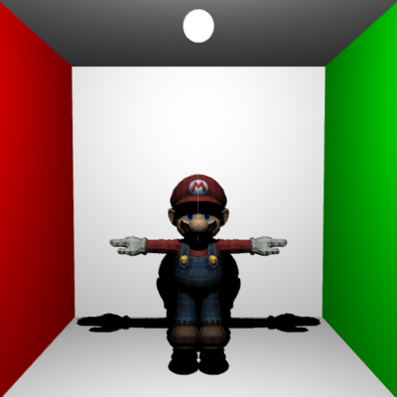

### Time Cost

1x1 Uniform Sampling AA 2x2 Uniform Sampling AA 4x4 Uniform Sampling AA

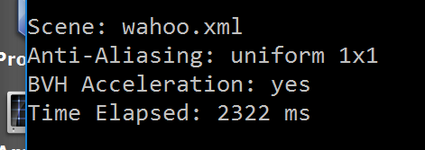 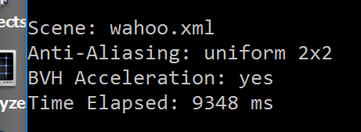 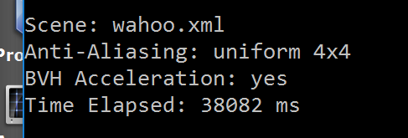

4x4 Uniform Sampling AA 4x4 Random Sampling AA 4x4 Stratified Sampling AA

 