**Swordsmanship Master**

Shuai Shao, Zimeng Yang, Liang Peng

**High Concept**

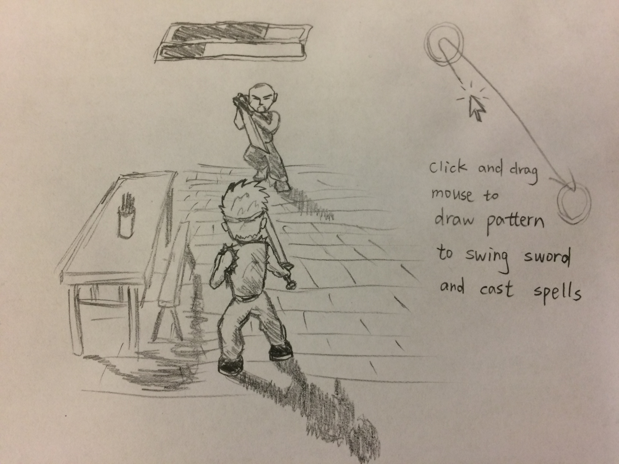

This is a Chinese martial fighting game with nontraditional playing control. Player will need to click and drag the mouse to make the character swing the sword to slash the enemy. Player can also use the mouse to draw particular patterns according to the prompts on the screen to cast spells.

**Genre**

Fighting.

**Main Features**

* The game is played in third-person view mode. The environment of the game is a tavern and the characters are dressed in Chinese martial art style.
* Both the player character and the enemy have limited HP and MP.
* The objective is to knock the enemy out by decreasing his HP to zero. Player will lose if his character’s HP is down to zero.
* The game plays with a player character and an enemy character in the tavern and are ready to fight. The player character is centered at the screen and the enemy character is some distance away in front of the player.
* The character will swing the sword to attack according to how the player is moving the mouse with LMB down. The skeleton kinematics of the character is dynamically computed based on the mouse input. The damage and direction will be affected by how the cursor is moved.
* Player can also block to by pressing down the RMB.
* Some special moves related to martial art can be acted by pressing a number button on the keyboard. Some pattern prompts will be shown on the screen and player. Successfully drag mouse following the pattern will lead to the character acting these special moves.
* Special moves have different effects ranging from extra damage to extra attacking range. Casting special moves will cost MP. MP will automatically recover slowly.
* As you successfully block the attack, you might be given an instruction to draw a particular pattern on the screen and if you draw it correctly, the player character will perform some effective counterattack. Also, the final effect of the special move is based on how well the player draws the pattern with the mouse.
* The player can also control the character to move with WASD on keyboard.
* A successful attack can force the enemy to back off involuntarily and player again might be given instructions on drawing patterns to perform extra special attack. A successful block will make the enemy freeze for a short time.
* The enemy with a simple state machine will try to beat the player’s character.

**Player Challenge/Motivation**

The game requires good eye/hand coordination to block enemy attacks accurately, to perform fast attack and to draw patterns correctly. The follow-up attack system is quite motivating because continuous operation requires high concentration and swift movement. Players getting better at playing the game will gain great satisfaction from the game.

**Design Goals**

Players will gain great fun from fighting enemy, especially due to the way of control, and feeling of achievement because it requires continuous operation and eye/hand coordination to play the game well.

**Target Customer**

Game players looking for fighting games with nontraditional playing control.

**Unique Selling Points**

* Dynamic humanoid kinematics
* Draw pattern to perform skills

**Competition**

Mount & Blade, Liu Xing Hu Die Jian, Traditional fighting games.

**Target Hardware**

PC