**Technical Specifications**

For my first game project, I am going to replicate an Asteroid game.

1. **GAME DESIGN**

* **Player goals and objectives**

The goal of the game is that player maneuvers a space fighter and emits missiles to destroy all the asteroids.

* **Challenge and conflict**

The fighter can be destroyed when hit by an asteroid. When a large asteroid is destroyed by a missile, it breaks into multiple smaller asteroids, which can be broken into multiple even smaller asteroids, till the asteroid is small enough.

* **Constraints and boundaries**

The space fighter is only allowed to move within the screen by accelerating forward or rotating. It can only emit missiles at a fixed frequency. It will keep moving in one direction unless player applies acceleration in different direction. There is a period of time for the space fighter to cool down its skill.

* **Resources**

The space fighter has 3 lives and a special skill “leap”, which will simultaneously have the fighter appear at a different position.

* **Detailed description of the rules, including win/low conditions**

When the game is started, player is presented a scene in the space with a space fighter and a large asteroids. Player presses keys to control the space fighter in the following ways:

* Press “UP” to accelerate
* Press “DOWN” to leap
* Press “LEFT” to rotate left
* Press “RIGHT” to rotate right
* Press “SPACE” to fire

Player will lose a life if the space fighter is hit by asteroids and lose the game when running out of lives. If the space fighter made it to destroy all the asteroids within the screen, it will enter the next level with more asteroids.

1. **SCENE DESCRIPTION**

The game contains four screens, which are start screen, level screen, tutorial screen, and game over screen. Different screen has different sets of GUI components.

* **Start screen**

There is a background, a game title, a game start button, and a tutorial button.

* **Game object list:**
* start
* tutorial
* **Player input:**
* Click start to start playing
* Click tutorial to show tutorial
* **Tutorial screen**

There is a background, a picture showing rules of playing, and a back button.

* **Game object list:**
* Back
* **Player input:**
* Click back to navigate back to start screen
* **Level screen**

There is a background, a space fighter, a few asteroids, a score display, and a life display.

* **Game object list:**
* spacefighter
* asteroids
* score
* life
* **Player input:**
* Press UP to accelerate
* Press LEFT to rotate left
* Press RIGHT to rotate right
* Press DOWN to leap
* Press SPACE to fire missile
* **Game over screen**

There is a message board showing “Game Over”, and a play again button.

* **Game object list:**
* gameover
* restart
* **Player input**
* Click restart to restart the game

1. **SCENE CONNECTIVITY**

The relationship between screens is shown as following.

**START SCREEN TUTORIAL SCREEN**

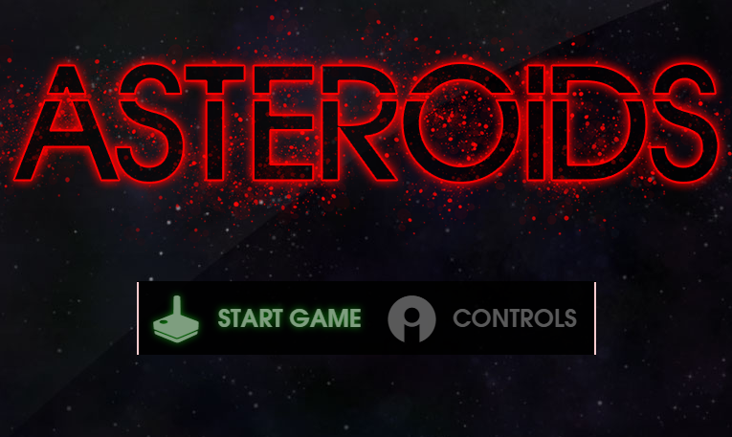 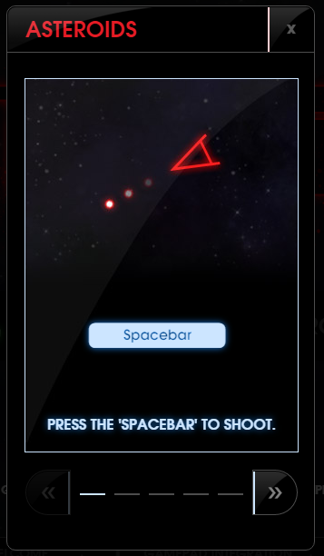

**LEVEL SCREEN ABOUT**

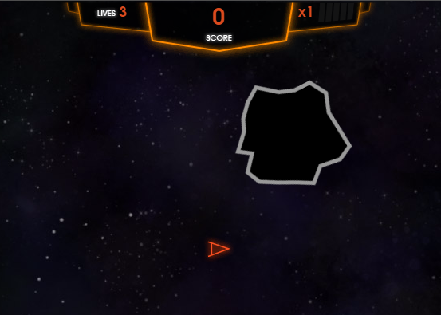 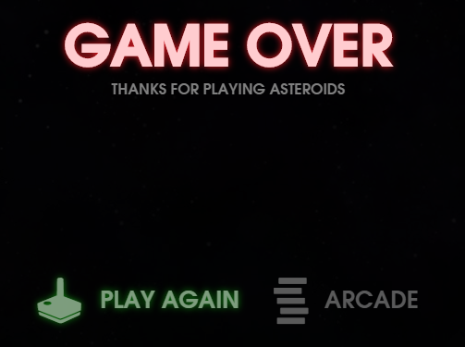

1. **OBJECT/PREFAB DESCRIPTIONS:**

* **Fighter**
* Assets

vehicle_playerShip.FBX, this is the 3D model file of the space fighter.

vehicle_playerShip_orange_dff.tif, this is the color map of the space fighter.

vehicle_playerShip_orange_nrm.tif, this is the normal map of the fighter.

vehicle_playerShip_dff.mat, this the material for the fighter.

* **Asteroids**
* Assets

Vehicle_playerShip_prop_asteroid_01.FBX, this is the model file of the asterods.

Vehicle_asteroid_01_dff.mat, this the material for the asteroids.

1. **INTER-OBJECT COMMUNICATION:**

* The Fighter communicates with asteroids in order to decide if an asteroid hit it.
* The Fighter communicates with missiles because it fires missiles.
* The missile communicates with asteroids because it destroys asteroids.