口语训练新湘少版五上U6
一、朗读单词。（15分）
请大声朗读你看到的单词，点击“录音”开始作答。每小题有10秒钟的准备时间，10秒钟的作答时间。
1. try 2. scarf 3. pair 4. idea 5. little
一级题型：朗读
二级题型：/
难度：容易
关键词：口语训练#新湘少五上U6
知识点：
1. try [v. 尝试]; try [n. 尝试] 2. scarf 3. pair [n. 双；对] 4. idea 5. little [pron. 少许；一点]; little [adj. 小的]
技能：说-说词汇
认知目标：识记
适用年级：五年级
编写年份：2026年

二、朗读句子。（15分）
请大声朗读你看到的句子，注意字母组合ar的发音。点击“录音”开始作答。每小题有10秒钟的准备时间，15秒钟的作答时间。
1. I have a red car.
2. We play in the park.
3. The shark is in the sea.
4. Mark works hard on the farm.
5. There is a star in the sky.
一级题型：朗读
二级题型：/
难度：容易
关键词：口语训练#新湘少五上U6
知识点：
1. ar 在单词中的发音 /ɑ:(r)/
2. ar 在单词中的发音 /ɑ:(r)/
3. ar 在单词中的发音 /ɑ:(r)/
4. ar 在单词中的发音 /ɑ:(r)/
5. ar 在单词中的发音 /ɑ:(r)/
技能：说-说句子
认知目标：识记
适用年级：五年级
编写年份：2026年

三、根据句型提示，看图说句子。（10分）
请结合句型和图片说句子，点击“录音”开始作答。每小题有10秒钟的准备时间，15秒钟的作答时间。
1. 句型提示：Which one do you want, ... one or ... one?
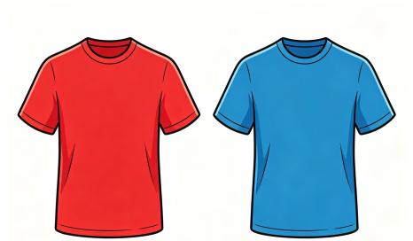
参考答案：Which one do you want, the blue one or the red one? / Which one do you want, the red one or the blue one?
关键词：red, blue
参考答案：Which one do you want, a blue one or a red one? / Which one do you want, a red one or a blue one?
关键词：red, blue
参考答案：Which one do you want, the left one or the right one? / Which one do you want, the right one or the left one?
关键词：left, right

2. 句型提示：Can I try ... on?

参考答案：Can I try the skirt on?
关键词：skirt

3. 句型提示：The ... one, please.
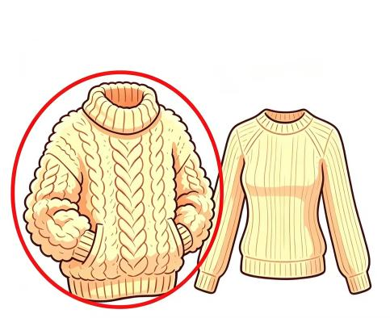
参考答案：The thick one, please.
关键词：thick

4. 句型提示：I want the ... one.
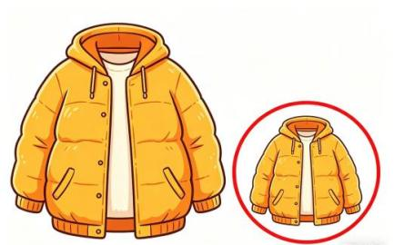
参考答案：I want the small one.
关键词：small

5. 句型提示： Can I have ... ?
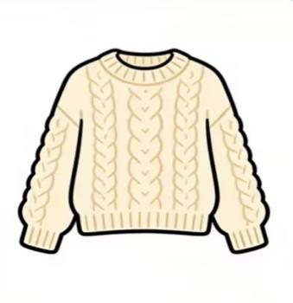
参考答案：Can I have the sweater? / Can I have a sweater? / Can I have this sweater?
关键词：sweater
一级题型：表达
二级题型：看图说话
难度：容易
关键词：口语训练#新新湘少五上U6
知识点：
1. Which one do you want, the/a ... one or the/a ... one? (询问在两事物中做选择)
2. Can I try ... on? (请求试穿衣服和配饰)
3. The/A ... one, please. (对询问在两事物中做选择的选择疑问句的回答); thick
4. I want the + 形容词 + one. (描述自己想要哪种服饰)
5. Can I buy/have ...? (提出购物请求); sweater
技能：看-看图片；说-说句子
认知目标：理解
适用年级：五年级
编写年份：2026年

四、阅读短文，回答问题。（10分）
请阅读短文，点击“小喇叭”播放问题，点击“录音”开始作答。每小题有10秒钟的准备时间，15秒钟的作答时间。
Amy has new clothes for autumn. But she doesn’t like all of them. The coat is too big. She likes the dress.
Jack wears new clothes too. The jacket is nice and warm. He has a new pair of socks, but he doesn’t like them. They’re too short.
Bob is in a clothes shop. He wants a green sweater. He likes the black trousers and the white shoes. He’s very happy.
听力材料：1. Whose coat is too big?
参考答案：Amy’s coat is too big. / Amy’s. (隐藏)
关键词：Amy’s
听力材料：2. Whose jacket is nice and warm?
参考答案：Jack’s jacket is nice and warm. / Jack’s. (隐藏)
关键词：Jack’s
听力材料：3. Which sweater does Bob want, the green one or the yellow one?
参考答案：Bob wants the green one. / He wants the green one. / The green one. (隐藏)
关键词：the green one
听力材料：4. What does Amy like?
参考答案：Amy likes the dress. / She likes the dress.
关键词：dress
听力材料：5. Why doesn’t Jack like his new socks?
参考答案：Because his new socks are too short. / Because they’re too short.
关键词：because, too short
一级题型：回答问题
二级题型：看文回答
难度：困难
关键词：口语训练#新湘少五上U6
知识点：
1. /
2. /
3. The/A ... one, please. (对询问在两事物中做选择的选择疑问句的回答)
4. /
5. Sth./It/They + is/are + (very/too) + 形容词. (描述或评价服饰)
主题：选择；类型
技能：说-说句子，读-读短文，听-听句子
认知目标：应用
适用年级：五年级
编写年份：2026年

口语训练新湘少版五上U7
一、朗读单词。（15分）
请大声朗读你看到的单词，点击“录音”开始作答。每小题有10秒钟的准备时间，10秒钟的作答时间。
1. iron 2. clothes 3. helpful 4. chore 5. visit
一级题型：朗读
二级题型：/
难度：容易
关键词：口语训练#新湘少五上U7
知识点：
1. iron [v. 熨烫] 2. clothes 3. helpful [adj. 有用的] 4. chore 5. visit
技能：说-说词汇
认知目标：识记
适用年级：五年级
编写年份：2026年

二、朗读句子。（15分）
请大声朗读你看到的句子，注意字母组合ay的发音。点击“录音”开始作答。每小题有10秒钟的准备时间，15秒钟的作答时间。
1. I will go away.
2. We usually play games on the playground.
3. I stay at home on Sundays.
4. Today is Sunday.
5. I may go swimming.
一级题型：朗读
二级题型：/
难度：容易
关键词：口语训练#新湘少五上U7
知识点：
1. ay 在单词中的发音 /eɪ/
2. ay 在单词中的发音 /eɪ/
3. ay 在单词中的发音 /eɪ/
4. ay 在单词中的发音 /eɪ/
5. ay 在单词中的发音 /eɪ/
技能：说-说句子
认知目标：识记
适用年级：五年级
编写年份：2026年

三、情景问答。（10分）
看图回答。请观察图片，点击“小喇叭”播放问题，点击“录音”开始作答。每小题有10秒钟的准备时间，15秒钟的作答时间。
1. 听力材料：What chores does she do in her room?
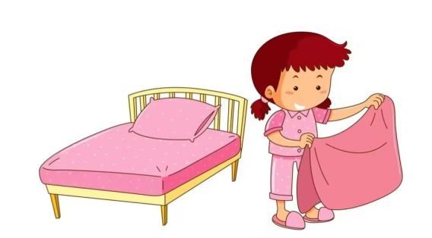
参考答案：She makes the bed in her room. / She makes the bed.
关键词：makes the bed

2. 听力材料：What chores does he do in his room?
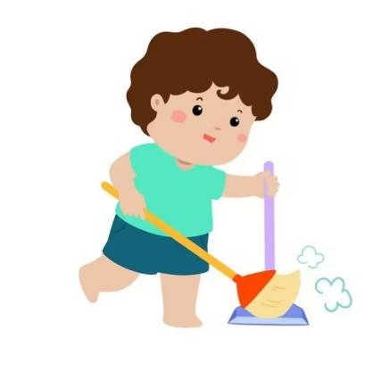
参考答案：He sweeps the floor in his room. / He sweeps the floor.
关键词：sweeps the floor

3. 听力材料：What chores does she do in the garden?
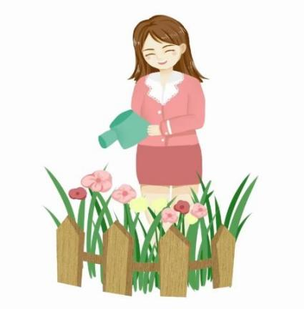
参考答案：She waters the plants in the garden. / She waters the plants.
关键词：waters the plants
参考答案：She waters the flowers in the garden. / She waters the flowers.
关键词：waters the flowers

4. 听力材料：What does she do to help cook a meal?
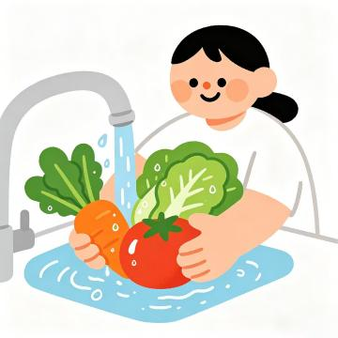
参考答案：She washes the vegetables to help cook a meal. / She washes the vegetables.
关键词：washes the vegetables

5. 听力材料：What chores does she do in the living room?
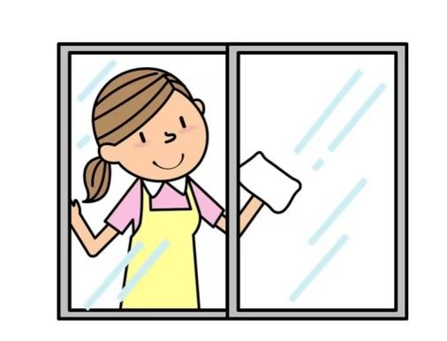
参考答案：She cleans the windows in the living room. / She cleans the windows.
关键词：cleans the windows
一级题型：回答问题
二级题型：看图回答
难度系数：中等
关键词：口语训练#新湘少五上U7
知识点：
1. What chores do/does + sb. + do (+ 地点状语)? (询问做的家务); Sb. (+ 副词) + do/does + 日常活动 (+ 地点状语). (描述日常活动); make the bed [短语]
2. What chores do/does + sb. + do (+ 地点状语)? (询问做的家务); Sb. (+ 副词) + do/does + 日常活动 (+ 地点状语). (描述日常活动); sweep the floor [短语]
3. What chores do/does + sb. + do (+ 地点状语)? (询问做的家务); Sb. (+ 副词) + do/does + 日常活动 (+ 地点状语). (描述日常活动); water the plants [短语]
4. wash the vegetables [短语]
5. What chores do/does + sb. + do (+ 地点状语)? (询问做的家务); Sb. (+ 副词) + do/does + 日常活动 (+ 地点状语). (描述日常活动);clean the windows [短语]
技能：看-看图片；听-听句子；说-说句子
认知目标：应用
适用年级：五年级
编写年份：2026年

四、阅读短文，回答问题。（10分）
请阅读短文，点击“小喇叭”播放问题，点击“录音”开始作答。每小题有10秒钟的准备时间，15秒钟的作答时间。
My name is Amy. I love helping my family do housework at home.
Every morning, I set the table in the kitchen. After breakfast, I make the bed in my room and I help my mother to do the dishes. I also water the flowers in the garden.
Doing chores makes me feel happy and helpful.
听力材料：1. What chores does Amy do in the kitchen?
参考答案：Amy sets the table. / Amy sets the table in the kitchen.
关键词：sets the table
参考答案：She sets the table. / She sets the table in the kitchen.
关键词：sets the table
听力材料：2. Where does Amy make the bed?
参考答案：Amy makes the bed in her room. / She makes the bed in her room. / In her room. (隐藏)
关键词：in her room
听力材料：3. What chores does Amy do in the garden?
参考答案：She waters the flowers in the garden. / She waters the flowers.
关键词：waters the flowers
参考答案：Amy waters the flowers in the garden. / Amy waters the flowers.
关键词：waters the flowers
听力材料：4. What does Amy help her mother do?
参考答案：Amy helps her mother do the dishes. / She helps her mother do the dishes.
关键词：do the dishes
参考答案：Amy does the dishes. / She does the dishes.
关键词：does the dishes
听力材料：5. How does Amy feel when she does chores?
参考答案：Amy feels happy and helpful. / She feels happy and helpful. / Happy and helpful. (隐藏)
关键词：happy, helpful
一级题型：回答问题
二级题型：看文回答
难度：困难
关键词：口语训练#新湘少五上U7
知识点：
1. What chores do/does + sb. + do (+ 地点状语)? (询问做的家务); Sb. (+ 副词) + do/does + 日常活动 (+ 地点状语). (描述日常活动)
2. Sb. (+ 副词) + do/does + 日常活动 (+ 地点状语). (描述日常活动)
3. What chores do/does + sb. + do (+ 地点状语)? (询问做的家务); Sb. (+ 副词) + do/does + 日常活动 (+ 地点状语). (描述日常活动); water [v. 给······浇水]
4. Sb. + help/helps + sb. (+ to do + sth.) [帮助某人(做某事)]; dish [n. 盘；碟]
5. helpful [adj. 有用的]
主题：劳动与家庭；劳动与生活
技能：说-说句子，读-读短文，听-听句子
认知目标：应用
适用年级：五年级
编写年份：2026年

口语训练新湘少版五上U8
一、朗读单词。（15分）
请大声朗读你看到的单词，点击“录音”开始作答。每小题有10秒钟的准备时间，10秒钟的作答时间。
1. then 2. listen 3. answer 4. question 5. join
一级题型：朗读
二级题型：/
难度：容易
关键词：口语训练#新湘少五上U8
知识点：
1. then [adv. 那么；因此；既然如此]; then [adv. 然后] 2. listen
3. answer 4. question 5. join [v. 加入]
技能：说-说词汇
认知目标：识记
适用年级：五年级
编写年份：2026年

二、朗读句子。（15分）
请大声朗读你看到的句子，注意字母组合er的发音。点击“录音”开始作答。每小题有10秒钟的准备时间，15秒钟的作答时间。
1. My father is a worker.
2. Our teacher is kind.
3. She is a good dancer.
4. I drink water every day.
5. My sister likes dancing.
一级题型：朗读
二级题型：/
难度：容易
关键词：口语训练#新湘少五上U8
知识点：
1. er 在单词中的发音 /ə(r)/
2. er 在单词中的发音 /ə(r)/
3. er 在单词中的发音 /ə(r)/
4. er 在单词中的发音 /ə(r)/
5. er 在单词中的发音 /ə(r)/
技能：说-说句子
认知目标：识记
适用年级：五年级
编写年份：2026年

三、根据句型提示，看图说句子。（10分）
请结合句型和图片说句子，点击“录音”开始作答。每小题有10秒钟的准备时间，15秒钟的作答时间。
1. 句型提示：My hobby is ...

参考答案：My hobby is taking photos.
关键词：taking photos
参考答案：My hobby is taking pictures.
关键词：taking pictures

2. 句型提示：She likes doing ...
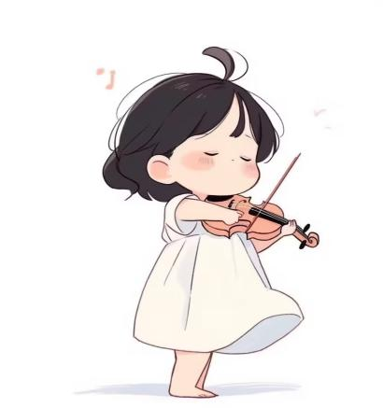
参考答案：She likes playing the violin.
关键词：playing the violin

3. 句型提示：Their hobbies are ...
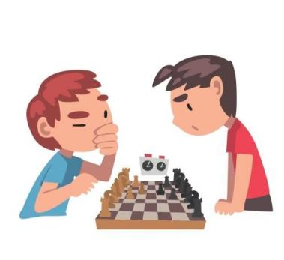
参考答案：Their hobbies are playing chess.
关键词：playing chess

4. 句型提示：His hobby is ...
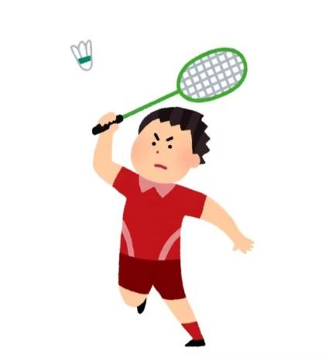
参考答案：His hobby is playing badminton.
关键词：playing badminton

5. 句型提示：He likes doing ...
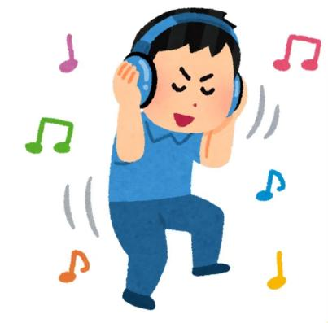
参考答案：He likes listening to music.
关键词：listening to music
一级题型：表达
二级题型：看图说话
难度：容易
关键词：口语训练#新新湘少五上U8
知识点：
1. One's/Sb.'s hobby/hobbies + be ... (介绍某人的爱好); taking photos [短语]
2. Sb. + (don't/doesn't) like/likes doing ... (谈论对文体娱乐活动的喜恶); playing the violin [短语]
3. One's/Sb.'s hobby/hobbies + be ... (介绍某人的爱好); playing chess [短语]; chess; hobby
4. One's/Sb.'s hobby/hobbies + be ... (介绍某人的爱好); playing badminton [短语]; badminton; hobby
5. Sb. + (don't/doesn't) like/likes doing ... (谈论对文体娱乐活动的喜恶); listening to music [短语]
技能：看-看图片；说-说句子
认知目标：理解
适用年级：五年级
编写年份：2026年

四、阅读短文，回答问题。（10分）
请阅读短文，点击“小喇叭”播放问题，点击“录音”开始作答。每小题有10秒钟的准备时间，15秒钟的作答时间。
Hello, everyone! My name is Amy. My friend and I have many hobbies.
My friend Bob’s hobby is drawing. He draws every weekend. My classmate Lily loves singing. She wants to be a singer. My brother Tim likes reading books. He thinks it’s very fun. I like playing the piano and I want to join the music club. We all love our hobbies.
听力材料：1. What is Bob’s hobby?
参考答案：Bob’s hobby is drawing. / His hobby is drawing. / Drawing. (隐藏)
关键词：drawing
听力材料：2. What does Lily want to be?
参考答案：Lily wants to be a singer. / She wants to be a singer. / A singer. (隐藏)
关键词：a singer
听力材料：3. What does Tim like?
参考答案：Tim likes reading books. / He likes reading books.
关键词：reading books
参考答案：Tim likes reading. / He likes reading.
关键词：reading
听力材料：4. Does Amy like playing the piano?
参考答案：Yes, she does. / Yes. (隐藏)
关键词：yes
听力材料：5. What club does Amy want to join?
参考答案：Amy wants to join the music club. / She wants to join the music club. / The music club. (隐藏)
关键词：the music club
一级题型：回答问题
二级题型：看文回答
难度：困难
关键词：口语训练#新湘少五上U8
知识点：
1. What + be + one's/sb.'s + hobby/hobbies? (询问他人的爱好); One's/Sb.'s hobby/hobbies + be ... (介绍某人的爱好)
2. (When ...) Sb. + want/wants to be + 职业. (谈论理想职业)
3. What do/does + sb. + like? (谈论他人的喜好); Sb. + (don't/doesn't) like/likes doing ... (谈论对文体娱乐活动的喜恶); reading books [短语]
4. Do/Does + sb. + like doing ...? (询问是否喜欢某活动); Yes, ... do.
5. Sb. + want/wants to join ... (谈论想要参加的社团)
主题：爱好
技能：说-说句子，读-读短文，听-听句子
认知目标：应用
编写年份：2026年
适用年级：五年级

口语训练新湘少版五上U9
一、朗读单词。（15分）
请大声朗读你看到的单词，点击“录音”开始作答。每小题有10秒钟的准备时间，10秒钟的作答时间。
1. noise 2. front 3. loudly 4. proud 5. excited
一级题型：朗读
二级题型：/
难度：容易
关键词：口语训练#新湘少五上U9
知识点：
1. noise 2. front [n. 前面] 3. loudly 4. proud 5. excited
技能：说-说词汇
认知目标：识记
适用年级：五年级
编写年份：2026年

二、朗读句子。（15分）
请大声朗读你看到的句子，注意字母组合ir的发音。点击“录音”开始作答。每小题有10秒钟的准备时间，15秒钟的作答时间。
1. The girl has a bird.
2. I wear a blue shirt.
3. My birthday is in March.
4. He is the first student.
5. The floor is dirty.
一级题型：朗读
二级题型：/
难度：容易
关键词：口语训练#新湘少五上U9
知识点：
1. ir 在单词中的发音 /ɜː/
2. ir 在单词中的发音 /ɜː/
3. ir 在单词中的发音 /ɜː/
4. ir 在单词中的发音 /ɜː/
5. ir 在单词中的发音 /ɜː/
技能：说-说句子
认知目标：识记
适用年级：五年级
编写年份：2026年

三、根据句型提示，看图说句子。（10分）
请结合句型和图片说句子，点击“录音”开始作答。每小题有10秒钟的准备时间，15秒钟的作答时间。
1. 句型提示：I’m ...

参考答案：I’m happy.
关键词：happy
参考答案：I’m great.
关键词：great

2. 句型提示：She’s ...

参考答案：She’s sad.
关键词：sad
参考答案：She’s upset.
关键词：upset
参考答案：She’s unhappy.
关键词：unhappy

3. 句型提示：I feel ...

参考答案：I feel shy.
关键词：shy

- 句型提示：I feel ...

参考答案：I feel excited.
关键词：excited
参考答案：I feel happy.
关键词：happy
参考答案：I feel proud.
关键词：proud

5. 句型提示：Are you ... ?
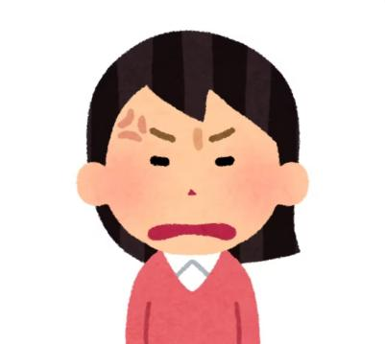
参考答案：Are you angry?
关键词：angry
参考答案：Are you mad?
关键词：mad

一级题型：表达
二级题型：看图说话
难度：容易
关键词：口语训练#新新湘少五上U9
知识点：
1. ... am/is/are + 形容词. (谈论情绪或心理感受)
2. ... am/is/are + 形容词. (谈论情绪或心理感受); sad
3. Sb. feel/feels + 形容词. (描述情绪感受); shy
4. Sb. feel/feels + 形容词. (描述情绪感受); proud; excited
5. Are you + 情绪形容词? (询问他人的感受); angry
技能：看-看图片；说-说句子
认知目标：理解
适用年级：五年级
编写年份：2026年

四、阅读短文，回答问题。（10分）
请阅读短文，点击“小喇叭”播放问题，点击“录音”开始作答。每小题有10秒钟的准备时间，15秒钟的作答时间。
Tom gets a new football. He feels excited. He likes playing football very much. Tom usually plays football with his dad. They have a good time. Tom is very happy. Tom’s PE teacher wants him to play in the school football match. Tom feels shy. His teacher says, “Come on! You’re a good player!”
At last, he wins the match and feels proud.
听力材料：1. How does Tom feel when he gets a new football?
参考答案：He feels excited. / Tom feels excited.
关键词：excited
参考答案：He is excited. / Tom is excited. / He’s excited. / Tom’s excited.
关键词：excited
听力材料：2. Who does Tom usually play football with?
参考答案：Tom usually plays football with his dad. / He usually plays football with his dad. / His dad. (隐藏)
关键词：his dad
听力材料：3. Is Tom happy when he plays football?
参考答案：Yes, he is. / Yes. (隐藏)
关键词：yes
听力材料：4. How does Tom feel before the football match?
参考答案：Tom feels shy. / He feels shy.
关键词：shy
参考答案：He is shy. / Tom is shy. / He’s shy. / Tom’s shy.
关键词：shy
听力材料：5. Why does Tom feel proud at last?
参考答案：Because he wins the match. / Because Tom wins the match.
关键词：because, wins the match
一级题型：回答问题
二级题型：看文回答
难度：困难
关键词：口语训练#新湘少五上U9
知识点：
1. Sb. feel/feels + 形容词. (描述情绪感受); ... am/is/are + 形容词. (谈论情绪或心理感受); excited
2. /
3. Yes, ... am/is/are.
4. Sb. feel/feels + 形容词. (描述情绪感受); ... am/is/are + 形容词. (谈论情绪或心理感受); shy
5. win
主题：情绪；情感
技能：说-说句子，读-读短文，听-听句子
认知目标：应用
适用年级：五年级
编写年份：2026年

口语训练新湘少版五上U10
一、朗读单词。（15分）
请大声朗读你看到的单词，点击“录音”开始作答。每小题有10秒钟的准备时间，10秒钟的作答时间。
1. before 2. next 3. fun 4. eve 5. reunion
一级题型：朗读
二级题型：/
难度：容易
关键词：口语训练#新湘少五上U10
知识点：
1. before [prep. 在⋯⋯以前] 2. next [adj. 下一个的；紧接着的；接下来的]
3. fun [n. 娱乐；乐趣] 4. eve 5. reunion
技能：说-说词汇
认知目标：识记
适用年级：五年级
编写年份：2026年

二、朗读句子。（15分）
请大声朗读你看到的句子，注意字母组合or的发音。点击“录音”开始作答。每小题有10秒钟的准备时间，15秒钟的作答时间。
1. I see a horse on the farm.
2. I use a fork to eat noodles.
3. There are forty students in our class.
4. The boy is short and cute.
5. I do morning exercises every day.
一级题型：朗读
二级题型：/
难度：容易
关键词：口语训练#新湘少五上U10
知识点：
1. or 在单词中的发音 /ɔ:/
2. or 在单词中的发音 /ɔ:/
3. or 在单词中的发音 /ɔ:/
4. or 在单词中的发音 /ɔ:/
5. or 在单词中的发音 /ɔ:/
技能：说-说句子
认知目标：识记
适用年级：五年级
编写年份：2026年

三、情景问答。（10分）
看图回答。请观察图片，点击“小喇叭”播放问题，点击“录音”开始作答。每小题有10秒钟的准备时间，15秒钟的作答时间。
1. 听力材料：What do people do on the eve of the Spring Festival?
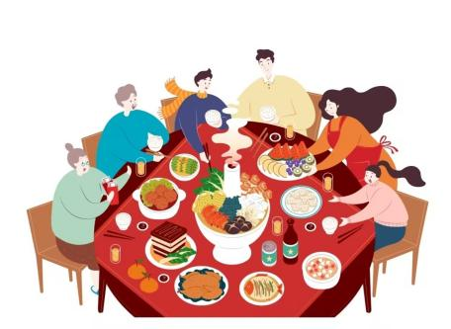
参考答案：They have a family reunion dinner together.
关键词：reunion dinner
参考答案：They have a big and delicious meal together.
关键词：meal

2. 听力材料：What does the boy get during the Spring Festival?
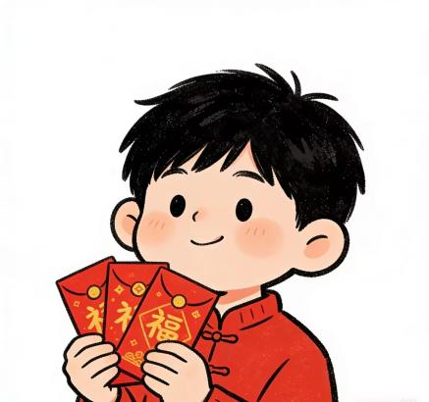
参考答案：He gets red packets during the Spring Festival. / He gets red packets. / Red packets. (隐藏)
关键词：red packets
参考答案：The boy gets red packets during the Spring Festival. / The boy gets red packets.
关键词：red packets

3. 听力材料：What do people watch during the Spring Festival?
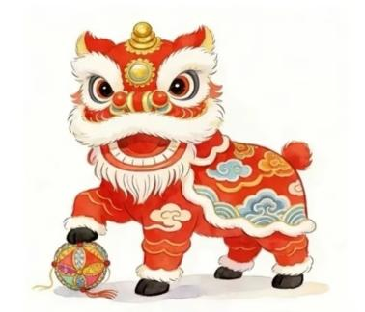
参考答案：People watch lion dances during the Spring Festival. / People watch lion dances.
关键词：lion dances
参考答案：People watch a lion dance during the Spring Festival. / People watch a lion dance.
关键词：a lion dance
参考答案：They watch lion dances during the Spring Festival. / They watch lion dances.
关键词：lion dances
参考答案：They watch a lion dance during the Spring Festival. / They watch a lion dance.
关键词：a lion dance

4. 听力材料：What do people hang up to celebrate the Spring Festival?
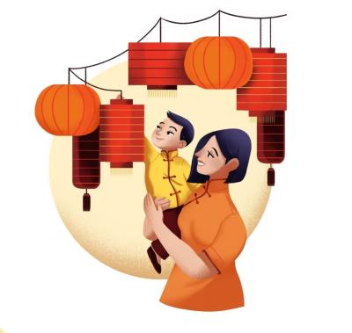
参考答案：They hang up red lanterns. / Red lanterns. (隐藏)
关键词：red lanterns

5. 听力材料：What do they do during the Spring Festival?
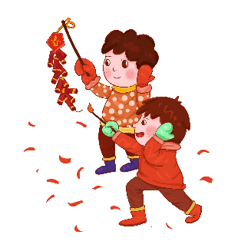
参考答案：They set off firecrackers.
关键词：set off firecrackers
参考答案：They light firecrackers.
关键词：light firecrackers
一级题型：回答问题
二级题型：看图回答
难度系数：中等
关键词：口语训练#新湘少五上U10
知识点：
- What do/does sb. (+ 频度副词) + do + 介词 + 节假日? (询问某人在节假日的活动); Sb. (+ 频度副词) + do/does ... (during/on/for + 节日). (谈论节日活动); a family reunion dinner [短语]
2. What do/does sb. (+ 频度副词) + do + 介词 + 节假日? (询问某人在节假日的活动); Sb. (+ 频度副词) + do/does ... (during/on/for + 节日). (谈论节日活动); the Spring Festival [短语]; red packet [短语]
3. What do/does sb. (+ 频度副词) + do + 介词 + 节假日? (询问某人在节假日的活动); Sb. (+ 频度副词) + do/does ... (during/on/for + 节日). (谈论节日活动); lion dance [短语]
4. Sb. (+ 频度副词) + do/does ... (during/on/for + 节日). (谈论节日活动); red lantern [短语]
5. What do/does sb. (+ 频度副词) + do + 介词 + 节假日? (询问某人在节假日的活动); Sb. (+ 频度副词) + do/does ... (during/on/for + 节日). (谈论节日活动); firecracker; light [v. 点着；点燃]
技能：看-看图片；听-听句子；说-说句子
认知目标：应用
适用年级：五年级
编写年份：2026年

四、阅读短文，回答问题。（10分）
请阅读短文，点击“小喇叭”播放问题，点击“录音”开始作答。每小题有10秒钟的准备时间，15秒钟的作答时间。
Hi, Amy!
I’m having a great time during the Spring Festival in China. Red is everywhere here. People think red brings good luck.
Before the Spring Festival, my family clean the rooms. We put up Spring Festival couplets. We also buy new clothes and nice food.
On New Year’s Eve, we have a family reunion dinner. We eat dumplings. They are yummy. After dinner, we watch TV together.
During the festival, we visit our grandparents. We say “Happy New Year” to them. We get red packets from them too. We are very happy.
We have a lot of fun during the Spring Festival.
Best wishes!
John
听力材料：1. What do people think red brings?
参考答案：People think red brings good luck.
关键词：good luck
参考答案：They think red brings good luck. / Good luck. (隐藏)
关键词：good luck
听力材料：2. What do John’s family put up?
参考答案：John’s family put up Spring Festival couplets. / They put up Spring Festival couplets. / Spring Festival couplets. (隐藏)
关键词：Spring Festival couplets
听力材料：3. What do they eat at the family reunion dinner?
参考答案：They eat dumplings at the family reunion dinner. / They eat dumplings. / Dumplings. (隐藏)
关键词：dumplings
听力材料：4. Who do they visit during the festival?
参考答案：They visit their grandparents during the festival. / They visit their grandparents. / Their grandparents. (隐藏)
关键词：their grandparents
听力材料：5. What do children get from their grandparents?
参考答案：They get red packets from their grandparents. / Red packets. (隐藏)
关键词：red packets
一级题型：回答问题
二级题型：看文回答
难度：困难
关键词：口语训练#新湘少五上U10
知识点：
1. luck [n. 好运]
2. couplet
3. /
4. /
5. red packet [短语]
主题：中国节日；庆祝活动
技能：说-说句子，读-读短文，听-听句子
认知目标：应用
适用年级：五年级
编写年份：2026年

