Football Playbook Online

**User Manual**

BCIT CST COMP4900

Group 16 - NoName

Justen DePorceq

Fred Yang

Yiaoping Shu

Tim Makimov

Matthew Goerwell

Supervisor: Farnaz Dargahi

2017-05-20

Introduction 4

Home Page 4

Design Page 5

New Play 7

Clear Field 7

Select Tool 7

Line Tool 8

Curve Tool 8

O Tool 8

X Tool 8

Rectangle Tool 8

Triangle Tool 9

Coloured Circle Tool 9

Text tool 9

Color Picker Tool 9

Save Button 9

Pattern Selection 10

Right Click Menu 11

Properties 12

Playbooks Page 15

Plays Menu 16

New 16

Edit 16

Clone 16

Delete 16

PDF Menu 17

All plays 17

Selected plays 17

Update 17

Support Page 17

Login Page 18

Register Page 20

# Introduction

Hello, and welcome to the User manual for Football Playbook Online. It is our hope that by the end of this document you will have a thorough understanding of how the site is meant to function.

Football Playbook Online is a website designed to enable coaches to draft out plays and strategies for their teams to improve their performance on the field. The app comes in two forms - A free version, and a premium version with additional features.

We hope you enjoy using Football Playbook Online!

# Home Page

This is the Primary entry page for the Website. From here you can click on the Navigation bar along the top of the screen to go to any of the other pages. Otherwise, you can read some basic information on Football Playbook Online.

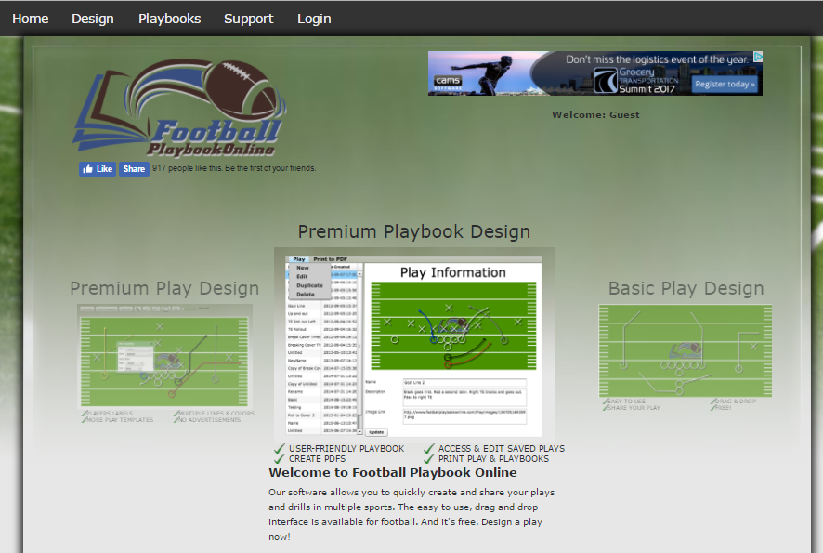

*Home page*

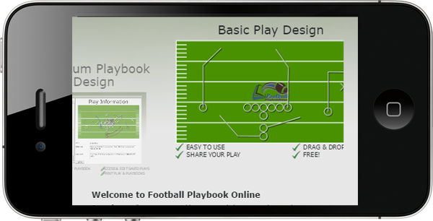

*Home page (mobile)*

# Design Page

This is the websites Main Page. On this page you can design a play that meets your needs. Feel free to play with any of the following features to your heart's content!

If you want new objects to snap to the grid itself, as opposed to other existing objects, this can be toggled with the checkboxes on top of the play.

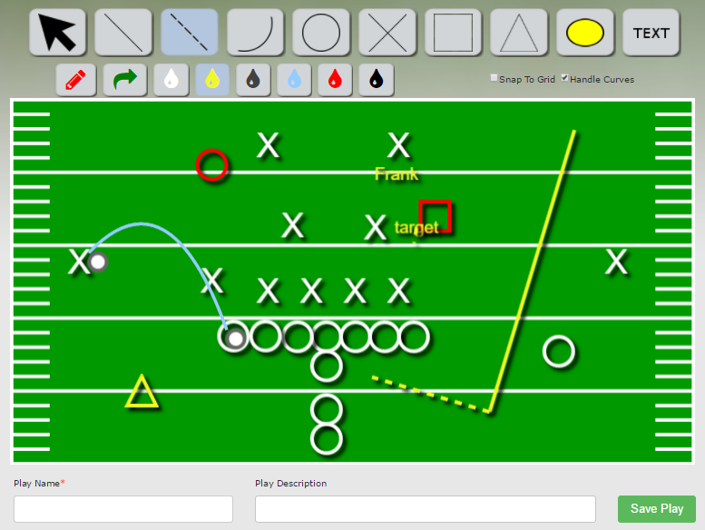

*Design page*

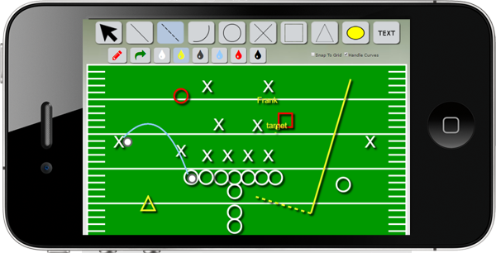

*Design page (mobile)*

## New Play

This button will allow you to choose from a variety of templates to create a new play Select the one you desire and begin designing.



## Clear Field

This button will wipe the field clean and let you start fresh. Use it if things get a bit too messy for you to easily clean up.



## Select Tool

This button will allow you to click on any object you've placed on the field, and drag it around in case you want to revise where you put it. If things are just a little bit off, you can adjust it easily until it's just right!



## Line Tool

This button will allow you to draw a solid or dashed line between any two points on the field. Simply click where you want the line to start and drag until you reach the point you want it to end at.



## Curve Tool

***NOTE:*** *This tool is accessible to premium users only.*

By using this tool, you can draw a curve between any two points on the field. Using the select tool, you can also adjust the depth of the curve to your satisfaction.



## O Tool

Use this tool to represent players going on the offense. Simply click the button and place the player anywhere you want.

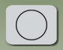

## X Tool

Use this tool to represent players acting as defense. Simply click the button and place the player anywhere you want.



## Rectangle Tool

Use this tool to represent players acting as offense. Simply click the button and place the player anywhere you want.



## Triangle Tool

Use this tool to represent players acting as defense. Simply click the button and place the player anywhere you want.



## Coloured Circle Tool

This tool allows you to place down a "Zone of Control" that a player is meant to cover. Feel free to resize the circle to whatever size you need by using the select tool.



## Text tool

Use this tool to place a standalone text label anywhere on the field. After placing it down, use the select tool and click on the text twice to edit it to whatever you want it to say.

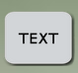

## Color Picker Tool

You can pick one of the color from the Color Picker Set to render / change the color of an object specified.



## Save Button

***NOTE:*** *This tool is accessible to premium users only.*

If you're a Premium user, you can fill out the fields here to save your current play for future reference. Simply enter in the play name and any description you want, then click the save play button.



## Pattern Selection

New play patterns will pop up when entering design page as below. Click on arrow buttons to choose the patterns you want. This will be populated onto the canvas when pressing “Continue” button.

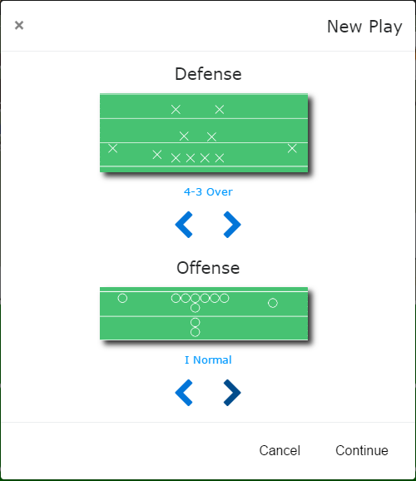

*New play patterns*

## Right Click Menu

Right click on an element on the canvas, the right click menu will appear. Click on “Properties” to edit the attributes of the element specified; click on “Delete” to remove the element specified from the canvas.



## Properties

The sub menu “Properties” allows you to edit the attributes of the current element. You can change / edit Color, Style, Arrow Style, etc for a Line / Dashed Line / Zigzag element, change / edit Color, Style, Label, etc for a Player.

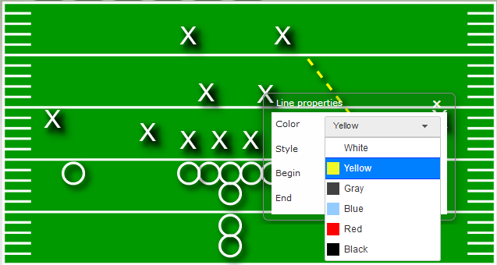

*Line properties – Change Color*

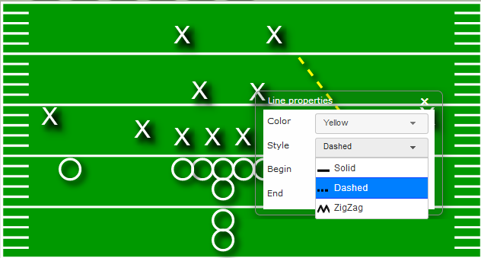

*Line properties – Change Style*

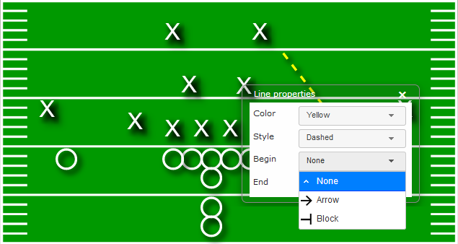

*Line properties – Change Arrow Style (Begin / End)*

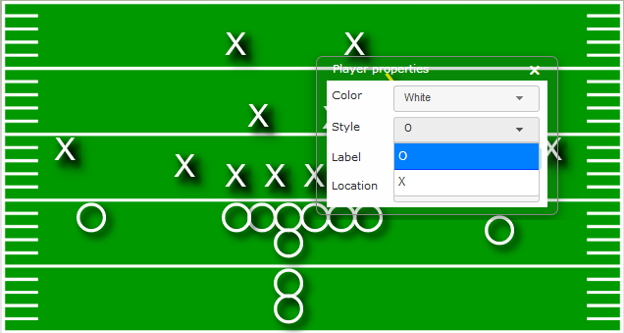

*Player properties – Change Style*

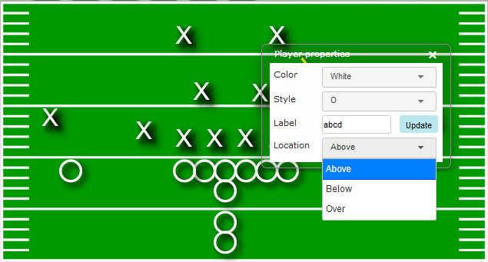

*Player properties – Add Label*

# Playbooks Page

***NOTE:*** *This page is accessible to premium users only.*

Using this page, you can access any plays you've previously made and perform a variety of actions upon them. Simply select plays from the list on the side in order to interact with them.

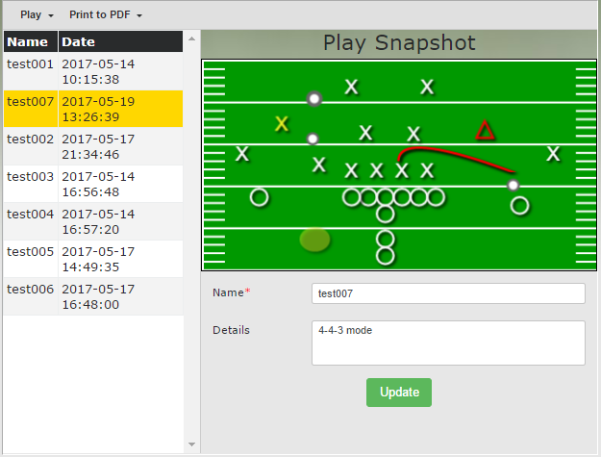

*Playbooks page*

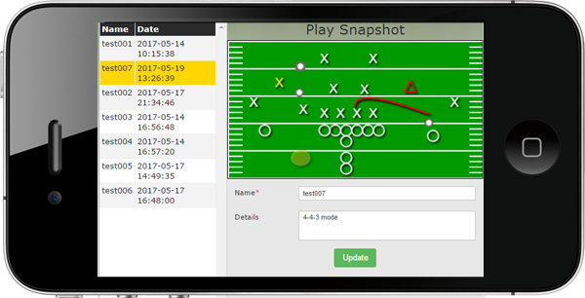

*Playbooks page (mobile)*

## Plays Menu

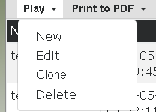

This menu allows you to perform various actions related to actual plays.

### New

This option will take you to the design page where you can make a new play like normal.

### Edit

This option will take you to the design page, but will preload the currently selected play. If you save again while on the design page, it will update the existing page instead of making a new play.

### Clone

This option will make a copy of the currently selected play that can be accessed separately.

### Delete

This option will remove the currently selected play from the database.

## PDF Menu

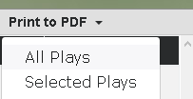

This menu will allow you to convert your plays to PDF format so you can take them on the go! There are two options for creating a PDF.

### All plays

This will take every play in your playbook and load it into the PDF. Simply follow the instructions on screen when the option is selected and get your PDF.

### Selected plays

This will take every play you currently have selected and load it into the PDF. Simply follow the instructions on screen when the option is selected and get your PDF.

## Update

When a play is selected, you can update the play name or description in the boxes underneath where the play is displayed. When you're done, simply click the update button and your change will be saved.

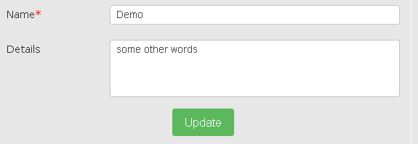

*Update play name and details*

# Support Page

Visit this page in order to find assistance relating to the website. In addition to the answers to some frequently asked questions, you can also find a simplified version of this user guide.

If for whatever reason this does not meet your needs, feel free to contact us by using the fields at the bottom of the page and clicking the send message button.

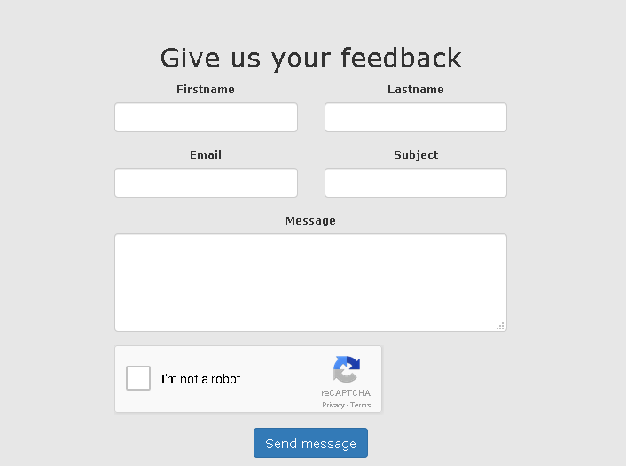

*Feedback fields*

# Login Page

From this page you can sign in to your account if you have one. Simply enter your details and sign in!

If you don't already have an account, don't worry! You can make one by clicking the register button instead!

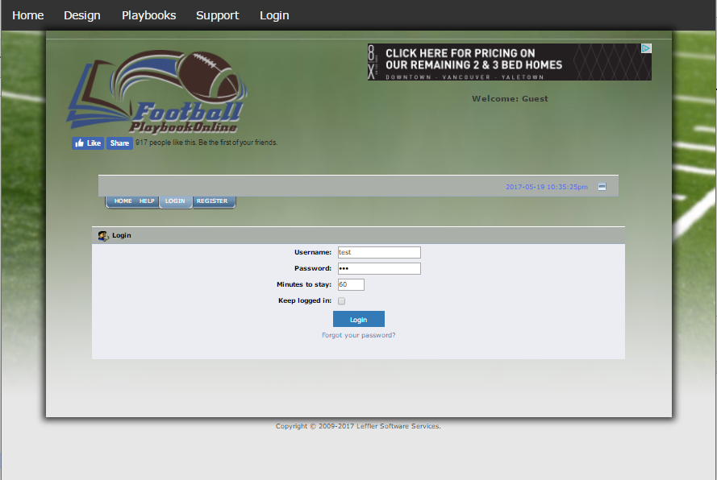

*Login page*

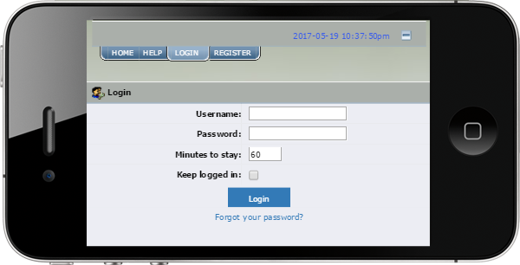

*Login page (mobile)*

# Register Page

Use this page to create your user account and join the Football Playbook Online Family!

Simply choose your username and password, then finish our verification checks and agree to our terms of service, and you'll be ready to go!

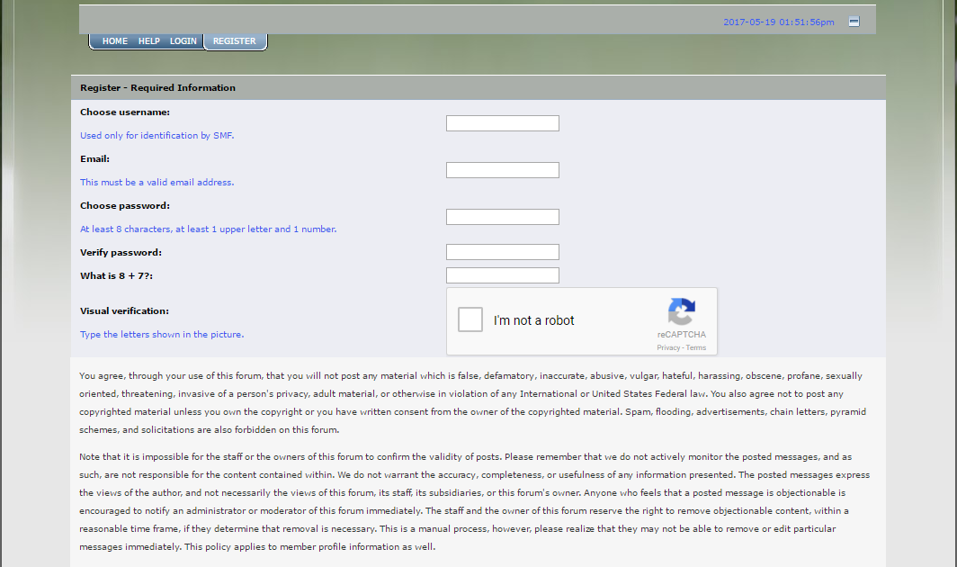

*Register page*

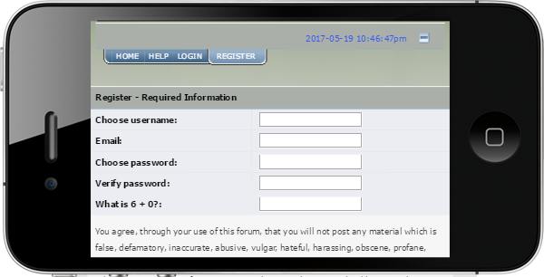

*Register page (mobile)*