K.H.U. Faculty of Engineering and Natural Sciences

MIS_400 BACHELORS PROJECT
PROPOSAL

IT PROJECT GOVERNANCE
(EXAMINATION OF PROJECT LIFE CYCLE,PRE-AND POST LIFE CYCLE)

Project Advisor:

EBRU DILAN
MEHMET NAZIF AYDIN

Project Team:

BUSRA BOSTAN 2010.01.04.024
MANAGEMENT INFORMATION SYSTEMS

DAMLA NUR KUMBASAR 2010.01.04.002
MANAGEMENT INFORMATION SYSTEMS

Submission Date:11.12.2014
ABSTRACT:

Project Governance is a subset of IT Governance. Project Governance refers to the rules and regulations under which an IT project functions.Project governance will outline the relationships between all groups involved in the project, describe the project information flow to all stakeholders and ensure reviews and approvals at appropriate stages of the project. Project governance not only provides a framework for the organization of responsibilities and decision-making capabilities, it also ensures that the project implementation and execution will go smoothly. Before the project starts, it is determined who will make project-related decisions and how they will make them. Setting up project governance decreases the probability of poor controls during the life of the project. “Project Governance[Online] http://glossary.tenrox.com/Project-Governance.htm ” So IT Project Governance is important for the all projects life cycle. And other important subject is Stakeholder Analysis. Stakeholder Analysis is a process of systematically gathering and analyzing qualitative information to determine whose interests should be taken into account when developing and or implementing a policy or program.“ Kammi Schmeer and Abt Associates Inc.(1999) Guidelines for Conducting a Stakeholder Analysis pp.3 ” As you become more successful in your career of Project management, the actions you take and the projects you run will affect more and more people. The more people you affect, the more likely it is that your actions will impact people who have power and influence over your projects. These people could be strong supporters of your work. “Stakeholder Analysis-Winning Support Your Project [online] http://www.mindtools.com/pages/article/newPPM_07.htm” Many organization started with the implementation of IT Project Governance because to achieve succeess for business life and IT. So we will examine and research for project processes such as project initiation, project planning, project execution, project monitor and control, and project close down of new products for big company from Service sector. All processes are so important for new project. If you want to finish project successful, you must do all processes on time. We will go to the company and we will meet Project Managers and other responsible who from the project. We will prepare some questions for our project, then we will transmit to Project Managers. And then we will search while project is doing, we will examine stakeholder’s role to all project management processes. Finally we will prepare report for the working on the case study and document examination.

AIM:

Our project aim is examine IT Project Governance for Service Company of the project life cycle of pre and post processes. We want to see all processes while project is doing. On the Service Company, team members how work while project is doing and what other members role on the project and other important members of project are stakeholders. Stakeholders affect directly or indirectly and positively or negatively from project processes. Stakeholders want to supply the needs and expectations. We will look and research stakeholder’s role and effect all project processes and how stakeholders join the steps. And other step is that we will examine all processes while project is doing and examined finished projects.

METHODOLOGY:

Qualitative Research

Qualitative Research is exploring issues, understanding phenomena and answering questions by analyzing and making sense of unstructured data. It generates data about human groups in social settings.Qualitative research aims to get a better understanding through first hand experience, truthful reporting, and quotations of actual conversations. It is uses data collection method. QUALITATIVE RESEARCH[online]
http://www.csulb.edu/~msaintg/ppa696/696quali.htm. Our aim is doing this method is we will meet project manager or responsible who of the project, we collect data and understand processes. Also we will do under this subject, the case study research method.

The Case Study Research Method

Case study research excels at bringing us to an understanding of a complex issue or object and can extend experience or add strength to what is already known through previous research. Case studies emphasize detailed contextual analysis of a limited number of events or conditions and their relationships.Case studies includes such as determined define research questions, select the cases and determine techniques, prepare to collect data, collect data in the field, evaluate and analyze the data, prepare the report. The Case Study as a Research Method[online] https://www.ischool.utexas.edu/~ssoy/usesusers/l391d1b.htm. We will do all steps and we collect data, research data, examine projects. Then finally, we will prepare case study report.

Data Collection

Data collection is simply how information is gathered. There are various methods of data collection such as personal interviewing, telephone, mail and the Internet. Depending on the survey design, these methods can be used separately or combined. The team aims to provide business areas with methodological standards and expert advice on procedures to minimise error, in order to produce accurate survey estimates and thereby maintain the quality of data output. Data Collection Methodology[online] http://www.ons.gov.uk/ons/guide-method/method-quality/general-methodology/data-collection-methodology/index.html. When we start to do project, we collect data from company and project managers. While we collect data, we will make two methods from data collection. These are interview and document examination.

Interview

A method of data collection, information or opinion gathering that specifically involves asking a series of questions. Typically, an interview represents a meeting or dialogue between people where personal and social interaction occur. Interviews are conducted on a face-to-face basis and they can take a variety of forms. Pamela Davies INTERVIEW[online] http://srmo.sagepub.com/view/the-sage-dictionary-of-social-research-methods/n106.xml. We will prepare some questions about our project and then we will go to the company. Then we will ask our questions about the project and we will take some notes about project processes.

Document Examination

Document Examination is the science involved in the analysis and evaluation of various types of documentation for the purpose of detecting forgery, identifying writers and proving or disproving document authenticity. Questioned document cases usually revolve around the handwriting and/or signatures surrounding the document. What is Document Examination?[online] http://documentexaminer.ie/what_is_dei.html. We will examine and look the project all documentations and analyze the documentations. We will examine finished project, and then we will prepare case study report.

WORK PACKAGE DESCRIPTION

Number and name of the package:
1.Planning
2.Execution
3.Close Down

Start date: 14.10.2014
Finish date: 05.05.2015

Short description:
1.Planning
1.1.Make a brainstorming
1.2.Searching subject
1.3.Meeting with company
1.4.Preparing proposal
2.Execution
2.1.Preparing design project progress
2.2.Preparing questions
2.3.Meeting with project managers
2.4.Collection of data
2.5.Analyzing projects
3.Close Down
3.1.Analysis of result
3.2.Final Results
3.3.Conclusion
3.4.Preparing final material

Methodology: The Case Study Research Method, Qualitative Research, Data Collection,Interview, Document Examination

Outputs: Case Study’s Report

Relations to other packages: All packages are related to each other.

Working team members (with contributions as percentages of the work packet):
BÜŞRA BOSTAN 50%
DAMLA NUR KUMBASAR 50%
Work to be done by any body outside the team: NOT APPLICABLE
WORK PACKAGE DESCRIPTION

Number and name of the package:
1.Planning

Start date: 14.10.2014

Finish date:11.12.2014

Short description:
1.Planning
1.1.Make a brainstorming
1.2.Searching subject
1.3.Meeting with company
1.4.Preparing proposal

Methodology: The Case Study Research Method, Qualitative Research, Data Collection, Interview, Document Examination

Outputs: Case Study’s Report

Relations to other packages: When Planning is finished, Execution will start, then when Execution is finished, Close Down will start.

Working team members (with contributions as percentages of the work packet):

BÜŞRA BOSTAN 50%
DAMLA NUR KUMBASAR 50%

Work to be done by any body outside the team: NOT APPLICABLE

WORK PACKAGE DESCRIPTION

Number and name of the package:
2.Execution

Start date: 05.01.2015

Finish date: 13.04.2015

Short description:
2.Execution
2.1.Preparing design project progress
2.2.Preparing questions
2.3.Meeting with project managers
2.4.Collection of data
2.5.Analyzing projects

Methodology: The Case Study Research Method, Qualitative Research, Data Collection, Interview, Document Examination

Outputs: Case Study’s Report

Relations to other packages: When planning is finished, execution will start, then when execution is finished, close down will start.

Working team members (with contributions as percentages of the work packet):

BÜŞRA BOSTAN 50%
DAMLA NUR KUMBASAR 50%

Work to be done by any body outside the team: NOT APPLICABLE

WORK PACKAGE DESCRIPTION

Number and name of the package:
3.Close Down

Start date: 14.04.2015

Finish date: 30.04.2015

Short description:
3.Close Down
3.1.Analysis of result
3.2.Final Results
3.3.Conclusion
3.4.Preparing final material

Methodology: The Case Study Research Method, Qualitative Research,Data Collection, Interview, Document Examination

Outputs: Case Study’s Report

Relations to other packages: When Planning is finished, Execution will start, then when Execution is finished, Close Down will start.

Working team members (with contributions as percentages of the work packet):

BÜŞRA BOSTAN 50%
DAMLA NUR KUMBASAR 50%

Work to be done by any body outside the team: NOT APPLICABLE

CONTRIBUTIONS OF THE TEAM MEMBERS:

Name, Surname | Work Packages |  |  | Total
Name, Surname | I | II | III | Total
Name, Surname | % | % | % | %
BÜŞRA BOSTAN | 50 | 50 | 50 | 50
DAMLA NUR KUMBASAR | 50 | 50 | 50 | 50
Total | 100 | 100 | 100 | 100

PROJECT CALENDAR

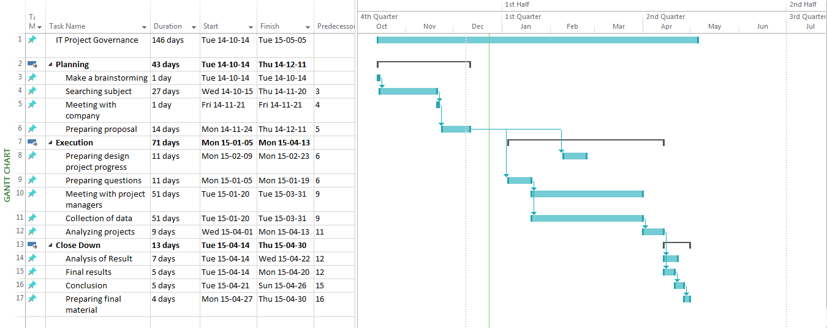
INFRA-STRUCTURE REQUIREMENTS:

Laboratory(ies): NOT APPLICABLE

Equipment: Articles, documents and computer.

Computer(s): We can search some information on the Internet.

Personnel: Company’s project managers.

REFERENCES:

1.QUALITATIVE RESEARCH[online] http://www.csulb.edu/~msaintg/ppa696/696quali.htm
2. The Case Study as a Research Method[online] https://www.ischool.utexas.edu/~ssoy/usesusers/l391d1b.htm
3. Data Collection Methodology[online] http://www.ons.gov.uk/ons/guide-method/method-quality/general-methodology/data-collection-methodology/index.html
4. Pamela Davies INTERVIEW[online] http://srmo.sagepub.com/view/the-sage-dictionary-of-social-research-methods/n106.xml
5. What is Document Examination?[online] http://documentexaminer.ie/what_is_dei.html
6. (Project Governance[Online] http://glossary.tenrox.com/Project-Governance.htm.
7.Stakeholder Analysis-Winning Support Your Project [online] http://www.mindtools.com/pages/article/newPPM_07.htm

