**Installing Node.js on macOS and Linux**

In this section, we'll look at installing Node on macOS and Linux. For Windows users feel free to skip to the next section, unless using Windows Subsystem for Linux v2 in which case this section may also be relevant.

The recommended way to install Node.js on macOS and Linux is by using a Node version manager, in particular [**nvm**](https://github.com/nvm-sh/nvm). See <https://github.com/nvm-sh/nvm> for full details.

We're going to install **nvm** and then use it to install Node.

The current **nvm** version is v0.35.3 (as of May 2020), so the install process will contain this version in the URL, if a greater version is out at time of reading, replace v0.35.3 with the current **nvm** version. For this installation process we assume that Bash, Sh, or Zsh is the shell being used, Fish is not supported but see the **nvm** readme for alternatives.

The way to install **nvm** is via the install script at <https://github.com/nvm-sh/nvm/blob/v0.35.3/install.sh>. If **curl** is installed (it usually is) a single command can be used to install and setup **nvm**:

**curl -o-  
https://raw.githubusercontent.com/nvm-sh/nvm/v0.35.3/install.sh | bash**

If using **zsh** (e.g. on newer macOS releases) the **bash** part of the command can be replaced with **zsh**.

Alternatively the file can be downloaded and saved, and then easily executed like so:

**cat install.sh | bash**

Again **bash** can be replaced with **zsh**. To check that the installation was successful execute the following in the terminal:

**command -v nvm**

It should output **nvm**. If this fails on Linux, close and reopen the terminal (or SSH session) and try running the command again. On macOS see <https://github.com/nvm-sh/nvm#troubleshooting-on-macos> for in depth troubleshooting.

Now that we have a version manager, let's install the Node version we'll be using on this course:

**nvm install 12**

This will install the latest version of Node 12:

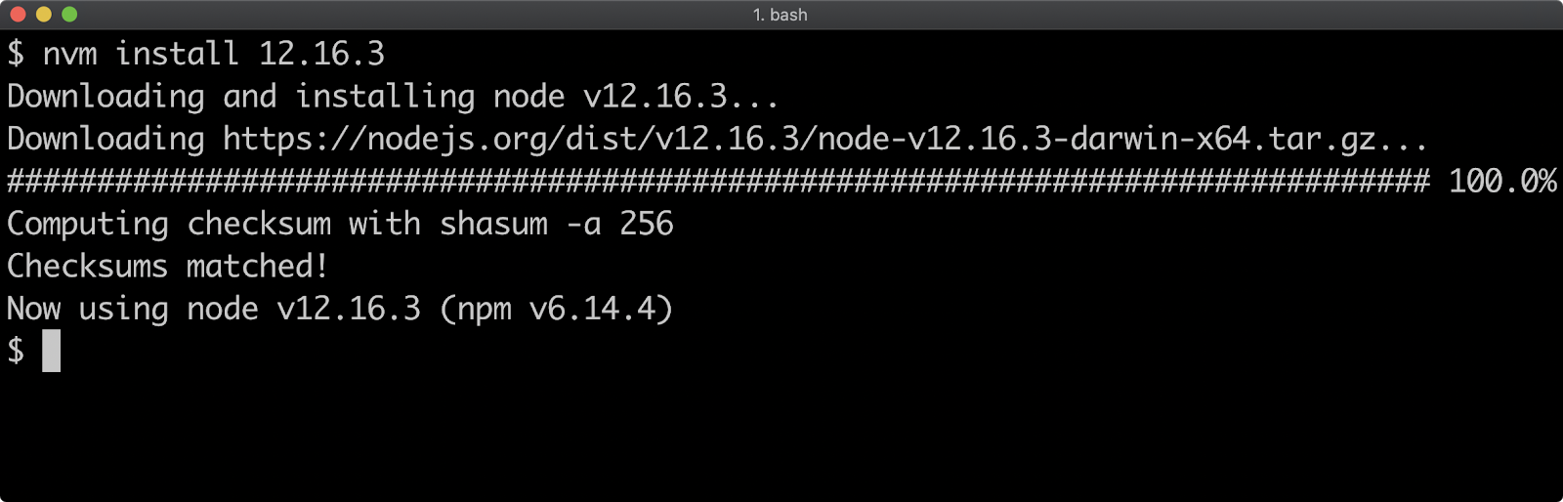

In this case, the command installed Node v12.16.3. It doesn't matter if the right-most numbers are higher for this course, as long as the major number (the first number) is 12.

We can verify that Node is installed, and which version, with the following command:

**node -v**

Congratulations, you now have the right setup on your macOS or Linux machine to proceed with the course.